Healthwatch Surrey logo

**Quarterly Impact Report**

April - June 2025

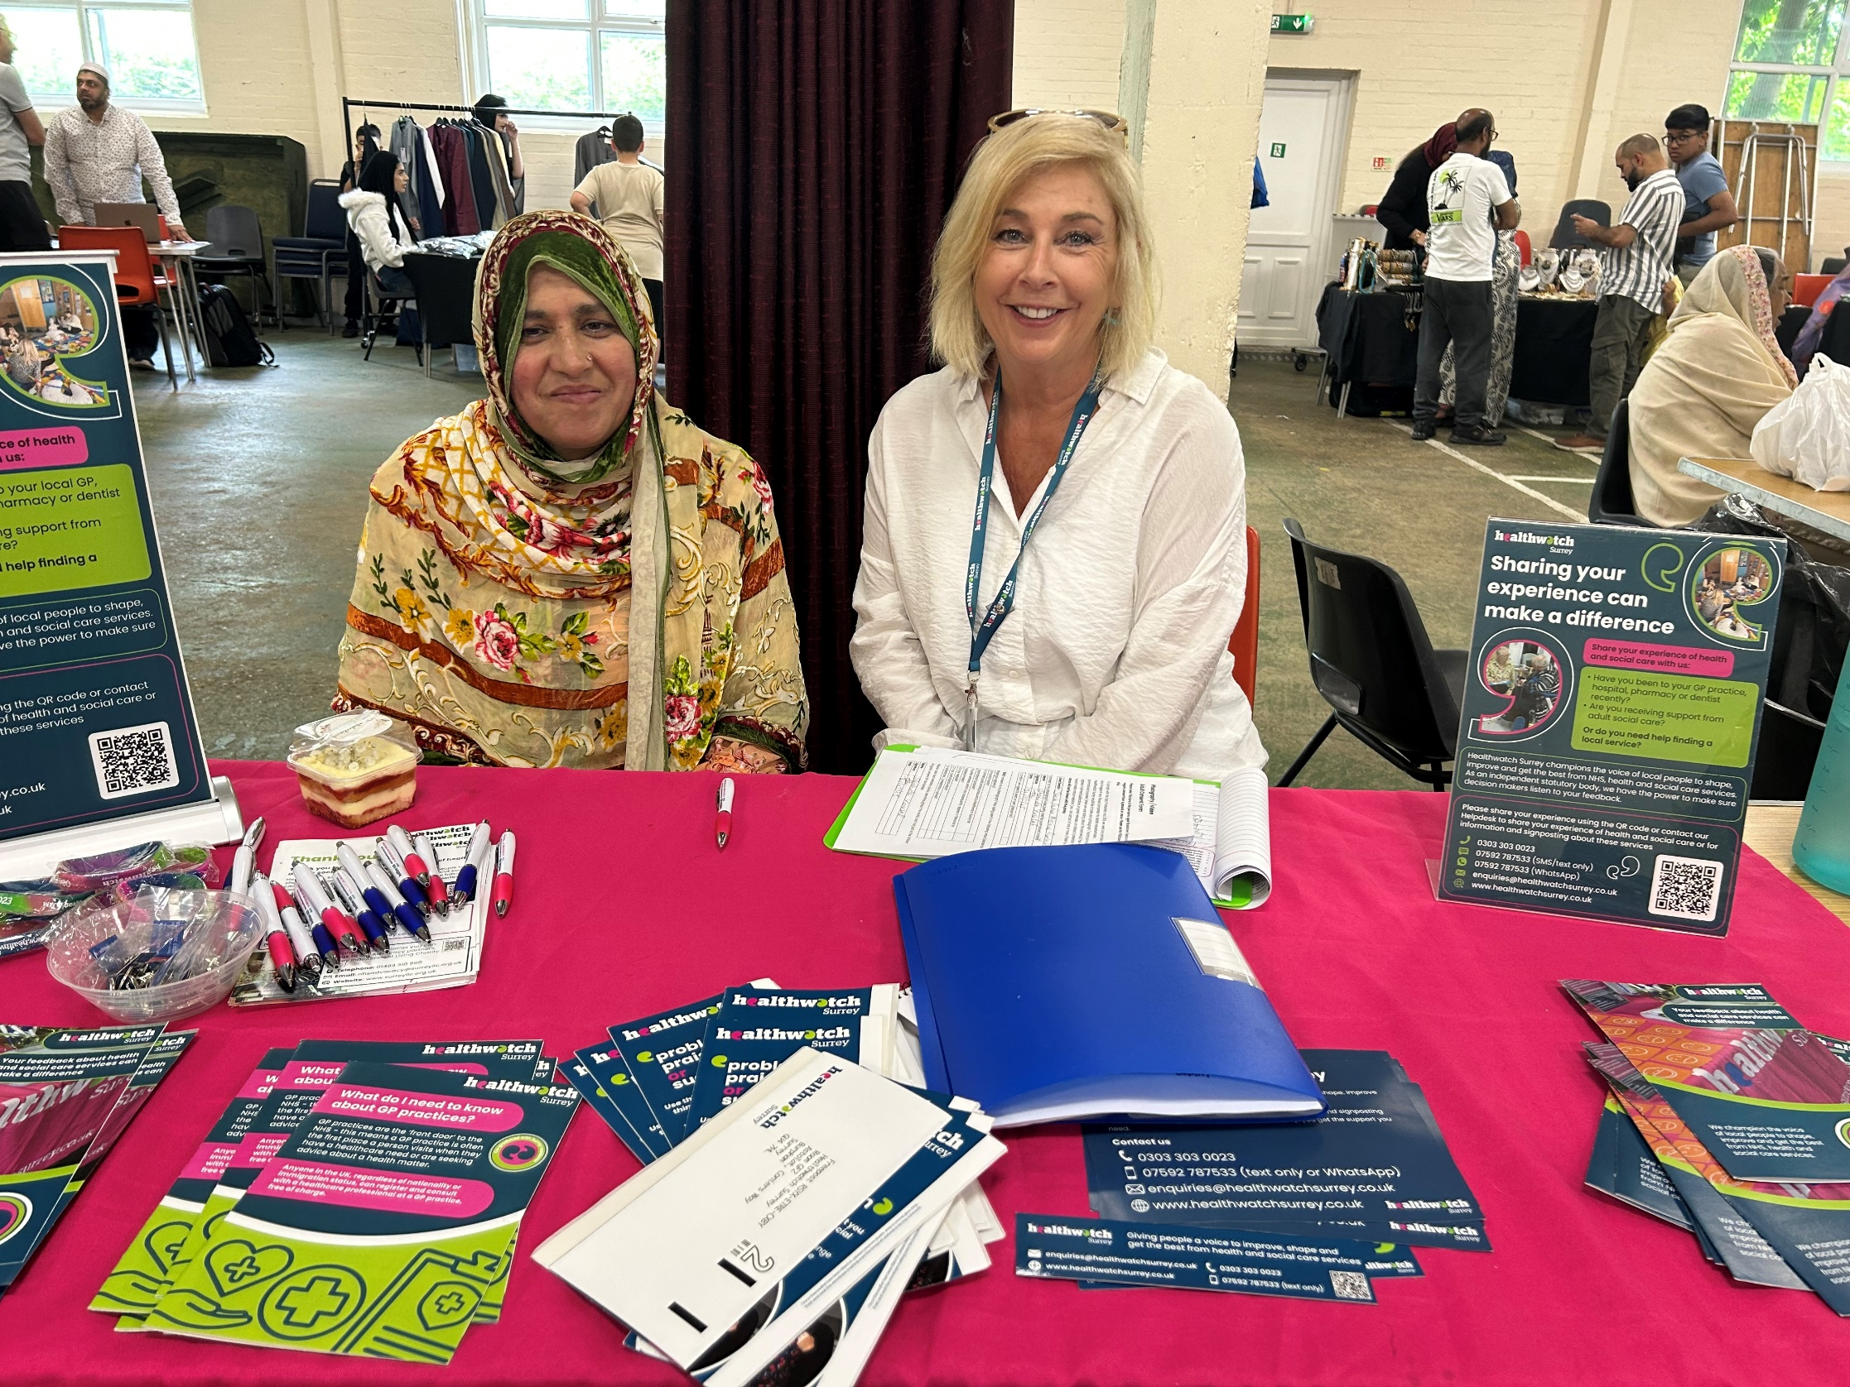

Contents

This quarter in numbers 3

Information and signposting 4

Supporting residents through our Helpdesk 5

Supporting residents in the community 7

Advocacy & complaints 9

Delivering on our thematic priorities 10

Primary care: domestic abuse survivors’ experiences of general practice 11

Making a difference at a system level 13

Utilising patient experience to improve non-emergency patient transport 13

Simplifying complaints routes 14

Maintaining momentum: checking in on long-term impact 15

Involving local people in health and social care 17

Ensuring Quality Accounts are accessible to all 18

Have your say! Upcoming projects 19

Healthwatch Surrey – Contact us 20

If you would like a paper copy of this document or require it in an alternative format, please get in touch with us.

# This quarter in numbers

|  |  |
| --- | --- |
| **Icon of a telephone.** | **101** People supported through our Helpdesk* |
| **Icon of a person holding up a sign** | 26 **People supported by our Independent Health Complaints Advocacy service** |
| **Icon of people gathered together and talking** | **15 Community engagement events** |
| **Icon of a speech bubbleIcon of a group of people** | **263 People helped, supported or engaged with whilst out in the community**  **989 Experiences shared with us\*\*** |
| **Icon of a report** | **18** [**Reports**](https://www.healthwatchsurrey.co.uk/reports) **published** |
|  | **302 Hours provided by our volunteers** |

* People contacting our Helpdesk for information, advice or to share an experience, via e-mail, telephone, text or WhatsApp, or via our website (internal reference – line 8)

** People contacting our Helpdesk for information, advice or to share an experience, via e-mail, telephone, text or WhatsApp, or via our website. Plus sharing their experiences via SmartSurvey, our Enter and View visits or some other means including projects and Healthwatch England (internal reference – lines 14, 15, 16)

# Information and signposting

Healthwatch Surrey offer information and signposting – via our Helpdesk or during engagement in the community - to support people to navigate health and care services across Surrey. We help people to identify the services and support they need and provide advice about what to do when things go wrong. Through our relationships with system partners, we can also escalate concerns; providing resolutions to individuals and ensuring an improved experience for others.

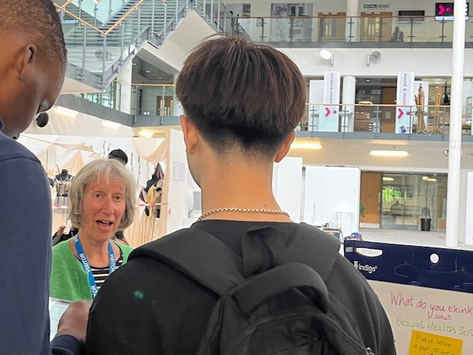

## Supporting residents through our Helpdesk

We helped **113** people navigate health and social care services after they contacted our [Helpdesk](https://www.healthwatchsurrey.co.uk/contact/).

“I spoke to [the Helpdesk advisor] who was very helpful and attentive to my questions, please would you thank her.”

Helpdesk user

“Thank you so much for your help today, we would not have been able to get this issue resolved without your support. Thank you again.”

Helpdesk user

### ****Case study: working with advocacy partners****

Two years ago, alongside our voluntary, community and social enterprise (VCSE) partners (Surrey Coalition of Disabled People, Citizens Advice, Surrey Care Association and VoiceAbility), we raised our concerns that there was an unmet need for Care Act Advocacy. As a direct result, the Advocacy Partners meeting was created; fast becoming a vital forum for us and other VCSE partners to share the experiences of people we support. This has fostered much closer working relationships between advocacy providers and in turn made referral processes for people in Surrey more efficient. This is particularly important for those needing advocacy support, who often have complex health and care needs and experiences.

#### Stephen’s story*

Stephen contacted the Helpdesk concerned that he was unable to get a referral from his social worker for Care Act Advocacy. Our Helpdesk team recognised that he was eligible, and also noted he was experiencing issues communicating directly with the provider. We felt sure Stephen was eligible for support so shared Stephen’s experience with the commissioners and the advocacy service who responded by reviewing Stephen’s case and taking steps to ensure that Stephen could access Care Act Advocacy.

#### Wider impact: system learnings

Raising our concerns also prompted a review of how calls are taken by the advocacy service and whether anything can be done to ensure better communication for people trying to access it. The service are now implementing a new phone system, to enable them to respond to queries in a more efficient and timely manner. They have also created a Surrey specific email inbox, so that any Surrey residents or professionals can get a quick response from the managers of the service.

* Names have been changed.

## Supporting residents in the community

We visited **15** venues across Surrey and engaged with **263** people.

The map below shows the venues we visited.

**Reigate & Banstead**

* East Surrey College
* East Surrey Hospital
* Woodhatch Place
* YMCA family centre

**Woking**

* Coldingley Prison
* Sha Jahan Mosque
* St. Paul’s Church (x 2 events
* Woking town centre

**A map of Surrey district and boroughs with places we visited written around it. 

Guildford:
• Royal Surrey County Hospital
• St. John's Church

Mole Valley:
• Leatherhead Community Hub

Reigate & Banstead:
• East Surrey College
• East Surrey Hospital
• Woodhatch Place
• YMCA Family Centre

Surrey Heath:
• St. Paul's Church

Waverley:
•Banardo's Family Centre
• Godalming College

Woking:
• Coldingley Prison
• Sha Jahan Mosque
• St. Paul's Church (x 2 events)
• Woking Town Centre









**Community case study: amplifying the voices of those less well heard

* **Guildford**
* Royal Surrey County Hospital
* St. John’s Church

**Surrey Heath**

* St Pauls Church
* **Mole Valley**
* Leatherhead Community hub
* **Waverley**
* Banardo’s Family Centre
* Godalming College

In May 2025 we attended a health promotion event at HMP Coldingley to hear about experiences of healthcare whilst in prison. Whilst there several men told us about the impact which ADHD medication shortages were having on their mental health.

**What impact did we have?**

We were able to share concerns around ADHD medication with the Heartlands Provider Quality and Safety Oversight Group, who are now escalating to the NHS England specialised commissioning team. We were pleased to be able highlight this important issue from the perspective of a group that aren't always heard.

You can read more about our visit on our [website](https://www.healthwatchsurrey.co.uk/report/what-were-hearing-from-the-prison-population-may-2025/).

### Community case study: making every contact count

Whilst at an engagement event at a local college to talk to students about sexual health, we were able to introduce the college to our contacts at [Central and North West London Foundation Trust](https://www.sexualhealth.cnwl.nhs.uk/) who run sexual health services across Surrey.

**What difference did we make?**

Thanks to our introduction, the service are now talking to the young people and providing them consistent, accurate and reliable information on sexual health.

At another college we were able to connect the Head of People with our [Giving Carers a Voice](https://luminus-cic.uk/services/giving-carers-a-voice-page/) colleagues, who will now contribute to an Equity Diversity and Inclusion event to ensure the voice of carers are heard and appreciated in the college environment. Our Giving Young Carers a Voice colleagues may also support with setting up a Young Carers Group.

## NHS Advocacy & complaints

This quarter **155** people contacted our [Independent Health Complaints Advocacy service](https://www.surreyilc.org.uk/independent-health-complaints-advocacy-service/) (IHCA) and were provided with information on how to pursue a complaint. **26** people needed additional advocacy help and were fully supported to submit and pursue their complaint. Run in partnership with the [Surrey Independent Living Charity](https://www.surreyilc.org.uk/independent-health-complaints-advocacy-service/), IHCA provides free, confidential and independent support.

#### Case study: Claire’s* Experience

Claire was referred to the Community Mental Health Recovery Services (CMHRS) following a traumatic brain injury. She waited over a year after initial assessment to see a psychiatrist, an experience which she found both overwhelming and unhelpful. Claire struggles cognitively, has short term memory issues and needs things read and explained to her face to face, but no adjustments were made. She was discharged back to the GP on several occasions without any help or support provided.

Once the IHCA team had taken on Claire’s case they ensured that all meetings with her were face to face. They took the time to listen to Claire’s concerns, to answer any questions she had and to explain the complaints process fully and clearly. The IHCA worked with Claire to think about what questions she wanted answers to and what outcomes she was seeking, before complaint drafts were written by the IHCA team from the information gathered at the face-to-face meetings. The IHCA team ultimately sent three letters to the service provider and monitored for a reply, then met with Claire to read the responses and discuss next steps at every stage.

**Outcome for Claire**

The provider has accepted that the waiting time for Claire’s assessment was too long and has acknowledged that insufficient support was provided and adjustments made. Claire is now receiving the help from the service she needs.

The Trust has confirmed that, following IHCA intervention, lessons have been learnt. They have reflected on accessible formats for patients and will ensure that there is consultation within the Trust to correct supportive measures moving forward. They have also stated they will ensure their team are aware of other Advocacy Services they can offer their clients who need extra help.

* Names have been changed

# Delivering on our thematic priorities

Along with our core priorities of agenda free listening, the provision of information and advice and amplifying the VCSE voice, we also have 4 thematic priorities – access to primary care, social care, mental health and the involvement of people.

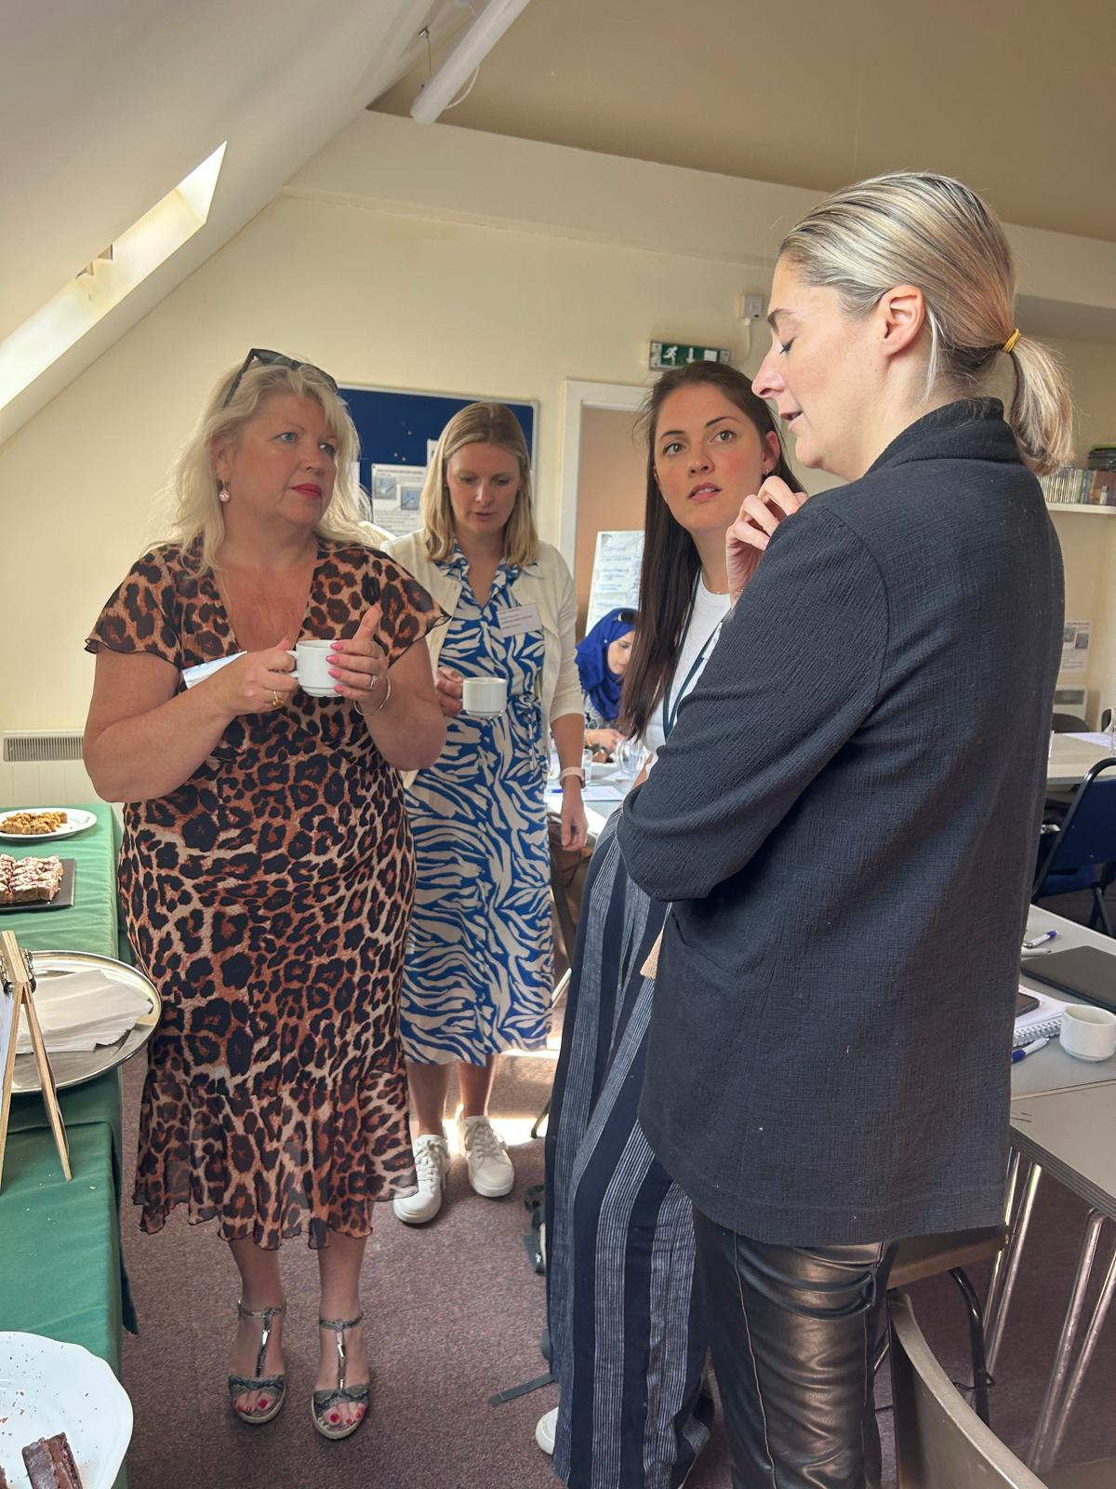

## Primary care: domestic abuse survivors’ experiences of general practice

**Primary care is an important point of contact for people to ask for help when experiencing domestic abuse, but little was known about this interaction. Our latest research project explored whether general practice is meeting the needs of people who are experiencing domestic abuse within Surrey, and what improvements could be made to better meet these needs.**

### Background

Numbers of domestic abuse cases are rising. In Surrey, 5,224 calls were made to the Surrey domestic abuse helpline in 2023, up by 24% from 2022. People experiencing domestic abuse are recognised as a priority population within [the Surrey Health and Wellbeing Strategy](https://www.healthysurrey.org.uk/about/strategy) as they are more likely to experience some of the poorest health outcomes.

### What did we do?

#### Surrey wide research

We asked 117 GP practices across Surrey to provide us with their domestic abuse data; only 2 were able to provide it, supporting our assertion that a knowledge gap existed.

We worked with the Surrey Domestic Abuse Partnership, and, through them, DA SEEN (formerly the Surrey Survivor Steering Group), the Surrey wide designated GP for safeguarding children and adults and the Surrey wide designated Safeguarding Nurse Adults to co-produce our research methodology.



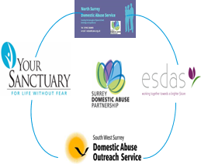

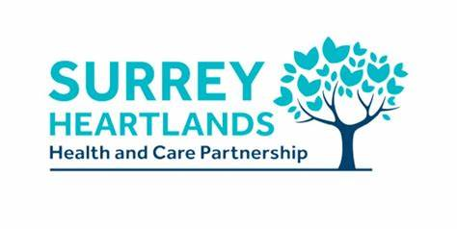

We spoke to **64** domestic abuse survivors via a survey, focus groups and individual interviews. We also engaged with **8** GP practices.

#### Convening workshop: co designing practical solutions

Our findings explored all stages of a survivors’ primary care journey, from the barriers to disclosing domestic abuse which exist, to experiences following disclosure and signposting and referrals.

In May we brought together an influential group of 21 key stakeholders, including system partners, GPs and groups representing survivors. The aim of the workshop was to review the findings of our research and **to work collaboratively to develop pragmatic and practical solutions to improve access to support and the experience of survivors.**

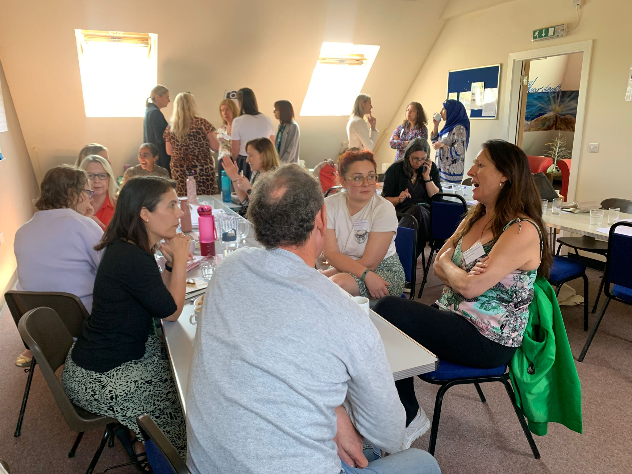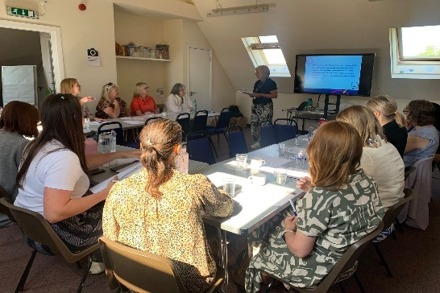

“I think there was a great willingness in the room to drive positive changes forward and good discussions around what is realistically achievable and how we can think about doing that.”

Convening workshop attendee

“Good range of solutions, both long term aspirations and some more achievable in a shorter time frame.”

Convening workshop attendee

**What improvements will be implemented for domestic abuse survivors?**

During the workshop, attendees identified a number of solutions to the issues identified, and there was a commitment from everyone in the room to implement one change. We are now working closely with system partners to make the solutions a reality and look forward to sharing progress over the coming months. Our report is on our website: [In safe hands - Domestic abuse survivors experiences of general practice - July 2025 - Healthwatch Surrey](https://www.healthwatchsurrey.co.uk/report/in-safe-hands-domestic-abuse-survivors-experiences-of-general-practice-july-2025/)

# Making a difference at a system level

We ensure that decision makers in Surrey Heartlands and Frimley Health hear about the insights and experiences residents have shared with us, both positive and negative. We sit on a number of boards and committees and proactively challenge system partners over issues identified to us by local residents and share when things have gone well to help to identify best practice.

## Photo of an EMED ambulance outside a hospital.Utilising patient experience to improve non-emergency patient transport

We were asked by NHS Surrey Heartlands to gather patient insights about using the NHS non-emergency patient transport service which has been delivered by EMED in Surrey Heartlands since April 2024. The aim was to reach out to those currently using the service to better understand the patient journey from booking, arriving for an appointment, and returning home and to identify any themes.

**What difference have we made?**

The [insight gathered](https://www.healthwatchsurrey.co.uk/reports/?_sf_s=EMED) will help improve and shape future EMED non-emergency transport services for Surrey residents – EMED have already committed to addressing some of the issues which we raised, including

reducing the time people need to be ready before their allocated pick up slot.

“Thank you for the comprehensive report on EMED. We truly appreciate the hard work that Healthwatch Surrey has put into this valuable piece of work.”

**Quality Lead Ambulance & Integrated Urgent Care (IUC), Surrey Heartlands.**

## Simplifying complaints routes

A recent [Healthwatch England report](https://www.healthwatch.co.uk/news/2025-01-27/nhs-complaints-system-lets-people-down-new-research-warns) found that less than half of those who had a poor experience of NHS healthcare last year took any action. Although the right to make a complaint is part of the NHS Constitution, this new research warned that people have low confidence in the NHS complaints system and struggle to navigate it, which prevents them from acting when they have a poor experience.

Our own [report](https://www.healthwatchsurrey.co.uk/report/summary-involvement-of-people-feedback-in-hospitals-march-2024/) regarding people’s awareness of feedback routes in hospitals showed that the majority of people did not know how to give feedback and had not heard of PALS (Patient Advice and Liaison Service) or the Friends and Family test. We also heard that people were reluctant to give feedback as they believed it might affect the care that they received.

**What’s changed?**

As a direct result of our insights, all complaints leads across Surrey Heartlands were instructed to ensure that Independent Health Complaints Advocacy Service information was published on all websites, in a location that is central and easily accessible for complainants to see. This will ensure that people who need support to speak up will be able to get that more easily.

## Maintaining momentum: checking in on long term impact

Real, lasting change takes time, which means often the full impact of our work can’t be felt immediately. That’s why we regularly re-visit our projects…

#### Impacting national policy: cervical screening

In our 2024-25 [quarter 2 report](https://www.healthwatchsurrey.co.uk/report/quarterly-impact-report-july-to-september-2024/) we discussed the findings of a [national study](https://www.healthwatch.co.uk/report/2024-09-16/cervical-screening-my-way) looking at women’s experiences of cervical screening. Healthwatch Surrey contributed to this report by interviewing local women with a learning disability and from minoritised ethnic backgrounds, thus ensuring that the voices of marginalised women from Surrey were heard on the national stage. In [November](https://www.healthwatchsurrey.co.uk/report/quarterly-impact-report-october-to-december-2024/) we were pleased to learn that NHS England’s new “ping and book” service will support one of the report recommendations - that access to cervical screening be improved with a variety of invitation reminder and booking methods, including the NHS App.

But the impact of the report didn’t stop there. In June the Government announced the roll out of more personalised cervical screening appointments. Younger women (ages 25-49) who test negative for human papillomavirus (HPV) will be invited for screening every five years rather than three year intervals. The Healthwatch England research showed many women can find it an uncomfortable experience, and sometimes difficult to schedule in around their busy lives, so reducing the number of times they need to attend may make these important appointments easier to manage.

#### Utilising national and local data to inform system partners: eye health

In our 2024-25 [quarter 4 report](https://www.healthwatchsurrey.co.uk/report/quarterly-impact-report-january-to-march-2025/) we shared our contribution to a national survey looking at people’s eye care experiences. In that report we noted that we’d be sharing both [national and local statistics](https://www.healthwatchsurrey.co.uk/report/a-strain-on-sight-waiting-for-nhs-specialist-eye-care/) with a number of boards and committees across Surrey.

**What difference have we made?**

Following presentation of the findings at the Frimley Pharmacy Optometry Dentistry Board, actions were taken to look at creating direct referral systems and there was a call for more patient information on self-care for minor eye complaints. There was also an ask to look at these issues within ethnic minoritised groups specifically. We’re pleased that local insights are being used to inform thinking around eye care, particularly for minoritised groups.

#### Self-funders: maximising the use of the user voice

As part of our 2024-25 [quarter 4 report](https://www.healthwatchsurrey.co.uk/report/quarterly-impact-report-january-to-march-2025/) we also highlighted how our insights into the journey self-funders may take to arrive in a residential care home setting will help to inform Surrey County Council’s ‘Planning for Your Future’ campaign and messaging.

This quarter we were pleased to see the impact of the contacts we made during this project being utilised further. We shared contact details of the self-funders we’d spoken to (who had agreed to be re-contacted) with the Digital Design Team at SCC. This team will now be engaging with these residents as they develop a ‘cost of care’ calculator, a simple tool highlighting the average cost of residential and nursing care as well as care in the home and showing people how long their money would last. The inclusion of the user voice in this project will help to ensure it is accessible and really meets the needs of all Surrey residents.

**How is the campaign helping Surrey residents?**

We were also pleased to hear that more than 2,700 people have now benefited from a Planning for Your Future presentation, either for themselves or on behalf of a relative who they support. 9 in 10 of them would recommend attending to others.

And congratulations to all involved, the Planning for your Future campaign was a shortlisted finalist at the MJ Awards in the category of Innovation in Children’s and Adult Services. The MJ Awards recognise individuals and programmes within local government which make a difference to the communities they serve.

# Involving local people in health and social care

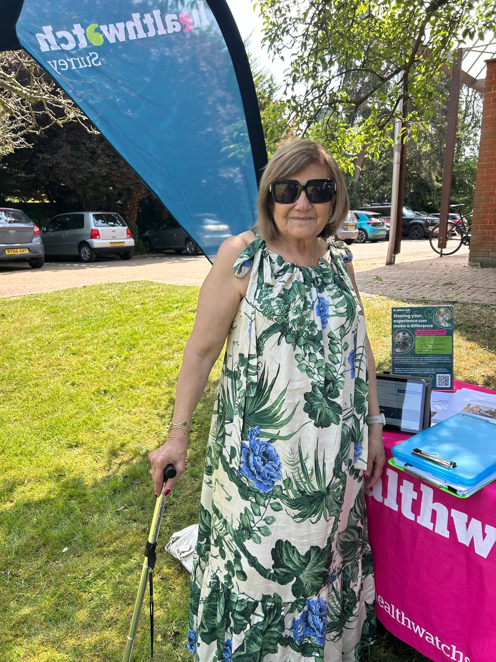Our dedicated team of volunteers help us to ensure that local people have their say, and that we hold decision makers to account.

This quarter our volunteers gifted us **302** hours of their valuable time!

## Ensuring Quality Accounts are accessible to all

We are committed to ensuring that system leaders and decision makers involve local people in health and care services. One way in which we do this is via our Reading Panel, who act as a vital sounding board for our system partners, scrutinising reports, strategies and other documents (written to provide details on decisions and services).

Under the Health and Social Care Act 2012 many NHS organisations are required to produce Quality Accounts if they meet certain criteria. A Quality Account is a published report about the quality of services and improvements offered by an NHS healthcare provider.

**What difference have we made?**

This quarter, 10 of our Reading Panel dedicated approximately 45 hours to scrutinising the Quality Accounts of 8 different providers, suggesting changes and improvements to ensure clarity and accessibility for all.

“Many thanks for sending this through and the very helpful comments from the reading panel which I will make sure are reflected in the final version.”

Head of Clinical Effectiveness, St Peter’s Hospital

“Please be assured that we will carefully review all the comments provided by the reading panel, and where possible, we will incorporate relevant amendments into the final version of our Quality Account. Your feedback provides valuable insight and will help strengthen the final document.”

Patient Engagement Lead, South East Coast Ambulance Service (SECAmb)

We would like to thank everyone who gave their time and shared their experiences with us this quarter.

# Have your say! Upcoming projects

|  |  |
| --- | --- |
| Icon of a group of people representing different roles. | For our Involvement of People priority we are looking at whether community healthcare services are accessible/available to people who are classified as being housebound, their needs are being met, and what improvements can be made to better meet these needs.  [**https://www.smartsurvey.co.uk/s/HWSYHouseboundProject0525/**](https://www.smartsurvey.co.uk/s/HWSYHouseboundProject0525/) |
| An icon showing a set of double doors with the word entrance above them and a healthcare cross above that. | For our **access to primary care priority** we arecurrentlylooking at online access to GP services, how people manage their health care needs with their GP practice using online technology and their views on the use of AI (Artificial Intelligence) within general practice.  [**https://www.smartsurvey.co.uk/s/HwSyOnlineAccessGPServices/**](https://www.smartsurvey.co.uk/s/HwSyOnlineAccessGPServices/) |
| An icon showing 2 people standing together under a roof. | For our **social care priority** we are looking at why there has been a downturn in the numbers of people using day centres and library services. This survey will be coming soon! |

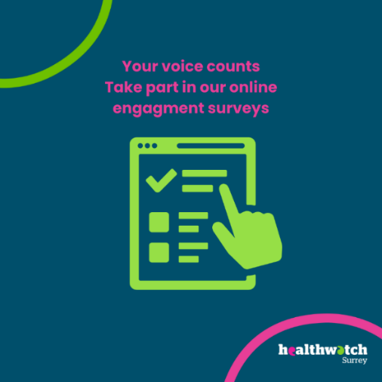

**The more people we hear from, the more impactful our research will be, and the more likely we are to be able to bring about positive change.**

# A blue background with a green curve going from one side of the page to the other.Healthwatch Surrey – Contact us

Website: [www.healthwatchsurrey.co.uk](http://www.healthwatchsurrey.co.uk)

Phone: 0303 303 0023

Text/SMS: 07592 787533

Email: [enquiries@healthwatchsurrey.co.uk](mailto:enquiries@healthwatchsurrey.co.uk)

Address: Freepost RSYX-ETRE-CXBY, Healthwatch Surrey, Astolat,

Coiners Way, Burpham, Guildford, Surrey, GU4 7HL

Facebook logo [Healthwatch Surrey](https://www.facebook.com/healthwatchsurrey)

Instagram logo [Healthwatch_surrey](https://www.instagram.com/healthwatch_surrey)

LinkedIn logo [Healthwatch Surrey](https://www.linkedin.com/company/healthwatch-surrey/)

The Committed to quality marque - in white there is an icon of a rosette, inside the rosette is a tick. Beside the rosette are the words - Committed to quality.

We are committed to the quality of our information.

Every 3 years we perform an audit so that we can be certain of this.

The Healthwatch Surrey service is run by Luminus Insight CIC

(known as Luminus).