

What we’re hearing

about waiting for care

May 2025



No one has reached out to me to give me updates or insights. I feel so overwhelmed at points and my mental health is really at rock bottom. More needs to be done for patients!



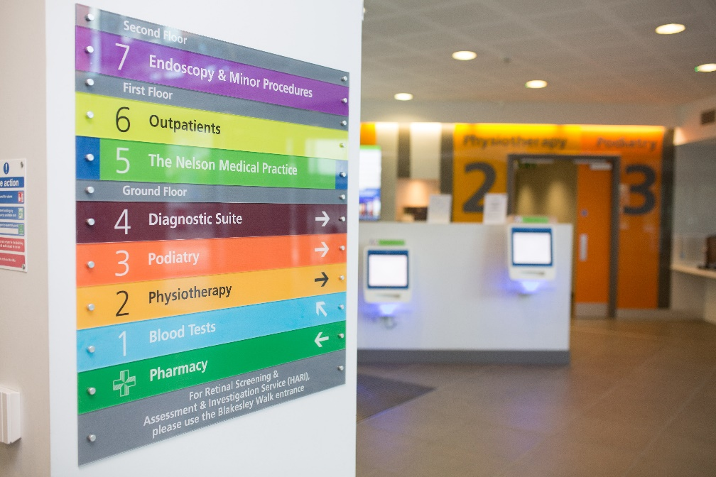

If you would like a paper copy of this document or require it in an alternative format, please get in touch with us.

Contents

Context 3

What we’re hearing 3

Better support still needed while waiting 3

Emotional toll waiting can take 5

Waiting times still at unacceptable levels 5

Summary 6

About Healthwatch Surrey 7

Contact us 7

# Context

According to NHS England, the number of people on waiting lists for treatment continues to fall as part of the [elective care reform plan](https://www.england.nhs.uk/long-read/publication-of-the-plan-to-reform-elective-care-for-patients/). As part of this plan, the NHS aims to treat 65% of patients within 18 weeks by March 2026, rising to 92% by March 2029.

In 2022 we highlighted the impact that waiting for treatment was having on the overall health and wellbeing of Surrey residents in our report ‘[Waiting for Hospital Care](https://www.healthwatchsurrey.co.uk/report/thematic-priority-report-waiting-for-hospital-care/)’. The aim of this report was to provide insight to enable services to support those waiting and to minimise the harm of long waits.

This latest report aims to provide an update on what waiting for treatment is like for people in Surrey, as, despite progress being made to reduce the time people wait, many are still experiencing a difficult wait which is significantly impacting their lives.

# What we’re hearing

## Better support still needed while waiting

In 2022 we recommended that services:

1. Review how to ensure patients are given the information, advice, contacts and signposting they might need to stay well and prevent avoidable deterioration while they are waiting.
2. Communicate with patients regularly (every 10-12 weeks) to improve trust and reduce anxiety, stress and time wasted on repeated inbound queries.

The following examples suggest that patients are still not being given adequate information, or receiving regular communication while waiting:

“I am a 66 year old lady who was referred to orthopedics on the 29th of May 2024. I need a hip replacement. I have severe osteoarthritis.

To put it briefly my life is ruined and pain relief inadequate.

I am still waiting and my condition is deteriorating. It may have affected my other hip and spine. I feel that to be left in my condition is unacceptable.

I have been very brief as I find any complaints procedure rather obscure and I am not sure what I can do or even who to contact.”

230711, Guildford resident, 65-79, April 2025

“I met the surgeon who told me I'd probably get seen in early 2025, which I took to mean January-March. It's nearly May and no one's even contacted me about an appointment. The app said average wait time for the hospital is 16 weeks, but what they don't seem to tell you is that that means from when you have your pre-operation assessment. I was referred in September 2024, so again, I thought I'd be treated in early 2025. Had I known I'd be waiting 9+ months from the start, I would have paid to go private. And even when I write in to try and get a realistic timeline, the theatre scheduler still can't give me one. All I got was ‘I do still have many patients before you on [the] waitlist awaiting surgery dates.’ They need to be more specific: how many exactly?! And how long should I expect to wait.

There needs to be more transparency on waitlists, and more contact!”

230730, April 2025

This person told us they have a disability/impairment but the information they were given about their appointment was not in an accessible format. This combined with a lengthy wait caused unnecessary confusion:

“I have been waiting over 14 months for an appointment. Originally I went all the way to [the hospital for my appointment], not realising my outpatients appointment was in the next year - because the letter was not in my required format. I feel with waits over a year the letter should remind people to check the year of the appointment. Now I have had no further communication from the hospital or GP. It feels like nobody cares.”

230763, 25-49, Reigate & Banstead resident, May 2025

## Emotional toll waiting can take

We have also heard how waiting can leave people “emotionally drained” and with their mental health at “rock bottom”:

“I'm writing to give some NHS feedback, as the PALs service just sent me back to the same theatre scheduler who keeps fobbing me off. I've found my experience with the NHS to be so emotionally draining it's untrue. I tore my meniscus and ACL in May last year - I went to the walk-in and all they did was X-ray me and send me on my way. After 2 months seeing a physio, he sent me for an MRI, which revealed my results [and I was referred for surgery].

When I got referred, I was a remote worker. Since then I've returned to the office and my pain has increased significantly. No one has reached out to me to give me updates or insights. I feel so overwhelmed at points and my mental health is really at rock bottom.

More needs to be done for patients! My health outcome could have been so much better if I'd had an MRI scan from the word "go", or knew I could pick a hospital based on wait times.”

230730, April 2025

## Waiting times still at unacceptable levels

Whilst official waiting times data may refer to individual pathways, in some cases a referral for treatment comes after other options for treatment have been explored. This means that people perceive their overall waiting time to be from the first time they sought advice from someone such as their GP. Therefore, further waits can exacerbate their experience.

“Saw GP with ongoing hip/pelvic/knee pain & over the course of 6 months and various x rays, it was determined that physio would help and was referred for some. Heard today that initial consultation for physio is a wait of 'at least 26 weeks'. That is completely and utterly unacceptable.”

230772, 65-79, Reigate & Banstead resident, May 2025

# Summary

We recognise that significant progress has been made in reducing waiting times, with the NHS delivering a record number of treatments in 2024. However, it’s clear from the experiences people continue to tell us about that many feel they are missing information and support while waiting and that services would benefit from considering our original recommendations from 2022.

# About Healthwatch Surrey

Healthwatch Surrey champions the voice of local people to shape, improve and get the best from NHS, health and social care services. We are independent and have statutory powers to make sure decision makers listen to the experiences of local people.

We passionately believe that listening and responding to local people's experiences is vital to create health and social care services that meet the needs of people in Surrey. We seek out people’s experiences of health and care services, particularly from people whose voices are seldom heard, who might be at risk of health inequalities and whose needs are not met by current services. We share our findings publicly and with service providers and commissioners to influence and challenge current provision and future plans.

We also provide reliable and trustworthy information and signposting about local health and social care services to help people get the support they need.

# Contact us

Website: [www.healthwatchsurrey.co.uk](http://www.healthwatchsurrey.co.uk)

Phone: 0303 303 0023

Text/SMS: 07592 787533

WhatsApp: 07592 787533

Email: [enquiries@healthwatchsurrey.co.uk](mailto:enquiries@healthwatchsurrey.co.uk)

Address: Freepost RSYX-ETRE-CXBY, Healthwatch Surrey, Astolat, Coniers Way, Burpham, Guildford, Surrey, GU4 7HL.

Facebook icon [healthwatchsurrey](https://www.facebook.com/healthwatchsurrey)

Instagram Icon [healthwatch_surrey](https://www.instagram.com/healthwatch_surrey)

LinkedIn icon [Healthwatch Surrey](https://www.linkedin.com/company/healthwatch-surrey/)



We are proud to be shortlisted in 2025, and commended in 2024, for the National Healthwatch Impact Awards recognising our work helping to improve local NHS and social care.



We are committed to the quality of our information.

Every three years we perform an audit so that we can be certain of this.

The Luminus logo. The word Luminus is deep purple in colour. It is in a rounded font. The ‘L’ is a capital but the rest of the word is in lower case. From each side of the dot above the ‘i’ of Luminus are yellow beams which run horizontally stopping to the left before the ‘L’ starts and to the right at the end of the letter ‘s’.

The Healthwatch Surrey service is run by Luminus Insight CIC, known as Luminus.

Registered office: GF21, Astolat, Coniers Way, Burpham, Surrey, GU4 7HL.