

Insight bulletin

June 2025

A large speech mark, outlined in pink.

“I feel like the diagnosis has helped me understand myself, my difficulties and my strengths. Over the years I have acquired many labels such as stupid, useless, lazy, annoying, etc. ADHD is the most validating label and is helping me undo years of thinking negatively about myself.”



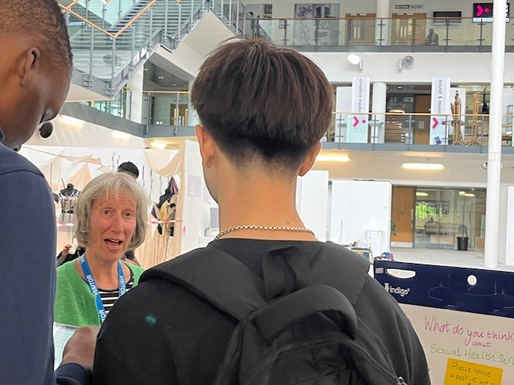

**If you would like a paper copy of this document or require it in an alternative format, please get in touch with** **us.**

# This bulletin: at a glance

## Hot topics

In this bulletin we are focussing on 5 key areas:

* Thanks and praise: care and compassion in hospital
* GP practices: access a continuing concern
* Spotlight on: the prison population
* Spotlight on: ADHD
* Mental health: dissatisfaction with complaints handling

## Who have we been hearing from?

Since the start of April 2025 we’ve heard from **136** people across Surrey, via our Helpdesk or during engagement events in the community.

* **35%** of the feedback relates to hospitals
* **20%** of the feedback relates to GP practices
* The majority of the remaining feedback relates to community, social care and mental health services
* Of those willing to share their age, **66%** were aged over 50.

# Thanks and praise: care and compassion in hospital

**Whilst people continue to talk to us about the** [**impact which extended waits for hospital care**](https://www.healthwatchsurrey.co.uk/report/what-were-hearing-about-waiting-for-care-may-2025/) **have on them, we’ve had some really positive feedback from people about their experiences in Surrey hospitals this month.**

People have praised the proactivity and efficiency of the service they have received.

“[the] hospital have been fabulous with me, I see them for some cardiac issues, they always call me in for my reviews and scans on time.”

230774, Surrey Heath resident

“[the hospital was] very efficient with staff that obviously cared. I had my appendix removed the same evening and could not have received better service.”

230753, Surrey Heath resident

People have also talked to us about how important empathy from staff members is to their experience, as well as the importance of clear explanations to provide reassurance at what can be a very difficult time.

“I had cataract surgery and the care I received by everyone in hospital was wonderful. Everything was explained to me to ease my anxiety by the surgeon.”

230767, Runnymede resident

“Consultant was knowledgeable and reassuring; useful information given; very little waiting time.”

230690, Surrey resident

“Cardiology department were helpful friendly and empathetic on 2 recent visits for both myself and my daughter.”

230675, Spelthorne resident

# GPs practices: access a continuing concern

People continue to talk to us about the issues they have accessing support from their GP. This feedback relates to delays in being seen, as well as to appointment booking processes which people believe don’t give them sufficient choice and flexibility.

“To make an appointment I must use an online form. This includes a long list of symptoms, none of which are related to my condition so I have to lie to get an appointment… This system doesn’t allow me to choose my named doctor so I see different GPs who don’t know me or my condition. This wastes time and resources and has meant mistakes have been made.”

230673, Spelthorne resident

“3 week wait for a face to face appointment for back ache - and that appointment would be with a paramedic. I suffered the pain for 2 weeks and it slowly went away so I cancelled the appointment.”

230722, Waverley resident

In the case below, a lack of timely, clear communication from the practice led to people feeling they were left without GP support.

“The practice have sent a letter to all patients that they are not receiving any requests for routine appointments from 6 to 30 May and have suspended the online appointment system in order to bring in a new one. I received this letter yesterday i.e. with no notice before the system is suspended after the bank holiday. I think it is extremely concerning that patients have been told not to contact the practice at all unless it’s an emergency. This is denying people access to GP services for a whole month...”

230736, Waverley resident

For more information on GP practices, visit our [website](https://www.healthwatchsurrey.co.uk/information-and-advice/understanding-gp-practices/).

# Spotlight on: the prison population

**At Healthwatch Surrey we seek out experiences of health and care services, particularly from people whose voices are seldom heard. In May we took part in a Wellbeing Day at HMP Coldingley, a category C men's prison.** [**Our one pager highlights the key themes people spoke to us about**](https://www.healthwatchsurrey.co.uk/report/what-were-hearing-from-the-prison-population-may-2025/)**.**

14 people shared their experience with us about their access to physical and mental health services whilst in prison; people told us that they were able to access the healthcare they needed – both specialist and routine care.

“I'm generally very healthy. I think the care I've received inside [HMP Coldingley] has been good - I needed a scan and I got it quickly.”

230775

“I would say I am healthy and I suppose I am eating healthier, but I haven’t been in long. I did have to go to hospital for treatment and I got good care, but it was embarrassing because of the chains. The thing that has been most useful has been better food.”

230782

A number of people told us that their health had actually improved whilst being in prison, due to access to resources such as the gym, and, for some, to the absence of recreational drugs.

“I am not healthy but my health has improved since I have been in prison as I have stopped using drugs.”

230785

A lack of nutritious food was cited as one barrier to health though.

“I am healthy and would say my health has improved while I have been here but there isn’t enough healthy food and there are lots of people smoking substances and you have to breathe in their smoke. I have been able to access routine healthcare but haven’t had to have any specialist treatment. Things like this [the healthcare fair] are really useful.”

230786

“I am healthy and my health is much better since being in prison; my physical, mental and dental health. I have been able to access healthcare but I don’t as I don’t like being touched. The thing that has been most helpful is the gym, not the food!”

230787

# Spotlight on: ADHD

# At the end of May, NHS England [published](https://digital.nhs.uk/data-and-information/publications/statistical/mi-adhd/may-2025) – for the first time – figures relating to the prevalence of attention-deficit/hyperactivity disorder (ADHD) and the number of people waiting for assessments in England. At the same time, Healthwatch England [released](https://www.healthwatch.co.uk/report/2025-05-28/how-improve-adhd-support-people#download) figures from a new poll highlighting the importance of diagnosis.

Healthwatch England spoke to **2,579** adults in England and found that diagnosis improved many aspects of their lives; of the 363 respondents who had already been diagnosed for example, over half (58%) said it helped them find new strategies to manage their ADHD traits, while the same number agreed it helped them to look after their mental health and wellbeing.

However, 70% of those who had been diagnosed said that they found the length of the process between referral and diagnosis difficult. In addition, long waits for assessments put people with suspected ADHD off seeking professional care. You can [find out more about the Healthwatch England poll in our one-pager](https://www.healthwatchsurrey.co.uk/report/adhd-diagnosis-long-waits-on-the-nhs-need-urgent-attention/).

Here in Surrey people talk about the impact ADHD has on their lives.

“I thought for years that I was mentally ill. But I think I am experiencing meltdowns and burnout. I don't externally fit the common understanding of the ADHD profile. Most of my chaos is internal.”

Surrey resident

“I have low self-esteem and feel like a burden to my family. They are frustrated and I am frustrated that they have to keep helping me with "simple" things. I don't know how I will care for my parents if they need it in old age, or how I will cope without their help. I literally have no one.”

Surrey resident

They also share the views of many across the country regarding the value of a diagnosis.

“I feel like the diagnosis has helped me understand myself, my difficulties and my strengths. Over the years I have acquired many labels such as stupid, useless, lazy, annoying, etc. ADHD is the most validating label and is helping me undo years of thinking negatively about myself.”

Surrey resident

During our engagement at HMP Coldingley a number of individuals we spoke to talked to us about treatment shortages and delays and the impact this can have, with sone choosing to forego treatment all together.

“I think I'm healthy physically but not mentally. I have ADHD but the wait for treatment is 3 years which is far too long.”

“My physical health is good but my mental health is not so good. I have ADHD and Post Traumatic Stress Disorder (PTSD) and Emotionally Unstable Personality Disorder (EUPD). There's apparently a national shortage of ADHD medicine and I’ve really suffered with that - for a while my dosing was really erratic so I just came off my meds as that was better.”

People also tell us that a lack of communication and updates around their ADHD treatment can affect physical and mental health.

“Despite repeated efforts I’m getting no clarity around the progress of my ADHD treatment. I had a video consultation appointment scheduled but it was cancelled due to technical issues with no rescheduling. I’m very frustrated and this is having a negative impact on my mental health, my work and my parenting as a lone parent.”

230718, Guildford resident

**The bigger picture**

In 2023, in the light of long waits for diagnosis and increased needs-based support for children and young people, we set out to explore what families perceive to be the benefits of a formal neurodiversity diagnosis. Our findings and recommendations can be found in our [Neurodiversity – the hidden value of diagnosis report.](https://www.healthwatchsurrey.co.uk/report/neurodiversity-the-hidden-value-of-diagnosis/)

# Mental health services: dissatisfaction with complaint handling

# Mental health is one of our thematic priorities. We work with the healthcare system to share people’s experiences of mental health support – as well as the impact that wider determinants of health and health inequalities can have on mental health – in order to improve services for local people.

People often come to us for information and advice on how to

submit feedback or a complaint, or to express their dissatisfaction with how the formal complaints process has worked.

This month people have shared their thoughts on the lack of timely and transparent responses once complaints are submitted about local mental health services.

“I have not received any responses to date and I therefore now refer to the regulators in regard to all 4 complaints.”

230768, Surrey resident

“I contacted you a while back regarding a complaint I had made...I was told it had been transferred to a post incident review. However, I’m highly unsatisfied by the fact I don’t seem to be involved in this process, and it does not address my complaint and their failures. It has been suggested that the review will document learning that needs to occur, but given there seems to have been clinical negligence, it does not seem proportionate or safe for the matter to be resolved with learning. Is there any way to challenge this process to escalate my concerns?”

230703, Surrey resident

For more information on mental health support in Surrey, visit our [website](https://www.healthwatchsurrey.co.uk/information-and-advice/mental-health-support/).

You can also find out more about how to give [feedback and complaints on all health and social care services..](https://www.healthwatchsurrey.co.uk/information-and-advice/feedback-and-complaints/)

# Have your say!

|  |  |
| --- | --- |
| An icon of a head and shoulders, the head has cogs inside it. | As part of our **mental health priority**, we are still looking at the emotional impact of financial insecurity on those with mental health and other long term conditions. <https://www.smartsurvey.co.uk/s/financeandmentalhealth/> |
| Icon of a group of people representing different roles. | As part of our **Involvement of People priority** we are asking people to tell us about their experiences of sharing feedback about NHS hospitals, GPs and community services. <https://www.smartsurvey.co.uk/s/HWSyFeedbackSurvey2025/> |
| An icon showing a set of double doors with the word entrance above them and a healthcare cross above that. | For our **access to primary care priority** we arelooking at the barriers to access and experience of sight (eye) tests for school age child/ren (aged 4 to 16 years). <https://www.smartsurvey.co.uk/s/HWSYSightTestsChildren/> |
| An icon showing 2 people standing together under a roof. | And finally, for our **social care priority** we’d love to her from those under 25 about sexual health services across Surrey. <https://www.smartsurvey.co.uk/s/HWSyU25sSexualHealthsurvey25> |

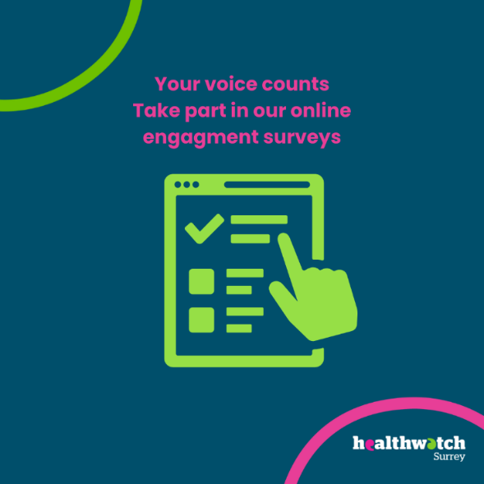

**The more people we hear from, the more impactful our research will be, and the more likely we are to be able to bring about positive change.**

# Sharing our insight and raising concerns

Whilst this bulletin accurately reflects what we hear from the individuals we speak to, we are aware that it may not be representative of everyone’s views of a particular service. Multiple references to a specific service may be due to where our community engagement has recently taken place.

If we hear a case of concern regarding patient safety, we immediately signpost the sharer to the appropriate body and escalate the case with the provider/commissioner. All appropriate information and signposting has already been given.

We share our wider themes with Trusts, Integrated Care Systems (ICSs), Surrey County Council, Public Health, Care Quality Commission (CQC), and in various boards and groups across Surrey.

If you would like more information or examples of what people have shared with us, please get in touch with us.

# Community engagement

Below are details of our upcoming engagement sessions where we visit venues in local communities to listen to what people think about local health and care services, and to ask specific questions related to [our priorities](https://www.healthwatchsurrey.co.uk/about-us/our-priorities/). We also provide information and signposting regarding health and social care. Throughout the year, we also attend events across Surrey to raise awareness of our work.

|  |  |  |  |
| --- | --- | --- | --- |
| Date | Place | Time | Open to |
| 18/6/2025 | Leatherhead Community Hub | 10am – 12noon | Public |
| 20/6/2025 | Managing my health, Redhill | 10am – 3.30pm | Group |
| 24/6/2025 | Godalming College | TBC | Private |
| 28/6/2025 | Royal Surrey County Hospital Open Day | 11am – 3pm | Public |
| 19/7/2025 | St Peter’s Hospital Community Day | 10am – 3pm | Public |
| 27/7/2025 | Surrey Hills Wellfest, Horsley | 10am – 6pm | Public |

**Please note: these dates may be subject to change.**

To share an experience with us, or for information and signposting about health and social care, people can also contact our Helpdesk in the following ways:

Phone: 0303 303 0023

SMS (text only): 07592 787 533

WhatsApp: 07592 787 533

Email: [enquiries@healthwatchsurrey.co.uk](mailto:enquiries@healthwatchsurrey.co.uk)

Share your feedback via our website: <https://www.healthwatchsurrey.co.uk/feedback-centre/>

# About Healthwatch Surrey

Healthwatch Surrey champions the voice of local people to shape, improve and get the best from NHS, health and social care services. We are independent and have statutory powers to make sure decision makers listen to the experiences of local people.

We passionately believe that listening and responding to local people's experiences is vital to create health and social care services that meet the needs of people in Surrey. We seek out people’s experiences of health and care services, particularly from people whose voices are seldom heard, who might be at risk of health inequalities and whose needs are not met by current services. We share our findings publicly and with service providers and commissioners to influence and challenge current provision and future plans.

We also provide reliable and trustworthy information and signposting about local health and social care services to help people get the support they need.

# Our distribution list

If you would like to be added to or removed from the distribution list for this Insight bulletin, please contact our Communications Lead [vicky.rushworth@healthwatchsurrey.co.uk](mailto:vicky.rushworth@healthwatchsurrey.co.uk)



We are committed to the quality of our information.

Every three years we perform an audit so that we can be certain of this.



The Healthwatch Surrey service is run by Luminus Insight CIC, known as Luminus.

Registered office: GF21, Astolat, Coniers Way, Burpham, Surrey, GU4 7HL.