

Jasmine House

Enter and View Report

April 2025

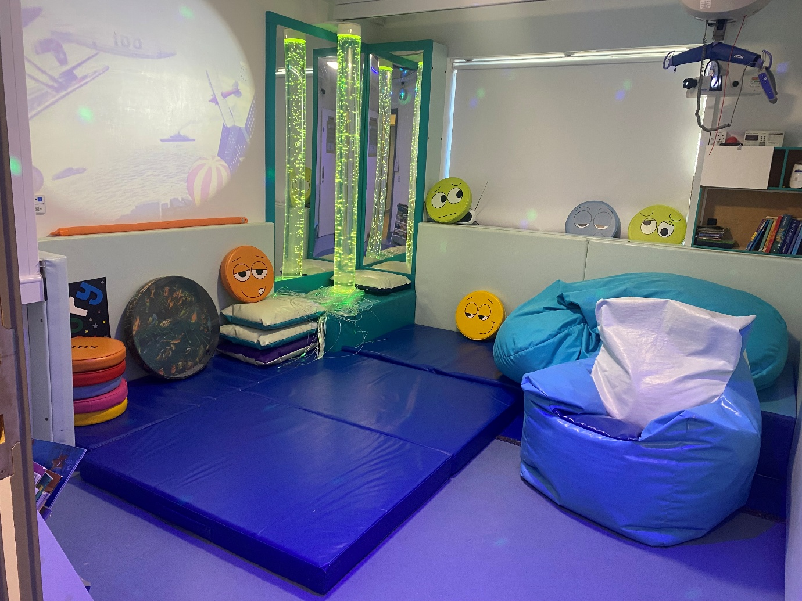

If you would like a paper copy of this document or require it in an alternative format, please get in touch with us.

Contents

Report overview 3

Why we visited 3

Who we heard from 4

Disclaimer 4

Recommendations 4

Observations about the service 6

Description of service 6

Environment 6

Facilities 6

What we heard in detail 7

Care 7

Staff 8

Daily life 8

Food 9

Visiting 9

Staying in touch 9

Visiting healthcare professionals 9

General Feedback on Learning Disability Services 10

Feedback 11

Next steps 11

Service provider response 12

Acknowledgments 13

Appendix 13

What is Enter & View? 13

About Healthwatch Surrey 14

Healthwatch Surrey – Contact us 15

# Report overview

## Why we visited

Enter and View is one way in which Healthwatch Surrey can observe and report on how services are being run, and collect the views of service users and their carers and relatives, as well as staff. [Enter and View Policy - Healthwatch Surrey](https://www.healthwatchsurrey.co.uk/enter-and-view-policy/)

We were asked to carry out this Enter and View visit by the learning disability management team at Surrey and Borders NHS Partnership NHS Foundation Trust (SABP). As well as giving people an opportunity to share their views of Jasmine House with an independent body, SABP were also keen to find out whether people are aware of feedback mechanisms - an important way to ensure people with learning disabilities and their families have a say in how in services are run.

|  |  |
| --- | --- |
| Details of visit: | |
| Service Address | Jasmine House, The Meadows, West Park, Epsom,  Surrey, KT19 8PB |
| Service Provider | Surrey and Borders NHS Partnership Foundation Trust |
| Date and Time | 06/03/2025 10.30am |
| Authorised  Representatives | Shelley Cummings, Jeni Cronin (Healthwatch Surrey Volunteer) |
| Contact details | Healthwatch Surrey GF21, Astolat, Coniers Way, Burpham, Surrey, GU4 7HL enquiries@healthwatchsurrey.co.uk Phone: 0303 303 0023 (local rate number) SMS (text only): 07592 787533 |

## Who we heard from

We spoke to the home manager, the service manager, 1 of the individuals who uses the service and 5 family members. We left paper copies of a survey and asked the manager to send the survey to the family members who were not present to get their impressions of the service. We heard from 2 further family members.

When we visited all but 1 member of the team were out with the individuals they support.

## Disclaimer

This report relates to findings observed on the specific date we visited. It is designed to highlight the themes we heard about and includes quotes to provide context on these themes.

# Recommendations

Following the visit to Jasmine House we have made the following 5 recommendations.

1. For SABP to review decorating schedule and contract. Last minute changes for services, especially those caring for autistic people, can be very disruptive and the service looked quite ‘clinical’ as all homely features had been temporarily removed.
2. For commissioning authorities to review the provision of transport to and from the placement to ensure minimal distress for people using the service.
3. Although those people using the service are often doing activities outside the service it was felt that work could be done to develop the small garden to be more user friendly and reflect the rest of the unit.
4. We were told that the service was not open every day due to variability in demand. Based on the extremely positive feedback we have received SABP might consider how they could make other families aware of the service.
5. Consider discussing long term plans with families to plan for when they are no longer able to be primary carers for their children.

# Observations about the service

## Description of service

Address: Jasmine House, The Meadows, West Park, Epsom,

Surrey, KT19 8PB.

Website: [Jasmine at Primrose : Surrey and Borders Partnership NHS Foundation Trust](https://www.sabp.nhs.uk/our-services/learning-disabilities/short-break-services/JasmineHse)

Provided by: Surrey and Borders Partnership NHS Foundation Trust

Registered Manager: Melanie Lees

Capacity: Jasmine House at Primrose is a short break service and can provide a service for up to six adults with a learning disability and health care needs.

## Environment

Jasmine House is a short break service in the old West Park Hospital site. The service is co-located with wards for older people, and there are also a variety of community services and other residential homes in this complex. Within the service there is a small enclosed outside area and they are hoping to get a group of volunteers to improve the garden. There is also a large green space and a play park within the site close to the service.

## Facilities

The service is part of a ward block on the old West Park Hospital site. It is co-located with older person’s inpatient wards. There is a shared entrance that is accessed by an entry phone. As it is not a purpose-built service it did have a “hospital” feel about it.

We were shown around the service by the service manager who explained that the service was due for redecoration, so they had removed transfers and activities from the walls in preparation for this. This was due to have been done a month before we visited and had still not been done, which was disruptive for people using the service and staff.

There was a large sensory room that could be varied for the individuals. Many of the people using the service use wheelchairs so there were facilities for people to be hoisted into bean bags or mattresses so they could be immersed in the room.

There were several bathrooms that had wheelchair accessible baths and showers, as a majority of individuals are not independently mobile.

As it is a short break service we had not expected that bedrooms could be personalised, however we were told that staff would change bedding to reflect people’s choices and all of the rooms have different themes to reflect a range of interests, and people were involved in choosing these themes. Although people may favour particular rooms, this was not encouraged in case 2 people with the same ‘favourite’ were in the service at the same time. There were also notice boards where family pictures can be displayed, and staff have a collection of photos for each person using the service so the room can be prepared before arrival.

There is also a laundry room for washing clothes individually; some parents choose to do their own washing when their child returns home.

# What we heard in detail

## Care

Jasmine House is a short break service and they have 30 families who regularly use their services. People can either do short stays (a couple of days) or longer (a full week) so their families can, for example, go on holidays. There is a large variation in the number of nights that families are entitled to, and the service accepts people from 9 different geographical areas. They have developed a specialisation in caring for people with increasing physical health issues and have individuals with feeding tubes, catheters, nebulisers, oxygen and assisted breathing machines (BIPAP).

The staff explained that the day before someone stays at Jasmine House, they call the family and go through a pre-admission checklist. This is to ensure they have up to date information on the person’s likes and dislikes, what they would like to do whilst at Jasmine House, and any changes in diet. They also have a discharge letter that they complete so the families know what their relative has been doing during stay. They explained that this has become more detailed in response to feedback from families.

“The service provides a safe, happy and holistic environment. All the staff are approachable and clearly enjoy working there. We are grateful her [their daughter] care is so amazing.”

## Staff

Because there is a huge variation in the needs of the individuals, and the number of individuals varies day to day, the manager has a spreadsheet that calculates the number of staff needed during the day to meet the needs of the individual people that are staying with them. At night there are always 2 staff on duty.

Although the service users have a range of complex health needs, the service is no longer registered for nursing care. Many of the staff have worked in the service for many years and the staff levels are calculated based on the individual’s needs. The service does use bank staff but these are well known and only do shifts in the service.

We were told

“This team is amazing.”

## Daily life

When we visited the service, we spoke to one person as all the others were out doing activities. They had also taken out another man who uses their services who had accompanied his mother to the family meeting. The routine in the service is flexible as we were told that, since many people who used the service are autistic, they try to replicate the person’s home routine. One person who uses the services calls it the “Jasmine Hotel” so staff reflect this when they “check him in” etc. This was because he had been distressed going into short breaks, away from his family, but was happy when it was treated as him having a short holiday.

There was a board on the wall displaying the activities the individuals were doing each day, and some were individual activities and others done as a group. Many of the individuals have known each other for many years (from school and day centres) and parents said they used to book their stay at the same time so the families could also go away together.

## Food

All food is cooked on site and there is a 4 week rotating menu. Although we were told bespoke meals are prepared for the people that are staying at the time, which reflect their favourite foods and any known allergies. People are supported with their nutrition, not all residents are able to eat and for these people staff administer their usual feeds.

## Visiting

The manager said that families are open to visit the service at anytime but, because families are having periods of short breaks, generally they would not visit during the stay. They did say that for longer breaks sometimes other family members (siblings or aunts and uncles) may visit.

One issue that was raised by the service manager was transport for people using services from and to day services and activities. If individuals are at the service for the weekend many had previously been dropped off by transport from day services, and then taken in again on the following Monday morning. This is apparently becoming more difficult and therefore more disruptive for those using the service. We were told that some individuals can be quite unsettled if their families bring and drop them off, and also it defeats the idea of families having “time off”.

## Staying in touch

The staff speak to families before each short break to ensure that all information on file is current, and also complete comprehensive discharge summaries. We were told that the discharge summary is now more detailed (what the person has eaten and activities carried out) following feedback from families. This also reflects the fact that many of the people using the service are non-verbal and therefore would not be able to tell families themselves.

“We regularly talk on the phone, any changes etc.”

## Visiting healthcare professionals

As people are only on short break, additional health support and visits are generally done while the individuals are at home. Families, however, mentioned occasions where they have called the manager to request extra support when the person was in an acute hospital (for example) and specialist LD teams were contacted on their behalf to speed up referrals.

## General feedback on Learning Disability Services

At the time of our visit, the home was having a regular family meeting that is held about every 3 months. The parents were happy to speak to us with the management team of the home present and spoke about the challenges of having a child with complex needs. Families described their ongoing struggles with the wider system and subsequently during the family meeting made these comments below:

“It might be nice not to have to fight anymore,”

But

“People who fight get services.”

Jasmine House was seen as one of the only places the families could leave their relative, without having to worry.

“When I leave my son at ‘Jasmine Hotel’ I feel totally safe.”

The families who spoke to us told us about how historical problems accessing other services (e.g. medication) had an impact on the short break provision as, if they did not have all the medication prescribed, they would not be able to use the service.

They said that there was flexibility on both sides with dates offered, and said that, because all families understand the difficulties of caring for a relative with complex needs, there is a mutual understanding between families that stays can be changed depending on another family’s needs.

The service manager said that some people like to plan months ahead, and send in their requests, others only work a few weeks at a time. Where there is no demand for the service, the service closes. She also said that there was huge variability between funding authorities, and also between families, as to the number of days they have allocated over the year (ranging from about 12 to 120). Families reported that because there is an increasing demand on the service there was now less flexibility.

“Some people are being turned down in a crisis.”

## Feedback

The staff arrange quarterly family meetings to discuss what is happening in the service, and as part of this they generally have summer and Christmas parties where there is an opportunity to speak to other families as well as the management team.

At the meeting we attended, the families spoke passionately about the care for people with complex needs and the difficulties they experience. They were all very positive about the care and support provided by the team at Jasmine House. They reported that the meeting was the way they would give general feedback about the service, but also said that they know the manager and team well enough that they would be comfortable feedback directly any specific issues they had. At the meeting the manager reported on changes made by the team following feedback they had received.

# Next steps

This report and the response from the service provider will be shared with commissioners and regulators of the service and will be published on our website.

# Service provider response

|  |  |
| --- | --- |
| **Service Name:** | Jasmine House Short Breaks |
| **Service Manager:** | Melanie Lees |
| **Visit date:** | 06/03/2025 |
|  |  |
| **Factual accuracy** |  |
| If you have any concerns about the **factual accuracy** of the report, please clearly identify the sections, content and corrections that are required in the space below: | |
| Corrections have been made through the report, mostly around terminology and factual inaccuracies. | |
|  |  |
| **Organisation response to the report** | |
| Please provide your response to the report and our recommendations here. This will be included in the final report.  **(This response will be published in full)** | |
| What we found:  **Headings**  Whilst we recognise that transport to and from the service is an issue, this is something that Jasmine house is unable to rectify, and this is a service organised by commissioner.  Whilst we will support families who are considering long term plans, these would need to be led by the commissioner, who is the lead agency. | |
| Respondent Name: | Melanie Lees |
| Respondent Job Title: | Service Manager |
|  |  |
| **Feedback on the visit** | |
| **If would like to provide some feedback to Healthwatch Surrey on the visit itself, please provide this in the space below:** | |
|  | |

Responses must be provided within 20 working days of receipt of our report.

## Acknowledgments

Healthwatch Surrey would like to thank individuals, family members, and staff who spoke to us for this report. We would also like to thank the Healthwatch Surrey volunteer for their invaluable help.

# Appendix

## What is Enter & View?

Healthwatch have a legal power to visit health and social care services and see them in action. This power to ‘Enter and View’ services offers a way for Healthwatch to meet some of their statutory functions and allows them to identify what is working well with services and where they could be improved.

Healthwatch have a power under the Local Government and Public Involvement in Health Act 2007 and Part 4 of the Local Authorities Regulations 2013 to carry out Enter and View visits.

The legislation places a duty on health and social care providers to allow Authorised Representatives of Healthwatch to carry out an Enter and View visit on premises where health and social care is publicly funded and delivered.

The purpose of an Enter & View visit is to collect evidence-based feedback to highlight what’s working well and what could be improved to make people’s experiences better. Healthwatch can use this evidence to make recommendations and inform changes both for individual services as well as system-wide.

Healthwatch Enter and Views are not intended to specifically identify safeguarding issues. However, if safeguarding concerns arise during a visit, they are reported in accordance with Healthwatch safeguarding policies. If at any time an Authorised Representative observes anything that they feel uncomfortable about they need to inform their lead who will inform the service manager, ending the visit.

In addition, if any member of staff wishes to raise a safeguarding issue about their employer, they will be directed to the CQC where they are protected by legislation if they raise a concern.

# About Healthwatch Surrey

Healthwatch Surrey champions the voice of local people to shape, improve and get the best from NHS, health and social care services. We are independent and have statutory powers to make sure decision makers listen to the experiences of local people.

We passionately believe that listening and responding to local people's experiences is vital to create health and social care services that meet the needs of people in Surrey. We seek out people’s experiences of health and care services, particularly from people whose voices are seldom heard, who might be at risk of health inequalities and whose needs are not met by current services. We share our findings publicly and with service providers and commissioners to influence and challenge current provision and future plans.

We also provide reliable and trustworthy information and signposting about local health and social care services to help people get the support they need.



We are proud to be commended in the National Healthwatch Impact Awards, recognising our work helping to improve local NHS and social care. You can view [our video](https://www.youtube.com/watch?v=y7jVu38Twno) highlighting how feedback has enabled us to make positive changes to health and social care services.



We are committed to the quality of our information.

Every 3 years we perform an audit so that we can be certain of this.

# Healthwatch Surrey – Contact us

Website: [www.healthwatchsurrey.co.uk](http://www.healthwatchsurrey.co.uk)

Phone: 0303 303 0023

Text/SMS: 07592 787533

WhatsApp: 07592 787533

Email: [enquiries@healthwatchsurrey.co.uk](mailto:enquiries@healthwatchsurrey.co.uk)

Address: Freepost RSYX-ETRE-CXBY, Healthwatch Surrey, Astolat,

Coniers Way, Burpham, Guildford, Surrey, GU4 7HL.

Facebook icon [/healthwatchsurrey](https://www.facebook.com/healthwatchsurrey)

Instagram Icon [@healthwatch_surrey](https://www.instagram.com/healthwatch_surrey)

LinkedIn icon [Healthwatch Surrey](https://www.linkedin.com/company/healthwatch-surrey/)

The Luminus logo. The word Luminus is deep purple in colour. It is in a rounded font. The ‘L’ is a capital but the rest of the word is in lower case. From each side of the dot above the ‘i’ of Luminus are yellow beams which run horizontally stopping to the left before the ‘L’ starts and to the right at the end of the letter ‘s’.

The Healthwatch Surrey service is run by Luminus Insight CIC, known as Luminus.

Registered office: GF21, Astolat, Coniers Way, Burpham, Surrey, GU4 7HL.