

Insight Bulletin

August 2024

A large speech mark, outlined in pink.

“I have been trying to book a doctor’s appointment for the last two weeks. I have tried using the online form and through my NHS App and every time it says they have reached capacity for the form and to try another day. I have tried early mornings, afternoons, evenings, all times and get the same response. I called the practice on Friday and was told receptionist don’t book appointments anymore and have to use the form. I explained I’ve tried and the receptionist said I have to keep trying.”



**If you would like a paper copy of this document or require it in an alternative format, please get in touch with us.**

# Our Quarterly Impact Report – (April – June 2024)

In August 2024 we published our first [Quarterly Impact Report](https://www.healthwatchsurrey.co.uk/report/quarterly-impact-report-april-to-june-2024/) of 2024/25. The report looked at how our information and signposting service helped local residents, how we delivered on our four thematic priorities (primary care, mental health, social care and the involvement of people), how we made a difference at a system level and ways in which we involved local people in health and social care between April and June 2024.

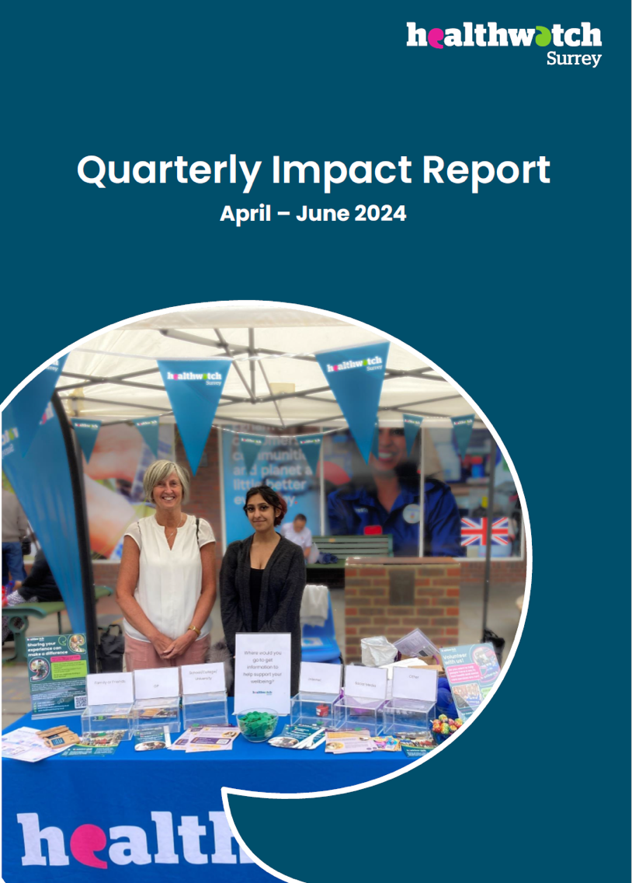

# This bulletin: at a glance

## Hot topics

In this bulletin we are focussing on 5 key areas:

* Thanks and praise
* Secondary care: communication can lack clarity and compassion
* Primary care: GP access (and communication around it) a continuing issue
* Spotlight on urgent and emergency care services: drivers and barriers
* Spotlight on social care: the self-funder’s journey

## Who have we been hearing from?

Since our last bulletin we’ve heard from **196** people across Surrey, via our Helpdesk or during engagement events in the community.

* **38%** of the feedback relates to GP practices.
* **32%** of the feedback relates to hospitals
* Of those happy to disclose their gender, **52%** identified as female.
* Of those willing to share their age, **51%** were aged over 50

We’ve heard the views of additional people via a series of online surveys on specific topics.

# Thanks and praise

**Some people have shared really positive experiences with us this month.**

We’ve heard praise for the ambulance service.

“Thank you for your great ambulance service today. My wife and I were due to go on holiday today but unfortunately, I fainted. My wife called an ambulance and [they] were fantastic at getting me back on my feet. Thank you all!”

217106, Surrey resident

We’ve also heard praise for the Urgent Care Centre in Aldershot and the A&E department at Frimley Park hospital.

“The service here [Urgent Care Centre] has been really good, it is quick and good to be seen on the same day.”

213543, Surrey resident

“My mum was in A&E last week and [although there was a long wait and Mum was assessed in a corridor] all of the staff, from nurses, doctors, and people giving out tea were kind and caring.”

216941, Surrey resident

More details on our visits to Frimley Park Hospital A&E and Aldershot Urgent Care Centre are detailed later in this report.

# Secondary care: communication can lack clarity and compassion

In this report period **62** people spoke to us about their experiences of Surrey hospitals.

## Patients not kept fully informed

People tell us that there is a lack of clear communication from clinicians in secondary care, which can be a particular issue when patients are being directed back to primary care.

“I went to the maxillofacial clinic. I was warned of the risks of fillings falling out and possibly swallowing extracted [teeth]. I heard the doctor say ‘oops’ during the procedure. The tooth came out ok, no problems. But a filling came out too. The doctor handed me the filling back and said that I could take it back to my dentist and they could put it back in free of charge. I couldn’t feel what was going on in my mouth. She said that she would write a letter to my dentist so that I didn’t have to pay and left the room. Another lady came in and I was given a standard after care letter. I went to my dentist (NHS) the same evening and was told that there was no way that they could just replace a filling. Also, the damage was much greater. The tooth was broken and would need a lot more work. Approximately £150 cost.”

218565, Spelthorne resident

In this case, a lack of clear communication around patient transport (both to patients and between services) led to unnecessary stress for a potentially vulnerable patient:

“My mum was told by a member of the stroke team that she would be able to sign up to the [transport] service online and book the sessions she needed. However, when they came to try and sign up, the site would crash and time out. They then tried to call the booking line but were put off by the message that plays when you call, which outlines the penalties that you could incur if you incorrectly try to book patient transport. This caused my mother great distress and anxiety, as she did not want to be in trouble for incorrectly booking transport.

My stepdad then tried to call on several occasions, and each time would give up as he would be on the phone for 30+ minutes waiting to speak to someone. There seems to be a misunderstanding in the processes to book patient transport from other NHS staff i.e. the stroke team which led to further delays in booking transport for my mum and a lot of confusion when trying to get transport arranged.”

216985, Guildford resident

Similarly, people regularly contact our Helpdesk for information about eligibility and availability of support with transport to appointments across Surrey.

## A lack of compassion from some members of staff

For some the communication they do have lacks compassion and understanding.

“I met with a nurse to discuss treatment options for weight loss and management of Hidradenitis Suppurativa (HS) through weight loss, a condition I suffer from. Unfortunately, the experience was far from positive. The nurse, upon my arrival, immediately informed me in a sarcastic and dismissive tone that the weight loss injection I was hoping for was unavailable due to a national shortage. This not only shattered my hope for managing my HS but also left me feeling unheard and disregarded.”

216641, North West Surrey resident

“[My son] is on melatonin and has been for the past 2 years. He takes it as described, but it doesn't work. We have highlighted this to his paediatrician, but they have said it is because he isn't taking it properly. She isn't following the NICE guidelines either. I raised a complaint with PALS [Patient Advice and Liaison Service] and had a letter sent to me in January saying they will send their response soon, but we have had nothing since.

217085, Reigate and Banstead resident

## Other factors affecting people’s care

For others, although staff are compassionate, long waits and space to be seen are the issue:

“My mum was in A&E last week and [although there was a long wait and Mum was assessed in a corridor] there were 20 patients ahead of her waiting for rooms, so she was in the corridor for ages. She was assessed and manipulated (what I mean by that is that they were moving around all of her limbs to check she had not broken any) and it was awful to be treated like that. Mum’s dignity was lost completely. There were people walking past all of the time which was very embarrassing for Mum and to be honest I found it hard to see. Although all of the staff, from nurses, doctors, and people giving out tea were kind and caring.”

216941, Surrey resident

# Primary care: GP access (and communication around it) a continuing issue

**In July, NHS England published findings from their** [**annual GP patient survey**](https://www.england.nhs.uk/statistics/2024/07/11/gp-patient-survey-2024/)**. While three quarters (74%) of patients reported a good overall experience of their GP practice nationally (slightly higher, 75%, across Surrey Heartlands Integrated Care Board and slightly lower, 70%, across Frimley Integrated Care Board), GP access remains an issue. Across Surrey Heartlands and Frimley, 36% and 41% of respondents respectively said they found it ‘difficult’ to contact their GP by phone, and 17% and 22% respectively said their experience of contacting their GP was ‘poor’.**

In this report period, **74** people spoke to us about their GP practice.

## Access issues

We continue to hear from people in Surrey who find the lack of flexibility when it comes to how and when they book GP appointments difficult. There is also a sense that getting an appointment is more down to ‘luck’ than clinical need. In our previous [What we’re hearing about GP practice websites report](https://www.healthwatchsurrey.co.uk/report/what-were-hearing-about-gp-practice-websites-january-2024/) we noted the importance of clear communication around service provision and GP access, and the need for a flexible approach to ensure inclusion.

“I phoned at 3pm one day, hung on for 1 hour. Eventually got through and was told that there were no appointments available.”

217031, Woking resident

Getting an appointment is a poor experience. Phone at 8am but no appointments. Online form - no appointments. If you can get an appointment it is for 2-3 weeks’ time.

218342, Epsom and Ewell resident

“I have been trying to book a doctor’s appointment for the last two weeks. I have tried using the online form and through my NHS App and every time it says they have reached capacity for the form and to try another day. I have tried early mornings, afternoons, evenings, all times and get the same response. I called the practice on Friday and was told receptionist don’t book appointments anymore and have to use the form. I explained I’ve tried and the receptionist said I have to keep trying.”

218279, Leatherhead resident

## Misunderstanding around triage

People continue to tell us that they are unhappy being triaged to other services and clinicians. A lack of effective communication to explain the reasons for this is often at the heart of the discontent. There is also a feeling that there is no personalised, holistic care when people are seen by a number of different clinicians.

“I contacted GP the week before Christmas last year due to itching and a ‘fizzy’ noise in my ear. I was informed that there were no appointments and that I should go to the Walk-In Centre at Woking, which I did and where I waited for approximately 4 hours to be seen, they did however treat the problem. The week after Christmas I contacted the GP again for an appointment as the noise in my ear continued and I was again told there were none available, but to come into the practice and be seen by a pharmacist. I expressed that I was unhappy about not being seen by a doctor and the pharmacist then called a doctor to come in, who advised me that I would need to be referred to the hospital with suspected tinnitus.”

216060, Guildford and Waverley resident

# Spotlight on urgent and emergency care services: drivers and barriers

**In April and June 2024, our local volunteers visited Aldershot Urgent Care Centre (UCC) and Frimley Park Hospital’s Emergency Department to gain a better understanding of people’s decision making and choices when seeking urgent or emergency care. We hope our insights will help the system learn and plan accordingly, ensuring people can get the best possible care in the most efficient and accessible way. Key findings from** [**our report - What we’re hearing about urgent and emergency care pathways**](https://www.healthwatchsurrey.co.uk/report/what-were-hearing-about-urgent-and-emergency-pathways-july-2024/) **- can be found below.**

We spoke to **46** people across **4** visits (2 to Aldershot Urgent Care Centre, 2 to Frimley Park Hospital A&E).

## Lack of awareness of UCC

[Aldershot Urgent Care Centre (UCC)](https://www.aldershoturgentcarecentre.co.uk/) is an alternative to hospital A&E services for non-emergency situations. It is currently a pilot service so lack of awareness is to be expected.

“I knew that this health centre was here, but I didn’t know that there was an urgent care department.”

213539, Surrey resident

## UCC as an overflow from the GP practice

15 out of 18 people we spoke to had been referred by their GP after requesting a GP appointment. No one had been redirected from A&E.

“I queued for over half an hour on the phone today to get an appointment with the GP. I was told by them that they only had one person in, so they were referring people to the UCC. They got me the appointment here.”

213539, Surrey resident

## Can UCC reduce demand on A&E?

Whilst most people said they wouldn’t have considered A&E for this episode of their care, there is some evidence to suggest being seen at the UCC reduces demand on A&E:

“I rang the surgery this morning who were unable to give me an appointment but as my throat got worse, I decided to ring 111. I was not aware of this centre, I was referred here by 111. I think it is a good service to have as it meant that I could be seen today rather than get worse overnight. I would go to A&E if I was unable to swallow and not be able to see anyone, which I thought I might be doing this evening before I was offered this appointment.”

239927, Surrey resident

## Are people attending A&E appropriately?

Most people we spoke to had contacted other services such as 999, their GP practice, Minor injuries unit (MIU) – Brants Bridge, first:

“Initially had an online consultation with my GP and was referred to Brants Bridge MIU in Bracknell. 1 hour later had had an ECG and was referred onto the Emergency Department at Frimley Park Hospital. Triaged quickly and had a further ECG. Referral pathway has been perfect.”

216914, Surrey Heath resident

Despite long waits, some people are put off alternative routes due to previous experiences or because they felt they wouldn’t be seen effectively elsewhere.

“I’ve used 111 before but found it a nightmare. They were asking the same questions over and over again. It put me off using them again, I would just come straight to A&E now. You get seen a lot quicker here than at the GP!”

213579, Surrey Heath resident

# Spotlight on social care: the self-funder’s journey

**The life expectancy of Surrey's residents exceeds the national average for both men (81.4 compared to 79.5) and women (84.6 compared to 83.1).**

**According to the Joint Strategic Needs Assessment (JSNA), 231,800 of Surrey’s 1,208,400 population are aged over 65 years old and 36,800 are aged over 85 years old. The number of older residents in Surrey is predicted to rise dramatically over the next 10 years.**

**Against this backdrop, Surrey County Council (SCC) approached Healthwatch Surrey to support them with gathering insight into the journey self-funders (people paying for their own care home accommodation) may take to arrive in a residential care home setting. Key findings from** [**our report – Who can help me plan for my future as an older person?**](https://www.healthwatchsurrey.co.uk/report/who-can-help-me-plan-for-my-future-as-an-older-person/) **- can be found below.**

We visited **6** care homes and **4** community settings and attended **7** Surrey Age UK Surrey ‘Planning for your future care’ events. These engagement events were supported by an online survey.

## Where do people turn to for information and advice?

People rely on a variety of information sources, there is no clear preferred choice of where people turn so information needs to be consistent across all channels.

## Living independently at home

Two thirds of our respondents were living independently in their own home with support from family and friends, paid for home care workers, or other paid help such as cleaners and gardeners.

94% of respondents said that they would look for advice in the future about living independently at home.

## Paid for home care workers

28% of the people we spoke to used paid for home care workers.

The main reasons people would consider paid for home care workers in the future is to enable them to carry on living at home, and to keep their independence.

## Financial assessments

13% of the people we heard from had had a financial assessment.

When asked about the kind of information people want, we heard that people are unsure about the criteria for getting a social care assessment, and how to get one.

I don’t know how to pick a good home care service. What it would cost and who pays. Would I have to sell my house? Do they need to get a social care assessment?

## Consideration of care homes

Just under two thirds of the people we heard from were either thinking about a care home for themselves or for a family member.

The main reasons for considering a care home were if the person would not be able to manage themselves at home anymore, and if they had mobility/frailty issues.

The vast majority (89%) told us they would look for information and advice if they or their family member were thinking about moving into a care home. Three quarters of our respondents thought they or their family member would have to pay for their care home.

# Call for eye care experiences!

In 2021 we [reported what we’re hearing about eye care](https://www.healthwatchsurrey.co.uk/wp-content/uploads/2021/08/What-we-are-hearing-about-Eye-Care-Aug-21.pdf), detailing the issues people had shared with us around pathways to eye care, looking particularly at how the lack of integration between different services impacts access to care.

Healthwatch England have just launched a national [eye care survey](https://www.smartsurvey.co.uk/s/YR8SHW) to help Government and NHS managers understand what is – and what isn’t – working across the country. The more people who complete the survey the more valuable the insights, so please do consider taking part and/or promoting and helping to create an accurate picture of the current situation in Surrey.

# Sharing our insight and raising concerns

Whilst this bulletin accurately reflects what we hear from the individuals we speak to, we are aware that it may not be representative of everyone’s views of a particular service. Multiple references to a specific service may be due to where our community engagement has recently taken place.

If we hear a case of concern regarding patient safety, we immediately signpost the sharer to the appropriate body and escalate the case with the provider/commissioner. All appropriate information and signposting to complaints processes has already been given.

We share our wider themes with Trusts, Integrated Care Systems (ICSs), Surrey County Council, Public Health, Care Quality Commission (CQC), and in various boards and groups across Surrey.

If you would like more information or examples of what people have shared with us, please get in touch with us.

# Community engagement

Below are details of our upcoming engagement sessions where we visit venues in local communities to listen to what people think about local health and care services, and to ask specific questions related to [our priorities](https://www.healthwatchsurrey.co.uk/about-us/our-priorities/). We also provide information and signposting regarding health and social care. Each month we focus on a different area of the county. Last month this was East Surrey and through August we’ll be focusing on Farnham.

Throughout the year, we also attend events across Surrey to raise awareness of our work.

|  |  |  |  |  |
| --- | --- | --- | --- | --- |
| Date | Place | Time | Open  to | Surrey Area |
| 19/08/2024 | Surrey Choices Anniversary event, Laleham | 10am – 2pm | Public | North West Surrey |
| 21/08/2024 | Farnham Hospital | 10am – 12noon | **Public** | Farnham |
| 21/08/2024 | Farnham Library | 10am – 12noon | **Public** | Farnham |
| 21/09/2024 | Pride in Surrey | 12noon – 6pm | **Public** | Surrey wide |
| 30/09/2024 | Frimley Baptist Church | 10.45am – 12 noon | **Public** | **Surrey Heath** |

**Please note: these dates may be subject to change.**

To share an experience with us, or for information and signposting about health and social care, people can also contact our Helpdesk in the following ways:

Phone: 0303 303 0023

SMS (text only): 07592 787 533

Email: [enquiries@healthwatchsurrey.co.uk](mailto:enquiries@healthwatchsurrey.co.uk)

Share your feedback via our website: <https://www.healthwatchsurrey.co.uk/feedback-centre/>

# About Healthwatch Surrey

Healthwatch Surrey champions the voice of local people to shape, improve and get the best from NHS, health and social care services. As an independent statutory body, we have the power to make sure decision makers listen to the experiences of local people.

We passionately believe that listening and responding to local people's experiences is vital to create health and social care services that meet the needs of people in Surrey. We seek out people’s experiences of health and care services, particularly from people whose voices are seldom heard, who might be at risk of health inequalities and whose needs are not met by current services. We share our findings publicly and with service providers and commissioners to influence and challenge current provision and future plans.

We also provide reliable and trustworthy information and signposting about local health and social care services to help people get the support they need.

# Our distribution list

If you would like to be added to or removed from the distribution list for this Insight Bulletin, please contact our Communications Lead [vicky.rushworth@healthwatchsurrey.co.uk](mailto:vicky.rushworth@healthwatchsurrey.co.uk)



We are committed to the quality of our information.

Every three years we perform an audit so that we can be certain of this.



The Healthwatch Surrey service is run by Luminus Insight CIC, known as Luminus.

Registered office: GF21, Astolat, Coniers Way, Burpham, Surrey, GU4 7HL.