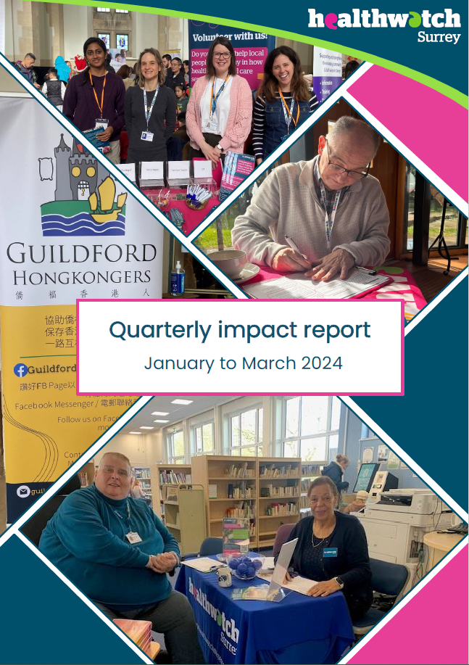

Quarterly impact report
  - January to March 2024

“Helping shape health and social care services in Surrey”

If you would like a paper copy of this document or require it in an alternative format, please get in touch with us.

Contents

Highlights 3
Information and signposting 4
Helpdesk 4
In the community 5
Our thematic priorities 7
Access to primary care 7
Mental health 8
Involvement of people 9
Advocacy & complaints 11
Healthwatch Surrey – Contact us 13

Highlights

Summary

130 People supported through Helpdesk

116 People supported by Advocacy

419 Hours provided by our volunteers

Quarter highlights:

Empowering communities to access services online (page 5)

Co-producing advice leaflets to improve people’s knowledge of primary care services (page 7)

Sharing Surrey residents’ experiences of dementia services on a national stage (page 8)

Working in partnership to make services more inclusive through the Accessible Information Standard (page 10)

Information and signposting
Healthwatch Surrey continues to provide valuable support for individuals who contact our Helpdesk. In addition to providing reliable and trustworthy information and signposting, our influential relationships with a wide range of health and care services means our team can escalate concerns, providing resolutions to individuals and ensuring an improved experience for others.

Helpdesk

Rosemary’s Experience
Rosemary* received a letter from her GP practice informing her that her address was no longer in the practice’s catchment area so she would need to register elsewhere. Rosemary had been registered with the practice for over 20 years so found the letter upsetting and unsettling. She had tried to contact the Practice Manager for clarification but had received no response.

Our Helpdesk Advisor explained the regulations regarding patient registration and that we would seek clarification regarding her circumstances.

Outcome:
Healthwatch Surrey escalated this case to Surrey Heartlands Integrated Care Board’s Primary Care Lead who confirmed that deregistering existing patients is in breach of the regulations. The ICB instructed the practice to reassure Rosemary directly, which Rosemary was very appreciative of. They also sought assurance from the Practice Manager that no further letters like this would be sent, meaning others don’t have to face the confusion and worry that Rosemary did.

Kathy’s experience
Kathy* was eligible to get free lateral flow tests but was confused about how to access these. The NHS England website had directed her to her 5 local pharmacies, however none of which had any stock or were even aware this was a service they provided.

Healthwatch Surrey contacted the regional pharmacy team, Surrey and Sussex Pharmacy, to share Kathy’s experience and ask for clarity regarding available services.

Outcome:
Surrey and Sussex Pharmacy provided further clarification on free lateral flow tests and how to access them. We shared this information with Kathy, who confirmed that the process was now much clearer. We were also able to update our own signposting information to help future enquires.

Following our escalation, Surrey and Sussex Pharmacy raised the issue with NHS England and requested that the information about Covid tests on their national website be reconfigured to make it clearer and easier to navigate and understand.

* Names have been changed.

If you have an experience to share, or need information and signposting about local NHS, health and social care services, please contact our Helpdesk via:
Phone: 0303 303 0023
SMS: 07592 787533
Email: enquiries@healthwatchsurrey.co.uk
You can share your experience via a website feedback form: https://www.healthwatchsurrey.co.uk/feedback-centre/

In the community
Healthwatch Surrey are able to build trusted relationships with communities through information and signposting, which opens up conversations and provides opportunities to help people better navigate health and care services.

Previous engagements with communities at risk of health inequalities have highlighted concerns about the increasing prevalence of online access and the difficulties some have in using it. So, we have been visiting community groups across Surrey to provide information and guidance on accessing services through the NHS App and other digital related advice.
We attended a community breakfast at St Martin’s Church in Camberley, as we knew that access to services was a particular challenge for those attending.

Mary’s Experience
Mary* wanted to talk about the challenges around digital access to services alongside caring for her husband. After listening to Mary’s experience, we discovered that Mary’s caring responsibilities had changed over time.

Mary told us that she didn’t identify as her husband’s carer but as we spoke, she recognised the care she gave her husband had become much more challenging and he was no longer able to cope without her. She told us she would like to know about available support.

Outcome:
Our Community Engagement Officer was able to help guide Mary through different ways to book appointments. We discussed that there is an option for patients to use a call back service when calling their GP practice to book an appointment making it easier for Mary to contact her GP.

We told Mary about some key organisations which could help support her to care for her husband at home. We were able to discuss her needs and give tailored signposting to a range of organisations. Learning that Mary preferred to speak to people in person, we found details of a local drop in with Action for Carers Surrey. Mary felt nervous about this but as we have also been to these drop ins, we were able to explain what they were like, which helped her to feel more confident in going. We also discussed what she felt would be beneficial to her and her husband going forward. After listening to her we suggested she could ask for a longer appointment with a GP for her and her husband to talk about his care needs and to look at his health holistically, especially if there had been a decline recently. We told her about Citizens Advice and the local library as additional places for information and advice and gave details of our Helpdesk for ongoing support. Mary told us she thought that these would all be good ideas that would suit her. She also told us that she would be following up on the information we had provided making Mary feel more supported as a carer.

Our thematic priorities

Access to primary care
In July 2023 we reviewed what people had been telling us about access to General Practice, identifying a need for more public information about changes in how to access their GP practice and what people can expect from the services offered there.

We involved local people in creating resources for Surrey residents about using their GP practice at a co-production event with our volunteers in October 2023.

Using key themes that local people had shared with us, we asked the volunteers to explore what is working well and where further information is needed.

Three main themes emerged from the session:
- Knowing your rights when booking a GP appointment.
- Questions about the triage process and why patients are triaged.
- Information on how to feedback or complain.

We have been busy researching and building materials based on these key themes and followed up with a further co-production event to finalise the design brief and content for 2 public facing leaflets.

- Leaflet 1 will cover information about registering with a GP practice and what services are available.
- Leaflet 2 will champion the importance of feedback to GP practices and guide people to the opportunities to have their voices heard.
Our leaflets are currently being produced and will be ready to trial with the public throughout the next quarter. Initial comments from system partners have been positive. We were told that they liked that we have clear, simple information for patients and that they would be happy to share the finished leaflet through their own widespread communication channels with the general public.

Mental health

Influencing national approaches to dementia services
In November 2021, we published our recommendations for services supporting people with dementia, and have continued to work to ensure that the voices of people are heard as dementia services continue to evolve.

In March, Healthwatch Surrey were invited to participate in a Care Quality Commission (CQC) workshop as part of the design for their new national strategy on dementia. Our volunteer, Robert Hill, represented the voices of Surrey residents joining a conversation, along with over 40 other Local Healthwatch to share what we’ve each heard regarding dementia services. This helped determine how the CQC could support the future monitoring and assessment of dementia services and what could be learned from people’s experiences.

Robert and the other Healthwatch representatives recommended that the wide range of insight captured across the Healthwatch network be reviewed and incorporated into the future strategy.

Robert has been the cornerstone of Healthwatch Surrey’s work on dementia over the past few years. He co-authored our 2021 report on experiences following a dementia diagnosis and has been representing Healthwatch Surrey in Surrey County Council’s Dementia Strategy Action Board to continue to bring the voices of people and their carers into the decision making process. The Healthwatch Surrey team greatly appreciate Robert’s energy and enthusiasm in this important and challenging area.

Supporting and nurturing a positive listening landscape
We have been working alongside colleagues in the voluntary sector, to support a more positive listening culture across mental health services. We have built new relationships with the organisations who support engagement and involvement with people with mental health services. We helped in the development and organisation of an inaugural lived experience conference, celebrating the importance of co-production in developing mental health services. This provided a unique opportunity to connect with a diverse range of people with lived experience of mental services who are actively involved in various projects and programmes working with mental health providers.
One of the key themes our review of experiences highlighted, is that people are not feeling heard by mental health services. We recognised that although people left feedback, participated in focus groups or directly complained to services, they felt that services had not listened to them or learned from this feedback.

This collaborative approach led to us being able to signpost the team leading the review of discharge from mental health services to various groups and organisations to enable a wide variety of people, with direct experience of services, to be heard.

Involvement of people
In the last quarter, we updated on our recent project exploring people’s understanding of how to give feedback to hospitals. We have produced a short video summary which highlights the commitments that the hospitals are undertaking to encourage more people to share feedback. This will provide them with more opportunities to learn and make improvements which will make for a better experience going forward.

Healthwatch Surrey continue to work with hospitals to improve opportunities for patients and their families to have their voices heard during their care.
Some examples of how hospitals have responded to the feedback are as follows:

- Patient experience workshop with focus on patient feedback,
- Announcement on hospital radio to encourage people to give feedback and know how they can do this,
- Review PALs leaflets, poster locations and website so that people can easily navigate their way to feedback opportunities
- Remind staff to ask patients for their feedback,
- Display information about how hospitals are acting on feedback,
- Reinstate voicemail facility in the PALS office for when the phone lines are busy,
- New poster campaign, QR Codes and noticeboards.

Amplifying VCSE voice to tackle health inequalities
Healthwatch Surrey are committed to ensuring that everyone in Surrey has equitable opportunity to access health and care services. We shape our approach, through our engagements and through building partnerships with other organisations, to seek out people who are less well heard by decision makers.

We have been working with voluntary sector colleagues to better understand the challenges people face about health services not meeting their communications needs. Last year, we connected VCSE organisations across Surrey with the ongoing work to ensure that organisations are conforming to the Accessible Information Standard. We continue to work with colleagues to challenge services and develop more inclusive services.

We participated in 2 working group meetings with Surrey Heartlands, VCSE organisations and service providers to discuss accessible information. Along with our voluntary sector colleagues, we shared experiences from people across Surrey highlighting the opportunities for services to learn. We are also working to develop similar working relationships in Frimley, connecting colleagues across the two ICS to help spread any learnings further.

Healthwatch Surrey also ensured that VCSE organisations across Surrey had an opportunity to feedback on Surrey Heartlands Joint Forward Plan, a strategic document that states the integrated care system’s commitments to the residents of Surrey. We invited the document’s authors to our voice group to provide opportunity for all communities to be represented in the plan. There was a strong message during this conversation that VCSE organisations wanted to see a greater emphasis on meeting people’s communication needs.

Healthwatch Surrey made a challenge to the authors regarding the plan, as it did not include any reference to the Accessible Information Standard, which all NHS organisations are required to comply with, and no reference to Surrey Heartlands commitment to partnering with voluntary sector organisations to ensure local people are involved in decisions about services. Our input was welcomed, and new sections were added to address these points, marking important commitments towards a more collaborative environment for future decision-making.

Advocacy & complaints
In circumstances where people wish to complain about a health service, we also provide the Independent Health Complaints Advocacy service. This provides free advocacy support, in partnership with Surrey Independent Living Charity, to ensure complaints are handled appropriately.

We continue to champion the importance of people being able to access their right to complain if they chose to and to share our Maximising the learning from complaints report. This ensures services are reminded of the importance of enabling people to complain and how each complaint provides a vital opportunity for services to improve services for the people they support. The following example demonstrates the importance of our advocacy service, particularly for people with difficulties in communicating, to have an opportunity to make challenges about their care and lead to improvements for other people with similar challenges.

Rose’s experience
Rose had been asked to attend an examination at hospital regarding some concerns with her smear test result. She was anxious about the procedure and found the whole experience overwhelming.

Rose was waiting for over an hour, only to find out there was a system error which meant 3 other patients went in before her. This delay further exacerbated her anxiety at the time.

During the appointment, there were 4 people in the room and no explanation from the consultant as to why the other people were there for such an intimate procedure. Rose asked the consultant to use the 3-2-1 technique, warning her when they would be touching her, but they didn't do this, even when prompted again. One of the staff members in the room also made an unprofessional comment to her as to her choice of contraception for someone her age, which Rose felt was unnecessary. Rose found the whole experience stressful, scary, and physically painful, causing her distress.

Our advocate explained the complaints process and supported Rose to draft a complaint. We discussed what outcomes she would like to achieve to help structure her complaint.

Outcome
The hospital investigated the complaint and apologised for the distress Rose experienced. They acknowledged the long wait was due to staffing challenges on the day, an emergency with another patient and a computer glitch. They recognise that Rose should have been informed of the delay and they have apologised. Processes have now been put in place to alert patients in the waiting room of any delays.

The hospital recognised that there should have been better communication with Rose, throughout the whole procedure. As a result, the hospital is now drafting a new sexual safety policy and have agreed to share this with Rose once it is completed.

Rose was happy with the outcome and felt the advocate helped her to express herself and made her feel empowered in highlighting the issue.

* Names have been changed to protect identities.

Need help to make a complaint?
If you live in Surrey and are unhappy with the NHS treatment you have received, our Independent Health Complaints Advocacy service can provide free, confidential and independent support to help you to make a complaint. This is provided in partnership with SILC (Surrey Independent Living Charity).
Contact the team via:
Phone: 01483 310 500
Text (SMS): 07704 265 377
Email: nhsadvocacy@surreyilc.org.uk
Website: www.surreyilc.org.uk

Healthwatch Surrey – Contact us

Website: www.healthwatchsurrey.co.uk
Phone: 0303 303 0023
Text/SMS: 07592 787533
Email: enquiries@healthwatchsurrey.co.uk
Address: Freepost RSYX-ETRE-CXBY, Healthwatch Surrey, Astolat,
Coiners Way, Burpham, Guildford, Surrey, GU4 7HL

Healthwatch Surrey
HW_Surrey
Healthwatch_surrey
Healthwatch Surrey

We are committed to the quality of our information.
Every three years we perform an audit so that we can be certain of this.

