Insight Bulletin

  - May 2024

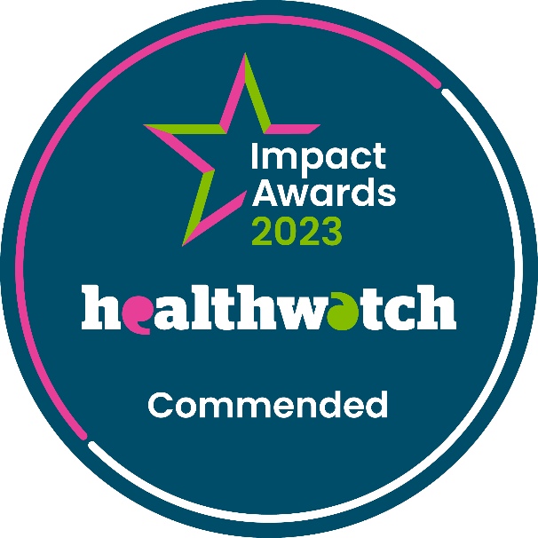

We are pleased to announce that we were commended in the National Healthwatch Impact Awards. This followed our work with a local resident, Chantelle, who was unable to access cancer screening. We appreciate Chantelle sharing her experience with us, which not only led to us ensuring she could access the screening that she should have, but also helped us ensure other people have better experiences going forward.
Our video tells Chantelle’s experience.

If you would like a paper copy of this document or require it in an alternative format, please get in touch with us.

What have we been hearing about this month?
Healthwatch England have recently launched their 2022-2023 Annual Report. The report drew attention to the value that the public's voices bring to health and social care services, and their power to show what is and isn’t working.

The report identified 3 key areas of focus for decision makers in the health and social care system. These national priorities are reflected here at Healthwatch Surrey, and the stories we’ve heard this month support the need to focus in these areas:

- Making the NHS easier to access and navigate
- Tackling health inequalities
- Building a patient centred culture

In addition to concerns in these three areas, we’ve also heard lots of positive stories from people this month, particularly in relation to excellence shown in both clinical and compassionate care.

Who have we been hearing from?
Since our last bulletin we’ve heard from 96 people across Surrey.
- Over half (55%) of the feedback we’ve received has been related to GP practices
- Two thirds (66%) of those we heard from identified as female
- Over half (57%) of those we heard from were aged over 50

Clinical and compassionate care excellence
We’ve heard from a few people this month who have praised the calm professionalism of NHS staff in an acute situation. Their ability to provide the clinical care necessary whilst also offering reassurance and individual attention has proved to be invaluable in very stressful circumstances.

“I was treated really well in casualty for an undiagnosed exacerbation of COPD.”
212242, Woking resident

“I thought the ambulance crew were excellent, they took the time to talk to me and reassure me, which helped me to stay calm and filled me with confidence. We can’t praise them enough.”
45351, Elmbridge resident

“My partner came home from work early because she was quite ill. She is asthmatic and an infection triggered an episode. she had already made a GP appointment and I drove her there. She began to collapse on arrival and the GP staff sprang into action with a nebuliser and called paramedics, who arrived within a couple of minutes. I noticed that GP staff adapted their responses when I informed them of co-occurring conditions. She was taken to hospital and the resuscitation team also took prompt actions, running various diagnostics and administering oxygen and more nebuliser and medications tackling infection. The ambulance crew were able to take me directly to my partner's side. She was allocated a bed in "the hub" and later admitted as an inpatient where she was supported to recover for several days. I would call all this excellent.”
212051, Epsom resident

GP practices responding to individual needs is having a positive impact on some people, as shown in these examples:

“My local GP service is great. Responsive, can be seen on the same day or you can book online. Facilities always clean and calm. Reception staff in particular go out of their way to be helpful. I recently rang up with regards to my immunisation status as going on holiday at very short notice. They printed it off there and then and I picked it up 30 minutes later. Cannot identify any concerns.”
210795, Surrey Downs resident

“My husband died in December 2022 and I had been caring for him for over 10 years. I felt that the staff at the GP practice really took their time with me to listen and sort out anything I needed which helped me to care for my husband.”
211443, Guildford resident

Making the NHS easier to access and navigate
The Healthwatch England report noted that many people feel that “administration and communication can be slow, inefficient and sometimes lacking in empathy.”

We’ve heard from several people who have experienced this lack of empathy, often translating in to perceived rudeness, first hand.

“I booked a blood test with a nurse when I was in the GP practice. I had it written down on a piece of paper. I needed to cancel the appointment so went on to the website to do that. It sent me to the NHS App to cancel which then said to contact the practice so I gave them a call. After 45 minutes wait, I was treated like some demented person. The person I spoke to was so rude I was shocked and appalled. She couldn't find my appointment to cancel and got so angry and accused me of making it up. I booked in person and had it written down but she was having none of it. She just kept cutting me off and eventually she hung up on me.”
211719, Elmbridge resident

“My 14 year old daughter has had a urinary infection for 1 week. The doctor was good and prescribed antibiotics and cream but they didn’t work. She asked for a urine sample to do a dip and a swab. Today I called at 4:10pm as my daughter is still in pain to ask if they have the results. The receptionist was very impatient and rude. When I asked for her name, as she could see that I wasn’t happy about the way she was treating me and also how she was dealing with the case, she refused to say her name many times and just hung up on me.”
212130, Surrey Heath resident

We’ve also heard from people who have found navigating the system a challenge, including this resident who tried to receive same day care in several places and ultimately failed.

“I couldn't get a GP appointment after presenting at pharmacy for a consultation for what looked like an infected molluscum on my son's leg. The pharmacist said I need antibiotics for him as it was hot to touch and had a big red bullseye rash around the area. I called the GP but all appointments for the day had gone and the online form was switched off. I drove to Woking walk in. Upon arrival, security stopped me and said the car park is still out of use and to use the local nearby pay and display car park. After parking we rushed into the main area to be greeted with a sign saying ‘waiting area is closed due to being over capacity and wait would be longer than 4 hours taking it to past closing time’.”
211717, Runnymede resident

People have told us that this makes them think they are very much ‘outside’ a system which doesn’t have their best interests at heart, despite the clinical care often being excellent once they receive it.

“On the one hand I dread coming here, I have had the sense that they don't really care about the patients and I don't have confidence that things will happen unless you push for yourself. On the other hand when I have had actual treatment here with the nursing staff I have felt the care has been excellent.”
210898, Elmbridge resident

Administrative issues and delays can have a real impact on patient care, as in this case where a resident was in danger of running out of vital medication.

“Recently I ordered 2 weeks’ worth of medications before needing it. It’s usually filled within a few days but I noticed the GP practice hadn’t sent the script through. I called them and spoke to the receptionist, who told me it was too soon to order the medication and it’s GP policy not to order too early. What they didn’t realise was the dosage I was on which was two doses, so my medication was due to run out in half the time that they thought it would run out. So then after I explained the receptionist said they would call me back. They didn’t.”
211445, Guildford resident

Tackling health inequalities
The Healthwatch England report noted that health inequalities in England are stark and growing. Those living in the most deprived areas can expect to live in good health for a far shorter time compared to those in the least deprived areas. The latest census from the Federation of the Royal Colleges of Physicians in the UK supports these assertions. Published at the beginning of March, the census found that almost a quarter (24%) of physicians said more than half or almost all of their workload is due to illnesses or conditions related to social determinants of health, factors such as living in mouldy and damp homes, lack of access to healthy food, smoking and obesity.

Healthwatch England want Integrated Care Systems to work with local authorities to ensure communities get the advice and support they need in order to prevent ill health, and people with extra communication needs get full support every time they interact with the NHS.

Here in Surrey, in the last month alone, we’ve heard from several people whose experience of health and social care has been negatively impacted by barriers they’ve faced as a result of additional needs, be those financial, language, cultural or communication needs.

Language barriers
“I wish there were more face to face GP appointments. My English is good but I find it easier to communicate and understand when it’s face to face. I have found booking by phone the most direct route, although I have the NHS App and use the website. When I have booked via the website it’s taken up to two weeks to be seen.”
211444, Epsom resident

Digital barriers
Digital access continues to be something we hear about regularly.

“I received a text about joining NHSMYCARE [MyCare Patient Portal]. I tried to join but I am 84 years old and I have dyscalculia. I am unable to register as the Patient Portal validation code appears on the screen for only a few seconds. I have tried several times but this is insufficient time for me to remember the numbers and to add them to the appropriate box.”
211732, Guildford and Waverley resident

“My feedback on E-consult, is that it is confusing to start with. I thought it was the same as patient access, which I am registered for. The first time I completed it my daughter talked me through the whole process and it took about an hour. I think I am quite IT savvy, but the length of the consultation forms, plus the detail you need to put in can be time consuming, confusing and seems repetitive. I get very frustrated and stressed when using it sometimes.”
211964, Surrey Heath resident

“I had an assessment booked in for me at the end of January, which was a couple of months wait. I was really disappointed as the appointment didn’t happen. The day before I was sent a text message to say the practitioner was ill and so the assessment was cancelled. No one has followed up with me since and there was no instructions as to what I should do next. I’m not very digitally savvy and I struggle a bit with long messages with lots of text.”
211440, Epsom and Ewell resident

Financial barriers
Financial concerns are often referred to in relation to dental treatment and access. This is perhaps not surprising in light of recent data from the General Dental Council which found that 19% of dentists provide only private care, with no NHS, and a further 14% said they worked predominantly (over 75% of their time) in private care.

“On 18th August 2024 I retired. I stopped receiving ESA and got my pension. What I didn’t realise was on that day I stopped getting free dental treatment. I have an abscess in a tooth under a bridge, my dentist quotes £960 for treatment. I have been on benefits for over 30 years as I am disabled. I cannot afford this. I can't believe that because I'm retired I'm no longer entitled to free dental treatment. I do not know what to do, I have an abscess in my mouth and cannot get treatment. I'm so angry I worked for 20years as a nurse and can't get care now. Despicable. Ageist oppression.”
211787, Surrey resident via Healthwatch England

“Have just checked the Dental practices in the Guildford/Woking Area, not one is taking on over 18's as NHS patients. What a mockery.”
210707, Woking resident

Building a patient-centred culture
The Healthwatch England report noted that “The NHS still has a culture
focused on the priorities of the delivery system, rather than the
needs and wishes of patients.” They, and we, are calling for a shift in the culture of the NHS and social care so that there is a greater focus on listening to patients and acting on their experiences to improve the care they receive.

This month we’ve heard from a number of people who feel that the health or social care system – not their care – has been the priority, including this resident who wasn’t involved in important decisions about the care of someone they have responsibilities for.

“My best friend has a rare form of early onset dementia. She is 59. Myself and her husband are her carers. He has had no contact from the social care team for 2 weeks now. Last night, he got a call informing him that at 10am the following day, his wife would be moved to a care home in Egham. We both would have a 40 minute journey to reach her but more importantly, neither of us were involved in this decision.”
211716, Surrey Downs resident

In the situation below, the resident told us they found themselves having to fit in with the way the system operates at the expense of their individual needs being met.
“Received a threatening letter from the practice manager after asking for a GP appointment as opposed to a paramedic appointment. The letter stated that if I wanted to go elsewhere I could. I tried to ask the GP partner about it but was told they didn't have time. I've not seen a doctor for a number of years due to a phobia. I collapsed and contracted sepsis which is why I registered with this practice in November. There is no support or understanding of my phobia, just an impression they're trying to get me off their books. I've had no health checks since I registered.”
211712, Mole Valley resident

Sharing our insight and raising concerns
Whilst this bulletin accurately reflects what we hear from the individuals we speak to, we are aware that it may not be representative of everyone’s views of a particular service. Multiple references to a specific service may be due to where our community engagement has recently taken place.

If we hear a case of concern regarding patient safety, we immediately signpost the sharer to the appropriate body and escalate the case with the provider/commissioner. All appropriate information and signposting to complaints processes has already been given.

We share our wider themes with Trusts, Integrated Care Systems (ICSs), Surrey County Council, Public Health, Care Quality Commission (CQC), and in various boards and groups across Surrey.

If you would like more information or examples of what people have shared with us, please get in touch with us.

Community engagement
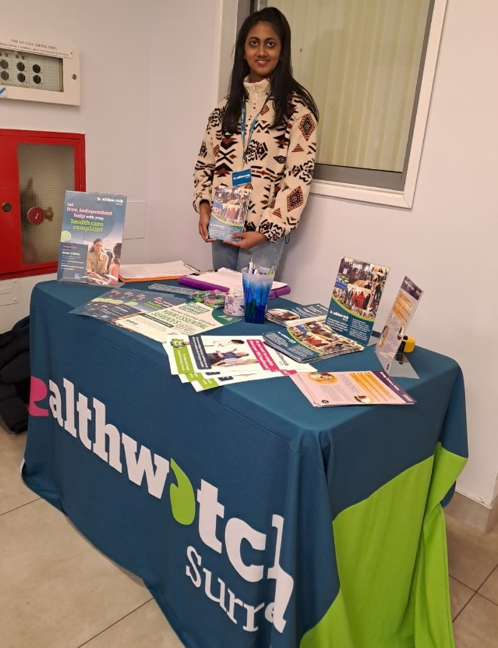

During March our engagement team focussed their visits in East Surrey and Surrey Downs and in April we were in Guildford and Waverley. Through May we’ll be focusing on Surrey Downs.

Date | Place | Time | Surrey Area
01/05/2024 | The Wharf Stay and Play, Godalming (Group engagement) | 10:30 – 11:30am | Guildford and Waverley
09/05/2024 | East Surrey College Careers Fair (Public) | 2 – 5pm | East Surrey
14/05/2024 | Safe Haven, Epsom (Group engagement) | 6pm – 8pm | Surrey Downs
16/05/2024 | Leatherhead Library, Leatherhead (Public) | 10am – 12noon | Surrey Downs
22/05/2024 | Roots Café, Epsom Methodist church (Public) | 10am-12noon | Surrey Downs

Please note: these dates may be subject to change.

To share an experience with us, or for information and signposting about health and social care, people can also contact our Helpdesk in the following ways:
Phone: 0303 303 0023
SMS (text only): 07592 787 533
Email: enquiries@healthwatchsurrey.co.uk
Share your feedback via our website: https://www.healthwatchsurrey.co.uk/feedback-centre/

Surveys
Another way we invite people to share their experiences with us is through surveys.

Finding out neurodivergent people’s experiences of hospital outpatient services

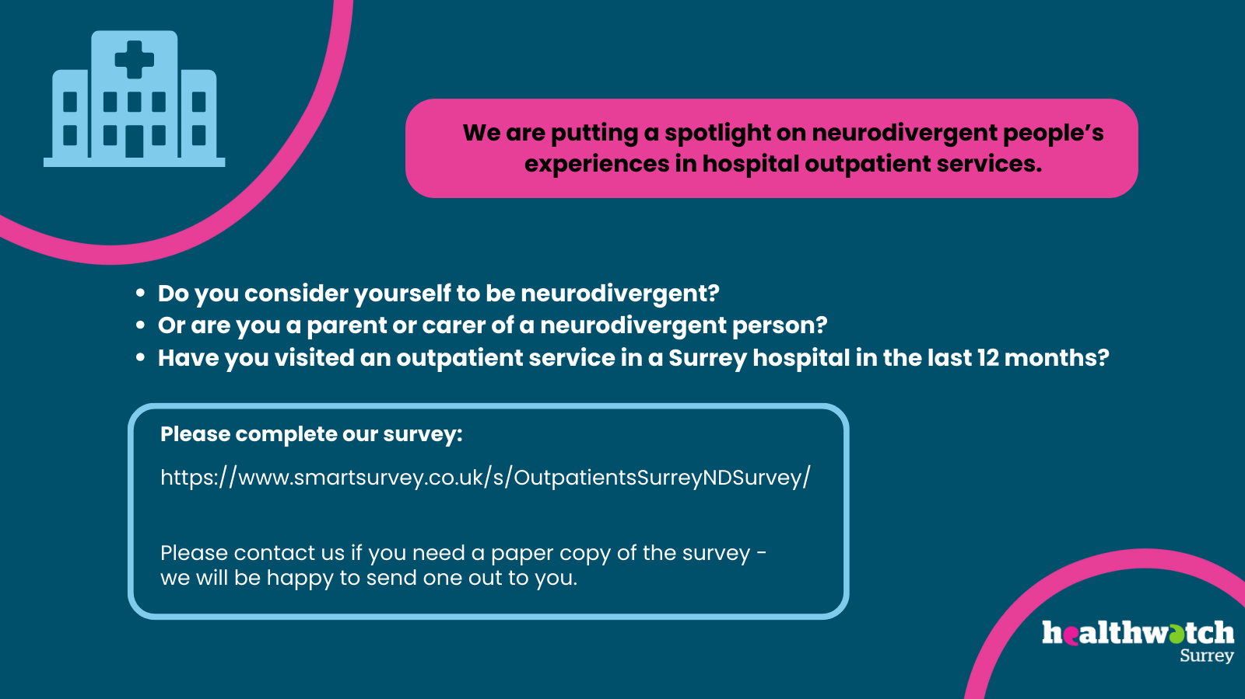

We are working in partnership with local organisations and community groups to gather neurodivergent people’s experiences of hospital care.

We will be visiting local groups and attending community engagement groups where we can talk to neurodivergent people about their experiences. As part of this work, we have also created a survey to ask neurodivergent people (or their parents or carers) for their experiences of local hospitals as an outpatient: https://www.smartsurvey.co.uk/s/OutpatientsSurreyNDSurvey/

Further information about this work is on our website: Finding out neurodivergent people's experiences of hospital outpatient services - Healthwatch Surrey

The impact of changes to GP practices and pharmacies – survey in Thames Ditton, Burpham, Merrow and Cranleigh

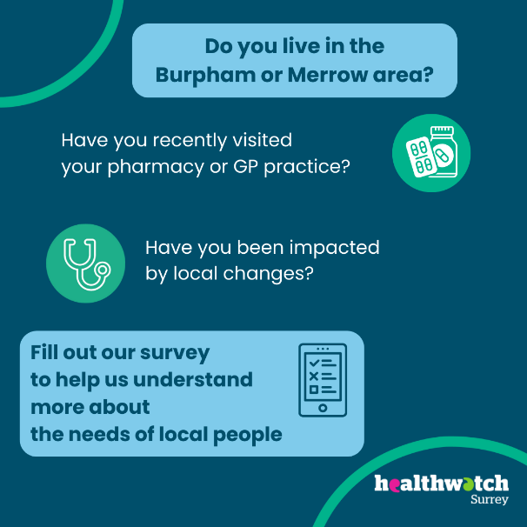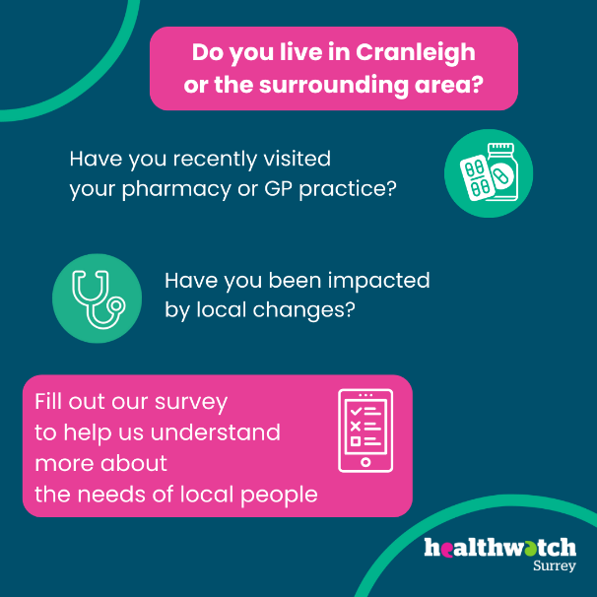

Our survey looking at the impact of a pharmacy closure and GP practice changes in Thames Ditton received over 200 local responses. In April we extended the survey to focus on two more areas (Cranleigh and Burpham/Merrow) and heard from a further 218 people in those areas. The insights we received are invaluable for helping us to build an accurate picture of the level and nature of this impact and the survey is now closed while we collate and analyse the results. Thank you to everyone who completed or shared this survey.

About Healthwatch Surrey
Healthwatch Surrey champions the voice of local people to shape, improve and get the best from NHS, health and social care services. As an independent statutory body, we have the power to make sure decision makers listen to the experiences of local people.

We passionately believe that listening and responding to local people's experiences is vital to create health and social care services that meet the needs of people in Surrey. We seek out people’s experiences of health and care services, particularly from people whose voices are seldom heard, who might be at risk of health inequalities and whose needs are not met by current services. We share our findings publicly and with service providers and commissioners to influence and challenge current provision and future plans.

We also provide reliable and trustworthy information and signposting about local health and social care services to help people get the support they need.

Our distribution list
If you would like to be added to or removed from the distribution list for this Insight Bulletin, please contact our Communications and Involvement Officer vicky.rushworth@healthwatchsurrey.co.uk

We are committed to the quality of our information.
Every three years we perform an audit so that we can be certain of this.

The Healthwatch Surrey service is run by Luminus Insight CIC, known as Luminus.
Registered office: GF21, Astolat, Coniers Way, Burpham, Surrey, GU4 7HL.

