Insight Bulletin

  - March 2024

“I have still not received an appointment so paid privately to have my moles checked and paid to have one removed which proved to be pre cancerous. I cannot afford to pay for another one which I have been advised to have removed. I still have not heard from my GP.”

If you would like a paper copy of this document or require it in an alternative format, please get in touch with us.

What have we been hearing about this month?
This Insight Bulletin highlights the themes and topics we have been hearing the most about this month:
- System updates positively impacting patient experience
- Long waits for GP practice appointments
- Difficulty obtaining prescriptions causing unnecessary stress for many
- Lack of communication between services continues to impact patients
- Are all services accessible to everyone?

Who have we been hearing from?
This month we heard from 181 people across Surrey.
- 59% of those we heard from identified as female
- Almost half of those we heard from (48%) were between the ages of 50-79.

System updates positively impacting patient experience
We’re pleased that people often share their positive experiences as well as their complaints and concerns. This month a few people acknowledged that changes to systems and processes are having a real and positive impact on their care.

“I do have the NHS App but I prefer calling [the GP practice]. I am flagged on the system as needing to be seen quickly as I have COPD and they know me there. There isn’t anything I would improve. The phone lines used to be exasperating but they’ve changed them over now and it’s better.”
208647, Waverley resident

“I think the process is improving, especially getting through by phone. I called and made an appointment, I’m not digitally savvy and I think it’s simpler to speak to someone. I was called back by a GP and had a consultation over the phone where they gave advice. To have that call was extremely reassuring to me and I didn’t need to be seen face to face, the issue I had rectified itself through a change in diet as suggested by the GP. I like this way of being triaged and it works for me.”
45349, Surrey Heath resident

For this resident, the speed of response in an acute situation was both reassuring and helpful in securing a positive clinical outcome.

“I had a recent need for urgent GP access. It is difficult to access the surgery by phone. But they arranged an appointment the same day. It resulted in a cancer concern and the 2 week wait rule was implemented by East Surrey. The outcome was prompt and I had excellent care through a scan and minor operation. I had excellent care from the NHS staff.”
209672, Mole Valley resident

Please note: In October 2023, NHS England removed the two-week wait standard in favour of a focus on the Faster Diagnosis Standard.

Long waits for GP practice appointments
Conversely, we’ve heard from several people this month who are concerned about the waiting time to see their GP. This comes as The King's Fund published a report (Making care closer to home a reality) on refocusing the health system around primary and community care. The report notes that, despite decades of government and health service leaders pledging to shift resources out of hospitals and into primary and community care, this re-balancing has not occurred. We were interested to see evidence of pressure on primary care here in Surrey.

“It takes 3 weeks to see the GP. But I don't want to wait or complain.”
209970, Waverley resident

“I don't use the NHS App, I call for appointments as its easier to do. Making the arrangements are easy but there is a long wait for appointments.”
209971, Guildford resident

“I presented to my GP practice with symptoms of finding it uncomfortable to swallow, coughing when eating or drinking and possible micro aspiration. I had a message from my practice who said to contact a triage number if I hadn’t heard within 9 days. I was told I had been triaged as urgent but they were unable to offer any appointments as there was already a years’ waiting list due to doctors strikes, staff shortages and clinic availability.”
209732, Waverley resident

In some cases longer GP waiting times have led people to seek help privately. This is an option not open to all and has the potential to increase the risk of health inequalities.

“October 2023 I was put forward for an appointment at my GP practice’s skin surgery. Despite calls I have still not received an appointment so paid privately to have my moles checked and paid to have one removed which proved to be pre-cancerous. I cannot afford to pay for another one which I have been advised to have removed. I still have not heard from my GP.”
210163, Woking resident

These health inequalities are further demonstrated in recent research conducted by Healthwatch England which found that less than half (42%) of people who are struggling financially believe the NHS can meet their needs. This is compared to 65% of those who are financially comfortable.

Difficulty obtaining prescriptions causing unnecessary stress for many
We know how important it is for people to be able to get their prescriptions when and how they need to. We’ve heard from several people this month for whom this has been a challenge.

“I’ve had the same prescription for well over 15 years – it has some controlled drugs – but I always have to chase to get them and never get them on time. I have tried to speak to the practice manager but don’t get put through. Receptionist doesn’t have any empathy. I was treated like an idiot. The pharmacist at the Hospital phoned her but they can’t do anything.”
207569, Epsom and Ewell resident

“My pharmacy never manage to have my meds ready no matter how early I put in a prescription request. Often items are missing or the packet says, for example, 14 and there are only 6. You take them back and they look at you as if you are lying! One time a whole months’ meds were missing. It was extremely stressful - they tried to tell me I had collected them but I had not. Turns out 3 months later that my meds had been found in a tray with rubbish. I now suffer from panic attacks and chronic anxiety going to collect my meds as I never know if they will have them.”
210598, Waverley resident

Lack of communication between services continues to impact patients
This absence of effective communication within and between services is a recurring insight in our feedback, and leaves people feeling confused and, in some cases, abandoned by the system.

“I'm in burnout and mental health crisis. Having multiple calls each day from different agencies all wanting to know what the other agencies are saying. No one is talking to each other or coordinating care.”
210178, Surrey resident via Healthwatch England

“The Surrey Care Record doesn’t seem to exist. There is no joined up data, not flowing between hospital and GP. My [hospital] appointments are not then recorded on my GP record. I tried speaking to Surrey Heartlands and they are looking into it. The problem is higher level and I want to know what the Surrey Care Record is for, it does not seem to exist. Why do Surrey bother having it?”
207751, Surrey Downs resident

“My husband was referred to audiology in January 2023. We were told that he would hear from audiology within a few weeks. Our Community Matron found the referral in March 2023 when it was transferred to the new computer system. The next day audiology called my husband and told him that it was up to us to prove when he had been referred. Spoke to the GP who was furious. Audiology said if not proved he would be at the bottom of the list and need to wait a further 6 to 7 months. We paid for a private hearing test which showed he had hearing loss. This report was submitted to audiology twice by the GP.”
209427, Mole Valley resident

Are services accessible to everyone?
In their Long Term Plan, launched in January 2019, the NHS made a commitment to deliver personalised care. Personalised care entails giving people choice and control over the way their care is planned and delivered, and ensuring this is based on ‘what matters’ to them and their individual strengths and needs. Since 2016 all organisations that provide NHS care and/or publicly funded adult social care are legally required to follow the Accessible Information Standard (AIS). The Standard sets out a specific, consistent approach to identifying, recording, flagging, sharing and meeting the information and communication support needs of patients, service users, carers and parents with a disability, impairment or sensory loss.

The positive impact of meeting individual requirements cannot be underestimated:

“In November 2023 [my daughter] was due to go in to [hospital] for some dental work. I completed the pre-surgery form and entered a lot of detail under the special requirements section. I shared my daughter’s trigger points and anxieties and things that would help i.e. her favourite music. The team read what I had written. They put her in a side room as there were babies crying and put my daughter’s favourite band on when she was anaesthetised and when she was waking up. The team were fantastic and I wrote to PALS to thank them.”
209496, Reigate and Banstead resident

However, we’ve heard from several people, across several providers, whose individual needs and requirements are not being met.

“The doctor is good but gives me information without context. You have high cholesterol or you are borderline hyperthyroidism. I need to understand more, like what is my normal range.”
208320, Waverley resident

“There are often no buses at certain times of the day so it is difficult getting to the surgery. The receptionist just tells me to go and physically queue at 8am but I can't as I'm disabled!”
209700, Tandridge resident

Sharing our insight and raising concerns
Whilst this bulletin accurately reflects what we hear from the individuals we speak to, we are aware that it may not be representative of everyone’s views of a particular service. Multiple references to a specific service may be due to where our community engagement has recently taken place.

If we hear a case of concern regarding patient safety, we immediately signpost the sharer to the appropriate body and escalate the case with the provider/commissioner. All appropriate information and signposting to complaints processes has already been given.

We share our wider themes with Trusts, Integrated Care Systems (ICSs), Surrey County Council, Public Health, Care Quality Commission (CQC), and in various boards and groups across Surrey.

If you would like more information or examples of what people have shared, please get in touch with us.

Community engagement
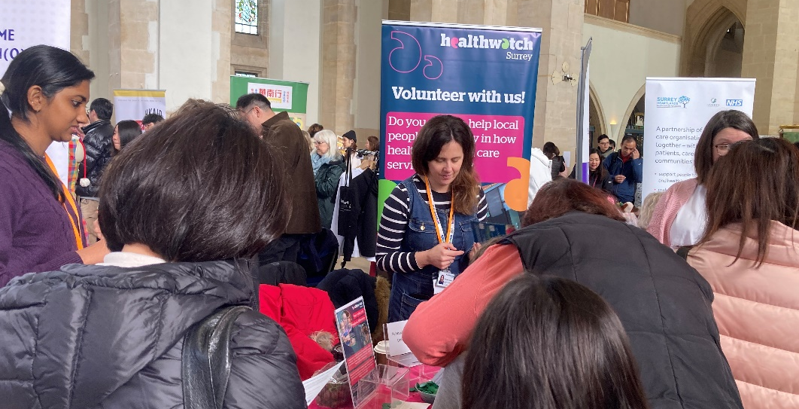

During February our engagement team focussed their visits in East Surrey and Surrey Downs.

The table below shows our events during March. Our community engagement team are visiting North West Surrey, Surrey Heath and Guildford and Waverley. We are also across Surrey raising awareness about our service.

Date | Place | Time | Surrey Area
04/03/2024 | Woking Library, Woking (Public) | 10am - 12noon | North West Surrey
06/03/2024 | Godalming Library (Public) | 10am - 12noon | Guildford and Waverley
13/03/2024 | Lightwater Library (Public) | 10am - 1pm | Surrey Heath
15/03/2024 | Hebrews, Addlestone (Public) | 10am - 12noon | North West Surrey
18/03/2024 | St David's & Herman Pharmacy (Public) | 10am - 12noon | North West Surrey
26/03/2024 | Oasis St Paul (Public) | 10am - 12noon | Surrey Heath
TBC | Community Café, St Johns, Walton on Thames (Public) | 10am - 12noon | North West Surrey
Please note: these dates may be subject to change.

To share an experience with us, or for information and signposting about health and social care, people can also contact our Helpdesk in the following ways:
Phone: 0303 303 0023
SMS (text only): 07592 787 533
Email: enquiries@healthwatchsurrey.co.uk
Share your feedback via our website: https://www.healthwatchsurrey.co.uk/feedback-centre/

Surveys
Another way we invite people to share their experiences with us is through surveys. We currently have 2 different surveys running to gauge local people’s views and experiences:

Future care needs survey

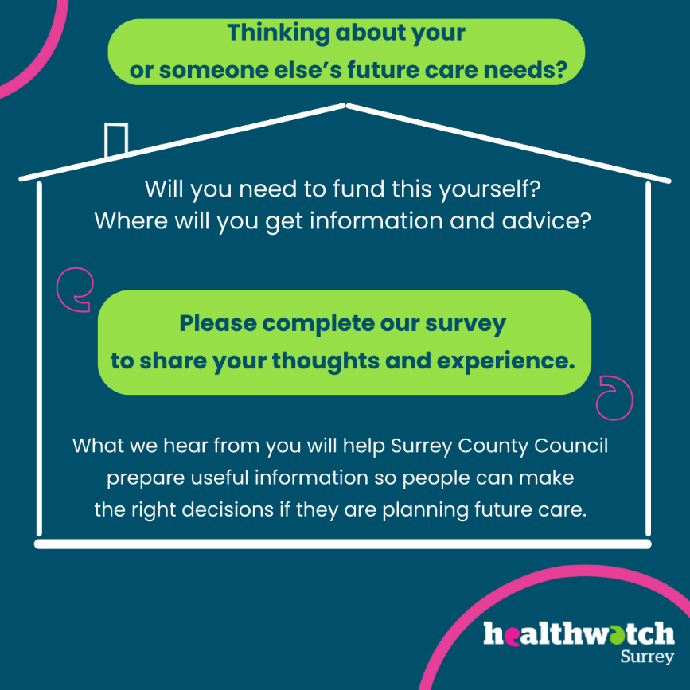

Surrey County Council (SCC) is conducting a communications awareness campaign to ensure people who are thinking about their future care needs have the right information. To support this campaign, they want to know what people currently consider when they are planning future care and where they might go for information.

Please help us to share this survey, or if you are someone who is thinking about their own future care needs or those of someone you know, and think this might need to be self funded, please complete our survey: https://www.smartsurvey.co.uk/s/HealthwatchSurreyFutureSelffunderssurveyonline

The impact of changes to GP practices and pharmacies in Thames Ditton and East Molesey

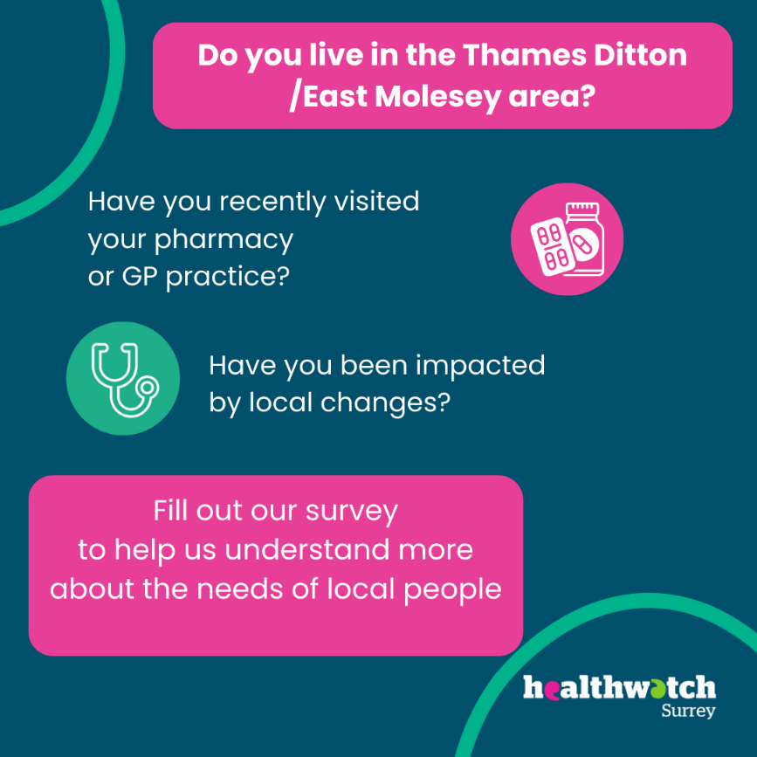

We’re aware that the recent closure of Thames Ditton pharmacy and a number of changes at GP practices in the area may have impacted local people.

If you or anyone you know is local to Thames Ditton/East Molesey, please complete, or share this survey so we can build an accurate picture of the level and nature of this impact: https://www.smartsurvey.co.uk/s/HwSyPharmacyGPExperience/

About Healthwatch Surrey
We are an independent service, empowering the residents of Surrey to have their voices heard. We seek out people’s experiences of health and care services and have a statutory duty to share these with service providers and decision makers, to support services to improve and tackle health inequalities. We believe that health and social care providers can best improve services by listening to people’s experiences.

We also provide information and signposting to help the people of Surrey find the care that best suits their needs.

Our distribution list
If you would like to be added to or removed from the distribution list for this Insight Bulletin, please contact our Communications and Involvement Officer vicky.rushworth@healthwatchsurrey.co.uk

We are committed to the quality of our information.
Every three years we perform an audit so that we can be certain of this.

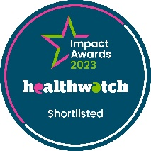
We are proud to be shortlisted for a national Healthwatch Impact Award, recognising our work helping to improve local NHS and social care. You can view our video highlighting how feedback from local people has been used to make positive changes health and care support.

The Healthwatch Surrey service is run by Luminus Insight CIC, known as Luminus.
Registered office: GF21, Astolat, Coniers Way, Burpham, Surrey, GU4 7HL.

