What we’re hearing

about

Frimley Park Hospital
  - November 2023

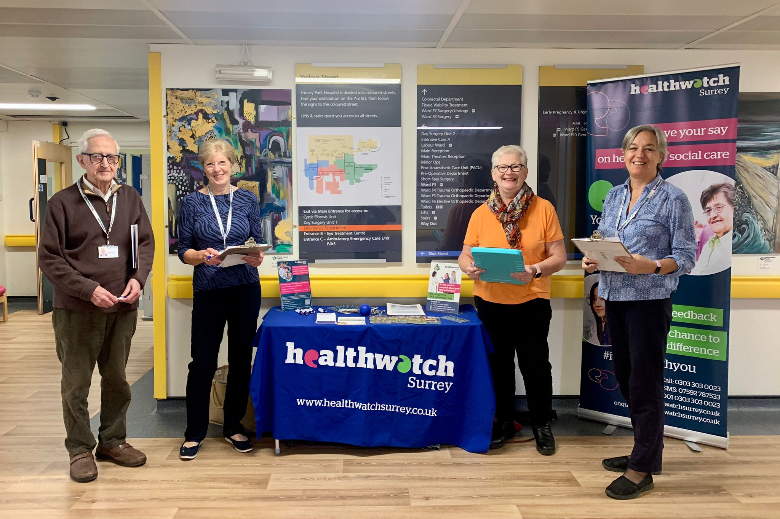
If you would like a paper copy of this document or require it in an alternative format, please get in touch with us.

Contents
About Healthwatch Surrey 3
About this report 3
Engagement event at Frimley Park Hospital 4
What people told us 5
Do people know how to share feedback? 5
Have you heard of PALS and Friends and Family Test? 5
Do people know how to share feedback? 6
Would people share feedback? 6
Do people think giving feedback brings any changes? 7
Have you given any recent feedback about your care? 7
Positive experiences 8
What one thing would have improved your experience? 9
Hearing about Frimley Park Hospital in the community 11
Summary 12
Recommendation 13
Thank you 13
Healthwatch Surrey – Contact us 14

About Healthwatch Surrey
Healthwatch Surrey is an independent service, empowering the residents of Surrey to have their voices heard. We seek out people’s experiences of health and care services and share these with service providers and decision makers, to support services to improve and tackle health inequalities. We believe that health and social care providers can best improve services by listening to people’s experiences.

We also provide advice and signposting to help the people of Surrey find the care that best suits their needs.

About this report
One of Healthwatch Surrey’s priorities is the involvement of people. This means that we want to learn how well the system is listening to people’s views. As part of this we want to speak to people who have received care in various departments across Surrey hospitals to find out their opinions and experiences of feedback. This report is based on what people told us on the day of our visit and is not designed to be representative of Frimley Park Hospital. The report includes examples of what people have shared with Healthwatch Surrey about Frimley Park Hospital.

Any urgent or concerning experiences within this report have been escalated to the appropriate teams. All appropriate information and advice and signposting to complaints processes has already been given.

During our visit to Frimley Park Hospital people told us they were happy with the care provided and were reluctant to say when things went wrong as they had a positive experience overall and people appreciated how hard the staff were working. People were not aware of the opportunities to provide both positive and constructive feedback which could provide information to improve and develop services, as well as improve staff morale and an opportunity to share when things are going well.
This report is designed to highlight the themes we have been hearing about and includes quotes to provide context on these themes. If you would like more information or examples of what people have shared, please get in touch.

We heard that despite not being well informed about how, people were prepared to give feedback. Some people also said that they felt it was beneficial giving feedback but there were a few people who were less convinced about the importance of feedback.

We also heard some suggestions as to how their experience could be improved – appointments, waiting times, communication, information, use of technology and food.

Engagement event at Frimley Park Hospital
Healthwatch Surrey staff and volunteers visited Frimley Park Hospital on 2 October 2023. The purpose of the visit was to:

- Improve people’s understanding and awareness of how to share their feedback about services through compliments, complaints (including advocacy support) and the Patient Advice and Liaison Service (PALS).
- Raise awareness that people can feedback to Healthwatch Surrey.
- Understand people’s perceptions of how effective the hospital is in listening to and acting on feedback.
- Understand enablers and barriers to people sharing feedback.
- Provide the hospital with recommendations for improvements from people accessing their services.

We were invited to speak to people at Frimley Park Hospital and we visited the café, ear nose and throat clinic, ophthalmology, outpatient areas, and the main entrance and spoke to 15 people. On the day of our visit there was a junior doctor and consultant strike and as such, several clinics had been cancelled.

We asked people questions about their understanding of how to give feedback. We also asked if there was one thing that would have improved their experience and have identified some themes below.

Healthwatch Surrey were welcomed by a member of the patient experience team. We observed that the staff were friendly and helpful.

In addition to our visit to Frimley Park Hospital, people have also shared their experiences of their care during our community engagement events throughout Surrey. Some of these experiences have been included in this report.

What people told us

Do people know how to share feedback?
We recognise there are multiple opportunities for people to give feedback and make complaints, such as Patient Advice and Liaison Services (PALS), hospital feedback such as Friends and Family Test, local and national patient experience surveys and through other organisations. During our visit to Frimley Park Hospital, we saw posters displaying how to give feedback directly to the hospital and to the department they were being seen in.

We designed the questions we asked to find out people’s knowledge of how to give feedback to Frimley Park Hospital and whether any methods were more well known than others.

Have you heard of PALS and Friends and Family Test?
We asked people if they had heard about PALS or the Friends and Family Test. Of the 15 people we spoke to at Frimley and 3 people in the community, 5 had heard about PALS and 3 about the Friends and Family Test. Another person told us they had completed a “smiley face” screen recently but did not know if this was the Friends and Family Test.

“At Farnham Hospital you can press a smiley or sad face – I have used this; they should have one here [at Frimley Park Hospital].”
201545 October 2023

“I am aware of PALS, Friends and Family Test.”
201875 October 2023

Do people know how to share feedback?
We found overall that people had limited awareness of how to share feedback or complain. Some said they would give feedback to the person in charge and other people said they would do an internet search and preferred to give feedback online. 3 people were well informed (but still reluctant to give feedback).

“I am aware of PALS, Friends and Family Test. I have never fed back directly to Frimley, but I have provided feedback to Healthwatch Surrey. I would probably give feedback or complain online or by phone.”
201876 October 2023

“If I were giving feedback, I would look at Friends and Family Test and PALS. I would also consider Healthwatch.”
201548 October 2023

“I know how to feedback and to complain. I have tried to use PALs once when I was having trouble with booking appointments. It was difficult to get through to them. I have made small complaints directly with my consultant’s secretary when there was an issue with getting tests done before appointments and when appointments were delayed. I have never complained or fed back about good examples of care or bigger complaints.”
201875 October 2023

No, but I would Google or go onto the hospital website.
201516 October 2023

Would people share feedback?
We heard that people were only prepared to complain if something especially serious had happened:

“No, I would not complain, I have never complained. I would if it were serious or necessary [prompted but unable to define what would be serious]”
201516 October 2023

“No, I would not complain, and I have never complained before. It would have to be really bad before I complained.”
201523 October 2023

Do people think giving feedback brings any changes?
People were unsure if it was beneficial to give feedback. One person had complained but felt no action had been taken and other people were unsure:

“My daughter raised a complaint via PALS for her father when he attended A&E. PALS acknowledged the complaint, but no definite action was taken as a result. No action came of our complaint.”
201526 October 2023

“Yes, I have previously complained. I had an injection into my eye. I felt it was clumsily dealt with and complained to Matron and it made a difference to me on the day, but I do not really know if it makes a [longer term] difference.”
201527 October 2023

“Yes, I think that feedback helps.”
201523 October 2023

“I don’t think from my point of view that feedback makes any difference.”
201542 October 2023

Have you given any recent feedback about your care?
Overall people were reluctant to say when things went wrong as they had received a positive experience overall and appreciated how hard the staff were working:

“I have not given feedback and have not been asked to.”
201542 October 2023

“The reason I have not given feedback or complained is because I have been concerned that it would impact the care I would receive. I have wanted to scream and shout out at the frustration of cancelled and moved appointments, not being able to talk to a clinic nurse when worried or having problems getting medication sorted, but do not want to think that my 2 consultants would be criticised as when I see them or have telephone appointments with them their care is good.”
201876 October 2023

“No… I feel we should all respect the NHS.”
201523 October 2023

Positive experiences
In addition to the conversations specifically about people’s feedback, people told us they were happy with the care provided at Frimley Park Hospital:

“I was impressed with Frimley Park Hospital. I ended up at Frimley last week after phoning 111 who were very good. They arranged an ambulance which was quick [out of breath condition]. I went to A&E and was transferred to a ward. I stayed 2 days last week and had very good care. I had lots of tests and checks, doctor explained everything, and a consultant also visited. I was attached to a plasma drip which made it difficult to go to the toilet. I managed to disconnect it, but it set off an alarm so if someone had shown me the call button this would have helped.
The discharge procedure was good, I was given 4-5 sheets of paper with explanations of what to do. I would like to feedback my gratitude to the wards.”
201542 October 2023

“I am having treatment for breast cancer. I was rushed into hospital with sepsis. I would want to say that the best thing about Frimley is the staff, they are all so kind, compassionate and caring”.
201543 October 2023

“Everything has been good, the hospital staff have been brilliant at helping me, especially when I get lost.”
201545 October 2023

“The care I have received since lock down finished has been good and I have a great patient/doctor relationship with both of my consultants as they have been constant.”
201875 October 2023

“I am accepting of the doctors’ strike, and it did affect my experience. I am waiting in the cafe for my ophthalmology appointment which has been delayed because of the strike. I was offered another day, but I had taken a day off work to attend so they offered me an appointment 1 hour later. My experience has been good, I have no complaints.
201523 October 2023

“I have received excellent care, the respiratory consultant, nurse and team at Frimley and Brompton have great, kind, empathetic and always take time to explain everything to my wife and I.”
201875 October 2023

What one thing would have improved your experience?
Whilst we heard that peoples’ experiences at Frimley Park Hospital were good. However, people were able to offer some suggestions as to how their experience could be improved:

Appointments
“I have not had my annual rheumatology review yet, which is overdue as this appointment has been moved twice with no explanation and the latest appointment date is next March. A change here would be about the letters sent, they should say why the appointment is being moved and be clear what people can do if they have concerns. The rheumatology nurse telephone number no longer works and there was no communication why or what the new one is. A text or a message on My Frimley App would have been good.”
201876 October 2023

“[To make my experience better] would be to see someone quicker. My wife is with Station Road Surgery and was referred to ENT by her GP 6 weeks ago. We heard nothing so contacted them after 5 weeks - they had no appointment registered. One week later we received an appointment.”
201550 October 2023

Communication across specialties
“I have multiple conditions and am under a geriatric consultant, the eye clinic, cardiac clinic and more recently the respiratory clinic following a diagnosis in February of pulmonary fibrosis. I have shared care for this condition with Frimley Park and the Brompton Hospital. What would make a difference is improved communication, within the departments at Frimley and between the hospital and my GP. I have had problems when medication has been changed, it is not picked up by my GP. My appointment this week was with the eye clinic (I have glaucoma which it is important is checked regularly): at my last appointment it had deteriorated, so I was prescribed an additional eye drop and that the pressure in my eyes was monitored more often. The clinic was chaotic, lots of noise and the nurse who checked my eye pressure seemed unsure of what she was doing, she did the test differently and said the pressure was still high, so to continue with the additional eye drops. I do not feel confident though in the result. “
201875 October 2023

Food
“The worst thing is the food.”
201453 October 2023

Use of technology for feedback
The people we spoke to attending outpatient appointments at Frimley Park Hospital were positive about how to share feedback with GPs, with text messages being used to seek feedback from patients. We did not hear about a text service being used by Frimley Park Hospital. This appears to be the way people are most familiar with sharing feedback as it was mentioned by many of the people we spoke with.

People we heard from were also confident using digital technology to manage their appointments and interactions with the department. Many people we spoke with were in the over 75 age range but despite a common assumption that older people may struggle to use technology, this was not the case in the sample of people we spoke with.

People preferred online means of communication (email or online forms) and although one person mentioned writing a letter to provide a compliment, this was not a common theme.

“I would want to change or bring in one app, I have to access three apps: the NHS App, My Frimley app and now Brompton have said I can use My Chart to see my health record with them. All of them are useful but it is confusing sometimes.”
201875 October 2023

Hearing about Frimley Park Hospital in the community
People have also told us their experiences of services provided at Frimley Park Hospital during our Healthwatch Surrey listening events across Surrey and this highlights the importance of enabling people to share their experience in several different ways, as we often find that people’s experiences of care are different when we’re talking to them in the community to when we’re talking to people accessing services in a clinical setting.

Clinic communication
One person shared the distress and inconvenience caused by an incorrect invitation for an appointment at a Giving Carers a Voice event:
“I care for my wife, who has dementia and macular degeneration. I have skin cancer and a hernia. My only grumble is the number of texts from Frimley Park we get about my wife having to go for injections in her eye. We received the first text to say an appointment has been made, then another a few days later, and then others followed (he showed me nine texts in total). We recently received a text to say the appointment was cancelled, so we did not go. We then got a phone call to say we had missed the appointment, I explained we had received a text cancelling and were told it was not from them, yet it was from the same number as the others. Perhaps they sent it to the wrong patient, and someone attended when it was their appointment that had been cancelled. When we keep being told missed appointments cost the NHS thousands, some of this waste of money is down to them. I think it should be one text to confirm the appointment is made, one before and then one the day before, not so many that people may stop reading them. When an appointment is cancelled, they could call and rearrange rather than send a text to save this mix up from happening.”
196744 August 2023

Summary
The people we spoke to at Frimley Park Hospital, in general did not know how to give feedback. Overall, people are not aware of the opportunities to provide both positive and constructive feedback which could provide information to improve and develop services, as well as improve staff morale and an opportunity to share when things are going well. Volunteers can be effective in guiding people to the feedback terminals.

During our visit to Frimley Park Hospital people told us they were happy with the care provided. They were reluctant to say when things went wrong as they had received a positive experience overall, and appreciated how hard the staff were working. People were not aware of the opportunities to provide both positive and constructive feedback. These could provide information to improve and develop services, as well as improve staff morale and an opportunity to share when things are going well.

We heard that despite not being well informed about how, people were prepared to give feedback. There were mixed views about whether giving feedback is beneficial, some people said that they felt giving feedback brings changes but there were a few people who were less convinced about the importance of feedback.

We also heard some suggestions as to how their experience could be improved – appointments, waiting times, communication, information, use of technology and food.

Recommendation
We recommend that Frimley Park Hospital review how they communicate with patients, their families, and carers about the available means to provide feedback and complaints. We suggest that the importance and benefits of feedback is highlighted to encourage more people to share their view, whether positive or negative, and people are provided with clearer information about the range of opportunities to provide feedback including PALS, the Friends and Family Test, and independent options such as Healthwatch Surrey.

Thank you
We would like to thank Frimley Park Hospital for welcoming us. We would also like to thank our Healthwatch Surrey volunteers for supporting these visits, the people we spoke with and those who shared their experiences.

Healthwatch Surrey – Contact us

Website: www.healthwatchsurrey.co.uk
Phone: 0303 303 0023
Text/SMS: 07592 787533
Email: enquiries@healthwatchsurrey.co.uk
Address: Freepost RSYX-ETRE-CXBY, Healthwatch Surrey, Astolat,
Coniers Way, Burpham, Guildford, Surrey, GU4 7HL

healthwatchsurrey
HW_Surrey
healthwatch_surrey
Healthwatch Surrey

