What we’re hearing about

East Surrey Hospital
  - December 2023

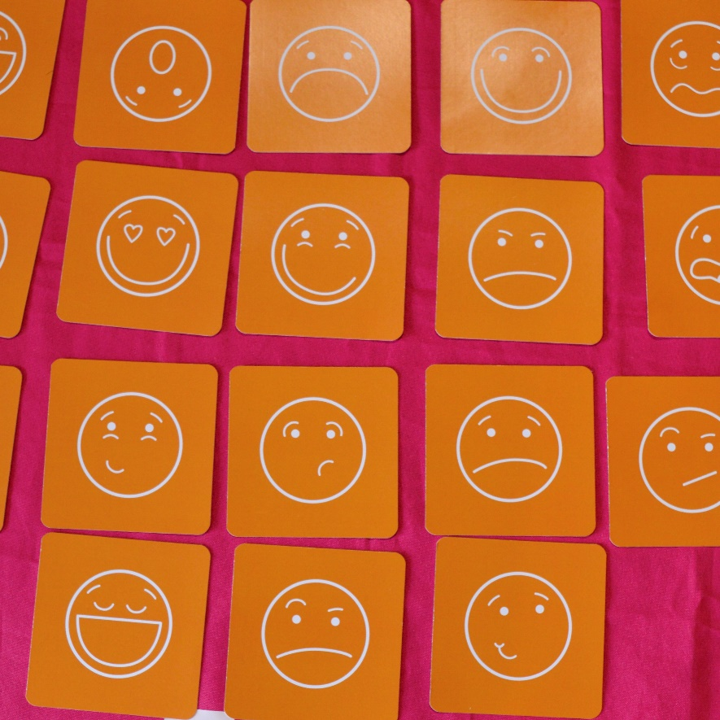
If you would like a paper copy of this document or require it in an alternative format, please get in touch with us.

Contents
About Healthwatch Surrey 3
About this report 3
Our approach 3
Our recommendation 4
Thanks 4
What people told us 5
Positive experiences 5
Have you given any recent feedback about your care? 7
Do people think giving feedback brings any changes? 8
What prevents people providing feedback? 10
What one thing would have improved your experience? 12
Additional feedback 15
Further questions to explore 15
Healthwatch Surrey – Contact us 17

About Healthwatch Surrey
Healthwatch Surrey is an independent service, empowering the residents of Surrey to have their voices heard. We seek out people’s experiences of health and care services and share these with service providers and decision makers, to support services to improve and tackle health inequalities. We believe that health and social care providers can best improve services by listening to people’s experiences.

We also provide advice and signposting to help the people of Surrey find the care that best suits their needs. Any urgent or concerning experiences within this report have been escalated to the appropriate teams. All appropriate information and advice and signposting to complaints processes has already been given.

About this report
One of Healthwatch Surrey’s priorities is the involvement of people. This means that we want to learn how well the system is listening to people’s views. We have spoken to people who have received care in various departments across Surrey hospitals to find out their opinions and experiences of feedback.

Any urgent or concerning experiences within this report have been escalated to the appropriate teams. All appropriate information and advice and signposting to complaints processes has already been given.

Our approach
Healthwatch Surrey staff and volunteers visited East Surrey Hospital on 27 November 2023 and 2 of our staff, along with 2 volunteers spoke with 13 people outside outpatients and in the waiting area inside the main entrance. The purpose of the visit was to:

- Improve people’s understanding and awareness of how to share their feedback about services through compliments, complaints (including advocacy support) and Patient Advice and Liaison Service (PALS).
- Raise awareness that people can feedback to Healthwatch Surrey.
- Understand people’s perceptions of how effective the hospital is in listening to and acting on feedback.
- Understand enablers and barriers to people sharing feedback.
- Provide the hospital with recommendations for improvements from people accessing their services.

In addition to our visit to East Surrey Hospital, people have also shared their experiences of their care during our community engagement events throughout Surrey. Some of these experiences have been included in this report.

Our recommendation
We recommend that Surrey and Sussex Healthcare NHS Trust review how they communicate with patients, their families, and carers about the available means to provide feedback and complaints. We suggest that the importance and benefits of feedback is highlighted to encourage more people to share their view, whether positive or negative, and people are provided with clearer information about the range of opportunities to provide feedback including PALS, the Friends and Family Test, and independent options such as Healthwatch Surrey.

Thanks
We would like to thank the people we spoke with and those who shared their experiences. We would also like to thank our Healthwatch Surrey volunteers for supporting these visits and East Surrey Hospital for welcoming us.

What people told us

Positive experiences
We asked people about their experience at the hospital on the day of our visit and people told us they were happy with the care and support they had received and were particularly pleased with the attitude of staff:

“My experience at East Surrey [Hospital] today has been positive. I found where I needed to go easily, and the receptionist remembered me. I didn’t have to wait that long to be seen.”
205524, November 2023.

“Today has been a good day – the staff found a wheelchair for my wife quickly so I could bring her off the ward for a cup of tea. I find East Surrey [Hospital] is well equipped for things like this compared to other hospitals. I think the staff cope well under the circumstances and with a quick turnaround of patients.”
205554 November 2023.

“The staff are good and make me feel important.”
205551 November 2023.

Do people know how to share feedback?
We asked each person we spoke to whether they had heard of opportunities to give feedback such as Patient Advice and Liaison Services (PALS) and hospital feedback such as Friends and Family Test (FFT). Of the 13 people we spoke with, 4 had heard about PALS and 2 had heard about the Friends and Family Test. The 2 people who knew about the FFT were either current or former employees of the hospital.

It should also be noted that people may not have had knowledge of the FFT by name but knew about some of the mechanisms through which feedback is gathered. For example, people were generally more familiar with text message requests for feedback following appointments:

“We do get texts after our appointments and we always fill them in to give feedback.”
205592 November 2023.

“I receive a text after each appointment asking for feedback – I always reply. I don’t feel uncomfortable giving feedback.”
205551 November 2023

We also heard that people who know how they can share their experience choose not to:

“I know that I can give feedback. I have seen those texts after an appointment but I never fill them in. I'm too lazy.”
205627 November 2023.

People would benefit from more information about what the Friends and Family Test is and how the information collected has informed changes to services. This is particularly important for people who do not feel they wish to complain but may have other points they wish to feedback.

We also heard how information about PALS would be helpful to communicate when appointments need to be rearranged. We spoke to someone who did not know about PALS but would have benefited from their service as both he and his wife were experiencing difficulties in accessing appointments:

“I turned up today for my phlebotomy appointment, but I’ve been turned away. I phoned this morning to confirm that the appointment was going ahead and they said yes, so it’s frustrating. It’s the third time this has happened. I wasn’t waiting too long here before I found out. They should be contacting me to make another appointment.
My wife is here today too. She has an appointment with cardiology but she got in. She also has glaucoma and is supposed to be checked regularly but hasn’t been seen for 2 years.

I’m happy to complain and give feedback to staff, and I did so today. But I’ve never heard about PALS – I might go to them today now I know about them.”
205548 November 2023.

Have you given any recent feedback about your care?
We heard that people were prepared to give feedback and would talk to health care professionals directly:

“I don’t know about PALS, Healthwatch Surrey or the Friends and Family Test. I wouldn’t use them. I would never complain but I would share good feedback to staff.”
205527 November 2023.

Similarly, another person who was caring for their wife, shared that they preferred a more personal approach to feedback, which they had experienced during privately funded care. They also shared that they would only raise a concern if their experience was particularly bad:

“I’ve never complained or given feedback to the hospital. If I did, I would start with the staff on the ward. She has been in other (private) hospitals where an advocate would speak to each patient about giving feedback or making a complaint. I wouldn’t complain unless things became really bad.”
205554 November 2023.

Our conversations with people highlighted that feedback was widely interrelated with complaints, which impacted people’s approach to sharing their experiences:

“I’d be happy to complain if I needed to, but I think people are too quick to complain usually.”
205524, November 2023.

We heard that people who hadn’t felt the need to complain related this to their knowledge of feedback opportunities:

“I’ve never had to complain before – I wouldn’t know how to complain or how to give feedback. I’ve not heard of PALS, or friends and family, or Healthwatch Surrey.”
205529 November 2023.

We also heard that there are some people who are regularly accessing services but aren’t sharing any feedback as they don’t perceive their experience as worth sharing:
“I don't feel the need to feedback and I haven't got anything to share.
I have quite lengthy experiences with health services - my whole life really. Some good, some bad.
I may have been asked for my feedback before but I don't remember it. Don't remember seeing anything about a Friends and Family Test and never heard of PALS before.”
205619 November 2023.

This example indicates that there are people regularly accessing services who might benefit from greater support to share their experiences of care.

Similarly, we heard that people felt that a complaint would only be shared when they felt it needed to be:

“I wouldn’t complain unless things became really bad.”
205554 November 2023.

People would benefit from more context regarding what feedback looks like and what the hospital would like to hear about.

Do people think giving feedback brings any changes?
More people had heard of PALS than the other opportunities for feedback. The people that we spoke to knew about the service as they had used it before or they had been told about it by someone else. In most cases, people shared that PALS had been able to help them. We heard that PALS was seen as a service to raise concerns about the care received:

“I did use PALS before, in October 2022. My issue was communication between the doctors. I was admitted as an emergency with an ovarian cyst, and I saw different doctors every day who all said different things about what treatment I should receive. If I hadn’t complained to PALS then I don’t think I would have had the surgery that I needed – I was in for 9 days before they operated. If they had decided earlier I could have been out earlier and freeing up the bed.
I also complained about the unprofessionalism of one of the medical admin team, who I heard making comments about me. It was a shame I had to do this as the rest of the staff were great, very helpful. The ward was very clean.”
205524, November 2023.

We also heard how PALS was a service that could support patients who were experiencing delays in their treatment, albeit assisted by a relative who works in healthcare:

“We've used PALS before and they were helpful to a point.

The results from an eye scan in April had gone missing and I wanted to know what had happened. I only found out in the summer when I when for a check-up with my optician. My daughter is a nurse so she told me I should call PALS. It was difficult getting a straight answer from them and they said they would look into it. I never heard anything [about what happened with the lost scan] but they were at least able to get me a new scan which was in August.
I had my first treatment today [November] and I have got further appointments in the diary so I'm happy with where I go from here.”
205592 November 2023.

What prevents people providing feedback?
People shared their experiences with us during our visit to the hospital and we were interested to know why they hadn’t shared these directly with the hospital. We heard a few examples of barriers people faced which prevented them from sharing with East Surrey Hospital directly, but also reiterates the value of providing independent opportunities for people to be heard, such as Healthwatch Surrey.

Previous negative experience creates a barrier
We heard how a negative experience of services can leave people wary of asking for support or leaving feedback. We met a parent carer who had been supporting their son for over 20 years and during that time has raised some concerns about his care, both directly with clinicians and through a formal complaint. Her experiences have left her wary of services:

“I don't think you've got enough paper there to get down what I have to say. I've been through a lot over the years and been accused of all kinds of things. A few years ago, the nurse reported me as having Munchausen’s [by Proxy]. They thought I was making it all up. I've really had to learn to fight to make sure my son is looked after.
I'm a carer for my son who has multiple conditions. He has a rare form of asthma which has taken a long time to be properly diagnosed. He also has some bariatric issues so is overweight.
About 10 years ago, my son was brought in as an emergency. He had a heart flutter and just crashed. But the doctors weren’t listening to me and he was going into renal failure. He was transferred to the Royal Brompton and then things improved.
I did go to PALS to complain about the doctors and what happened with my son. I didn’t find it very helpful. I actually wanted to sue the hospital after they accused me of making everything up. When we got the diagnosis [for the rare asthma] it felt good to know that I was right all along.
Right now, we're just trying to sort my son's discharge. I’ve been speaking with the social worker here and she’s been giving some options. She suggested supported living, but I don’t trust they can keep him safe. He can't come home to our current home because it’s not suitable, but the problem is, I don't trust anyone else to look after him after what's happened before.”
205646 November 2023.

Feedback is impersonal
We spoke to someone who was aware of some of the opportunities to share her feedback, however they didn’t use them. They found the method too impersonal and would prefer that someone contacted them directly:

“I've never given any feedback to the hospital before. I've never heard of PALS or what you would use it for. I haven't seen any text messages from the hospital after my appointment, but I do get those after the pharmacy or GP, saying 'how was your appointment' etc. But I don't like filling them in. I find surveys really irritating. I would prefer someone called me up to talk about things. I thinks that's unrealistic but that's what I would want.”
205591 November 2023

Working at the hospital
Working at the hospital gave people access to information however it deterred people from wanting to share experiences. We spoke with some who worked at the hospital who had an experience the hospital would benefit from hearing, however he didn’t want to do directly because the hospital was his workplace:

“I was at A&E a couple of weeks ago. I was at work [in the hospital] and my supervisor took one look at me and said, 'get yourself down to A&E'. The doctor in A&E looked at me and said that I've just got a cold and sent me home. I spoke to my mum later and she disagreed and insisted that I should go and see the GP which I did. Turns out I had quite a bad chest infection and needed antibiotics. The GP said that if I'd left it any longer, I could have had pneumonia.
I do know about [the Friends and Family Test] and I've heard of PALS but don't really know what they do. [After explaining what PALS do)] I wouldn't want to use them because I wouldn't want to get anyone in trouble. I wouldn't want to give feedback because I work here.”
205609 November 2023

What one thing would have improved your experience?
We asked each of people we spoke with what could have improved their experience at East Surrey Hospital.

Expecting to wait
There were multiple instances in our conversations when people told us that they were expecting to wait to be seen and appreciate that services are busy:

“I’m here for a blood test today and then I need to wait for results. I’ve been here since 9am (2 hours). I know lots of people need to be seen so I don’t mind the wait and so there isn’t anything that I would improve.”
205527 November 2023.

“I was brought in this morning by ambulance at 4am. I was told I would have a 3 hour wait but only waited an hour. They saw me really quickly in A&E. I’ve been given medication and I didn’t have to wait long for that either. The staff have been good.
There’s nothing I would improve about my experience today. I expect to wait when I come to hospital. There are a lot of people that need treatment.”
205529 November 2023.

However for another person we spoke with, they found the busyness of the service more difficult:

“I don't think much could be improved about my experience. The car park is good now so it was easy to find a space. Maybe if there were less people around I would be happier, but that's not going to happen.”
205591 November 2023

Support for carers
The parent carer who told us that she is now more wary of services because of her prior experience, also discussed the strain that caring has on her and her daughter. Their experience also raises the importance of ensuring carers are included in decisions about care and the impact decisions about care have on the wider family:

“I'm dyslexic and have some other health problems too. We’re waiting on a decision for my son’s discharge. I’m speaking with the social worker at the hospital and she’s given some options but none of them are suitable. People forget there's a whole family involved and that what happens to my son affects [me and my daughter]. I’m not very good with technology because of my dyslexia so it can be hard looking up the right information. I’ve just heard from the [occupational therapist] that there’s a meeting tomorrow to discuss how we move forwards. Would have been nice if the social worker had told me.”
205646 November 2023.

Support for inpatients and families
A carer supporting their wife asked if more entertainment could be provided to help support patients who are admitted:

“She was admitted via A&E and waited for 4.5 hours to be seen at that time. This isn’t good when you’re here for stress related issues like she has. She was moved 3 times in 3 days to different wards. It was very hard for her.
Today has been a good day – the staff found a wheelchair for my wife quickly so I could bring her off the ward for a cup of tea. I find East Surrey is well equipped for things like this compared to other hospitals.
My wife would like it if they started up a second-hand book swap or loaned magazines like they did before COVID. She is on the Kingsfold ward, which is new but feels like it was rushed to be completed. There are no TVs and she gets bored. But the hospital radio station is good.”
205554 November 2023.

Access to Wi-Fi
People who were visiting or supporting family on a visit to the hospital would like to see an improvement in availability of the Wi-Fi network:
“If I could improve anything it would be the Wi-Fi. I’ve now got a four hour wait here for my next appointment and nothing to do. The Wi-Fi isn’t good so I can’t even look on my phone. It would be good to have a nicer waiting area as well.”
205551 November 2023

“Phone reception and Wi-Fi is a problem. The Wi-Fi cuts out every time you stop using it so you are constantly logging back in.”
205554 November 2023

Car park charge for short stays
One person would like to see a cheaper alternative for a short stay in the car park:

“The car par is really expensive - I've been charged £4.50 and we've been here less than 30 minutes.”
205619 November 2023

Additional feedback

Waiting for treatment
We visited a foodbank in Caterham to speak with people who are in need of additional support. We spoke to someone who was supporting their daughter, who themselves were in need in of greater support with their health. The experience reflects what we heard during previous research, detailed in our Waiting for hospital care report:

“I’m frustrated by the long waiting times to see consultants at East Surrey Hospital. I was referred to orthopaedics by my GP following an X-ray at Caterham Dene which found that two parts of my spine are out of place. The X-ray took place in March 2023 and I recently had a letter [November 2023] saying that the wait to see the consultant was still 28 weeks. I spoke to my GP about it to see if they could help but they couldn’t really do anything to help. I also have 2 hernias and I have been seeing the gastro consultant about that. [Asked if knows about how to feedback?] Yes I do know and I know all about PALs but I didn’t need to contact them. When I was speaking to the gastro consultant I mentioned my back and the waiting times, the gastroenterology consultant got his dictaphone out and personally contacted the orthopaedic consultant by letter on my behalf. I now have an appointment next week. I was seeing gastro as I am also waiting for an operation to deal with 1 of my 2 hernias which has popped out. The waiting time for that operation is 6 months, it feels too long when these are things impacting day-to-day life.”
205564 November 2023

This experience raises the significance of promoting opportunities to give feedback to the hospital in community settings and the promotion of services such as PALS.

Further questions to explore
Our interactions with people at East Surrey Hospital have served to shape the recommendation we made at the beginning of this report to ensure that people are as informed as possible with where and how they can give feedback. However, we recognise that our conversations represent a small sample of people who access the hospital, therefore Healthwatch Surrey would encourage East Surrey Hospital to consider the following questions with regards to any future engagements or developments of opportunities to provide feedback:
- How accessible are feedback opportunities or information regarding complaints? Are leaflets or signage presented in clear and easy to understand language?
- How inclusive are feedback opportunities and complaints? Are a diverse range of voices represented and are their equitable opportunities to have voice heard?

Healthwatch Surrey – Contact us

Website: www.healthwatchsurrey.co.uk
Phone: 0303 303 0023
Text/SMS: 07592 787533
Email: enquiries@healthwatchsurrey.co.uk
Address: Freepost RSYX-ETRE-CXBY, Healthwatch Surrey, Astolat,
Coniers Way, Burpham, Guildford, Surrey, GU4 7HL

healthwatchsurrey
HW_Surrey
healthwatch_surrey
Healthwatch Surrey

We are committed to the quality of our information.
Every three years we perform an audit so that we can be certain of this.

The Healthwatch Surrey service is run by Luminus Insight CIC, known as Luminus.
Registered office: GF21, Astolat, Coniers Way, Burpham, Surrey, GU4 7HL.

