Insight Bulletin

  - January 2024

The importance of listening

“Listening to a patient or carer is not a ‘nice to have’ – it is part of the fundamentals of delivering not only care with dignity and respect but also high-quality safe and effective care.” Kings Fund, 2023

The above quote is from an article by the King’s Fund Patient experience: who is listening? which asks why, despite the many examples, inquiries and reviews, recognising the important of patients’ experiences and listening to patients and their families are still not a priority for the NHS.

At Healthwatch Surrey, empowering the residents of Surrey to have their voices heard is a fundamental part of what we do. We listen to people’s experiences of health and care services and have a statutory duty to share these with service providers and decision makers, to support services to improve and tackle health inequalities. We believe that health and social care providers can best improve services by listening to people’s experiences.

If you would like a paper copy of this document or require it in an alternative format, please get in touch with us.
Healthwatch Surrey also provide information and signposting to help the people of Surrey find the care that best suits their needs.

This bulletin is designed to highlight the themes we have been hearing about and includes quotes from local people to provide context on these themes. Whilst this bulletin accurately reflects what we hear from the individuals we speak to, we are aware that it may not be representative of everyone’s views of a particular service. Multiple references to a specific service may be due to where our community engagement has recently taken place.

Any urgent or concerning experiences within this report have been escalated to the appropriate teams. All appropriate information and signposting to complaints processes has already been given.

If you would like more information or examples of what people have shared, please get in touch with us.

Positive about the quality of care
The quality of care was the most frequently mentioned theme from the 97 people who have shared their experience of health and social care with us in the last month.

During a visit to a charity supporting homeless and vulnerable people in East Surrey, we heard about the quality of care being given by a GP practice as well as mental health services:

“I was at the GP practice yesterday. I’m at Wall House they are really good people… I’ve been seeing mental health services since I was 14. This time it’s been going really well and they’ve done everything I’ve asked like upping my medication.”
206105, East Surrey resident

We have also visited a community workshop aimed at supporting men to combat isolation and loneliness by coming together to connect and create. One person there told us about the good quality of care they received in a recent emergency:

“I was in hospital October 2023 because I had stomach pains and I called 999. The ambulance came really quickly, within 10 minutes, the paramedic said to me you are a very poorly man and we would like to take you to hospital…They took me to East Surrey Hospital. It was midnight on a Saturday and the handover was quick, the ambulance staff were really good.

Once I was at East Surrey Hospital, I thought they were very quick to respond. I was almost immediately put on painkillers and a drip. The doctor was talking about operating but he said he'd rather not… and he wanted to keep me in overnight and check my markers in the morning.

I was left overnight to rest, I felt communication was good and I had great faith in them. The next morning my markers had gone down and after that I was transferred to a ward. I felt very well looked after, so I wasn't worried -I was monitored regularly. The surgeon who I'd spoken to the night before actually came out and checked in on me several times as I was quite ill but improving.”
206109, East Surrey resident

Less positive about communication
Whilst people often tell us they receive good care, their experience is sometimes negatively affected because of issues with communication in the process of receiving care. We met this person during our visit to a charity supporting homeless and vulnerable people in East Surrey who told us that they ended up frustrated with the process and the communication so ended up accessing private services:

“I had some health issues this time last year, well actually it started in November 2021. I went to my GP practice. I had some worrying symptoms, blood in my urine and it was found that I had an infection and was given antibiotics. I had a long running infection and had to go back and had further antibiotics. It took time to get it all sorted out, the care was good but it’s the processes around the care that adds time. For instance, a series of tests had been organised for me, but there was poor communication around test results, I had to chase up and I was told they would get back to me, but they didn’t, so I chased again. I don’t think we should work on no news is good news, they then said they wanted to get me in for a Cystography. It was 2 months later, after Christmas that I was seen in hospital, they investigated further as there was a worry it could be cancer, they gave me the all clear for cancer. A scan showed a large kidney stone, they tried to dissolve the stone and I was also given more medication.

By April I decided I needed to get it sorted out and so I paid privately to see a consultant. It was only with his intervention things started to move, he pushed my case forward and wrote a letter to the NHS hospital explaining that the delay to treatment had actually made my case more urgent, as the private tests showed the kidney stone may move into the urethra, which was dangerous for me. I was very quickly given a date for Cystography and stent, in June 2022.

I had day surgery, although one appointment was cancelled due to an urgent cancer case, it was rescheduled for 3 weeks after. Medical care was good. Nursing care and staff were also good.

Booking part created frustrations, waiting to hear from the hospital, they sent letters or sometimes phone calls. Improvement for me would be around communication, reassurances, and managing and communicating test results go a long way to improving the journey for the patient. Treatment was good when being treated, it’s the waiting and not knowing parts that are harder.
206106, East Surrey resident

Digital hiccups causing problems
As part of our discussions with people during our engagement in community settings, we have been asking people about their use of the NHS App and helping people to download and use this. People have started to tell us that have got used to using it, but recent changes can be off putting, meaning they are giving up:

“It used to be really easy to book my appointments via the NHS App but it kicked me out recently and I just ended up getting rid of the app I didn't re download it but I'll definitely re download it now after our chat.”
206331, Reigate and Banstead resident

“I was using the NHS App all okay but then I suddenly wasn't able to do a repeat prescription. I looked but I can’t figure out where to find the information out for myself on the App. It was like it wasn't linked to me anymore or something. So, I went into the surgery for their help, as I was unsure who to ask about it. The surgery had a pamphlet that they gave me, but they also helped me work through the steps and I had to fill in a form to be able to get everything linked again. They were helpful but it was annoying in having to start again when it was working okay until then.”
206309, Reigate and Banstead resident

Another person felt frustrated that not knowing their NHS number felt that the app was taking them “round in circles” and they would give up as there wasn’t an alternative way of accessing the app:

“I tried to download the NHS App [after speaking to Healthwatch Surrey] but because I didn’t know my NHS number I was unable to do it and have given up.”
206105, East Surrey resident

Concerns with medical records
We often hear from people who require medical records to help support benefits claims. During a visit to a community fridge, we met someone who relies on this service to provide food, as their Personal Independence Payment (PIP) has been rejected. They believe part of the reason for the rejection was because their medical history has not been documented properly:

“I applied for PIP [and was rejected.] I have complex health conditions and have accessed my records through a subject access request to be able to use them in my appeal. A lot of my problems have not been documented sufficiently. Citizen’s Advice have been helping me with my appeal, I feel it is due to inadequate records that my PIP was rejected. I will be representing myself today [at a tribunal], as my Citizens Advice adviser is not around.”
206753, Woking resident

Having access to test results and not properly understanding what they mean is also causing worry and stress for some people:

“Visited the GP as not been feeling 100%. She advised blood tests and a chest Xray. I had a follow up appointment booked but before this, I checked the NHS App to find my blood test results (apparently the chest Xray results aren't available via the App). A lot of my blood results showed as abnormal, including a lower liver function. It also said I needed to see my GP regarding the results. Although I knew I had the follow up appointment booked in 2 weeks, it did play on my mind whilst I waited as I was concerned that there might be something seriously wrong.

When I got to the appointment, the doctor said I was vitamin D deficient but had no other concerns. When I queried the blood test results on the App, she said she wasn't concerned about those as they hadn't altered from blood test results I'd had over the years. She started explaining that the numbers and levels were in line with previous ones - I explained that the numbers meant nothing to me so I couldn't interpret them against my previous ones.
She also said that the reference to needing a GP, was just to flag to the GPs that they need to look at the results.
I did say that I felt this could cause concerns for other people if the same thing happened to them.

Maybe there should be a separation between what the GP needs to see and what the individual does?”
207139, Reigate and Banstead resident

Capacity to care
Many people are commenting on how busy services feel and how they perceive a shortage of staff is affecting care across a number of services, and in particular in A&E.

We were contacted by this person who was very concerned for their mother and we helped to share these concerns with the hospital who assured us that they were supporting the patient:

“My mother is on palliative care, end stage dementia. She is paralyzed and has been in A&E since Wednesday. She has not been offered food or water, and has been left in urine and faeces soaked pads for 30 hours.

I went into A&E last night to challenge this and the staff guaranteed that she was to have a scan this morning and then could be discharged , they also said she would be put on a ward. She is still in A&E but has been given food and water and cleaned but I have to stress this was after 30 hours and after I had to go the hospital and complain. I have phoned today and my mother is still in A&E and has not, as far as I can tell, had the promised scan. I can’t get through to anyone who can explain what is happening.”
206272, North West Surrey resident

“A&E is rubbish at mental health support - took overdose, just stuck in corner and ignored. Was there for 17 hours and no drink offered.”
206294, Guildford and Waverley resident

“A few weeks ago I collapsed and blacked out where I live in my retirement flat and someone there called the ambulance… I was in A&E for 9 hours. I had a CT scan as must have hit my head too. My blood pressure was very low so they kept an eye on me. They called my daughter to take me home as they couldn't arrange patient transport for me as too busy. I could see everyone was busy but it was hard as I was left in a wheelchair all that time and no one offered me any food.”
206772, Runnymede resident

“My Mum is currently in [a community hospital] for reablement although I find that a bit of a joke as they just don’t have the staff to be able to offer enough reablement… She went in pretty independent and active but I feel like she’s been there for ages and it’s going to have taken its toll on her physically and mentally. I think her confidence will have taken a massive knock. Whilst she has been in hospital we have the reassurance that she has 3 square meals a day and is safe but I think my main issue is the practicalities around reablement, she has been there a few weeks now and the staff are just not there. The physiotherapist called me to update me yesterday and said we think she can be out by Tuesday we want to keep her in for a bit longer, but part of me thinks what’s the point, nothing happens at the weekend and now it’s just a case of them holding on to her. The physio updated, which was great the contact is there, but they know themselves they are unable to provide enough of the care for the patients they have, they are just so stretched.”
206834, Runnymede resident

Sharing our insight
If we hear a case of concern regarding patient safety, we immediately signpost the sharer to the appropriate body and escalate the case with the provider/commissioner.

We share our wider themes with Trusts, Integrated Care Systems (ICSs), Surrey County Council, Public Health, Care Quality Commission (CQC), and in various boards and groups across Surrey.

Community engagement

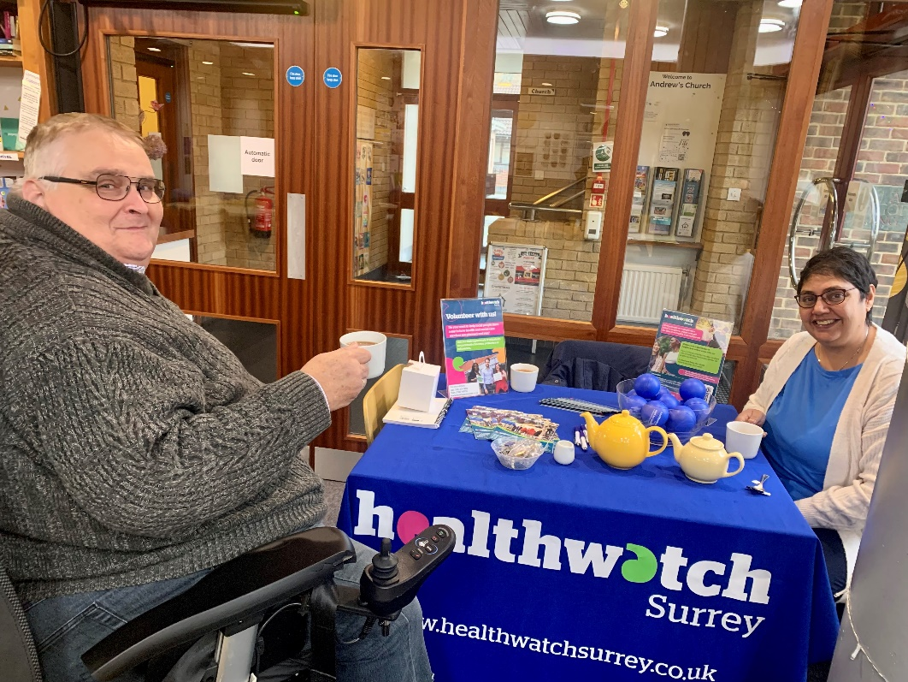

During December our engagement team focussed their visits in North West Surrey.

The following table shows our events during January, when our community engagement team will be visiting North East Hampshire and Farnham (NE Hants and Farnham), and Surrey Heath. We will also be across Surrey to raise awareness about what we do and speak to people about volunteering.

Date | Place | Time | Surrey Area
08/01/2024 | Meet up Monday, Frimley Green Methodist Church (Public) | 10.30am - 12noon | Surrey Heath
17/01/2024 | St Martin's Old Dean coffee morning (Public) | 10am - 11.30am | Surrey Heath
17/01/2024 | The Clockhouse, Milford (Public) | 10.15am - 12.15pm | Guildford and Waverley
18/01/2024 | High Cross Church Café, Camberley (Public) | 10am – 12noon | Surrey Heath
23/01/2024 | The Spire Café, Farnham (Public) | 10am - 12noon | NE Hants and Farnham
23/01/2024 | Oxted Library (Public) | 10.15am - 12.15pm | Surrey Downs
25/01/2024 | The Hive, Guildford (Public) | 10am- 12noon | Guildford and Waverley
25/01/2024 | Presentation - Good Neighbours (Group engagement) | 12noon - 1pm | Guildford and Waverley
29/01/2024 | Farnham Centre for Health (Public) | 10am - 12noon | NE Hants and Farnham

Please note: these dates may be subject to change.

To share an experience with us, people can also contact our Helpdesk in the following ways:
Phone: 0303 303 0023
SMS (text only): 07592 787 533
Email: enquiries@healthwatchsurrey.co.uk
Share your feedback via our website: https://www.healthwatchsurrey.co.uk/feedback-centre/

Our distribution list
If you would like to be added to or removed from the distribution list for this Insight Bulletin, please contact our Communications and Involvement Officer vicky.rushworth@healthwatchsurrey.co.uk

We are committed to the quality of our information.
Every three years we perform an audit so that we can be certain of this.

The Healthwatch Surrey service is run by Luminus Insight CIC, known as Luminus.
Registered office: GF21, Astolat, Coniers Way, Burpham, Surrey, GU4 7HL.

