What we’re hearing

about

Epsom Hospital
  - October 2023

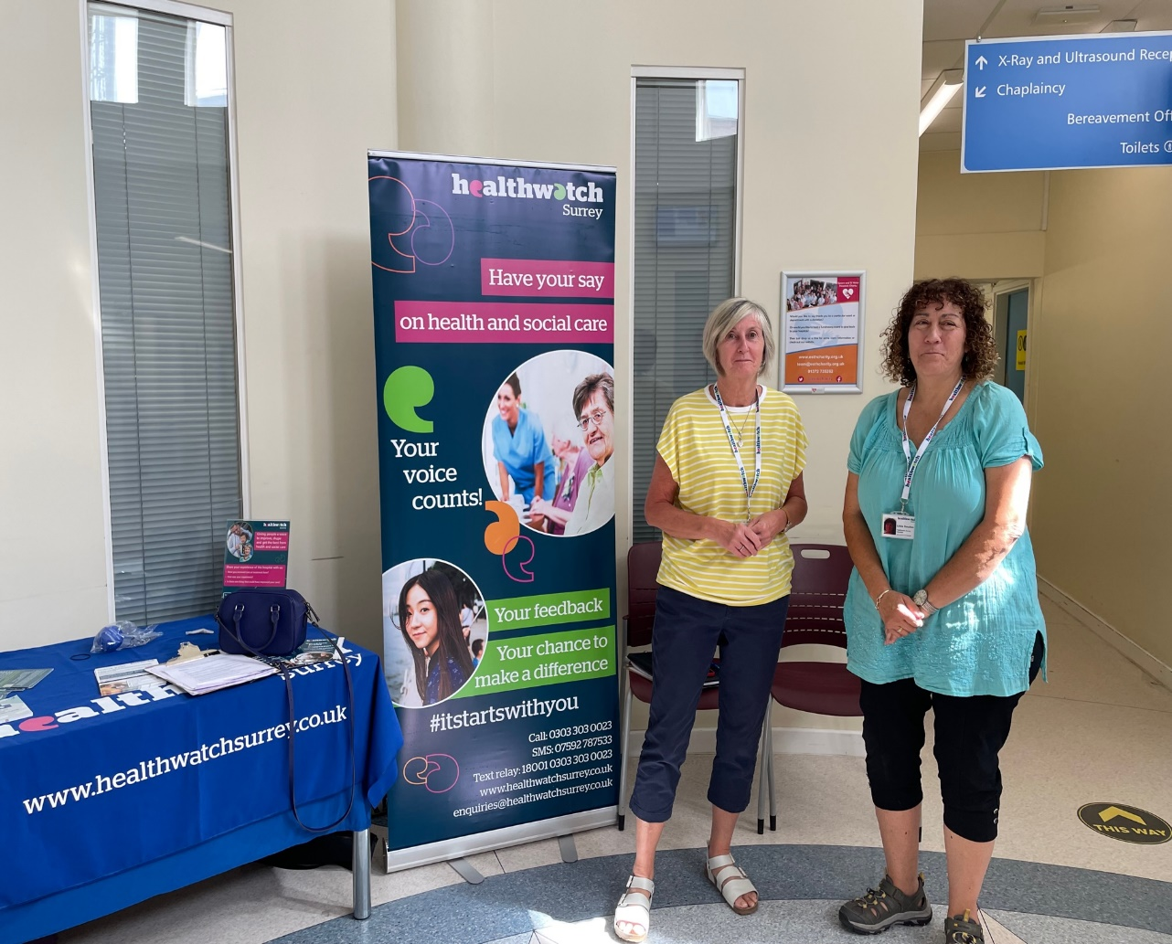

If you would like a paper copy of this document or require it in an alternative format, please get in touch with us.

Contents
About Healthwatch Surrey 3
About this report 3
Engagement event at Epsom Hospital 4
What people told us 5
Positive experiences 5
Do people know how to share feedback? 5
Would people share feedback? 6
Do people think giving feedback brings any changes? 6
Have you given any recent feedback about your care? 7
What one thing would have improved your experience? 7
Hearing about Epsom Hospital in the community 9
Summary 11
Recommendations 12
Thank you 12
Healthwatch Surrey – Contact us 13

About Healthwatch Surrey
Healthwatch Surrey is an independent service, empowering the residents of Surrey to have their voices heard. We seek out people’s experiences of health and care services and share these with service providers and decision makers, to support services to improve and tackle health inequalities. We believe that health and social care providers can best improve services by listening to people’s experiences.

We also provide information and signposting to help the people of Surrey find the care that best suits their needs.

About this report
One of Healthwatch Surrey’s priorities is the involvement of people. This means that we want to learn how well the system is listening to people’s views. As part of this we want to speak to people who have received care in various departments across Surrey hospitals to find out their opinions and experiences of feedback. This report is based on what people told us on the day of our visit and is not designed to be representative of Epsom and St Helier University NHS Trust. The report includes examples of what people have shared with Healthwatch Surrey about Epsom Hospital.

Any urgent or concerning experiences within this report have been escalated to the appropriate teams. All appropriate information and advice and signposting to complaints processes has already been given.

During our visit to Epsom Hospital people told us they were happy with the care provided and were reluctant to say when things went wrong as they had a positive experience overall and people appreciated how hard the staff were working. People were not aware of the opportunities to provide both positive and constructive feedback which could provide information to improve and develop services, as well as improve staff morale and an opportunity to share when things are going well.

We heard that despite not being well informed about how, people were prepared to give feedback. People also said that they felt it was beneficial giving feedback.

We also heard some suggestions as to how their experience of care could also be improved such as communication about clinic waiting times and signposting to clinics.

Engagement event at Epsom Hospital
Healthwatch Surrey staff and volunteers visited Epsom Hospital on 6 September 2023 to:
- Improve people’s understanding and awareness of how to share their feedback of services through compliments, complaints (including advocacy support) and Patient Advice and Liaison Service (PALS).
- Raise awareness that people can feedback anonymously to Healthwatch Surrey.
- Understand people’s perceptions of how effective the hospital is in listening to and acting on feedback.
- Understand enablers and barriers to people sharing feedback.
- Provide the hospital with recommendations for improvement from people accessing their services.

Our Healthwatch Surrey team were welcomed by the Patient Experience Team and Nursing Team. The outpatient staff we met/observed were friendly and helpful.

We were invited to speak to outpatients in the Oaks Suite at Epsom Hospital. There were multiple clinics running and we talked to people in neurology, orthopaedics, and pharmacy as they waited for their clinic appointment or for medication.

We asked people questions about their understanding of how to give feedback. We also asked if there was one thing that would have improved their experience and have identified some themes below.

In addition to our visits to Epsom Hospital, people have also shared their experiences of care during our community engagement events, where we visit a variety of non-clinical community locations. Some of these experiences have also been included in this report where relevant.

What people told us

Positive experiences
People told us they were happy with the care provided by Epsom Hospital:

“It has been very good. My husband came into A&E last week, he waited about 11 hours in a cubicle overnight but received excellent service once seen. The nurses were good. Follow up has been very good. I thought the staff were amazing.”
200356 September 2023

“Care for my bladder cancer has been excellent, very caring, good humour. I think the staff here are terrific.”
200398 September 2023

Do people know how to share feedback?
We recognise there are multiple opportunities for people to give feedback and make complaints, such as Patient Advice and Liaison Services (PALS), the Friends and Family Test (FFT), local and national patient experience surveys and with a variety of other organisations.

We designed the questions we asked to find out people’s knowledge of how to give feedback on services received at Epsom Hospital and whether any methods were more well known than others.

We asked people if they had heard about PALS or the Friends and Family Test. Of the 21 people we spoke to at Epsom Hospital, 6 had heard about PALS and 3 of those 6 people had heard about the Friends and Family Test.

We observed that there were posters on the walls inviting feedback (with QR codes) in the outpatient clinics and in the corridors, but from the feedback we were given, people were unaware of these.

3 people said that they would use the phone number on their appointment letter to give feedback. The methods of giving feedback were varied, with some people preferring to give face to face feedback and others preferring online:
“Soft feedback as I prefer to feedback face to face.”
200355 September 2023

“If I needed to make a complaint, I would go directly to the department in the first instance.”
200387 September 2023

“I would go online but do not want to be filling in lots of forms.”
200317 September 2023

“I would go to PALS initially. It would take a lot for me to complain though. It would have to be serious to complain.”
200375 September 2023

Depending on the service, people have different ideas about how to feedback and some people are not clear at all.

Would people share feedback?
We heard that despite not being well informed about how, people were prepared to give feedback:

“Yes, I would [give feedback] but it would depend on the severity, or if I felt someone was in danger.”
200301 September 2023

“Yes, but it would depend on the severity – if I felt that the care was inappropriate, I would complain.”
200307 September 2023

Do people think giving feedback brings any changes?
People also said that they felt it was beneficial giving feedback:

“I have not given feedback, but I do see value in giving feedback. I believe that feedback does bring about changes.”
200315 September 2023

“Yes, feedback helps make changes - beneficial.”
200355 September 2023

“I have not complained [about a recent experience] but feel that complaining could possibly make changes.”
200303 September 2023

Have you given any recent feedback about your care?
People were reluctant to say when things went wrong as they had a positive experience overall. 2 people had made complaints through PALS, over 2 years ago but only 1 person had given recent feedback:

“Yes, I was prompted by text to give feedback.”
200314 September 2023

“The highest ranking on FFT and questionnaires is ‘very good’ but there should be an ’excellent’. I have fed this back several times.”
200398 September 2023

What one thing would have improved your experience?
We heard that peoples’ experiences at Epsom Hospital were good. However, people were able to offer some suggestions as to how their experience could be improved:

Communication
“It would help if reception staff acknowledged me and gave eye contact.”
200387 September 2023

“Communication between departments [hospitals] needs to be improved. Mum was given appointments at 2 different hospitals for the same time.”
200393 September 2023

The following experience was fed back to the Head of Nursing at the end of our visit, and she confirmed that she would do some background research:

“Yesterday someone phoned from neurology and asked why I was coming to my appointment. I thought it was a check. I have MS [Multiple Sclerosis] and I don’t see doctors regularly. The person I spoke to implied I did not need to come. I have a MS nurse, but I felt I needed to come. I left it with them that I would come then I got a phone call from the booking office this morning asking if I was coming in today and was told I did not need to come. It looked like the left hand doesn’t know what the right hand is doing. I do have a specialist nurse, but I have to make contact and I never get a check. I have a blue badge but could not get a space.”
200298 September 2023

Signposting
We observed that people entering the outpatient area reception were looking for help and directions. We were approached by several people for help directing them to their clinic. A few people commented on this:

“[I need] detailed information as to where to go for an appointment that matches the signposting.”
200387 September 2023

“Signposting could be better. I ran out of time trying to find the clinic today.”
200398 September 2023

“The hospital needs a main reception desk to help people.”
200354 September 2023

Waiting times
People also mentioned that they had been waiting for their appointments.

“Today I have been waiting a long time in the orthopaedic clinic. My experience would have been better if there was no delay. There was no communication about why [there were delays].”
200317 September 2023

“Nothing significant could have improved the current service except [I had] a long wait this morning in orthopaedics.”
200314 September 2023

“Waiting times have been very big every time I come to this hospital. The thing that would have improved my experience is if I had been seen at the time of my appointment [at the time of talking had waited for 1 hour].”
200315 September 2023

Other
“The water machines are always broken.”
200354 September 2023

Hearing about Epsom Hospital in the community
People have also told us their experiences of services provided by Epsom Hospital during our Healthwatch Surrey listening events across Surrey. This highlights the importance of enabling people to share their experience as we often hear different experiences compared to when we visit clinical settings where people are at the point of receiving care.

We attended a Health Visitors clinic in Epsom. The clinic was busy, with a diverse group of parents attending. They shared experiences of inpatient maternity services at Epsom Hospital and transfer of care to the Community Midwives.

Maternity Services at Epsom Hospital
“I had a baby at Epsom Hospital, she’s 11 weeks now [September 23]. I had conceived my daughter after 4 rounds of IVF. Because she was IVF, my age and weight they said no to a water birth, midwives felt I was too high risk even though I’d had a very good pregnancy with no problems. This was a barrier to me when I was planning what I wanted to happen and so I fed this back and one of my friends who works in the service also had a chat with my midwife. This resulted in the midwife calling me and we went over my birth plan, so my birth plan was amended. I felt happy and included in the decisions around my care… The aftercare was good, midwives and health visitors came every day at the beginning.”
201431 September 2023

“My daughter is 8 months old. She was born… at Epsom Hospital. I ended up having to have an induction which didn’t go well and ended up having a C section. I had a reaction to the anaesthetic and spent some time in hospital after this to recover with my daughter. After this I was booked to have a follow up at St Helier to find out what I was allergic to. When the appointment came through in the April I spoke to the team and they said I couldn’t bring my daughter with me, I explained that I was breast feeding, she wasn’t well, and I didn’t want to leave her for 3-4 hours. They said no I couldn’t take her and that they would book me in for a later date. The next date came through and it was whilst I was in India, I called and explained that I would be in India and I was still breastfeeding, could we do another date when I was back, and they said no as I had already cancelled once, and I still couldn’t bring my daughter along. I did leave feedback online about it with the hospital, I can’t remember what I did but it was via their website. When you are breastfeeding, you cannot leave your baby for 3-4 hours. A better outcome for me would be for me to understand what the problem is with her being there with me, I wish they explained rather than just saying no.”
201432 September 2023

“I think the Epsom Maternity services are good. The delivery suite was excellent but the care on the ward was not so good. There were student midwives and my newborn had to go through a lot when one [student midwife] was trying to draw blood. I just wished a more experienced nurse would do the test, so I did say something, and it was resolved. Preparing for discharge on a Sunday and I was worried I did not have enough bottles so I worked out how many supplies I thought I would need. The midwife disagreed how much I needed. She was brusque. You feel vulnerable when you have just had a baby.”
200891 September 2023

Transfer of care from inpatient care to community midwifery services.
“I chose St Helier (which was very good) for my recent birth because I had issues at Epsom with my first baby, although I have heard that friends have had positive experiences. I used PALS. Because I live in Epsom, the postnatal care was transferred to the community team, and this has been good.”
200874 September 2023

“I gave birth at Kingston Hospital. I chose to go there because I work there and it was easier to manage. On discharge I was transferred to the Epsom Community Team, and this was seamless. It was a good experience, and I was seen by community midwives and a health visitor. They gave me the link to the Epsom Health Visitor Clinic.”
200889 September 2023

“I gave birth at Epsom Hospital. I had a birth plan and was booked in for a water birth. The care at Epsom was very good, good transition between Epsom Hospital and the Community services. Nothing would have made my experience better.”
200886 September 2023

Summary
The people we spoke to at Epsom Hospital in general did not know how to give feedback. Overall, people are not aware of the opportunities to provide both positive and constructive feedback which could provide information to improve and develop services, as well as improve staff morale and an opportunity to share when things are going well.

We heard that despite not being well informed about how, people were prepared to give feedback. People also said that they felt it was beneficial giving feedback.

We also heard some suggestions as to how their experience could be improved - communication about clinic waiting times and signposting to clinics.

Recommendations
The people we spoke to at Epsom Hospital and in the community did not know about the opportunities available to give feedback. Overall, people are not aware of the opportunities to provide both positive and negative feedback. This feedback could help to improve and develop services as well as improve staff morale if people are able to share when things are going well.

We recommend that Epsom and St Helier University NHS Hospital Trust review how they communicate with patients, their families, and carers about the available means to provide feedback and complaints. We suggest that the importance of feedback is highlighted to encourage more people to share their view, whether positive or negative, and people are provided with clearer information about the range of opportunities to provide feedback including PALS, the Friends and Family Test and independent options such as Healthwatch Surrey.

We recommend that signposting to clinics and information for people attending outpatient clinics are reviewed.

Thank you
We would like to thank Epsom Hospital for welcoming us so warmly. We would also like to thank our Healthwatch Surrey volunteers for supporting this visit and to the people we spoke with who shared their experiences.

Healthwatch Surrey – Contact us

Website: www.healthwatchsurrey.co.uk
Phone: 0303 303 0023
Text/SMS: 07592 787533
Email: enquiries@healthwatchsurrey.co.uk
Address: Freepost RSYX-ETRE-CXBY, Healthwatch Surrey, Astolat,
Coniers Way, Burpham, Guildford, Surrey, GU4 7HL

healthwatchsurrey
HW_Surrey
healthwatch_surrey
Healthwatch Surrey

We are committed to the quality of our information.
Every three years we perform an audit so that we can be certain of this.

The Healthwatch Surrey service is run by Luminus Insight CIC, known as Luminus.
Registered office: GF21, Astolat, Coniers Way, Burpham, Surrey, GU4 7HL.

