What we’re hearing

about

Ashford and St Peter’s Hospitals
  - October 2023

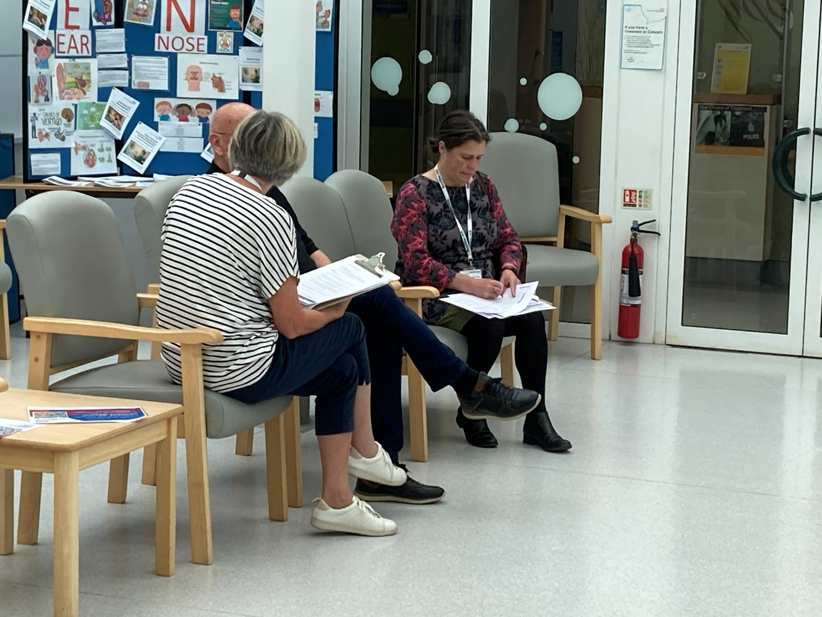
If you would like a paper copy of this document or require it in an alternative format, please get in touch with us.

Contents
About Healthwatch Surrey 3
About this report 3
Engagement events at St Peter’s Hospital and Ashford Hospital 4
What people told us 5
Positive experiences 5
Would people share feedback? 6
Do people think giving feedback brings any changes? 7
Have you given any recent feedback about your care? 8
What one thing would have improved your experience? 8
Hearing about Ashford and St Peter’s Hospitals in the community 9
Summary 11
Recommendation 11
Information about Viewpoint 12
Thank you 13
Healthwatch Surrey – Contact us 14

About Healthwatch Surrey
Healthwatch Surrey is an independent service, empowering the residents of Surrey to have their voices heard. We seek out people’s experiences of health and care services and share these with service providers and decision makers, to support services to improve and tackle health inequalities. We believe that health and social care providers can best improve services by listening to people’s experiences.

We also provide advice and signposting to help the people of Surrey find the care that best suits their needs. Any urgent or concerning experiences within this report have been escalated to the appropriate teams. All appropriate information and advice and signposting to complaints processes has already been given.

About this report
One of Healthwatch Surrey’s priorities is the involvement of people. This means that we want to learn how well the system is listening to people’s views. As part of this we want to speak to people who have received care in various departments across Surrey hospitals to find out their opinions and experiences of feedback. This report is based on what people told us on the day of our visit and is not designed to be representative of Ashford and St Peter’s Hospitals NHS Trust. The report includes examples of what people have shared with Healthwatch Surrey about Ashford and St Peter’s Hospitals.

Any urgent or concerning experiences within this report have been escalated to the appropriate teams. All appropriate information and advice and signposting to complaints processes has already been given.

During our visits To Ashford and St Peter’s Hospitals people told us they were happy with the care provided and were reluctant to say when things went wrong as they had a positive experience overall and people appreciated how hard the staff were working. People were not aware of the opportunities to provide both positive and constructive feedback which could provide information to improve and develop services, as well as improve staff morale and an opportunity to share when things are going well.

We heard that despite not being well informed about how, people were prepared to give feedback. Some people also said that they felt it was beneficial giving feedback but there were a few people who were less convinced about the importance of feedback.

We also heard some suggestions as to how their experience could be improved – communication and information, use of technology, food, transport.

Engagement events at St Peter’s Hospital and Ashford Hospital
Healthwatch Surrey staff and volunteers visited St Peter’s Hospital on 7 August 2023 and Ashford Hospital on 14 August 2023. The purpose of the visits was to:

- Improve people’s understanding and awareness of how to share their feedback about services through compliments, complaints (including advocacy support) and Patient Advice and Liaison Service (PALS).
- Raise awareness that people can feedback to Healthwatch Surrey.
- Understand people’s perceptions of how effective the hospital is in listening to and acting on feedback.
- Understand enablers and barriers to people sharing feedback.
- Provide the hospital with recommendations for improvements from people accessing their services.

We were invited to speak to inpatients on the medical wards at St Peter’s Hospital and to people attending outpatients at Ashford Hospital.

We visited May and Holly wards at St Peter’s Hospital and found that whilst we were able to listen to some people, most were not able to engage with conversations. The patients on the cardiac discharge ward, however, were very engaged and gave rich feedback. We spoke to 10 people.

At Ashford Hospital we were based in the atrium and 20 people were able to speak to us as they waited for their clinic appointment (multiple clinics were running).

We asked people questions about their understanding of how to give feedback. We also asked if there was one thing that would have improved their experience and have identified some themes below.

In addition to our visits to Ashford and St Peter’s Hospitals, people have also shared their experiences of their care during our community engagement events throughout Surrey. Some of these experiences have been included in this report.

What people told us

Positive experiences
People told us they were happy with the care provided by Ashford and St Peter’s Hospitals:

“Nothing would have made this experience better. I received brilliant care at St Peter’s, and the staff were very attentive. The meals have been good, and the tea is the best I have ever had!”
196402 August 2023

One person appreciated the support given by volunteers:

“My experience with the volunteers in audiology has been really good, they are very good at solving problems.”
196647 August 2023

Healthwatch Surrey were welcomed at both hospitals by the Patient Experience Team and Nursing Team. The staff at both hospitals were friendly and helpful.

We observed that people were being greeted by staff at both hospitals who were friendly, courteous, professional, and welcoming. There was a volunteer who was supporting people to attend their appointments.
We also observed that Ashford outpatient's premises were bright, clean and there was sufficient space for people to wait.

Do people know how to share feedback?
We recognise there are multiple opportunities for people to give feedback and make complaints, such as Patient Advice and Liaison Services (PALS), hospital feedback such as Friends and Family Test (FFT) or Viewpoint, local and national patient experience surveys and through other organisations. During our visit to both Ashford and St Peter’s Hospitals we saw posters displaying how to give feedback directly to the hospital and to the department they were being seen in.

We designed the questions we asked to find out people’s knowledge of how to give feedback to Ashford and St Peter’s Hospital and whether any methods were more well known than others.

We asked people if they had heard about PALS or the Friends and Family Test. Of the 30 people we spoke to across Ashford and St Peter’s Hospitals, only 3 had heard about PALS and 2 about the Friends and Family Test. We have subsequently been advised by Ashford and St Peter’s that they use Viewpoint (online platform) for patient feedback. Although, we did not specifically ask about people’s awareness of Viewpoint it was mentioned in some of our conversations, but awareness generally was low on the various ways to feedback.

Further information about Viewpoint is available on their website: Patient Experience Feedback Solutions - ViewPoint (viewpointfeedback.com)

Would people share feedback?
We heard that despite not being well informed about how to share feedback, people were prepared to give feedback:

“I have not used any way to feedback but would do if it were necessary. I would use a method of feedback appropriate to the details and knowing that there are platforms to use is very good.”
193119 August 2023

“I would give feedback/make a complaint. I don’t know how but I would Google it.”
196648 August 2023

“I would complain at the time to the person in charge/the most senior person available at the time…”
196197 August 2023

Do people think giving feedback brings any changes?
People also said that they felt it was beneficial to give feedback:

“…I would complain because you have to make it right for other people.”
196197 August 2023

“I would give feedback online as necessary. Feedback sometimes brings about change.”
1964022 August 2023

“I think that giving feedback makes a difference.”
200996 August 2023

There were a few people who were less convinced about the importance of feedback:

“I am sceptical about giving feedback as I think that generally nothing comes of it.”
196405 August 2023

“I have given feedback when asked by text. Giving feedback is better online for me. I don’t really think that giving feedback brings any changes.”
200954 August 2023

“Does it make a difference? We don’t have a strong enough voice.”
200998 August 2023

Have you given any recent feedback about your care?
Overall people were reluctant to say when things went wrong as they had received a positive experience overall and appreciated how hard the staff were working:

“I recently attended endoscopy at St Peter’s Hospital. The treatment was excellent. Staff were friendly, compassionate, efficient, and expert in their field. On arrival I saw a banner in the outpatient block asking for feedback on my experience, an iPad was co-located and there were posters on display with a QR code. In endoscopy there were several posters with QR codes on the walls for feedback. I was not asked to give feedback or directed to the QR code. The suite was busy, and this feels like a lost opportunity.”
200536 September 2023

“I attended Rowley Bristow unit at St Peter's Hospital in February. After my appointment a very helpful volunteer was beside the Viewpoint unit beside the exit. She asked me if I'd like to share my feedback. In this instance it's very helpful to have a volunteer beside the terminal, given the fact that most patients will be using crutches or canes. The volunteer offered to type for me, but instead I asked her to hold one of my crutches. She did suggest that I could skip over the open-ended questions, but I wanted to fill them in. I was happy to share my feedback.”
201564 October 2023

What one thing would have improved your experience?
We heard that peoples’ experiences at Ashford and St Peter’s Hospitals were good. However, people were able to offer some suggestions as to how their experience could be improved:

Communication and information

“I had a problem with my correspondence – the surgeon said there was no family history of cancer but there was.”
195550 August 2023

“Communication is an issue…with masks I cannot hear people speaking especially if they have a soft voice or a dialect.”
196206 August 2023

Food

“One thing that would improve [the] experience is choice of halal food. I am 2nd generation Asian and eat food such as roast dinners (not spicy) but cannot eat that here as the meat is not halal.”
196198 August 2023

Hearing about Ashford and St Peter’s Hospitals in the community
People have also told us their experiences of services provided at Ashford and St Peter’s Hospitals during our Healthwatch Surrey listening events across Surrey, and this highlights the importance of enabling people to share their experience in a number of different ways.

Clinic communication
One person shared the distress and inconvenience caused by an incorrect invitation for an appointment at the GP Acute Illness Unit at St Peter’s Hospital:

“I received a text informing me of an appointment at the St Peter’s Acute Illness GP Clinic for the next day. I had recently had a scan and a consultant appointment the following week, so I attended the appointment which had been unexpectedly sent feeling it may be related. When I was called by the clinician I stood up and another man by the same name did too. I reported this to my consultant as I felt this was a systemic failure of electronic records/human error.”
194199 August 2023

Transport
One experience relating to transport was shared with our Giving Carers a Voice colleagues:

“I’m here bringing my husband for an oncology appointment and scan. We have both suffered from skin cancer recently. My husband also has mobility problems and as you see, he uses a wheeler. This makes it hard for me to get him in & out of the car. We keep being given appointments at Ashford [Hospital] which I cannot drive to. At one time there was a shuttle bus from St Peter’s Hospital to Ashford Hospital but that has been taken away. This was helpful to us; we parked the car here and got on the shuttle bus. We now must get taxis which can cost over £100! I do not understand why, when we need to have a scan, we cannot go to Woking which is nearer, has parking and has a scanner. Instead, they send us to the Royal Surrey County Hospital or here. We have used hospital transport but then no one picks us up and when you ask someone, they point us to a telephone. This is so unhelpful; it should have already been arranged, and what happens if you are deaf or have some other type of disability which prevents you from organising your own transport? There is no system in place for those who cannot get to appointments, it is disappointing and makes us cross when all we need is help.”
193119 August 2023

This person seemed unaware that the shuttle bus has been re-instated for patients for off peak times.

Use of technology for feedback
The people we spoke to attending outpatient appointments at Ashford Hospital were positive about how to share feedback with GPs, with text messages being used to seek feedback from patients. This appears to be the most familiar way of asking for feedback as it was mentioned by many of the people we spoke with.

People we heard from were also confident using digital technology to manage their appointments and interactions with the department. Many people we spoke with were in the over 75 age range but despite a common assumption that older people may struggle to use technology this was not the case in the sample of people we spoke with.

People preferred online means of communication (email or online forms) and although one person mentioned writing a letter to provide a compliment, this was not a common theme.

“I would give [feedback] in person or by text when asked. I use many methods such as email, phone, computer. It is good to say when you have received a good service.”
200997 August 2023

Summary
The people we spoke to at both Ashford and St Peter’s Hospitals, in general did not know how to give feedback. Overall, people are not aware of the opportunities to provide both positive and constructive feedback which could provide information to improve and develop services, as well as improve staff morale and an opportunity to share when things are going well. Volunteers can be effective in guiding people to the feedback terminals.

Recommendation
We recommend that Ashford and St Peter’s Hospitals NHS Foundation Trust review how they communicate with patients, their families, and carers about the available means to provide feedback and complaints. We suggest that the importance and benefits of feedback is highlighted to encourage more people to share their view, whether positive or negative, and people are provided with clearer information about the range of opportunities to provide feedback including PALS, the Friends and Family Test Viewpoint survey, and independent options such as Healthwatch Surrey.

Information about Viewpoint
The following information was included in the Ashford and St Peter’s Hospitals NHS Foundation Trust Quality Account 2022:

“FFT [Friends and Family Test] submissions were paused in March 2020 and the Trust began collecting data again in October 2020 with the implementation of the new provider, Viewpoint. From March 2021 data began to be collected from SMS (text message) survey follow - up as well as feedback obtained from tablet and kiosks during hospital attendance. The FFT results for 2020/2021 are considerably lower than in previous years. This may be for a combination of factors including the effect of changing services and additional pressures as a result of COVID-19 as well as using different methods to obtain feedback. The mandatory question that is used now to assess satisfaction changed in April 2020 to ‘Overall, how was your experience of our service?’
As part of a revision of guidance by NHS England. NHS England acknowledges that implementation of the new guidance will have been affected by COVID-19. Improving the scores continues to be a focus for 2022/2023 and benchmarking will be possible once national scores for the new mandatory question are available for comparison. The Trust strategic questions were included in the Viewpoint patient surveys from October 2020. In the reporting period April 2021 to March 2022 97% of patients said they were treated with compassion, 92% of patients said they were involved in decisions about their care and treatment, and 97% of patients said they was treated with respect and dignity.”

Thank you
We would like to thank Ashford and St Peter’s Hospitals for welcoming us so warmly. We would also like to thank our Healthwatch Surrey volunteers for supporting these visits, the people we spoke with and those who shared their experiences.

Healthwatch Surrey – Contact us

Website: www.healthwatchsurrey.co.uk
Phone: 0303 303 0023
Text/SMS: 07592 787533
Email: enquiries@healthwatchsurrey.co.uk
Address: Freepost RSYX-ETRE-CXBY, Healthwatch Surrey, Astolat, Coniers Way, Burpham, Guildford, Surrey, GU4 7HL.
healthwatchsurrey
HW_Surrey
healthwatch_surrey
Healthwatch Surrey

We are committed to the quality of our information.
Every three years we perform an audit so that we can be certain of this.

The Healthwatch Surrey service is run by Luminus Insight CIC, known as Luminus.
Registered office: GF21, Astolat, Coniers Way, Burpham, Surrey, GU4 7HL.

