Insight bulletin

  - Themes of 2023 - December 2023

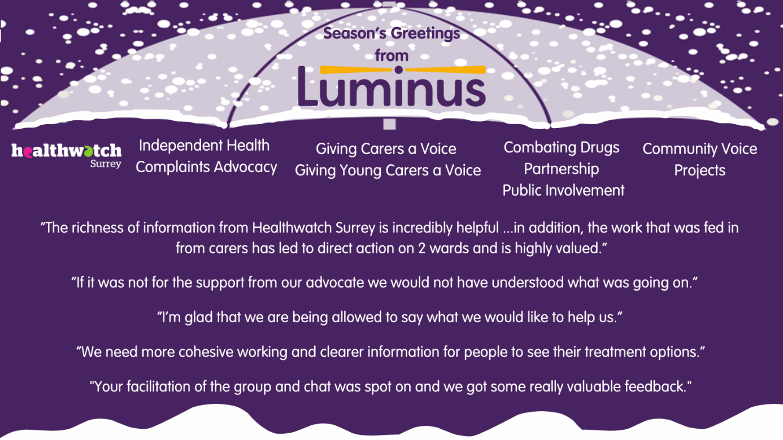

Firstly, we wanted to take this opportunity to wish you all the best over this festive season.

Having extended our services this year to provide more Surrey residents with the opportunity to have their voices heard, this year our card shows the different services that sit under our Luminus umbrella. All of these services work to ensure that Surrey residents' voices (particularly those who may be at risk of health inequalities) are heard by service providers and decision makers, so that everyone receives the support they need for their wellbeing.

If you would like a paper copy of this document or require it in an alternative format, please get in touch with us.

About Healthwatch Surrey
Healthwatch Surrey is an independent service, empowering the residents of Surrey to have their voices heard. We seek out people’s experiences of health and care services and have a statutory duty to share these with service providers and decision makers, to support services to improve and tackle health inequalities. We believe that health and social care providers can best improve services by listening to people’s experiences.

We also provide information and signposting to help the people of Surrey find the care that best suits their needs.

Themes of 2023
Each month we share our Insight bulletin with the aim of shining a light on what people tell Healthwatch Surrey about health and care. Local people often tell us that the standard of care that they receive is good which we try to reflect each month in a section of praise and thanks:

“I wish to pass on thanks, admiration and gratitude for the response we had when it became necessary to call for an ambulance in the early hours of Saturday morning… Please will you direct our special thanks and admiration to the paramedics and our gratitude for your service.”
196662, Mole Valley resident

“The staff here do a phenomenal job.”
189411, Guildford resident

“I called 111 as my son was struggling to breathe. They called back within 20 minutes. They then sent a video link… so they could assess his breathing. [They suggested we attend the hospital.] He was seen immediately.
It was a really good service from everyone.”
189835, Guildford resident

However, accessing support in the first place is often the biggest challenge for Surrey residents which we regularly highlight in our Insight bulletins.

Healthwatch England have also recently published a report: The public’s perspective: The state of health and social care which echoes these findings. The report warns that faster action is needed to help tackle access issues to prevent a two-tier health and care system. It also contains recommendations for each area of care on how support can be improved.

Some of the recurring themes that we have heard about this year are featured below and include:
- Involving people: Does feedback make a difference?
- Access to GPs
- The impact of not communicating with compassion
- Coordination of appointments

Involving people: Does feedback make a difference?
One of Healthwatch Surrey’s priorities this year is the involvement of people and how well the system listens to and acts upon feedback from Surrey residents. As well as encouraging people to get involved by promoting opportunities to have their say, during a number of visits to Surrey hospitals, we have also explored whether people know how to share feedback, their experiences if they have shared feedback, and if it has made a difference.

Overall, we’ve found:
- People associate sharing feedback with making a complaint
- People don’t have good awareness of how to share feedback with services
- There are mixed views as to whether feedback makes a difference.

Of the people we spoke to, those who believe feeding back does make a difference, often haven’t shared feedback themselves. However, people who have shared feedback, told us they haven’t seen evidence of any changes. As a result, we have made recommendations to hospital trusts across Surrey to improve information and communication with their patients about the importance of feedback.

You can read our reports from our visits to the Royal Surrey County Hospital, Ashford and St. Peter’s Hospitals and Epsom General Hospital on our Reports page, Involvement of people section. We will be publishing reports on visits to Frimley Park Hospital and East Surrey hospital in the next few weeks.

We have also visited a number of care homes this year to talk to residents, carers, and family members about how confident they feel in sharing feedback. Our survey revealed that two thirds of respondents (families and carers) were very confident they would know how to raise a complaint and who to raise it with, however, half of our respondents had previously raised a concern. Of those who hadn’t previously raised a concern, around one in ten did not feel at all confident in what to do.
We published a summary of this work: Enter and View Programme – effectiveness of feedback mechanisms in care homes – Summer 2023

Access to GPs
It is well reported that demand on GP services is increasing, and we are continually working with colleagues in primary care to ensure that the voice and experiences of Surrey residents is used to drive improvements. Access to general practice is the topic most shared by the public with us, and has been featured throughout the year in our Insight bulletins.

We often hear the care that people receive is excellent:

“I would like to praise my GP who I believe saved my life, when I went to her with my problem, she knew there was something wrong and took a sample, that evening she texted me and had arranged scans.”
201242, Surrey Heath resident

However, people’s needs are often not being met when it comes to communicating with their practices. In January we highlighted the need for practices to offer a range of contact options to meet different patient
access needs and for special arrangements to be made for some
patients. Throughout the year, people have continued to tell us that this has not been the case for them:

“I walked to the front desk this morning and spoke to the receptionist who said that although she had access to systems, it was not policy to book people face-to-face appointments at the surgery reception, but I could call the practice number from reception and the admins in the office behind reception would then be able to speak to me about a face-to-face booking. 20 minutes later I spoke to an admin assistant who informed me that the practice policy is not to book face-to-face appointments…”
Surrey resident, via Healthwatch England

“My mother-in-law is deaf. GP has said she must only be offered face to face appointments. But when she tries to book the receptionist said she can't offer that and can only offer telephone appointments. She then wastes a telephone appointment as she can't understand everything and ends up having to come in.”
205660, Runnymede resident

The impact of not communicating with compassion
When we visit people in their communities, as well as talking about their experiences of services, we also give people the opportunity to talk about what impact this has on them. A recurring theme is the impact that not communicating with compassion has on people:

Last week I went to [a] Safe Haven, they told me I should go to my GP. My GP tells me to go to A&E. A&E tells me to call the crisis line more, when I call them it's just a perpetual cycle I'm stuck in. No one wants to help me… I don't want to feel like this, it effects my life so much. I'm just bounced around between this place and that place, it makes me feel irrelevant.”
201110, Epsom and Ewell resident

“As a first-time mum I didn’t find my midwife great, I didn’t
feel heard by her and wasn’t keen on the way she delivered
news to me, she tended to give me the worst case scenario
each time and that gave me anxiety. The midwife I had also
commented every time I came to the appointment on how
‘massive’ I was, it turned out later in the pregnancy that this
was undiagnosed excess amniotic fluid. … I had stated on my
birthing plan no pethidine and I mentioned I was doing
hypnobirthing, the midwife was dismissive of me, she said
‘we’ll see when the contractions come’ - it felt condescending. With the no pethidine it was because I have had funny reactions to medicines.”
184661, Surrey Heath resident

“I have an issue with a hernia that has got out of control growth wise… I've chased PALS 5 times in last few months. I need to know when I am going to have the operation… I started the process before the pandemic and the hernia has grown and grown. Obviously, the waiting list has grown but I really need to know…I don't go out because people stare at me. Children have asked my son if his Dad is pregnant. It's really demoralising… The consultant agreed I could have a brace in the meantime to hold my stomach to take pressure off my back. My GP said they haven't got the referral which I've chased a few times. I feel like I don't matter, that I'm just forgotten about.”
196541, Spelthorne resident

Coordination of appointments
One of the major frustrations that people often share with us is around how confusing it can be to know what appointment to attend, when and why, and people often tell us that they get conflicting information from services:

“Yesterday someone phoned from neurology and asked why I was coming for my appointment… [following a discussion] I left it with them that I would come in. I then got a phone call from the booking office this morning asking if I was coming in today and was told I didn’t need to come in. It looked like the left hand doesn’t know what the right hand is doing.” 200298, Reigate and Banstead resident

“Communication between departments need to be improved - mum was given appointments at 2 hospitals for the same time.”
200393, Epsom and Ewell resident

“I turned up today for my phlebotomy appointment but I’ve been turned away. I phoned this morning to confirm that the appointment was going ahead and they said yes, so it’s frustrating. It’s the third time this has happened.”
205548, Reigate and Banstead resident

“Whilst travelling here I got a text to say I had missed my 1st I-Access appointment. I didn't even know I had one!”
203832, Woking resident

Sharing experiences with us

As well as sharing experiences through our community engagement sessions, Surrey residents can also do this via our Helpdesk or feedback form on our website. People can also contact our Helpdesk for information and signposting about health and social care services. Our Helpdesk can be contacted in the following ways:
Phone: 0303 303 0023
SMS (text only): 07592 787 533
Email: enquiries@healthwatchsurrey.co.uk
Share your feedback via our website: https://www.healthwatchsurrey.co.uk/feedback-centre/

Our distribution list
If you would like to be added to or removed from the distribution list for this Insight bulletin, please contact our Communications and Involvement Officer vicky.rushworth@healthwatchsurrey.co.uk

Further information
This bulletin aims to highlight some of the topics that people have shared with us in the past month and includes quotes to provide context on these themes. This bulletin is not designed to be a representative portrayal of individual services.

Any urgent or concerning experiences within this report have been escalated to the appropriate teams. All appropriate information and signposting to complaints processes has already been given.

If you would like more information or examples of what people have shared, please get in touch with us.

We are committed to the quality of our information.
Every three years we perform an audit so that we can be certain of this.

The Healthwatch Surrey service is run by Luminus Insight CIC, known as Luminus.
Registered office: GF21, Astolat, Coniers Way, Burpham, Surrey, GU4 7HL.

