Insight Bulletin

  - October 2023

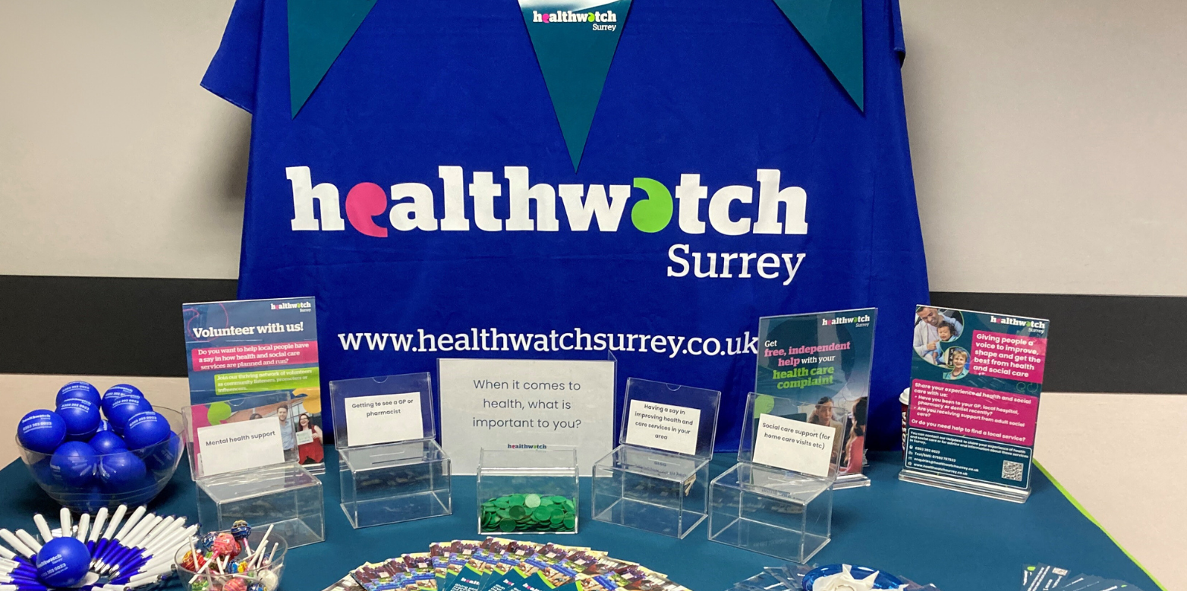

If you would like a paper copy of this document or require it in an alternative format, please get in touch with us.

About Healthwatch Surrey
Healthwatch Surrey is an independent service, empowering the residents of Surrey to have their voices heard. We seek out people’s experiences of health and care services and have a statutory duty to share these with service providers and decision makers, to support services to improve and tackle health inequalities. We believe that health and social care providers can best improve services by listening to people’s experiences.

We also provide information and signposting to help the people of Surrey find the care that best suits their needs.

This bulletin is designed to highlight the themes we have been hearing about and includes quotes to provide context on these themes. This bulletin is not designed to be a representative portrayal of individual services.

Any urgent or concerning experiences within this report have been escalated to the appropriate teams. All appropriate information and advice and signposting to complaints processes has already been given.

If you would like more information or examples of what people have shared, please get in touch.

Praise and thanks
Last month 166 people shared their experiences of health and social care in Surrey. We frequently hear from people who are very happy with the care and support they have received from a range of services. This month we are highlighting 2 areas that we have received positive comments about.

Vaccinations
The process for booking and receiving a flu and/or Covid vaccination is working well for those people who have shared their experience with us:

“I was contacted by text to say I was eligible for a Covid vaccine - I assume because I am registered as a carer with my GP practice as I don't meet the other requirements. The text gave me the option to book via the NHS App which I did - this was very straightforward. Having booked I then got a text with the location time and date and also information on how to change or cancel the appointment. I needed to change it so used the link - this worked well (although you had to cancel and re-book rather than change but it worked ok). At this time it then gave me the option to add the flu vaccination as well (this hadn't been offered when I first booked). I was a bit early for my appointment but was greeted by a volunteer who checked a few details. After a very short wait I received my vaccinations and was also given clear verbal information about what might happen afterwards (a slight headache/ mild flu symptoms etc.) and to contact my GP if I had any concerns. Whole process went like clockwork really!”
220421, Mole Valley resident via website

“As I am asthmatic I was sent a text to say that I should have a flu jab. I haven't had one before. I ignored the first message but was then sent another. I booked an appointment through the patient access app which I always use. It's so quick and I have never had an issue getting a face to face appointment with a doctor. I had the jab and all went smoothly. Nothing to add except it was so easy from beginning to end.”
220988, Guildford resident via website

Maternity
“I gave birth to my daughter, now 3 months at the Royal Surrey. I have had both my children there and received the best care possible. Before being left with a student, the senior midwife asked if I would be ok with a student taking care of me. Of course, I didn’t mind; everyone has to learn, and this was my 2nd baby. The senior midwife was always contactable and kept popping in to see how things were going. I wanted a water birth but couldn’t, the student nurse did everything possible to make it special, she even brought in some fairy lights and made the room special for me. I couldn’t have asked for better care and attention.”
202391, Guildford resident at family centre engagement

“I do want to feedback about the Epsom Hospital home birth team, they made the entire experience of homebirth excellent and I felt that this was a personal and amazing service which I can’t speak highly enough about.”
201509, Epsom and Ewell resident at community cafe

Being informed
What sometimes may seem like inconsequential communication issues can often build to have a significant impact on individuals. The following examples that were shared with us this month demonstrate that at a time of worry and concern for a person, the communication and information that they receive from services has a big impact; from being told about the professional they can expect to see, to being kept informed about next steps:

“I got referred in February as had a tight, squeezing pain in my neck and was worried. Was seen by a nurse practitioner when I thought I was seeing a doctor. They said they would refer me urgently to the urgent chest pain clinic.

I then got a telephone consultation appointment in March. This then got cancelled by letter and moved to July. Then got a letter in June saying there would be a follow-up in August. I then called them up to say how can I have a follow-up when not been seen yet. They said oh don't worry, it's just standard wording. I was then 'seen' via telephone consultation who said it was a Hiatus Hernia and subsequently sent me a letter confirming this. I was seen at [hospital] and the consultant said no it wasn't. GP is now referring me for an endoscopy. Not sure why I am having one.

When I went to see the GP, she said 'how are you managing your diabetes?'. I was surprised as I don't have diabetes. Think she was confused as I did have gestational diabetes but this was a long time ago.”
202260, Tandridge resident via Healthwatch Surrey volunteers

“My social worker is unreliable they don't turn up to appointments and don't go back to you. Promises the earth and delivers nothing, they were supposed to be increasing direct payments in the school holidays. 5 hours a week during term time, this was supposed to be in place June 2023, ready for this summer. Nothing has happened, I've had an appointment arranged for the middle of September but they didn't turn up and there was no communication. I will need to ring the central line for the southeast children with disabilities team to follow up. It's a very inconsistent service.”
201717, Mole Valley resident via Healthwatch Surrey volunteers

Being involved
People have been telling us that they don’t feel involved in their own care but would like to be:

“It would be better if mental health services were communicating with me rather than doing things without my input. I want to be involved in my care.”
201793, Mole Valley resident at library engagement

“[Mental health services] have refused to talk to me and they have meetings about me without me being involved. Patients don't have any right to choose treatment.”
201531, Waverley resident via telephone

People are also sharing examples of the impact of not involving and understanding the needs of the young people they care for:

“The first thing to say is that I have never had a bad experience with an SCC (Surrey County Council) social worker in either a personal or professional capacity. However, my recent experience (in mid-late August 2023) with my daughter's care assessment review and my carer's assessment review was very poor. Before the reviews I felt like they would go well, with initial cheery email interactions… I also explained about [my daughter’s] agoraphobia. As expected, [my daughter] was very agitated leading up to the review. I spent two days coaching her about why the social worker was coming to the house, what she might be asking… where she would sit, the fact that it would be okay for [my daughter] to say nothing if she wasn’t able etc etc. On the day she had an allowed extra anti-psychotic tablet prior to the review - without this prep [she] would have been unable to participate at all.

Quickly became obvious the review would be very difficult. The social worker's style of question was quite brusque… The social worker did not seem to have any understanding of or empathy in dealing with a young person with ASD never mind severe mental health problems. One of the first things [she] was asked was what she likes to do… and the social worker then asked if [she] liked to go for a walk. [My daughter] looked at me horrified and I reminded the social worker that [she] is agoraphobic. The social worker replied that she did remember, but… it was part of the assessment! I said that I had been clear that this was a difficult/upsetting area… The trust had gone at that point… [My daughter] shut down pretty quickly after that... [My daughter] was wiped out for 3 days after the assessment, and the ‘trick question’ obviously bothered her. She kept asking why did the person try to trick her, didn’t she believe her, why would she lie about being agoraphobic? I had no answer, I didn’t understand it myself.”
201519, Guildford resident via Healthwatch Surrey website

“We had been waiting 6 months for a referral to ENT for my 8 year old daughter who has been complaining of hearing difficulties and tinnitus. In this time we have been for 2 hearing tests which showed glue ear and a subsequent drop in hearing. At the time of the second hearing test, they weren't sure why we were there as we were awaiting an ENT appointment and were told they would repeat the whole thing but be able to help with the tinnitus, which they couldn’t.

My daughter was pinning her hopes on the ENT appointment to officially diagnose and offer support and ways to cope. It's been affecting much of her life at school, creating anxiety and worries in class about not being able to hear properly. So, she was left incredibly upset and disappointed following the appointment. She did have to repeat the hearing test which showed a further decline in her hearing, but when we were called in to speak to the consultant, this was dismissed along with the previous results as all being in the normal range, despite the audiologists saying it wasn't. My daughter also didn't feel listened to – the consultant asked when the tinnitus was worse and then ignored my daughter when she answered and then only directed her conversation directly to me. Just the physical turning to face me made it very difficult for my daughter to understand let alone hear what was going on.

We were with the consultant for about 2 minutes before being told we'll hear back again and being told to go to bed with the window open to hear traffic noise (not thinking whether this was appropriate given we live in a quiet area). It all felt very rushed and dismissive. When you've waited admittedly only 6 months but had almost daily conversations about how a doctor may be able to help and make things better, it was a big blow to my daughter to come out of there confused and ignored.”
203296, Waverley resident via Healthwatch Surrey website

Involvement of people is one of our key priorities. Each of our priorities, the work we are undertaking in each area and our impact, are all detailed in our latest Quarterly impact report.

Being supported as a carer
In March 2023, Giving Carers a Voice published their report ‘Identifying as a carer’ which explored why people don’t identify as carers, what
triggers their realisation that they are an unpaid carer, and the value of
identifying as a carer. This report included recommendations aimed at improving the number of people identifying as a carer and accessing the support they need. During conversations Healthwatch Surrey has with people, it’s apparent that many people still do not identify as a carer and that services they are accessing are not signposting them effectively:

“I’m here today with my mum who has vascular dementia. I’m not registered as a carer but I do most things for mum. It’s very hard. Mum has carers in on [2 days] but I still have to go round to check she is ok on the other days. She needs more support but I feel more relief now I have some help. There is a lot of pressure from my [siblings] to make sure she is looked after well, but they don’t help. I haven’t had a holiday since 2020 and I’ve been trying to get mum into respite care so I can go on a break.
I’ve been referred to a clinic in Woking who promised to ring me but didn’t. We’re both registered [at the same GP surgery] and they’ve been very good… I am going to register as a carer now I’ve spoken to you.”
201880, Spelthorne resident at community group engagement

Dentistry
We continue to hear from people who are being denied NHS dental treatment despite meeting eligibility criteria. The information made available to the public is still confusing and exacerbating the issue:

“I registered with this practice a few years ago as a private patient (and had treatment and paid accordingly) as they were not accepting NHS patients at the time. I am now pregnant and eligible for free NHS dentistry. On the NHS website it states that this practice is currently accepting new NHS patients. So, I contacted them and asked whether I could be moved from private to NHS patient and they said I couldn't. I enquired as to why given that they are supposed to be taking in new NHS patients and they said that if I were completely new to the practice they would accept me but they couldn't change my status from private to NHS. I don't understand how they can justify this and would be grateful for some advice on whether I should raise a formal complaint.”
220456, Woking resident via website

The following example demonstrates the impact that being able to access dental care can have on someone:

“If I had my teeth done it would really help. I’m in pain and it really affects my confidence. I went to the dentist in July. They said that I’m too complex so they were going to refer me to the hospital. But I haven’t heard anything. This is the missing piece of my puzzle. I feel like if I can sort this, it would make such a difference.”
201251, Runnymede resident at community engagement

Our engagement sessions

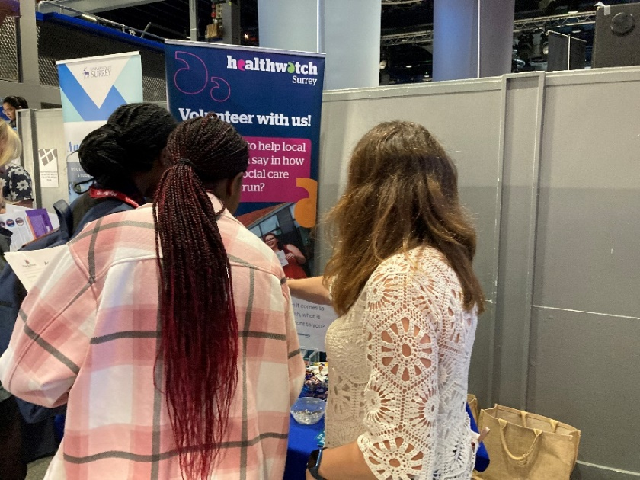

During October our engagement team focussed their visits in Guildford and Waverley with the wider Healthwatch Surrey team also visiting Frimley Park Hospital and Surrey University’s Part Time Work Fair where we also spoke to students about volunteering.

During November our community engagement team will be visiting East Surrey. We will also be visiting a Working Together for Woking event, East Surrey Hospital and making presentations about our work to several community groups.

Date | Place | Time | Surrey Area
04/11/2023 | Hongkongers Group, Hideaway café, Guildford  (Group engagement) | TBC | Guildford and Waverley
06/11/2023 | Guildford Library, Guildford  (Public) | 10am - 12noon | Guildford and Waverley
07/11/2023 | Presentation: Good Neighbours scheme – Surrey Heath and Woking  (Group engagement) | 2 – 3pm | Surrey Heath
09/11/2023 | Renewed Hope, Redhill  (Group engagement) | 10am - 12noon | East Surrey
09/11/2023 | Presentation: Macular Society – Staines  (Group engagement) | 10:30am – 12noon | North West Surrey
09/11/2023 | Working Together for Woking (Public) | 10am - 2pm | North West Surrey
13/11/2023 | Men in Sheds, The Woodhouse Centre, Oxted  (Group engagement) | 10am - 12noon | East Surrey
13/11/2023 | Presentation: Good Neighbours scheme – East Surrey  (Group engagement) | 2 – 3:30pm | East Surrey
17/11/2023 | Merstham Library, Merstham Hub (Public) | 10am – 12noon | East Surrey
21/11/2023 | Presentation: Good Neighbours scheme – North West Surrey  (Group engagement) | 2 – 3pm | North West Surrey
22/11/2023 | Presentation: Good Neighbours scheme – Waverley  (Group engagement) | 10:30am – 12noon | Waverley and Guildford
25/11/2023 | Ashford Hospital Community Day (Public) | 10am – 3pm | North West Surrey
29/11/2023 | Presentation: Citizen Advice Esher  (Group engagement) | 9:30 – 10:30am | Surrey Downs
To be confirmed | East Surrey Hospital, Redhill  (Public) | 10am - 12noon | East Surrey
To be confirmed | Oakhall Church and Foodbank, Caterham  (Public) | 11am - 1pm | East Surrey

Please note: these dates may be subject to change.

To share an experience with us, people can also contact our Helpdesk in the following ways:
Phone: 0303 303 0023
SMS (text only): 07592 787 533
Email: enquiries@healthwatchsurrey.co.uk
Share your feedback via our website: https://www.healthwatchsurrey.co.uk/feedback-centre/

Our distribution list
If you would like to be added to or removed from the distribution list for this Insight Bulletin, please contact our Communications and Involvement Officer vicky.rushworth@healthwatchsurrey.co.uk

We are committed to the quality of our information.
Every three years we perform an audit so that we can be certain of this.

