Insight bulletin

  - September 2023

About Healthwatch Surrey
One of the statutory duties of Healthwatch Surrey is to share Surrey residents’ experiences of health and social care with the people and organisations who make decisions about those services. This report aims to highlight some of the topics that people have shared with us in the past month.

If you would like a paper copy of this document or require it in an alternative format, please get in touch with us.

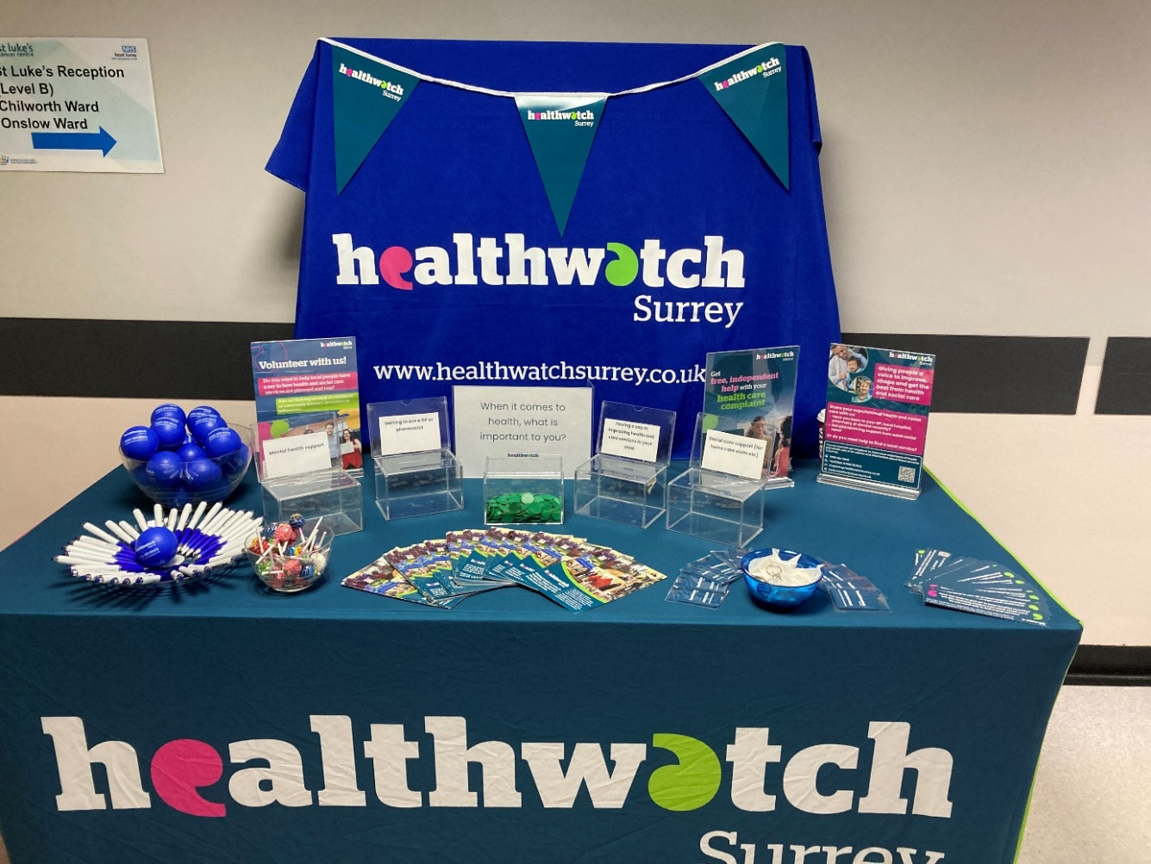

Who we have heard from
This month 134 people have shared their experiences of health and care services with us through our community engagement, Helpdesk, Independent Health Complaints Advocacy service, and via Healthwatch England. In September, we visited a number of locations throughout Surrey Downs including Epsom Hospital, a foodbank, a library and a community café, as well as group sessions aimed at supporting members of their local community. People have shared their feedback about a wide-ranging number of services and local issues.

Of the people who shared specific information this month:
- 29% have long-term conditions.
- 18% consider themselves to have a disability.
- 15% are from ethnic minoritised groups.
- 12% identified as unpaid carers.

If we hear a case of concern regarding patient safety, we immediately signpost the sharer to the appropriate body and escalate the case with the provider/commissioner/safeguarding as appropriate.

If you would like to know more about a particular topic or service, please get in touch.

Praise and thanks
Once again, during our conversations with people, we heard examples of people being grateful and impressed with the care and treatment they have received and include some examples here:

“We were recommended Royal Surrey County Hospital for maternity by our consultant and so we went there. With my second child we decided to also request Royal Surrey County Hospital as we felt the care was excellent.”
201451, Epsom and Ewell resident

“I would like to praise my GP who I believe saved my life, when I went to her with my problem she knew there was something wrong and took a sample, that evening she texted me and had arranged scans.”
201242, Surrey Heath resident

“I come to the health visitors once or twice a month. I’ve been breastfeeding for a year now and so their advice and help has been brilliant... I found the advice they gave practical and helpful. I tried out some of the advice and it seems to be helping him and encouraging him to eat more. I find this clinic is good for me and we have received good care, it’s easily accessible, for me to get here as it’s walking distance.”
201438, Epsom and Ewell resident

Spotlight on communities
During our community engagement sessions, we tend to hear a mixed picture of people’s experiences, ranging from glowing praise to immense frustration and many in between.

When we visited a Community Café in Epsom this month, most of the people at the café told us about their positive experiences of accessing GP practices in the area:

“I've had no problems with them and I think they are good there, good care. I book either by calling up or going online and writing to them. I find it easy to get an appointment and I am heading there this afternoon.”
201449, Epsom and Ewell resident

“I tend to book online, but that doesn’t work for every appointment and so sometimes I call, especially if it’s for my son as those kind of appointments are more likely to be urgent for on the day. I called recently for him and I got put in a queue but there was an option for them to call back. I was slightly dubious but I pressed the button and it worked, so I would definitely use that call back service gain, much easier when you are caring for an unwell newborn or my 2 year old!”
201451, Epsom and Ewell resident

Others told us that they had difficulties:

“Last week I called to make an appointment with my GP and they gave me a phone appointment for the next day. By the evening my leg was very painful and so I didn’t know what to do, my daughter suggested I called 111 and so I called them, I spoke to 3 different people and in the end they said go to the hospital and see a GP and they made an appointment at 8pm. I was seen at the hospital, my neighbour took me. The Doctor said I needed to get a blood test done at my GP practice and so I called the next day to ask to book a blood test. They said I had to do it online, I tried but I couldn’t understand how to do it and so I called back. I’m in my 80s and I try to be as independent as I can, but some of these processes defeat me. By this time, it was Thursday, but my phone appointment didn’t happen, nobody called me. Friday morning, I called and I explained that my phone call hadn’t happened, they didn’t say anything about that but they did then book me in for an appointment on Friday and my blood test. A better outcome for me would have been less calling up lots of times, I wish they could have fitted me in sooner and I would have found that more reassuring, this was all last week. I’m waiting for my blood test results.”
201487, Epsom and Ewell resident

“I have had an infection recently [September 2023] but when I went to book this time it had all changed and I couldn’t figure out what to do, the forms have changed, it used to be easy on the practice website. It now seems like I should be booking via the NHS app, but I don’t have it and so I had to do all these things to prove who I was, I went through the whole process and I still couldn’t figure out how to book via the thing and so I called up. Also, since the forms have changed, I now don’t know how to ask the reception a question, it used to be so simple, I want to send in a copy of some tests from the hospital and now I don’t know how to set about even asking how, let alone actually sending them in.”
201489, Epsom and Ewell resident

When we visited a local support group in Woking, we heard more frustrations in the local community that people don’t feel are being addressed:

“The surgeries are not answering the phone. Communities like ours are suffering from lack of information and lack of education about the systems. Everything changed when covid came and people do not understand the system. It’s all about education and understanding. We have an elderly population and the IT issues are going to grow. People don’t and can’t access services. People are hesitant to let people into their homes as they want their privacy. Information is key. I’ve just had my flu jab but how many people will go online and book theirs? There are not enough GPs and information is not being fed through to the community. I’m really pleased that we have a group like this [local support group for men].”
201500, Woking resident

“In our community - there are problems with language barriers and online booking systems for appointments. Now pharmacies are closing in the area too. Where are people supposed to go to get their prescriptions?”
201498, Woking resident

“They don’t pick up the phone. You have to go online to make an appointment and that used to work but now they have put up loads of questions to answer before you can make an appointment. People my age can’t use the internet, we don’t go to school or speak English at home. You can’t walk into the GP practice for an appointment, and they don’t answer the phone when you ring.

I have lots of health problems [including diabetes, high blood pressure] and I need to be able to see the doctor. [The person who runs the support group] wrote a letter for me which I sent to my local MP and two months later he replied to say the matter had been forwarded to the practice. The practice then rang me but they didn’t have a clue why they were ringing me and just asked if I needed an appointment. Now there is a note on my records saying that I can make appointments by phone. However, they don’t answer the phone and if they do, they always say I can’t and that I have to use the internet but I have to insist they check my records and read that I am allowed to make appointments on the phone.”
201497, Woking resident

You can read more about what people are telling us about primary care in Surrey Heartlands in our report What we’re hearing about Primary Care Surrey Heartlands - September 2023 that was shared at the Surrey Heartlands Primary Care Commissioning Committee. We will be publishing what we’re hearing about primary care in Surrey Heath this month.

Sharing feedback with hospitals
One of our priority areas this year focuses on how involved people feel in the care that they receive and the extent to which they feel their feedback makes a difference to the quality of care they receive. Involving local people in decision making and the design and changes of services also ensures that services truly serve their local communities and acting on feedback can help to achieve this. Our first project under this priority is to talk to people about sharing feedback relating to their experiences of hospital care. Overall, we are finding that people are willing to share feedback but do not feel informed as to how. You can read about our visit to Royal Surrey County Hospital on our website: What we’re hearing about St Luke’s Cancer Centre at Royal Surrey County Hospital – July 2023. We will also be publishing results from our visits to other hospitals in due course.

In the course of these conversations, people are also telling us what could make their experience better. Whilst most people we have spoken to are very happy with their care…

“Nothing could be better, very good service, very quick.” 200997, Hospital engagement event

…some people have shared examples where communication could be improved:

“Yesterday someone phoned from neurology and asked why I was coming for my appointment… [following a discussion] I left it with them that I would come in. I then got a phone call from the booking office this morning asking if I was coming in today and was told I didn’t need to come in. It looked like the left hand doesn’t know what the right hand is doing.” 200298, Hospital engagement event

“Communication between departments need to be improved - mum was given appointments at 2 hospitals for the same time.”
200393, Hospital engagement event

Others have commented on the timeliness of their appointments on the day:

“1 thing that would have improved my experience today is for my appointment not to have been late.”
200958, Hospital engagement event

“I have waited over an hour to get meds from pharmacy. It’s early in the day so there shouldn’t be a build-up yet.” 200375, Hospital engagement event

“Waiting times have been very big every time I come to this hospital. The thing that would have improved my experience is if I had been seen at the time of my appointment [currently waited over 1 hour].”
200315, Hospital engagement event

Information and signposting
We offer an information and signposting service for people in Surrey. People often come to us frustrated and having already tried a number of ways to resolve their issues. These are often complex and involve a number of services. The following example shows the cumulative effects of not feeling listened to by a number of services:

“I was supposed to be monitored every 4 months, after being on this medication, I have not been monitored. I had an appointment for a phone call in March, I sat and waited for an hour for this call, it never happened… When I challenged not being called in March, I had to phone them, they arranged another phone call for May, this call never happened either… I approached my GP as I was feeling suicidal due to all these problems and the lack of treatment. My GP [referred me for] CBT [cognitive behavioural therapy], I told them I didn’t think this would help as it is a physical problem that cannot be changed, I went ahead and had one session of CBT, the therapist then spoke to their supervisor who said it was not going to work for me so I have now been abandoned by them. I put in a complaint to PALS [Patient Advice and Liaison Service at the hospital] which was acknowledged [and] they said they aimed to get back to me by [early September]. I have had no [further] correspondence. I contacted them and they told me they were on the case, they apologised and said the letter is with their executive team for signing, still no letter has come.” 201501, Reigate and Banstead resident

People have also been telling us that they’re finding it difficult accessing mental health support through a range of avenues and often feel like there are no services available to support them:

“I am fed up with the lack of mental health support. I called my key worker from the community mental health team yesterday as felt I was being overwhelmed and getting into a crisis state. They said they are all short staffed and attending with ambulance etc and no one could help. Said would call back the next day, am still waiting for the call. I am autistic and have anxiety and depression.

Last week I went to [a] Safe Haven, they told me I should go to my GP. My GP tells me to go to A&E. A&E tells me to call the crisis line more, when I call them it's just a perpetual cycle I'm stuck in. No one wants to help me… I don't want to feel like this, it effects my life so much. I'm just bounced around between this place and that place, it makes me feel irrelevant.”
201110, Epsom and Ewell resident

“What went well? Nothing. I've experienced services that apply non-existent eligibility criteria (apparently because I've only had ‘one trauma’ I'm not traumatised enough!?!). IAPT have advised that they cannot help me as I need long term intervention and they can only offer 12 sessions (18 max). My work, my life, my family, my health has been a disaster for 6 years because there are no suitable mental health services.”
200907, Surrey resident via Healthwatch England

“The GP practice are hopeless. If you call up, it just tells you to go online. If you try to go in and book and appointment, they say you have to call up! I tried to get an appointment today and it was like this. The options on the online form didn't apply before. I'm not sure what the new form has, but there wasn't a clear option for what I wanted so you just go round in circles. If you click on mental health, then you just get a bunch of options for self care which just makes you want to give up!”
200126, Reigate and Banstead resident

Feedback mechanisms in care homes
In 2022-23 our staff and volunteers visited a number of care homes as part of a programme of Enter and View visits. We ran an accompanying survey to hear from residents and carers about their experiences and how they share feedback. People who live in care homes are not easily heard and can be isolated from decision-making.

During our Enter and View visits, we found that there were many different feedback mechanisms in use across the care homes, such as residents’ meetings, suggestion boxes, surveys, and an iPad at reception for family and friends to give feedback. Many care homes told us that they had an ‘open door’ policy and residents, and family member were welcome to talk to staff at any time. Our survey revealed that two thirds of respondents (families and carers) were very confident they’d know how to raise a complaint and who to raise it with. We have recently published a summary of this work on our website – Enter and View Programme – effectiveness of feedback mechanisms in care homes – Summer 2023.

Community engagement plans
During September our engagement team focussed their visits on Surrey Downs. The wider Healthwatch Surrey team also visited several university and college Fresher Fairs and were at Royal Surrey County Hospital’s Community Day.

During October our community engagement team will be visiting Guildford and Waverley. We will also be visiting Frimley Park Hospital, the University of Surrey and starting a series of presentations to Good Neighbours Schemes.

Date | Place | Time | Surrey Area
02/10/23 | Frimley Park Hospital, Frimley (Public) | 10am –  12 noon | Surrey Heath
03/10/23 | Surrey University Part time work fair (Public) | 12 noon - 3pm | Guildford and Waverley
04/10/23 | Hilary's Hut, Christ Church Staines (Group members only) | 10am –  12 noon | North West
05/10/23 | Farncombe Day Centre, Farncombe, Godalming (Centre visitors only) | 10am –  12 noon | Guildford and Waverley
12/10/23 | Café at Adult learning Centre, Guildford (Centre visitors only) | 9.30am - 10.30am | Guildford and Waverley
16/10/23 | Direct Pharmacy, Madrid Road, Guildford (Public) | 10am –  12 noon | Guildford and Waverley
16/10/23 | Broadwater Youth Centre, Farncombe (Group members only) | 3pm-5pm | Guildford and Waverley
17/10/23 | Access to primary care, co-design event (Group members only) | 10am – 12noon | Guildford and Waverley
19/10/23 (TBC) | Open Grounds Café, Guildford Baptist Church, Millmead, Guildford (Public) | 10am –  12 noon | Guildford and Waverley
30/10/23 | Presentation: Good Neighbours Scheme - Guildford Borough | 2pm - 3pm | Guildford and Waverley
October | Men in Sheds at Merrist Wood, Guildford (Group members only) | TBC | Guildford and Waverley
October | Guildford Library, Guildford | 10am –  12 noon | Guildford and Waverley
04/11/23 | Hongkongers Group, Hideaway, Guildford (Group members only) | TBC | Guildford and Waverley

Please note: these dates may be subject to change.
To share an experience with us, people can also contact our Helpdesk in the following ways:
Phone: 0303 303 0023
SMS (text only): 07592 787 533
Email: enquiries@healthwatchsurrey.co.uk
Share your feedback via our website: https://www.healthwatchsurrey.co.uk/feedback-centre/

Our distribution list
If you would like to be added to or removed from the distribution list for this Insight bulletin, please contact our Communications and Involvement Officer vicky.rushworth@healthwatchsurrey.co.uk.

