What we’re hearing

from children and young people

  - September 2023

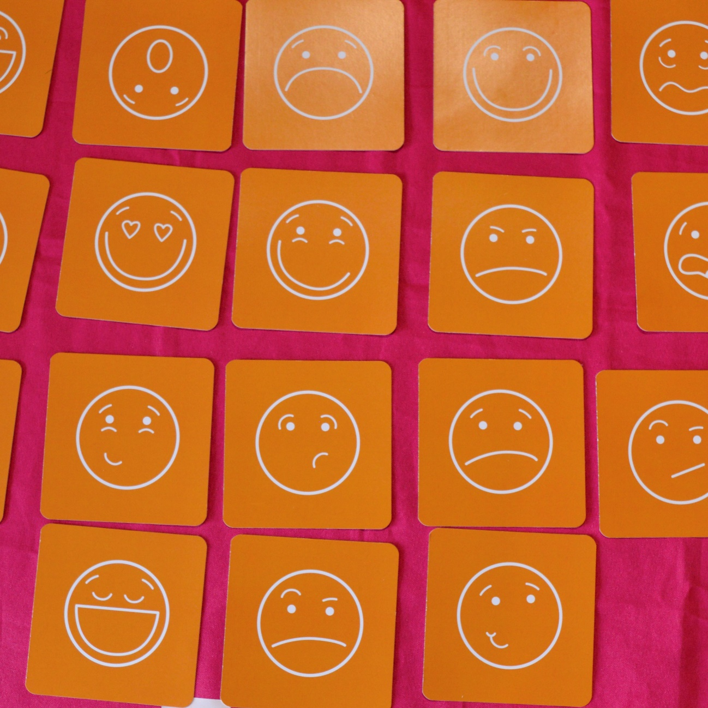
If you would like a paper copy of this document or require it in an alternative format, please get in touch with us.
Contents
About this report 3
About Healthwatch Surrey 3
Our engagements with young people 4
Twister LGBT+ Group 5
Overview 5
Our conversations 5
‘My wish would be to meet other people like me’ 6
‘My community is so important to me’ 7
‘I would not go to the doctors, it would be too intense’ 8
‘It's very life changing to get the healthcare I need’ 9
‘I have only come out to my family a few weeks ago’ 10
Matrix youth drop in 12
Overview 12
Our conversations 12
Who would you talk to/ask for help? 13
Where do you go for information? 14
What do you enjoy? 15
How do look after your wellbeing? 16
What is your biggest worry? 18
Contact us 20

About this report
This report provides a summary of what we heard from children and young people during engagement events in August.

The clearest theme we heard was the importance of community organisations. The young people we met told us these organisations provide a physical space for them to go, socialise and find other young people like themselves they can connect with. These spaces also provide opportunities to feel heard and understood and to access trusted and informed advice.

We also heard how young people really value being listened to and appreciate when organisations and services respond to what they say and provide support which is tailored to their needs. Trust was a vital part of this process and young people were more likely to have positive experiences with services, if people had taken the time to get to know them, understand them and learn how best to support them.

We recognise this report represents a small sample but we hope that it can provide a starting point for organisations and service to see the importance of engaging with young people and the insightful conversations you can have if you give them the time and space, and a willing ear to listen.

About Healthwatch Surrey
Healthwatch Surrey is an independent health and care champion, empowering the residents of Surrey to have their voices heard. We seek out people’s experiences of health and care services and share these with service providers and decision-makers, to support services to improve and tackle health inequalities. We believe that health and social care providers can best improve services by listening to people’s experiences.

We also provide advice and signposting to help the people of Surrey find the care that best suits their needs. Any urgent or concerning experiences within this report have been escalated to the appropriate teams. All appropriate information and advice and signposting to complaints processes has already been given.

Our engagements with young people
In April 2023, our Community Cash Fund provided small grants of up to £1500 for community organisations providing a variety of support for children and young people across Surrey.

We visited two of these organisations in August to hear from young people about their experiences and learn about what kind of support they would like to see from local services in the future.

First, we visited Twister in Woking, a youth group for people aged 14-19 who are lesbian, gay, bisexual, transgender or are questioning their gender or sexuality. Then we went to Matrix’s Drop In at The Hideaway Café.

Our conversations were loosely structured around core themes – where did young people go for support and information, what did they do to look after their wellbeing and what worries them or things they would like to see improve.

Thank you to all the young people who shared their experiences.

Twister LGBT+ group

Overview
Twister offer information, advice, and guidance along with activities that range from having discussions about things that are important to the young people, to activities such as arts & crafts and learning new skills.

We also spoke to the group leader who provided some context to the challenges of running this group:

“We offer a safe space here, we help with contraception, signposting to other services and have people visit the group, for instance we have a session with Catalyst coming up. We also have a clothes exchange and can help with sanitary products.

My only rule is that you can’t attend if you are under the influence. We sometimes have instances where people are turned away if they turn up with drink or drugs. Occasionally we’ll have to make a decision if we need to keep them safe, even if they are under the influence, we would never send someone away if it was going to be unsafe. So, it’s a balancing act. Mainly the people who come respect the rule. We can’t always help. We had a great volunteer who had attended as a young person and we supported them to come and volunteer here, but they took their own life and that reminds us that sometimes we just can’t prevent things from becoming too much.

We are working on a project around accessing services as a neurodiverse LGBTQ+ young person. We have already identified that the young people think staff need more training but we are hoping to find out a bit more about what kind of training they feel they need.” 196368, August 2023

Our conversations
On the day we visited, there were about 10-12 people plus volunteers. We spoke to 4 young people and 1 volunteer who had also attended the group. One of the volunteers said they would like to leave feedback in their own time so we gave them contact information to contact us at a later date.

We have presented summaries for each the 5 conversations we heard below, discussing the challenges in accessing services and where people found support most appropriate to them.

‘My wish would be to meet other people like me’

“I live with my mum in Woking. I joined the military after my mum suggested it would be suitable for me after seeing an ad on the TV. It was her choice more than mine but now I do like it.

I'm currently on appeal due to my mental health records. So I initially got accepted but can't start the training currently. This is due to medication I previously was on but changed from as they were the wrong ones, and this has caused issues. We are working with the military to get this changed and then it will be ok. I am not on that medication now.
I've been involved with CAMHS for a while. My mum supported me and came with me. I have a really rare condition, premenstrual dysphoric disorder. It used to destroy my life every day. Now it affects me severely once a month. I am on a hormone pill to try and stabilise my moods. I just need to let it out, so I cut myself to allow this. My mum screamed at me when she first saw I had self-harmed, but it is the only way to cope.
I come [to this support group] for friendship and support. I have friends and a boyfriend I can chat to. I went to Safe Haven once but they called the police and they turned up at my house and my mum was so cross and embarrassed.

My wish would be to meet other people like me. The only groups I found were in London. I also wish more consultants and clinicians could understand what my disorder is. I've been misdiagnosed as bi-polar in the past.”
196143, 18 -24, Woking.

‘My community is so important to me’

“At the beginning of the year, I went to Citizen Advice in Guildford. Previously I had applied for PIP as my health got worse, but I got turned down so wanted to reapply. The person I met at Citizen Advice was totally unrelatable. I had previously called up and gone through all the info but then had to repeat it all again. They were very old and, I don't mean to be ageist but, they had no idea about my kind of disability or illnesses let alone my gender. The man asked me if I went to my appointment looking like I did and walking like I did. I said yes. He said; "If you had spilt food down you and walked in with a stick, you'd have got funding." That attitude is disgusting and so unprofessional. If the man had understood my condition it would have been easier. It felt demeaning. He also frequently asked me about my transition. I would have preferred a female but was never given the choice.
He asked about my endometriosis, asking if I often bled through clothing. He never asked if I was ok talking about it or if it was relevant, it felt really uncomfortable.
At Royal Surrey, they ask which pronouns I prefer. They understand me and understand trans.
I'm having Gynae Endo keyhole surgery soon at Royal Surrey. The consultant asked about my pronouns so they could let everyone know in the team. That was nice.
I live in shared flat with some other queers. We have our own community. [Where we used to live] there seemed to be some half-way houses and there were a lot of issues so have moved. I've kept the same GP; Dapdune as really like them and their on-site pharmacy is very good for my meds [anti-depressants]. Receptionists are very nice. In an ideal World, Dapdune would get my hormones on NHS and I'd be exempt paying. I first accessed the Tavistock 6 years ago. But I have had to go privately to GenderGP. I was paying £100 per month for gel. Now I pay £25 per month for the shots. I've done the training so I can administer it myself as it's very personal and I prefer it that way.
I have chronic fatigue and was referred by Guys and St Thomas’ ages ago to a pain specialist in Bath. Heard nothing. Have asked my GP 3 times. I was also assessed there for a sleep disorder.
I also still go to Relate. They subsidise my sessions. They do help me. I go every 3 weeks.
I make sure I take my medication, vitamin D and get enough sleep. Sleep helps most things. I use the app, Headspace. I also do Yoga. It helps. I am also very spiritual. I also avoid social media.
My community is so important to me. Everyone I interact with is neurodiverse. It is subconscious, not a conscious decision. For advice, I tend to ask my friends, particularly those who have chronic conditions and are trans. We talk about medical oppression together. Would also ask [here at the group].”
196208, 18-24, Guildford.

‘I would not go to the doctors, it would be too intense’

“I enjoy art [young person was avidly sketching in the session]. I am awaiting my GCSE results. Not sure yet about college.
I come here from Epsom as not found another group nearer. My mum drops me off.
For physical health I would see my GP. For mental health or anything else, I would not go to the doctors it would be too intense. Maybe I would ask my parents. I wouldn't talk to anyone here [Twister]. To help my wellbeing, I see my friends. I like to go for a walk and I draw.
At points, it was very uncomfortable getting my autism diagnosis from CAMHS. I didn't start speaking until I started school.
I don't access any mental health support. I do have a smart phone and go online. I like to look up stuff. I have used the resource library at Twister and it did really help me.”
196146, 16-17, Epsom and Ewell.

‘It's very life changing to get the healthcare I need’

“I come [to this support group] every week. My mum found it for me. Here I am safe, amongst my type of people.

I've been trying to get hormone treatment. The waiting list is like 10 years long! Twister gave my mum the details for GenderGP and they’ve provided me with puberty blockers for 6 months. Researching gender online worked well for me. I was able to find out what I needed. It's very life changing to get the healthcare I need.
We have our GP at Maderia Medical who couldn't help with the hormones. I did speak to Eikon at school, but I couldn't get on with them. They didn't know how to relate to me as a trans person or an autistic person.
Haven't really used health or NHS websites. GenderGP had a lot of information and resources for me which was ideal.
My younger brother has helped me a lot as he came out before me.
I wish health professionals would learn and educate themselves more about the trans community and the way we need to be treated. I've been with CAMHS a long time. They also struggled to interact with me the way I need to be interacted with. It was a total barrier to helping me.

I went to an orthodontist last year to have braces off and the dentist saw my name had changed and asked me lots of questions. It was invasive and unnecessary, nothing to do with the work he had to do.
I wouldn't go to a sexual health clinic. At school in sex education, it was very hetero. Coming [to a support group] to get sexual health advice and contraception for queer people works.

I like communicating by WhatsApp and text best. Less intrusive. I'm suspicious of phone calls.
I like skateboarding and hanging out with my girlfriend and friends. But the nearest good skate park is Guildford so have to get the train, a bit annoying.”
196179, 16-17, transgender, Runnymede.

‘I have only come out to my family a few weeks ago’

“I did some counselling through Mindworks. My mum organised it for me. I was really struggling with school. The counselling was in person. My mum dropped me off for the first session and then I got the train for the rest by myself. I had 6 sessions. I felt very involved with the decision to get help.
The therapist was quite nice, didn't know I was non-binary though and I didn't feel ok putting this on the forms. I have only come out to my family a few weeks ago after my last exam. I always worry about bringing up stuff unless someone asks me in a conversation. I also don't like complicated conversations, I try and avoid them. I wanted my family to know this about me before I went away to university.
My friends supported me but didn't put pressure on me telling them. The pressure for the exams was a lot so it felt good to get this off my chest too.
My mum heard about Twister through work. I came here last September. At that time I was most worried about my future exams. I had spoke to my head of year about my issues and they were very supportive and confidential. I might ask my mum for advice or I'd text my friends. Also might [here at the group].
To look after my wellbeing I listen to music. I enjoy rock climbing too. If stressed, it makes you forget about everything.
I am also a carer for my younger brother. I used to go to a weekly young carers meeting but don't go now. At the time it was very useful. I had to look after him when my parents were not around, supervise his showers etc.”
196147, 16 -17, transgender, Woking.

You can find more information about Twister on Surrey County Council’s website.

Matrix youth drop in

Overview
We visited a youth drop-in cafe in Guildford providing a space for 11-16 years olds to socialise, play games and have a free hot lunch.

There were 3 youth workers at the drop-in to run the session and provide support:

“We work with 11 to 18 year olds during term time, both in school and in the community. We also have another programme which supports 16 to 24 year olds. All our programmes support neurodiverse young people too.

Youth workers are like mentors really. Sometimes, we are able to approach conversations that perhaps a parent wouldn’t want to have and vice versa. Young people are able to speak to us about topics they wouldn’t necessarily want to ask their parents about.

We support the young people with their mental and physical health. We don’t have a medical background and we look at our work as preventative rather than action based. We have a wellbeing team and we receive referrals from Mindworks, from schools and we have social workers who bring young people along to the drop in sessions. We would like to build more knowledge with local GPs.“
196683, August 2023.

Our conversations
We spoke with 10 young people who attended, with some more willing to speak with us than others. We had 4 individual conversations and 3 with a small group.

We have framed the responses under the key questions we asked to illustrate the themes and trends across the experiences.

Who would you talk to/ask for help?
We heard that the most common places young people go to for help were their parents or staff at school.

“If I had a problem or needed to know something I’d speak to my teacher or my parents.”
196686, 11, male, Guildford.

“My twin brother and I both really enjoy school. We've just finished Year 7. Some teachers are strict but most are nice and we would go to them if we had any problems.”
196702 12, male, Guildford.

However, in the case of schools there were different answers including teachers, to dedicated counsellors or school nurses.

“At my school there is a school nurse [we can talk to] and we can see a therapist or a counsellor.”
196688, 15, female, Guildford.

Parents were seen as someone children felt comfortable talking with. We heard that young people were aware of formal options available at school, however they preferred the idea of speaking with a parent:

“I’ve just finished year 7. I do have a safeguarding team at school, that’s who you go to if there is anything wrong and things aren’t working out at school, say if you were bullied or felt sad. I would probably speak to my mum though if I was upset about anything. I would go to them if something bad had happened at school but so far things have been okay.” 196684, 13, female, Guildford.

“I probably wouldn’t want to talk to anyone at school but I think it would be dependent on what I wanted to talk about as to who I spoke to. I would chat to my mum about most things, I wouldn’t really want to talk to someone I don’t know at school.”
196685, 12, male, Guildford

Trust was an important factor in determining who young people feel happy to speak with:

“I can speak to my head of year and my tutor, they listen and promises are made, but not usually acted on and nothing ever changes. I wouldn't want to speak to someone else, I don't trust them. [I need to have] a truly confidential conversation.”
196687, 15, male, Guildford.

“I was offered to see them after speaking to the Head of Year. Nope I didn’t go, no way, it’s not that I don’t like them, I just wouldn’t go, it’s not something I would do. What would stop me? I need them to be confidential and I need to trust they wouldn’t speak to my parents. I talk to my friends, I don’t want anything else.”
196688, 15, female, Guildford.

Where do you go for information?
The young people told us that they liked to look up information themselves, through technology such as smart phones or tablets. They also felt confident to ask a parent depending on what they wanted to look up:

“If I needed to find information, I would research online, I’d use my phone, computer or iPad and I could ask my mum but it depends what I wanted to know.”
196685, 12, male, Guildford.

“I would prefer to look up information for myself - I would look on my phone.”
196687, 15, male, Guildford.

“If I wanted to find some information I would speak to my mum or I can use my phone too, I feel confident I would be able to find out anything I might need to know.”
196684, 13, female, Guildford.

“I’d look up my own information if I needed to, I’d go online. I would talk to my mum, she’s really good and would help me find information and I would talk to her about some stuff.” 196688, 15, female, Guildford.

What do you enjoy?
Getting outside was popular, either playing games or sports, or enjoying green spaces. Some had a few ideas about what additional activities they would like to see in their local area:

“There is loads to do round here, lots to choose from, Spectrum [leisure centre] football, good parks and places to play football. Maybe a ski slope, we don’t have one of those, but we’ve got lots we can do.”
196686, 11, male, Guildford.

“We used to live in West London and there is lots more to do in Guildford than there. We have been to this group a few times. We like it here, the people that work here are nice.”
196702 12, male, Guildford.

“I always wanted a ninja course and now one has opened and I like the recreational areas around Guildford. I like animals, so somewhere to visit animals would be good.”
196684, 13, female, Guildford.

However, we also heard that one young person didn’t feel there were other places they could go outside of this drop-in:

“On the holidays me and my friends come [to the drop-in] loads. I like it here. I don't think there is anything to do in Guildford.”
196687, 15, male, Guildford.

We also heard that watching films and playing video games were popular activities:

“I like to watch old movies and old TV shows over again, that’s what helps take my mind off things and that’s what I like to do.”
196688, 15, female, Guildford.

“We go to the cinema, we’re on 3 movies a day. I like to watch YouTube for hours, not into doing anything else not screen related.”
196687, 15, male, Guildford.

“I like playing FIFA on the Xbox. My favourite thing to do at home is play on my VR headset with my twin brother. We have one each and play games together.”
196702 12, male, Guildford.

One young person told us that socialising was more of challenge as they lived in a different area to their school, requiring her to have to travel to meet friends:

“I live around here but I’m at school in Woking, so I don’t have many friends here to meet up with. I do go over to Woking to go shopping with my friends and go shopping, we don’t buy anything, we don’t have any money!”
196684, 13, female, Guildford.

How do look after your wellbeing?
The majority of the young people had an activity or space they would go to which helped them look after themselves:

“I look after my wellbeing by going for a walk or reading, that’s what helps me.”
196685, 12, male, Guildford.

“I’d go and play football outside.”
196686a, 11, male, Guildford.

“I’d go to my room and chill out.”
196686b, 11, male, Guildford.

“I’d look after myself, go to my room and listen to music, that is good if you are feeling sad.”
196686c, 11, male, Guildford.

“I look after my wellbeing by doing something creative, I like to make something or building something, that always takes your mind off things when you can make something.”
196684, 13, female, Guildford.

One young person hoped that there could be more opportunities for spaces in towns to help accommodate different sensory needs:

“If I had a magic wand I would wish for a sensory room in Guildford Town Centre, with a sensory swing, liquid tiles on the floor a hammock and bubble walls and somewhere to hang out.”
196688, 15, female, Guildford.

We heard one example of how a young person was supported throughout a series of surgeries which helped his recovery:

“I have needed lots of surgery since I was born and I'm about to have another surgery at Royal Surrey. I am not looking forward to it but I'll be pleased when it’s done. It should be my last surgery. The teachers have been really supportive while I recovered from old surgeries and I was allowed my brother with me at school to help me, even though he was in the other class.”
196702 12, male, Guildford.

What is your biggest worry?
We wanted to better understand what kinds of things were impacting the young people’s wellbeing, so we asked about the kinds of things they are worried about.

One person shared that their homelife was difficult:

“My biggest worry at the moment is home, homelife is a bit tough at the moment.”
196685, 12, male, Guildford.

School was the most common challenge with some young people having some mixed feelings about starting at a new school:

“We are all starting secondary school in September. Feeling nervous and excited about starting secondary school, don’t know what it will be like.”
196686a, 11, male, Guildford.

Or in another case, a group found school very difficult:

“School is terrible it’s like hell on earth, it’s the other people there, the kids are horrible.”
196687, 15, male, Guildford.
We also heard that changing school years meant that some people were separated from their friends and they were anxious about meeting new people:
“School is my biggest worry at the moment, when I go back my classes have changed and my friends are in different classes and so my worry is not knowing people.”
196684, 13, female, Guildford.

“School is really horrible. I hate it and the people, they are the worst, so unkind. The massive worry for me is going back to school next term and the timetable. The timetable has been on my mind since we got the new one. The choices I made for subjects means I have been totally split from my friends and the school splits in half and then those classes mix, but there is no one I know on that side of the school, I’m not going to know anyone, it’s worrying me.”
196688, 15, female, Guildford.

More information about Matrix and their youth support services is available on their website.

Contact us
If you would like to know more about our work with children and young people then please contact adam.connelly@healthwatchsurrey.co.uk.

You can find more information about our wider work on our website:
www.healthwatchsurrey.co.uk.

If you require information and advice or would like to share an experience of health and care services please contact our Helpdesk using the details below:

Phone: 0303 303 0023
Text/SMS: 07592 787533
Email: enquiries@healthwatchsurrey.co.uk
Address: Freepost RSYX-ETRE-CXBY, Healthwatch Surrey, Astolat,
Coniers Way, Burpham, Guildford, Surrey, GU4 7HL.

HW_Surrey
healthwatch_surrey
/healthwatchsurrey
Healthwatch Surrey

