

What we’re hearing

about

St Luke’s Cancer Centre

at Royal Surrey County Hospital

July 2023

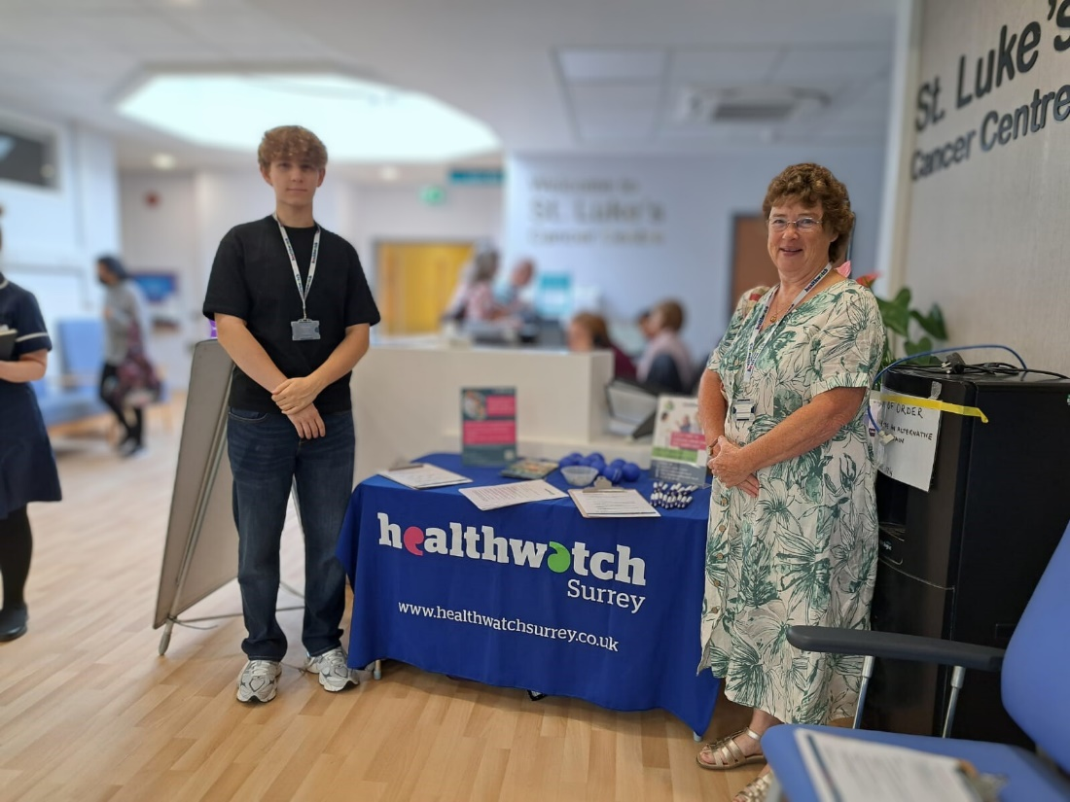

If you would like a paper copy of this document or require it in an alternative format, please get in touch with us.

Contents

About Healthwatch Surrey 3

Engagement event at St Luke’s Cancer Centre, Royal Surrey County Hospital. 3

What people told us 4

Positive experiences 4

Would people share feedback? 5

Have you given any recent feedback about your care? 6

Do people think giving feedback brings any changes? 6

What one thing would have improved your experience? 7

Hearing about St Luke’s at another engagement 8

Thank you 9

Recommendation 9

Healthwatch Surrey – Contact us 10

# About Healthwatch Surrey

Healthwatch Surrey is an independent service, empowering the residents of Surrey to have their voices heard. We seek out people’s experiences of health and care services and share these with service providers and decision makers, to support services to improve and tackle health inequalities. We believe that health and social care providers can best improve services by listening to people’s experiences.

We also provide advice and signposting to help the people of Surrey find the care that best suits their needs. Any urgent or concerning experiences within this report have been escalated to the appropriate teams. All appropriate information and advice and signposting to complaints processes has already been given.

# Engagement event at St Luke’s Cancer Centre, Royal Surrey County Hospital.

Healthwatch Surrey staff and volunteers visited St Luke’s Cancer Centre in July 2023 to speak with patients, and their families and carers, to:

1. Improve people’s understanding and awareness of how to share their feedback through compliments, complaints (including advocacy support) and Patient Advice and Liaison Service (PALS).
2. Understand people’s perceptions of how effective the hospital is in listening to and acting on feedback.
3. Understand enablers and barriers to people sharing feedback.
4. Provide the hospital with recommendations for improvement from people accessing their services.

St Luke’s is a regional cancer centre so people are often referred by other NHS Hospitals in Surrey and beyond and may live outside Surrey. These responses have been included as they refer directly to their experience of care at St Luke’s. Some people shared experiences relating to other NHS services which will be shared with other providers where appropriate.

We asked people questions about their understanding of how to give feedback. We also asked if there was one thing that would have improved their experience and have identified some themes below.

In addition to the event at St Luke’s, people have also shared their experiences of cancer care during our community engagement events throughout Surrey. Some of these experiences have been included in this report.

### Who we spoke to

During our visit, we spoke to 17 people. We also heard from 3 people during other community engagement events. 16 people consented to sharing additional information about themselves.

# What people told us

## Positive experiences

We heard that people were happy with the care provided by St Luke’s:

“Everyone is very friendly, smiley and efficient. The communication is good. It feels like I am getting the best service in the world.”

195361 July 2023

“St Luke’s have been supportive. I phoned at 2 am with a question about symptoms and got an answer.”

195206 July 2023

We spoke to 2 patients who had opted to travel a long distance to receive care:

“I live in West Sussex, but my nearest cancer centre is St Luke’s. Originally, I was told I needed to go to Portsmouth but asked if I could come to St Luke’s.”

195205, July 2023

“I lived in Godstone and then moved to Orpington temporarily but am now planning to come back to Surrey. For continuity of care, I chose to be treated at St Luke’s.”

195206 July 2023

### Do people know how to share feedback?

We recognise there are multiple opportunities for people to give feedback and make complaints, such as Patient Advice and Liaison Services (PALS), Friend and Family Test, Local and National Patient Experience Surveys and online methods.

We designed the questions to find out peoples’ knowledge of how to give feedback and whether any methods were more well known than others.

We asked people if they had heard about PALS or the Friends and Family Test. Of the 17 people we spoke to at St Luke’s, 2 had heard about and used PALS (at hospitals outside of Surrey). None had heard about the Friends and Family Test.

## Would people share feedback?

We heard that people were prepared to give feedback, however would only do this if they felt something serious had happened:

“I would give feedback - It would have to be something drastic for me to give feedback.”

195205 July 2023

“Yes, I would give feedback if I felt it was serious.”

195198 July 2023

However, people also shared that they do not know how they can provide feedback:

“There must be some way of [providing feedback], but I don’t know.”

195205 July 2023

“I wouldn’t know how to give feedback. I would get in touch with the main switchboard and ask to be put through to cancer services.”

195198 July 2023

## Have you given any recent feedback about your care?

None of the people interviewed had given feedback to Royal Surrey/St Luke’s about their experience. Most told us that they had experienced good care and were very grateful.

We observed that due to good experiences, people were reluctant to say anything when things went wrong.

## Do people think giving feedback brings any changes?

We heard that people did not know what difference giving feedback would make:

“I gave feedback to the Cancer Specialist Nurse at my local NHS Hospital about a poor experience with cancer surgery but I was unsure if this ever got passed on.”

195198 July 2023

The Shepperton Cancer Support Group (all of whom received treatment at St Luke’s) were approached to be interviewed about the Hospitals Project. All attendees (8) declined to be interviewed as they said that giving feedback did not make any difference. An email from the group organiser said;

“Regrettably there weren't any takers in giving feedback and although some used to do it, they don't bother now as nothing really changes No explanations were sufficient to persuade anyone to change their minds.”

195721 July 2023

## What one thing would have improved your experience?

We heard that peoples’ experiences at St Luke’s were good. However, people were able to offer some suggestions as to how their experience could be improved.

### Communication and information

“I feel that mistakes are often no one’s fault but do feel staff shortages have had an impact on my partners care; for example we had to come back the following day because the drugs for the infusion were not available on that day. This happened a couple of times and we were not advised. One thing to improve the experience is clear and accurate information on appointment letters. Twice he received a letter dated after the scan had been booked for [gastro oncology]. This was a waste of resources and created unnecessary upset. Surely an email or text message would be more efficient.”

195204 July 2023

“I would improve the problem of waiting times [radiology appointment] – there should be greater communication around what we can expect.”

195366 July 2023

“My only improvement would be the procedures can be hard to get your head around. I would like a display of facts and details about procedures that is simple to consume. Too much information is given, and important information is difficult to take in.”

195364 July 2023

### Car parking

Half of the people we spoke to, suggested the car park as the part of their experience they would like to improve:

“The only thing I would change is the parking, you need to make the time to get here to ensure you get a space.”

195361 July 2023



“The oncology parking area is good but other areas are not. People are double parked and over yellow lines. I once parked accidently in the Nuffield Hospital parking area and received a £100 fine. The signs were there but when you’ve got lots of things going on in your head about your appointment and your treatment it is hard to concentrate. The building is bolted on to the main hospital as well so it’s not clear. The Fountain Centre helped me draft a latter to the parking company asking them to revoke it but they are still proceeding so I am now writing to my MP.”

195359 July 2023

### Environment

On the day of our visit, the café had been temporarily relocated due to refurbishment works, and this impacted on the available waiting environment:

“There are no chairs in the changing room and no TV in the [radiotherapy] waiting room. I would like that to be improved.”

195360 July 2023

## Hearing about St Luke’s at another engagement

We also hear experiences about St Luke’s during our engagements across Surrey. We were able to share the experience cited below with St Luke’s and the situation has been resolved, however this circumstance highlights the importance of enabling people to share their experience:

“My partner was taken to A&E last night via ambulance. He was having difficulty breathing and it's never happened before, and we are all terrified. He was diagnosed with head and neck cancer in January. He has had 3 sessions of chemotherapy and 6 weeks of radiotherapy at St Luke's. He finished that 3 weeks ago. We got a letter then to say they will be making us a follow-up appointment for 6 weeks’ time. I've tried calling the number on that letter so many times to check that appointment is being made and about his breathing but no one ever answers. I've left so many voicemails and not one gets replied to. We have never been given a dedicated nurse contact or team or even a Macmillan nurse. I have no support, we feel abandoned.” [This experience has been previously shared with St Luke’s]

195519 July 2023

The people we spoke to at St Luke’s did not know about the opportunities available to give feedback. From what people told us during this visit to St Luke’s, what we are hearing on our engagement events and via our Helpdesk is that people are not aware of the opportunities to provide feedback which could improve staff morale and provide information and experiences to improve and develop services.

# Thank you

We would like to thank everyone who shared their experiences with us, our volunteers who assisted us during our engagement session, and to the hospital staff team who welcomed us into the hospital.

# Recommendation

We recommend that Royal Surrey Hospital review how they communicate with patients their families and carers about the available means to provide feedback and complaints. We suggest that the importance of feedback is highlighted to encourage more people to share their view whether positive or negative, and people are provided with clearer information about the range of opportunities to provide feedback including PALS, the Friends and Family Test and independent options such as Healthwatch Surrey.

# Healthwatch Surrey – Contact us

Website: [www.healthwatchsurrey.co.uk](http://www.healthwatchsurrey.co.uk)

Phone: 0303 303 0023

Text/SMS: 07592 787533

Email: [enquiries@healthwatchsurrey.co.uk](mailto:enquiries@healthwatchsurrey.co.uk)

Address: Freepost RSYX-ETRE-CXBY, Healthwatch Surrey, Astolat,

Coniers Way, Burpham, Guildford, Surrey, GU4 7HL

Facebook icon [healthwatchsurrey](https://www.facebook.com/healthwatchsurrey)

Twitter icon [HW_Surrey](https://twitter.com/HW_Surrey)

Instagram Icon [healthwatch_surrey](https://www.instagram.com/healthwatch_surrey)

LinkedIn icon [Healthwatch Surrey](https://www.linkedin.com/company/healthwatch-surrey/)