Insight bulletin

  - August 2023

About Healthwatch Surrey
One of the statutory duties of Healthwatch Surrey is to share Surrey residents’ experiences of health and social care with the people and organisations who make decisions about those services. This report aims to highlight the topics that people have shared with us in the past month.

If you would like a paper copy of this document or require it in an alternative format, please get in touch with us.

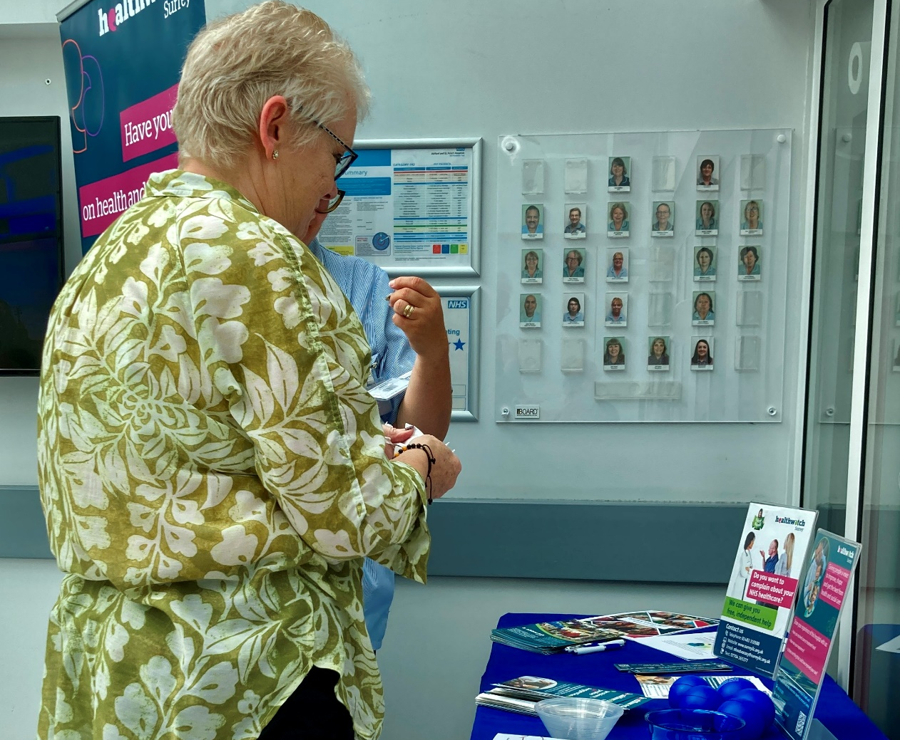

Who we have heard from
This month 110 people have shared their experiences of health and care services with us through our community engagement, Helpdesk, Independent Health Complaints Advocacy service, and via Healthwatch England. In August, we visited projects supported by the 2023 Community Cash Fund, Ashford and St Peter’s Hospitals, a community café and library in North West Surrey, and in conjunction with Giving Carers a Voice at a leisure centre in East Surrey.

The map on the page below shows the geographical spread of those people who have shared their experiences with us in the last month, with darker areas (Guildford, Runnymede, Spelthorne and Reigate and Banstead) representing more people.

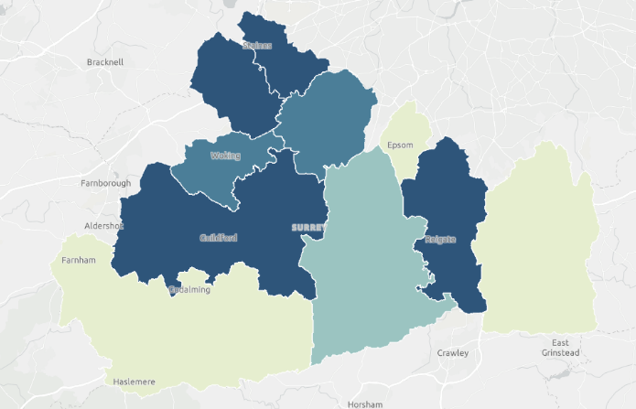

Of the people who shared their demographic information:
- 58% have long-term conditions
- 34% consider themselves to have disabilities
- 18% identified as carers
- 16% are from minoritised ethnic communities.

The word cloud below shows the different themes people told us about, with the top one again being quality of care, followed by complaints handling, referrals, and mental health. This includes both positive and negative remarks.

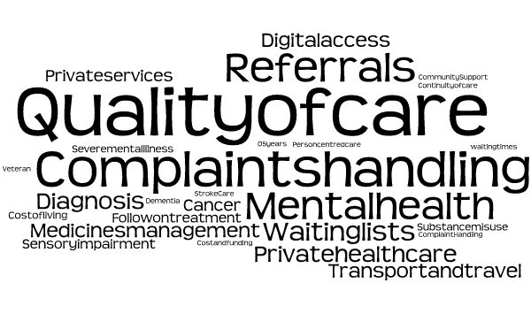

If we hear a case of concern regarding patient safety, we immediately signpost the sharer to the appropriate body and escalate the case with the provider/commissioner/safeguarding as appropriate.

If you would like to know more about a particular topic or service, please get in touch.

Praise and thanks
We recognise the importance of sharing what’s been a good experience for people, and we often hear of positive examples of care for a wide array of services.

“I am in remission for prostate cancer. I think the services and the treatment I have had has been excellent, truly excellent. My cancer treatment was back in 2017 at Royal Surrey County hospital.” 196679, Community Drop-in Café engagement

“Boots in Horley is fantastic. I’ve lived in this area for 40 years and they give such great personal service. There is one particular assistant who is wonderful and we have known for years.” 196789, Leisure Centre engagement

Paying for services
We have been hearing from people who have said that they have felt “forced to go private” as a result of not having their needs met by NHS services:

“I had breast cancer 5 years ago... Last month… I found another breast lump and could not get past the [GP] receptionist for an appointment for a referral. In desperation my daughter paid for a private appointment to gain referral into hospital. It is about time surgeries kept back at least one appointment a day for urgent referrals and not expect patients to keep ringing back each day at 8am to join a queue which results in ‘ring back tomorrow at 8am.’” 196357, Healthwatch England

“My partner has Alzheimer’s. I went privately to get him diagnosed as our GP ‘forgot’ to refer him to the memory clinic for a whole year. Now another situation has developed and so far I am getting nowhere… In late July I used Patch to contact the practice and expressed my concern. It is now the 12 August and the only thing I have been offered is a phone call from a GP on the 22 August.” 196660, Healthwatch England

Community Cash Fund 2023 - Supporting those aged 16 to 24
In April 2023, we awarded grants up to £1500 to help small groups start or build upon local projects in the community aimed at supporting young people aged 16 to 24. We’ve been catching up with these groups and the people benefitting from them to talk about their experiences of health and care.

We heard the impact that community groups have had on people’s lives by providing valuable support:

“I come to Twister every week. My mum found it for me. Here I am safe, amongst my type of people…Twister gave my mum the details for GenderGP. I've been on puberty blockers for 6 months through GenderGP. It's very life changing to get the healthcare I need.” 196179, Community Cash Fund Engagement

People also told us about improvements in communication and awareness that they feel would be beneficial:

“I wish health professionals would learn and educate themselves more about the trans community and the way we need to be treated… I went to an orthodontist last year to have braces off and the dentist saw my name had changed and asked me lots of questions. It was invasive and unnecessary, nothing to do with the work he had to do.” 196179, Community Cash Fund Engagement

However, we have also heard that people have been appreciative of the efforts made to get people’s pronouns correct:
“At Royal Surrey Hospital they ask which pronouns I prefer. They understand me and understand trans… I'm having gynae endo keyhole surgery soon... The consultant asked about my pronouns so they could let everyone know in the team. That was nice.” 196208, Community Cash Fund Engagement

You can read more about what young people told us mattered to them, in our report ‘What we’re hearing from children and young people’ on our website. If you would like to know more about our work with children and young people then please contact adam.connelly@healthwatchsurrey.co.uk.

Communicating information
We often hear from people who tell us how communication between services or to patients directly impacts on their experience but also on the quality of care that they receive:

“I’m waiting for an operation at [one] hospital. I saw the consultant there on 7th June but I haven’t heard anything more yet. I did have an MRI at [another] hospital before that but the two hospitals didn’t communicate my results with each other.” 196751, Leisure Centre Engagement

“I received a text message from my GP practice, I presumed about a hospital letter following a blood test. I phoned the practice, they did not know what I was talking about [when I mentioned the text]. Medication? No. I had to mention the hospital letter. [They] came back and have an appointment 3 weeks later. Still waiting to see someone. Very disappointed.” 196356, Healthwatch England

“Told I have kidney disease over text!” 196665, Healthwatch England

“We have also been trying to get a hospital bed at home for my mum, she keeps on having falls which is why they keep taking her in to the hospital. We have been sent round the houses trying to get a hospital bed for mum, to try and start reducing the risks of her falling. The OT at [the hospital] has said it is not for them, the community OT has said that it is not for them, I have been in contact with her GP to try and get a bed, but they don't seem to know the system well enough. The practice manager has been helping, but we are really struggling to get anywhere it with.” 196666, Healthwatch Surrey Helpdesk

“I suppose the only improvement would have been around communication after the operation. They did surgery and I was left with a problem where they had cut in and I have been left incontinent and have been wearing incontinence pads since. Apparently, I found out about a year later the exercises they gave me for pelvic floor, I hadn’t been doing properly, I had no idea really and the pamphlet I was given I couldn’t understand really, I thought I was doing them ok but didn’t realise how important they would be. When the person explained to me recently, I understood more clearly what I was doing wrong, so I guess that would have been a big improvement for me if I was clear from the start.” 196679, Community Café Engagement

Medication issues
We continue to hear from people who are struggling to access a range of medications and the lengths they are having to go to, to try and resolve this. People are often given conflicting information which adds to the confusion and frustration felt by many:

“I have been trying to sort out some medication which hasn’t been able to be fulfilled by the pharmacy, it’s been a bit of a palaver. The medication is Letrozole, and the pharmacy are usually really good, but they can’t get hold of it. I asked if I could get my other drugs from the same prescription but they were explaining to me that if they dispense from the prescription the other drugs then I need to get a voucher for that medication and will have to wait for them to source it.
[The pharmacy] suggested I went back [to the GP] and ask for an alternative medication to be prescribed. The alternative medication the pharmacy suggested, apparently costs too much and so they won’t prescribe any new meds.” 196678, Community Café Engagement

“Long term diabetic prescribed Semaglutide 1 mg. Previously on 10 insulin injections daily with a very high HbA1c of 133. Awaiting double transplant for kidney and pancreas. This is keeping my blood glucose stable and at 33. It took 12 years to get a drug that worked. Prescribed and order placed with chemist. Chemist said the drug was no longer manufactured and would never be available. Didn’t tell me for 3 months. Finally asked them in desperation what was happening and they said they only had 0.5 mg but would not release it to me as my prescription was for 1 mg. I tried explaining the importance and how two shots of 0.5 would make 1 mg.

I have sourced [an alternative pharmacy] who has the Semaglutide. Could not get [original pharmacy] to release the prescription without getting assertive and demanding they release my prescription which was distressing. I feel lied to and very unhappy the chemist can restrict access to long term meds.” 197033, Healthwatch England

Community engagement plans
During August our engagement team focussed on visiting projects supported by the 2023 Community Cash Fund. We also visited Ashford and St Peter’s Hospitals, a community café and library in North West Surrey, and in conjunction with Giving Carers a Voice, a leisure centre in East Surrey.

During September our community engagement team will be visiting Surrey Downs. We will also be visiting several university and college Fresher Fairs and will be at Royal Surrey County Hospital’s Community Day.

Date | Place | Time | Surrey Area
06.09.23 | Epsom Hospital Oak Suite, Epsom (Public) | 10am –  12noon | Surrey Downs
11.09.23 | Ewell family centre, health visitors baby clinic (Service users only) | 9.30 - 11.15am | Surrey Downs
11.09.23  12.09.23 | East Surrey College Freshers Fair (Public) | 10am -4pm | East Surrey
15.09.23 | Addlestone Advice and Information Hub, (Group members only) | 2 – 4pm | North West Surrey
18.09.23 | Fairfield Centre, Leatherhead (Group members only) | 10am –  12noon | Surrey Downs
19.09.23 | Include Choir, Epsom (Group members only) | 6 – 7.30pm | Surrey Downs
20.09.23 | Roots community café, Epsom (Public) | 10am –  12noon | Surrey Downs
20.09.23 | Royal Holloway Volunteering Fair (Public) | 10am – 3pm | Northwest Surrey
22.09.23 | Dorking library, Dorking (Public) | 10am –  12noon | Surrey Downs
23.09.23 | Royal Surrey County hospital, Guildford, Community Day (Public) | 10am – 3pm | Guildford and Waverley
26.09.23 | Foodbank at Merland Rise Church, Tadworth (Service users only) | 10am –  12 noon | Surrey Downs

Please note: these dates may be subject to change.
To share an experience with us, people can also contact our Helpdesk in the following ways:
Phone: 0303 303 0023
SMS (text only): 07592 787 533
Email: enquiries@healthwatchsurrey.co.uk
Share your feedback via our website: https://www.healthwatchsurrey.co.uk/feedback-centre/

Our distribution list
If you would like to be added to or removed from the distribution list for this Insight Bulletin, please contact our Communications and Involvement Officer vicky.rushworth@healthwatchsurrey.co.uk.

