Enter and View Programme – effectiveness of feedback mechanisms in care homes.

Summer 2023

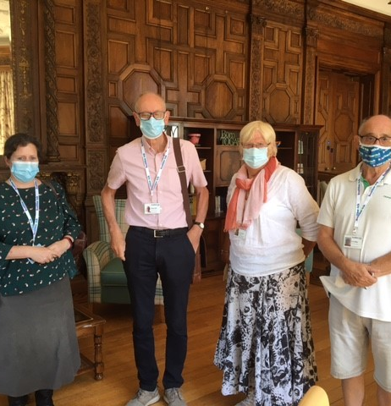

If you would like a paper copy of this document or require it in an alternative format, please get in touch with us.

Contents
Executive summary 3
Background 4
Objectives 5
Summary of findings 5
Where we visited 6
Who we heard from 7
Evidence of feedback mechanisms from our Enter and View visits 8
Feedback from the family and friends survey 10
Care home-specific insight around feedback 13
Thanks 19
Healthwatch Surrey – Contact us 20

Executive summary
Healthwatch have a legal power to visit health and social care services and see them in action. This power to Enter and View services offers a way for Healthwatch Surrey to meet people within health and care settings and allows us to identify what is working well with services and where they could be improved.

Through a combined method of face-to-face Enter and View visits, paper questionnaires and an online survey, we received 135 pieces of feedback about care homes in Surrey, from residents, families and staff between May 2022 and June 2023.

Our main focus was to find out about feedback mechanisms, as it’s vital that care home residents and their families feel able to speak out and have their voices heard. Work by Healthwatch England Our position on complaints in the NHS and social care shows that;
‘Only some people want to make a formal complaint. When services focus on encouraging and acting on informal feedback, this can empower patients to speak up through informal routes, avoiding the complexity of a formal process while giving services the same opportunity to learn and improve.
We know that many people would like to share feedback with services on how they could improve, but only a small proportion do. The most common reason for this is that people don’t know how to share concerns.’
On the whole we found that a range of feedback mechanisms existed, and residents and their families were satisfied with how to feed back to staff at the home. Many of the residents who we spoke to told us that they would be happy to raise a concern with staff members, some would speak to the manager straight away, others would speak to their main carer or, in one particular home, the activities coordinator was often used to relay concerns.

Two thirds of our family and friends survey respondents told us that, if they weren’t happy with their family member’s care, they were very confident in what to do and who to raise it with.
However, it is worth noting that half of our respondents had previously raised a concern. Of those who hadn’t previously raised a concern, around one in ten did not feel at all confident in what to do.

We are aware that our interviews did not represent all care home residents (we did not speak to residents with dementia - and our survey indicates that this is the reason for living in residential care for approximately 50% of our respondents’ family members). We are also aware that that our friends and family survey respondents do not represent all carers.

Previous Healthwatch Surrey work shows that sometimes service users and their families are reluctant to complain due to fear of repercussions: Healthwatch Surrey Adult Social Care for Adults and Health Select Committee. This corresponds to Healthwatch England’s findings.
Healthwatch England research showed that fewer than half of those who experience poor care actually report it:
Healthwatch England Complaints Summary- Suffering in Silence.

One of our respondents told us, when asked about raising concerns:

“I did just that, often in several care homes over 10 years. Also advised CQC! Suffered as result and caused breakdown in relationship with management. Seriously chastised for contacting CQC, and for doing as CQC requested, “check with other relatives, to ask them to report their problems if they had any”. They did. Moved to another placement.”

In our survey, we also asked about satisfaction with their family member’s care at day, night and the weekends, well as awareness of personalised care plans. In the light of Covid -19 restrictions, we also asked about visiting arrangements, more detail on these questions is available on request.

Background
Healthwatch exists as the independent champion for users of health and social care services, and we want to hear feedback about all aspects of NHS and social care services. For reasons including the Covid-19 pandemic, Healthwatch Surrey has not heard from many care home residents or their families, and we have recognised this as an important gap in our insight. Surrey County Council, (SCC), the Care Quality Commission (CQC) and Surrey Heartlands (SH) also felt that they were not hearing from care home residents and their families.

We discussed our concerns that care home residents, and their families and carers were not having their voices heard with system partners, and concluded that a series of Enter and View visits, conducted by Healthwatch as an independent organisation, and supplemented by a wider reaching survey, would be helpful in ensuring that all residents and families have equitable access to sharing feedback and making complaints about the care and services they are accessing.

Enter and View visits to Care Homes were included in our Healthwatch Community Engagement Strategy 2022-23, in order to enable us to hear more from care home residents, their families and carers.

Objectives
To identify and share good practices in ensuring that residents of care homes and their families have adequate feedback mechanisms and make recommendations for other services to make improvements.

This programme of work also enabled us to hear from a community of people who we were not reaching through our other engagement methods and provided an opportunity to amplify their voices in respect to their experiences of other health or care services.

Summary of findings
In order for feedback to work effectively as a vital part of service improvement, opportunities to give feedback need to be accessible and communicated well; and people using services and their families and carers need to feel confident and supported to give that feedback without any fear or repercussions. A transparent “You said, we did” demonstration of how feedback is acted on demonstrates the value of providing feedback.

During our Enter and View visits, we found that there were many different feedback mechanisms in use across the care homes, such as residents’ meetings, suggestion boxes, surveys, and an iPad at reception for family and friends to give feedback. Many care homes told us that they had an ‘open door’ policy and residents, and family member were welcome to talk to staff at any time.

Our survey revealed that two thirds of respondents (families and carers) were very confident they’d know how to raise a complaint and who to raise it with.

Where we visited
SCC and CQC provided a list of suggested homes to visit. The intention was to visit one care home per month for the duration of 2022-23 in line with our community Place-based engagement strategy. However, Covid outbreaks in two of the homes disrupted these plans.

We also ran a survey alongside these visits to encourage feedback from as many families and carers covering as many homes across Surrey as possible.

How did we decide which care homes to visit?
We used the suggested lists provided by SCC and planned in conjunction with CQC to ensure we did not clash with other planned visits.

Criteria for care homes: all to be on the SCC council list, with at least two residents to be council funded (in order that our statutory Enter and View powers applied).

As shown in the table on the following page, we visited care homes in line with our Engagement Spotlight months for each of the Places in Surrey.

Month | Care home | Place
May | Charlton Grange | Northwest Surrey
June | Elmfield | Surrey Heath
August | Greathed Manor | East Surrey
September | Priory Court | Surrey Downs
December | Beaumont Lodge | Surrey Heath
February | White Gates | Northwest Surrey
March | Brownscombe Care Residences | Guildford and Waverley

In addition to face-to-face visits, we also ran an online and paper survey for friends and family which we sent out in advance to the care homes that we visited. The survey ran from May 2022 until June 2023. Links to the survey were distributed via care homes’ own newsletters, in Surrey County Council’s Surrey Matters online magazine and promoted on Healthwatch Surrey’s communication channels and by other stakeholders.

Who we heard from
In total, we gathered 135 pieces of feedback. During our 7 Enter and View visits, we spoke to 34 residents, 48 members of staff and received feedback from 27 friends and family (some of the friends and family experiences came via our online survey and some were gathered at the time of our visit).

We also heard from 26 other family and friends about 17 other care homes via our online survey.

These were:
Arbrook, Broadwater Lodge, Martham House (2), Kingsleigh Care home, Coppice Lea, Woodside View, St Catherine’s manor, Loughta House, Chestnut view, Kingsbury Court (2), Queen Elizabeth Park (2), Combe House, The Grange, Old Wall Cottage, Windmill Manor (3), Shannon Court and Acorn Court.

Evidence of feedback mechanisms from our Enter and View visits
Residents told us that if they had a problem they would speak to staff. Depending on what the issue was, some would speak to care staff, the nursing staff or management. If the issue was not resolved, sometimes the resident would involve a family member.

Overall, family and friends told us that they were confident in what to do and who to raise any concerns with. Staff all told us that if an issue was raised with them, they would either try to deal with it themselves or escalate to the correct person.

We saw evidence of different feedback mechanisms throughout the homes we visited. From suggestions boxes, “You said, we did” displays, notices about residents’ meetings, an iPad for visitors to share feedback/ request a meeting with staff, to a complaints procedure prominently displayed, to care review postcards at the entrance.

We only struggled to see any feedback mechanisms in one home, where information about the complaints procedure was displayed at the top of a notice board, meaning it was so high on the wall that it was difficult to read.

Across our Enter and View visits, we made a number of recommendations. On the whole these were around activities and menus.

We only made recommendations about feedback mechanisms in two cases:
In one case we highlighted the fact that there seemed to be an over-reliance on the activities coordinator to deal with any concerns. Our recommendation was:
- Ensure that families and residents are aware of the formal complaints process. There could be a risk of over-reliance on the activities coordinator to escalate issues.

In another case we highlighted the fact that the complaints process was difficult to find.
- Ensure the complaints procedure is visible (it is currently positioned very high up in a display).

Examples of feedback mechanisms from the 7 visits that we carried out.
A suggestion box in a reception area.

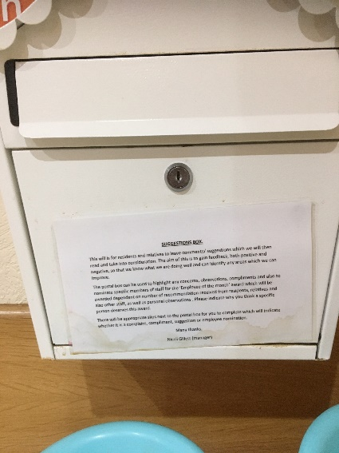

A ‘You said, we did’ display.

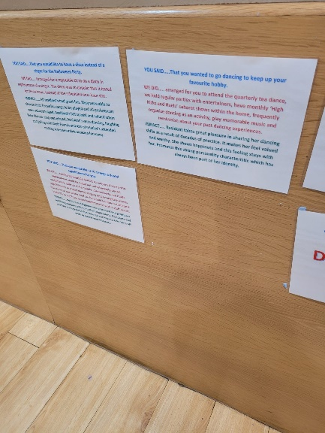

A residents meeting poster, a complaints procedure poster, an iPad and ‘review us’ postcards with a suggestions box.

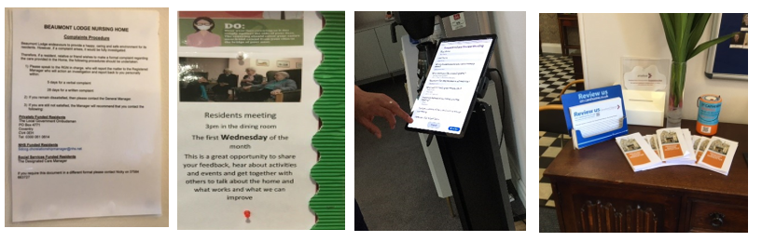

The complaints procedure below was difficult to see as it was at the top of a display board, close to the ceiling.

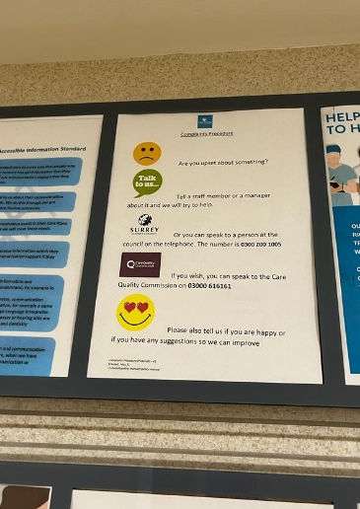

Feedback from the family and friends survey
From the family and friends’ feedback, as shown in the bar chart below, two thirds of our respondents were very confident they’d know how to raise a concern and who to raise it with. However, half of our respondents had raised a concern in the past, which might explain their motivation in responding to our survey, so their confidence levels may not necessarily be representative of friends and family of care home residents more generally. Of those who hadn’t raised a concern in the past, around one in 10 were not at all confident in knowing what to do or how to raise it with.

Level of confidence in how to raise a concern.
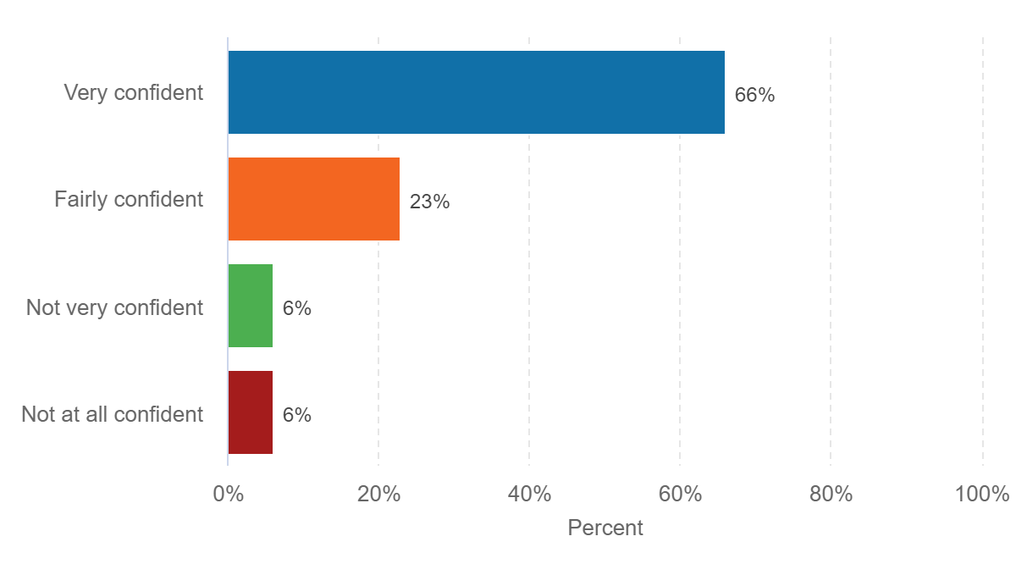

Positive feedback regarding raising a concern:

“I have a great rapport with the staff, if l wasn’t happy with anything, l would go straight to them.”

“Very approachable management, always make themselves available if needed and will help in any way possible.”

“The senior staff at the home are approachable and concerned for my mum's welfare.”

Negative feedback about raising a concern:

“[Should I complain to] SCC or the care home? - it’s never clear.”

“Because I have complained in the past to various bodies and unfortunately find myself having to regularly complain about my relative’s care.”

“I did just that, often in several care homes over 10 years. Also advised CQC! Suffered as result and caused breakdown in relationship with management. Seriously chastised for contacting CQC, and for doing as CQC requested, 'check with other relatives, to ask them to report their problems if they had any. They did. Moved to another placement.”

The pie chart below shows that 49% of respondents had raised a concern in the past.

Have you raised a concern in the past?

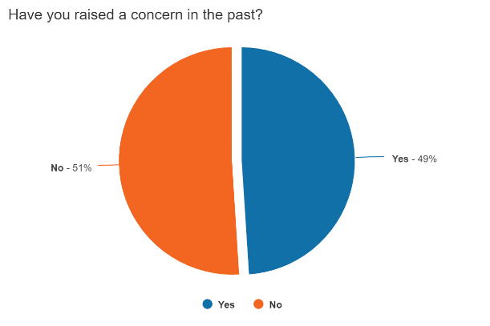

Half of those who had raised a concern, had been very satisfied with the response, as shown by the bar chart below.

Level of satisfaction with process of raising a concern.

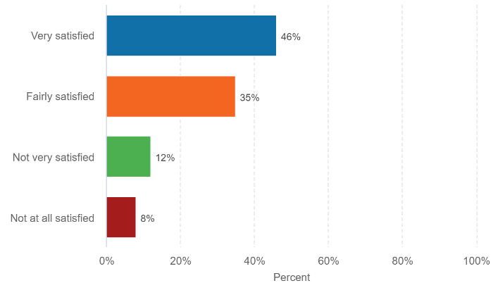
Reasons for satisfaction were around responsiveness of the staff, and speed of fixing the problem.

“The staff immediately took measures to sort it out.”
“Easy to do.”
“It was sorted in a matter of days.”
“Concerns resolved quickly.”

Reasons for dissatisfaction were regarding lack of communication and changes not being made:

“Around 18 months ago I raised issues with regard to the heating and hot water system in the home, which broke down on several occasions during an extended period of time. I raised this issue with the manager and then had to escalate on several occasions to the regional manager. I was not given any updates on the situation unless I chased them up.”

“Sometimes emails were not acknowledged from the manager.”
“No change seen in enrichment activities.”

Care home-specific insight around feedback
Charlton Grange
The overall impression we had was that residents, families and staff are all very happy to raise issues with any member of staff, and they will be resolved. Family members felt very confident that they’d know what to do - which was generally to raise it with senior management. No one we spoke to had ever had a need to raise a more formal complaint and therefore weren’t aware of any more formal feedback mechanisms.

Elmfield
There is a regular tenants coffee morning and a more formal residents meeting where any issues can be raised, such as missing laundry items and feedback about food. Residents and family members are all happy to raise issues with any member of staff, and they will be resolved. Family members felt very confident that they’d know what to do, - which was generally to raise it with the registered manager, or with the owner. No one we spoke to had needed to raise a more formal complaint and therefore weren’t aware of any more formal feedback mechanisms. We saw a suggestions box in the dining room.

“If I wasn’t happy with something I would ask my carer, and tell my daughter, or go to the office.”

There was a good level of knowledge concerning the processes for managing complaints within the home and it was evident that staff took ownership and would aim to resolve any complaints and concerns as soon as possible. One staff member said,

“We speak to them and they will say little things that will let you know what we could do better.”

Staff were aware of the need to escalate concerns or complaints if they were not able to resolve them and the manager had processes in place to document and monitor complaints. This meant it was possible to identify learning from complaints.

Greathed Manor
It was apparent that there was good communication between residents, their families, staff and the manager. We saw a suggestion box in the entrance hall, and we were told by residents and a family member that a questionnaire had been circulated the day before our visit.
One resident told us:

“If I wasn’t happy with anything I would speak to the manager, if that didn’t help then I would go to my family.”

Staff working at all levels had a good understanding of the need to manage complaints and concerns – they would try to resolve minor issues themselves and would escalate more significant concerns to their manager, the care coordinator or the nurse depending on what the issue was.

One staff member said they would try to gauge how serious a complaint was and would offer to take the conversation into a private area if the person wanted to discuss issues further. Another staff member said:

“I will make changes to resolve issues if I can or tell the manager if needed.”

A family member told us that:

“in terms of complaining, I feel I could trust them with my family member, they are responsive to any suggestions made.”

Priory Court
We heard that the staff and manager are always available to discuss any concerns.

“The Manager is always available to talk to.”
“The Manager is on top of my concerns. I have had two so far and had been resolved quickly.”
“Very approachable management always make themselves available if needed and will help in any way possible.”

Family and residents can request a meeting with staff via the iPad which is installed in the entrance foyer.

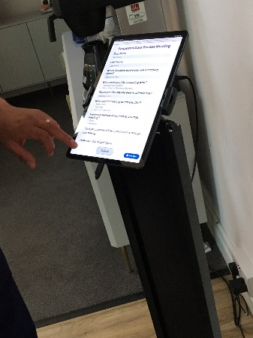

Staff told us that people were supported to raise concerns and make comments when they wished to do so. Information about how to raise concerns was on display and all of the staff spoken with were aware of the policies and told us they would take action if concerns were raised. Staff would resolve minor issues if they were able to do so and would escalate to more senior managers if this was appropriate.

Staff reported good relationships with the families of the people who lived at the home and said that family members would raise any concerns with them or via email with the managers if this was what they wished to do.

Beaumont Lodge
There appears to be good communication between residents, their families, staff and the manager.

The complaints procedure was clearly displayed in several locations.

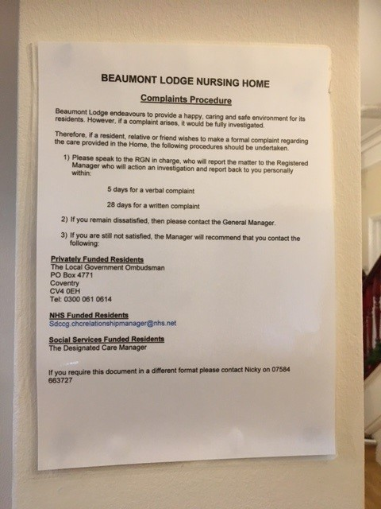

All residents and family members who we heard from said that if they raised a concern, it would be acted upon, and that they knew what to do if they had an issue.

One resident told us:

“I complained that they were getting me up too late, and staff brought it earlier.”

Several residents told us that if they had a problem, they’d raise it with the activities coordinator, who clearly has a good rapport with many of the residents.

“I’d speak to [named activities coordinator]. If nothing improves, she would go to the manager.”

Another resident told us:

“If I’m not happy, I’d complain, to [named activities coordinator] or the manager.”

Another said,

“If I had a problem I’d tell [named activities coordinator].”

N.B. the activities coordinator was present during all of these interviews, so perhaps the residents referred to her as she was ‘top of mind’.

Residents clearly feel very comfortable with sharing any issues with the activities coordinator. However, we would recommend that residents are reminded of the formal complaints process, and alternative pathways to escalate problems. We are concerned that there is an over reliance on the activities coordinator.

All staff we spoke to had a good understanding of the need to manage complaints and concerns – they would try to resolve minor issues themselves and would escalate more significant concerns to the nurses or the manager.

A resident told us:

“If I wasn’t happy, I’d speak to a nurse. I haven’t needed to raise a concern but I’m sure they’d listen.”

A family member fed back:

“I am confident in how to escalate a problem if I’m not happy. The manager is very approachable, and any concerns are dealt with quickly. I have raised a concern and I was very happy with the process. “
One staff member said:

“If there was a problem with a resident, the resident will inform the manager or the nurse in charge.”

White Gates
We were told that a survey is sent to family members every four months, which is looking at what can be improved. This is reported back as ‘You said, we did’. We were told that there is an open-door policy for families to speak to the manager and nursing staff. If a family member has any concerns about isolation or engagement, they are encouraged to telephone staff.

We also saw evidence of regular residents’ meetings.

When we asked family members about raising a complaint, twelve out of fifteen were confident they would know what to do and who to raise it with.

“The senior staff at the home are approachable and concerned for my mum's welfare.”

“There is usually someone available to speak to.”

“I would just ask at reception; they are very friendly and helpful.”

“When I have made any complaints, they have taken care of it.”

Half of the respondents had raised complaints in the past and all but one were satisfied with the process.

“It was sorted in a matter of days.”

Brownscombe Care Residences
Information about complaints was difficult to see - it was positioned in the top row of a display board very close to the ceiling.

This display board also included out of date information about Advocacy service available in Surrey (this service is no longer provided by Surrey Disabled People’s Partnership (SDPP)).

Residents told us that said that if they had a problem, they would either deal with it themselves by speaking to the manager, or the nurse if it was medical, or they would ask a family member to get involved.

One resident told us;

“I would see the manager, Alison, who would sort it. I’d be happy to do this on my own.”

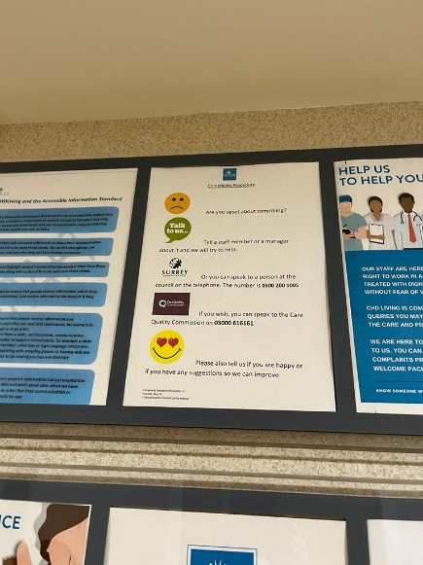
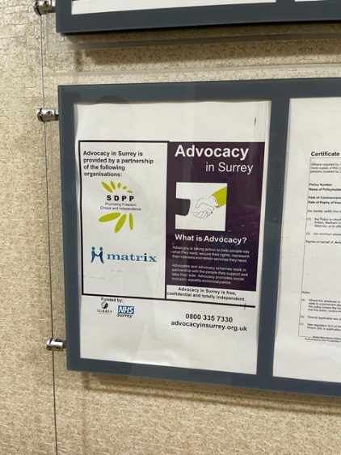

Thanks
Healthwatch Surrey would like to thank everyone who participated in this project, from the residents, their families, staff, and management who spoke to us on our Enter and View visits, to the people who shared feedback via our friends and family survey, and not forgetting our team of Authorised Representatives who conducted interviews and helped shape the reports.

Healthwatch Surrey – Contact us

Website: www.healthwatchsurrey.co.uk
Phone: 0303 303 0023
Text/SMS: 07592 787533
Email: enquiries@healthwatchsurrey.co.uk
Address: Freepost RSYX-ETRE-CXBY, Healthwatch Surrey, Astolat,
Coniers Way, Burpham, Guildford, Surrey, GU4 7HL

@HW_Surrey
@healthwatch_surrey
/healthwatchsurrey
Healthwatch Surrey

