Insight Bulletin

  - July 2023

About Healthwatch Surrey
One of the statutory duties of Healthwatch Surrey is to share Surrey residents’ experiences of health and social care with the people and organisations who make decisions about those services. This report aims to highlight the topics that people have shared with us in the past month.

If you would like a paper copy of this document or require it in an alternative format, please get in touch with us.

Gathering and sharing insight
The map below shows the geographical spread of those people who have shared their experiences with us in the last month, with darker areas representing more people.
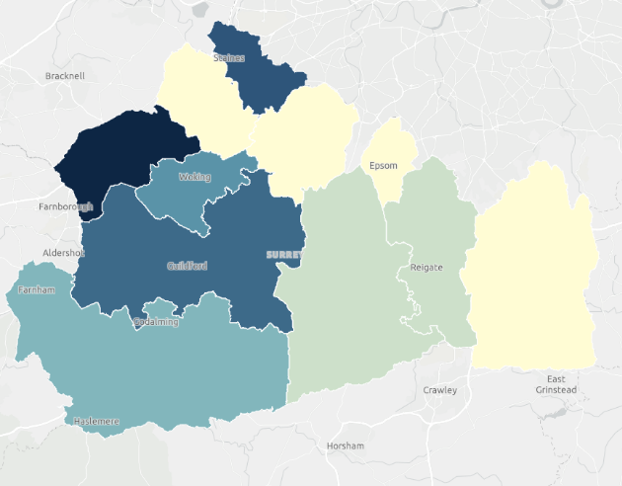
Throughout July, we have visited locations in Surrey Heath, North West Surrey and Guildford. We have spoken to people in libraries, at a community day, at health visitor sessions and at a veterans hub. Other people have been in touch to share their experience with our Helpdesk, the Independent Health Complaints Advocacy service and via Healthwatch England.

123 people shared their experiences with us. The word cloud below shows the different themes people told us about, with the top one again being quality of care, followed by cancer (largely as a result of our visit to St Luke’s Cancer Centre), waiting times and digital access. This includes both positive and negative remarks.
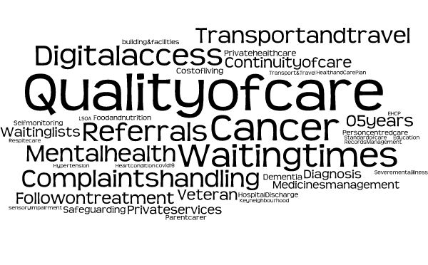
If we hear a case of concern regarding patient safety, we immediately signpost the sharer to the appropriate body and escalate the case with the provider/commissioner.

If you would like to know more about a particular topic or service, please get in touch.

Praise and thanks
We recognise the importance of sharing what’s been a good experience for people, and we often hear of positive examples of care for a wide array of services.

I thought the midwife was lovely and I had the same one most of the time. The birth centre at St Peters was good, staff were good. 195728, Health Visitor drop-in clinic, June 2023

My GP [Guildowns] is excellent. 3 months ago I got a text saying we haven't seen you in 5 years, please make a blood pressure check appointment with the nurse. I thought that was very proactive of them. A month ago, I did need the GP though. I rang at 8am… They answered at 8.15 am and I told them I thought I had a UTI. At 8.25am, the doctor called me back, asking me to send a urine sample in… so gave a sample that morning. Dropped it in and upon arriving home, 10 minutes later, the GP called to say a prescription for antibiotics was at the chemist! I was so impressed. 195737, Veterans Hub July 2023

I've spoken to my doctor [at Park Road Surgery] about my mental health. It started when I had seen him about tinnitus. Since then, he sees me quarterly for a chat, he's my man, he's who I want to talk to, he's organised some medication for me too which helps me. 194230, Library, July 2023

I needed to visit Hillview Medical Centre twice in the last month. On both occasions I sent the online form at 8 am, received a phone call from the GP and had a face to face appointment the same morning. Caring and efficient consultation. Excellent service. 195749, Healthwatch England, July 2023

Really happy with St Luke’s Cancer Centre. Cancer caught early so just having radiotherapy…I’m so happy with my care, they are great here. 195200, Hospital engagement, July 2023

Breastfeeding week 2023
1st-7th August is World Breastfeeding Week supported by World Health Organisation and UNICEF. In honour of this week, we are sharing what people have told us recently at family centres, parent & toddler groups and health visitor drop-in sessions, about the support that they have received regarding breastfeeding.

During a visit to a health visitor drop-in clinic at Eastwood Leisure Centre, we heard about good support:

I was impressed with the breastfeeding team they were really supportive, they also gave video calls as help. After my son was born they found he had tongue tie on day one and this was sorted out quickly. I had a history of mastitis with sepsis and so they kept a close eye on me and I felt well looked after. 195728, Health visitor drop-in clinic, May 2023

People elsewhere have mentioned that they would have appreciated more information on breastfeeding to help prevent issues:

I wish I had more information about the post-partum days especially breastfeeding but got this support when readmitted [2 days after birth]. 194574, Surrey Hospital,
July 2023

We have also been told that some people would like to see changes to how the subject of breastfeeding is approached:

I found the antenatal care really mixed depending on who I was seen by. I was asked about my intentions to breastfeed multiple times. It felt like I had to start from scratch each time and that was frustrating. 192854, Family Centre, June 2023,

I had some issues feeding which resulted in a private visit to the cranial osteopath. I’ve got nipple trauma and it’s been painful feeding, also thought that my little one had tongue tie. I came along to the breastfeeding clinic here, they told me they thought it was his jaw rather than tongue tie and suggested I went to the cranial osteopath. I did feedback about the drop-in breast clinic as I felt very awkward talking about bleeding nipples with other women there. I fed that back at the end of the session and the person said they don’t want to stop women chatting about problems together in an open session as they thought it was beneficial. I would have rather had a private one on one chat. 195728, Health visitor drop-in clinic, July 2023

Support needs in the community
During our visits to libraries, we have spoken to people looking for specific information relating to health conditions including Parkinson’s and the menopause who have not been able to access any information.

Libraries also provide help from ‘digital buddies’ and organisations such as Citizen’s Advice who hold sessions in some libraries. Some people who are attending often have a number of issues they require support with such as paying bills online, Personal Independence Payments and Pension Credits. Their priorities are often to address their financial needs over health. For example, when we asked people attending if they would use the NHS App to access services we heard “I'm not at all interested in the app,” and “I feel like a totally forgotten demographic… I don't have a computer or a phone so how can I use this. I would want to look at my blood test results but I am excluded from this because I am not digital.”

Some people have also told us that they are affected by a reduction of support available to them in the local community:

My daughter has recently had a baby. She has a big gap between her two children [10 years]. What she has noticed a change in, is baby weigh in type clinics. Previously, she could turn up, now most have to be booked in. There is only one place she can turn up to in her locality and that is Addlestone, which from Thorpe isn't the nearest.
It puts a lot of pressure on new parents, it isn't making life easier. 195201, Library, July 2023

There used to be a lot more baby groups with my first two but there doesn’t seem as many or they are all booked up. 195728, Health visitor drop-in clinic, July 2023

Response to emergencies
This month we have heard from people who felt they needed the support of an ambulance to get to hospital. They have been frustrated with waiting times and have not felt able to get to hospital themselves:

My wife fell on Monday at lunch time. We phoned 999 as we have done before. The service was very busy but said they would aim to have someone come out to help lift my wife in a couple of hours. We waited until 8pm, when we received a call from the ambulance service, recommending that we get some neighbours to come and help lift my wife on the bed.

My daughter and son-in-law came over and helped lift my wife on to the bed, but the ambulance did not come out to check her over. However, they did arrange for a doctor to come out and check my wife over later in the evening, and we had a visit from a nurse the following morning to ensure my wife was ok. I have my own health conditions, including a recent surgery that took place last Friday, which impacted on my ability to lift my wife. 194480, July 2023, Helpdesk

I had issues last year in my neck with some lumps. The GP dismissed me, saying I was fine. I went home and felt really ill next day and ended up needing an ambulance. It came the following day! Taken to [hospital] and discovered I had 3 blood clots. I stayed in a few days and now on blood thinners and feel ok. 195732, Veterans Hub, July 2023

111 [requested an ambulance] after my pregnant wife was experiencing pain. Ambulance arrived but asked me to take my wife to the hospital and left after doing checks. Condition of wife deteriorated and another ambulance was called. This was a van and unable to transport patients, the original crew then returned to take my wife to hospital. The baby was delivered but did not survive. I have questions regarding the process of examination and transportation of my wife. 195506, Supported by Independent Health Complaints Advocacy, July 2023

Access to GP surgeries
We continue to hear about people’s experiences of trying to get to grips with how to access care through their GP surgeries and how important it is to communicate with and involve people in changes to access routes:

My doctor’s practice [has merged] with another practice... It used to be so good but now it's not accessible. I used to use the My GP app, it was meant to open at 8am-2pm but it then started to open for an hour only until 9am… I don't know what system they are now wanting us, as patients, to use. You try to email and phone but no one gets back to you. Then you'll suddenly get a phone call to say that they have booked an appointment, but they hadn't checked with me first. I work full time and I don't get the chance to check my personal emails all the time.

2 months ago, my daughter had eczema. I sent pictures to the surgery and was told that she would get a prescription, and this would be sent to the pharmacy. This was Thursday and by the Tuesday, there was still no prescription at either of the pharmacies that I use. I then phoned the surgery and was told that my daughter should have seen a doctor… My original call hadn't been logged with the GP. I then had to wait for a call from the GP. Why, when they had the photos? I had to chase this. I did get the prescription in the end.
The doctors are lovely there, but the system is terrible. They keep changing how you book appointments and no-one knows what's happening. 194429, Community day, July 2023

Understanding the communication needs of patients also makes a big difference to how they can support themselves:

I saw a clinical pharmacist for a heart check-up and I had high cholesterol and was referred to GP. I had a call from the GP, all my appointments were done over the phone which I didn’t feel was ideal, as I think it took longer. I was given information in a text in the form of links to websites, which I then had to click through and access myself. I can just about use my smart phone but for me, I would have welcomed a printed out information sheet on paper, as I found the amount of information overwhelming. I wasn’t sure what was relevant and what wasn’t. I found it hard to pull together everything I’d seen and had to write notes as I only accessed the websites via my phone and I kept losing track of where I had seen something. 194482, Library, July 2023

Community pharmacy
We are increasingly hearing more about people’s experiences with pharmacies. This month we have heard of good support:

I try to avoid the doctors and use the pharmacist a lot… My pharmacy advises me and gives a better service than the doctors. 195735, Veterans Hub, July 2023

However, people also continue to share the issues they are having, particularly around availability of medications:

[My local pharmacy is] terrible. Long queues all the time. You queue with your prescription, get to the front to find they don’t stock it. Even if they do, then you have to come back later while they get it ready, and queue again. Not great for older people who can’t stand for long periods. There is only one Pharmacist and no service while they are at lunch.
194608, Healthwatch England, July 2023

…the [pharmacy] next to the GP is rubbish. They never had Insulin for me so I went elsewhere. 195735, Veterans Hub, July 2023

Had to try 3 different pharmacies before I could find one with Nitrofurantoin 100mg prolonged release capsules in stock and no local pharmacy had Ovestin cream in stock - had to wait a week and make another trip to pick up. 194503, Healthwatch England, July 2023

Community engagement plans
Our spotlight for engagement sessions in July was North West Surrey.

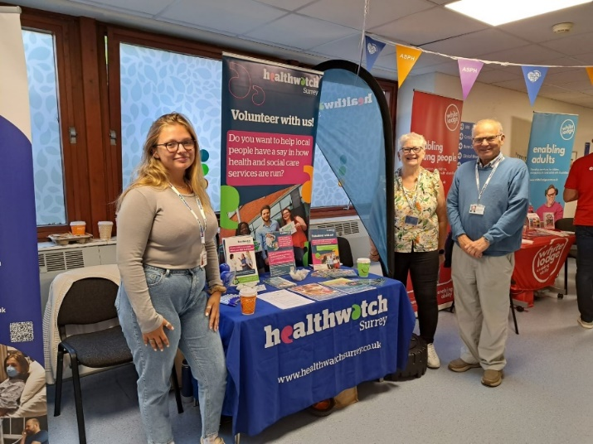

During August our community engagement team will be listening to young people and visiting some of the winners of our Community Cash Fund. We will also be listening to people’s experiences at Ashford and St Peter’s hospital and have several awareness raising presentations led by our comms team.

Date | Place | Time | Surrey Area
04.08.23 | Twister LGBTQ+ youth project  (Group members only) | 6 – 8pm | Northwest Surrey
07.08.23 | St Peter's Hospital  (Public) | 10 – 12noon | Northwest Surrey
07.08.23 | Hideaway café - Matrix  (drop in - Group members only) | 11am – 1pm | Guildford & Waverley
14.08.23 | Ashford Hospital  (Public) | 10 – 12noon | Northwest Surrey
14.08.23 | Macular Society presentation - Leatherhead (Group members only) | 2 – 3.30pm | Surrey Downs
29.08.23 | Macular Society presentation – Cranleigh (Group members only) | 2 – 4pm | Guildford & Waverley

Please note: these dates may be subject to change.
To share an experience with us, people can also contact our Helpdesk in the following ways:
Phone: 0303 303 0023
SMS (text only): 07592 787 533
Email: enquiries@healthwatchsurrey.co.uk
Share your feedback via our website: https://www.healthwatchsurrey.co.uk/feedback-centre/

Our distribution list
If you would like to be added to or removed from the distribution list for this Insight Bulletin, please contact our Communications and Involvement Officer vicky.rushworth@healthwatchsurrey.co.uk

