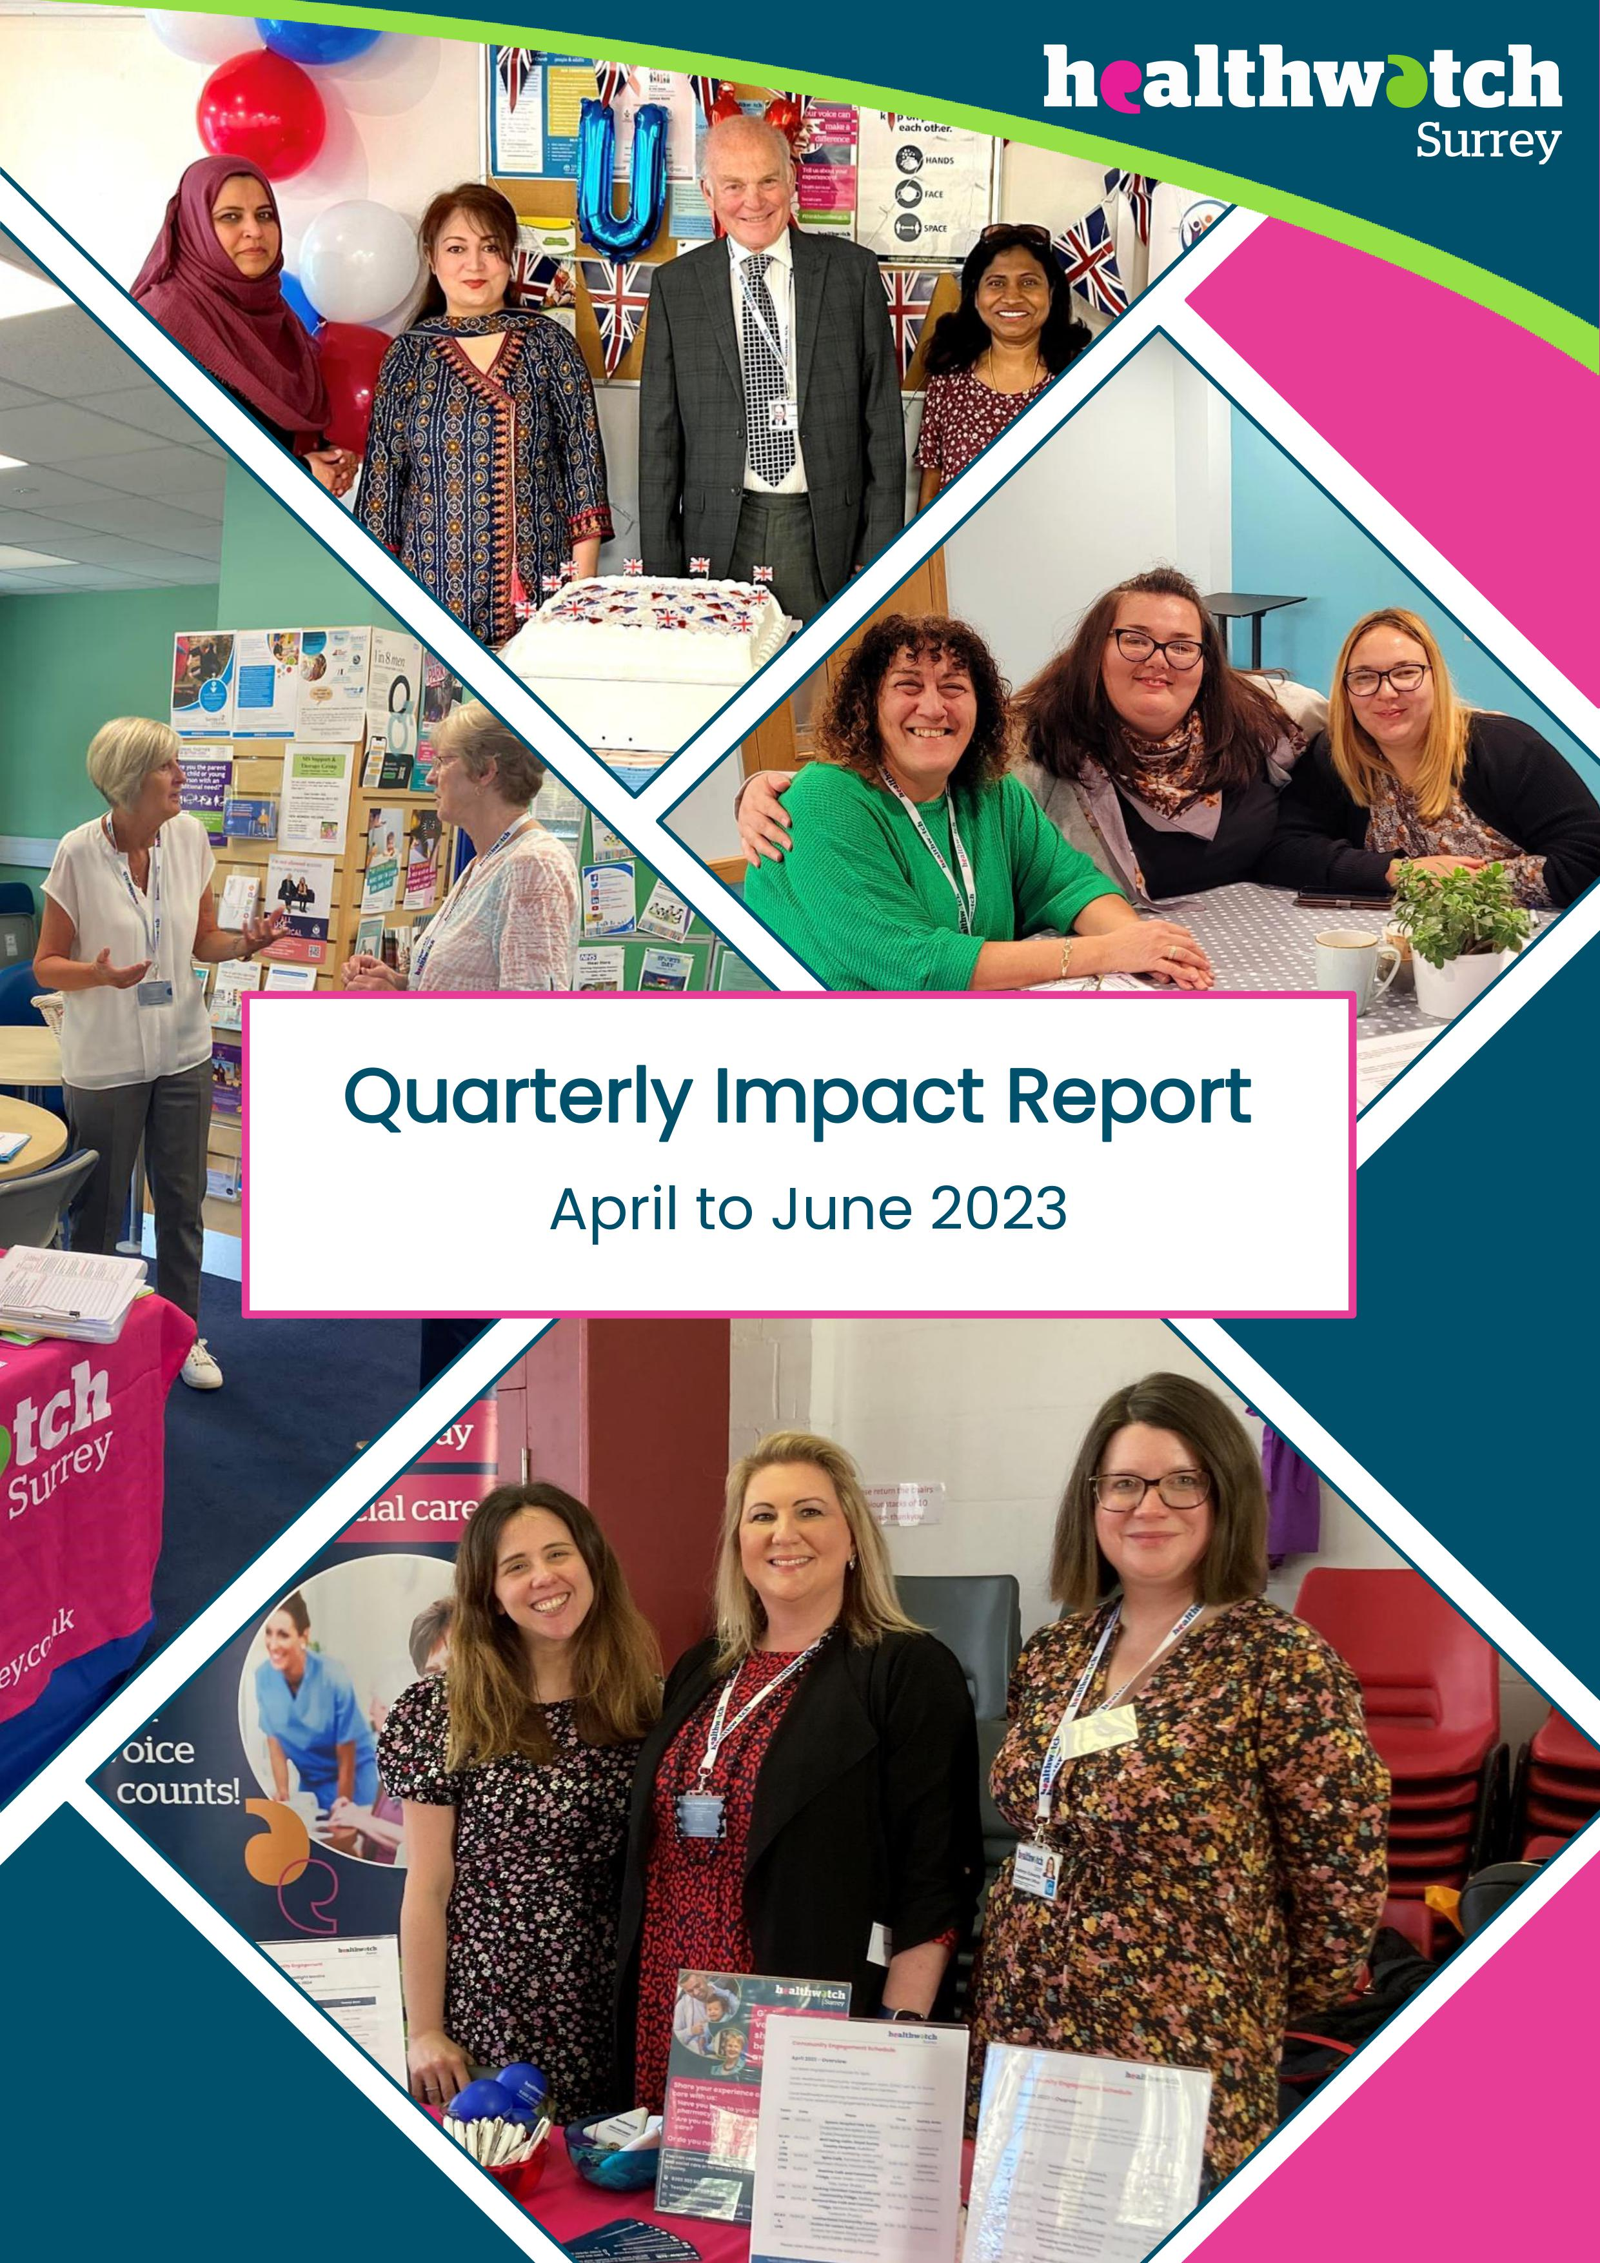Healthwatch Surrey logo

**Quarterly Impact Report**

April to June 2023

Quarterly Impact Report

April to June 2023

**“Helping shape health and social care services in Surrey”**

If you would like a paper copy of this document or require it in an alternative format, please get in touch with us.

# Contents

Contents 2

Highlights 3

Listening to Your Voices 4

Information and Advice 5

Helpdesk 5

Providing Information in the Community 6

Our Priorities 8

Access to Primary Care 8

Mental Health 9

Social Care 11

Involvement of People 13

Tackling Health Inequalities 15

Advocacy & Complaints 18

Independent Health Complaints Advocacy 18

Healthwatch Surrey – Contact us 20

# Highlights

## Summary

**126 People supported through Helpdesk**

87 **People supported by Advocacy**

446 **Hours provided by our volunteers**

## Key achievements: new opportunities for listening

**Accessing primary care:** Our primary care insights have been shared within Surrey Heartlands GP Newsletter, enabling your feedback to be heard by GPs across Surrey (page 8).

**Social care:** Building connections with the Customer Support team in Surrey County Council to help tackle concerning cases more appropriately (page 11).

**Mental health:** New patient experience forums established at Surrey and Borders Partnership NHS Foundation Trust and the Mindworks Alliance where we can share experiences directly with service managers (page 9).

**Involvement of people:** Increased collaborations with other voluntary sector organisations helping us reach more residents and hear from people less well heard by the system (pages 13 and 15)**.**

# Listening to your voices

The activity of Healthwatch Surrey centres around the voices of Surrey residents. Our aim is to empower people to share their experiences and champion involvement at every level of decision-making in health and care.

This quarter we completed a review of our service to ensure we are remaining true to these aims and focus our future work on what matters most to Surrey residents. Listening closely to experiences shared with us, in discussion with our volunteers and advisory group, looking at our previous insight and identifying the challenges in the system, we decided on four priority topic areas which will focus our work for the next 3 years:

* Access to Primary Care
* Social Care
* Mental Health
* Involvement of People

These priorities will be focussed on ensuring that a diverse range of voices are heard. We are designing our engagement programme to visit communities most at risk of health inequalities and whose voices are less well heard. We will also continue to listen out for emerging themes and concerns and work closely with colleagues in health and care services to do this. Alongside this, we will prioritise ensuring that information and advice available to Surrey residents through our own service, as well as more widely, is meeting their needs.

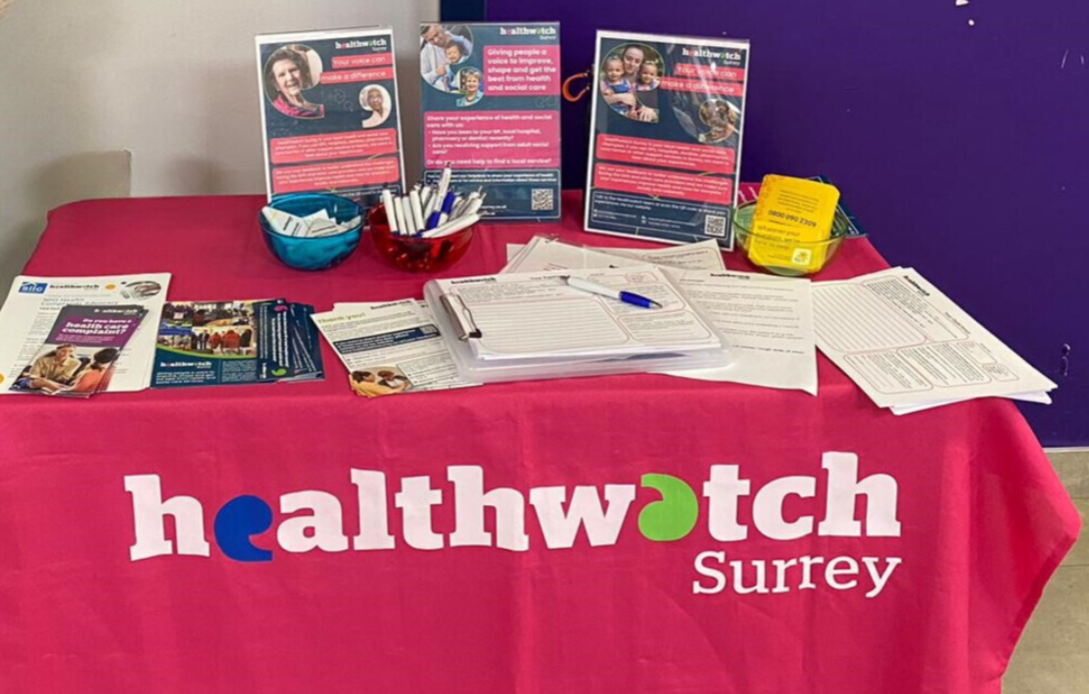

# Information and advice

## Helpdesk

Since April 2023, our Helpdesk service has been operated within the Healthwatch Surrey staff team. The service continues to provide vital information and advice to Surrey residents. Better integration with our wider team has already enabled greater access to support to advise people thoroughly and quickly identify opportunities to escalate experiences and concerns further where necessary.

The following experience is a great example of our new Helpdesk model being able to support people to access the care they require while also sharing these experiences more widely to improve services for other Surrey residents.

### Arthur’s* experience

Arthur was seeking support in booking a Covid-19 vaccination for his wife who was unable to leave her home due to ill health. He had previously booked through his GP Practice however, the practice no longer offered this and did not provide an alternative option.

Our Helpdesk Advisor advised Arthur to contact the vaccination helpline 119, however after trying for a couple of days, he was unable to get through to an advisor. He remained concerned that, as he believed his wife was registered as a patient who requires home visits with the GP practice, that this would affect his ability to book an appointment. Our Helpdesk Advisor contacted the 119 advice line on behalf of Arthur and confirmed all of the information he required to get a vaccination booked, that this was suitable for a home visit and also to confirm the right numbers to press to navigate the automated system and speak directly with an advisor and book the appointment. This information was then passed on to Arthur.

#### Outcome for Arthur and his wife:

Arthur was then able to book an appointment for his wife:

‘Thanks to your clear precise instructions I’ve at last managed to start the booking procedure. Apparently, the NHS covid vaccination booking service will now get back to us to confirm a time and date.’

Arthur confirmed a suitable appointment had been booked within a week.

#### Wider impact:

We shared this experience with a clinical lead at Surrey Heartlands prompting a conversation about the differences between a GP’s definition of a person who requires home visits and a patient’s understanding, which could be leading to confusion about what services are available. This conversation prompted the Surrey Heartlands team to look into how they could clarify the terminology to provide residents with clearer information.

* Names have been changed to protect identities.

If you have an experience to share, contact our Helpdesk via:

**Phone:** 0303 303 0023

**SMS:** 07592 787533

**Email:** [enquiries@healthwatchsurrey.co.uk](mailto:enquiries@healthwatchsurrey.co.uk)

**Website feedback form:** [https://www.healthwatchsurrey.co.uk/feedback-centre/](https://www.healthwatchsurrey.co.uk/feedback-centre/?fbclid=IwAR2SRvElHX8cv0ez7uvNwNDO1ejYw3jqRcgxGg3Hky44vmWkSxXxlLPx9JE)

## Providing information in the community

Our community engagement brings information and signposting to community settings across Surrey, supporting people to learn more about the services available and how to access care appropriate to their needs.

We visited Oxted Community Centre in May listening to older residents’ challenges about getting an appointment with their GP and hearing their concerns about how access has changed. We talked about the triage process and what GP practices can now offer, reassuring people about their options for booking appointments and that they can see doctors in person if they prefer.

We also met with Ukrainian residents at events in Caterham to hear about the support they’ve received since arriving in Surrey. We heard positive experiences about services and that they had effectively been offered support screening services. We answered their questions about the triage system, the different services within primary care, their local pharmacy and wider services such as NHS 111 and the 0-19 Advice phoneline.

We chatted to a person caring for their autistic grandson whilst also being treated for lung disease. We discussed what additional support is available and how to access this, along with self-referral options such as talking therapies and Marie Curie for additional support.

A person who shared their experience with us about their poor eye care experience felt empowered to take their concern further. We signposted them to PALS and gave them details for our advocacy service should they need support with a complaint.

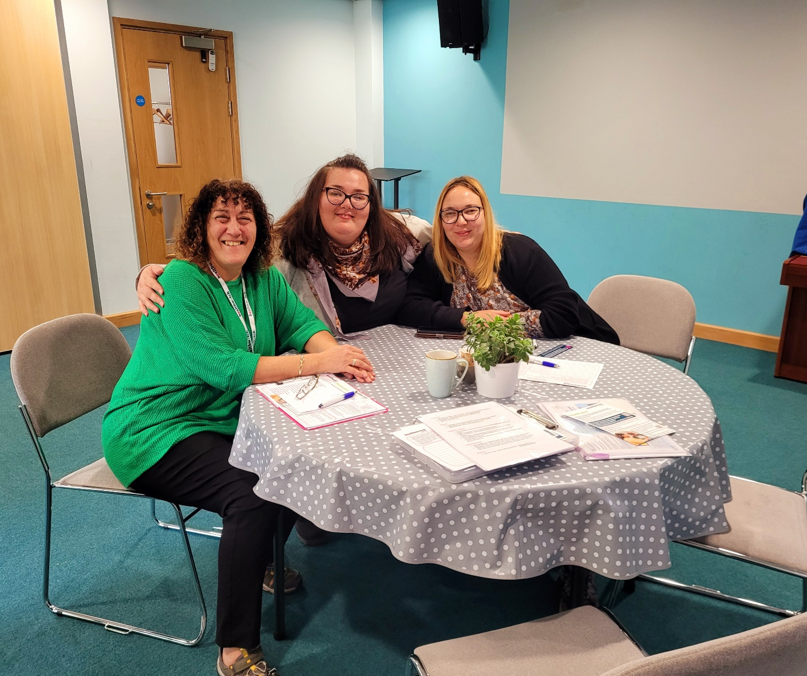

# Our priorities

## Access to primary care

Access to primary care has been an issue that the people of Surrey have told us about frequently in recent years. As a result, this is a key priority of ours. We have been regularly sharing people’s experiences of accessing their GP surgery in particular and have seen our feedback embedded into many improvements made in both Frimley and Surrey Heartlands.

We share our insight each month with the Surrey Heartlands Primary Care Access Board and the experiences shared by Surrey residents have informed part of the decisions and the design of new services. This quarter, our monthly update has been incorporated into the Surrey Heartlands newsletter that is shared with all GP practices. This will enable practices to hear more from patients and identify what patients would like to see improve. The primary care team have included tools for GPs to help drive improvement for patients accessing care.

We invited two members of the Surrey Heartlands Primary Care team to share details about their new support programme to help GP Practices develop and expand what they can offer their residents. We heard about how the feedback we’ve shared has informed improvements such as in Cranleigh where they are developing new approaches to communication to help address some of the concerns raised with Healthwatch during engagement in November 2022. We also heard how positive experiences demonstrate where things are working well and boost morale:

“Thank you so much for forwarding positive feedback to the surgery. Our entire team try so hard, and we have an incredible team ethic. […]The day we received the feedback, we had had a difficult day, with patient demand exceeding capacity, and everyone trying their best.[...] Your email was shared with the entire team, and it was incredible to see the positivity that spread as a consequence. You serve an important function, and it felt important to thank you for sharing positives, especially when the timing was so perfect!” June 2023

### Driving digital transformation

This quarter, we heard that feedback shared by Healthwatch Surrey had a direct impact on the redevelopment of Primary Care practice websites across Surrey. The [drivers of frustration](https://www.healthwatchsurrey.co.uk/report/review-of-remote-consultation-experiences-and-the-drivers-of-frustration-in-gp-access/) shared by residents helped the teams involved to identify the key problems and create a design that will help address these.

The Grove Medical Centre in Egham was the first practice to go live with the website and then the others will be staggered over Summer. There will be a 4-week process involved in the switch over which should include practices engaging with their patients to tell them about the changes, how it will work and also ensure practice staff are fully trained.

New websites will also include clearer information about opportunities for feedback and will provide details for contacting Healthwatch Surrey should residents require help with a complaint.

### Access to pharmacies and assessing pharmaceutical needs

Surrey’s Health and Wellbeing Board is responsible for ensuring that Surrey residents have adequate access to pharmacies. This quarter, we contributed to the Board’s response to revisiting the Pharmaceutical Needs Assessment following the closing of Lloyd’s pharmacies in Sainsbury’s. Locally people have raised concerns with us about the impact of the closures of some pharmacies, leading to longer and costlier travel times for example. We raised these concerns directly with the Health and Wellbeing Board who have committed to looking in more detail at the travel aspects of pharmacy access.

## Mental health

We have heard the challenges faced by many Surrey residents in accessing appropriate mental health support and we have set our priority to address this.

### New outlets for hearing experiences

This quarter we have built on good relationships with those providing mental health services to explore new ways of connecting the experiences we hear with the people that run services.

We have been invited to and attended a new service user Improvement Forum at Surrey and Borders Partnership which invites all the divisional service leads to share the feedback they’ve received and indicate where they have been able to make changes as a result. It also provides the opportunity to share feedback directly with service managers who are better positioned to act on this and provide more detailed responses. We will continue to share experiences in this forum and work with the patient experience team at Surrey and Borders Partnership to ensure that patient experience remains at the heart of decision-making.

The Mindworks Alliance is building a similar forum to focus on feedback regarding children and young people’s services, with a wider group of participants including more representatives from the voluntary sector such as Family Voice Surrey and Surrey Youth Focus. This provides the opportunity to share what we’ve all been hearing in one space, identify where the key themes are and make combined challenges to the decision-makers. This is more powerful and impactful than our previous approach, adding more weight to the experiences we share and enhancing the potential impact.

### Neurodiversity

In March 2023, we published our report on [Neurodiversity: the hidden value of diagnosis](https://www.healthwatchsurrey.co.uk/report/neurodiversity-the-hidden-value-of-diagnosis/), encouraging services to work closer with young people, their families and carers to ensure that any opportunities to provide support are identified.

We met with service users at the Autistic Reference Group to discuss our findings with people with lived experience of Autism Spectrum Disorder and associated conditions. The group were supportive of our work and welcomed further conversation about this topic. We were also invited to share at a meeting with the Heartlands Integrated Care Board non-executive directors, and with senior health and social care leaders at the Co-production and Insight Group for mental health services. Following this presentation, we have since made links with other organisations either supporting people with neurodiverse conditions or working on similar projects, collaborating to continue to raise the profile of this important issue.

We have also been invited to take part in a whole system event in September which will bring together a wide range of organisations such as schools, voluntary sector organisations, community group and mental health services to explore ways of tackling the current waiting list but also to design a service that better understands the needs of the population.



### Dementia care

Our volunteer Robert Hill has continued to champion our recommendations from our [Dementia project](https://www.healthwatchsurrey.co.uk/report/how-people-find-advice-and-support-to-live-well-in-the-early-years-after-dementia-diagnosis/), supporting the Dementia Strategy Partnership Board and representing the service user experience in the discussions. His participation in these discussions have enabled him to comment on the new guidance information being provided to carers and to challenge on the suitability of potential new commissioning options for Dementia Navigators.

## Social care

### New connections

Developing relationships with colleagues delivering services is an important step in us improving access and information for the people of Surrey. By sharing examples of the difficulties people have had in getting the support they need from Adult Social Care and barriers they have found to sharing those challenges, we are developing better connections to sources of information to share with people who need it. One example from this quarter is connecting with Adult Social Care customer service team, to share with them some of the difficult experiences we hear, and to understand more about how they operate. They have shared an Easy Read version of their complaints leaflet with us, which will help those we meet whilst on community engagement events as well as helping those who contact our Helpdesk. Two of our Engagement and Insight Officers have also been invited to attend a training session on Adult Social Care complaints, meaning that we can provide better informed advice to those seeking our help.

### Access to Care Act Advocacy

We’ve been increasingly hearing from Surrey residents looking to raise a complaint about their care arrangements. However, we have often been unable to successfully refer people to Care Act Advocacy and we’re concerned that people are not being heard as a result. Additionally, the people requesting support are particularly vulnerable which suggests the ability to complain is not equitable. We have connected with other charity sector colleagues who have experienced similar challenges, enabling us to jointly address commissioners with our concerns. As a result, this issue will feature on the agenda of the August Surrey County Council Partner Update meeting to establish how the service is supporting people who need it most.

In some cases, people raising concerns with us can help them to have their voice heard and access the help they need, without having to navigate a formal complaint procedure. One of the people we have been supporting through our Helpdesk came to us with a concern about her mother being discharged from the care home she is currently in, back into her care. She did not have direct contact with the social worker, so it was not clear to her if her mother was being discharged or not. With her consent, we were able to contact the Adult Social Care Customer Relations team, who then put us in direct contact with the social worker assigned to her mother's case. The social worker was then able to tell us what the plan is moving forward with the mother's care, which we in turn have fed back to the daughter, so she can decide what they would like to do next. The social worker who spoke to us said that they wanted to speak to us directly, as they are aware of who we are and that Healthwatch Surrey is usually the last port of call before a formal complaint is submitted.

## Involvement of people

### Influencing better listening nationally

We often hear from people who have been referred to us from other organisations, which can often be frustrating as they are repeating their stories at a time when they might be unwell or feeling particularly stress or anxious about an issue. We have recently had people being referred to us from CQC who could perhaps have been better supported elsewhere or before they reached us. By us sharing these examples with Healthwatch England, they were able to flag the issue with the CQC Contact Centre who will be reviewing the internal resources available to their staff. This means that residents of Surrey as well as elsewhere in England will be given better information and advice at an earlier point in their journey and receive a better service.

### Influencing better listening regionally

We have been collaborating with other local Healthwatch to provide our local ambulance service, South East Coast Ambulance NHS Foundation Trust (SECAmb) with regular examples of patient feedback that we have collected about their services. This feedback has been discussed at SECAmb's Patient Experience Group and helped to inform and shape some initiatives being developed by SECAmb to improve patients’ experience. They said the report allowed them "the opportunity to understand what our patients are saying in order for us to continuously improve." Amongst other projects, we heard that SECAmb have recently commenced a Quality Improvement project aimed at ensuring patients remain safe whilst waiting for an ambulance which will help mitigate some of the issues that were raised by Healthwatch.

As a result of Healthwatch feedback, SECAmb are investigating ways to communicate with the public about what to expect when you call an ambulance. They are aiming to develop this with Healthwatch and we will be supporting this by sharing with the public to improve their understanding of the process and improve experiences of accessing the service. In addition, we will be supporting SECAmb to create, along with service users and carers, methods of gathering direct feedback from those who may have experienced delays, to enable the service to learn from and improve.

### Listening in partnership

Healthwatch Surrey are always actively pursuing opportunities to work closer with our voluntary sector colleagues to hear from a wider range of residents. This quarter we conducted a series of joint engagements with Marie Curie, which has proved a positive experience for both organisations. It has been great to find out about and utilise the information and advice resources that Marie Curie provide. We have been able to direct people to both our services and the helplines that both Healthwatch Surrey and Marie Curie offer.

“The partnership with Healthwatch Surrey and the help both I and Maire Curie have received has been invaluable. It’s been really useful attending events with Healthwatch Surrey that have been set up through existing partnerships that you have. Listening and learning from the way Healthwatch Surrey asks questions and gains information (especially more difficult topics and how to open up discussion areas) has been helpful too, along with talking about and sharing some of the challenges we both face as organisations in the community.” **Marie Curie Engagement Officer, May 2023**

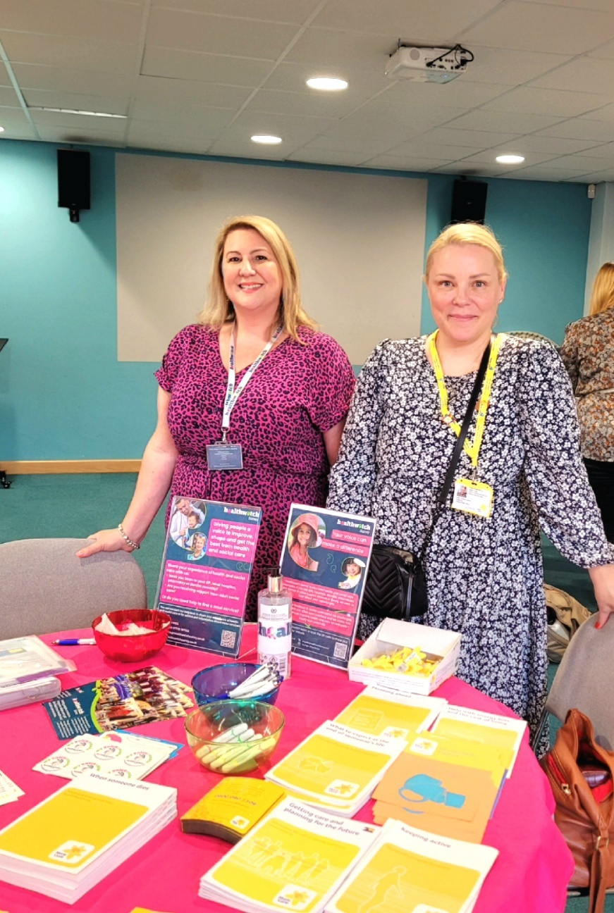

### Volunteers supporting involvement

This quarter some of our volunteers took part in PLACE Lite assessments at Ashford and St Peter’s hospitals. On this occasion they were visiting sites within the hospital and looking at the following:

* Cleanliness, condition and appearance
* Dementia-friendly environment
* Privacy, dignity and wellbeing.

Our volunteers were able to provide comments and suggestions for areas of improvements for patients as well as speaking to patients and sharing their feedback.

Last year, we supported in establishing a Stroke Survivors and Carers Panel to support the Integrated Stroke Delivery Network. Our volunteer, Mary Probert, has continued that support by attending the June meeting of the panel. Mary also shared an opportunity for members of the group to get involved with work by South East Coast Ambulance Service NHS Foundation Trust looking to improve the patient experience whilst waiting for an ambulance as part of their ‘Keeping Patients Safe in the Stack' (KPSitS). By connecting organisations with people who have relevant, direct lived experience and encouraging their contribution, services can improve to better meet the needs of those using it.

### Volunteers raising challenges

Some of our volunteers help to support the sharing of residents’ experiences in a variety of meetings, raising the importance of involving people in the development and design of services. Some of our volunteers also provide vital support with reviewing meeting papers and briefing staff members on the themes or gaps in the information, helping to identify where best to make challenges.

## Tackling health inequalities

We have heard clear messages from Surrey residents about what we need to focus on, however we are also aware there are voices we haven’t yet heard and we are working to ensure we do. Our community engagement programme is planned around the available data regarding health outcomes and the population, enabling us to visit places where we believe help and support are needed most, and perhaps hear voices that aren’t heard as readily as others. Our [upcoming events](https://www.healthwatchsurrey.co.uk/news-and-events/events/) are detailed on our website.

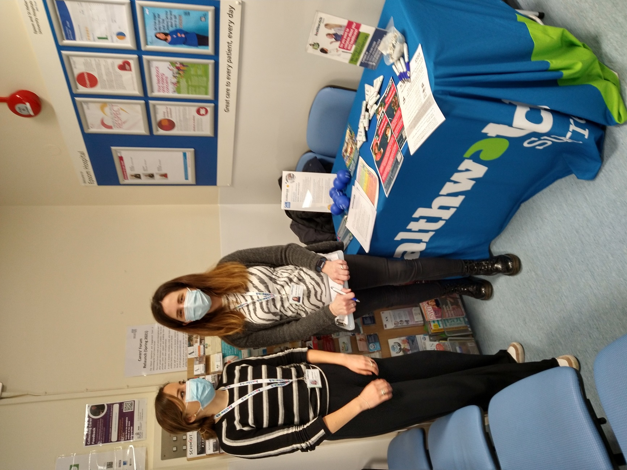

The Department for Health and Social Care (DHSC) has launched a Call for Evidence to seek views on how major conditions can be better prevented, diagnosed, treated and managed. Those working in health and care services, local government, the voluntary and community sector, and wider industry are also invited to contribute views on how best to tackle one or more of these major conditions and improve the lives of patients living with them. We have been able to support Surrey Heartlands in their submission of evidence by providing insight into people’s experiences of living with major conditions and their experiences of services providing support. Surrey Heartlands told us that: “Hearing from individuals who have lived experience, either as patients, services users carers or staff is crucial to delivering a strategy that tackles England's burden of disease”.

### Collaborating to amplify voices

We continue to build our relationships with our colleagues in the voluntary sector and are always looking for opportunities to collaborate to ensure opportunities for residents to be involved in service design are widely shared.

In November 2022, we, along with other VCSE organisations, were asked to be witnesses for Surrey County Council’s Health Inequalities Task Group which was set up to explore health inequalities for three priority populations in Surrey namely:

* Minoritised communities, especially Gypsy Roma Travellers
* People experiencing homelessness, drug and alcohol abuse.
* People experiencing domestic abuse.

The task group made a number of recommendations based on their learning from the witness sessions.

“Can I once again thank Healthwatch on behalf of the task group for your extensive contributions to this project on health Inequalities within Surrey”*.* **Scrutiny Officer (Health and Adult Social Care) Surrey County Council*.***

We have continued to support the development of the Joint Strategic Needs Assessment; a live, statutory document which aims to capture the needs of the population of Surrey on a given topic to inform future decisions about services. We facilitated the involvement of VCSE organisations in a new chapter on multiple disadvantage, which looks to understand the experiences of residents living with more than one condition, and explore how services can provide better support.

We have also arranged for a programme lead for the forthcoming chapters to speak with the VCSE Voice Group (a grouping of organisations from the voluntary, community and social enterprise sector in Surrey) in August, to share their plans and help voluntary sector organisations plan their involvement accordingly, but also to potentially influence what subjects need greater focus and help shine a light on what matters most to Surrey residents.

# Advocacy and complaints

In circumstances where people wish to complain about an NHS health service, we also provide free advocacy support to ensure people are empowered and complaints are handled appropriately.

We continue to champion the importance of people being able to access their right to complain if they chose to and we continue to share the recommendations from our [Maximising the learning from complaints report](https://www.healthwatchsurrey.co.uk/report/maximising-the-learning-from-complaints/) to ensure services engage with complaints in the right way.

Our Helpdesk was contacted by a resident who had been given some misleading information about how to access advocacy services to raise a complaint on behalf of her mother. We reviewed the Frimley Park Hospital website and noticed some errors with the information being provided. We raised this with Frimley Park and, after proposing some new wording, the information has now been updated.

## Independent Health Complaints Advocacy

Our advocates continue to support residents with their complaints to help them formulate their concerns more succinctly and communicate these with the providers concerned.

### Morgan’s experience

Morgan* had been referred by their GP for an assessment by the community mental health team. However, this team turned down this referral saying Morgan would be best treated by primary care services, which their GP disagreed with. Caught between these two services, Morgan was experiencing very low mood and suicidal thoughts. There seemed no way forwards without support.

Morgan wanted to raise a complaint against the community mental health team so they contacted our advocacy service. Our advocate helped Morgan draft a letter which captured their feelings or being at and being vulnerable, before formally submitting these to Surrey and Borders Partnership, who provide the community mental health service. The advocate had to then repeatedly follow up to ensure the complaint was acknowledged, providing regular updates to Morgan throughout.

### Outcome

The complaint took, over a year to get a final response. Surrey and Borders Partnership apologised for the delay and explained why Morgan had been referred to back to the GP, but did not provide the outcome the client was hoping for. Our advocate was able to use the information provided about referral criteria in the complaints response to advise Morgan about how to proceed with their GP to get a new referral. Morgan was very appreciative of the support and advice he received from our advocate. Some weeks later, after the advocacy relationship had ended, Morgan got in touch to inform us that they were happily now under the care of the community mental team and he was very thankful for our advocate’s support as this may have changed their life.

* Names have been changed to protect identities.

**Need help to make a complaint?**

If you live in Surrey and are unhappy with the NHS treatment you have received, our Independent Health Complaints Advocacy service can provide free, confidential and independent support to help you to make a complaint. This is provided in partnership with SILC (Surrey Independent Living Charity).

Contact the team via:

**Phone:** 01483 310 500

**Text (SMS):** 07704 265 377

**Email:** [nhsadvocacy@surreyilc.org.uk](mailto:nhsadvocacy@surreyilc.org.uk)

**Website:** [www.surreyilc.org.uk](http://www.surreyilc.org.uk)

# Healthwatch Surrey – Contact us

Website: www.healthwatchsurrey.co.uk

Phone: 0303 303 0023

Text/SMS: 07592 787533

Email: [enquiries@healthwatchsurrey.co.uk](mailto:enquiries@healthwatchsurrey.co.uk)

Address: Freepost RSYX-ETRE-CXBY, Healthwatch Surrey, Astolat,

Coniers Way, Burpham, Guildford, Surrey, GU4 7HL

Facebook logo Healthwatch Surrey

Twitter logo HW_Surrey

Instagram logo Healthwatch_surrey

LinkedIn logo Healthwatch Surrey

