Enter and View Programme

White Gates Care Centre

  - Spring 2023
If you would like a paper copy of this document or require it in an alternative format, please get in touch with us.

Contents
1. Summary 4
1.2 Why we visited 4
1.3 Summary of key findings 4
1.4 Acknowledgements 5
1.5 Disclaimer 5
2. What we found 6
2.1 Description of service 6
2.2 Environment 6
2.3 Facilities 6
2.4 Staff 9
3. What we heard 10
3.1 Who we heard from 10
3.2 Daily life 10
3.4 Staff levels 12
3.5 Activities 12
3.6 Care and hygiene 14
3.7 Personalised care plans 17
3.8 Staff feedback 18
3.9 Visiting health care professionals 18
3.10 Visiting 18
3.11 Staying in touch 19
3.12 Feedback mechanisms 20
4. Next steps 21
5. Service provider response 21
6. Appendix 22
6.2 What is Enter & View? 22
6.2 Purpose of Visit 23
6.3 Strategic drivers 23
6.4 What we did 23
Healthwatch Surrey – Contact us 25

1. Summary

1.2 Why we visited
During the Covid-19 pandemic, we were not able to carry out any face-to-face engagement at care homes, and therefore we have been concerned that the voice of care home residents has not been heard, and residents and families may be unaware of the existence of Healthwatch as their independent champion. Enter and View is one way Healthwatch Surrey can gather information about services and collect views of service users, their carers and relatives, as well as staff. We are working with Surrey County Council, Surrey Heartlands and CQC on our programme visits to care homes across Surrey.

As well as giving residents an opportunity to share their general views of the care home, our focus is on finding out whether residents and families are aware of or have used any feedback mechanisms.

In addition to face-to-face visits, we also ran a survey for friends and family and distributed paper copies. Links to the survey were distributed via Care homes’ own newsletters and promoted on Healthwatch Surrey’s communication channels and by other stakeholders such as Surrey County Council’s Surrey Matters publication.

Details of visit:
Service Address | White Gates Care Centre Ltd
Service Provider | White Gates Care Centre Ltd (part of CHD Living group)
Date and Time | 23rd February 2023 11am- 1pm
Authorised  Representatives | Katharine Newman, Sarah Browne, Errol Miller, Angus Paton.
Contact details | Healthwatch Surrey GF21, Astolat, Coniers Way, Burpham, Surrey, GU4 7HL  enquiries@healthwatchsurrey.co.uk  Phone: 0303 303 0023 (local rate number)  SMS (text only): 07592 787533

1.3 Summary of key findings
Overall,

We have nine recommendations based on our visit:
- Ensure that friends and family, as well as residents are aware of, and are involved in, the creation of personalised care plans.
- Ensure that residents are able to have their hair washed / can have a shower when they want.
- Ensure that catheter procedures are followed correctly.
- Encourage staff to help residents with physio.
- Support residents to choose whether they want to come out of their rooms or not.
- Continue to provide stimulating activities, and display the activities plan so that residents can see it.
- Ensure the menu is displayed.
- Consider using dementia friendly signage around the home.
- Improve access for weekend visiting.

1.4 Acknowledgements
Healthwatch Surrey would like to thank residents, their families, and the staff at White Gates Care Centre, for their contribution to our Enter and View programme.

1.5 Disclaimer
This report relates to findings observed on the specific date set out on Page 4. Our report is not a representative portrayal of the experiences of all residents, their families, and staff, only an account of what was observed and contributed at the time.

2. What we found

2.1 Description of service
Address: White Gates Care Centre Ltd. 1 Condor Road, Laleham, Staines-upon-Thames, TW18 1UG (01784) 441287
Website: CHD Living - Whitegates
Provided by: White Gates Care Centre Ltd. Part of CHD Living group.
Registered manager: Alina-Georgeta Babate
Capacity: According to CQC, White Gates Care Centre is a care home providing nursing or personal care for up to fifty-one people including some people living with dementia.
At the time of our visit in February 2023 there were forty-six residents, fifteen with dementia. This includes twenty-one Discharge to Assess beds commissioned by SCC, four of which were empty when we visited.
At the time of our visit, fifteen residents were living with dementia.
Between twelve and fifteen residents were funded by SCC.

2.2 Environment
White Gates Care Centre is a large house, with accommodation split across two floors. The first floor is accessed via a staircase and a lift.
The home was clean, and, as it was lunchtime when we visited, there was a good smell of home cooked food.
The atmosphere was tranquil and quiet.
Residents were up and dressed and busy/happy.
Bedroom doors were open.
We saw evidence that our visit was expected, with our posters displayed throughout the home.

2.3 Facilities
The large lounge had plenty of armchairs, and a large TV. At the time of our visit, it was being used by several residents.

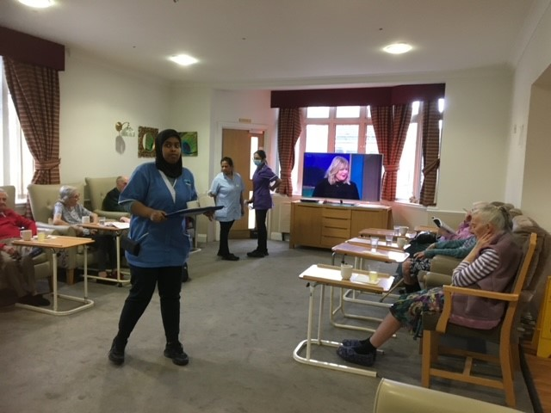
The dining areas. There were a number of different dining areas but only one was in use when we visited during lunch time. This had two chairs per table, with space for residents to sit in wheelchairs.
We observed that the music in the dining room was very loud and asked for it to be turned down.

In the bedrooms, we saw evidence of personal décor including art, photographs, plants, and soft furnishings.

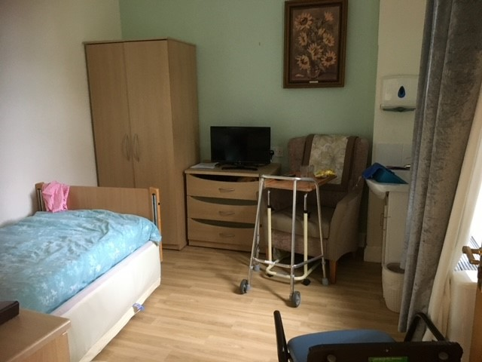

N.B. when we entered any bedrooms, we did so in pairs, we asked permission of the resident and the door was left open.

Ten bedrooms have ensuite bathrooms (basin, shower, toilet), four have a toilet and basin, other bedrooms have shared bathroom facilities – one bathroom is shared between five or six rooms.

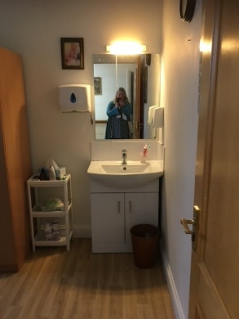

The manager told us that there is enough equipment for everyone’s needs to be met whether they wanted to be in or out of their rooms.

There is a “coffee shop” with a kitchenette area - we were told that this has been used for family visits, and some residents choose to have their breakfast there.
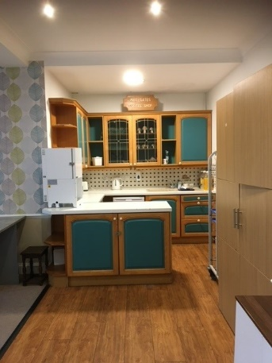

However, one family member told us:
“The small lounge which can be used for private visits used to have a small kitchenette area stocked with tea/coffee/cups/plates/biscuits so that relatives could make refreshments for themselves and their relative, but these are no longer available and the room is less inviting, probably due to lack of use”. (October 2022)

There was an attractive garden area.
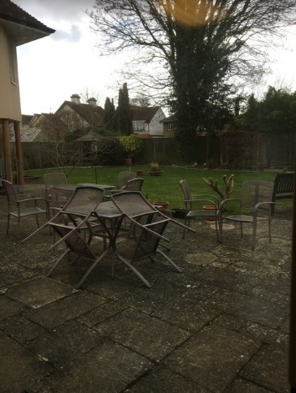

We did not notice dementia friendly signage around the home, which we have seen in other homes that we have visited. Dementia friendly signage allows people to orientate themselves and navigate their environment.

Recommendation
- Consider using more dementia friendly signage around the home.

2.4 Staff
The registered manager told us that they do use agency staff but have used the same four agencies since the pandemic, and block book a staff member to give continuity of care. CHD has a scheme whereby they recruit overseas workers and provide accommodation for them until they can find permanent accommodation.
They have recruited some staff from a local care home in Staines which closed (Meadowside).
On a day shift, there are ten health care assistants, two team leaders and two nurses. On a night shift there are two nurses and six other staff. The regional manager told is that her aim is to “use zero agency staff”.

We were told that there are two chefs – one chef works per day and there are two kitchen assistants. Some agency staff are used.

3. What we heard

3.1 Who we heard from
On the day of our visit, we spoke to five residents; staff advised which residents would have capacity to speak to us. We also spoke to six members of staff.
We received fifteen completed family and friends’ questionnaires, some of these were handed to us by the manager, some were completed online. A number of these responses were from October/November 2022, when we had originally planned to visit, but this was cancelled due to a Covid outbreak in the home. We have included these in our analysis but have noted that circumstances/issues raised may have been resolved since then.

This is the largest number of family and friends’ questionnaires that we have received for any one care home across our current programme of visits.

3.2 Daily life
We spoke to five residents. One told us:

“It is very pleasant here; I have plenty of other residents who know from my youth (I lived locally).
I could stay in my room but I’m not sure if staff would be happy about that.”

The other residents were less positive and seemed to live a more isolated life.
One resident said:

“I stay in my room; the lounge is crowded, and I don’t know anyone”.

The only activity she told us that she did was watching TV, she said that the staff are happy for her to stay in her room if she wants to.

Another resident told us:

“it’s not a chatty place, as many residents have dementia.”

This resident told us that she reads and watches TV.
When asked whether the staff would be happy for her to stay in her room she said:
“Yes, I never get out of bed.”

Another resident (who had been discharged to Whitegates from hospital) told us:

“There is too much sitting. I feel fidgety, I am looking forward to going back home. I am lacking confidence at the moment.”

She told us that:

”I like to lie in, as I sleep badly, but the staff don’t like it if I do.”

3.3 Food
We were told by the registered manager that all food is prepared on site by the chef.

The manager told us that there are two options per meal every day, and that every week is different, and this varies seasonally. For example, there is a cooked/cold breakfast, two lunch options, snacks such as fruit cocktail or cakes are provided at 3pm.
Each resident’s dietary requirements are catered for.

We heard mixed feedback from the residents themselves about the food.
One resident told us that:

“The food is excellent”.

One resident told us:
“The food is too continental. I don’t like pasta and spicy food”.

Another resident said:

“I don’t like the food, I don’t like porridge and salmon, but both were given to me. There might have been curry, but there was none left for me”.

A family member told us:
“Poorer food is available at weekends”.

The weekly meal plan was not displayed anywhere during our visit, and we had to ask several times before we were given a copy of the menu.

Recommendation:

- Display the menu in accessible formats so that it is visible for residents and their family members.

3.4 Staff levels
We were told that there is one chef for weekdays, and two kitchen assistants, sometimes an agency chef is used at weekends.
There are no named senior carers, all staff care for all residents. Each nurse is responsible for a group of rooms.
The manager’s aim is to stabilise staffing levels.
Family members told us that they felt there were not enough staff at the weekends.

3.5 Activities
We saw evidence of activities - including a notice board which displayed the activity plan – however this was quite difficult to read.
We were told by the regional manager (who has a focus on wellbeing) that activities are planned 12 months in advance, and there are activities planned across different homes within CHD, such as a Valentines Day party, and a summer party/ project. The regional manager told us about the monthly wellbeing meetings that are held across the CHD group, where themed ideas such as “travelling week” were discussed. She told us that CHD’s philosophy is that “wellbeing is everyone’s responsibility”.
We spoke to the wellbeing coordinator who has worked at White Gates for over a year but is relatively new in the wellbeing coordinator post.
She told us that she does gentle exercises with the residents, and that there is an activities box in the lounge. We also heard that each staff member is allocated two residents per day to spend 5-10 minutes with this could just be having a cup of tea and a chat, giving them a hand/head massage or listening to music together.

There is a desire to “give back to the community” with plans to involve the local school, with Duke of Edinburgh activities and local places of worship.
We were told about the “Big Wishes” programme, across CHD whereby special activities were arranged, for example a day out at Silverstone, and a couple renewed their wedding vows.
There was also a poster advertising monthly family afternoon tea events.
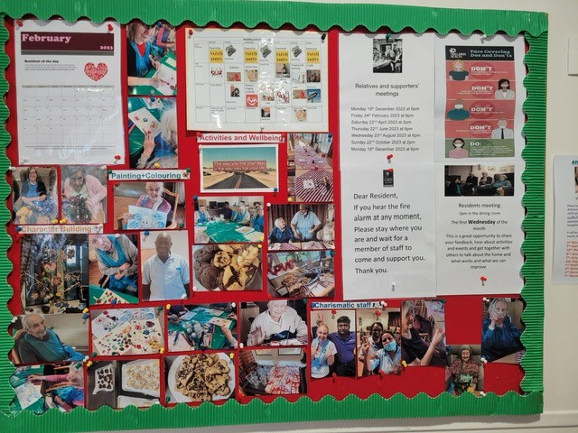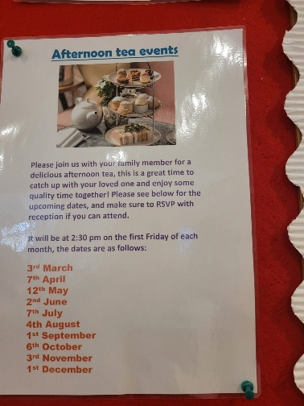

The residents we spoke to said that during the day they watch TV, read, only one resident described any social interaction.

“I have plenty of other residents (to chat to) who I know from my youth.” (Lived locally).

However, another told us:

“It’s not a chatty place as many residents have dementia.”

Recommendation:

- Continue to provide stimulating activities, and display the activities plan so that residents and visitors can see it.

3.6 Care and hygiene
The manager told us that the nursing staff decide on staff allocation on a daily basis, dependent on residents’ needs.
There are no named senior carers, all staff members look after all residents, so that they are not too dependent on one person.

Daytime care
We heard mixed feedback about daytime care, some positives but some negatives, in terms of residents not having their hair washed, catheter care and lack of support to regain mobility.

Positive:
“She is clean and well cared for.”

“Dad's always being visited by the carers to see if he needs anything, (change pad, something to drink or eat)”.

“When we visit, she seems comfortable and is not pressured to sit in the lounge if the noise/bustle is overwhelming her. I'm not sure we can really judge unless we are there all day as her dementia means she cannot tell us anything about what she has done since our last visit.”

“He seems to have enough food and drinks supplied, water or juice jug appears to be changed daily”.

Negative:
“It was a long time and lots of moaning for the home to realise that my mother could not drink by herself, and she was always very thirsty when we visited her. Also, she relied on her TV for company as she is bed bound and it’s not always switched on”.

A concern was raised about catheter care:
“I do have to check he has the correct and sufficient supplies regarding his catheter. I have had to request several times over the last month for catheter bag straps to be ordered. Catheter bag is not always fitted correctly.” (February 2023).

One resident (short term, hospital discharge) said
“The staff washed my hair yesterday, I haven’t had a shower yet, since I’ve been here (5 days) but I do like a shower once or twice per week.” (February 2023).

Another family member said:
“I don't think her hair is washed enough, as she is always scratching it. Not sure if her teeth are being cleaned as her breath seems unfresh”. (April 2023).

One family member told us:
“My mother has recently returned to White Gates following a three week stay in hospital after breaking her hip. Since her return, she has been given no support or encouragement by the staff, with her desire to regain her mobility - indeed one of the staff members told her directly that she would not walk again which upset and depressed her. Before her accident, my mother would go into the residents lounge every day - now she sits alone in her room. The staff say that this is her choice, but they are not encouraging her to go back into the lounge with the other residents. I am now going into the home every day to help her with her physiotherapy exercises and to try and help her walk with her frame”. (October 2022).

We observed one resident, who was a stroke survivor, who never left his bed, he told us that he washes in bed, and can feed himself, but he does not receive any physiotherapy. He was alert and seemed to be content.

Night time care
Positive:
“She is safe.”

“There was one occasion when she fell over during the night while using her commode and staff were quickly with her and were able to check her over and get her back into bed.” (October 2022).

Negative
“Not sure what time they put her to bed, but it was very early.” (November 2022).

“Dad wakes frequently at night and has fallen or had accidents with catheter which seem to go unnoticed.” (February 2023).

“They don’t attend when called.” (March 2023).

Weekend care
We heard that there was a perceived lack of staff at the weekend.

“I also have a concern that staffing levels at weekends - especially on Sunday - are at a bare minimum and using agency staff who are unfamiliar with the residents or the building. (I had a situation where a carer on a Sunday was unable to open the front door to me when I visited because they did not know where the front door unlock switch was located.) My mother is currently unable to get out of bed on her own - on a recent visit to my mother on a weekend she was still in bed at 11:20 and was just being washed and dressed by staff.” (October 2022).

“Trying to find a staff member if my wife needs attention is very difficult.” (April 2023).

Recommendations:

- Ensure that residents are able to have their hair washed / can have a shower when they want.
- Ensure that catheter procedures are followed correctly.
- Encourage staff to help residents with physio.
- Support residents to choose whether to come out of their rooms or not.

3.7 Personalised care plans

We were told that before a resident arrives, there is a pre-assessment of their needs, and that this is used as a foundation for their care plan. The manager told us that this is reviewed monthly and discussed with family members.

Of the fifteen responses we received to our survey, six family members said that their resident had a personalised care plan, two said that they didn’t and six said that they didn’t know. Of the six who said that they did have a personalised care plan, only two were very satisfied with it.
One family member said:

“I don't believe we have seen any updates since she was admitted or at least since we had an assessment for funded nursing care and that is about 18 months ago.” (November 2022).

A new online system “Nourish” was being implemented at the time of our visit, which is being used across the CHD group. Staff update personal care and wellbeing logs, if medication has not been given, an alert is sent to management. Incidents and accidents are automatically escalated.

Recommendation:

- Ensure that friends and family, as well as residents are aware of, and are involved in, the creation of personalised care plans.

3.8 Staff feedback

We spoke to six members of staff, who all said they were happy at Whitegates; one staff member told us that “the team work is excellent.”
All agreed that weekends were busier with more visitors. All were willing to try to solve residents’ issues but would pass on to the senior team or nursing staff when appropriate. Staff told us that they help residents to stay in touch with their families.

Visiting health care professionals

The registered manager told us that the GP from Shepperton Medical Practice attends every Wednesday.
Regular medication is provided by Prochem Pharmacy, which is a centrally managed contract. Antibiotics are provided by the local pharmacy.
We were told that a dentist does check-ups every six months. We were told that there had not been any cases where residents had required additional dental care, so the question of how this is accessed was not relevant.
In terms of speech and language therapy, we were told that that referrals are made via the GP. We had heard from another care home that assessments had been done via video, but we were told that all were done face to face at White Gates.
Regarding physio, we were told that some residents had referrals made by the GP, but were waiting to hear, other residents paid for private physio.

3.10 Visiting

The manager told us that there were no visiting restrictions at the time of our visit, however they would follow public health guidelines if there was a covid or norovirus outbreak.

One resident told us:
“My family can come to visit whenever they want to.”

Family members all told us that they were happy with visiting arrangements.

"There are no problems, I am always welcome.”

And another said,
“I am happy with the visiting arrangements there are no restrictions.”

Another said,
“We can have unlimited visits and can also take in the dog”.

However, we heard from a number of family and friends that visiting at the weekend can be problematic.

“Post Covid, visiting is unrestricted, but it can sometimes be problematic getting access into the building, especially at weekends if there is no reception staff in attendance. I have often had to wait at the front door for up to 10 minutes at weekends, waiting for a member of staff to open the door. Even during the week, I have sometimes had to wait several minutes after ringing on the front door bell. Also, when leaving, if there is no one in reception, I regularly have to operate the front door release switch located under the receptionist’s desk in order to exit”. (October 2022).

Recommendation:

- Improve access for weekend visiting.

3.11 Staying in touch
We heard from a resident that they didn’t have a phone, but staff will call their family for them.

3.12 Feedback mechanisms
We were told that a survey is sent to family members every four months, which is looking for ideas for improvements. This is reported back as “You said, we did”. We were told that there is an open door policy for families to speak to the manager and nursing staff. If a family member has any concerns about isolation or engagement, they are encouraged to telephone staff.
We also saw evidence of regular residents’ meetings.

When we asked family members about raising a complaint, twelve out of fifteen were confident they would know what to do and who to raise it with.
“The senior staff at the home are approachable and concerned for my mum's welfare.”
“There is usually someone available to speak to”.
“I would just ask at reception; they are very friendly and helpful.”
“When I have made any complaints, they have taken care of it.”

Half of the respondents had raised complaints in the past and all but one were satisfied with the process.
“It was sorted in a matter of days.”

4. Next steps
This report and the response from the service provider will be shared with commissioners and regulators of the service and will be published on our website.

5. Service provider response

Service Name: | White Gates Care Centre
Service Manager: | Alina Babate
Visit date: | 23.2.23
Factual accuracy
If you have any concerns about the factual accuracy of the report, please clearly identify the sections, content and corrections that are required in the space below:
The amendments have been made within the body of the report.
Organisation response to the report
Please provide your response here. This will be included in the final report.
(This response will be published in full)
.

Respondent Name: | Alina Babate
Respondent Job Title: | Registered manager
Feedback on the visit
If would like to provide some feedback to Healthwatch Surrey on the visit itself, please provide this in the space below:
Responses must be provided within 10 working days of receipt of our report to ensure it is included in the final published report.

6. Appendix

6.2 What is Enter & View?
Part of the local Healthwatch programme is to carry out Enter and View visits. Local Healthwatch representatives carry out these visits to health and social care services to find out how they are being run and make recommendations where there are areas for improvement. The Health and Social Care Act allows local Healthwatch Authorised Representatives to observe service delivery and talk to service users, their families and carers on premises such as hospitals, residential homes, GP practices, dental surgeries, optometrists and pharmacies. Enter and View visits can happen if people tell us there is a problem with a service but, equally, they can occur when services have a good reputation – so we can learn about and share examples of what they do well from the perspective of people who experience the service first hand. All our Authorised Representatives have a current DBS check in place.

Healthwatch Enter and View visits are not intended to specifically identify safeguarding issues. However, if safeguarding concerns arise during a visit, they are reported in accordance with Healthwatch safeguarding policies. If at any time an Authorised Representative observes anything that they feel uncomfortable about they need to inform their lead who will inform the service manager, ending the visit.

In addition, if any member of staff wishes to raise a safeguarding issue about their employer, they will be directed to the CQC where they are protected by legislation if they raise a concern.

6.2 Purpose of Visit
The purpose of the visit was to listen to the views and experiences of people who live and work within the home.

6.3 Strategic drivers
Our Enter and View programme is one of our strategic priorities for 2022/2023, enabling us to hear the voices of seldom heard groups; on this occasion- care home residents.

6.4 What we did
The visit to White Gates Care Centre was an announced visit. Before the visit we gave the care home posters to display around the home to make staff, residents, and their families aware of our visit. This poster included a QR code which links to our feedback form on our website. We saw the posters displayed when we visited. We also sent the home some paper questionnaires and pre-paid envelopes to share with friends and family.

We spoke to five residents, six members of staff, and fifteen family and friends’ paper questionnaires were returned by post/given to us by the care home or via our online survey.

Four Authorised Representatives (ARs) of Healthwatch Surrey conducted the visit.

On arrival we were greeted by the registered manager. We explained what we would like to do. One member of our team was given a tour by the registered manager and spoke to one resident in their bedroom. The door was open, and the registered manager was outside. The AR was then seated in the visitors’ room and staff members were brought in to give their feedback. Two ARs were shown into the lounge and around the home to speak to residents who were there. We were allowed to take photographs. All the questions we asked were answered openly. We observed the surroundings to gain an understanding of how the home works and how the residents engaged with staff members and the facilities, these findings were recorded on observation sheets. We used a semi-structured questionnaire when talking to residents, family members and staff.

We explained to residents, their family members, and staff that we were from Healthwatch Surrey and that we were gathering experiences of what it’s like to live at White Gates Care Centre, and particularly to find out whether they would know what to do if they wanted to give feedback about the service.

Healthwatch Surrey – Contact us

Website: www.healthwatchsurrey.co.uk
Phone: 0303 303 0023
Text/SMS: 07592 787533
Email: enquiries@healthwatchsurrey.co.uk
Address: Freepost RSYX-ETRE-CXBY, Healthwatch Surrey, Astolat,
Coniers Way, Burpham, Guildford, Surrey, GU4 7HL

@HW_Surrey
@healthwatch_surrey
/healthwatchsurrey
Healthwatch Surrey

