Enter and View Programme

Brownscombe Care Residences

  - Spring 2023
If you would like a paper copy of this document or require it in an alternative format, please get in touch with us.

Contents
1. Summary 4
1.1 Why we visited. 4
1.2 Summary of key findings 5
1.3 Acknowledgements 5
1.4 Disclaimer 5
2. What we found 6
2.1 Description of service 6
2.2 Environment 6
2.3 Facilities 7
2.4 Staff 10
3. What we heard 10
3.1 Who we heard from 10
3.2 Daily life 11
Recommendation: 13
3.4 Activities 13
3.5 Personalised care 15
3.6 Staff feedback 16
3.7 Visiting health care professionals 16
3.8 Visiting 17
3.9 Staying in touch. 18
3.10 Feedback mechanisms 18
4. Next steps 19
5. Service provider response 19
6. Appendix 20
6.2 What is Enter & View? 20
6.2 Purpose of Visit 21
6.3 Strategic drivers 21
6.4 What we did 21
Healthwatch Surrey – Contact us. 23

1. Summary

1.1 Why we visited.
During the Covid-19 pandemic, we were not able to carry out any face-to-face engagement at care homes, and therefore we have been concerned that the voice of care home residents has not been heard, and residents and families may be unaware of the existence of Healthwatch as their independent champion. Enter and View is one way Healthwatch Surrey can gather information about services and collect views of service users, their carers, and relatives, as well as staff. We are working with Surrey County Council, Surrey Heartlands and CQC on our programme visits to care homes across Surrey.

As well as giving residents an opportunity to share their general views of the care home, our focus is on finding out whether residents and families are aware of or have used any feedback mechanisms.

In addition to face-to-face visits, we also ran a survey for friends and family – available online and as paper copies. Links to the survey were distributed via Care homes’ own newsletters and promoted on Healthwatch Surrey’s communication channels and by other stakeholders such as Surrey County Council’s Surrey Matters publication.

Details of visit:
Service Address | Brownscombe Care Residences
Service Provider | Brownscombe Care Residences (part of CHD Living group)
Date and Time | 21st March 2023 10.30am- 12.30pm
Authorised  Representatives | Katharine Newman, Hannah Gilmour, Errol Miller, Louise Daborn, Gabrielle Summerhays.
Contact details | Healthwatch Surrey GF21, Astolat, Coniers Way, Burpham, Surrey, GU4 7HL  enquiries@healthwatchsurrey.co.uk  Phone: 0303 303 0023 (local rate number)  SMS (text only): 07592 787533

1.2 Summary of key findings
Overall, we found residents to be content, and happy with the care they received. Staff were friendly and helpful, and the environment was pleasant.

We have seven recommendations based on our visit:
- Ensure the complaints procedure is visible and accessible (it is currently positioned very high up on a display board).
- Ensure up to date advocacy information is displayed.
- Provide stimulating activities which are inclusive to all, and display the activities plan so that residents can see it.
- Make a private space available so that the visiting podiatrist can treat residents in private, ensuring their privacy and dignity.
- Consider using more dementia friendly signage around the home.
- Display the menu so that it is visible for residents and their family members.
- Consider ways to better assist residents in finding lost property such as glasses/dentures.

1.3 Acknowledgements
Healthwatch Surrey would like to thank residents, their families, and the staff at Brownscombe Residences, for their contribution to our Enter and View programme.

1.4 Disclaimer
This report relates to findings observed on the specific date set out on Page 4. Our report is not a representative portrayal of the experiences of all residents, their families, and staff, only an account of what was observed and contributed at the time.

2. What we found

2.1 Description of service
Address: Brownscombe Care Residences Hindhead Road, Haslemere, Surrey, GU27 3PL
Website: CHD Living - Brownscombe Care Residences
Provided by: Mr Liakatali Hasham. Part of CHD Living group.
Registered manager: Ali Packham.
Capacity: Brownscombe Care Residences is a care home providing residential, nursing or respite care for up to 55 people including some people living with dementia, including 12 beds for Discharge to Assess commissioned by SCC.
At the time of our visit in March 2023 there were forty-three residents, including six using Discharge to Assess beds.
We were told that less than 50% of residents would have capacity to speak to us.
Fifteen residents were funded by SCC, three residents were funded by other local authorities.
We were told that more nursing and dementia care is being provided rather than residential. Many residents come for short term convalescence.

In 2022, Brownscombe House and Lodge were amalgamated into Brownscombe Residences. At the time of our visit substantial building work was taking place, when the building work is complete, (refurbishing the lodge as well as the house) total occupancy will be 85.
We were told that the purpose of the building work is to ensure that the building is sustainable and suitable.

2.2 Environment
Brownscombe is a large Edwardian country home which has undergone considerable extensions. It is set in extensive grounds on a steep hill, with views over the valley.
We saw evidence that our visit was advertised, with our posters displayed in the reception area.
The main house is split over four floors: lower ground, ground, mezzanine and first floor. The lodge is split over three floors, ground, first and second. On the day of our visit one of the lifts was out of action due to the building work and consequently some residents were restricted to their room all day.

We arrived at the Lodge entrance where we noticed a urine smell which was being cleaned up. We were directed up to the House entrance.
The rest of the premises were very clean (despite the building work).

All the staff were very friendly and helpful.

2.3 Facilities
There is a “main lounge” on each side of the home with plenty of armchairs, and a large TV and a fish tank. At the time of our visit, the lounge areas were being occupied by several residents.
There is also a cinema room, a hair salon, and a nail bar.

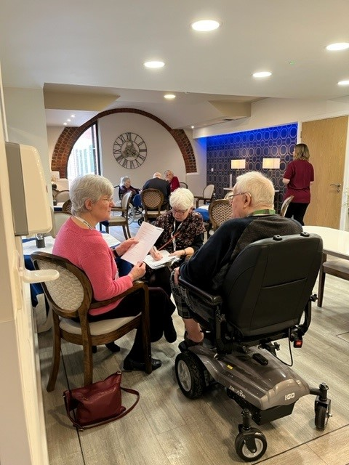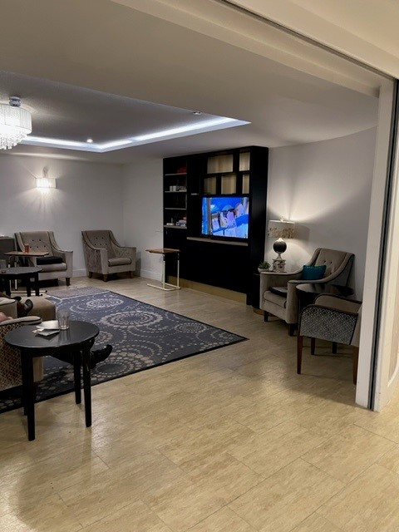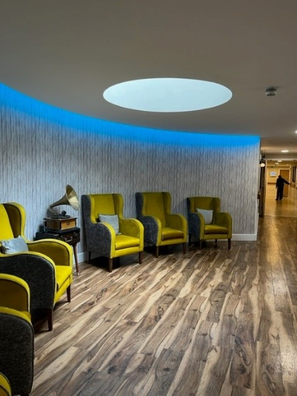

There are two different dining areas, one in a conservatory area, with square tables, some with chairs and spaces for wheelchairs, and one which was designed for visiting families, with a kitchenette.

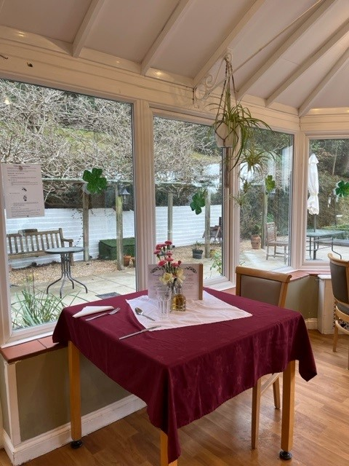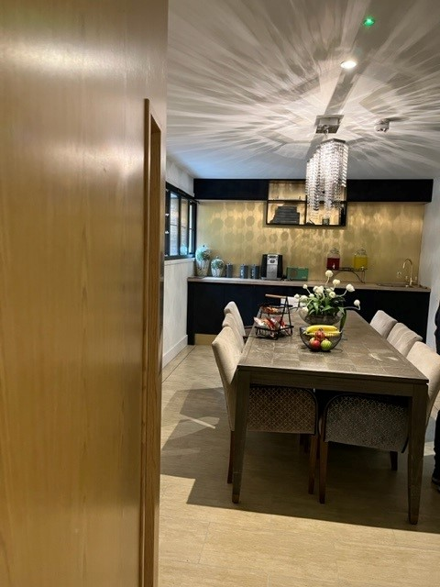

Many of the bedrooms have external access onto the accessible garden/ terrace. In the bedrooms, we saw evidence of personal décor including plants, teddies, photographs, musical instruments, and soft furnishings.

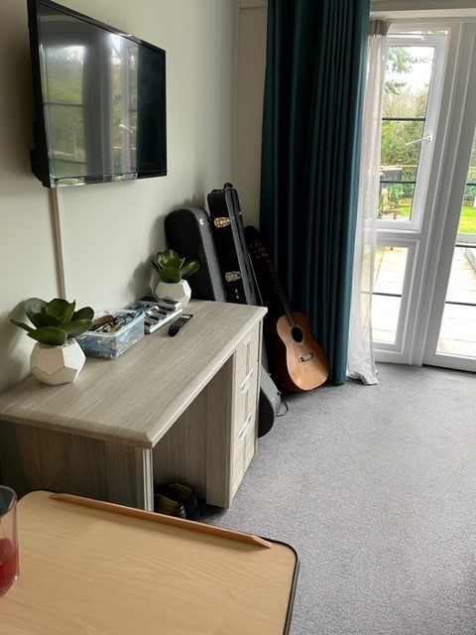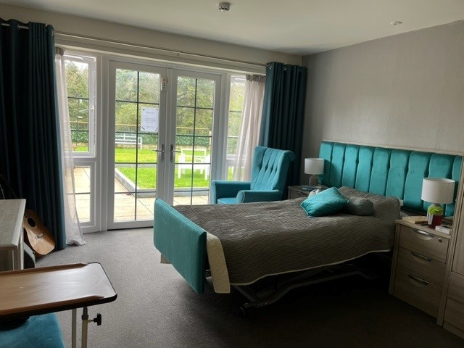

N.B. when we entered any bedrooms, we did so in pairs, we asked permission of the resident and the door was left open.

Not all bedrooms have en suite shower facilities.

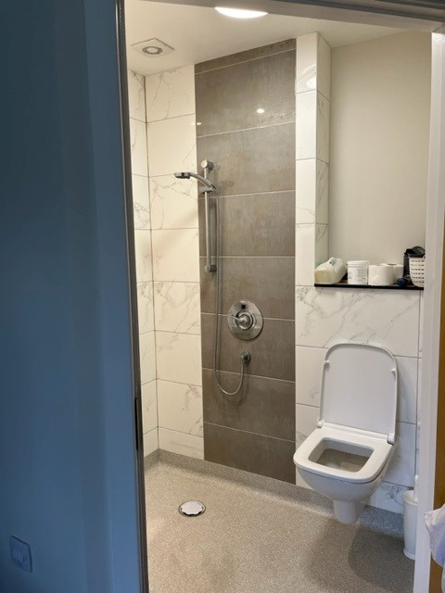

There was a large attractive garden terrace, which could be accessed via most bedrooms and the reception area.

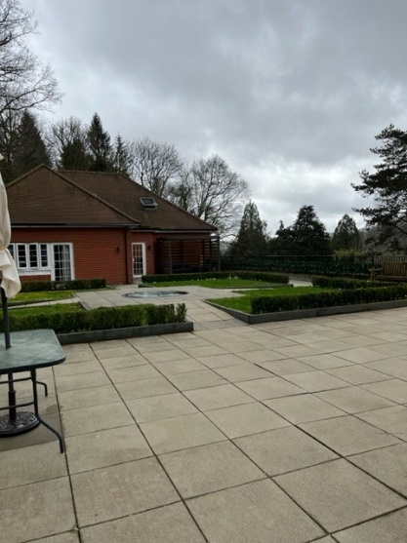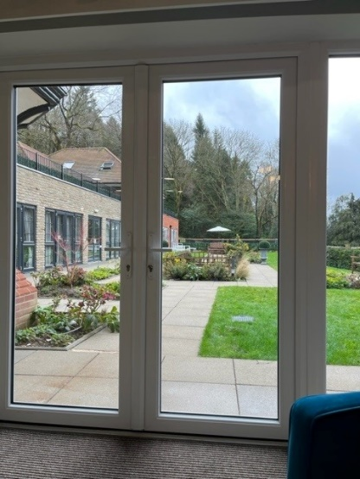

We were told about the “feelgood Friday” gathering, which a lot of residents attend, and there are sufficient wheelchairs and mobility aids for all residents to attend if they wish.

We did not notice dementia friendly signage around the home, which we have seen in other homes that we have visited. For example, the name of the room, alongside a picture demonstrating the function of the room – i.e. “Shower room” with a picture of a shower head.

Recommendation
- Consider using more dementia friendly signage around the home.

2.4 Staff
The registered manager told us that they currently use no agency staff, and they have no staff vacancies. They have recruited staff from overseas, who they accommodate on site.
They work to a ratio of 1 staff member to 5 residents. On shift were two nurses, one team leader and three healthcare assistants. There are no specific named carers for residents, they work on the basis that all care staff look after all residents.
There are two wellbeing coordinators, two in-house chefs and an in-house laundry.
We were told that the owner and the regional manager visit weekly.

3. What we heard

3.1 Who we heard from
On the day of our visit, we spoke to six residents who had the capacity to speak to us; staff advised which residents would have capacity to speak to us (although staff had directed us to speak to three further residents who we deemed to be unable to speak to us). We also spoke to eight members of staff.
We also spoke to a visiting member of staff from the intensive support team Surrey and Borders Partnership (part of the community mental health team).

We received no completed family and friends’ questionnaires either by post on via our online survey.

3.2 Daily life
We spoke to six residents; most gave positive feedback. One resident told us:
“It’s a nice place to live.”

Another told us:
“It’s very nice, I like living here a lot.”

Another said:
“Everything is fantastic.”

However, one resident, who was there for respite after being discharged from hospital said:
“It’s not great, I just want to get home.”

We were told by the staff about “resident of the day” – which happens once per month, whereby a person is pampered and has special activities/ treats. Their family is given special updates on this day.

Residents appeared to be well looked after, most were up and dressed and happy.

Three residents told us that they had lost their glasses or dentures.
One resident (respite care) who was struggling to read the newspaper in the lounge told us:

“I lost my glasses on my first day, which was three weeks ago.”

Another said:

“I lost my glasses two days ago.” Healthwatch staff found them immediately.

Recommendation
- Consider ways to better assist residents in finding lost property such as glasses/dentures.

3.3 Food
We were told by the registered manager that all food is prepared on site by the chef. We also spoke to the chef.

The manager told us that there are two choices per meal every day, and alternatives can be provided if residents do not want what is on the menu. There is a nutrition folder for every resident, detailing their dietary requirements and preferences.

Overall, feedback about the food was positive:

“The food is very good. There is a nice chef, they bring the food up and I can ask for what I want even if it’s off the menu.”

“The food is ok; you can see it being made fresh. It tastes nice, it’s basic good food.”

However, there were some comments that the food was perhaps a little bland. One resident told us:

“There is enough choice, it could be better - there are two choices, veg and main. It’s quite bland, but I appreciate they have lots of people to feed.”

We didn’t see a weekly meal plan displayed anywhere; the day’s menu was displayed on a table in the dining room.

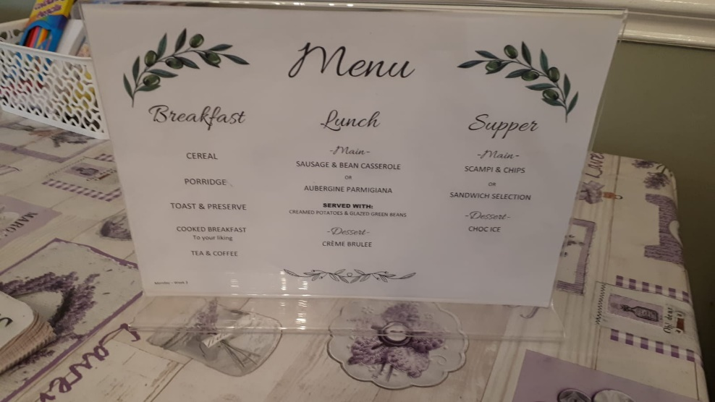

Recommendation:

- Display the menu so that it is visible and accessible for residents and their family members.

3.4 Activities
We were told by the registered manager that there are two wellbeing coordinators who run the activities. The manager told us about a visit to a farm, and everyday activities such as quizzes, bingo, and baking that happen on site. They also told us about larger events that happen such as a Christmas family party, summer fetes, and planned coronation activities.
They also hold quarterly parties for staff wellbeing, and culture days for sponsored overseas staff, celebrating their culture, and providing traditional foods.

There were some residents in the lounge when we visited, and no activities were happening. The TV was turned on part way through our visit.
We saw one notice board with photos of residents doing activities, however the activity planner notice board was empty.

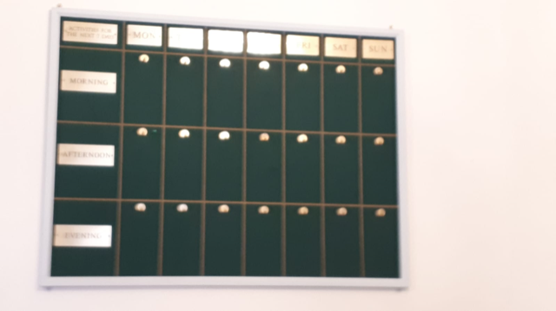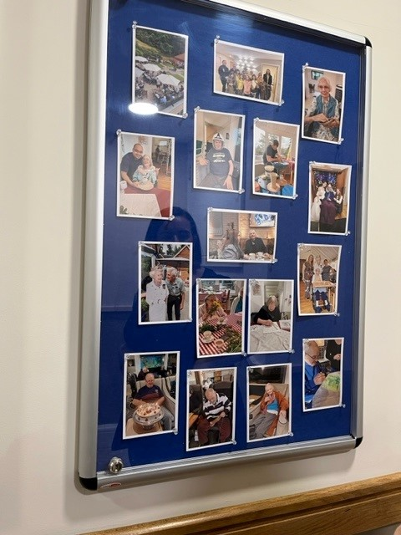

Some residents told us that they join in with activities:

“There are a lot of activities like singing, cooking with the entertainment girls. There’s also drawing, colouring, I can put the TV on to hear the news in my room. There are people to talk to.”

“I can do activities. I read a lot and do my word search. I watch TV but find it very loud in the lounge because of my hearing aids.”

Other told us that they were happy not to join in:

“I just watch TV, I don’t do activities, I’m happy to sit and do that.”

Others told us that they wished more activities were provided, and one person said that their participation was limited:

“The care is good, but there could be more activities.”

“There is nothing practical to do which I miss. The day is divided by meals, I could do with more activities. I don’t go for walks which I’d like to do as I miss my dog.”

“I get involved with the quizzes. Sometimes cooking is on offer, but my disability restricts this.”

Recommendation:

- Continue to provide stimulating activities which are inclusive to all, and display the activities plan so that residents can see it.

3.5 Personalised care
All the residents that we spoke to said that the care they received was good. They were all very positive about daytime care, nighttime care and weekend care.

“The care is good; I have a call button around my neck which I can use if I need a nurse.”

“They do check the rooms regularly at 2am.”

“I press the buzzer and there’s no hesitation if I want to go to the toilet during the night.”

“There is no real difference at the weekend.”

“You might see different staff at the weekend, but there’s enough of them.”

However, one resident told us:

“The weekends are a bit down as the manager and senior carers aren’t around. I get a bit bored.”

We heard positive stories from residents about individual needs being met. For example, the team leader had arranged transport to take a resident to a wedding, and to get a tattoo.

The team leader told us about the progress that one resident had made, with the support of the staff:

“He had been bed bound and was on a diet of pureed food. With the encouragement of the staff, the resident had been able to feed himself in front of his nephew, and the resident’s mobility was improving so much that he was able to start getting out of bed.”

We were told that there is a care plan for every resident which is displayed in their room. The nurses and care team leader told us that they update care plans regularly as part of their daily work. The care assistant told us that she follows whatever is written on the care plan.

3.6 Staff feedback

We spoke to six members of staff, as well as the manager and regional manager.
All the staff were very positive about the working environment.

“This is my second home, I am so attached to the patients, I give all my heart and I am fully dedicated. I can’t imagine working elsewhere.”

“It’s comfortable here, I love the atmosphere, and the environment.”

We were told that management are approachable, and supportive of staff working towards qualifications.

Visiting health care professionals

The registered manager told us that they have weekly visits from the GP.
They also have access to the community matron– who they can contact prior to contacting the GP. The community matron can prescribe and is easily contactable via a direct number. This alleviates the problem of waiting to get through to the GP surgery. This service is provided by NHS community in partnership with Milford Surgery. The community matron will also attend for residents needing end of life care.

They also have visits from physios, speech and language therapists, opticians, dentists, and chiropodists.
We were told that the dentist visits every three months and that there is an oral care plan in every resident’s room. If a resident needs further treatment, they are referred to Buryfields community dentist. Either NHS Patient transport is arranged, or CHD drivers are used. For some community appointments such as diabetes clinics, the stroke club or chiropody appointments, the local Hoppa service is used.

The chiropodist was visiting during our visit. She was treating residents in the public lounge area. We would like to suggest that a more private area is made available so that residents can be treated in private.

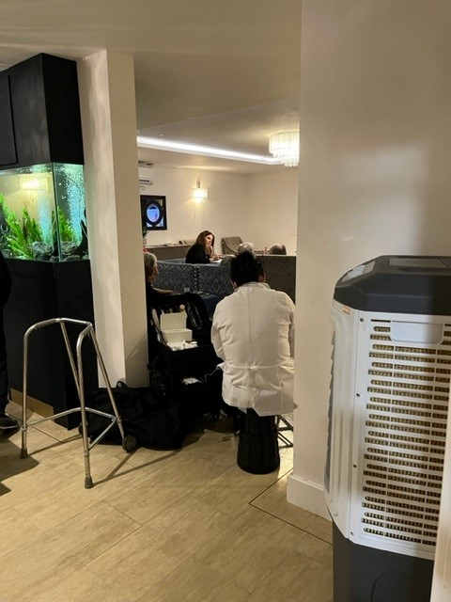

Recommendation:

- Make a private space available so that the visiting podiatrist can treat residents in private, ensuring their privacy and dignity.

3.8 Visiting

The manager told us that visiting is unrestricted, although they prefer families to avoid mealtimes. Families can visit 24/7 if they wish.

We were told that they are recruiting for weekend receptionist cover; the health care assistant told us that at weekends she escorts visitors from reception to their family in the absence of a receptionist. There is a bell for visitors to ring to get in and out of the building.

One resident told us:

“My wife visits twice per week, my children and grandchildren come whenever they want.”

All the residents seemed to be content with the visiting arrangements.

3.9 Staying in touch.
We heard from residents that if they needed help with staying in touch with their family staff would help them to do so, via Facetime, WhatsApp etc.

Staff told us about the “adopt a grandparent scheme” that they had joined during the Covid-19 Pandemic to prevent isolation which some residents still enjoyed.

3.10 Feedback mechanisms
Information about complaints was difficult to see - it was positioned in the top row of a display board close to the ceiling.
This display board also included out of date information about the Advocacy service available in Surrey.

Residents told us that if they had a problem, they would either deal with it themselves by speaking to the manager, or the nurse if it was a medical issue, or they would ask a family member to get involved. One resident told us:

“I would see the manager, Alison, who would sort it. I’d be happy to do this on my own.”

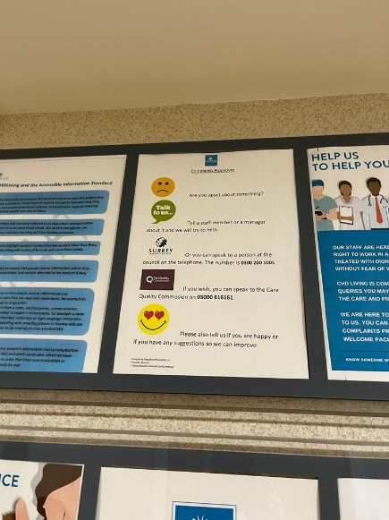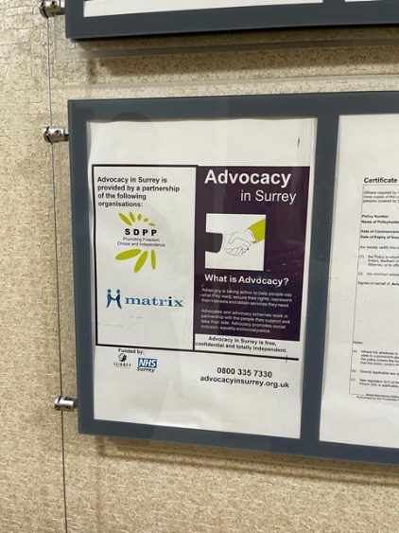

Recommendation:
- Ensure complaints procedure is visible (currently positioned very high up in a display).
- Ensure up to date advocacy information is displayed.

4. Next steps
This report and the response from the service provider will be shared with commissioners and regulators of the service and will be published on our website.

5. Service provider response

Service Name: | Brownscombe Residences
Service Manager: | Ali Packham
Visit date: | 21.3.23
Factual accuracy
If you have any concerns about the factual accuracy of the report, please clearly identify the sections, content and corrections that are required in the space below:
The amendments have been made within the body of the report.
Organisation response to the report
Please provide your response here. This will be included in the final report.
(This response will be published in full)
.

Respondent Name: | Ali Packham
Respondent Job Title: | Registered manager
Feedback on the visit
If would like to provide some feedback to Healthwatch Surrey on the visit itself, please provide this in the space below:
Responses must be provided within ten working days of receipt of our report to ensure it is included in the final published report.

6. Appendix

6.2 What is Enter & View?
Part of the local Healthwatch programme is to carry out Enter and View visits. Local Healthwatch representatives carry out these visits to health and social care services to find out how they are being run and make recommendations where there are areas for improvement. The Health and Social Care Act allows local Healthwatch Authorised Representatives to observe service delivery and talk to service users, their families, and carers on premises such as hospitals, residential homes, GP practices, dental surgeries, optometrists, and pharmacies. Enter and View visits can happen if people tell us there is a problem with a service but, equally, they can occur when services have a good reputation – so we can learn about and share examples of what they do well from the perspective of people who experience the service first hand. All our Authorised Representatives have a current DBS check in place.

Healthwatch Enter and View visits are not intended to specifically identify safeguarding issues. However, if safeguarding concerns arise during a visit, they are reported in accordance with Healthwatch safeguarding policies. If at any time an Authorised Representative observes anything that they feel uncomfortable about they need to inform their lead who will inform the service manager, ending the visit.

In addition, if any member of staff wishes to raise a safeguarding issue about their employer, they will be directed to the CQC where they are protected by legislation if they raise a concern.

6.2 Purpose of Visit
The purpose of the visit was to listen to the views and experiences of people who live and work within the home.

6.3 Strategic drivers
Our Enter and View programme is one of our strategic priorities for 2022/2023, enabling us to hear the voices of seldom heard groups; on this occasion- care home residents.

6.4 What we did
The visit to Brownscombe Residences was an announced visit. Before the visit we gave the care home posters to display around the home to make staff, residents, and their families aware of our visit. This poster included a QR code which links to our feedback form on our website. We saw the posters displayed when we visited. We also sent the home some paper questionnaires and pre-paid envelopes to share with friends and family.

We spoke to six residents, and eight members of staff, we had no feedback from friends or family.

Five Authorised Representatives (ARs) of Healthwatch Surrey conducted the visit.

On arrival we were greeted by the registered manager. We explained what we would like to do. One member of our team was seated in the reception area and members of staff were brought to speak to them Afterwards the staff member was given a tour by the registered manager. Two pairs of ARs were shown into the lounge and around the home to speak to residents who were there. We were allowed to take photographs. All the questions we asked were answered openly. We observed the surroundings to gain an understanding of how the home works and how the residents engaged with staff members and the facilities, these findings were recorded on observation sheets. We used a semi-structured questionnaire when talking to residents and staff.

We explained to residents and staff that we were from Healthwatch Surrey and that we were gathering experiences of what it’s like to live at Brownscombe Care Residences and particularly to find out whether they would know what to do if they wanted to give feedback about the service.

Healthwatch Surrey – Contact us.

Website: www.healthwatchsurrey.co.uk
Phone: 0303 303 0023
Text/SMS: 07592 787533
Email: enquiries@healthwatchsurrey.co.uk
Address: Freepost RSYX-ETRE-CXBY, Healthwatch Surrey, Astolat,
Coniers Way, Burpham, Guildford, Surrey, GU4 7HL

@HW_Surrey
@healthwatch_surrey
/healthwatchsurrey
Healthwatch Surrey

