Insight Bulletin

  - May 2023

About Healthwatch Surrey
One of the statutory duties of Healthwatch Surrey is to share residents’ experiences of health and social care with the people and organisations who make decisions about those services.

If you would like a paper copy of this document or require it in an alternative format, please get in touch with us.

Praise and thanks
We hear from a wide range of people who are very happy with the care and support they have received.

I have some positive feedback for the North West adult social care team. Really good support. Our social worker left and we were then given a trainee – I was a bit wary but they have been really diligent. They do what they say they’ll do and this makes such a difference. I feel very supported by her.
Community Engagement, Carers Group

I had to take my daughter to A & E at St Peters three and a half weeks ago…There was a long wait but the nurses there recognised her and know that she is genuine…When my daughter goes into hospital it is flagged that she has complex needs and what she will find difficult, so staff are aware of how best to deal with her. This has been in place for a few years as it started when I made a complaint to PALS [Patient Advice and Liaison Service]. The patient experience team at St Peters got involved and set this up.
Community Engagement, Carers Group

I called the GP at 8am on a Friday morning as I had a bad UTI [Urinary Tract Infection]. I got through after a 5 minute wait (during which I was kept informed about my position in the queue), and was offered a face to face appointment at 9.30 the same day. I was back home within an hour with antibiotics, after seeing a friendly GP who put my prescription straight through to the pharmacy on site. I felt this was an excellent service all round.
Healthwatch Surrey Website

I think my GP practice, Medwyn Surgery, is really good. You can email in and they respond quickly - you can get an appointment the same day/ next day. I have now been given a designated GP, they do this for the patients over 70 after the check up when you get to 70 at Medwyn. It has worked really well and I think that emailing has been a good way for me to communicate.
Community Engagement, Community Centre

Our Priorities
While we will continue to listen and feed back on a wide range of issues, especially where we hear positive feedback, our priorities for the coming years are:
- Social Care
- Mental Health
- Access to Primary Care
- The Listening Landscape (Understanding how organisations enable, value and use people's views and experiences to inform service improvements).

This bulletin highlights some of the more challenging themes we’ve heard recently relating to our new priorities.

The added burden of navigating social care
People using social care tell us how difficult it can be to navigate the system, and the impact of poor communication. These difficulties – mental load, time, effort – add to existing burdens for carers and for the people receiving services, and can prevent people receiving services they are entitled to:

There was no information included in the care package on how to appeal the decision, and we would like to try and get more help than we have been given.
Healthwatch Surrey Helpdesk

He had his EHCP [Education, Health and Care Plan] back in December 22 and it’s now March 23 and I have only just been emailed this. He is meant to have access to a specialist provision but he can’t access this. He has an EOTAS package [education out of school].

He has a targeted youth support worker too…I’ll have to keep chasing her as usual … He needs a specialist worker not a targeted youth worker but I know I have to play the system and jump through these hoops again. I know they’ll fail but they just won’t listen to me. It’s all such a waste of everyone’s time and energy. It’s so tiring…I can’t emphasise enough the importance of early intervention and listening to parents’ concerns. We’re not bad parents who need to be sent on parenting courses. We know our children and just want to get them the help they deserve…Because of all this[management, supporting child] I’ve had to reduce my hours of work. I’m now on anti-depressants, have sleepless nights and just feel so aged and weathered.

This has now been going on for 7 years and it really does get on top of you. But I’m now getting my complaints done as otherwise nothing will change.
Healthwatch Surrey Helpdesk

I started the application March 2022. After finally being assessed to see if we can have an assessment I was allocated a social worker last July…

She visited again in September still saying she’s put our case forward and we should go to panel in October.

Still nothing, then in November … I contacted her about it and she said she’d put our case forward as urgent and then started asking loads of questions and needing a photo… so clearly she hadn’t put our case together at all.

… In January this year I phoned the central number to ask for an update. I had a phone call a couple of days later to say she was on long term sick and a social worker called [Named Social worker] would pick up my case. This was a Friday, and by the Monday I had 5 hours a week awarded, a prepaid card and a contact from SILC [Surrey Independent Living Charity] allocated. She had done in 2 days what my social worker had failed to do in 8 months.

… I contacted social services and was told our social worker would be coming back … I contacted her 13th March and still nothing.
Healthwatch Surrey Website

Experiences of Mental Health Crisis
People have told us about the lack of joined up services and lack of follow up after a mental health crisis or emergency:

I was admitted to the Royal Surrey after a suicide attempt… The police came as they said that I was a danger to myself and others. I was voluntarily sectioned and the police took me to A & E at the Royal Surrey. The police stayed for an hour and then left. Before they did I had to sign a form to say that I wouldn't leave the hospital until I had had treatment. I waited for 4 hours and then a psychiatrist came to see me for about 5 mins. They did take me into the family room to discuss what had happened.

They prescribed me different medication and that was it. I was then left in A & E. Nobody asked how I was getting home or who would come and get me. Or was it ok for me to go back home to my partner. I was left. I had no money and no way of getting home…It was only after a couple of weeks that the GP contacted me.
Community outreach, Food Bank

(Person lives on the Surrey/Hampshire border; maternity care provided by a Surrey hospital but primary services in Hampshire)
...Then things got really bad, to the point of psychosis, looking back it’s hard to believe now, but I was so ill, like nearly a mother and baby unit type situation. At that point I had deteriorated so much I did meet the criteria for the peri mental health team and they took me on…When I was discharged from the Perinatal health team they discharge you to the talking therapies service which was the Hampshire ‘italk’ talking therapy. I then received a letter from them (italk) rejecting me from the service.
Community Engagement, Day Centre and Warm Hub

I care for my [adult] daughter… It’s like disappearing into a big black hole after you are discharged from hospital. There is no after care. The home treatment team at Woking are no help either. The problem is that no one speaks to each other.

She had a suicide attempt in Jan 23 and was taken to A & E at St Peters. She was discharged back home. The HTT visited and assessed her … The man who did the assessment told her that there was a new crisis place opening in Woking and that she met the criteria and as there were only 2 people in there at the moment, there was space for her…I phoned the HTT and was told … that as she is suicidal, she didn’t meet the criteria.

… This sent her into a downward spiral and she ran off. We had to call the police… She was found in the park by the police and in that time had managed to buy paracetamol and take them. The police sectioned her and she was in St Peters for 3 days.

They then discharged her back home again. No help/support was offered to her. We were then phoned and somebody asked where she was. I said at home and they said that she had a bed in a hospital in Kent. Nobody had told us.
Healthwatch Surrey Helpdesk

Access to Primary Care
We know significant improvements in access to GP services have been put in place, and more are being planned. However, access to GPs, and the consequences for patients and services is still one of the topics we hear about most frequently:

There are so many problems getting an appointment to see a GP at my surgery. I have a skin condition and I've been trying to see a GP face to face for the last 3 months. I can't get past the receptionist. They seem to think that they are the doctors. I explain why I want to see the doctor and they say to me that I don't need to see a doctor. … Even if you try to ring at 8 in the morning, you can't get an appointment. All the time, my skin condition is getting worse.

In the end I had to phone 111 as I couldn't get to see the doctor. An ambulance came out and checked me. The paramedic then phoned the doctors and got me antibiotics. All this because the doctor wouldn't see me.
Community Engagement, Food Bank

I care for my husband who is 84 and has dementia.
I think that I am now registered [as his carer] with my GP. It has taken me 3 attempts. The first and second times, I had registered online but when I went to the surgery to discuss my husband, they wouldn't talk to me as they said that they had no record of me registering online. Luckily, both times he was in the car and I could go and get him but he was very confused and couldn't really understand what was happening. Hopefully, third time will work!
Community Engagement, Dementia Information Day

I really struggle to get an appointment at my doctors. Have to call them at 8:30am, by the time you get through they have no appointments left or are not available for a couple of weeks.

I do use the app for repeat prescriptions. You can also message them via that app but they don’t read them or respond. If it was urgent, I would go to A & E as the only way of seeing someone.
Community Engagement, Dementia Information Day

I have macular degeneration in both eyes … I have asked both the pharmacy and the receptionists at the GP whether I can get the prescription in large print (22pt) but they’ve both said that this isn’t possible and the printer can’t be changed.
Macular Society

Gathering and sharing our insight
We heard from 106 people in April. Quality of care was the most talked about theme (both positive and negative) followed closely by transport and travel, Continuity of Care and Waiting times.
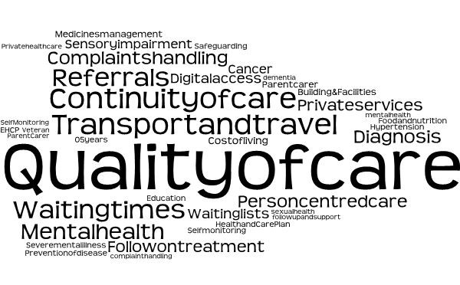
We receive experiences in a number of ways as demonstrated in the chart below. The majority of these this month were via our engagement sessions and telephone calls to our Helpline. We also received contacts via our volunteers, our website, emails, awareness raising events, our Independent Health Complaints Advocacy team and through Healthwatch England.

The map below shows the different areas we received experiences from. The highest numbers this month were from the Districts and Boroughs of Guildford, Waverley, Surrey Heath, Reigate and Banstead and Epsom and Ewell.

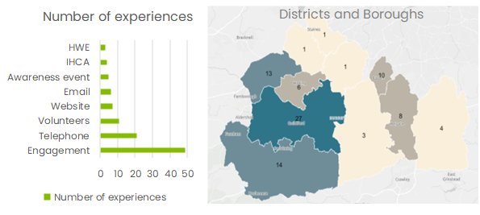

Who have we shared our insight with?
If we hear a case of concern regarding patient safety, we immediately signpost the sharer to the appropriate body and escalate the case with the provider/commissioner.

We have shared our insight in the following meetings:
- Surrey Heartlands Quality, Performance and Assurance Committee (presenting Neurodiversity report)
- Surrey Heartlands Primary Care Access Board
- Surrey Heartlands System Quality Group (JIG) (Asylum seekers and refugees)
- Ashford and St Peter’s Hospitals
- Healthwatch England
- Care Quality Commission (CQC) - Primary care and care homes.

We were also represented at other committees and meetings to encourage inclusion of local people and their priorities:
- Adults Health Select Committee (GP access and community mental health services)
- Frimley Health Foundation Trust Patient Experience Forum
- North West Surrey Community Day
- East Surrey Engagement Network
- North East Hampshire and Farnham (NEHF) Partnership at Place Forum
- Individual meetings with the CEOs (or representatives) of the Surrey Heartlands acute hospitals.

Our spotlight for engagement sessions in April was Surrey Downs and East Surrey in May.

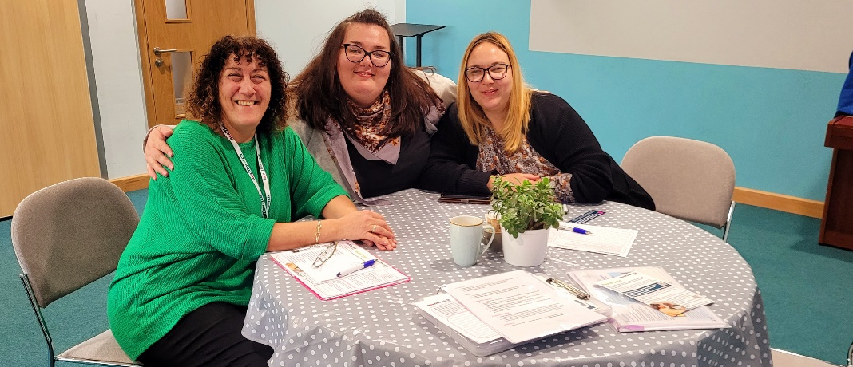
In June we will be in Surrey Heath.

Date​ | Place​ | Time​ | Surrey Area​
06.06.23 | Surrey Heath Family Centre, Camberley, Health Visitor Drop in Clinic (Group members only) | 9.15-11.00 | Surrey Heath
20.06.23 | Camberley Library, Camberley (Public) | 10.00-12.00 | Surrey Heath
21.06.23 | The Hope Hub, Camberley (Group members only) | 12.00-14.00 | Surrey Heath
27.06.23 | Best start in life group, Homestart, Camberley (Group members only) | 10.00-11.30 | Surrey Heath
TBC | St Andrews Church Community Café (The Ark), Frimley Green (Public) | 10.00-12.00 | Surrey Heath
Please note: these dates may be subject to change.

To share an experience with us, people can also contact our Helpdesk in the following ways:
Phone: 0303 303 0023
SMS (text only): 07592 787 533
Email: enquiries@healthwatchsurrey.co.uk
Share your feedback via our website: https://www.healthwatchsurrey.co.uk/feedback-centre/

Our distribution list
If you would like to be added to or removed from the distribution list for this Insight Bulletin, please contact our Communications and Involvement Officer vicky.rushworth@healthwatchsurrey.co.uk

