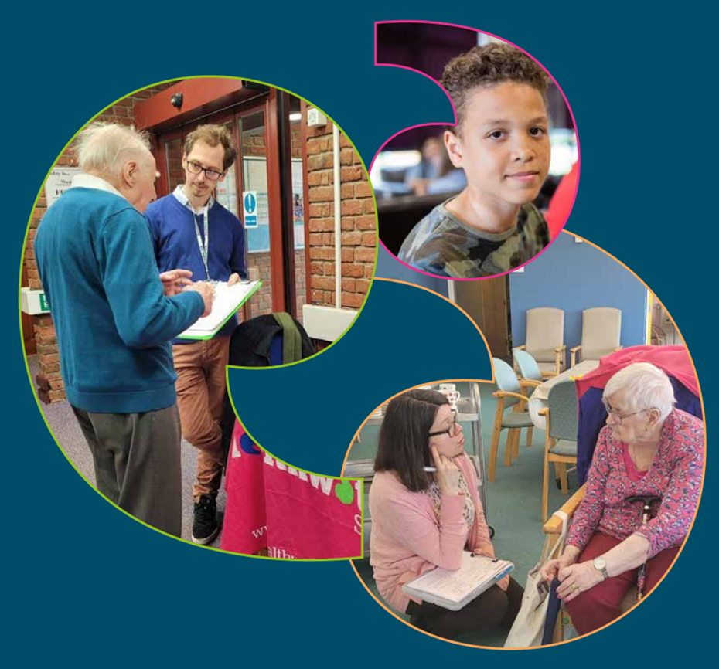

Healthwatch Surrey logo

Influence and Impact Report

January to March 2023

“Helping shape health and social care services in Surrey”

Influence and Impact Report

January to March 2023

“Helping shape health and social care services in Surrey”

If you would like a paper copy of this document or require it in an alternative format, please get in touch with us.

# Contents

Contents 2

Hearing Local Voices 3

Supporting Community Organisations 5

What we’ve been hearing 7

Community Pharmacy 7

Hospitals 8

Dentistry 8

Accessible Information Standard 9

Research Projects 10

The Hidden Value of Diagnosis for Neurodiversity 10

Maximising Learning from Complaints 11

Enter and View 12

Beaumont Lodge 12

Wider Influence and Impact 13

Supporting the Future of Social Care 13

Working Together to Raise Voices 13

Our Volunteers 14

Engaging with Communities 14

Influencing Decision-Making 15

Helpdesk and Advocacy Services 16

Helpdesk 16

Advocacy 17

Healthwatch Surrey – Contact us 19

# Hearing Local Voices

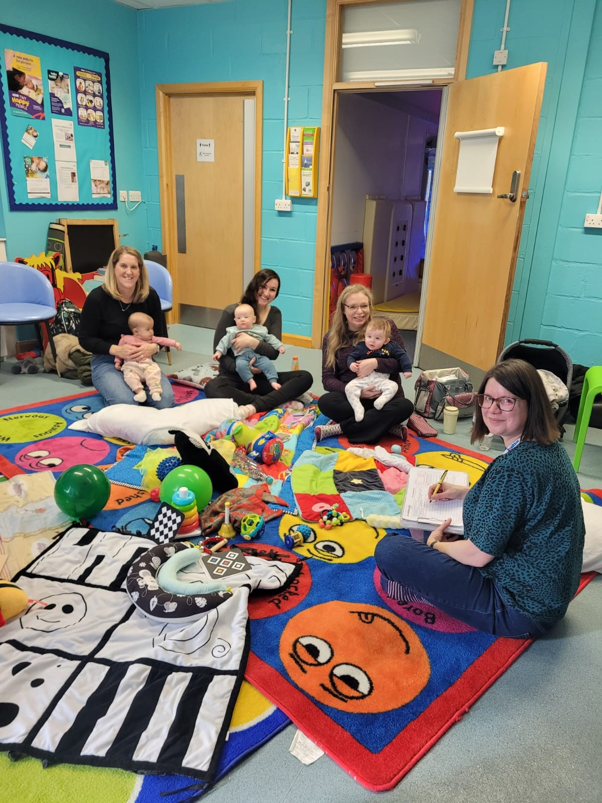

Our community engagement team, supported by our volunteers, have been speaking with residents across Surrey to hear experiences about health services across the county. We have focused our attention on voices that are seldom heard in decision making.

For instance, we spoke to people receiving support at a community fridge in Knaphill and a food club in Horley, hearing about the challenges faced by families in managing their physical and mental wellbeing during the current economic hardships. We also visited a warm hub in Lingfield, to see how these hubs have been helping their community throughout the winter.

With ongoing challenges faced by maternity services, we visited a family centre in Horley and the Baby Bubble in Hythe to speak with parents about the support they received and ensure residents’ voices are heard in helping services to develop.

### Making connections

Signposting people to appropriate support is a crucial part of engagement, both for the individuals sharing their stories and also for the community organisations we visit. We met a leader of an African Community group in Horley who was looking for advice on how to support her community. She was arranging a health event to raise awareness of health issues within the community and wanted to invite health and care advisors to provide information and support. We connected her with a wide range of health professionals and networks who provided supporting material for the event. We also recommended some organisations who offer free health checks.

We were delighted to hear that the event was a success with a high turnout and the health checks were so popular they arranged to come back for the next event.

### Supporting Refugees

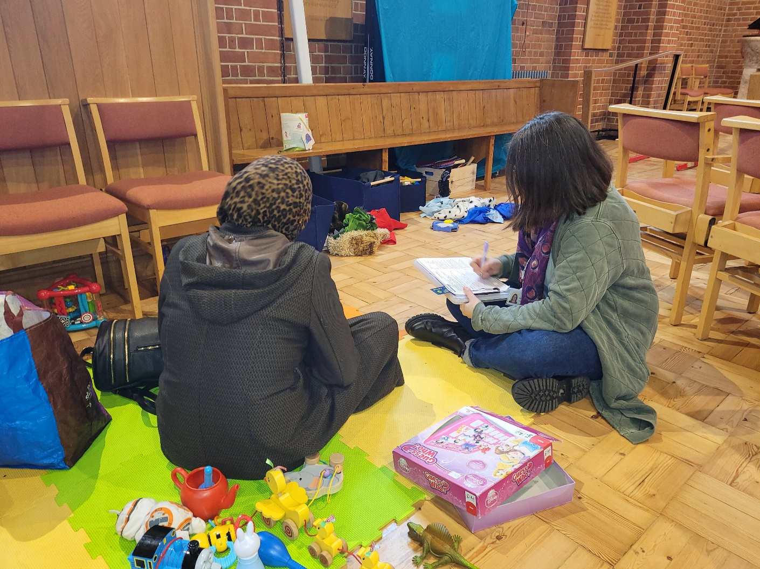

We visited Ukrainian hubs in Woking and Guildford to speak to people adapting to life in Surrey. We provided advice about how to access support, how to register with a GP and the opportunities for getting help for health conditions. We learned that there is a clear gap in signposting and information, causing many to turn to emergency services as their sole means of seeking help. Some are also being required to travel large distances to access services with limited means of affording public transport. We also signposted people who were previously healthcare professionals in Ukraine and wanted to know how they could use these skills locally.

We shared what we heard with Surrey Heartlands’ engagement team, who will now be attending these hubs to help signpost and advise. We also raised these issues at the Surrey Heartlands System Quality Group to highlight people's lived experience in order to better understand the needs of these communities.

# Supporting Community Organisations

We are always looking to ensure that Healthwatch Surrey champions and listens to as many Surrey residents as possible. Through our Community Cash Fund, we have sought to aid community organisations that support and empower seldom heard voices. This year we invited applications from community groups providing vital health and wellbeing support to young people across Surrey.

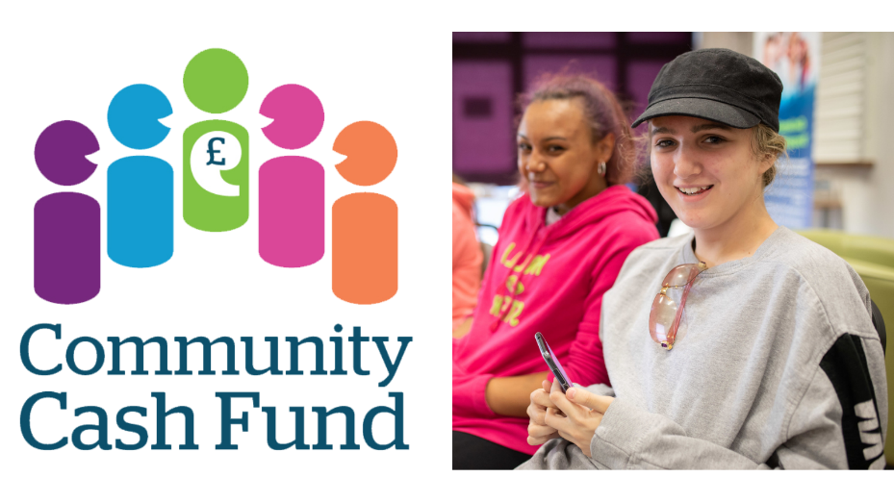

Our shortlisting panel was led by three members of our Young Healthwatch; Katie Grinyer, Rosie Pannett and Lucas Taylor, and volunteer Angus Paton. The panel awarded over £11,000 to 8 community organisations:

* **Appeer CIC** - Supporting a 4 to 6 week autistic-friendly work experience programme for girls aged 16 to 18.
* **Youth Include Choir** – Funds to provide a new accessible group in Epsom.
* **The Matrix Trust** - Support for their BOOST project which seeks to ‘improve the wellbeing of the young people aged 16-24 by building their confidence and transferable skills through supportive work experience’ at The Hideaway Café, Guildford.
* **Intergenerational Music Making (IMM)** – Help to develop a social action pilot enabling young people to connect, through a combination of think tanks, podcasts and mentoring.
* **Red and Black Roots Football team** - Providing young Albanians in East Surrey an opportunity to socialise, exercise and improve their wellbeing.
* **Leatherhead Youth Project** – helping their vital mental health support service for young people from deprived areas.
* **Addlestone Salvation Army** – Aiding their drop-in service to continue helping young homeless people access help and support.
* **Twister** -Providing a group for LGBTQ+ young people aged 14 to 19, with the means to provide education and support regarding problems with drugs and alcohol in the community.

We will continue to work closely with each of these projects throughout the coming year to learn how we can better support and encourage young people to be involved in the shaping of their local communities.

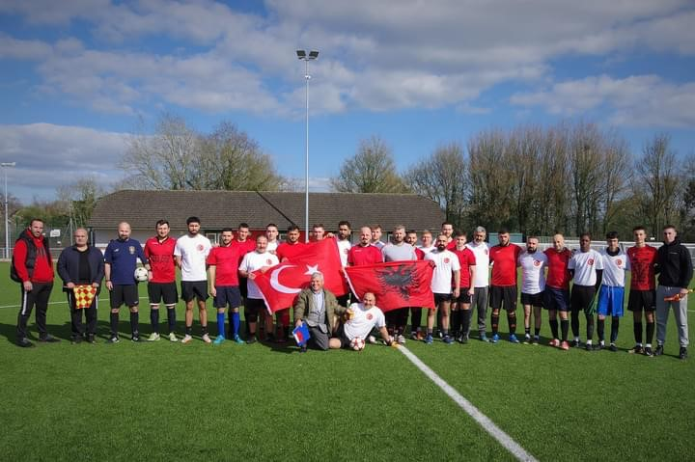

# What we’ve been hearing



**This quarter 389 people shared their story with us**

## Community Pharmacy

We have continued to hear that access to community pharmacy services is challenging for residents across Surrey. We heard that access to some medications has been increasingly difficult with issues with supply chains and unexpected changes to opening times leaving people without the means to collect prescriptions.

We have also raised concerns regarding the closures of Lloyd’s Pharmacies in Sainsbury’s and the impact this is having on some communities.

We have shared residents’ concerns with Surrey Heartlands primary care access board and the Chief Executive of the Surrey and Sussex Community Pharmacy Board.

We have also shared concerns more locally. For example, we discussed the problems residents were having with medicine at the Guildford and Waverley Quality, Performance and Assurance Committee. As a result, a subgroup has been formed to better understand the challenges with medicine shortages and how best to communicate with residents about the services, ensuring that local people have the information they need in order to obtain the medications they rely on.

## Hospitals

We’re hearing of increasing delays for residents trying to access advice and support through Patient Advisory Liaison Services (PALS). Residents have shared experiences regarding multiple weeks waits for acknowledgement of enquiries as well incorrect information about the feedback process and opening hours to contact the service.

We continue to work closely with each of the hospitals in Surrey to share residents' experiences and support PALS teams to liaise directly with people to discuss their concerns.

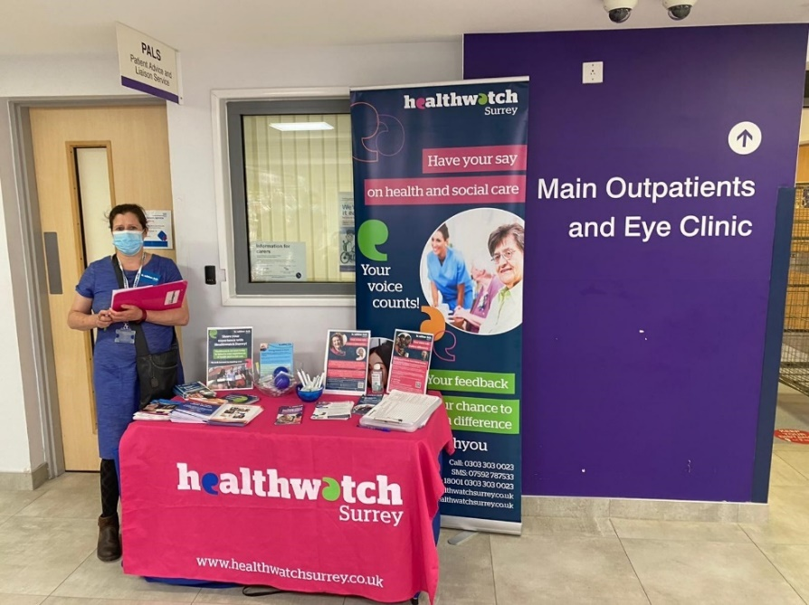

In order to help services improve we are developing new connections. Our Independent NHS Complaints Advocacy service met with the patient experience lead at Ashford and St Peter’s to develop a better understanding of how each of our services operate, sharing the issues we face and how we work together to better support residents in the future.

## Dentistry

Access to NHS dentist appointments continues to be a barrier for many Surrey residents and we continue to raise the profile of these concerns. Patients are not always properly informed of whether services are being provided as NHS treatments or privately and information was not clear as to what costs patients are accountable for. We shared this experience with the Surrey Heartlands Quality Performance and Assurance Committee, who agreed the information needed to be improved. The chair raised with the representatives from NHS England that communication needed to be improved.

Surrey residents’ challenges in accessing NHS dental care were also shared as part of a parliamentary inquiry on NHS dentistry. Healthwatch Surrey, along with more than 30 other local Healthwatch organisations, submitted evidence to the Health and Select Committee to form part of a national review.

## Accessible Information Standard

We have continued to raise the importance of providing information about health and care services in a format preferred by individuals. Following Healthwatch England’s national campaign last year, we have written to the communication leads in the Surrey Heartlands Integrated Care System to ask for assurance regarding accessible information and availability of preferred formats across health services. We are also working in partnership with other Local Healthwatch colleagues across the Frimley Health Integrated Care System to raise a similar challenge.

We also continue to share experiences regarding residents facing challenges in accessing services due to services not accommodating their needs. One such experience of a resident in a wheelchair not being able to access cervical screening has now been incorporated into the Macmillan Cancer Pathway Interface Programme in Surrey Heartlands to form a part of training for new staff. One person sharing their story, will provide more opportunities for other residents to access services.



# Research Projects

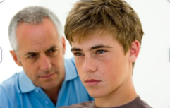

## The Hidden Value of Diagnosis for Neurodiversity

Our [latest research](https://www.healthwatchsurrey.co.uk/wp-content/uploads/2023/03/Neurodiversity-–-the-hidden-value-of-diagnosis.pdf) project reflects on experiences shared with us by parents, children, and young people who are waiting for, or who have received, a formal diagnosis of Autism Spectrum Disorder (ASD), Attention Deficit Hyperactivity Disorder (ADHD), or other conditions relating to neurodiversity.

Our main finding was that diagnosis brought certainty for families, so they better understood their child and what support they require. This then enabled families to explore options for how to seek support and developing strategies to reduce difficulties and connect with others with similar experiences.

Our recommendations:

* Continue to listen to families waiting for referrals or diagnosis; work with them to develop support that meets their wider needs - are there any additional benefits of diagnosis that could be delivered pre-diagnosis?
* Continue to work with schools at an individual level
* Empower grassroots and community groups, ensuring they have the support they need to thrive
* Ensure those willing and able to fund private diagnosis have the information they need to ensure their diagnoses are valid across all statutory services.

## Maximising Learning from Complaints

In December we published [our report](https://www.healthwatchsurrey.co.uk/wp-content/uploads/2023/01/Maximising-the-Learning-from-Complaints-_-Learning-from-Advocacy.pdf) sharing what we’ve learned from our Independent Health Complaints Advocacy service who support Surrey residents with complaints about their healthcare.

We have been sharing what we’ve learnt in a variety of platforms, meetings, and groups, and in January we discussed our recommendations in a group comprised of various stakeholders from across health and care organisations who are involved with handling complaints.

Among our recommendations, we called for clearer and more readily available information about complaints as well better promotion of the Independent Health Complaints Advocacy service. Surrey Heartlands acknowledged the importance of clear communication and revised their website accordingly, consulting with us before publishing the new version.

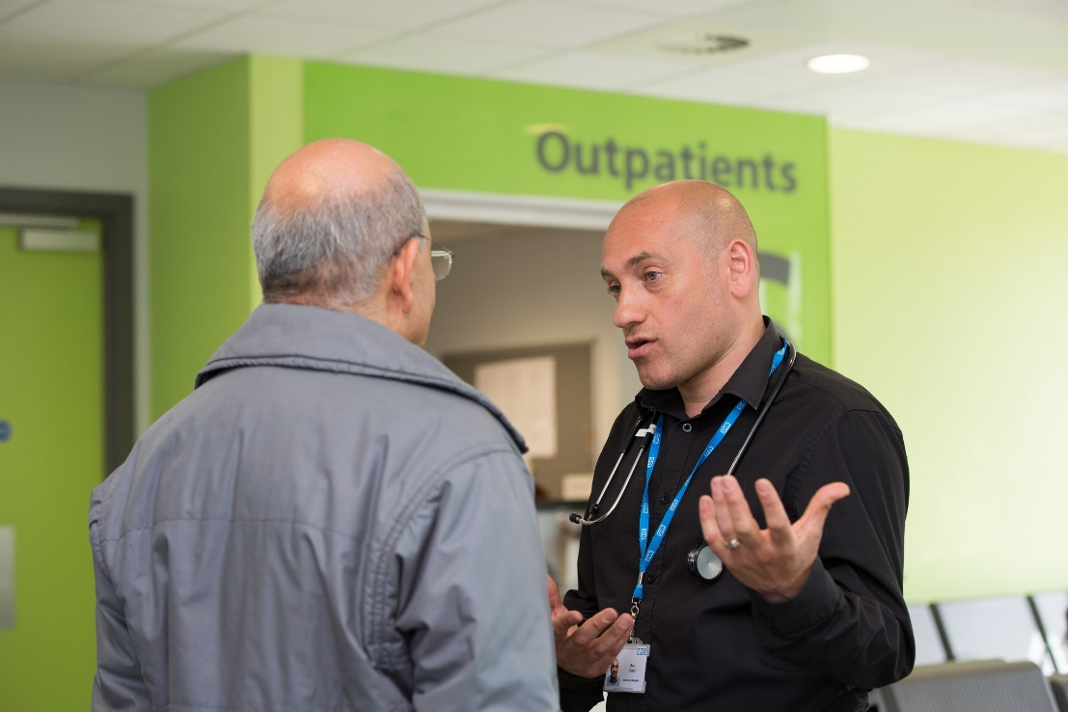

# Enter and View

Enter and View visits are one of the powers local Healthwatch have to enable us to visit places not readily accessible, such as inpatient wards and care homes.

## Beaumont Lodge

In December, we visited [Beaumont Lodge](https://www.healthwatchsurrey.co.uk/wp-content/uploads/2023/03/Healthwatch-Surrey-Enter-and-View-report-for-Beaumont-Lodge-March-2023-including-Provider-Response-1.pdf) in Camberley, a care home providing nursing and residential care for up to 43 people including people with dementia. We shared our findings with the management, who have made some changes following our recommendations.

We shared some residents’ concerns about flexibility of options in the menu and the manager acknowledged that the menu did not reflect the range of options available to residents, so a new menu will now reflect this.

We were also concerned that information about feedback and complaints was not freely accessible. Following our visit, the manager asked residents about their knowledge of the complaints process and reassured them that they would be supported through the process if necessary. Every room now has the written complaints procedure on the wall to make the information readily available for family members, who will also be given access to the new digital portal with further information regarding feedback and complaints.

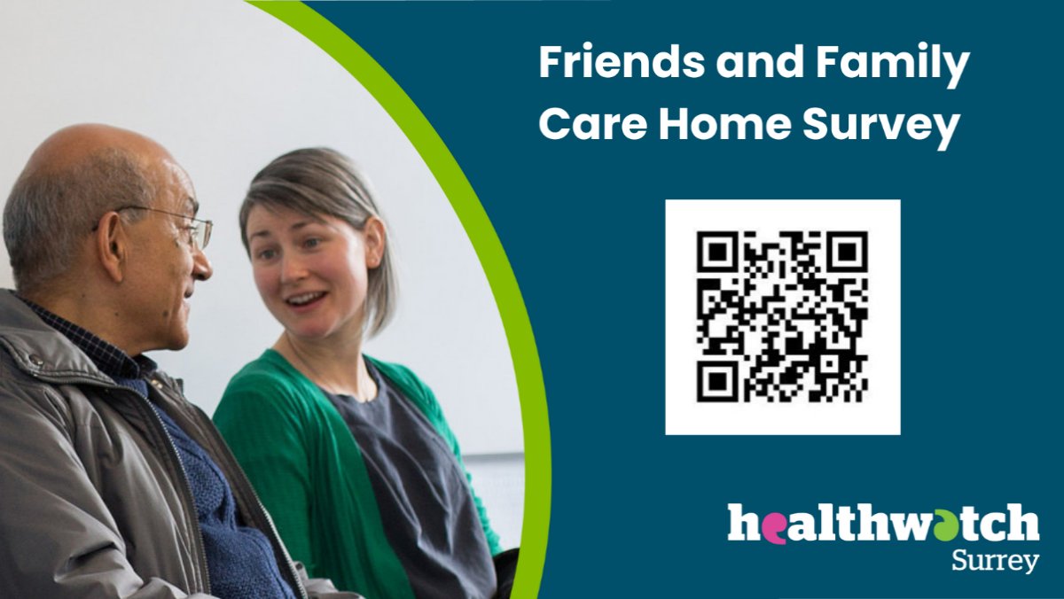

# Wider Influence and Impact

Healthwatch Surrey are always looking for opportunities for furthering our reach. Here are some examples of how we are working closely with other organisations locally to champion involvement of Surrey residents in the development and design of services.



## Supporting the Future of Social Care

Healthwatch Surrey continue to champion opportunities for people to have their voices heard and encourage organisations across Surrey to involve residents in decisions about services. We were invited as a key speaker to two events focusing on involving residents in social care services, the Future Care Forum which brought together a variety of stakeholders supporting and developing Surrey’s older people's residential and nursing care services.

## Working Together to Raise Voices

There are many organisations in Surrey working with communities to encourage organisations to involve people in the design of services. We have helped develop a group of organisations who engage with residents, where we can meet and share insight about what we’re hearing form the communities we support and discussing how we can work together to bring about meaningful change.

This quarter we collaborated to contribute to various sections of the Joint Strategic Needs Assessment, a process by which local authorities assess the current and future health, care and wellbeing needs of the local community to inform local decision making. We jointly shared insight from Surrey residents on housing and screening services.

# Our Volunteers

This quarter, our dedicated volunteers gave 443.5 hours of their time. This

equates to approximately £16,885 in social value.

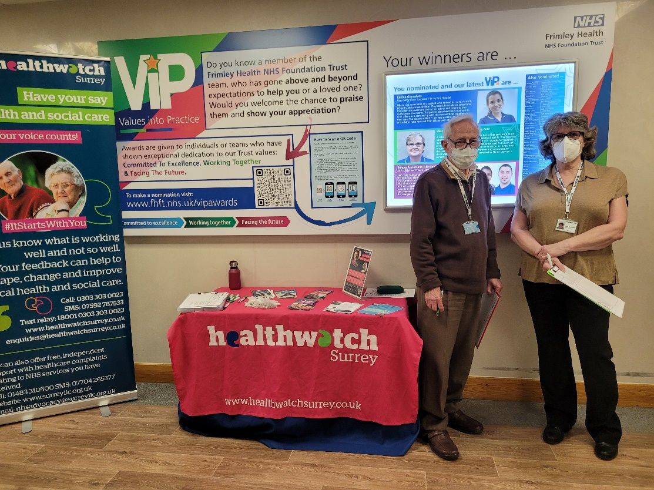

## Engaging with Communities

Each quarter, our volunteers visit places in their local communities to hear residents’ experiences of health and care services. This enables Healthwatch Surrey to build a fuller picture of how services are operating across all of Surrey, to identify where the challenges are and to help to improve where we can:

### Guildford & Waverley

Jill Bowman led an engagement event at the Haslemere Health Centre hearing mixed experiences about getting appointments, for some the service was very good and for others more difficult.

### Surrey Heath

In Camberley, Gareth Jones visited the Oasis Café at St Paul’s Church speaking to residents regarding their difficulties accessing GPs and hearing about challenges with people accessing mental health crisis support in Surrey Heath.

### East Surrey

Deborah Mechaneck attended workshops in Horley and Redhill, bringing together health, care and community organisations to learn how to better support people in their communities.

## Influencing Decision-Making

Some of our volunteers help to support the sharing of residents’ experiences in a variety of meetings involving senior health and care leaders. They also raise the importance of involving people in the development and design of services:

Healthwatch Surrey are represented at the Primary Care Commissioning Committee for Surrey Heartlands and for Frimley Health, by Peter Gordon and Maria Millwood respectively. These groups are responsible for the commissioning of primary care services across their integrated care systems. In the Surrey Heartlands meeting in January, Peter challenged the group’s Terms of Reference, a set of operational conditions describing the purpose of the group and how it intends to work to achieve this purpose. He challenged that the current version did not adequately state the involvement of residents or inclusion of engagement as part of decision-making, which has now been redrafted to address this. At the Frimley meeting in March, Maria raised a similar issue, following challenges she has made at previous meetings. This was acknowledged by the leadership and we were able to share the example from the Surrey Heartlands meeting to ensure the Terms of Reference were amended. This will help to ensure that people’s experience of primary care will be instrumental in the development of services across Surrey going forwards.

# Helpdesk and Advocacy Services

This quarter 191 people have received information and advice through our Helpdesk and our Independent Health Advocacy Service.

|  |  |
| --- | --- |
| **Helpdesk**  **80** | **Advocacy**  **111** |

Each quarter, our Helpdesk provides support and advice to Surrey residents who have questions about services or who are having difficulties with their care.

## Helpdesk

### Adrian’s experience

Adrian’s* daughter has been receiving treatment for leukaemia and is currently in remission but is in a fragile state both mentally and physically. Adrian lives near his daughter and he and his wife care for her and her seven-year-old daughter. His daughter receives some benefits and had applied to Surrey County Council for financial assistance to help with her care. Her application was turned down as her former partner was still financially helping with household bills. Adrian is worried about his daughter being able to financially manage and asked for help with how to contest the condition.

#### Outcome

Adrian was provided with details of the complaints procedure and a link to a factsheet on how to complain. He found the information very helpful and had been enabled to raise a complaint.

If you have an experience to share, contact our Helpdesk via:

**Phone:** 0303 303 0023

**SMS:** 07592 787533

**Email:** [enquiries@healthwatchsurrey.co.uk](mailto:enquiries@healthwatchsurrey.co.uk)

**Website feedback form:** [https://www.healthwatchsurrey.co.uk/feedback-centre/](https://www.healthwatchsurrey.co.uk/feedback-centre/?fbclid=IwAR2SRvElHX8cv0ez7uvNwNDO1ejYw3jqRcgxGg3Hky44vmWkSxXxlLPx9JE)

## Advocacy

In circumstances where people wish to complain about a health service, we also provide free advocacy support to ensure complaints are handled appropriately.

### Ana’s experience

Ana* had been diagnosed with depression and had been prescribed medication by the Community Mental Health Team. However, she then experienced severe side effects from this medication, significantly impacting her life, however requests for the medication to be changed were ignored. Instead she was signposted to attend workshops which she had attended previously and which hadn’t helped. Ana opted to consult a private Psychiatrist who prescribed an alternate medication and her condition immediately improved.

#### Outcome

Our advocate helped to write a letter of complaint and then followed up with the organisation involved multiple times to ensure the complaint was acknowledged appropriately. Ana was not happy with the proposed plan of investigation, so the advocate helped to raise this and make sure her concerns were addressed. The advocate followed with the organisation involved regularly, keeping Ana updated throughout, until she was able to receive a full response to her complaint.

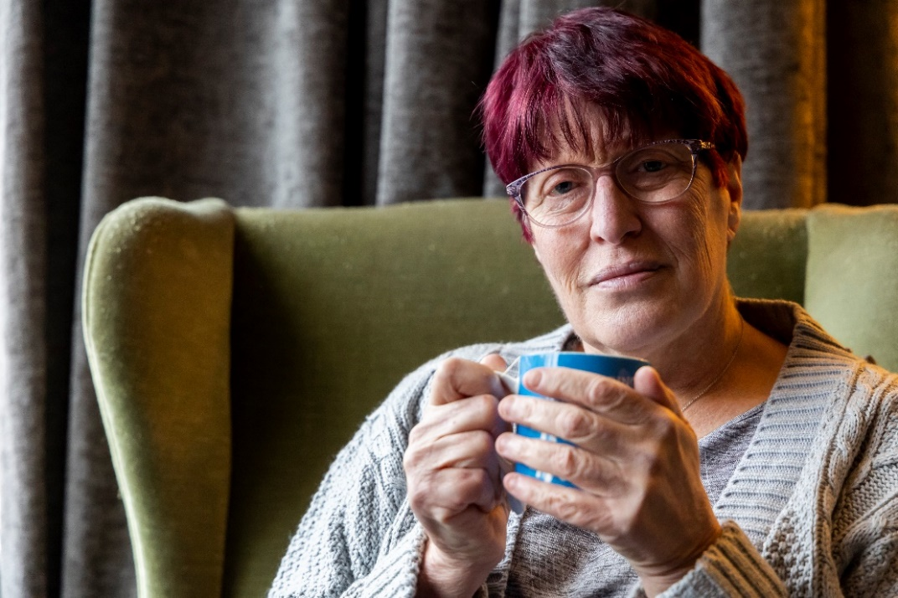

* Names have been changed to protect identities.

**Need help to make a complaint?**

If you live in Surrey and are unhappy with the NHS treatment you have received, our Independent Health Complaints Advocacy service can provide free, confidential and independent support to help you to make a complaint. This is provided in partnership with SILC (Surrey Independent Living Charity).

Contact the team via:

**Phone:** 01483 310 500

**Text (SMS):** 07704 265 377

**Email:** [nhsadvocacy@surreyilc.org.uk](mailto:nhsadvocacy@surreyilc.org.uk)

**Website:** [www.surreyilc.org.uk](http://www.surreyilc.org.uk)

# Healthwatch Surrey – Contact us

Website: www.healthwatchsurrey.co.uk

Phone: 0303 303 0023

Text/SMS: 07592 787533

Email: [enquiries@healthwatchsurrey.co.uk](mailto:enquiries@healthwatchsurrey.co.uk)

Address: Freepost RSYX-ETRE-CXBY, Healthwatch Surrey, Astolat,

Coniers Way, Burpham, Guildford, Surrey, GU4 7HL

Facebook logo Healthwatch Surrey

Twitter logo HW_Surrey

Instagram logo Healthwatch_surrey

LinkedIn logo Healthwatch Surrey

