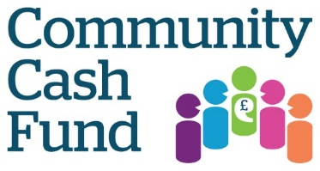

Application Form 2023

Name of organisation/group applying:

Contact name:

Address: (including postcode)

Telephone Number:

Email:

How much is the total grant you are applying for? £_________
(Max £1,500)

How did you find out about the Community Cash Fund?

Have you been awarded a Community Cash Fund grant previously? If so, please give details:

Please provide a brief description of your Community Cash Fund project - what you want to do with the money and how you plan to achieve your goals - in a maximum of 500 words. Please include a description of how the money will improve the health and wellbeing of people aged between 16-24.
Please use additional sheets if needed

Please give a comprehensive financial breakdown to show how you intend to use the grant:
Please use additional sheets if needed

Are you willing to attend a 2 hour Winners Workshop in April 2023 to receive your grant and talk to us about your project should you be successful in your application?

Are you willing to allow Healthwatch Surrey to visit your project/meet with you after the grant has been awarded to see how the money is making an impact?

We are keen to understand more about what matters to young people in Surrey and hear their experiences of health and social care. Please explain how you can help facilitate us hearing from young people e.g. a focus group, survey, having Healthwatch Surrey attend a session to get feedback etc.

Please send your completed Community Cash Fund application to: hannah.gilmour@healthwatchsurrey.co.uk

Alternatively, please post your application to Hannah Gilmour, Healthwatch Surrey, GF21 Astolat, Coniers Way, Guildford, GU4 7HL.

The deadline for all applications is Friday 17th February 2023 at 5pm.

You can call Helpdesk on 0303 303 0023 if you have any questions or contact Hannah Gilmour at the above email/postal address.

The selection panel will be meeting week commencing 20th February 2023 to discuss entries and we will be in touch once a decision has been made.

