Enter and View

Charlton Grange Care Home

June 2022

Table of Contents
Table of Contents 2
1. Summary 3
1.2 Why we visited 3
1.3 Summary of key findings 4
1.4 Acknowledgements 4
1.5 Disclaimer 4
2. What we found 5
2.1 Description of service 5
2.2 Environment 5
2.3 Facilities 7
2.4 Staff 7
2.5 Covid measures 8
3. What we heard 8
3.1 Who we heard from 8
3.2 Daily life 8
3.3 Food and nutrition 9
3.4 Activities 10
3.5 Care 11
3.6 Staff 12
3.7 Visiting health care professionals. 12
3.8 Visiting 13
3.9 Staying in touch 13
3.10 Feedback mechanisms 14
4. Next steps 15
5. Service provider response 16
RESPONSES MUST BE PROVIDED WITHIN 10 WORKING DAYS OF RECEIPT OF OUR REPORT TO ENSURE IT IS INCLUDED IN THE FINAL PUBLISHED REPORT 17
6. Appendix 17
6.1 What is Enter & View? 17
6.2 Purpose of Visit 18
6.3 Strategic drivers 18
6.4 What we did 18

Summary

Why we visited
Due to the pandemic, we have not been able to carry out any engagement at care homes, and therefore we have been concerned that the voice of care home residents has not been heard, and residents and families may be unaware of the existence of Healthwatch as their independent champion. Enter and View is one way Healthwatch Surrey can gather information about services and collect views of service users, their carers and relatives, as well as staff. We are working with Surrey County Council, Surrey Heartlands and CQC on our programme visits to care homes across Surrey and we will be carrying out one visit per month during 2022/23.
As well as giving residents an opportunity to share their general views of the care home, our focus is on finding out whether residents and families are aware of or have used any feedback mechanisms.
As well as the face-to-face visits we are also running a survey for friends and family – available at: https://www.smartsurvey.co.uk/s/HealthwatchSurreyCareHomeFamilyFriendsSurvey/ and as paper copies. This will run for a year, links to the survey will be distributed via Care homes own newsletters and promoted on Healthwatch Surrey’s communications and by other stakeholders.
Details of visit:
Service Address | Charlton Grange Care Home, CHARLTON LANE, UPPER HALLIFORD, SHEPPERTON TW17 8QN, UK
Service Provider | Golden Manor Healthcare (Ealing) Limited
Date and Time | 26th May 2022 3-5pm
Authorised Representatives | Katharine Newman, Sarah Browne, Errol Miller, Angus Paton, Virginia Fenton.
Contact details | Healthwatch Surrey GF21, Astolat, Coniers Way, Burpham, Surrey, GU4 7HL  enquiries@healthwatchsurrey.co.uk  Helpdesk: Telephone: 0303 303 0023 (local rate number)SMS (text only): 07592 787533

Summary of key findings
Our overall impression was positive; residents, family and staff all appeared to be happy with the care, visiting arrangements and feedback mechanisms. We were particularly impressed that the home operates fully with its own staff, and has had no Covid outbreaks.
Based on our visit, we have three recommendations to help improve the experience of residents:
- Increase the choice of main meal to 3 options per day
- Incorporate raised beds in the garden to ease accessibility
- Add extra chairs to the corridor seating (to allow two people to chat)

Acknowledgements
Healthwatch Surrey would like to thank residents, their families, and the staff at Charlton Grange, for their contribution to our Enter and View programme.

Disclaimer
This report relates to findings observed on the specific date set out above. Our report is not a representative portrayal of the experiences of all residents, their families and staff, only an account of what was observed and contributed at the time.

What we found

Description of service
Charlton Grange is an independent, family-run home which provides accommodation, nursing and personal care for up to 62 older people, including people living with dementia. It is also registered for disease, disorders and injury, which includes palliative care. The home is purpose-built, and accommodation is arranged over two storeys.
Website: www.charltongrange.co.uk
Provided by: Golden Manor Healthcare (Ealing) Limited
Registered manager: Daria Maria Leszczynska
Capacity: 62 residents, currently 60. Some residents have funded nursing care. 20 residents were male, 40 female.
We were told that there were no agency staff being used, and that there was a high staff retention.
Staff identified patients who would have capacity to speak to us on the day.

Environment
The accommodation is split across two floors, those with mild dementia live on the ground floor. The first floor is split into separate wings, one for palliative care and the other for those with dementia with challenging behaviour.
The home was very clean and fresh smelling. There was a calm, well managed atmosphere. Most residents were out of their rooms.
On the first floor we saw a ‘sensory wall’ and we observed patients in their rooms.
There was a ‘dementia house’ display created by a member of staff. This included posters about how to speak to a person with dementia, and quotes to remind visitors of the dementia journey that their loved one is on.

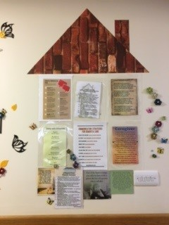
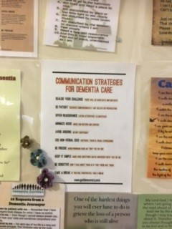
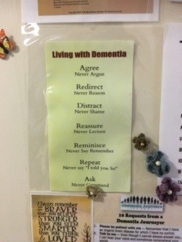
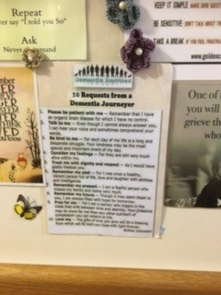
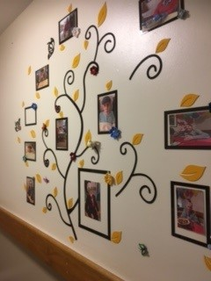

We also saw a ‘residents tree’ which displayed photos of each of the residents

On the ground floor, we saw themed corridors, such as the London corridor, and the history area, with pictures of historical newspapers.

There was a lot of interesting artwork on the corridor walls, and also a ‘book nook’ with a comfortable chair and side table on the corridor.
Recommendation: We recommend having two seats together in the book corners so people could chat with a friend outside a busy lounge environment

Facilities
The dining room was being used when we visited, as the residents were enjoying ‘posh tea’ – eating the results of the baking club which had taken place in the morning.
Residents had been able to choose the theme for the café- they had chosen Elvis, there was lots of memorabilia /artwork displayed. Residents had also chosen the colour of the dining room and the lounge. Staff told us they had had done a lot of decorating in their own time, to minimise disruption to residents.
All the bedroom doors displayed photos of the resident and their name.
One resident invited us into their room which was clean and spacious enough, and showed personalisation, with family photos on the bedside table and pictures on the wall. Two authorised reps entered the room (in line with our Enter and View guidance).
Each bedroom was ensuite, with a WC, basin, and shower.
There was a hairdressing salon, which is due to be renovated, so that manicures and pedicures can take place there.
The lounge was spacious, with a large TV and opened out into the garden. No residents were in the lounge when we visited. Herbs and vegetables were grown in the garden, which were used in the kitchen.
Recommendation: We recommend considering raised beds to aid accessibility.

Staff
Staff were friendly and approachable, and clearly loved their work. Staff interacted well with each other, residents and families. We were greeted cheerily on arrival by a maintenance staff member, which set the tone for our visit.

Covid measures
We were asked to show evidence of a negative Lateral Flow Test on arrival. We wore face masks but checked with staff for permission to lower them when we felt that residents might find it hard to understand us.
There were several hand sanitizer units around the home.

What we heard

Who we heard from
We spoke to two residents, three family members (with the resident they were visiting), seven members of staff, and the local GP. We also received feedback from one family member via our website ahead of the visit. At the time of writing, we have received no responses to our online family survey relating to this home.

Daily life
Residents we spoke to were very happy and said that they couldn’t fault the care they receive. Most had been involved in the decision to move to Charlton Grange and could see the benefits of living there. Other residents had been discharged there from hospital and had been given no choice. However, we were told that despite initial reticence, their families were very happy.
“I got a call from the hospital to say they were transferring him that very day to this care home in Shepperton! I came to the home and saw the room in the palliative care wing and ok, it was nice, and I felt alright about it. His room is nice, and we can open the door and he can be made comfortable in his bed and listen to his music. This place smells nice and clean, also of home cooking”.

Residents enjoy going in the garden, chatting with friends, watching films. They can stay in their rooms or can go to the lounge if they want “a bit of quiet”.

This quote sums up the experience of all the families we spoke to:
“My uncle’s dementia was getting worse, and he was becoming very difficult to handle at home for my auntie. Since his admission my family has had a break and is able to enjoy his company again, which is something we couldn't imagine. I would like to thank the wonderful staff at Charlton Grange for giving us this opportunity and removing the obstacle of care from our shoulders! Care received is excellent”.

Food and nutrition
Catering is provided by an external firm, but all cooked on site. We were told that there is a 4-weekly menu rotation, which changes for winter/summer. We were told that if any resident wants to eat something different /lighter such as eggs/omelette/sandwich the kitchen will provide this. This was confirmed by residents:
“The food is very good. If you ask for something they would try and prepare it for you”.

The kitchen will cater to different diets and consistency requirements (e.g., pureed) and will do their best to make it look like the other residents’ food.
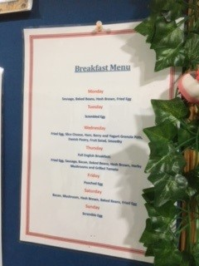

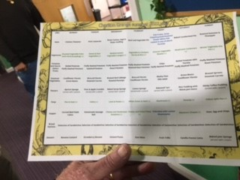

However, we felt that the menu choice was limited.
Recommendation: We recommend adding more options for main courses each day.

Activities
Activities take place Monday- Friday, however we were told that if there was a special occasion, e.g., the Queen’s Jubilee, activities would take place at the weekend.
There was evidence of activities, with a weekly planner on display around the home. We saw residents eating the cakes they’d made in the morning at baking club. This was a weekly event, which the residents appeared to enjoy. Residents can go into the garden and help to grow herbs and vegetables which are used in the kitchen. Residents have access to the garden if the weather is good and garden parties and BBQs are held there.
There was a large TV in the lounge, and we heard about regular film nights, sport/exercise and craft activities. We saw lots of displays showing residents taking part in activities, these displays are changed every two months.

From the staff’s point of view, there was a lot of emphasis on activities in the home and it was apparent that this kept people engaged, and they enjoyed what was on offer. One staff member said:
‘People are always asking – what are we doing now? They like to be involved’
The activities coordinator gave a good account of the programme she runs, and this includes celebrating special occasions and there were plans for the upcoming Jubilee Weekend celebrations. There was evidence seen during the visit that there was a busy schedule of events and people were kept stimulated.
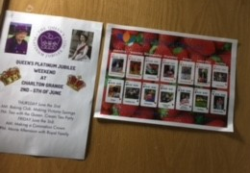

Care
The residents and families were all very satisfied with the care they received irrespective of whether it was daytime, nighttime, or weekend.
“Very satisfied with daytime care. Never any complaints, she’s always calm”.
Very satisfied with nighttime care. Very satisfied with weekend care, not aware of any changes”.
Most of the staff spoken with were day staff and unable to comment about what the service was like at night, but the operations manager confirmed that checks were carried out to ensure that high standards of care were maintained at night. One resident told us:
“I press the bell if I need anything at night. The staff are quite on the ball. They would all be concerned and would run in if I press the bell, same at weekends, Monday to Sunday it’s all the same level of care.”
Weekends were described as ‘busy’ as many people had visitors coming to see them and take them out. This was particularly noticeable after restrictions were lifted.

We asked whether residents or family members were aware of a named senior carer. It was apparent that families were not, but this was a positive:
“Not aware of a named senior carer, I think they all look after him. I don’t know one person who just looks after him.
I don’t know if there is a named carer. Just everyone cares.”

We asked whether family members were aware of a personalized care plan, - the majority were not aware, but again this was perceived to not be an issue, as staff will talk to family members when they visit, and if any changes are needed, they will discuss them.
“Not aware of personalised care plan. Very satisfied with his care, cannot fault the plan.”
Staff were aware of the need to involve and inform nurses and managers if there were changing health needs – such as changes to mobility – they needed to raise.
They said that support plans would be altered to ensure needs were met and they would be told about any changes.

Staff
We spoke to seven members of staff, including one nurse, the operations manager, the activities coordinator, one HCA, one senior HCA and one HCA training to be senior HCA as well as the maintenance person
All of the staff spoken with were positive about their experiences of working at the home. They reported that they were well-supported by their managers and would be helped if they were short staffed on the floor.
Comments from staff included:
“I love my job. I love to care for people – I see them as like my grandparents – I ask how would I like my grandparents to be treated?”

“Care is very good – we treat them as family and not as strangers.”
“I love working with older people – it’s the perfect job.”
Staff members appeared to work well as a team and one person commented ”I’m shown what to do and I can ask for help from my senior or the nurse.”
Another staff member said, “Staff are good here – they will always help.”
The maintenance person worked flexibly to meet the needs of the service and would come in out of hours if needed

Visiting health care professionals.
The local GP visits every Thursday, her testimony was positive, and she commented that the home had really improved. She reported that she was able to communicate easily with staff at the home and that they followed her advice. She said she saw ‘familiar faces’ when she came into the home, and this indicated that there was stable staffing. She said that staff were responsive and that they would get in contact as soon as they noticed any changes in health that they should be informed of and would ensure relevant details were passed on. There were no concerns about health monitoring – weights, fluid intake etc. – and they would send regular emails and respond when needed. The GP commented:
”Sometimes they build them up so well they can go home.”

We were told that the chiropodist visits regularly; the dentist visits 6 monthly. Three ladies have broken dentures, they have been told there is a 3-4 week wait for an NHS dentist appointment. One resident is waiting for a physio appointment, following a referral which was made in November.

Visiting
We were told that on the palliative care wing family are able to visit 24/7, with no restrictions.
Residents on the ground floor concurred with this:
“I have family and friends who visit. They can come whenever they want/ it’s a family thing here, it’s not all set out, they don’t need to make appointments.”
Family and friends agreed and stated that they were very satisfied with current visiting arrangements
“I visit every single day without fail 11-6pm. My husband gets lots of visitors and we are left to do what we want mostly.”
Staff confirmed they had good relationships with families and welcomed them into the home. There were no restrictions on visiting.

Staying in touch
Staff reported that people were supported to stay in contact with their families,
“I used to have a mobile phone, so I can call my sister. And friends who can sort things out for me. The staff are good people and help me.”

Most communication from the home to the family seemed to be managed through the nurses or the managers rather than the care staff – which was not problematic as it is often easier to have clear lines of responsibility for communication.

Feedback mechanisms
The overall impression we had was that residents, families and staff are all very happy to raise issues with any member of staff, and they will be resolved. Family members felt very confident that they’d know what to do, - which was generally to raise it with senior management. No one we spoke to had ever had a need to raise a more formal complaint and therefore weren’t aware of any more formal feedback mechanisms
“I just ask the nurse and she’ll sort it.” (resident)
“Very confident I would know what to do or who to raise it with. I’d speak to the manager.” (Family member)
“There hasn’t been a need to complain really but I would go to Daria or Kulvinder. I did have a niggle about something the carer said but it was a miscommunication, and it is sorted now. I’m happy with his care and if I wasn’t I’d speak up.”
While we did not hear any comments from residents about a desire to move into another room, such instances must occur from time to time. Clearly, practical care considerations should be paramount, but perhaps residents could be made aware that if a room becomes vacant a request to move into it will be considered, if reasonable.
When asked about concerns being raised, it was clear that staff were responsive and would try to resolve issues if they could – such as a remote control not working – and they would escalate to managers if they were not able to solve problems.
Staff were not fully aware of the formal complaints procedure and may benefit from some training, but this is a minor issue and did not appear to have any impact as they were aware of the need to escalate to senior managers.

Next steps
This report and the response from the service provider will be shared with commissioners and regulators of the service and will be published on our website.

Service provider response
Service Name: | Charlton Grange Care Home
Service Manager: | Daria Maria Leszczynska
Visit date: | 26th May 2022
Factual accuracy
If you have any concerns about the factual accuracy of the report, please clearly identify the sections, content and corrections that are required in the space below:
Organisation response to the report
Please provide your response here. This will be included in the final report.
(THIS RESPONSE WILL BE PUBLISHED IN FULL)
What we found:
HEADINGS

Respondent Name:
Respondent Job Title:
Feedback on the visit
If would like to provide some feedback to Healthwatch Surrey on the visit itself, please provide this in the space below:

RESPONSES MUST BE PROVIDED WITHIN 10 WORKING DAYS OF RECEIPT OF OUR REPORT TO ENSURE IT IS INCLUDED IN THE FINAL PUBLISHED REPORT

Appendix

What is Enter & View?
Part of the local Healthwatch programme is to carry out Enter and View visits. Local Healthwatch representatives carry out these visits to health and social care services to find out how they are being run and make recommendations where there are areas for improvement. The Health and Social Care Act allows local Healthwatch Authorised Representatives to observe service delivery and talk to service users, their families and carers on premises such as hospitals, residential homes, GP practices, dental surgeries, optometrists and pharmacies. Enter and View visits can happen if people tell us there is a problem with a service but, equally, they can occur when services have a good reputation – so we can learn about and share examples of what they do well from the perspective of people who experience the service firsthand.
Healthwatch Enter and Views are not intended to specifically identify safeguarding issues. However, if safeguarding concerns arise during a visit, they are reported in accordance with Healthwatch safeguarding policies. If at any time an Authorised Representative observes anything that they feel uncomfortable about they need to inform their lead who will inform the service manager, ending the visit.
In addition, if any member of staff wishes to raise a safeguarding issue about their employer, they will be directed to the CQC where they are protected by legislation if they raise a concern.

Purpose of Visit
The purpose of the visit was to listen to the views and experiences of people who live and work within the home.

Strategic drivers
Our Enter and View programme is one of our strategic priorities for 2022/2023, enabling us to hear the voices of seldom heard groups; on this occasion- care home residents.

What we did
The visit to Charlton Grange was an announced visit. Before the visit we gave the care home posters to display around the home to make staff, residents and their families aware of our visit. This poster included a QR code which links to our feedback form on our website. We saw the posters displayed when we visited. We also gave the home Healthwatch Surrey “Problem Praise Suggestion” leaflets, which residents and family members could use to send their feedback via post. We gave out Healthwatch Surrey branded thank you postcards to all of the people we spoke to.
We received one experience via our website ahead of our visit. We spoke to two residents, three family members (and their resident) and seven members of staff. We also spoke to the local GP who was visiting on the day.
Five Authorised Representatives of Healthwatch Surrey conducted the visit.
On arrival we were greeted by the registered manager and owner. We explained what we would like to do. One member of the team was seated in the Elvis café, and staff members were brought in to give their feedback. The other ARs were taken on a tour of the building, starting on the first floor, in the palliative care wing. Two members of the team then chatted to residents and their family member. The other members of the team were escorted around the premises by the registered manager. We stopped and chatted to residents in the dining room, where many residents were enjoying ‘posh tea’. On all occasions, we checked with staff who would have the capacity to talk to us. We were allowed to take photographs. All of the questions we asked were answered openly and enthusiastically. We observed the surroundings to gain an understanding of how the home works and how the residents engaged with staff members and the facilities, these findings were recorded on observation sheets. We used a semi-structured questionnaire when talking to residents, family members and staff.
We explained to residents, their family members and staff that we were from Healthwatch Surrey and that we were gathering experiences of what it’s like to live at Charlton Grange, and particularly to find out whether they would know what to do if they wanted to give feedback about the service.

