Ward Feedback Form
Return to:

Sonya.scammell@sabp.nhs.uk
Pre-development (as existing) mental health ward, service user / carer feedback
Please note: Feedback deadline is Friday 12th July

Your views matter – mental health ward environments can be less than ideal, we are going to improve them by listening to those who live and work in the facilities. Our starting point is to collect your thoughts on how we can make the ward environment better. We will try to respond directly to your needs, wishes and preferences to ensure the building supports recovery.

It would help us to hear your views and experiences on the existing wards, how it makes you feel, how we could better respond to your
needs. We will use this feedback to help shape the design proposals. We will ask the same questions when the new facility is open, to see whether we have achieved our goal of making the ward environment better for service users. If you would
like to be involved with this and be kept appraised of the Project’s progress please provide your contact details on page 4 (optional). There are no right or wrong answers, we would like to hear your views on what works well, what doesn’t work and any ideas you may wish to share for improving the ward environment inside and outside.

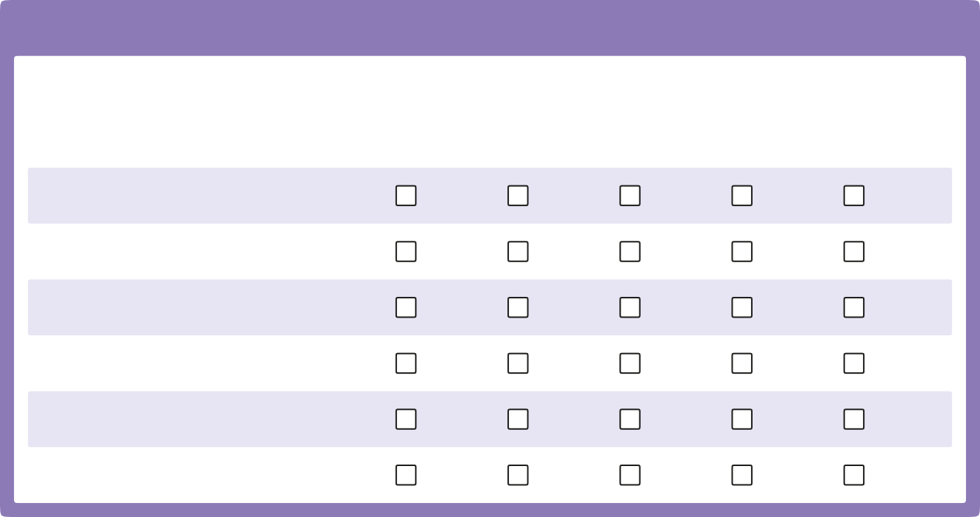Please complete the following sections. If you would like to include any more general comments, photos or drawings to help illustrate your feedback, please feel free to attach these to page 4.
2. Feeling valued
On a scale of 1 to 5, please rate the following: (tick box)

There was enough space where I could meet with others?
There were areas where I could
retreat when I wanted to?
The layout of the building made it easy to see and engage with staff?
The ward environment helped my well-being?

The building protected my privacy? The building supported my dignity?
1. Hospital and ward name

1 | 2 | 3 | 4 | 5
Strongly | Disagree | Neither | Agree | Strongly
disagree |  | agree nor |  | agree
 |  | disagree

3. Atmosphere – first impressions
What type of facility did the building look like when you first arrived?
Please describe your first impression of the ward environment?
What, if anything, did you find unexpected about the building, in either a good or bad way?
Please describe how your ward environment made you feel?
What changes would you make to your ward environment if you were able to?
What was it about the ward environment that made you feel better or worse?
4. Safety
On a scale of 1 to 5, please rate the following: (tick box)
1
Strongly disagree
2
Disagree
3
Neither agree nor disagree
4
Agree
5
Strongly agree
The overall ward layout made me
feel safe?
The seperate spaces on the ward made me feel safe?
The building safety features made me feel safe?

I felt safe at night?

I felt safe during the day?

When I needed help I could get it?

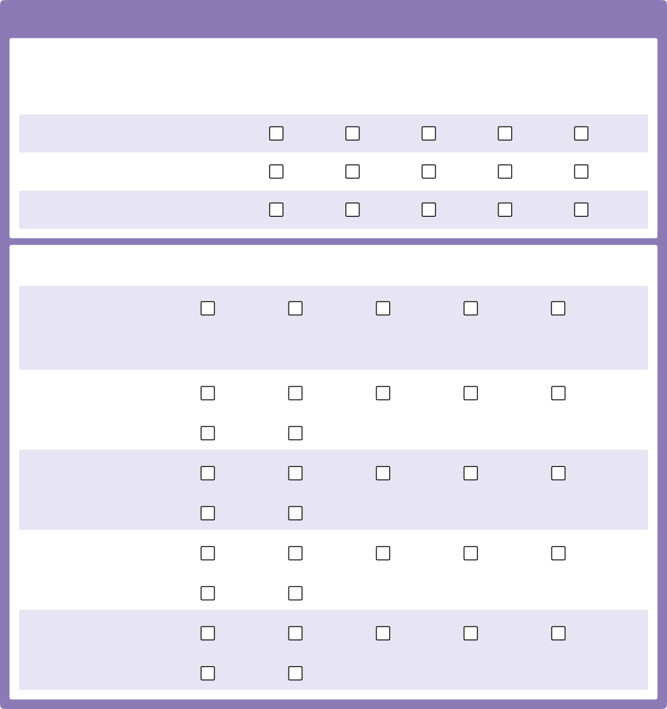5. Choice and control

On a scale of 1 to 5, please rate the following: (tick box)
1
Strongly disagree
2
Disagree
3
Neither agree nor disagree
4
Agree
5
Strongly agree

The building supports the development of trust between me and staff?
The building supports the development
of trust between me and service users?
It is easy to access an outside space
or garden?

Please answer the following: (tick box)

I benefitted most from spending time in?

Day room Bedroom Garden Activity
room

Other

If Other, please state:

How would you rate the internal temperature?

Too hot Too cold Just right Varies Don’t know

internal air quality?
Can you control this? Yes | No
How would you rate the Stale/airless | Too fresh | Just right | Varies | Don’t know
Can you open a window? Yes | No
How would you rate the Too bright | Too dull | Just right | Varies | Don’t know
Can you control this? Yes | No
How would you rate the Too noisy | Too quiet | Just right | Varies | Don’t know
Can you control this? Yes | No

internal lighting?

sound-proofing on the ward?

6. Ward environment
What single element of the ward environment has the most positive impact on you?
What single element of the ward environment has the most negative impact on you?
On a scale of 1 to 5, how would
you rate the ward environment overall? (tick box)
1
Very poor
2
Poor
3
Neither good nor poor
4
Good
5
Very good

6. Ward environment (continued)
Any other suggestions you would like us to consider in designing the new ward environment?
7. Any other more general comments?
Please feel free to attach photos or drawings to help illustrate your feedback.
8. Your details (optional)
If you would like to receive updates on the re-development and be involved in feedback on the new building, please provide your contact details below.

Name
Telephone
Email

Thank you for your time, which is greatly appreciated in providing feedback on the ward environment.
Pro-forma compiled by:

