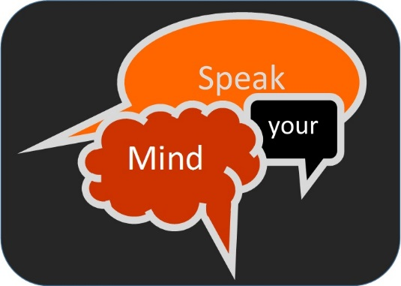
Help Create a New Independent Mental Health Network
For people who have experienced mental illness and carers

Make a difference in Surrey

Over 70 carers and people who have experienced mental illness attended an initial workshop on 25th September to begin discussions. We promised to send out a questionnaire to obtain the views of those unable to attend.
The network aims to provide flexible opportunities to get involved with, influence and develop mental health services. We want you to be able to ask questions, challenge the system and share views.
Together, people who people who have experienced mental illness and carers in Surrey can build a new, strong collective voice to engage with and influence the services available to them.
Please take some time to answer the following questions. Your views, comments and ideas will help shape the new independent mental health network.
- Do you agree with the proposal to create an Independent Mental Health Group/Network for people who have experienced mental illness and carers?
Yes ☐ No ☐
Any comments: Click here to enter text.
- What form could the network take? Please tick any that may work for you.
One meeting located centrally in the county ☐
One main meeting touring around different boroughs in the county ☐
Smaller regional meetings i.e. North, South, East & West ☐
Smaller regional meetings (as above) that feed into a central meeting ☐
Telephone conference meeting ☐
Video conference meeting ☐
Surveys / Questionnaires ☐
Hot topics (topics for discussion are sent to existing groups and mailing lists via email) ☐
Facebook group ☐
Any comments: Click here to enter text.

- How can we include people who already come together as a group and don’t want to or can’t attend additional meetings?
Click here to enter text.

- Please give us details of any mental health related groups and meetings that you already attend.
Click here to enter text.

- Who attends?
Combined meetings for people who have experienced mental illness and carers ☐
Separate meetings for people who have experienced mental illness and carers ☐
Any comments: Click here to enter text.

- Who leads the meetings?
Co-chairs (mix of people people who have experienced mental illness and carers) ☐
Co-chairs (people who have experienced mental illness, carers and independent professional (from voluntary sector) ☐
Professionals from the voluntary sector ☐
Any comments: Click here to enter text.

- What support might the network need?
Administration ☐
Training ☐
Access to research ☐
Accessible information ☐
Travel expenses ☐
Replacement care costs ☐
Any comments: Click here to enter text.

- When should we meet?
Mornings ☐
Afternoons ☐
Daytimes ☐
Evenings ☐
Mixture of the list above ☐
Any comments: Click here to enter text.

- How frequently should we meet?
Monthly ☐
Bi-monthly ☐
Quarterly ☐
6 monthly ☐
Annually ☐
Any comments: Click here to enter text.

- How can we reach more people and make the network inclusive?
Any comments: Click here to enter text.
- How can it be made attractive and relevant to young adult carers and young adults who have experienced mental illness?
Any comments: Click here to enter text.
- What shall we name this network?
Your suggestions: Click here to enter text.
- Any further comments that may help us to create a strong independent mental health network?
Click here to enter text.

If you would like to have your views on mental health services heard and acted upon by joining this new network, please give your contact details:
Name: Click here to enter text.
Email: Click here to enter text.
Address (if no email): Click here to enter text.
Tel. / Text: Click here to enter text.
The information you have given us will be kept confidential, and stored and used in accordance with the Data Protection Act 1998. The information will only be used in connection with your involvement in the Mental Health Network / Group

Thank you for giving us your views. Please return your completed form or your written response by Tuesday 10th November 2015 to:
carol.pearson@surreycoalition.org.uk

or return it by post to:
Surrey Coalition of Disabled People / Action for Carers
Freepost RTRR-GHXS-YHHZ
Astolat
GUILDFORD
Surrey
GU4 7HL

