Care at Home Phase 1 Report
“Do people who use Care at Home services have a voice?”
December 2018

Background

Following public consultation, Healthwatch Surrey have adopted ‘care at home’ as a strategic priority. While care at home encompasses all types of care carried out in home, Domiciliary Care (personal, social care such as help with personal hygiene, food preparation, medication reminders) dominates the sector. Surrey County Council fund over 4,000 people who use of Domiciliary Care, and the need for high-quality home-based personal care services is set to grow as our population ages and we enable people to live independently for longer.

Person-centred care is a driving goal for health and social care provision, but it can only be delivered if the systems are in place to enable Service Users to express their preferences and needs.

As the independent champion that gives the people of Surrey a voice to improve, shape and get the best from health and social care services. Healthwatch Surrey has set out to answer the question ‘In Surrey, do Domiciliary Care Users have a voice?’.

In this first phase of our two-phase project, we have examined the system (regulatory, commissioner, providers, advisors) that surrounds the User and considered two questions:

1. Does this system empower the User to express their preferences and needs?

2. Are those preferences acted upon in care planning and care delivery?

Executive Summary

Key findings

- Our research revealed no statutory barriers to the User making their voice heard – on the contrary, the User Voice is mandated into social care provision at multiple levels. The Regulator, (CQC) Commissioner (Surrey County Council for funded clients), and Influencers (such as Nice and the VFCS) all work to promote person-centred care and enable the User Voice to be heard.
- Providers demonstrated they understand the need to comply with the statutory requirements, and work hard to ensure compliance
- Providers appear to listen to Users, and respond quickly and appropriately as far as possible
- The User Voice is most often heard through Care Workers, and through informal direct contact with Agency staff. Users appear to have multiple opportunities to make their voice heard directly to their care providers.
- Agencies understand the requirement for a complaints policy, and do appear to provide their Users with the complaints policy at an early stage.
- Agencies do appear to handle complaints according to policy, but formal complaints are infrequent: agencies work hard to prevent informal grumbles escalating into formal complaints

- There does not seem to be an independent organisation dedicated to Domiciliary Care Users – no single point of expertise to represent User interests or provide a central resource for information and advice
- Care Agency user surveys vary widely in frequency and content, and Agencies do not appear to find them a valuable tool for understanding Users.
- Complaints policies are long and complex: few agencies appear to provide their Users with a simple complaints procedure to follow

Questions Raised

We will not make firm recommendations until Phase 2 of the project is complete. However, phase 1 has raised some important questions:

- Are Person-centred Care and Client Listening a mandatory training requirement for Care Workers? If not, should they be considered?

Care Workers are one of the most valuable conduits of the User voice: do Care Workers understand the importance of person-centred care? Do they feel enabled to feed back to providers their unique observations and understanding of their User’s wishes and needs? Are they listened to?

- Is there a Domiciliary Care User independent helpline/ organisation/charity/lobbying group? If not, should there be?

There are multiple sources of advice and information, but there does not seem to be a specific independent body whose primary focus is Domiciliary Care. Domiciliary Care Users do not have a dedicated collective Voice.

- Should Surrey County Council reconsider their Engagement KPIs?

SCC KPIs currently focus on Complaints and Surveys. These do not appear to be the most insightful ways of measuring User Engagement.

- Should Care Agencies be mandated to provide a client-friendly complaints procedure (such as the Quality Matters model, Appendix 1) not just a policy?

The policies we have seen are thorough and no doubt meet legal requirements but are written from the provider’s perspective (‘we will respond in xxx…’, ‘if the service User…’); they are long, detailed and complex. They do not make the process accessible for Users.

Project Rationale

Person-centred care lies at the heart of the health and social care agenda - to the extent that it is one of the fundamental standards regulated under the Health and Social Care Act 2008 (Regulated Activities) Regulations 2014.
Person-centred care can only be delivered if providers, commissioners and regulators are willing and able to listen to service Users: to hear their needs and preferences clearly, and to work in partnership with them in developing services that meet those needs.

Surrey County Council funds over 4,000 people’s domiciliary care; it is estimated that there are at least the same number again who are self-funding domiciliary care; the over 65 age group in Surrey is projected to grow by 17% between 2016 – 2026: three times as fast as the population as a whole.
While we have heard stories from care at home Users receiving excellent person-centred care, we have also heard stories of Users who are not receiving good care, and of Users unwilling or afraid to complain about the quality of their care. Healthwatch Surrey exists to give the people of Surrey a voice to improve, shape and get the best from health and social services. We believe service Users have a right to person-centred care, and to be listened to without fear of reprisal. We have prioritised domiciliary care users as they may be particularly reluctant to raise concerns with their service providers.
We therefore initiated this project to answer the question “Do care at home Users have a Voice?”.

Approach and Objectives

We have approached the project in two phases:

Phase 1 – provision: Do the systems in place give Users a voice?
To do this we have reviewed:
- Regulatory requirements: CQC
- Commissioner priorities: Surrey County Council
- Influencer and adviser materials: NICE, Social Care Institute for Excellence (SCIE), the Voluntary Charity Faith Sector (VCFS)
- Provider processes and experiences: 45-minute semi-structured Depth Interviews with Registered Managers of Care Agencies

Phase 2 – User experiences: Do Users feel listened to?
We plan to interview Care at Home Users to explore:
- Do they feel their wishes and preferences have been taken into account in their care plans?
- Do they feel enabled, comfortable, safe and supported to express their wishes regarding their care?
- Do they feel their care provision is responsive to their wishes?
The findings from Phase 1 have highlighted the role of Care Workers, so we are hoping to add Care Worker interviews to Phase 2.

Phase 1 – What We Did

Review of CQC – Regulatory Framework; Guidance for providers

Review of advisor and advocate sources
- NICE – NG21 and QS123 – guidance and quality standards for home-based care
- SCIE
- Age UK, Independent Age, Action for Carers and other VFCS advice

Surrey County Council – Service specification for Home Based Care, meetings and discussions. We are very grateful for the cooperation and support we have received from SCC.

Care agencies – depth interviews with 12 Care Agency Registered Managers. A semi-structured discussion guide was used. Interviews were undertaken face-to-face or by phone and lasted from 30-60 minutes.
Agencies interviewed were:
- Geographically spread across Surrey
- Range of size from 10 to 200+ clients
- Independent agencies, franchises, multi-branch agencies all represented
- Dependence on SCC ranging from 90% of clients to 10%
Agencies were also asked to share their Complaints Procedure and their Staff Survey with Healthwatch Surrey, and the majority complied with this request.

What we learned

The Regulator – CQC Regulations and Guidelines

The CQC guidelines fully integrate the User Voice: their approach is captured in a quote from their report Case studies from nine adult social care services, June 2018 which says “.... [of a failing agency] care plans did not demonstrate that the care being provided was person centred. It is simply not possible to provide good care if the care staff do not understand the needs of the person being cared for.”
Two CQC regulations focus on the patient voice
- Regulation 9: person-centred care. The regulation sets out clearly the requirement for collaborative working with the User, assessing their needs, with a view to achieving the User’s preferences. In the detail of 9 (3) (f) there is an explicit requirement to ‘actively seek the views of Users…’ and ‘demonstrate [providers] took action...’ to satisfy Users.
- Regulation 16 details requirements for a robust complaints system

The focus on person-centred care and the User voice is reflected in inspection criteria:
- A Key Line of Enquiry (KLoE) is “is the care Responsive?”, and includes the questions “Is the care person-centred?” “How does the agency handle concerns and complaints?”
- KLoE also include topics around the User voice – “Do they assess patient needs comprehensively?”; “are people involved in the decisions that affect them?”; “does the agency ensure they have consent?”

The Influencers – organisations offering support, advice, guidance and advocacy for Service Users

National Institute for Clinical Excellence (NICE)

NICE guidance both implicitly and explicitly references the User voice in NG21, the guideline that covers the planning and delivery of person-centred care for older people living in their own homes
- “People using services have the right to be involved in discussions and make informed decisions about their care”
- Recommendation 1.1: ensuring care is person-centred
- Recommendation 1.3.11 “ask people…”
- Quality Statement 1: Person-Centred Planning
- Quality Statement 5: Reviewing Outcomes – Satisfaction with Services

The NICE “Quick guide for people who arrange their own care” sets the expectation that “the care you get should reflect what you want and what you have agreed”. This Quick Guide also offers clear guidance on what to do if you are not happy with the standard of your care.

Social Care Institute for Excellence (SCIE) and the Voluntary, Faith, Charity Sector (VFCS)

There is an abundance of guidance that positions the User’s voice as central to care. The examples below are very representative in content and tone:

“a care assessment is your chance to explain … what support you would like”
“you must be involved throughout and your views and wishes must be taken into account as well as your needs”

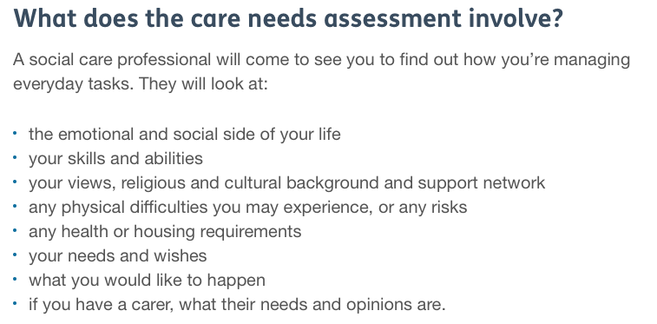

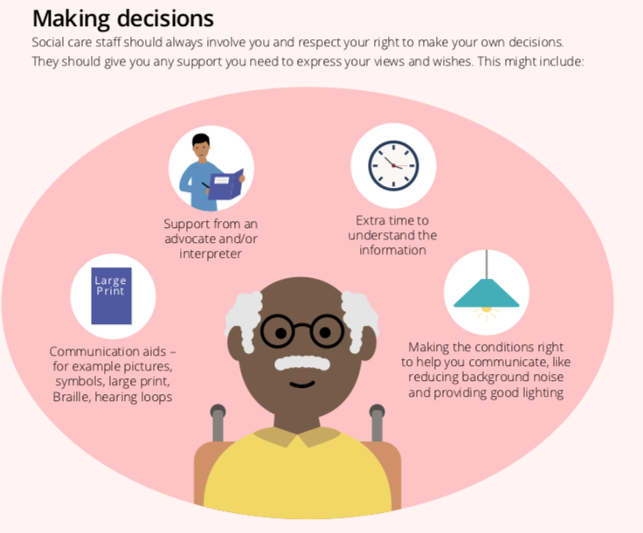

There is also a wide range of written, telephone and face to face support available. A range of organisations such as Citizens Advice and the charities above give free guidance on how to raise concerns or a formal complaint, signposting should the User not be happy with the outcome of their complaint, and access to advocacy.

A gap in the market – is there a ‘National Association of Domiciliary Care Users’ group?

Our research has failed to find any group – nationally or locally – whose focus is Domiciliary Care Users. While they are represented in organisations with high populations of Users, such as Age UK or Surrey Independent Living Council (SILC), there does not seem to be a dedicated lobbying group whose primary objective is to support Care at Home Users.

While systems may be in place to ensure individual Domiciliary Care Users are listened to, this cannot replace the power and influence of collective voices amplified by a dedicated, expert organisation.

This is a particular issue for self-funded Users, who are estimated to make up the majority of Domiciliary Care Users. Self-funded clients are their own Commissioners; they often struggle to navigate the market on their own behalf and as individuals have no power to lobby for systemic improvements. This lack of institutional Voice is a concern.

The Commissioner - Surrey County Council

Surrey County Council’s Service Specification includes and builds on statutory requirements:

- All Providers must be CQC registered “and meet any other legal requirements”
- “All providers are expected to … adhere to NICE quality Standard for Home Care for Older People”
  - Statement 1 “…identifies how their personal priorities…will be met”
  - “care should reflect what they want”
- “It is important that providers note” … National Framework for CHC and NHS Funded Nursing Care “put the individual, their needs and choices…at the centre of the process”
- Individual Outcomes and performance monitoring “I’ statements – Complaints procedure, Resolving Issues
- Providers are required to conduct their own customer feedback surveys
- User complaints can be grounds for suspension

Customer Engagement is also a KPI for agencies on the Surrey County Council register. Agencies report quarterly on a range of measures such as client turnover, but the Customer Engagement section focuses on service satisfaction.
  - Number of complaints, and how many of these were upheld
  - Frequency of client survey, and number of respondents
  - Response rate, and % satisfied or very satisfied with the home care received
  - SCC also ask Agencies for a copy of the customer satisfaction questionnaire.
SCC tell us there is about 80% compliance with this KPI.

Every two years SCC run their own Customer Satisfaction survey on Domiciliary Care the next is currently being planned and is scheduled for Winter 18/Spring 19.

All care Users are supplied with contact information for their Locality Team, and there is an opportunity to discuss their care at care reassessments.

The Providers – Care Agency Experiences and Perspectives

In our discussions, Care Agency Registered Managers (RM) appear to be highly motivated to deliver excellent care:

Because agencies depend on self-funded clients who have a free choice of supplier – reputation is crucial to a successful business, and good reputations are built on excellent customer experience. All agencies we spoke to had self-funded clients as well as funded clients, and for some the self-funded clients were in the majority.

Because theirs is a regulated industry: the CQC is taken very seriously, a poor CQC rating will impact negatively on their business, and the SCC contract is crucial to their survival.

Because they genuinely want to make a difference:
“I left corporate life because I wanted to do something that actually made a difference to people”
“You don’t go into this business to get rich”
“I still keep my hand in doing care visits, I love it”

The impression given in the interviews was that this is a genuine commitment, and that responding to client wishes and needs is seen as a crucial element of excellent care.

The RM do accept that things go wrong and are not complacent about their delivery, but their intention is to provide the best quality care to their Users.

There are multiple moments of communication between care agencies and Users – often thousands across a year – and by far the majority of these are informal and unrecorded.

Formal:

  - Initial assessment
  - Regular reassessments
  - Quality Assurance checks
  - Client surveys
  - Complaints

These may number up to 10 per year.

Informal:

  - Care worker visits
  - Compliments passed to the office
  - Requests/grumbles made to the office

For a client receiving care 3 visits per day this could number around 1,000 per year.

A User who is confident and willing to discuss their care with their care worker has the opportunity to do this as often as they have a care visit.

Some methods are highly valued by care agencies:

Care Worker feedback – many care workers are their clients’ trusted friends and advocates. There is frequent, intimate contact and care workers have the opportunity to take a longitudinal view and pick up on unspoken issues or wishes. As one agency Registered Manager told us “We’ll often hear about things from their favourite carer, things they wouldn’t tell me”.

Informal requests and grumbles – calls or emails into the office with minor comments or everyday requests. Different agencies handle these with different levels of formality, but our interviews indicate they are taken seriously and given immediate attention.

Assessments, reassessments, quality assurance checks - Initial assessment is considered crucial to understanding client needs. The value and frequency of care reassessments varies depending on the client’s stability but this is often used as an opportunity for a general quality check. A minority of agencies reported carrying out focussed quality checks with clients, and if there is a cause for concern with a care worker agencies will run spot checks with other clients to assess the issue.

Less useful routes to client feedback include:

Compliments – these are highly valued by the agency and staff, used as an important staff morale and management tool, and an important marketing tool. However, they tend not to be actionable: compliments tend to be given to those who have delivered gold standard care or gone above and beyond their duty or come from families when the care package has ended.

Customer surveys – These are useful for CQC inspections, and some are clearly designed specifically for that purpose. They may also be used for marketing or for staff morale. However, they are too infrequent to be actionable (once or twice per year); response rates are unreliable; being quantitative and using closed-ended questionnaires they rarely elicit anything surprising or fresh; and some agencies struggle to administer them or analyse the results. Impartiality cannot be guaranteed – it is possible that care workers may help clients complete the surveys.

Complaints – these appear to be taken seriously and handled appropriately: the RM often verbalised the complaints process including reference to the Ombudsman. However, they are rare events and not all are upheld, so they do not form part of everyday client listening.

Do Care Agencies feel they are responsive to what they hear from clients?

Yes – the agencies we spoke to genuinely want their clients to be happy; responding to clients well is part of good practice. Agencies told us they work hard to set clear expectations with clients at assessments, respond as quickly as feasible to client requests and informal grumbles, and handle complaints appropriately.

…but – Agencies tell us that not all requests are reasonable or practical. In particular our respondents talked about time constraints – the care package and timings simply won’t allow for all the client would like done. They also mentioned occasional differences of opinion between Users and their families – one example was a family who felt the User should have a shower every visit but the User not wishing to be showered. Whenever this was mentioned the impression was given that the agency would prioritise the User’s preferences wherever appropriate.

Complaints – policies more than procedures

All agencies we spoke to have a written complaints policy, and many Registered Managers (RM) could quote the procedure verbatim.

The source of the policy varied
  - Purchased and tailored commercial packages
  - Supplied by ‘Head Office’
  - “borrowed” or adapted from previous employers or other agencies

All agencies said the policy was in every client’s care folder; the majority confirmed it is given to the client at the assessment and at the start of service. Many have the policy available on their website.

We received policies from just over half the agencies we spoke to. Our observation on these is;
  - They are policies, not procedures.
  - They tend to be contained within broader T&C
  - They are long, dense, verbose and use very small font sizes
  - They are very unfriendly for Users
One or two agencies also supply a simpler Procedure – a form that can be sent back to the agency, or simplified instructions – but most agencies did not supply us with anything designed to make the process accessible to service Users.

When is a grumble a Complaint?

Complaints are client-defined: clients may write or call, may state “I am writing to complain…”, or the agency may offer to manage their issue as a complaint if they feel it warrants investigation and a formal response. As a result, the number of complaints reported to SCC as part of the KPIs is somewhat subjective.

Next Steps - Phase 2

The results from Phase One of this project have been shared directly with key stakeholders and made publicly available, but we will not request a formal response to our recommendations until the completion of the project in Spring 2019.

Our next steps are as follows:

Interview Domiciliary Care Workers. The importance of Care Workers became apparent in the first phase of the research, so we have added a phase of Care Worker interviews to the project. These will be in-depth qualitative phone interviews designed to answer key questions: are Care Workers aware of the importance of person-centred care, and the rights of their clients in care delivery? Do Care Workers understand their role in the communication chain between Care User and the service they receive? Do care workers feel Users have a voice, and is their voice being listened to? Do Care Workers understand how to raise and escalate issues, and do they feel safe and confident in doing that?

Call: 0303 303 0023 Text: 07592 787 533 Email: enquiries@healthwatchsurrey.co.uk
Write: Freepost RSYX-ETRE- CXBY Astolat, Coniers Way, Burpham, Surrey, GU4 7HL www.healthwatchsurrey.co.uk

We aim to complete 15-20 depth interviews by mid January 2019.

Interview Domicilary Care Users (or their responsible carers/family): how do people who use services experience being ‘listened to’? do feel they have a voice, and that their preferences and views are taken into account on an ongoing basis? Do they understand how to raise and escalate issues, and do they feel safe and confident in doing that?

We aim to complete 20-25 depth interviews by March 2019.

Anecdotal from various sources and agencies – we have not been able to find hard data relating to Surrey

