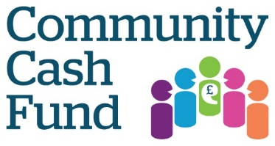

Application Form

Name of applicant:

Name of organisation applying:

Address: (including postcode)

Telephone Number:

Email:

Charity number (if applicable):

How much is the total grant you are applying for? £_________(Max £1,500)

Please provide a brief description of your Community Cash Fund project: what you want to do and how you plan to achieve it in a maximum of 500 words.

Does your project contribute to one or more of the following;

- Everyone lives healthy, active and fulfilling lives, and makes good choices about their wellbeing
- Everyone gets the health and social care support and information they need at the right time and place
- Communities are welcoming and supportive, especially of those most in need, and people feel able to contribute to community life

Y or N

(circle answer)

Please let us know how you found out about our CCF (circle appropriate one)

Word of mouth
Poster
Facebook
Radio
Twitter
Website
E-Bulletin
Leaflet
Other (please state)

Please send your completed Community Cash Fund application by Friday 18th February 2019 to: sarah.browne@healthwatchsurrey.co.uk

Alternatively, please post your application to Sarah Browne, Healthwatch Surrey, GO9/G010, Old Millmead House, Guildford Surrey GU2 4BB before 18th February 2019. You can call enquiries on 0303 303 0023 or text 07592 787533 if you have any questions.

