

Who can help me plan for my future as an older person?

June 2024

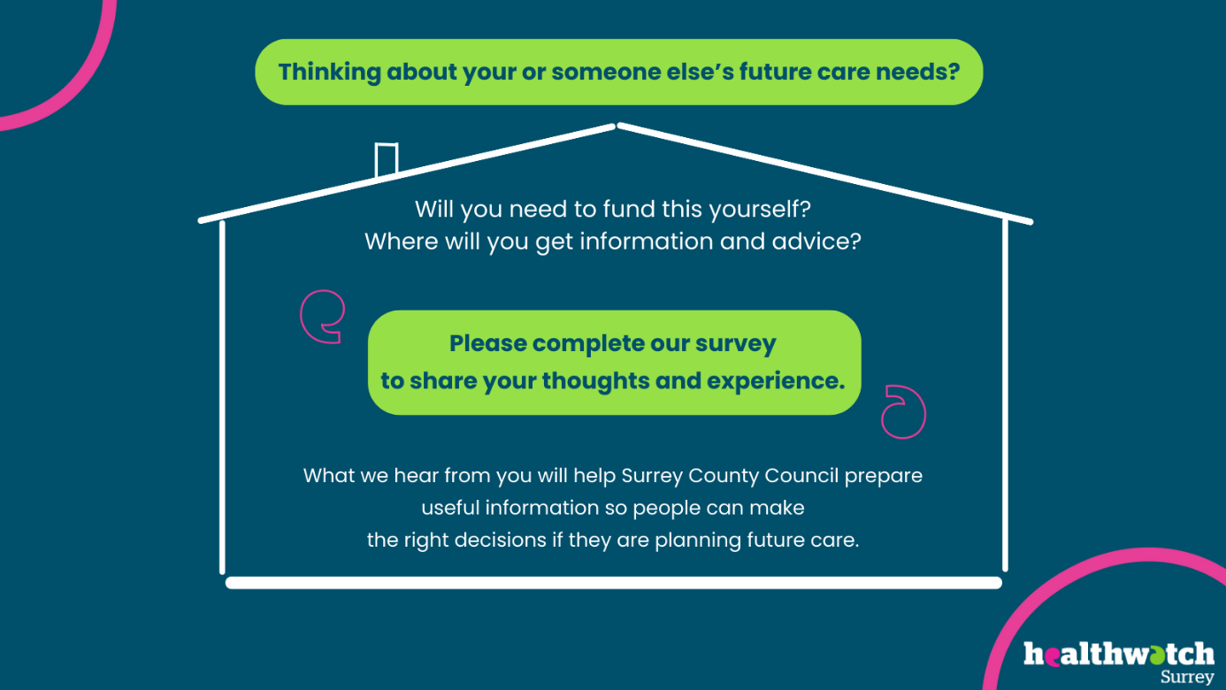

If you would like a paper copy of this document or require it in an alternative format, please get in touch with us.

Contents

Executive summary 3

Background and objectives 3

Key findings 3

Involvement in and knowledge of the social care landscape 3

Information sources 4

What information are people looking for? 5

Recommendations 6

Main report 7

Background 7

Objectives 7

Context 8

Main findings 10

Involvement in and knowledge of the social care landscape 10

Where do people turn to for information and advice? 12

Living independently at home 14

Paid for home care workers 14

Financial assessments 15

Consideration of care homes 15

Detailed findings 16

Living independently at home 16

Paid for home care workers 24

People’s experiences of financial assessments by SCC. 26

Consideration of care homes 27

Current self-funders 32

Appendix 33

Approach in detail 33

Current self-funders 33

Future self-funders 33

Who we heard from 36

Summary and thanks 38

About Healthwatch Surrey 38

Healthwatch Surrey – Contact us 39

# Executive summary

## Background and objectives

With an ageing population, Surrey County Council (SCC) approached Healthwatch Surrey to support them with gathering insight into the journey self-funders (people paying for their own care home accommodation) may take to arrive in a residential care home setting.

We looked at what information and advice sources people would turn to, at various stages of their journey.

We spoke to future self-funders in community settings and used an online questionnaire. In total we had 97 respondents.

We also carried out face to face interviews with care home residents, their families and care home managers.

## Key findings

Future care planning is a subject that many people don’t want to talk about at all, they are happy to ‘leave it to their children’.

Many people have very limited knowledge of the basics - we heard many times that some people don’t know that they might have to pay for social care- ‘why isn’t it like the NHS?’.

When people do then have to make arrangements for social care it is often in a crisis situation.

### Involvement in and knowledge of the social care landscape

We found that the people we spoke to fell into 3 different groups:

1. **I know what I’m doing.** Those who were very knowledgeable and confident about the social care landscape, (they were not necessarily current users of social care but may have been in the past e.g. for their parent and were now considering for themselves).
2. **I think we might need help soon.** Those who are considering needing paid for home care workers in the future (and possibly care homes) for a parent or themselves.
3. **We have help, but I don’t know what to do next.** Those who currently use paid for home care workers (for their family member) – but are not confident about planning for the future – for more care workers or for care homes. This group are the people who are feeling the pressure of caring, and don’t know where to turn, and what to do next. They are often trying their best to keep their family member at home, but many of them were at breaking point even using paid for home care workers.

People’s confidence in decision making when it comes to considering care homes is low and they need more support; people told us they want information on care home costs, the quality of care, and reviews.

The majority of people told us that they look for different information from different organisations. This highlights the perception that there is no “one stop shop” for the provision of information and advice.

### Information sources

People rely on a variety of information sources, there is no clear preferred choice of where people turn so information needs to be consistent across all channels.

**Information about living independently**:

The main sources used for information about living independently at home are:

* Friends and family (primarily), followed by
* GP/NHS and Age UK Surrey/Age Concern.

**Paying for care at home**:

To find out about paying for care at home, people turn to:

* The internet
* Adult social care/’the council’.

**Paying for adaptations**:

Information sources for paying for adaptations that people mentioned were:

* Adult social care /the council and the local council
* The internet.

**Paying for care homes**:

For information about care homes, the main sources that people used were:

* The internet
* The CQC (Care Quality Commission).

Primary sources for information about paying for care homes were:

* Adult social care/the council
* The internet.

### What information are people looking for?

**How to access support and what support is available is the main thing people want information and advice on.**

The other key areas are:

* Care costs
* Financial assessments.

**What kind of information or advice do people want about care homes?**

People told us they want information on:

* Care home costs
* The quality of care
* Reviews.

# Recommendations

When considering the future of the ‘Planning for your future’ campaign, we recommend considering the following:

* **Target family members.** Recognise that planning for their own future care is not something that many people wish to do. Given the uncertainty of what the future holds, some people see this as a pointless exercise. Often these decisions will be left to family members, and it is they who will need the support, advice and information.
* **Go back to basics.** Some people we spoke to didn’t know that they’d have to pay for social care at all, which was evident in some of the comments people made in the survey. As a result, people are frustrated and incorrectly perceive social care teams to be at fault.

Many people will initially turn to the internet to find out what they need to know; many people are unaware of the services available and how to access them. Many people do not know that information is available from the council, and the differences in what’s provided at county or district and borough level.

Knowledge of financial assessments – what they’re for and how to access them is patchy – “you only need to know when you need to know.”

* **Recognise** that those who are in need of the most support in navigating the system are probably those who are already users (due to people not investigating the social care landscape until they need to). These people will often be experiencing high stress levels, so they need simple, straightforward explanations.

# Main report

## Background

Surrey County Council (SCC) approached Healthwatch Surrey to support them with providing some benchmark insight into the journey self-funders (people paying for their own care home accommodation) have taken to arrive in a residential care home setting. It is anticipated that this will help inform the impact of a communication awareness campaign aimed at self-funders in the care market, ensuring that the campaign provides the right information, at the right time and in the right places. The objective of the campaign is to help self-funders (people paying for their own care home accommodation) make the right decision about their future care.

The ‘business reason’ for creating the communications campaign is to educate self-funders about the social care landscape to ensure they make the right choices at the right time. This will minimise the risk that they might run out of money or face unexpected costs. If this happens and the self- funder reaches the capital threshold, SCC will step in and initially pick up the funding of the package straightaway and will pay the guide rate to the care home.

Currently, on average 14 people per month are reaching the capital threshold - totaling 168 people per annum.

## Objectives

1. To deepen commissioners’ understanding of self-funders to understand their journey of how they arrived in a care home setting - were they discharged from hospital? etc. Have they considered capital depletion issues?
2. Highlight what key information is needed by future self-funders to help them make the right decisions.
3. Contribute to any changes for the SCC communications awareness campaign in terms of messaging or tone.
4. Develop the funding information that providers should have in place.

Objectives to be completed post this report:

Establish if the campaign has been successful in changing people’s behaviour and attitudes over time by completing a second stage in the autumn.

## Context

Surrey's residents tend to live longer and healthy lives, exceeding the national average for both men (81.4 compared to 79.5) and women (84.6 compared to 83.1).

According to the Joint Strategic Needs Assessment (JSNA), Surrey’s population is 1,208,400 residents, of which 231,800 are aged over 65 years old and 36,800 are aged over 85 years old. They have predicted that Surrey's population in 10 years’ time will be 1,264,000. The number of older residents in Surrey is predicted to rise dramatically over the next 10 years.

**The percentage of Surrey's population now versus 2030 projection:**

Residents aged over 65 and over will increase from 19.18% to 22.23%.

Residents aged over 85 will increase from 3.05% to 3.88%.

There are approximately 22,000 frail residents in Surrey, many with complex medical conditions.

This figure is expected to increase by 30% over the next decade.

Additionally, 17,700 Surrey residents live with dementia (a range of conditions which affect the brain).

This figure is predicted to rise to 22,672 by 2030.

There are also changes in the structure of our society which mean that increasingly older people are living alone with less family support.

By 2030, the number of people aged 75+ predicted to be living alone will have increased by 27%.

Surrey has a relatively large number of residential homes, 420 in total, housing individuals with frailty, cognitive impairment, behavioural conditions, and end of life care.

Surrey has a strong self-funder market which means individuals and families will often arrange and pay for their own care, and many Surrey residents typically do not consider contacting adult social care.

For example, as of January 2020, SCC commissioned a total of 2,133 residential and nursing placements in the county out of the 10,762 beds available in local services with the remainder being used by people who fund their own care.

The placements SCC funds equate to around 20% of the Surrey care home market. *(*source: Living Well in Later Life Strategy 2021 – 2030 Commissioning Strategy for Older People 2021*).*

The average cost of residential care per week in Surrey is £1600 - this is double the national average. (source: Age UK Surrey presentation).

## Main findings

### Involvement in and knowledge of the social care landscape

The people we spoke to fell into 3 different groups:

1. **I know what I’m doing.** Those who were very knowledgeable and confident about the social care landscape, (they were not necessarily current users of social care but may have been in the past e.g. for their parent and were now considering for themselves).

“I am very aware of what's available, having been through it with my husband and stepdaughter’s mum. I know about the local care homes that are available, and I know about the carers. I feel confident about making decisions for future care.”

“Because I have experienced this situation previously with a family member, and so now know to continuously research for help and to ask everybody for information on how to get support. There is no one place to find all the relevant information; you have to keep on asking and researching.”

1. **I think we might need help soon.** Those who are considering needing paid for home care workers in the future (and possibly care homes) for a parent or themselves.

“Additional care and support is urgently needed - however, the individual concerned is adamant they do not want “strangers” in their home.”

“We are both getting older and may need help in the future.”

**3. We have help, but I don’t know what to do next.** Those who currently use paid for home care workers (for their family member) – but are not confident about planning for the future – for more care workers or for care homes. This group are the people who are feeling the pressure of caring, and don’t know where to turn, and what to do next. They are often trying their best to keep their family member at home, but many of them were at breaking point even using paid for home care workers.

“I am confident about making decisions, but I am not confident about the knowledge I have. I need to do some research.”

“Once you leave your home there's no going back and some care and homes really aren't that good... Some are wonderful. Hard to know ‘til you are there.”

“He refuses to consider options fully as so worried he will run out of money. I have less money than him and need to support myself financially, so God knows what happens when I need supportive care for myself as I have no family at all. I'm in my 60s and have my own health problems.”

“It’s a scary move I don’t expect mum to enjoy or survive.”

Just over a quarter of our sample currently use paid for home care workers. The bar chart below shows the difference in confidence in making decisions about future care for different subgroups: those who are not using paid for home care workers and wouldn’t consider in the future, current users who wouldn’t consider using again in the future, current non -users who would consider, and current users who would consider. The chart shows that confidence (about making future care decisions) is highest amongst non-users who would consider using paid for home care workers in the future, whereas we predicted that confidence would be higher among current users of paid for home care workers.

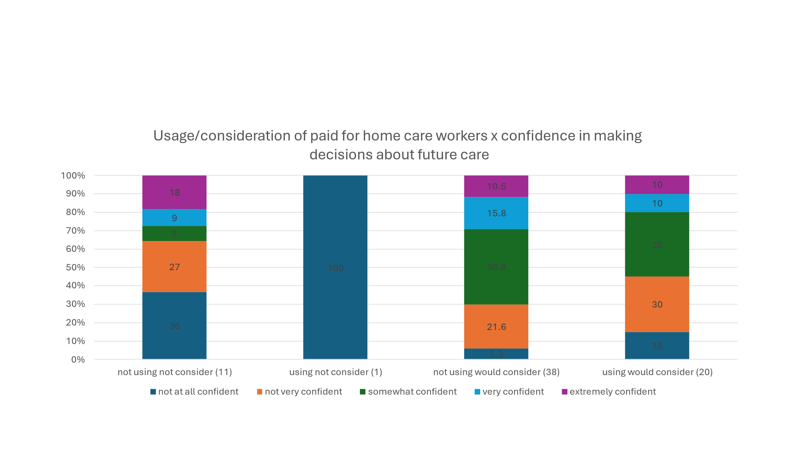

Furthermore, those who consider themselves to be an (unpaid) carer are also less confident about making decisions about the future. 23% of carers feel extremely/very confident about making decisions about their own/their family member’s future care in a care home, whereas 33% of non-carers felt confident about their future care in a care home. This is shown in the chart below.

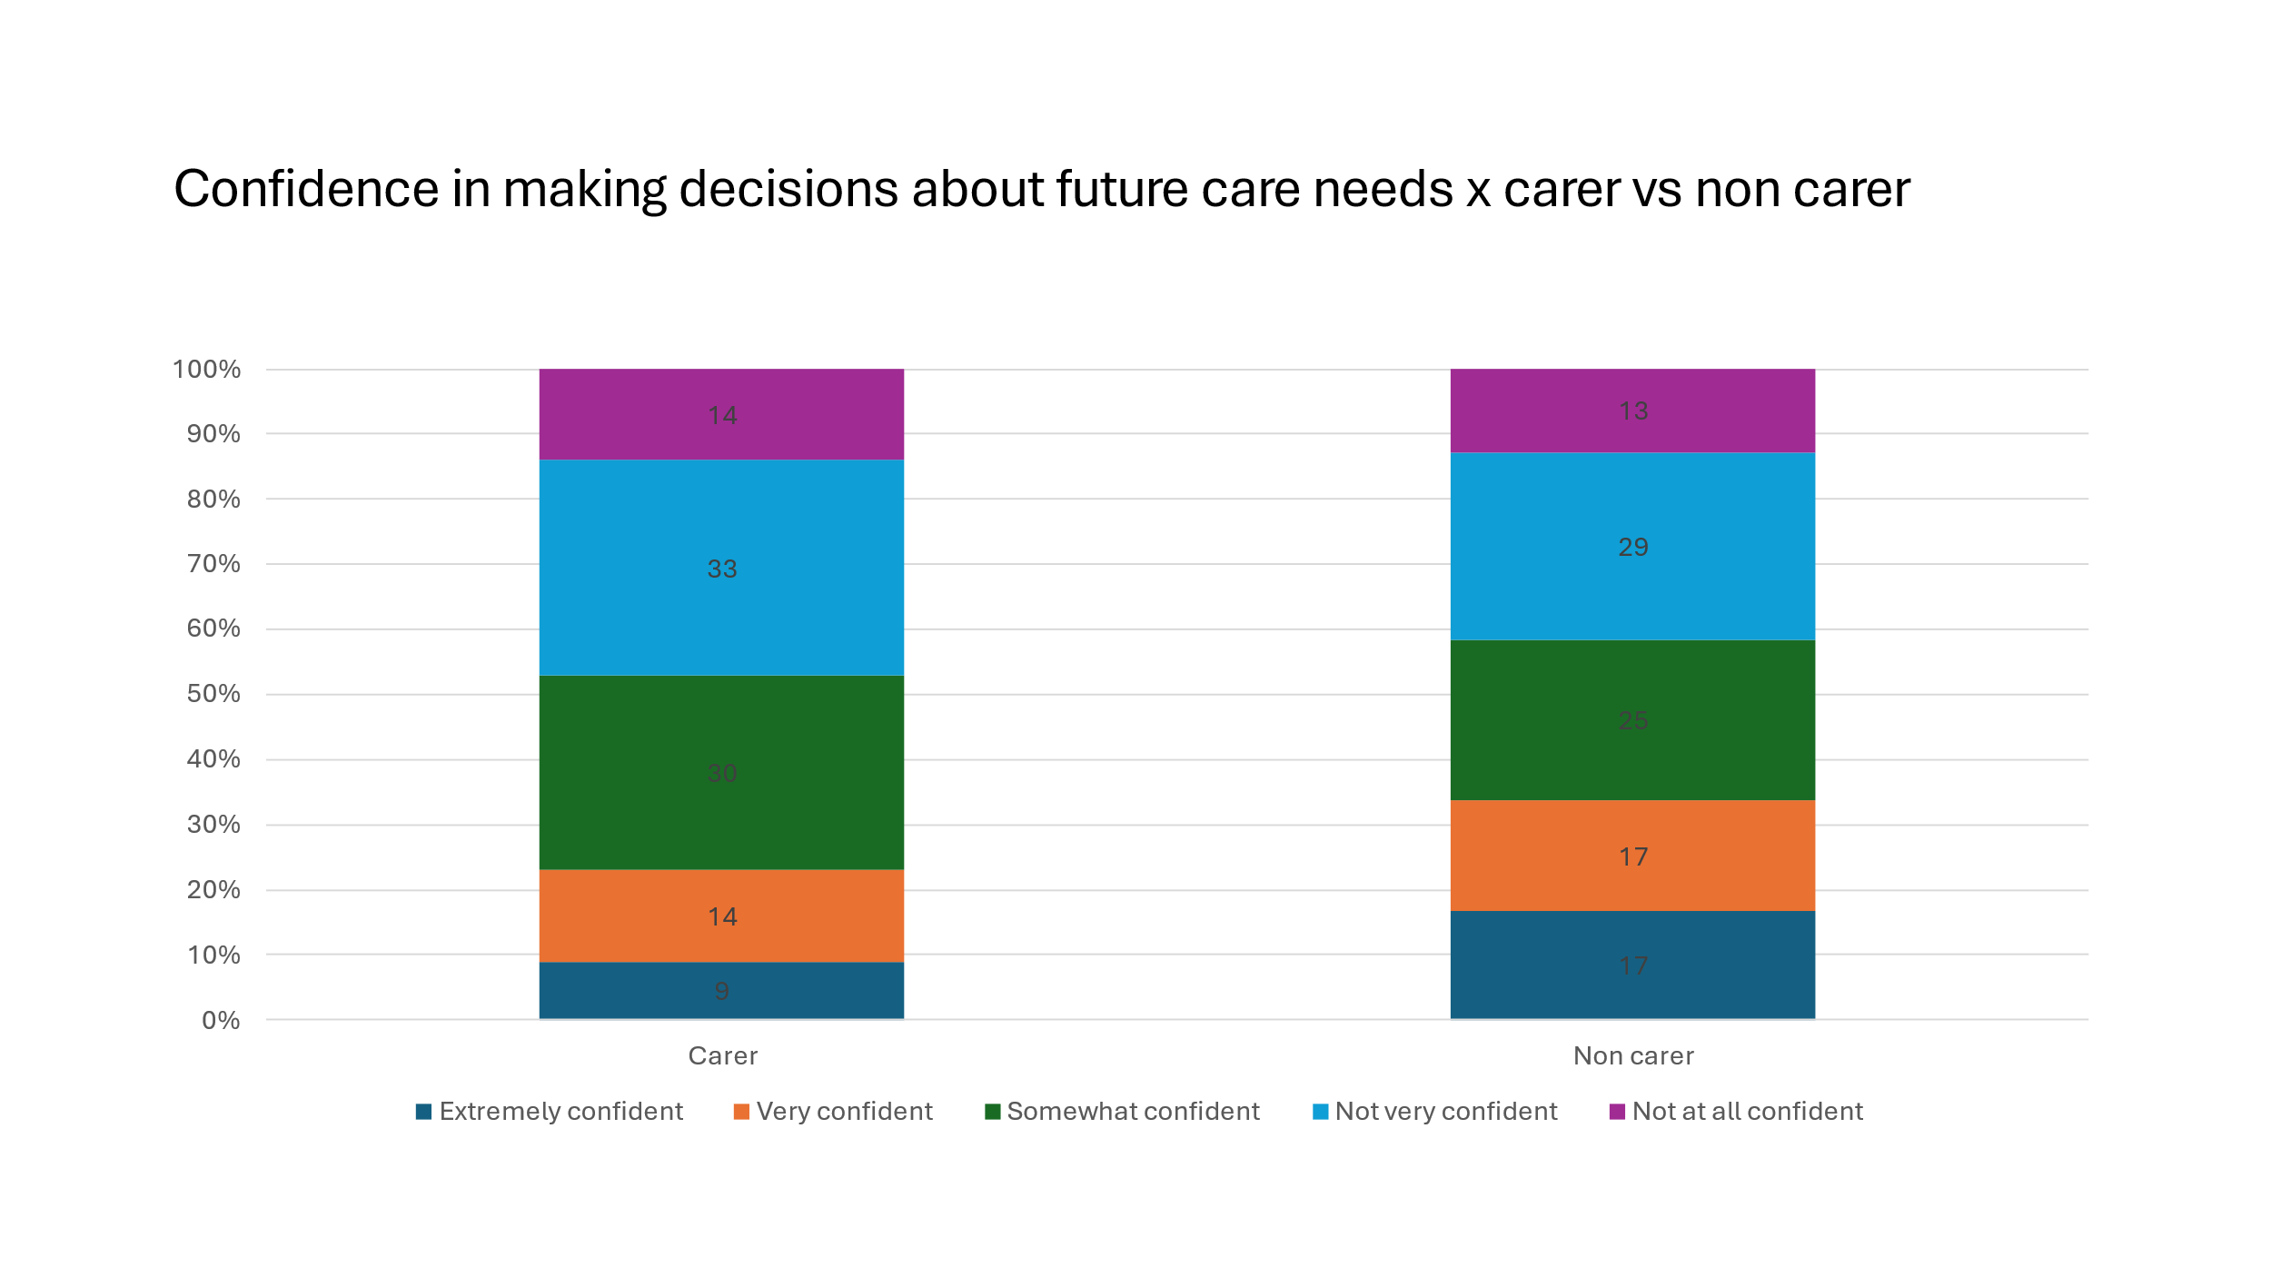

### Where do people turn to for information and advice?

20% of respondents said they’d seen promotional material about the "Planning for your future" campaign from Surrey County Council and Age UK Surrey. This survey had been promoted during the “Planning for your future” events.

11% had looked up online information from Age UK Surrey on this campaign, 9% people had contacted Age UK Surrey to have a conversation, 4% had attended an information event.

We asked several questions about where people would source information and advice.

The charts below summarise the data collected about information and advice sources.

**Information about living independently**: Friends and family are the main source used for information about living independently at home, followed by GP/NHS and Age UK Surrey/Age Concern.

**Paying for care at home**: People turn to the internet and adult social care/’the council’ to find out about paying for care at home.

**Paying for adaptations**: Adult social care /the council and the local council are mentioned as info sources for paying for adaptations as well as online.

**Paying for care homes**: Online and the CQC are the main sources for information about care homes. Adult social care/the council and online are the primary sources for info about paying for care homes.

### Living independently at home

Two thirds of our respondents were living independently in their own home with support from family and friends, paid for home care workers, or other paid help such as cleaners and gardeners. The majority of respondents were aware of community centres for day activities and around a third had used them. Generally, there is very positive feedback around these services. However, not everyone knew about the services, some people said that they were not available to everyone and not everyone wants to use them.

Around half of our respondents had added handrails, and around a third had adapted the bath/shower room in their homes. Some had adapted by moving house, or by moving a bedroom downstairs, and some people told us that the adaptations had already been made to their home.

We also asked about technology enabled care (TEC). There were some mentions of smart plugs attached to electronic devices and motion sensors, and care alarm systems. On the whole, feedback around TEC is very positive, although there are some comments around devices not being needed yet, concern around costs, concern around usability and also a concern that people needed human care rather than digital care.

### Paid for home care workers

Around a quarter of our respondents use paid for home care workers, around half are very satisfied with the service they receive. Roughly 8 in 10 would consider using them again in the future.

The main reasons why people would consider paid for home care workers in the future is to enable them to carry on living at home, and to keep their independence. They also acknowledged the benefit to the family, of giving respite to their carer, and taking the pressure off the wider family (see chart below). The main reasons for not considering paid for home care workers in the future are:

* Cost
* Not wanting strangers in their home

### Financial assessments

Around 1 in 10 of the people we heard from had had a financial assessment.

When asked about the kind of information people want, we heard that people are unsure about the criteria for getting a social care assessment, and how to get one.

### Consideration of care homes

Just under two thirds of the people we heard from were either thinking about a care home for themselves or for a family member.

The main reasons for considering a care home were if the person would not be able to manage themselves at home anymore, and if they had mobility/frailty issues.

Reasons why people would not consider a care home include:

* Preferring to retain their independence
* The cost involved
* Suspicion of the quality of care/heard negative stories.

## Detailed findings

### Living independently at home

Two thirds of our respondents were living independently in their own home with support from either family and friends or paid for home care workers or other paid help such as cleaners and gardeners.

This is shown in the bar chart below.

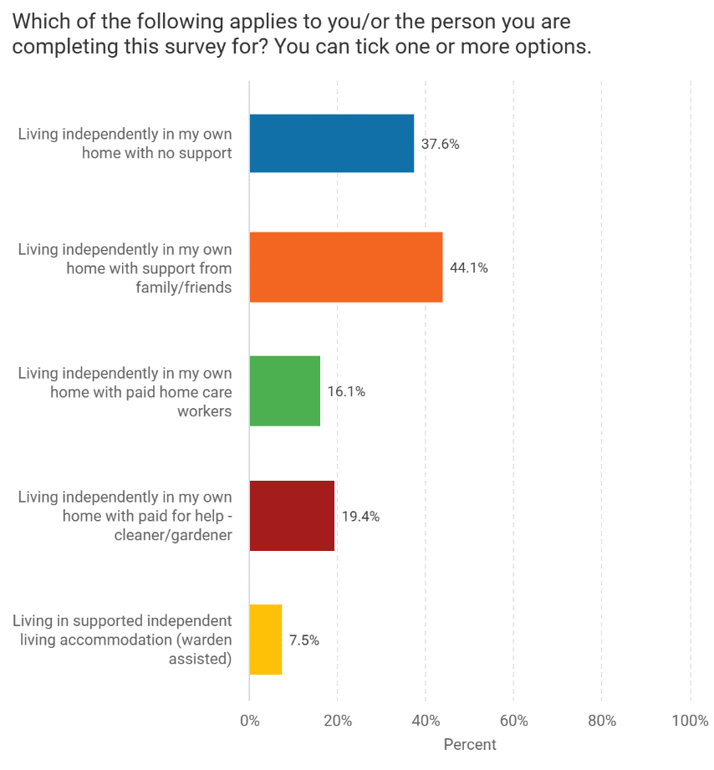

#### Awareness of and getting help

The majority of respondents were aware of community centres for day activities and around a third had used them, meaning they should be an effective place to provide information and advice to those who need it.

Other service awareness:

* Less than half were aware of meals on wheels
* Around a third were aware of short stays in residential care
* Around a sixth were aware of short breaks for unpaid carers.

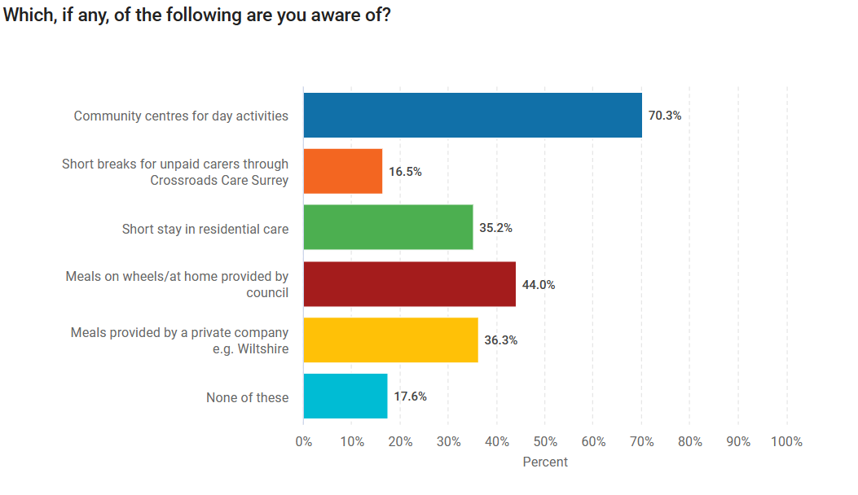

Bar chart showing use of services. 
Key details are in the report text.

#### Opinion of the services

Generally, there is very positive feedback around these services. However, some people were unaware of the services, some people said that they were not available to everyone and not everyone wants to use them.

“I am a carer for my mother who lives alone in her own home. I think all the services mentioned are very valuable. However, my mother is extremely defensive about accepting help so it would be difficult to encourage her to use any of these services. She will then complain that no one helps her!”

#### Looking for information about living independently at home

94% of respondents said that they would look for advice in the future about living independently at home.

#### Sources of information and advice about living independently at home

The main sources of information are family and friends, followed by GP/NHS, ‘the council’ (combination of adult social care, local council and ‘the council’) and Age UK Surrey/Age Concern. This is shown in the chart below.

#### What information are people looking for about living independently at home?

The chart below shows that the main area that people seek information and advice for is how to find out how to access support and what is available. The other key areas are care costs and financial assessments.

#### Would people look for different information from different organisations?

Having asked what kind of information people would be looking for, we then asked whether people would look for different information from different organisations - two thirds of people said that they would, however a lot of people said probably or unsure, only around 1 in 10 gave a definite no, therefore around 9 in 10 could be expected to look for different information from different organisations. This highlights the perception that there is no “one stop shop” for the provision of information and advice.

#### Where would people look for information and advice about paying for care at home?

We also asked respondents where they would look for information and advice about paying for care at home. Responses were spread across many sources, the main one being online (25%) followed by adult social care (17%) the council (14%), local council (6%).

#### Where would people look for information about paying for adaptations?

* 12% of respondents said they would ask adult social care/ social services
* 9% said local council
* 11% said the council (not specified whether local or county)
* 12% said online
* Other sources were:
  + 13% said they did not know
  + 9% said they would pay for it themselves
  + GP/NHS 10%
  + Other charities 6%
  + Age UK Surrey 3%
  + Government website 3%.

#### Adaptations made to the home

Around half of our respondents had added handrails, and around a third had adapted the bath/shower room. Some had adapted by moving house, or by moving a bedroom downstairs, and some people told us that the adaptations had already been made to their home. This is shown in the chart below.

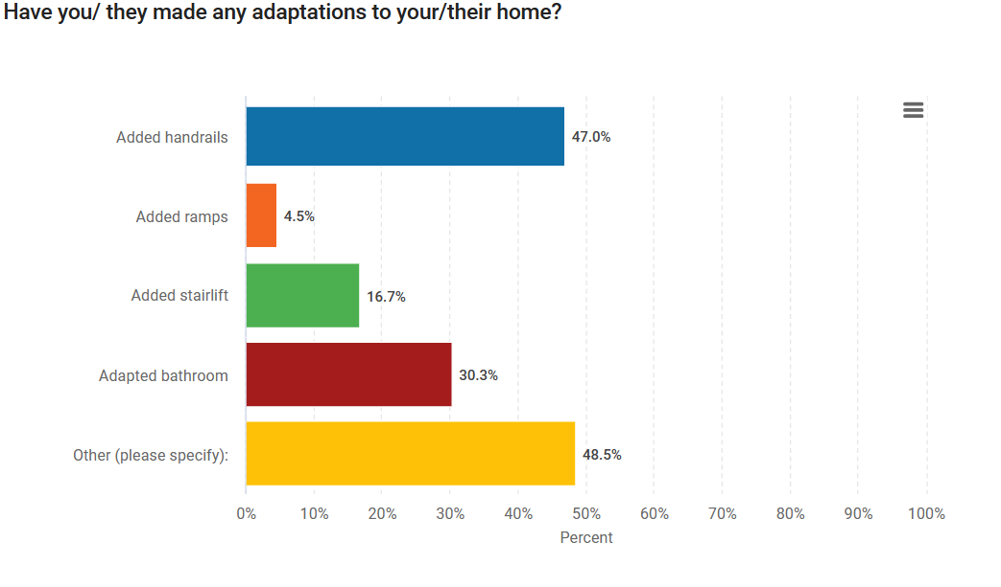

#### Technology enabled care

We also asked about technology enabled care (TEC). There were some mentions of smart plugs attached to electronic devices and motion sensors, but many people added comments into the ‘other’ category. This is shown in the chart below.

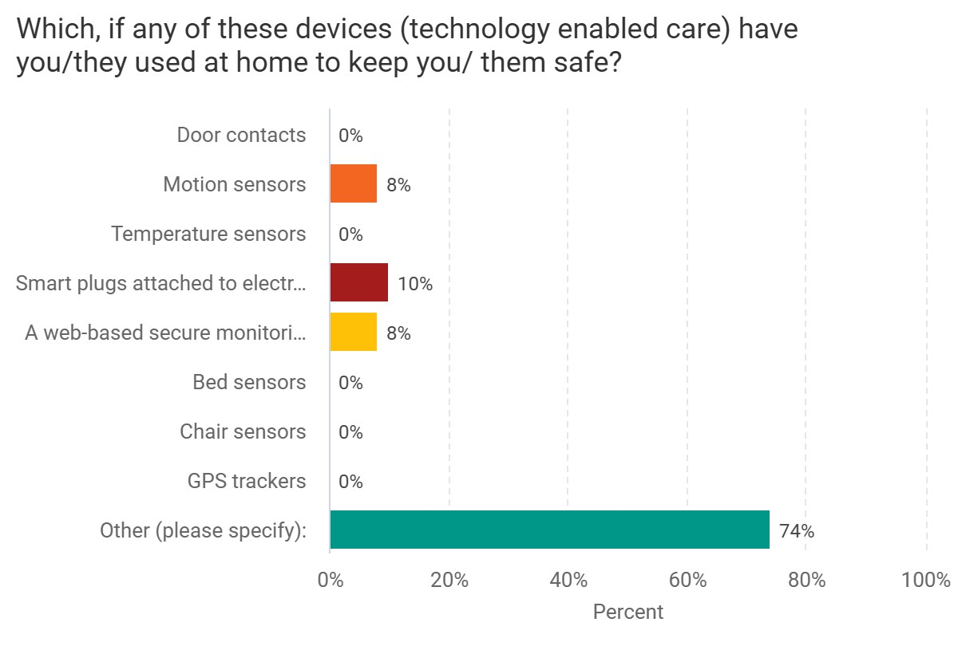

There was a high level of ‘other’ devices mentioned – see pie chart below.

50% of the “Other” technology enabled care comments were about care alarm systems.

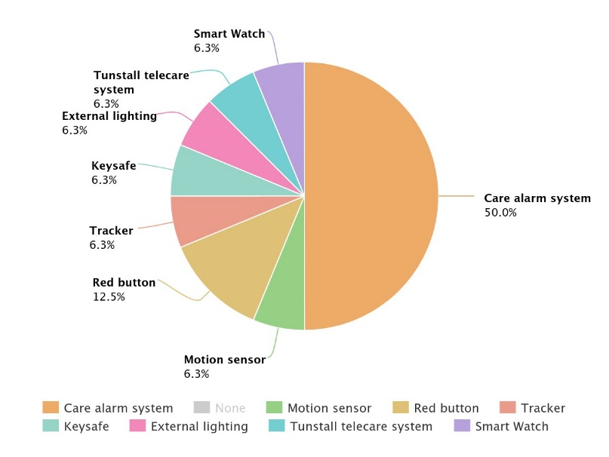

#### Opinions of technology enabled care

Feedback around TEC is very positive – with 59% of people making a positive comment.

“These ideas all make sense they allow us to keep going in our own homes, the longer the better. The time may come when cooking etc. may be too difficult, but we are not there yet.”

“They are essential to my independence and invaluable to both monitor me and give reassurance to others concerned for my welfare. They also give me confidence.”

The negativity was around devices not being needed yet, concern around costs, concern around usability and also a concern that people needed human care rather than digital care.

“If I could see them set up somewhere and talk to someone about how to use them, I would be more likely to consider it.”

“To a degree they are sensible but direct contact with people is better.”

### Paid for home care workers

**28% of respondents use paid for home care workers: 56% are very satisfied with them, 32% are fairly satisfied with them, and 12% are not very satisfied.**

**79% of respondents said they would consider using paid for home care workers in the future.**

#### Reasons why people would use paid for home care workers

The main reasons why people would consider paid for home care workers in the future is to enable them to carry on living at home, and to keep their independence. They also acknowledged the benefit to the family, of giving respite to their carer, and taking the pressure off the wider family, see chart below.

Some people told us that they would consider paid for home care workers in the future, but they do have some concerns:

“It’s not yet necessary. However, allowing strangers in your home is a worry.”

#### Reasons why people would not consider paid for home care workers in the future

The main reasons for not considering paid for home care workers in the future are cost and not wanting strangers in their home.

### People’s experiences of financial assessments by SCC.

**13% of the people we heard from had had a financial assessment.**

When asked about the kind of information people want, we heard that people are unsure about the criteria for getting a social care assessment, and how to get one. People told us:

“I don’t know how to pick a good home care service. What it would cost and who pays. Would I have to sell my house? Do they need to get a social care assessment?”

“He has refused a Social Care Assessment when I suggested he have one. However, I don’t know how to arrange it even if he did agree.”

The case study below shows that people don’t always have a good understanding of the adult social care system and only come to learn about it through direct experience, at a time when a loved one is often particularly vulnerable as is the carer themselves:

“I’ve cared for my husband for many years…I’ve done this without pay or recognition and I’m worn out now. When he had a stroke, he was discharged from hospital with 12 weeks of supported discharge care. This was a great help, and I would have liked to have had ongoing care for my husband. We had an assessment and were told that we would have to pay for a care package and so we didn’t go ahead…

I’m waiting to hear from [local charities who provide support]. We have applied for the Attendance Allowance…We’ve had a stairlift and wet room fitted which we had to pay for because our savings are above what a disabled grant would allow. He has a care alarm so that I can at least leave him for a couple of hours.

I would also benefit from 2 nights a week of a carer sleeping over so that I could stay with my son for those nights. I could enjoy time with my family, especially my grandchildren whilst my husband is looked after.”

### Consideration of care homes

**Just under two thirds of people were either thinking about a care home for themselves or for a family member.**

The chart below shows the main reasons for considering a care home were if the person would not be able to manage themselves at home anymore, and if they had mobility/frailty issues.

Reasons why people would not consider a care home, centre around preferring their independence, the cost involved, and suspicion of the quality of care/heard negative stories, this is shown in the chart below.

The majority did not know whether they would need nursing or residential care (understandable as this depends on their needs at the time).

Only around a quarter of our sample said they were extremely/very confident about making future decisions about their (or their family member’s) future care in a care home. Around a third said they were somewhat confident, and under half were not very/not at all confident.

Their confidence comes mainly from prior experience and plans they have already made.

People are not confident when they lack experience and feel that they need more information.

People don’t feel they have much knowledge of options of home care available as an alternative to residential care.

#### What kind of information or advice do people want about care homes?

The vast majority (89%) told us they would look for information and advice if they or their family member were thinking about moving into a care home.

People told us they want information on care home costs, the quality of care, and reviews the most, however, many aspects of daily life in a care home were also important.

People said:

“I want information about inspection ratings, services provided, a visit to get the feel of the care home and how well cared for the residents appeared, how motivated and kind the staff appeared.”

People would look for this information online in many cases:

#### Where would people look for information about paying for a care home?

People told us they would mainly find this information online/CQC website or through visiting themselves. Some mentioned “the council” but didn’t specify whether this was Surrey or their local district/borough. Some mentioned adult social care. There were a couple of mentions of the third sector – namely Age UK Surrey and the “Dementia Society” this could be reference to Alzheimer's Society or Dementia UK) and healthcare professionals.

10% said they didn’t know where they’d find this information.

#### Paying for a care home

Three quarters of our respondents thought they or their family member would have to pay for their care home. 80% of our respondents had some knowledge; just under a third mentioned either the £23,250 figure, or that they were aware of the SCC charging policy. However, around a third said they had a little/no knowledge.

A quarter would ask adult social care/the council for information and advice about paying for a care home. 1 in 5 would look on the internet, others would ask financial advisers or friends and family; other people mentioned charities including Age UK Surrey. 13% said they wouldn’t know where to look. This is an opportunity to continue to educate.

The chart below shows where people would look for information about paying for a care home.

Around a third had received independent financial advice about their finances. About a third said they would like independent financial advice specifically about paying for a care home.

Of those who said they wanted financial advice about paying for a care home, a quarter said they would ask an independent financial adviser, others would look on the internet, others would ask a family member, some would ask third sector organisations such as Age UK Surrey, Action for Carers and 1 in 5 said they didn’t know who they would get financial advice from.

The chart below shows where people would look for financial advice about paying for a care home.

When asked whether they’d like independent financial advice, answers were split evenly between yes/no/don’t know.

10% were aware of SOLLA (Society of Later Life Advisors).

### Current self-funders

**6 of our respondents were care home residents, the other 5 were family members.**

**6 had looked for information and advice before moving into the care home, 2 had been placed in the care home straight from hospital and**

**2 had moved care home as their previous care home had closed.**

**They looked for information and advice on the CQC website, from friends and family and on local Facebook groups.**

In terms of knowing whether they needed to pay, a couple said they ‘just knew’ due to their financial situation, others had family members who advised them. One person was initially receiving Continuing Health Care after being discharged from hospital but now paying for care.

* 2 people had financial assessments conducted by Surrey County Council. 2 people had independent financial advice.
* 3 people said they had been told what would happen if they ran out of money.
* 3 people were not told what would happen.

Two people told us that they were told “it would be ok” and “they wouldn’t be kicked out if they ran out of money.”

Some people are often surprised to learn that social care is not free for everyone and that many people will need to pay for care depending on individual circumstances. This shows why it’s important to increase the understanding of people’s rights and responsibilities when it comes to social care.

# Appendix

## Approach in detail

We visited 6 care homes and 4 community settings. We attended 7 Surrey Age UK Surrey Planning for your future care events.

Our approach had 2 key targets – current self-funders, and future self-funders.

### Current self-funders

We targeted current self-funders by visiting care homes. A number of care homes invited us to visit, following our presentation and request for support at a Care Home Providers drop-in meeting (run by SCC) in September.

We also asked 2 care homes that we visited last year for our Enter and View programme if we could speak to their residents.

When we visited the care homes, we sent personal invitations to self-funder residents in advance, to advertise our visits and to promote our survey to their family and friends.

When we visited the Burlington private luxury care home, we knew that all residents were self-funders, and therefore did not send out invitations in advance.

We also spoke to family members of self-funders; we spoke to 11 people in total, we spoke to 6 current care home residents and 5 family members.

We left copies of the survey with a number of care homes for them to share with relatives (with pre-paid envelopes to return the surveys to our office).

We also spoke to some current self-funders and self-funder family members at the community events described in the future self-funders section below.

### Future self-funders

We targeted future self-funders by visiting community settings, and 7 of the Surrey Age UK Surrey ‘Planning for your future’ events. We interviewed people in person, handed out paper questionnaires for them to post back, and also shared an online survey.

The online survey was promoted on Healthwatch Surrey’s social media, advertised in Action for Carers Surrey’s newsletter and was in Surrey Matters March and April 2024 editions.

Age UK Surrey ran a series of events ‘Planning for your future’ targeting future self-funders, where we were invited to have a marketplace stall. A flyer with a QR code linked to our survey was included in all the brochures which attendees received. The estimated overall attendance at these events was about 300 people.

We also gave out paper copies of the online questionnaire, (with pre-paid envelopes to return them), as we felt some of the target demographic might be less inclined to complete an online survey. At the time of writing this report, none have been returned.

We had considered asking people to complete the survey at the event, but due to the number of attendees this was not possible; we spent a lot of time raising awareness of Healthwatch Surrey and we estimate that we reached about 200 people over the course of 7 events. We did not attend every event that was run by Age UK Surrey (which explains the discrepancy with the overall “reach” figure above).

We have 97 responses in total, 79 of which were completed online, 18 were via our face to face engagement.

A note on the sample:

**Future self-funders**

The people we spoke to face to face in community settings were generally in their 80s and they were talking about their own future needs.

Their attitude to thinking about the future was often “I’ll leave that to my children” – they really didn’t want to think about the future.

It’s also worth noting that these people are the more active and socially engaged 80 year olds… we did not hear from elderly people who are more isolated.

Our online respondents tended to be talking about their parents’ needs.

We also spoke to some people in community settings who were talking about their parents’ needs.

Almost two thirds of our sample were living independently at home, but with some support - from friends and family, paid for home care workers or other paid for help such as cleaners or gardeners. Therefore, just over a third were living at home independently with no support.

Overall, 28% of our sample currently use paid for home care workers, and 57% of our respondents considered themselves to be a carer.

75% thought they would have to self-fund a care home in the future, 16% said that they did not know whether they would have to self-fund.

**Current self-funders**

When we visited the care homes, we ensured that the people we spoke to had capacity – this diminished the number of potential people we could speak to on each visit. We were also somewhat limited by people’s ability to hear what we were saying. We adjusted our approach by speaking slowly and clearly and only asking a few questions.

We also felt that some of the questions such as “did anyone give you advice about what would happen if you/they ran out of money” could cause distress – so we did not ask these questions.

We took a more qualitative approach to these interviews – i.e. we used the questionnaire as a guide and were led by what the respondent wanted to tell us, we did not follow the questionnaire rigidly.

### Who we heard from

57% considered themselves to be a carer, and of those, 61% had been signposted for help and support from their GP, 29% had been signposted but not received any support and 10% had not been signposted.

Online survey: 97 responses.

Face to face engagement details below:

|  |  |  |  |  |  |
| --- | --- | --- | --- | --- | --- |
| Where we visited : | |  |  |  |  |
| Name | **Type of setting** | **Future self-funder**  **(FSF)** | **Self-funder/ family of self-funder**  **(SF)** | **Manager** | **Date** |
| Hilary’s Hut, Staines | Community group | 4 |  |  | 4/10/2023 |
| Farncombe | Day Centre | 5 |  |  | 5/10/2023 |
| Camberley | Oasis community group | 4 |  |  | 31/10/2023 |
| Parkside | Care home |  | 1 SF  1 family member | 1 | 21/11/2023 |
| The Grange  Plus care home manager | Care home |  | 1 | 1 | 28/11/2023 |
| Hope Hub Egham | Community group | SF FSF families | 1 |  | 29/11/2023 |
| Birdscroft Plus care home manager | Care home |  |  | 1 | 16/1/2024 |
| Burlington | Care home | SF |  |  | 17/1/2024 |
| Springfield Manor plus care home manager | Care home |  |  | 1 | 18/1/2024 |
| Farnham Spire | Community group | FSF |  |  | 23/1/2024 |
| Hilary’s Hut | Community group |  |  |  | 2/2024 |
| Moor House Staines | Care Home | SF (not a SF) | 1 (not a SF) |  | 25/3/2024 |

Age UK Surrey Events:

|  |  |
| --- | --- |
| Where we visited : | |
| Place | Date |
| Worplesdon QE Park Centre | 2/2/2024 |
| Caterham | 7/2/2024 |
| Addlestone | 23/2/2024 |
| Staines Hub | 24/2/2024 |
| Leatherhead Community Association | 4/3/2024 |
| Chertsey Hall | 12/3/2024 |
| Staines community centre | 14/3/2024 |

#### Care home managers’ feedback:

In the course of our face to face engagements we also had conversations with care home managers. They told us that overall, they felt people entering their services are well informed about the costs involved in their care, they get information from Surrey County Council, Age UK Surrey, the internet, and if they lack some information, such as the threshold, they would give them the information they need.

We also heard about situations when self-funders run out of money, and how care home managers try to minimise the impact on the resident as well as the financial impact that this can have on the care home as well.

# Summary and thanks

“My husband and I manage everything between us, but it won't always be that way. But we want to stay in our own home for as long as possible. I feel somewhat confident about making decisions about my future care in a care home. Completing this survey makes me realise I don't know enough about the available alternatives.”

We hope our report shines a light on the journeys that people experience when navigating the social care landscape.

We would like to thank all our interviewees for sharing their experiences with us. We would also like to thank Age UK Surrey for inviting us to their events and the care homes that welcomed us. Finally, we would like to thank our volunteers who supported us at the Age UK Surrey events and at the care home visits.

# About Healthwatch Surrey

Healthwatch Surrey champions the voice of local people to shape, improve and get the best from NHS, health and social care services. As an independent statutory body, we have the power to make sure decision makers listen to the experiences of local people.

We passionately believe that listening and responding to local people's experiences is vital to create health and social care services that meet the needs of people in Surrey. We seek out people’s experiences of health and care services, particularly from people whose voices are seldom heard, who might be at risk of health inequalities and whose needs are not met by current services. We share our findings publicly and with service providers and commissioners to influence and challenge current provision and future plans.

We also provide reliable and trustworthy information and signposting about local health and social care services to help people get the support they need.

# Healthwatch Surrey – Contact us

Website: [www.healthwatchsurrey.co.uk](http://www.healthwatchsurrey.co.uk)

Phone: 0303 303 0023

Text/SMS: 07592 787533

Email: [enquiries@healthwatchsurrey.co.uk](mailto:enquiries@healthwatchsurrey.co.uk)

Address: Freepost RSYX-ETRE-CXBY, Healthwatch Surrey, Astolat,

Coniers Way, Burpham, Guildford, Surrey,GU4 7HL

Twitter icon [@HW_Surrey](https://twitter.com/HW_Surrey)

Instagram Icon [@healthwatch_surrey](https://www.instagram.com/healthwatch_surrey)

Facebook icon [/healthwatchsurrey](https://www.facebook.com/healthwatchsurrey)

LinkedIn icon [Healthwatch Surrey](https://www.linkedin.com/company/healthwatch-surrey/)



We are proud to be shortlisted for a national Healthwatch Impact Award, recognising our work helping to improve local NHS and social care. You can view [our video](https://www.youtube.com/watch?v=y7jVu38Twno) highlighting how feedback from local people has been used to make positive changes to health and care support.



We are committed to the quality of our information.

Every 3 years we perform an audit so that we can be certain of this.

The Luminus logo. The word Luminus is deep purple in colour. It is in a rounded font. The ‘L’ is a capital but the rest of the word is in lower case. From each side of the dot above the ‘i’ of Luminus are yellow beams which run horizontally stopping to the left before the ‘L’ starts and to the right at the end of the letter ‘s’.

The Healthwatch Surrey service is run by Luminus Insight CIC, known as Luminus.

Registered office: GF21, Astolat, Coniers Way, Burpham, Surrey, GU4 7HL.