


What we’re hearing

about weight management support in Surrey

  - June 2026

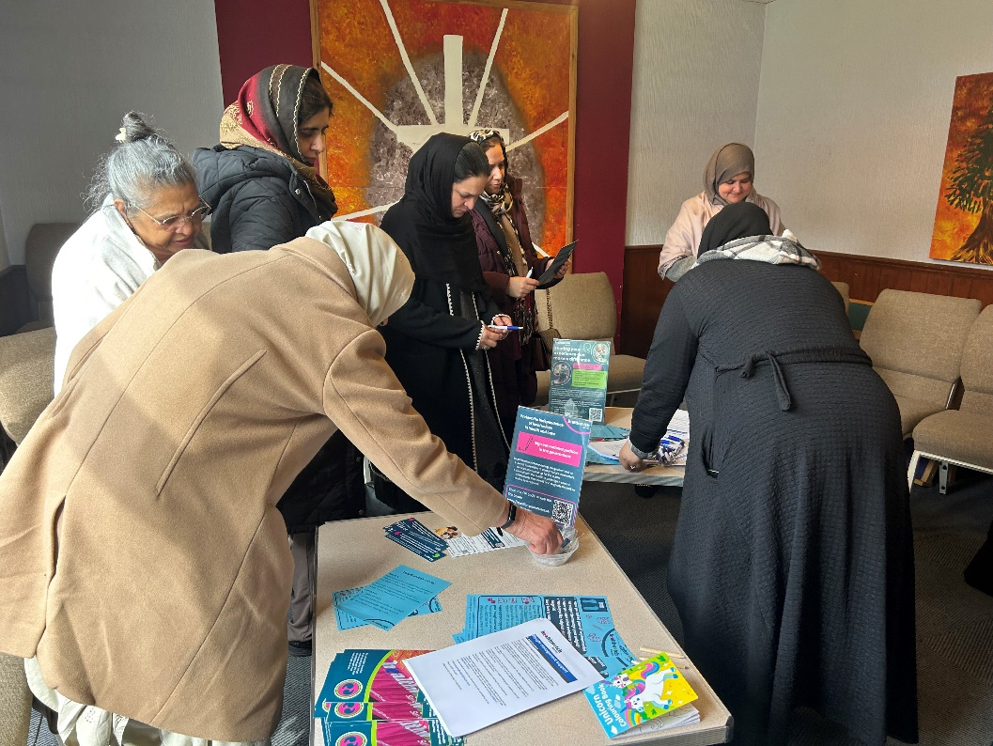

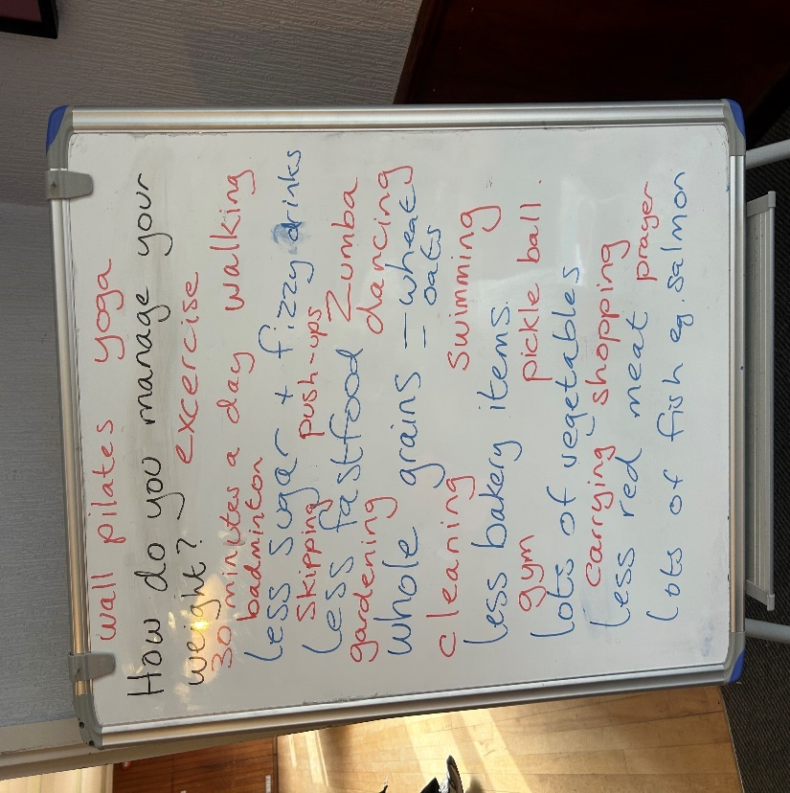




“I think that there needs to be better education around the use of weight loss medication and the potential effects it can have so people can make an informed choice. I also feel that there needs to be a more holistic approach to weight management, looking at people’s circumstances, their mental health and their physical health to make a meaningful change.”
xxxxxxxxxxxxxxxxxxxxxxxxxxxxxxxxxxxxxxxxxxxxxxxxxxxxxxxxxxxxxxxxxxxxxxxxxxxxxxxxxxxxxxxxxxxxxxxxxxxxxxxxxxxxxxxxxxxxxxxxxxxxxx

If you would like a paper copy of this document or require it in an alternative format, please get in touch with us.

Contents
Background 4
What did we do? 5
Key findings 6
Summary 22
Recommendations 23
Further information 24
Appendices 25
Thank you 31
About Healthwatch Surrey 31
Contact us 33

TRIGGER WARNING: this report contains accounts and discussion of people with varying eating patterns/behaviours and extreme weight loss approaches. Please continue to read only if you feel comfortable and able to do so.

Background
In 2022/23 an estimated 58% of adults in Surrey were classified as overweight or obese (Healthy Surrey). Whilst this is lower than the England average at that time of 64%, this represented an increase on the previous 5 years. Certain districts/boroughs in Surrey have a higher than average prevalence - Spelthorne, Mole Valley, Tandridge, Epsom and Ewell, and Surrey Heath - and there is a strong correlation between higher obesity rates and areas of deprivation.

The Surrey JSNA (Joint Strategic Needs Assessment) food and health chapter states that men are more likely to be overweight than women, while women are more likely to be obese, which aligns with national patterns. Surrey also mirrors national data with black minoritised ethnic groups having the highest rates of excess weight and white British following closely behind. Obesity peaks in middle age and tails off in later years. Surrey ranks among areas with some of the lowest childhood obesity rates in England but there is a worrying trend of excess weight doubling between reception and year 6, consistent with national patterns.

The most recent change in the support available to people needing weight management help is the availability of GLP-1 drugs, specifically tirzepatide (Mountjaro) and semaglutide (Wegovy), which was added to specialist weight management services in March 2025 and became available on prescription for eligible patients from June 2025. NHS prescriptions represent only a small fraction (5-10%) of total use however, with the vast majority (90 – 95%) accessing these drugs privately via online providers, clinics or pharmacies. In their January 2026 blog about weight loss drugs Healthwatch England identified access to these drugs being a “postcode lottery”.

In this report, weight management refers to the process of making lifestyle changes to maintain a healthy body weight based on your age, height and sex. Common weight management methods can include eating a healthy, balanced diet, increasing levels of physical activity, getting enough sleep and reducing stress levels. Weight management support can include commercial weight management programmes, the use of Apps and medication, including injections. Some of these can be used inappropriately and, if so, may be detrimental to health.

What did we do?
The new year is often a time when people think about managing their weight. We spoke to people between January and March to understand if they knew what options are available to them and to identify any barriers to access.

We talked to people at weight management groups, leisure centres and minoritised ethnic community groups in Surrey Heath, Surrey Downs, East Surrey and North West Surrey. As well as hearing about their experiences we also helped people to work out their BMI (Body Mass Index) and understand its meaning and provide signposting to weight management support.

 | 159 Surrey residents spoke to us
 | 83 people responded to our online survey

What immediate impact did we have?
18 people said that they were more motivated to manage their weight because of completing our survey; a straw poll at our in-person engagements suggested two thirds were more likely to manage their weight because of speaking to us.

Key findings

Why do people want to manage their weight?

- People’s primary concern is reducing their risk of heart disease but some did not realise the correlation between weight and specific health conditions.
- People’s motivation changes over time, from concern over appearance to concern to stay healthy for others they care about and for.
- There is a strong psychological and emotional relationship with weight management support, often rooted in childhood and lasting throughout life.

One third of those surveyed said that they had tried to manage their weight ‘too many times to count’, a further one third said they had tried many or quite a few times and a final third said they had tried a few times. An informal poll of women at a focus group with British Asian women found that one third had never tried to lose weight.

We asked people to choose why – out of a list of possible reasons - they wanted to lose weight. In order of popularity, they were:
- I want to reduce the risk of heart failure
- I want to improve my energy levels
- I want to improve my mood
- I want to improve my mobility
- I want to reduce the risk of diabetes
- I want to improve my appearance.

People were less concerned about losing weight to improve their libido or lower cholesterol and/or blood pressure (BP) but there was some confusion about the latter:

“I don’t know cholesterol or BP so I can’t answer. I didn’t know weight had an impact on cancer.”
Mole Valley resident, 65 – 79 year old white British woman

Some people told us that their motivation changed over time and the reasons for losing weight as a younger person were not the same as they aged.

“In the past I wanted to improve my appearance. Now I would say it's more for health reasons with a long-term health condition.”
Spelthorne resident, 50 – 64 year old white British woman

In addition, we heard that people were concerned about setting a good example for their children, staying fit and well so that they could carry out their duty as a carer as they aged, aligning weight management with their sense of identity, and being healthy to better manage menopause symptoms.

“I want to set a positive body image role model for my children and help them also develop lifelong healthy habits.”
Waverley resident, 25 – 49 year old white British woman

“I have an autistic son who will need me to care for him longer. I want to feel better about myself and get back to feeling like the old me! Get back my identity and purpose!”
Reigate & Banstead resident, 25 – 49 year old white British woman

Weight management and weight management support: emotional and psychological factors

We heard that problems managing weight often stem from poor self-body image during childhood. This can lead to a reliance on unhealthy methods to lose weight.

“When I was younger, I made myself sick to limit food intake into my stomach; it worked very well short term but was absolutely not sustainable!”
Surrey Heath resident, 50 – 64 year old white British woman

“I remember my mum saying, ‘You're getting grotesque.’ I wanted to do ballet and she said, ‘You're too fat.’ We laugh about it now but those early messages about food led me to binge eating and secret eating.” (full shared experience in appendices)
Elmbridge resident, 50 – 64 year old white British woman

For some, weight management support can have a negative psychological impact.

“I've tried Slimming World about 30 years ago but found the regime too rigid then. I lost weight then but almost became anorexic. I also attended a hospital where my eating disorder was diagnosed. The psychologist I first saw was amazing but was replaced with another doctor who suggested my husband lock the door cupboards when he went to work. I've worked with the dietitian in my GP practice because I had bowel problems, but she had no idea about eating disorders and simply told me to eat less fruit.”
Reigate & Banstead resident, 65 – 79 year old white British woman

What weight management support are people using?

- Most people try a number of different weight management support options, often including “fad” diets and misuse of medication or practices that can have detrimental effect on overall health.
- Commercial weight management groups, diet and exercise and weight management apps are the most common forms of support, and there is growing use of weight loss injections.
- Cost is a significant barrier for people to access some forms of weight management support, especially weight loss injections.
- People felt the criteria for weight loss injections was too stringent and detrimental to the prevention of long term health conditions relating to obesity in the future.

51 people told us that they are currently using some form of weight management support. Most were using commercial weight loss programmes such as Slimming World or Weight Watchers. The least popular forms of support, used currently or in the past, were the use of meal replacement shakes and over the counter medications such as Alli or Ayds. Many people had tried more than one form of weight management support recently.

“Weight Watchers, the Cambridge diet, the Atkins diet, Slimming World, the pH diet, a vegetarian diet, Slim Fast, the Jane plan, etc. I have literally tried everything, and every diet known to man!”
Runnymede resident, 65 – 79 year old white British woman

Some also considered fad diets and the misuse of medication as forms of weight management support.

Many who had tried weight management support had some initial success but were unable to sustain the weight that they had lost.

“I’ve tried the cabbage soup diet, taking water retention pills, taking laxatives (not to be recommended), calorie counting, a low carb diet, changing to low fat everything. All made me lose weight for a period of time but, as soon as I either got fed up of following them or started to eat 'normally', the weight would go back on.”
Guildford resident, 50 – 64 year old white British woman

Many appreciated approaches that focused on health and nutrition education, rather than reducing weight.

“Weight loss injections are a lazy way of losing weight. Once you stop taking them the weight goes back on. It was the same many years ago when I took slimming tablets; the only way to lose weight is to change the way you eat and the way you cook.”
Reigate & Banstead resident, 50 – 64 year old white British woman

Weight management groups
People liked the idea of weight management groups because of the social aspect of the regular meetings and sense of accountability to others.

“I have tried Weight Watchers, Slimming World, Noom and Slimpod. I was successful on Weight Watchers and Slimming World, even though the group environment was cringe. Sometimes I felt I did just go for the social aspect!”
Spelthorne resident, 50 – 64 year old white British woman

Others found the social aspect difficult and did not like the promotion of branded ready meals, though this is less of an emphasis today. They also found it expensive.

“At Slimming world, I felt judged and uncomfortable, feeling like I have to talk.”
Surrey Heath resident, 50 – 64 year old white British woman
“It’s very expensive. I’ve been to Slimming World and it’s just talk, talk, talk. It’s not effective.”
Woking resident, British Asian woman

For some, this form of support was chosen because they were eligible for free membership.

“The doctor offered me a 9 month free membership to Weight Watchers which was government funded so I took it up.”
Waverley resident, 65 – 79 year old white British woman

Weight management apps
Though common, generally people did not favour the use of apps, preferring face to face support.

“My Fitness Pal app was okay, but I lost motivation as there was no face to face contact.”
Surrey Heath resident, 50 – 64 year old white British woman

“I can ask but they [GPs] do not help. I’ve tried. They just send you an app to read through it and exercises to do. It does not help at all.”
Guildford resident, 50 – 64 year old white British woman

Those who were more positive about apps felt that they helped to educate them about foods and their nutritional value, which shifted their mindsets and changed habits.

Weight loss injections
People were very aware of weight loss injections as a form of weight management support. Those that were thinking about managing their weight expressed concern about possible side effects.

“I’d avoid the injection because I don’t like needles and I’m worried about the side effects.”
Woking resident, British Asian woman

People had some knowledge of the criteria for accessing weight loss injections from the NHS via their GP. Many believed that they would not meet the requirements and that this could be demotivating.

“I just feel I would be turned away and feel more disheartened than I already feel.”
Surrey Heath resident, 25 – 49 year old white British woman

There was frustration about the criteria and how individual circumstances, including caring responsibilities and specific health conditions relating to weight management, were not considered.

“I’m morbidly obese and really want to take Mounjaro to help me lose weight so I am in better health to care for my disabled adult daughter who lives with me.”
Guildford resident, 50 – 64 year old white British woman

“I want to lose weight but feel lost as to how as I do not fit the eligibility requirements for the injection that I feel is the best method for my circumstances and co-morbidities. It’s only the rigid criteria that prevents me; however, I do not feel this is the best criteria to use. Surely prevention is better than cure?! Shouldn’t it be those at high risk of heart disease, diabetes, sleep apnoea etc than those who already have these?”
Waverley resident, 25 – 49 year old mixed/multiple ethnic woman
Body Mass Index (BMI)

Body Mass Index (BMI)
- 9 in 10 people surveyed thought they knew what the term BMI means
- Just over 3 in 5 people said that knowing their BMI increased their desire to use weight management

“I had no idea I was obese”

- However, there was also a strongly held view that BMI was not a useful measure to help people manage their weight and that BMI targets for a healthy weight were unrealistic and unnecessary.

“An archaic measurement comparing weight and height.”

“It is not about a number; it is how I feel about my size and how confident I am wearing clothes I want to.”

The affordability of paying privately for weight loss injections was an issue.

“It is clear on the website that they will not prescribe weight loss medication unless there is a clinical risk factor alongside being obese so I felt I had no option but to go privately.”
Mole Valley resident, 25 – 49 year old white British woman

“My GP and the bariatric clinic did nothing to help me. They said I did not qualify for weight loss jabs on the NHS. I feel that I would've needed to be practically dead to get the help I need. I am still paying nearly £300 every 4 weeks to get my 4 weeks supply of Mounjaro which is a huge chunk out of my pension money. I am forced to pay privately to save my life and keep my health reasonable so that I can continue to care for my severely autistic, learning-disabled daughter.”
Runnymede resident, 65 – 79 year old white British woman

3 in 10 people surveyed said that knowing that they would not fulfil the criteria for weight loss injections would encourage them to seek weight management support from somewhere other than their GP practice, most commonly from a pharmacist.

However, there was evidence that people were seeking alternative, potentially unregulated routes.

“I used weight loss jabs to lose 14kg which I obtained from a practising midwife offering weight loss management privately.”
Mole Valley resident, 50 – 64 year old white British woman
Others did not know where they could access weight loss support, specifically injections, if not through their GP.

“I have no idea where, other than going to places offering it privately which I cannot afford. I need funds to put a roof over my children’s heads, not be selfish and use money to buy weight loss injection as they are so expensive!”
Waverley resident, 25 – 49 year old mixed/multiple ethnic woman

We spoke to a Pharmacy Technician (full interview in appendices) about her observations on the management of patients taking weight loss injections. She shared her concerns about the existence of a “black market” for this medication. She also raised concerns about the appropriateness of prescribing medication to people whose BMI is already at a healthy weight, with insufficiently robust assessments both at the outset and ongoing.

7 in 10 said they would not look elsewhere for weight management support and would trust the advice of their doctor.

“If I spoke to my GP about it, I would ask what they would suggest. If they suggested injections I would consider it, but in the context of other health issues. I would be concerned about muscle loss. I would trust my GP. I wouldn't trust another source.”
Spelthorne resident, 50 – 64 year old white British woman

“The cardiologist said, as my BMI was at 40, I should qualify for injections but my GP said no as [s/he] worries a lot about side effects and most people are diabetic who are on it. I was disappointed but took her advice as I’m bit worried myself.”
Reigate & Banstead resident, 65 – 79 year old white British woman

People who are using weight loss injections seemed happy with this form of support:

“Mounjaro has helped with controlling my appetite and hormones issues.”
Guildford resident, 50 – 64 year old white British woman

Access to weight management support

- Just over half of the people we spoke to knew that they could go to their GP for weight management support.
- Those that did go said they were offered generic “one size fits all” solutions.
- Two thirds of people said that they would not go and see their GP because they wouldn’t want to waste the GPs time.

2 in 3 people said that they felt that they were currently receiving their first choice weight management support though this wasn’t necessarily through their GP and many were funding it themselves.

Awareness and use of GP support
Just over half of the people we spoke to said they did not know that they could go to their GP for weight management support. Those who did had seen their GP in the past or had seen their GP for another reason and weight management support had been offered at that time.

Those that did know from previous experience said that they had been referred to a weight management group (Weight Watchers or Slimming World) or, more commonly, had been referred to online/telephone support which they did not find helpful

“I was offered a phone and online service commissioned by Surrey Heartlands. It was generic and not individualised.”
Guildford resident, 25 – 49 year old white British woman

“I was offered an online weight loss programme by my GP in 2024 but I think because I was going on holiday the timings didn't fit.”
Spelthorne resident, 50 – 64 year old white British woman
Two thirds of people said that they would be unlikely to ask for support from their GP (though this was significantly less when we spoke to British Asian women). Reasons for this included confusion about the support that their GP could offer and questioning whether the support was responsive to individual needs as it is seen as a “one size fits all” approach.

“They will point me in the direction of what I already know about. Advice is also not specific to the individual - it’s the usual eat low fat and exercise rather than seeing the person with differing needs, for example, in menopause women need to eat differently. Also, key to successful weight management is the psychological support to try and unpick why people overeat. This does not happen in enough detail with the services such as Slimming World, Weight Watchers or the online commissioned service within Surrey Heartlands.”
Guildford resident, 25 – 49 year old white British woman

There was concern that they would be wasting the GP’s time talking to them about weight management and should be able to research, support and manage their weight themselves

“It was never that bad that I thought to ask my GP. I wouldn't want to waste their time over something I could Google and research myself. I wasn't ill.”
Guildford resident, 50 – 64 year old white British woman

People said that as it is difficult to make a GP appointment anyway, or to have a consultation in the way they preferred, they would not try to make one for something that they felt was not urgent.

“It’s impossible to get an appointment unless you call at 8 for same day and I don’t see this as an emergency. You can't get to see a GP and it's a low priority plus it's embarrassing to not be able to control your own weight.”
Waverley resident, 50 – 64 year old white British woman

Awareness and use of pharmacy support
4 in 5 people surveyed said that they did not know that they could go to their pharmacist for weight management support. This was less, 1 in 6, when we spoke to people on engagement.

Once they were made aware, 3 in 5 people said that they would be unlikely to ask for support from their pharmacist. A common reason was concern about discussing weight management in a public space, especially where there is already a relationship with the pharmacist.

“I have several friends using the local pharmacist for Mounjaro injections. I wouldn’t as they know me personally as we get repeat prescriptions there and I’d be embarrassed.”
Hampshire resident, 65 – 79 year old white British woman

“It’s not private enough there and I’ve got a big problem with it in that I feel they won’t understand and I’ll likely cry and be a mess which I’m not going to do in the pharmacy.”
Guildford resident, 50 – 64 year old white British woman

There was also concern that the pharmacist does not have access to their medical records and so does not have the necessary information to advise/prescribe.

“It feels weird. If I ever have a prescription it does get sent to a specific pharmacy, but they won't have access to any of my other medical records, so it feels a bit strange.”
Spelthorne resident, 50 – 64 year old white British woman

People were unsure of the support available from the pharmacist but the assumption was that it is predominately weight loss injections and that these, and other forms of support, would be costly.
“I imagine they will tell you all about the private route of getting the Mounjaro jab which isn’t appropriate for me as I am on highest rate PIP for mobility and daily living. Therefore, I cannot afford to pay for the Mounjaro jab and currently get my prescriptions free.”
Waverley resident, 25 – 49 year old mixed/multiple ethnic woman

What do people want?
We asked people what would help them with their weight management. They asked for a more holistic approach within GP practices, which might be helped by having a nutrition/weight management specialist as part of the multi-disciplinary team. Clearer promotion of the support available would also help.

“It would be helpful if GP surgeries knew more about eating disorders and were able to offer support for sufferers. The basis of my problems are due to my eating disorders and weight loss programmes are not directly dealing with that.”
Reigate & Banstead, 65 – 79 year old white British woman

“I think people only think that they will recommend the skinny pens and not all will want them. Maybe advertise exactly what it is GPs and pharmacists can offer. But will they just signpost and leave you to it? If so, people can just do their own research and pick a programme that suits them.”
Guildford resident, 50 – 64 year old white British woman

“We are constantly being told the NHS is at breaking point which puts me off asking for any help. It is very hard to get a doctors appointment and I don’t want to take an appointment away from someone in more need. A nutritionist at the doctors which can be booked would help.”
Hampshire resident, 25 – 49 year old white British woman

Barriers to accessing weight management support

The main barriers to people accessing weight management support were concern that they would not be able to maintain their goal weight when the support ended, a fear of failing and cost.

People also struggled to find the motivation to ask for and then follow a weight management programme; this was compounded by low mood and for those who are neurodivergent.

People could usually start their weight management support quickly (especially if self-funding) but faced long waiting lists if they were referred to specialist services such as bariatric surgery.

Half of those asked said that their biggest concern about weight management support was whether they would be able to maintain their weight once the weight management supported ended. 2 in 5 people were concerned about the cost and then the fear of failing and giving up comforting habits.

“I’ve gone back to bad habits now it’s over. I’m worried about failing but I need to stick to it – it’s a mind game with myself.”
Mole Valley resident, 18 – 24 year old black Caribbean man

There was also concern about lack of psychological and long term support for some of the weight management programmes available.

“I would consider weight loss medication once I have explored all other options. I believe my overeating is psychological so I would like to explore a long-term solution. I enjoy exercise and find that it encourages me to eat better.”
Mole Valley resident, 50 – 64 year old white British woman

We also heard that people struggle to find the motivation to ask for help in the first place and this is compounded by low mood. Those who are neurodivergent also struggle to stay focussed on a specific programme.

“I have ADHD and find staying on task very hard. I’ve tried Apps, in person, Weight Watchers and low calorie drinks like SlimFast.”
Surrey Heath resident, 50 – 64 year old white British woman

“I’d try anything that would help. I have depression and find it difficult to initiate any help.”
Reigate & Banstead resident, 50 – 64 year old white British man

Cultural and language barriers
We spoke to black and Asian women who experienced specific barriers to accessing weight management support.

“It’s not a problem to talk about weight with the GP if you can take someone with you who can translate.”

Most attempted to manage their weight through culturally acceptable exercise such as pilates or going to the gym. For some, some forms of physical activity would not be deemed appropriate according to cultural beliefs.

“Sport and dancing would not be considered appropriate for women.”

Sources of information

Most people found generic information about weight management support that they were interested in from internet searches. However, when we asked people how they had found out about the weight management support they were actually using, just under half said through word of mouth and just under a third said through internet searches. 1 in 5 had sought advice from their GP. Information/communication from GP practices was sometimes slow and not followed up.

“Curiosity. I did know someone who had done it. People at work were miraculously losing weight. They were all on jabs.”
Elmbridge resident, 50 – 64 year old white British woman

“My friend’s daughter was successful on Mounjaro, and other friends were also successfully losing weight on weight loss jabs. They recommended them to me and said the jabs stop the constant food noise and make you eat less. I can now confirm the Mounjaro jabs do exactly that with minimum side effects.”
Runnymede resident, 65 – 79 year old white British woman

“The doctor was reviewing blood tests and saw that I was pre-diabetic and said losing weight would help reverse this and suggested Weight Watchers.”
Waverley resident, 65 – 79 year old white British woman

“I was looking for local slimming groups & came across One You Surrey and their offer of free weight loss support if you had a high BMI.”
Reigate & Banstead resident, 50 – 64 year old white Irish woman

“I had done it before and friend had done it. It took a while to pluck up courage to come.”
Reigate & Banstead resident, 65 – 79 year old white British woman

7 in 10 people were either very satisfied or satisfied with the information they received but those that weren’t reported too much information which could be confusing for some, delays in receiving information or decisions being made about the weight management support to be offered and not following through once a decision had been made.

What do people want?
People told us that they would like more support to help them maintain their weight once they have reached their goal and that it would be helpful to see the weight management support available promoted in health care setting such as waiting rooms.

“In some respects, reaching the goal is the easiest bit - maintaining is harder and more support is needed to help people stay healthy.”
Mole Valley resident, 50 – 64 year old white British woman

“More posters in hospitals and surgeries which we can read whilst waiting but as most consultations are done online, this probably isn't too effective!”
Waverley resident, 65 – 79 year old white British woman

“Maybe don't send a patient who is 8 months pregnant a text asking if she wants to join weight watchers it will not
go down well!”
Outside of Surrey resident, 25 – 49 year old white British woman

Summary
Weight management is a lifelong issue for many people, often rooted in poor body image and negative messages about diet and exercise during childhood.

Many people have tried numerous forms of weight management support but, whatever they try, often find it hard to sustain their weight management goals in the longer term.

Many people access support privately; they are often unaware of what is offered via the NHS, or don’t believe it will meet their specific needs.

More can be done to educate people about the weight management support which is available to them through the GP and pharmacist and to ensure that this is tailored to meet individual needs.

Recommendations
- Ensure people are clear where to go for weight management support on the NHS
- Consider people’s individual circumstances when referring e.g. group support, digital access, wider determinants of health
- Consider how to work with people on their specific needs e.g. carers, people who are neurodivergent and people from minoritised communities – avoid a one size fits all approach
- Consider how best to support people to sustain healthy lifestyles.

These recommendations will be shared with GP practices, pharmacists and commercial weight management providers operating in Surrey.

Further information
For help managing weight, contact your GP or your pharmacist.
You can also get support from One You Surrey and the NHS Digital Weight Management Programme.

Read more about the experiences, views and opinions of weight management support for people aged 50 to 66 in our Living, coping, thriving report.

Appendices

Case Study 1 – Interview with 50 to 64 year old white British woman
I’ve been overweight all my life - pretty much since born – I was adopted. My brother is tall and slim and so is mum. I don't share their DNA. I was always plump, fat and fatter and have been on every diet under the sun. At about 9 years old my mum said that she had different milk for me because it was less fattening. I was given diet sheets from my GP about that time. She gave me more “diety” food, specifically for me. I went to Weight Watchers when I was about 15/16 years old. I went to occupational health as I was working as a nurse and was given more diet sheets and put AYDS which is an appetite suppressant. I tried Limit biscuits, the Cambridge diet, weight loss surgery, Lighter Life and, when I was getting married, I went to a diet consultation clinic and was put on amphetamines. I lost 2.5 stone and was aged 27 then. I put on weight when I had kids and went to Slimming World. My childhood experiences definitely affected me. Mum said, "You're getting grotesque”. I wanted to do ballet and she said, "You're too fat". Those early messages about food led to binge eating. I used to make cake mix up and eat it, always with a sense of shame. I hated sport. I did a lot of secret eating.

I’m unlikely to see my GP about my weight now but have done in the past. I went to my GP when I wanted to have weight loss surgery. This was 10 to 15 years ago. They referred me because I said I'd tried everything. I was a nurse so better informed and the GP knew this. It was reasonably effective. I was on a low percentile so surprised that I got it for nothing. If you are vast it works quicker and better but for me it wasn't as effective because my BMI was borderline. I waited about a year. I wasn’t worried about it. I just wanted to go ahead. I will say everything I can to get what I want because I know what terms to use. I have a good level of health literacy that others don't have.

I'm not that bothered by BMI as I know that it's only part of the picture. Every time I ask for my prescription for Wegovy, they ask me for my height and weight so they can calculate my BMI so they can reduce the medication. When you order it, you have to give height and weight and they review it; you order and pay first, then it’s authorised after it’s looked at by a doctor. They haven't said no to me yet. They wouldn't say enough; they would reduce the dosage. I am now reducing it myself. They do give you information and support. I think they are doing a good job personally. I understand that there are people who don't need it. People with eating disorders? I can't comment. But there are people who just want to be smaller. I am very lucky that I can afford it. People will go on the black market to get it. Once you get it on tablet form, the price reduces significantly. For a lot of people it would just be completely out of reach at £300/month.

I went privately as I knew that there was no way I'd get injections from my GP. You need 4 to 5 co-morbidities to get the injections. I wouldn’t have been heavy enough. You have to have BMI more than 30 (as with ASDA which is where I got my medication) but criteria set by the GP is massive.

I have lost 3.5 stone but I’d like to lose 4 stone. I have this in my head. I thought, I loved to but I won't. I'd love to be 11 stone – a size 14.

As soon as I knew I good afford it, I went to Superdrug. The doctor took my photographs and I got on it. I looked at side effects, mainly feeling sick and wasn’t bothered. I went to Superdrug as I knew the name so trusted the brand. I looked at them and Asda. Boots was very expensive. Eli Lily had a good deal with Brexit with Mounjaro but then Trump said no, charge the same as the US so it went from £170 to $340 which was too expensive. My pharmacist wouldn't take me on as a new patient but Asda did. So long as I could give them the evidence, they were happy to let me have it. If you collect it from Asda, you'll probably go into the shop.

Curiosity got me on it. I did know someone who had done it and people at work were miraculously losing weight. They were all on jabs.

People’s attitudes towards me have been interesting. My friend said to me, head on her side, “This is coming from a place of love, you have to stop now!” Yes, I get it, I am no longer your fat friend. Most people are thrilled for me. I thought it was a last chance saloon and then, it totally worked! I'm eating like a slim person. I don't want to draw attention really. People have been concerned for my health – they thought I could have had cancer – and have asked if I wanted to lose weight. Equally, if I’d put on six stone I wouldn't want people to comment on that either. Oh my gosh, I am half the size. I do want to give up comforting habits! To say that I am scared - it’s a bit strong - I am apprehensive. I don't want to put it back on so I will probably stay on it for life. I have exactly what I want when we go out for dinner but will leave half of it.

Case Study 2 – Interview with Pharmacy Technician, Primary Care
When I was working in Community Pharmacy there was over the counter medication called Alli – the fat absorption drug – you had to eat healthier because if you went and ate fish and chips you would poo it all out. We used to have to monitor patients taking this. We had a questionnaire that they had to complete and had to ascertain their BMI. They had to be a certain weight for us to be able to sell it to them. Its pharmacy name was Xenecol and we could see 30mg over the counter or 120mg on prescription. That was approximately 6 years ago. We didn’t just take their word for it when they told us their weight. We took them into the consulting room and weighed them and measured their height. Now there are a lot of online services including access to Mounjaro where they can’t weigh them. They verbally say their weight. We also gave general lifestyle advice. We saw many more women than men and not so many elderly people. A lot of the people we saw weren’t that obese. We did make a lot of sales according to the criteria but, to be honest, if they had just followed general advice on diet and exercise they could have done it themselves. A lot of people are looking for a miracle cure. I personally knew one of the patients on it and I know that if they wanted to go out for a meal, they just didn’t take it, so they weren’t really changing their lifestyle. There was no follow up after the sale.

Today, I talk to patients about risk factors which would be relevant to the medication they have been prescribed and flags would include their BMI. I signpost them to, for example, Heart UK for cardiovascular issues or the NHS website on healthy living. I know that Mounjaro is being prescribed internally, within the practice, but I also know that patients are buying it externally. I see the clinical letters that come in from the private clinics for patients who have signed up to Mounjaro or Wegovy and I have to put that information onto the patients’ records. Their BMIs are 24, I’ve even seen it as 22, so really they shouldn’t be having it when their BMI is that low, so why are these clinics still supplying this patient with this product that they don’t actually need? I saw a letter where a patient was advised that she would be putting herself at risk if she took it but then saw that it was prescribed anyway. I raised my concerns with the Practice Manager who said that we couldn’t interfere with the prescribers decision. Patients will just go elsewhere – if they can’t get it from one private clinic, they’ll just go to another. I see letters saying that the patient has had a consultation and has been prescribed a weight loss drug but I don’t know how this is happening because how do they know that they are the weight they are saying there are without physically seeing them. How do they know they are the weight they say each time they request their next supply? As far as I can tell, they don’t have a video call where they can see the patient and see them weigh themselves. If they did, the notes would say it was a consultation via video call. How in depth is the consultation? There is a questionnaire asking them how many times they have a takeaway a week or eat fruit and vegetables a day but they could lie. They should be receiving one month’s prescription at a time so should be repeating the questionnaire verbally every month but I’m not sure that happens, I think they may just be sent it to complete and return digitally. These questions are designed to help people change their lifestyles so, if this process isn’t happening properly, and they aren’t making any changes, they will be on these drugs for life and they can’t stay on them for life. I saw one patient who had their dose reduced before Christmas but they put on weight over Christmas so their dose was increased again. What has she learnt from that? They just wanted to see the weight go down on their scales. They don’t care what’s going on in their bodies or their bone health in 20 or 30 years time when they are OAPs. I know so many people, even on a personal level, who have sold their drugs to other people. He was getting them from the doctor and stopped them because he didn’t like the side effects but had a couple left so he sold them to somebody – it goes on! And what good is a couple of doses to someone?

People do get prescribed it if they meet the right criteria but it’s different up and down the country. Round here, you can have it if you are diabetic but I know someone further up north who is diabetic and can’t get it so has to pay for it privately. It depends on your catchment area. If you’re obese and have other risk factors, you can have it but if you’re just fat, you can’t. But there is other support for people in this category. I don’t ever hear of Weight Watchers or Slimming World anymore. That’s “back in the day!”. If you are overweight, you need to change your lifestyle and people just aren’t getting that. People on Mounjaro should join groups like that to support them on their journey so that they learn how to eat. A lady I go to running club with told me she lost 3.5 stone on jabs. She said that she was going to stay on it because she wanted to be thin. I asked her if she has changed the way she is eating and she said no. Years down the line, I think there are going to be so many more problems. They are going to be falling over and breaking bones and will be even more obese because the cost will have gone up even more because they can’t afford it. They are only in the now. You should be thinking about how you want to be in your old age. You have to put in the work and it is hard work. My friend had to stop because it affected her eyes. She didn’t want to go on an alternative. She knew someone else who also had problems with her eyes. My friend’s daughter is on it. She looks fantastic but she has had side effects throughout and is going to stay on it because she’d rather be skinny and put up with them than to be fat. That is where we are at. If you’re obese and have got high BP, it’s a good thing because it will cost the NHS more to deal with you than prescribe injections. I like the expression, “Lifestyle got you in, lifestyle can get you out”. Unless it’s hereditary, type 2 is down to a western diet and can be manage through lifestyle. I understand that some people have other risk factors, such as high cholesterol and could have a heart attack, but you should have an in depth consultation and follow up with a designated nurse. I understand that does happen but, if it’s a 10 minute follow up, they won’t have time to do much more than weigh them. They need signposting and giving all the information to make their weight loss journey simpler.

Access to support
We asked people how they got access to this support. 56 people surveyed answered this but were able to give multiple responses (the most popular forms of support in ascending order are shown in the following table):

Through GP | Through pharmacist | Through self-referral
11 out of 56 | 3 out of 56 responses | 39 out of 56
- Commercial weight loss programmes  - Use of the NHS digital weight management App  - Surgery  - Weight loss or shape up programmes provided by gym or sports centres  - Prescription only medicines such as Wegovy. | - Prescription only medication such as Wegovy  - Over the counter medication such as Alli or Ayds. | - Commercial weight loss programme  - Diet and exercise advice and information  - Prescription only medication such as Wegovy  - Meal replacements such as SlimFast, Huel or Shake that Weight food counselling weight loss or shape up programmes provided by gym or sports centres  - Use of the NHS digital weight management App

Thank you
We would like to thank everyone who gave their time and shared their experiences with us.

About Healthwatch Surrey
Healthwatch Surrey champions the voice of local people to shape, improve and get the best from NHS, health and social care services. We are independent and have statutory powers to make sure decision makers listen to the experiences of local people.

We passionately believe that listening and responding to local people's experiences is vital to create health and social care services that meet the needs of people in Surrey. We seek out people’s experiences of health and care services, particularly from people whose voices are seldom heard, who might be at risk of health inequalities and whose needs are not met by current services. We share our findings publicly and with service providers and commissioners to influence and challenge current provision and future plans.

We also provide reliable and trustworthy information and signposting about local health and social care services to help people get the support they need.


Contact us
Website: www.healthwatchsurrey.co.uk
Phone: 0303 303 0023
Text/SMS: 07592 787533
WhatsApp: 07592 787533
Email: enquiries@healthwatchsurrey.co.uk
Address: Freepost RSYX-ETRE-CXBY, Healthwatch Surrey, Astolat, Coniers Way, Burpham, Guildford, Surrey, GU4 7HL.
 healthwatchsurrey
 healthwatch_surrey
 Healthwatch Surrey


The Healthwatch Surrey service is run by Luminus Insight CIC, known as Luminus. Luminus is a Surrey based, independent, community interest company which exists to empower people to have their voices heard. We help organisations provide equity of access and the best services possible, through the inclusive involvement of local people.


We are committed to the quality of our information.
Every 3 years we perform an audit so that we can be certain of this.


We are proud to have signed up to the End Poverty Pledge –
End Poverty Surrey – Good Company.

Phased implementation prioritises those with the highest clinical need based on BMI and multiple comorbidities.
56 people responded to our survey question asking how they were accessing weight management support (full response in appendices).

