

Waiting for hospital care
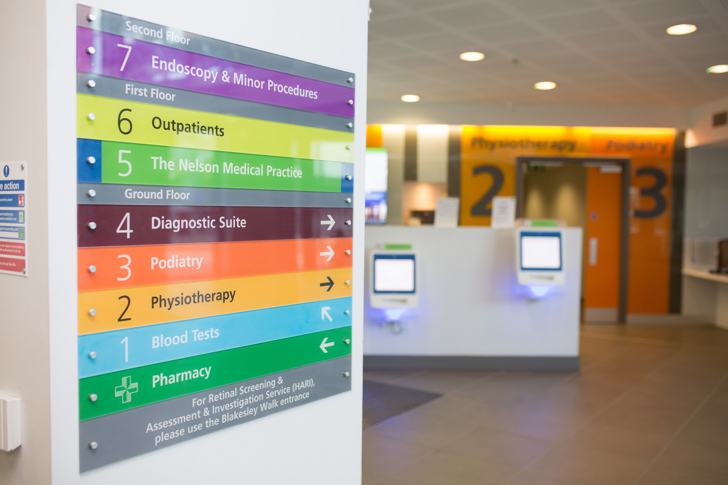
Protecting people’s health and wellbeing while they wait for hospital appointments
Summer 2022

Contents

Background and Rationale 2
Research Objectives 3
Method 3
Scope, risks and limitations 3
If you take one thing from this report… 4
Key Findings 5
Recommendations 7
Sample 8
Main Findings 9
The experience of waiting 9
Healthcare Advice and Support While Waiting 12
Waiting Times 15
Some final comments 17
Summary 17

Background and Rationale
The number of people waiting for hospital appointments or treatment has been growing since 2009, and the pandemic has resulted in many more people having their operations, treatment and appointments cancelled or delayed. In Surrey c. 100,000 people are currently waiting for hospital treatment and this figure is not expected to start falling until 2024.
Research by Healthwatch England has revealed that people from poorer households, ethnic minorities, disabled people and women are hardest hit while they are waiting https://www.healthwatch.co.uk/news-and-reports.
The NHS delivery plan for tackling the backlog acknowledges that longer waits can have a wide range of impacts on people. One of the commitments in the plan is “better information and support to patients”, including more personalised information, targeted support for those waiting and to help them prepare for surgery, and more opportunities to provide feedback to the NHS.
Healthwatch Surrey ran this survey to provide insight that will enable services to support those waiting and minimise the harm of long waits.

Research Objectives
To understand people’s experiences of waiting for hospital treatment:
- Attitudes to waiting, and the impact of waiting
- Information and advice received while waiting
- Advice about health and care, and advice on waiting times
- People’s sources for advice and guidance while waiting

Method
We ran a survey online and on paper, using two distribution methods:
- Our own social media, and partner communications
- Hosted on a paid-for research panel
We received a total of 182 validated responses. The survey ran for 8 weeks from early March to late April.
The questionnaire was developed with neighbouring Local Healthwatch – Healthwatch Slough, Healthwatch Windsor Ascot and Maidenhead, Healthwatch Bracknell Forest and Healthwatch Hampshire - who have also reported findings for their own areas that are available on their websites.

Scope, risks and limitations
This survey shines a light on a range of experiences of waiting.
As the respondents were self-selected it does not deliver a representative sample of people in Surrey waiting for treatment and should not be used as a quantitative record of experience. Inevitably, we hear more from those with a bad experience to share than those whose experience was as expected or better than expected.
However, it does provide real experiences of people who are, or have been, waiting for treatment. There is a particular focus on opportunities to improve, but we also recognise good practice. Our aim is that our findings and recommendations are used as insight to enrich strategy and inspire opportunities to improve systems.

If you take one thing from this report…
Active management – are the people on wating lists being actively managed? Are they being empowered to manage their condition and their health so they can achieve the best possible outcomes? Or once people are on a waiting list are they out of sight, out of mind?
We received a clear message that many people feel they are missing information and support while they are waiting. They told us they had not had worsening care advice or been told who to contact if their condition deteriorated. They want more information about how long they are likely to have to wait so they can make informed decisions about managing their condition and their health, and to reduce anxiety and uncertainty.
Given that we will be living with long waits for several years we suggest services with the longest waits could consult targeted groups of patients to co-design processes for efficient but active management of their condition while they wait.

Key Findings
- The experience of waiting
The focus of our survey was on information needed and received by those waiting. Work by Healthwatch England and The King’s Fund shines more light on the day-to-day realities of waiting for treatment https://www.healthwatch.co.uk/news/2021-09-27/people-living-poorest-areas-waiting-longer-hospital-treatment
Locally we found:
- any need to wait is worrying for many patients – 40% of those currently waiting for just a month or two feel negative about their waiting time
- uncertainty about the length of wait is a major concern in its own right
- most of those waiting 5 months or more felt generally negative about their wait (80% +)
- negative effects of waiting included physical effects (24%), effects on mental health (18%) and socio/economic detriment (8%)
- Information, advice and support
- only one in three felt the hospital had given them helpful information and support; one in four felt their GP had given them helpful information and support
- 62% told us they’d been given information by the hospital about their condition, 57% had been given information about their treatment
- 44% had been given information by the hospital about managing their condition, 29% about preventing their condition from worsening
- 26% had been given a contact by the hospital in case of their condition worsening, 12% had been given a contact by their GP.
- Information about waiting times
  - c. 40% had been given information on how long their wait might be
  - when asked what information or support they would have liked to receive, 25% spontaneously mentioned information about the length of their wait
- 56% said they had not received enough information about their waiting time
- 64% agreed the hospital should update them every month to every three months on the length of their wait (most felt there should be a monthly update)
- 64% said they would be happy to attend a different local hospital for their treatment if it meant they could be seen sooner

Recommendations

We recognise that providers are already doing their utmost to minimise waiting times for patients, that the situation is not going to resolve quickly, and may get worse over the coming year.
With this in mind, and based on the feedback received, we therefore make only 2 recommendations.

Both relate to how people could be actively supported to manage their condition to reduce anxiety and stress whilst waiting for treatment.
- Review how to ensure patients are given the information, advice, contacts and signposting they might need to stay well and prevent avoidable deterioration while they are waiting.
  - Worsening care advice; clear signposting for advice including who to contact if their condition worsens
  - Information to manage or improve health while waiting – how to manage their condition, how to reduce the possibility of complications, general health advice, external sources of information
  - Signposting to non-NHS support – support groups, charities
  - Consider codesign with specific patient groups to develop patient-centred approaches to support and information while waiting
- Communicate with patients regularly - every 10-12 weeks – to improve trust and reduce anxiety, stress and time wasted on repeated inbound queries
  - As a minimum, provide reassurance the patient is still on the list
  - Ideally give an update of their likely waiting time, even if vague
  - Where this is not possible be open – explain why not
  - Reiterate key self-care information and contact information
  - Consider automated services such as text messaging or emails rather than hardcopy communications where patient-appropriate

Sample

All responses/respondents related to:
- Experiences since January 2021, or currently waiting for treatment
- Respondents living in Surrey, or treated in Surrey hospitals - most of the sample were Surrey residents with experiences in Surrey hospitals
Ethnicity:
White British 85%
Other white 5%
Black 3%
Other 6%
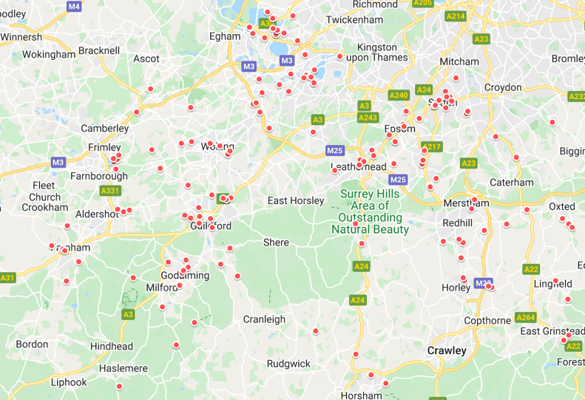
Respondents who are:
Unpaid carer 9%
Disabled 13%
Long term health condition 24%
Waiting for:
Outpatients 45%
Diagnostics 21%
Day Surgery 17%
Routine appt/treat 13%
Overnight stay 10%
Other 6%
Age of patient:
Under 18 3%
18-44 38%
45-64 30%
65+ 29%
Sex:
Female 71%
Male 29%
Other 1%
Hospital:
RSCH 19%
St Peters 15%
Epsom 14%
Specialist/OOA/Other 12%
SASH 11%
Frimley Park 10%
Ashford 9%
St Helier 9%
Experience:
Treatment since Jan 21 24%
Appointment since Jan 21 20%
Test since Jan 21 7%

Currently waiting for treatment 24%
Currently waiting for appointment 18%
Currently waiting for test 7%
Survey completed on behalf of:
Myself 82%
Another adult 13%
A child 4%

Main Findings

The experience of waiting

Length of wait
Our respondents split very broadly 50:50 between shorter waits (4 months or under) and longer waits.
Treated since Currently
Jan 21 waiting
0-2 months 38% 29%
3-4 months 15% 19%
5-6 months 13% 15%
7-12 months 14% 19%
1-2 years 6% 10%
2+ years 4% 5%
With due caution given the nature of our sample and the size of sample cells, we saw that:
- Around 25% of those who were treated within 0-2 months felt negative about their wait
  - Around 40% of those who have been waiting for 0-2 months feel negative about their wait
  - Around 50% feel negative about a 3-4 month wait
    - Around 80% feel negative after a wait of 5 months or more

“It was AMAZINGLY FAST to investigate rectal cancer and operation within weeks of colonoscopy; and a very delayed angiogram”
Waited 7-12 months, cancer and angiogram

“Concerning. Last time I was put on the two week pathway for the same problem”
Currently waiting, 0-2 months, ?basal skin cell cancer

“Disappointed and concerned at risk of permanent damage while condition untreated.”
Currently waiting, 7m+, trapped nerve

When asked if the length of wait had had any effect, positive or negative, the longer people waited the more likely they were to have experienced a negative effect
- 35% reported a negative effect after waiting 0-2 months for treatment
  - 50% of those still waiting reported negative effects after just a 0-2 month wait
      - 55% after a 3-4 month wait
          - 80% reported negative effects after a 5 month wait

People told us about a range of effects on their health and wellbeing:
Any negative effect 57%
Physical 24%
Mental 18%
Social/economic 8%
No effect 31%
Base: All answering
“I have not had a full night’s sleep in 6 weeks due to the pain, cannot walk properly, cannot exercise, cannot drive and cannot look after my kids. I still have no idea what is wrong with my knee, how long it will last, whether I should be using it or not. It’s mentally very draining.”
Currently waiting, 0-2 months, orthopaedic assessment

“Bad - worsening symptoms, no treatment, no referral onwards to specialist, holding up treatment for other conditions as these needs fixing first”
Currently waiting over a year, renal

“I’m now … unable to work or do anything for myself, it's awful my life is on hold waiting for this treatment.”
Currently waiting, 1-2 years, gastro

Of those who had had an appointment:
- 32% told us their appointment had been changed by the NHS
  - 20% changed once
  - 11% changed more than once
A small group of people told us the changes had had their own negative impact:
“Feel like … I am not important”
Currently waiting, 1+ years, pelvic floor

“I need to prepare for possibly 4-6 weeks of no weight bearing, possibly 10 weeks off work. For that I need to plan how I'm going to cope. I’m somewhat stressed.”
Currently waiting, 5-6 months, orthopaedic

Only two people told us they had changed their own appointment: one for fear of covid, one because the date was not convenient.

Healthcare Advice and Support While Waiting
Most of our respondents did not feel the information they received from hospital or their GP was helpful. Only one in three found the information from hospital helpful; and just one in four found the information from their GP helpful.
Overall how helpful did you find the information or support you received from…?
Hospital GP
% %
Not at all 27 32
Not very 10 18
Neither/nor 28 19
A little 15 14
Very 20 11
Base: all answering

Given the wide range of conditions and wait times it’s impossible to know what information or support people should have been given.
However, we can see that the proportion of respondents given information about condition management and risk reduction is lower than those given information about their condition and treatment.
Base: all NOT saying that information was not applicable. Question options were yes, no, not applicable. For those saying it was applicable, 62% said they had received information from the hospital about their condition.
Even if we assume that every patient is given some information about their condition and treatment, this does imply that some people may not be receiving (or not assimilating) information on how to manage their condition or look after their health while waiting.
Additionally, over half those responding told us they had not been told who to contact if their condition worsened.
Were you offered:
Offered by: Hospital GP not not
offered applicable
% % % %
… someone to contact if condition worsened 26 12 54 11
…pain relief 15 18 39 28
… physio 8 8 45 38
…mental health support 8 6 58 29
…community groups or charities 6 4 50 28
Base: all answering

“The information the hospital provided (about Chron’s Disease) was very useful”
Currently waiting 0-2 months, Gastro

“The only advice I received was to try a splint at night”
Currently waiting, 7-12 months, orthopaedic

“The hospital did not explain anything to me at all. The only correspondence I received was being cc’d on a letter from one consultant to another. I had to google basal cell carcinoma.”
Currently waiting 5-6 months, basal cell carcinoma

When asked about information from other sources most people told us they had received none (40%) or didn’t need any (33%) but
- 21% said they had gathered information online or via an app
- 5% from a charity or voluntary organisation
- 2% from social care
- 13% from a range of other sources including private healthcare, private physiotherapy, friends with the same condition and specialists such as hospices and stoma nurses

“Good old Google”
Completed treatment, 0-2 months, cardiology

A handful of people told us about information or support they found especially useful:
- 8% from a clinician
- 5% leaflets
- 7% online resources

“I had a 2nd pre op assessment as the first had timed out. The nurse was very sympathetic and it was helpful to talk about my situation not just the proposed surgery”
Currently waiting, 5-6 months, orthopaedic

When we asked about information or support people would have liked to receive:
- 36% said nothing
- 16% wanted information about their condition
- 4% would like a named contact to call for updates
- A handful of respondents gave general/nonspecific answers

25% spontaneously said they would have liked more information about their waiting time.
“I've not had any information about my diagnosis since October. Have had all the tests and investigations but have not heard any information back about the MDT meeting or about when and whether the operation will even go ahead”
Currently waiting, 5-6 months, cardiac

“I would like to know an idea of where I am on the list. I would also like to know if there is a contact I could use when my condition worsens”
Currently waiting, 1 year +, gastro

“Accurate information on the waiting time. We were initially told a year, then it became a "rolling" year and now there is no information available on the wait times”
Currently waiting, 1yr +, mental health

Waiting Times
For most people the clarity of hospital communication is acceptable rather than excellent – one in five told us they felt it was not clear and easy to understand, but the bulk of responses were in the middling/acceptable range.
Agree/disagree “letters about my appointment/treatment were clear and easy to understand”
%
Strongly agree 8
Agree 37
n/n 30
disagree 11
strongly disagree 11
base: all answering

We received a very clear message that most people want more information about their waiting time – they felt the information they had received was inadequate, and that hospitals should be doing more to keep them informed.
Agree/disagree “I was given enough information about my waiting time”

%
Strongly agree 8
Agree 14
n/n 20
disagree 24
strongly disagree 34
base: all answering

None had been sent a link to My Planned Care: almost nobody was aware of it; a tiny handful had found and used it.
My Planned Care
%
Not heard of it 93
Heard of it but not used it 5
Have used it 1
Sent a link by the NHS 0
Base: all answering

More people told us they had not received information about their wait than told us they had received information
Did the Hospital/GP give you information about how long you might need to wait, or updates on your waiting time?..
Hospital GP
% %
Yes 36 20
No 50 63
Not applicable 14 17
Base: all answering

Only 1/5 felt they were given enough information about their waiting time. While the sample sizes are small, directionally we saw that those who had waited longest were the most unhappy with the information they had been given.
“It wouldn't be too bad if I knew for certain when my operation would take place.”
Currently waiting, 5-6 months, orthopaedic

“Frustrated by lack of information about waiting time after no call back from consultant’s PA even after leaving message on direct line twice”
Currently waiting, 5-6 months, orthopaedic

2/3 of people told us they felt the hospital should be proactively contacting them every 1-3 months with an update and reassurance.

2/3 told us they would be willing to be treated elsewhere if that would result in quicker treatment, and most would be able to do this without travel assistance from the NHS.

Some final comments
At the end of the questionnaire we asked people if there was anything else they would like to tell us about their experience of waiting:

“I had to chase up but recognise how busy the hospital was. Overall very impressive”
Completed treatment, 0-2 months, ophthalmic

“Why not use email instead of expensive postage?”
Ongoing treatment, 0-2 months, orthopaedics

“When you are in pain a day is a long time and the weeks drag and months ahead seem unbearable. It’s detrimental to mental health to not have a diagnosis or idea when you will be treated.”
Currently waiting, 0-2 months, orthopaedics

Summary
Waiting Well is set to become an important component of patient care: for many people the time spent waiting for their appointment or treatment will make up a significant portion of their patient journey.
This survey shines a light on the need to take an active approach to the waiting period, to protect the wellbeing of the many Surrey residents who are (for the most part!) patiently waiting their turn.










Freepost RSYX-ETRE-CXBY,
Healthwatch Surrey,
Astolat,
Coniers Way,
Burpham,
Guildford,
Surrey, GU4 7HL

www.healthwatchsurrey.co.uk
0303 303 0023
Text/SMS: 07592 787533 enquiries@healthwatchsurrey.co.uk
@HW_Surrey
@healthwatch_surrey
/healthwatchsurrey
Healthwatch Surrey

https://www.england.nhs.uk/coronavirus/wp-content/uploads/sites/52/2022/02/C1466-delivery-plan-for-tackling-the-covid-19-backlog-of-elective-care.pdf

