Waiting for hospital care

Protecting people’s health and wellbeing while they wait for hospital appointments

Context, Aims, Scope and Method
Against a background of growing waiting lists, this project was undertaken to help understand and minimise the impact of delayed treatment on the health and wellbeing of those waiting.
We conducted an online and paper survey receiving 182 responses, split evenly between those who had received treatment/tests since January 2021 and those still waiting. Whilst not an audit, the findings shine a light on what is and is not happening while people wait.

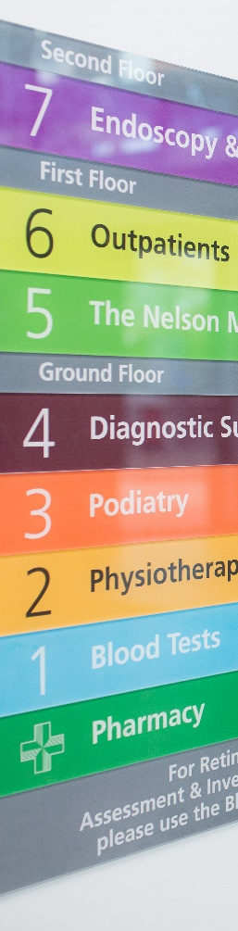
Key Findings

Waiting is worrying
- Even a short wait can be worrying – 40% of those currently waiting less than 2 months felt negatively about their wait
- After just 5 months most people (4/5) told us they felt negatively about their wait, and/or had experienced negative effects

Healthcare information and safetynetting is inconsistent
- A majority of our sample told us they had not been given information about managing their condition, or a contact in case their condition worsened
- Only one in three felt the information given by the hospital was helpful

Information about waiting status would relieve stress and worry
- Uncertainty about the length of wait is a stressor for many
- More than half said they had not received enough information about their waiting time
- 2/3 want the hospital to update them regularly on the length of their wait – nearly half would like this information monthly
- 2/3 would be happy to attend a different hospital to be seen sooner

Recommendations
Think Active Management – is the health of people on waiting lists being actively managed, or is it a hiatus in their care?
- Review processes to ensure all patients are given the information, advice, contacts and signposting they need to stay well and minimise deterioration while waiting
- Communicate with patients regularly to reduce stress, improve trust, and reduce timewasting inbound queries

The full report is available on our website https://www.healthwatchsurrey.co.uk/wp-content/uploads/2022/06/Waiting-for-hospital-care-June-2022.pdf

