


Sight on equity:

Understanding the barriers faced by black and Asian minoritised communities when accessing sight tests
  - March 2026


“I have never had my eyes tested. Sometimes everything seems blurry to me and, many times, my eyes hurt and I get headaches because of it. My eyes water a lot in the wind and sun and, in my family history, both my parents have eye problems. I had these problems in Bangladesh and have been in this country for 2 years now. I wouldn’t know how to make an appointment or how to get to an optician. I am worried about the cost also. I don’t know if I’m worried about the test itself as I don’t know what to expect.”
Woking resident, 25 year old Asian British Bangladeshi woman



If you would like a paper copy of this document or require it in an alternative format, please get in touch with us.

Contents
Foreword 3
Executive summary 5
Introduction 7
The team 8
The methodology 8
Findings 10
Not everyone is having a regular sight test 10
Motivators and barriers 11
Awareness of NHS entitlements 22
Awareness of lifestyle factors and eye health 23
The sight test experience 25
Summary and conclusion 28
Appendices 29
Summary of Recommendations 29
Acknowledgements/thank yous 32
Case studies 32
Survey data 34
Relevant research or project outputs from other sources 38
About Healthwatch Surrey 39
Contact us 39

Foreword
The Healthwatch Surrey “Sight on Equity” community engagement has been an excellent tool to gain more insight and understanding into the barriers to eye care faced by black and Asian communities within Surrey. It has been an opportunity to learn and to challenge assumptions.

It is reassuring that the vast majority of those who were surveyed said they had a positive experience when visiting an opticians for an sight test. However, there are improvements to be made with some patients feeling they still had unanswered questions regarding their eyes and vision. Communication is a key area for improvement, with some confused regarding the difference between Diabetic Retinopathy Screening and an sight test.

It is an essential principle of NHS care that patients should be able to receive their health assessments in a language they understand, this can be facilitated by an ICB funded interpreter, which can be arranged if requested prior to the appointment. The survey highlights that assumptions should never be made and optical practices should be mindful of some cultural sensitivities, where it is preferable the examining optometrist is the same gender as the patient. Equally, practices reminding patients to return for another sight examination helps to make people aware how often eyes should be examined.

For those newly resident in the UK there can be a lack of understanding how the system works and how to access care. This can be compounded further for those with language barriers.

It is of utmost importance that people are seen regularly for sight examinations, to ensure their eyes are healthy and so they can be given the most appropriate care and advice regards their sight. There is work to be done to challenge the misconception that if a person can see adequately, they do not need to attend a sight test. A sight test checks not only how well a person can see, but also how healthy their eyes are, which is especially important if there are underlying systemic conditions such as diabetes, as well as screening for eye conditions such as glaucoma.
Costs were a concern for some and optical practices clearly communicating NHS eligibility and voucher costs would help, particularly when the cost of living in the UK is much higher than in other parts of the world.

Hopefully we can all help to make access to eye care more accessible to all, by understanding the barriers that may exist for some community groups.

Jo Lindley
Chair, Surrey Local Optical Committee

Executive summary
Those of black and Asian heritage are at increased risk of developing conditions such as glaucoma and diabetic retinopathy. Despite this, engagement with preventative eye care is lower among these communities. National research suggests that eye health is often not prioritised due to a lack of cultural sensitivity and relevance.

In the course of our engagement we were also able to offer real-time advice and information on the importance of regular sight tests and to book or signpost where appropriate.

We found a lack of consistency in how often people from Surrey’s black and Asian communities have sight tests, with some not having them as regularly as recommended. There is also a reliance on opticians to instigate appointment booking.

Sight tests are usually prompted by a deterioration in vision around the age of 40; preventative eye health (and the link between sight tests, eye health and general health) was neither widely understood nor prioritised.

The cost of sight tests, as well as fear of the costs of glasses or contact lenses, was identified as the key barrier preventing people from having a sight test. We asked how aware people were of NHS entitlements and identified widespread uncertainty, with only half of surveyed participants correctly identifying eligibility criteria and focus group discussions revealing further confusion. The report concludes that improved awareness could meaningfully increase uptake.

Another significant barrier people identified was a concern about language; a particular issue for the older cohort who are reliant on family and friends to support them throughout the sight test process. Awareness of the right to a translator was low, but an appealing prospect which the research concludes would improve uptake.

For those who make the decision to have a sight test, the experience is generally positive; having translators available, flexible appointment times and more guidance and explanations would improve people’s experiences further.

The report recommendations are to providers and commissioners of eye care services. These primarily relate to education – specifically tailored to black and Asian minoritised communities – around the role of sight tests for supporting overall health, the importance of prevention, what a sight test entails, rights related to translators and eligibility for NHS entitlements.

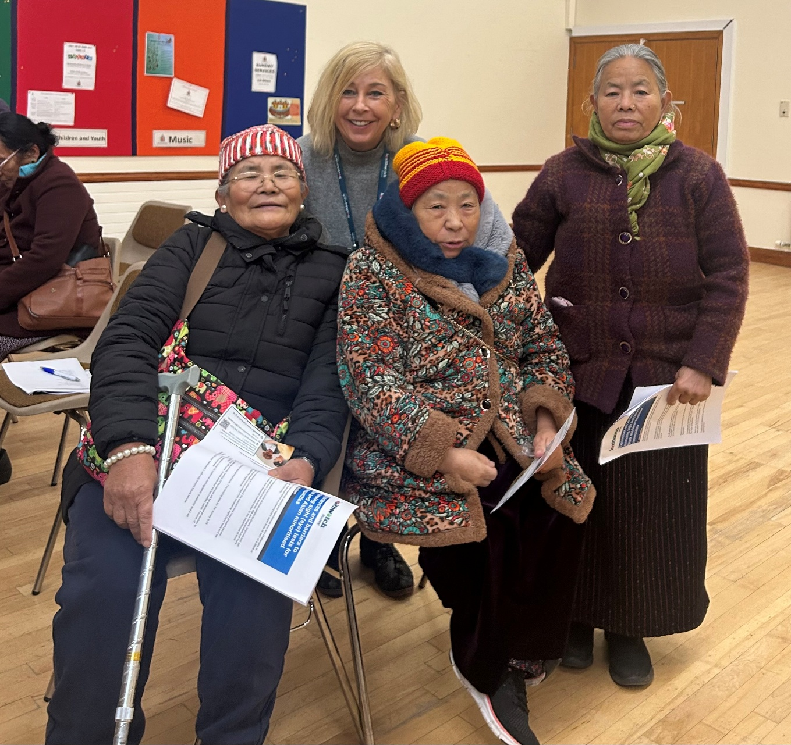

Introduction
This project (through community-based face to face engagement and a supporting survey which collectively reached over 200 people) sought to:
- Understand the level of uptake of sight tests amongst black and Asian minoritised communities
- Investigate the experiences and perceptions of eye health, routine sight tests and NHS entitlements
- Identify barriers to accessing eye care services
- Co-produce practical recommendations that address those barriers.

A note on study remit
This report is designed to highlight the themes we have been hearing about and includes quotes from local people to provide context on these themes. Whilst this report accurately reflects what we hear from the individuals we speak to, we are aware that it may not be representative of everyone’s views of a particular service. Multiple references to a specific service may be due to where our community engagement has recently taken place. Any urgent or concerning experiences within this report have been escalated to the appropriate teams. All appropriate information and signposting has already been given.

If you would like more information or examples of what people have shared, please get in touch.

The team

  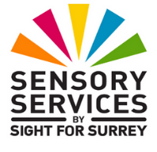   | The project was supported by a team of external stakeholders, including:  - Surrey Local Optical Committee (LOC)  - Sight for Surrey  - InHealth Surrey Diabetic Eye Screening Programme delivered on behalf of the NHSSurrey  - Minority Ethnic Forum (SMEF)  - Local opticians from Specsavers  - Surrey Heartlands ICB.
  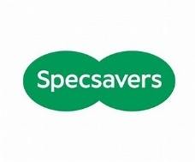 | The project team:  - Ensured clinical accuracy  - Offered cultural, language and system insight  - Attended community engagements to explain sight tests and their importance, supporting understanding across different languages and cultures.

The methodology

200+ people contributed to this research:

141 people spoke to us at in person focus groups and community engagement events (critical for building trust, overcoming language barriers and correcting misconceptions in real time). Engagement reflected the ethnic, age and geographic diversity of Surrey’s black and Asian communities, with specific sessions tailored to community identified needs. Residents who identify as Asian are the largest percentage of the non-white population and represented 7.7% of all Surrey residents in 2021. Those who identified as mixed or of multiple ethnicities represented 3.4% of the overall Surrey population and residents who identified as Black represented 1.7% according to Surrey-i data.

This map shows that most respondents were residents of Woking, with the darker areas showing higher areas of respondents.

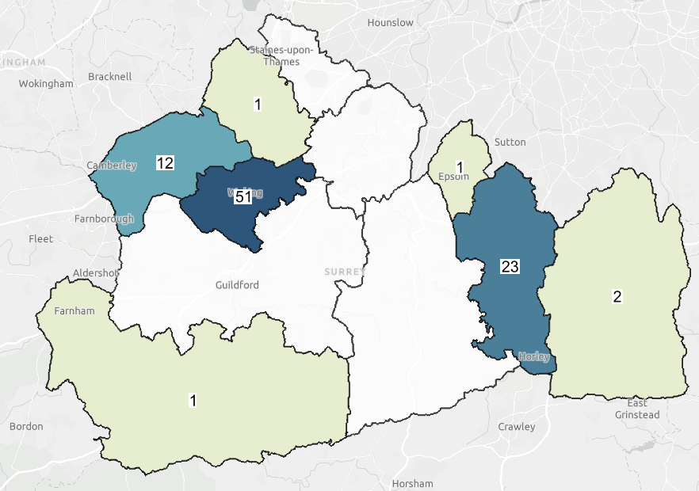


  - surveys completed.

At each engagement event we provided information on the importance of regular sight tests and what to expect and offered to book appointments at local high street opticians. 19 people booked routine sight test appointments. 6 signposting referrals were made to specialist services in the course of the project. Almost a third (29%) of people who completed our survey said that they would go for a sight test as a result of taking part, though some community leaders predicted the actual number to be higher.

Findings

Not everyone is having a regular sight test

There are clear differences in how often people from Surrey’s black and Asian communities have sight tests, with some not having them as regularly as recommended. There is also a reliance on opticians to instigate appointment booking, with people waiting to be invited for a first or follow-up appointment.

Approximately half of those we spoke to at our focus groups had had a sight test, falling to a third when looking at the Nepali community specifically. Most used a high street optician though some had had sight tests in their home country before coming to live in the UK.

How regularly do people have sight tests?
The NHS recommends that people have sight tests every two years, and eight of ten people surveyed told us they had them as regularly as this. However, we also heard that people would only continue to attend if they were reminded to by the optician:

“I’m not sure how regularly I go; I go when they tell me.”
Woking resident, 80 – 89 year old Asian British man

(See the Survey data section for how regularly people have their sight tested).

Motivators and barriers

Though many people had had a sight test within the last two years this was usually prompted by deteriorating vision. Some didn’t start testing until around age 40; preventative eye health (and the link between sight tests, eye health and general health) was neither widely understood nor prioritised, with cost and language acting as key barriers.

Sight tests seen as reactive not preventative

Almost two thirds (65%) of those surveyed who had had their sight tested indicated that they were primarily concerned with checking their vision, suggesting that their main concern was their ability to see, rather than the possibility of picking up eye or general health conditions. Similarly, amongst those who hadn’t had their sight tested, 1 in 6 surveyed said they didn’t see the need; as long as they were able to read they had little motivation to get a test.

“I am only really concerned about being able to read so would only go if I can't see the letters properly.”
Woking resident, 24 – 49 year old Asian British Pakistani woman

For the same reason, many were choosing not to return for checks to monitor their sight if they felt that their vision and general health were stable.

“I’d go again If my vision got worse, but it's been good for the last six years but it may deteriorate as I get older.”
Reigate & Banstead resident, 65 – 79 year old, Black British Caribbean man

Some people weren’t aware of the importance of regular checks to confirm their prescription hadn’t changed.

“The women I spoke to told me that they didn’t know that they needed to get their eyes re-tested as their prescription might change. They thought that once they had glasses or contact lenses, they wouldn’t need to change them or have new ones.”
Sana Sahid, SMEF (at Shifa Engagement, Sheerwater)

Other reasons for getting a sight test included watery, blurry and painful eyes and getting headaches/migraines, though reasons other than sight were only given by 12% of respondents.

(See the Survey data section for the reasons why people have their sight tested and the reasons why they don’t or haven’t done so recently).

Sight tests associated with age related degeneration, not prevention
Approximately 5 in 10 people surveyed did not start having their sight tested until after the age of 36; 3 in 10 people did not start having their sight tested until after the age of 46.

Preventative eye health was neither widely understood nor prioritised. This finding is also supported by an optician from the Asian British community and community leader from the Nepali community.

“People won’t think of coming to get their eyes tested before the age of 40. They come when their vision starts deteriorating. They won’t bring their kids either unless something has been picked up by school or they know there is a problem with their sight. They will go straight to the GP for everything, including sight, and don’t realise they can go straight to an optician.”
Woking based optician, Asian British Pakistani (at Shifa engagement, Sheerwater)
Read the full interview in Case study 1

“They wouldn’t have had their eyes tested as children. They won’t go for preventative checks. They will only go if something is wrong with their vision.”
Camberley resident, Nepali community leader (at Nepali community engagement, Camberley)
Read the full interview in Case study 2

(See the Survey data section for the age people had their sight tested for the first time).

Recommendations
Providers and commissioners to design new, or improve existing, information on the importance of routine sight tests as a preventative measure to encourage uptake. If possible, co-produce with target communities and collaborate with VCSE organisations with co production expertise (Healthwatch Surrey can advise).

Encourage members of these communities to take their children from an early age (the only school sight test takes place when a child starts school and there are none thereafter), and every two years or as directed by the optician or health care professional.

Consider the co-production of an illustrative guide for people, outlining the care pathway for different eye conditions and including signposting information for specialist eye care services.

Lack of awareness of the link between sight tests, eye health and general health

There was some evidence to suggest that people are aware of eye conditions related to diabetes, as they know of family members who have been diagnosed.

However, less than half (43%) of people believed that having a sight test is important for general good health. 40% said they know that sight tests can detect eye conditions but only 37% that they know that sight tests can detect other health conditions.

“I'm glad I went. I didn't have any symptoms but thought I should still go. I had the puff on my eye and they looked at the back of my eye. My eyes have improved over time. I think a lot of people don't go because they don't have any symptoms but you don't have to have any for some conditions and things may get missed if you don't.”
Woking resident, 25 – 49 year old Asian British Pakistani woman

There was also evidence that people believed that diabetes was “inevitable” based on their family history.

“I spoke to a young woman this morning who told me that both her parents were diabetic and, as such, she would get diabetes and there is nothing she could do about it. She told me she has accepted her fate.”
Simona Origgi, Diabetic Eye Screening Programme Engagement Officer (at Asians Women’s Hub engagement, Redhill)

What a sight test is for
We asked people if they understood what a routine sight test is looking for; approximately half of the 87 respondents surveyed did, 1 in 4 didn’t and 1 in 6 were “unsure”. Those that commented “yes” were generally correct.

“Certain eye conditions. I'm not sure which ones.”
Woking resident, 50 –64 year old Asian British Pakistani woman

“To help for my eyesight to improve – the belief that it can be improved rather than slow deterioration.”
Runnymede resident, 50 – 64 year old Asian British Bangladeshi woman

The impact of increased knowledge

When we explained what opticians are looking for, 1 in 6 participants said it would make a difference to them having a sight test.

“I find it reassuring that other conditions can be picked up, ones that you wouldn't even know about.”
Woking resident, 50 – 65 year old woman, mixed/multiple ethnicity

Some commented that having the sight test procedure explained to them would encourage them to book an appointment.

Cost – a significant barrier for many

The cost of the test deterred many people, even when they believed one might be needed. This was true across both the cohort of people who had had a sight test and those who hadn’t.

“Cost would put me off going to get my eyes tested if there hasn't been any change to my eyes. I wouldn't go for routine tests just in case because I wouldn't want to spend the money on tests when I have other things I need to spend it on.”
Woking resident, 25 – 49 year old Asian British Pakistani woman

This was compounded for people on low incomes or on visas with no access to public resources.

“I am currently on a visa which has no recourse to public funds so I cannot get a sight test for free and I can't afford to pay for one.”
Reigate & Banstead resident, 25 – 49 year old Black British African woman

Some people told us that reducing the cost of the sight test would encourage them to have one.

Fear of cost if there’s a problem
For many it was not only the cost of the test itself, but the potential costs of glasses or contact lenses if a problem was found which was the main barrier.

“Cost is an issue – I would put food first. I made a decision not to have glasses as I can still see without them. I need them to read and I am a teacher so I need them for my job so I have to pay for them. I use a magnifying glass instead when I need to zoom in to see things.”
Woking resident, Asian British Pakistani woman

“Cost is an issue, particularly if your sight changes rapidly. I have to buy new glasses frequently because I need different lenses as my sight changes. It's a lot. It's too much.”
Woking resident, 80 – 89 year old Asian British Pakistani

Some people told us that they would wait to give their optical prescription to friends or family members travelling to their “home country”, where they could buy the prescription for significantly less cost than in the UK.

“Cost is the biggest issue. It’s cheaper for them to get glasses back home. A member of my family got his for £50 which would have cost £250 here. But this is not an option for everyone. People don’t like the upselling, but high street opticians must do this to stay in business.”
Woking based optician, Asian British Pakistani (at Shifa engagement, Sheerwater)

Distrust of the commercial nature of opticians
People were wary of the commercial nature of opticians and the potential for upselling. This issue was uncovered as a concern for the wider population of Surrey in our A strain on sight report about waits for specialist eye care in March 2025. Worry over upselling, in turn, created a sense of distrust, compounding people’s reliance on their GP as a trusted health care professional for all health conditions including eye health.

“I can see why people are cautious about the commercial nature of opticians. I see people who have been sold glasses when the really shouldn’t have been because they are suffering from a rapidly deteriorating eye condition.”
Justine Jasper, Sight for Surrey (at Shah Jahan Mosque engagement, Woking)

“When you are given a prescription for your glasses, they then add things to them which adds to the cost. I was prescribed varifocals and opted for the cheapest version and then if you want extra things like anti-glare and blue light, it all adds up and it gets expensive.”
Woking resident, 50 – 64 year old Asian British Pakistani woman

Recommendations
Providers and commissioners to explore how best to provide information to black and Asian minoritised communities on the role of the optician and the wider healthcare landscape, looking in particular at their professional expertise vs the GP. Consider working with an independent VCSE organisation specialising in community engagement to listen to the views of residents.

The impact of a language barrier

People shared concerns about language in relation to sight tests with 1 in 9 survey respondents mentioning this as a reason why they had not had their sight tested. This was a particular issue for the older cohort who might be reliant on family and friends to support them throughout the sight test process. People were not aware that they could request a free translator, but some commented that this would encourage them to attend.

“My eye sight hasn’t deteriorated but mum’s has and she would worry about language.”
Woking resident, 25 – 49 year old Asian British Pakistani

“I could read the English alphabet but would not be able to understand instructions or explanations about my eyes or what the test has shown but I would have my children with me to translate.“
Redhill resident, Asian British Pakistani (Asian Well woman’s hub, Redhill)

“Young people will only help as translators at the opticians in an emergency; they are busy working three jobs to earn enough money to support themselves and their families. “
Camberley resident, Nepali community leader

“I think a free translator would be a good idea. Many in my community, the older ones especially, can't speak English.”
Woking resident, 50 – 64 year old Asian British Pakistani woman

The Nepali community
The majority of people we spoke to do not read Nepalese or English, having had no formal education in Nepal. They rely on verbal communication through family and friends who can translate. However, family and friends may not always be available and the individual concerned may not want them at the sight test due to the confidential nature of the test. It is also widely accepted that this is not best practice in the NHS due to safeguarding concerns. The chair of the Surrey LOC attended our focus group with this community and commented:

“The engagement was invaluable to understand that, within this group, verbal communication is the primary communication method and that this is predominantly in Nepalese. Translating written information in to Nepalese was not considered to be worthwhile due to low literacy levels. There was a strong sense of community and a real need for it, as support to understand what to do and how to do it, comes from community members who can translate and explain the process, whether this is arranging an appointment or getting on a bus.

Language really is the barrier for this group; there was interest in third party translators to attend NHS appointments. Whilst family members may be willing, they may not translate all that has been said and patients may wish to have a higher level of privacy when attending medical appointments.

Understanding the needs of this particular community group will really assist in providing support in a way that is most effective and help to break down barriers to health care.”
Jo Lindley, Chair of Surrey LOC

Getting to an optician was seen as an issue by some of this community.

“[One of] the main barriers for them will be…and how to get to the optician.”
Nepali community leader

Recommendations
Ensure that people are told about their right to request translations services to support them during their sight test. Ensure opticians promote this service to relevant customers. See the NHS England » Improvement framework: community language translation and interpreting services.

People don’t always understand the appointment booking process
1 in 14 survey respondents who haven’t had a sight test said that not knowing how to make an appointment was a barrier to getting their sight tested.

“I'm new to the country - I don't know the process.”
Woking resident, woman

“This community have only been in this country for 10 years. They are still learning how the whole system works. When I first started this group, I had to tell them how to catch a bus (there are few buses in rural Nepal), cross the road (there is little traffic in rural Nepal) and not to litter in the way they do at home. I encourage them but a lot of it doesn’t stick. [One of] the main barriers for them will be not knowing how to make an appointment; they wouldn’t even know how to approach the shop.“
Camberley resident, Nepali community leader (at Nepali community engagement, Camberley)

Some people expressed a desire for more control over appointment times to suit them (particularly after school times). This may support those who cited lack of time as a barrier.

“The biggest barrier for me is time constraints as I find it difficult to make the time to go regularly. I worry about my eyes because I am on my computer most of the time due to my job which can have an effect on eyes, weight, and my back but I can’t commit to getting regular eye tests as it depends on my work.”
Redhill resident, 49 year old Kashmiri woman (Asian Women’s Hub, Redhill)

Recommendations
Ensure opticians understand the importance of flagging follow up appointments for people and that they provide multi-channel methods of communication for their customers.

Opticians should consider “outreach” clinics, supported by language translators, for people from black and Asian communities, to negate the need to make an appointment. Consider optician training on communicating with specific groups.

Language translation, cultural awareness and reasonable adjustments not being met

Most people we spoke to didn’t know that they could ask for language, cultural or reasonable adjustments to enable them to access a sight test (of those that did and had requested them, only 40% of those surveyed said they were completely met). Although the main request was for language translation and that an interpreter be made available for people whose first language isn’t English, people did talk about other cultural and reasonable adjustments required. For example, although for most we spoke to the gender of the optician was not a concern as they were viewed as a professional, a small number of people did note that only a female should touch another female’s head in certain cultures.

We gave people the opportunity to tell us if there were any other reasons why they didn’t go for sight tests. We were told that some people may struggle with the close proximity of the optician, particularly if they suffer from anxiety or past trauma which could be triggered.

“People who have experienced PTSD would struggle with the test. I think optician should ask, “Do you suffer from mental health problems; how to you feel about being in close proximity with an optometrist?” I believe that Specsavers currently ask that.”
Redhill resident, 49 year old Asian British Kashmiri woman (at Asian Women’s Hub, Redhill)

“I’m less likely to have it. I don't want people touching my eyes.”
Out of Surrey area, 16 – 17 year old Asian British woman

Recommendations
Encourage and support opticians to make reasonable adjustments to support their customers. See NHS guidance on making reasonable adjustmentshttps://www.england.nhs.uk/learning-disabilities/improving-health/reasonable-adjustments/ or the NHS language framework.

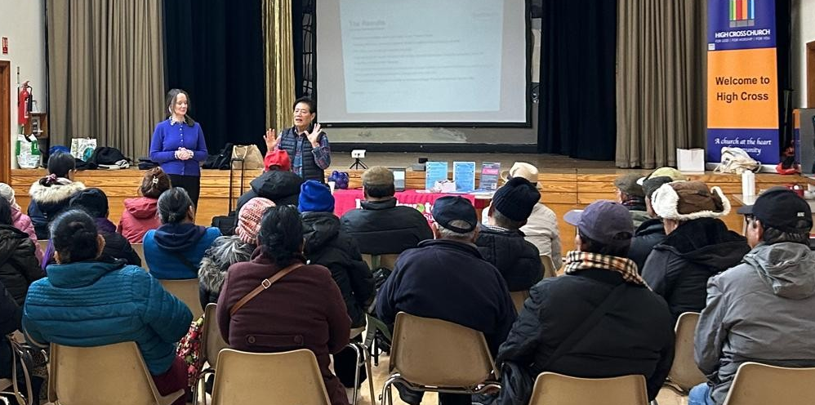

Awareness of NHS entitlements

With cost identified as a key barrier we asked about people’s awareness of NHS entitlements and identified widespread uncertainty, with only half of surveyed participants correctly identifying eligibility. Although some people understood the criteria, others held misconceptions and focus group discussions revealed further confusion. When asked whether clearer understanding of eligibility would influence their decision to have a sight test, half of respondents said that it would, indicating that improved awareness could meaningfully increase uptake.

We asked people via our survey if they knew who was entitled to a free sight test; approximately half said they did and a further third said they didn’t, leaving a fifth of people who were “unsure”. Those who said they knew the criteria for NHS entitlements were generally correct, although some thought that those with migraines would be entitled to free sight tests and people who have a very high prescription would be entitled to optical vouchers. There was noticeable confusion amongst our focus group attendees as well.

“I know what the criteria is but only because I work for a dentist. I don’t think many people in my community would know.”
Redhill resident, Asian British Pakistani (Asian Women’s Hub, Redhill)

The impact of improved understanding
We asked if knowing who would be entitled to free sight tests and optical vouchers would make a difference to people attending. Half of the 83 people who responded to this question agreed that it would.

Recommendations
Improve information about eligibility for free NHS sight tests and optical vouchers and signpost to organisations such as Citizen’s Advice for information on benefits. Ensure opticians promote these entitlements to their customers and potential customers. Consider working with an independent VCSE organisation with expertise in appropriate signposting to different community groups (Healthwatch Surrey can advise).

Awareness of lifestyle factors and eye health

Around half of participants said they understood how lifestyle choices affect eye health, but further discussion revealed considerable misunderstanding. When asked whether increased understanding would influence future lifestyle choices, only around half said it would, highlighting the need for clearer information within black and Asian minoritised communities about how healthy lifestyle habits can help protect eye health.

When we probed, the people we spoke to at our focus groups showed some confusion about how lifestyle choices affect eye health.

“My wife's sister was diabetic - I didn't realise it could affect your eyesight.“
Woking resident, 80 –89 year old Asian British man

“I didn't know that these things [diet, alcohol, smoking, etc] would affect my eyesight.”
Woking resident, 25 – 49 year old Asian British woman

“I am Muslim, so we don't smoke or drink but many in our community do have diabetes.”
Woking resident, 80 –89 year old Asian British woman

The impact of improved understanding

When we discussed the impact of lifestyle choices on eye health and asked if this would make a difference to their lifestyle choices going forward, approximately half of those we spoke to said yes.

“I didn’t know what the optician is checking for and this would not make a difference to me going. I would only go if couldn’t see.”
Woking resident, 40 – 65 year old Asian British Pakistani woman (at Angelic engagement, Woking).
Recommendations
Providers and commissioners to consider the provision of information on the importance of making healthy lifestyle choices for eye health to help to reduce health inequalities amongst these communities.

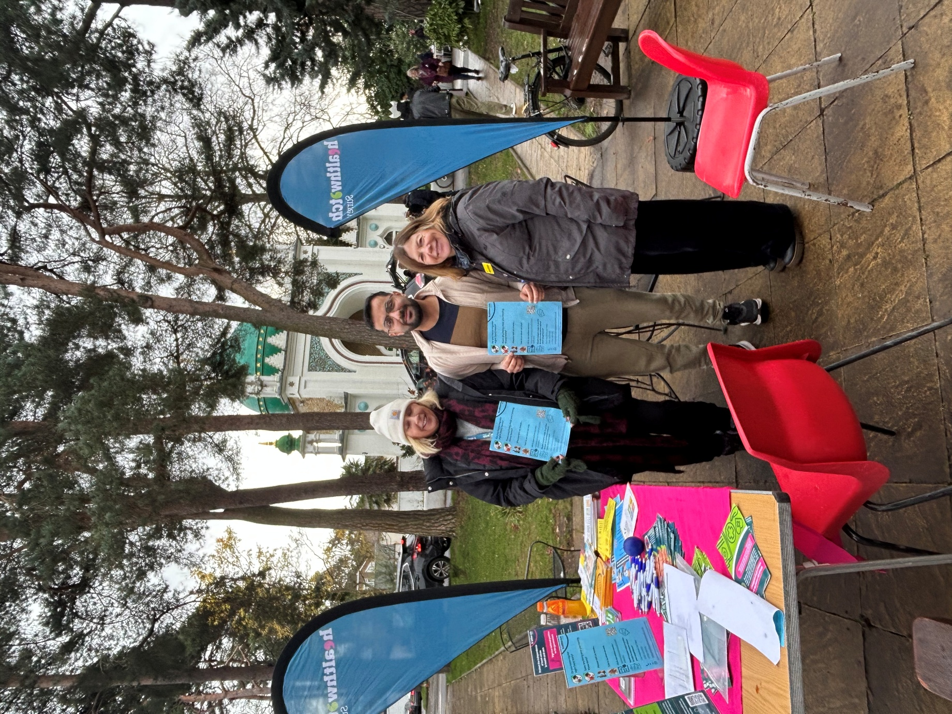

The sight test experience

For those who make the decision to have a sight test, the experience is generally positive; however, having translators available, flexible appointment times and more guidance and explanation would improve it.

Praise for opticians
88% of people surveyed were satisfied with their sight test experience. People complimented how well the optician explained the sight test process and put them at ease. People also reported a calm and professional approach and appropriate referrals to specialist services where necessary.

“They explain what they are doing and why. This puts me at my ease.”
Woking resident, 50 – 64 year old Asian British Pakistani woman

“It was all very straightforward and everything was explained to me, so I knew what was going to happen and what they were testing for.”
Woking resident, 50 – 64 year old woman from mixed/multiple ethnic group background

“This [what they are looking for] was all explained to me at the appointment – opticians are doing their job!”
Woking resident, 80 – 89 year old Asian British Pakistani woman

Reasons for dissatisfaction and areas for improvement
As well as issues related to cost and language (specifically people being reliant on a time when relatives could be present), people talked about the following:

- Lack of guidance or explanation of their eye condition – test results need to be fully explained
- Insufficient time spent assessing their sight
- Glasses prescribed being uncomfortable.

“My condition with my sight is that sometimes it’s normal and sometimes my vision gets blurry and I didn't get a satisfactory guidance for that.”
Woking resident, 50 – 64 year old Asian British Pakistani woman

“Someone told me that she went to the opticians and was given glasses that don’t work for her so she hasn’t bothered to ever go back. I explained to her that it takes time to get used to new glasses and she should wear them for at least two weeks before deciding if they are working or not. People need time at their appointment to ask questions and for things like this to be explained. The brain needs time to catch up with new glasses or contact lenses.”
Simona Origgi, Diabetic Eye Screening Programme Engagement Officer (at Shifa engagement, Sheerwater)

People told us that a more flexible appointment booking system, where online booking is promoted and people are given the flexibility to choose appointment times that are convenient for them, would improve their experience. A reduction in waiting time before the sight test commences would also help.

“My results for the eye test came in 2 weeks but I was not given any instructions to action further.”
Woking resident, 50 – 64 year old Asian British Pakistani woman

“More information about booking online, I didn't know you could so I rang up.”
Woking resident, 25 – 49 year old Asian British Pakistani woman

“Ask what appointment times would be suitable instead of telling you when you can have one.”
Woking resident, 80 – 89 year old Asian British Pakistani woman

“The appointments given for children should be after school or at the weekends. They should be given priority for these appointments. I don't want to take them out of school for an eye test.”
Woking resident, 25 – 49 year old Asian British Pakistani woman

Recommendations
Opticians allow sufficient time to fully explain the sight test process before each appointment and ensure customers have the time and means to ask questions during and after an appointment.

Ensure best practice is shared between opticians, possibly utilising community leaders to share cultural insight where possible.

Encourage opticians to prioritise appointment times after school for people with school aged children.

Summary and conclusion
Inconsistency prevails in terms of Surrey’s black and Asian communities and sight tests, both in terms of who is having them and how regularly. Across the board a lack of appreciation of the importance of preventative healthcare and the significance of eye health for general health means that the impetus for sight tests can be lacking. This is compounded by financial constraints and a lack of awareness of financial support, as well as some accessibility issues related to language.

This study concludes that more information is needed on the role of sight tests for supporting overall health, the importance of prevention, what a sight test entails, rights related to translators and eligibility for NHS entitlements. Commissioners and providers should look to make this information specifically targeted to individual communities to ensure maximum impact, co designing with community members where possible.

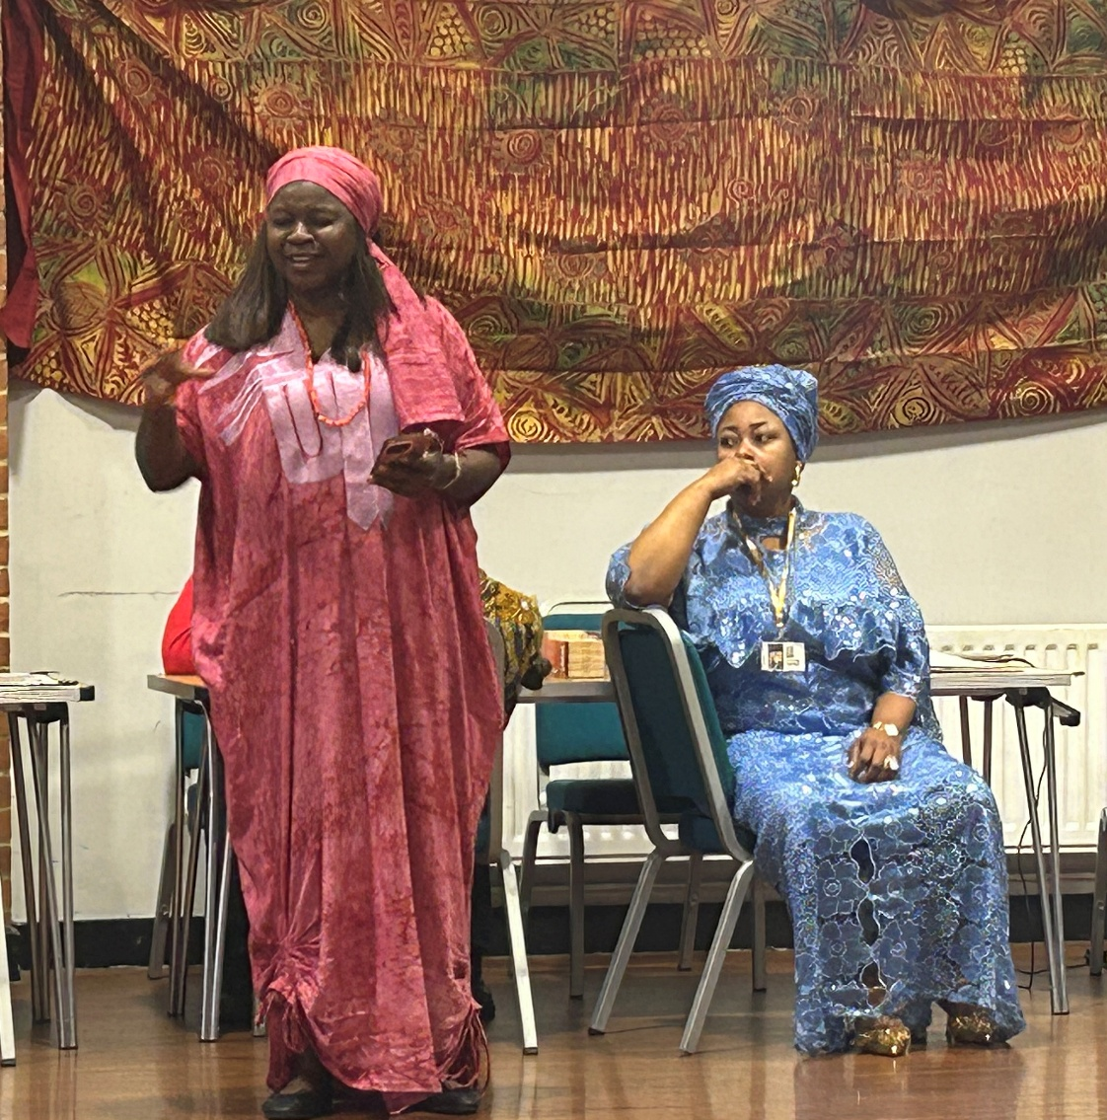

Appendices

Summary of recommendations

Motivators and barriers to having sight tests: | Recommendations:
- Many people had had a sight test within the last two years and this was usually prompted by deteriorating vision.  - Some didn’t start testing until around age 40 when eye sight typically starts to deteriorate.  - Preventative eye health was neither widely understood nor prioritised.  - Cost and language barriers are key deterrents. | - Providers and commissioners to design new, or improve existing, information on the importance of routine sight tests as a preventative measure to encourage uptake. If possible, co-produce with target communities and collaborate with VCSE organisations with co production expertise (Healthwatch Surrey can advise).  - Encourage members of these communities to take their children from an early age (the only school sight test takes place when a child starts school and there are none thereafter), every two years or as directed by the optician or health care professional.  - Consider the co-production of an illustrative guide for people, outlining the care pathway for different eye conditions and including signposting information for specialist eye care services.  - Providers and commissioners to explore how best to provide information to black and Asian minoritised communities on the role of the optician and the wider healthcare landscape, looking in particular at their professional expertise vs the GP. Consider working with an independent VCSE organisation specialising in community engagement to listen to the views of residents.  - Ensure that people are told about their right to request translations services to support them during their sight test. Ensure opticians promote this service to relevant customers. See the NHS England » Improvement framework: community language translation and interpreting services.  - Encourage and support opticians to make reasonable adjustments to support their customers. See guidance on making reasonable adjustments. See guidance on making reasonable adjustments https://www.england.nhs.uk/learning-disabilities/improving-health/reasonable-adjustments/ or the NHS language framework  - Ensure opticians understand the importance of flagging follow up appointments for people and that they provide multi-channel methods of communication for their customers.  - Opticians should consider “outreach” clinics, supported by language translators, for people from Black and Asian communities, to negate the need to make an appointment. Consider optician training on communicating with specific groups.

Awareness of NHS entitlements:
- Only half of surveyed participants correctly identified eligibility  - Half said that, now they understood the criteria, it would make a difference to them attending. | - Improve information about eligibility for free NHS sight tests and optical vouchers and signpost to organisations such as Citizen’s Advice for information on benefits. Ensure opticians promote these entitlements to their customers and potential customers. Consider working with an independent VCSE organisation with expertise in appropriate signposting to different community groups (Healthwatch Surrey can advise).

Awareness of lifestyle factors and eye health:
- Around half of participants said they understood how lifestyle choices affect eye health.  - Only half said that understanding this impact would make a difference to them changes their life style choices. | - Providers and commissioners to consider the provision of information on the importance of making healthy lifestyle choices for eye health to help to reduce health inequalities amongst these communities.
The sight test experience:
- The sight test experience is generally positive.  - Having translators available, flexible appointment times and more guidance and explanation would improve it however. | - Opticians allow sufficient time to fully explain the sight test process before each appointment and ensure customers have the time and means to ask questions during and after an appointment.  - Ensure best practice is shared between opticians, possibly utilising community leaders to share cultural insight where possible.  - Encourage opticians to prioritise appointment times after school for people with school aged children.

Acknowledgements/thank yous

Project team
- Jo Lindley, Chair, Surrey LOC
- Justine Jasper, Sight for Surrey
- Simona Origgi, Surrey Diabetic Eye Screening Programme Engagement Officer
- Sana Shahid, Surrey Minorities Ethnic Forum (SMEF)
- Bryony Allen, Surrey LOC and Optician, Specsavers
- Shelley Eugene, Surrey Heartlands ICB.

Stakeholder organisations
- Angelic Network, Woking
- Africa Community in Surrey & Sussex (ACISS)
- Asian Women’s Hub, Redhill
- Nepali Community, High Cross Church, Camberley
- North East Surrey College of Technology
- Shifa Network, Sheerwater
- Shah Jahan Mosque, Woking.

Case studies

Case study 1

Interview with British Asian Optician, Shifa Event 24.11.2025

Locum optician works for Boots in Woking and Guildford (and previously Specsavers).

Most women will come with a family member to act as an interpreter.
Cost is the biggest issues. It’s cheaper for them to get glasses back home. A member of my family got his for £50 which would have cost £250 here. But this is not an option for everyone. People don’t like the upselling, but high street opticians must do this to stay in business.

People won’t think of coming to get their eyes tested before the age of 40. They come when their vision starts deteriorating. They won’t bring their kids either, unless something has been picked up by school, or they know there is a problem with their sight. They will go straight to the GP for everything, including sight, and don’t realise they can go straight to an optician.

I don’t think gender or language are issues. There is now a large availability of opticians from various ethnicities so there is always someone appropriate to see.

Case study 2

Interview with Nepali community leader (volunteer), Nepali Event 20.11.2025
Young people will only help (as translators at the opticians) in an emergency; they are busy working three jobs to earn enough money to support themselves and their families.

50% of the community are diabetic or borderline diabetic. They will go to have a diabetic eye screening test now that they know that it’s free. Approximately a third of the population have had a sight test. In Nepal, no one will have had their sight tested as it’s completely private and most people can’t afford it. They wouldn’t have had their sight tested as children. They won’t go for preventative checks. They will only go if something is wrong with their vision.

This community have only been in this country for 10 years. They are still learning how the whole system works. When I first started this group, I had to tell them how to catch a bus (there are no buses in Nepal), cross the road (there is no traffic in Nepal) and not to litter in the way they do at home. I encourage them but a lot of it doesn’t stick. They don’t want to be a nuisance or to be people that live off the state. The main barriers for them will be not knowing how to make an appointment (they wouldn’t even know how to approach the shop), how to get to the opticians and being worried about the cost of the sight test in addition to not speaking the language. It wouldn’t be helpful to have information translated. Most are illiterate I can’t read their own language or English.

Survey data

Please tell us why you don't have sight tests or haven't had a sight test recently.
Reason | Number
None apply | 15
I am worried about the cost of the sight test (and subsequent cost of glasses or contact lenses to remedy my sight if necessary) | 14
I don't see the need to get my sight (eyes) tested | 11
I am concerned that I will have difficulty completing the test because English isn't my first language | 8
I don't know how to make an appointment | 5
I can't get to an opticians | 5
Other | 5
I am concerned about the gender of the optician | 4
I am concerned about the technology used in the test | 2
I am worried about what the test might tell me (e.g. that I am no longer able to drive) | 1

Demographics
Ethnicity
Reason | Number
Asian/Asian British: Pakistani | 50
Asian/Asian British: Any other Asian/Asian British background | 24
Black/Black British: African | 16
Asian/Asian British: Bangladeshi | 4
Asian/Asian British: Indian | 4
Black/Black British: Any other Black/Black British background | 3
Black/Black British: Caribbean | 2
Mixed/multiple ethnic groups: Asian and White | 2
Other (Not specified) | 2
Arab | 1
Asian/Asian British: Chinese | 1
Mixed/multiple ethnic groups: Black African and White | 1
Mixed/multiple ethnic groups: Any other Mixed/Multiple ethnic group background | 1
White: British/English/Northern Irish/Scottish/Welsh | 1
White: Irish | 1
White: Any other White background | 1
Prefer not to say | 1
Mixed/multiple ethnic groups: Black Caribbean and White | 0
Gypsy, Traveller or Irish Traveller | 0
Roma | 0

Relevant research or project outputs from other sources
- The Frontiers in Public Health research February 2023
- Healthwatch Dudley report March 2016
- Healthwatch Surrey report, "A strain on sight: waiting for NHS specialist eye care", March 2025
- Glaucoma - NHS (www.nhs.uk)
- Diabetic retinopathy - NHS (www.nhs.uk) = NHS England).
- A rapid review of evidence relating to service use, experiences, and support needs of adults from minority ethnic communities along the eyecare pathway in the United Kingdom”

About Healthwatch Surrey
Healthwatch Surrey champions the voice of local people to shape, improve and get the best from NHS, health and social care services. We are independent and have statutory powers to make sure decision makers listen to the experiences of local people.

We passionately believe that listening and responding to local people's experiences is vital to create health and social care services that meet the needs of people in Surrey. We seek out people’s experiences of health and care services, particularly from people whose voices are seldom heard, who might be at risk of health inequalities and whose needs are not met by current services. We share our findings publicly and with service providers and commissioners to influence and challenge current provision and future plans.

We also provide reliable and trustworthy information and signposting about local health and social care services to help people get the support they need.

Contact us
Website: www.healthwatchsurrey.co.uk
Phone: 0303 303 0023
Text/SMS: 07592 787533
WhatsApp: 07592 787533
Email: enquiries@healthwatchsurrey.co.uk
Address: Freepost RSYX-ETRE-CXBY, Healthwatch Surrey, Astolat, Coniers Way, Burpham, Guildford, Surrey, GU4 7HL.
 healthwatchsurrey
 healthwatch_surrey
 Healthwatch Surrey


We are committed to the quality of our information.
Every three years we perform an audit so that we can be certain of this.


We are proud to have signed up to the End Poverty Pledge - End Poverty Surrey – Good Company.


The Healthwatch Surrey service is run by Luminus Insight CIC, known as Luminus. We are a Surrey based, independent, community interest company which exists to empower people to have their voices heard. We help organisations provide equity of access and the best services possible, through the inclusive involvement of local people.

Registered office: GF21, Astolat, Coniers Way, Burpham, Surrey, GU4 7HL.

