Healthwatch Surrey logo

**Quarterly Impact Report**

April – June 2024

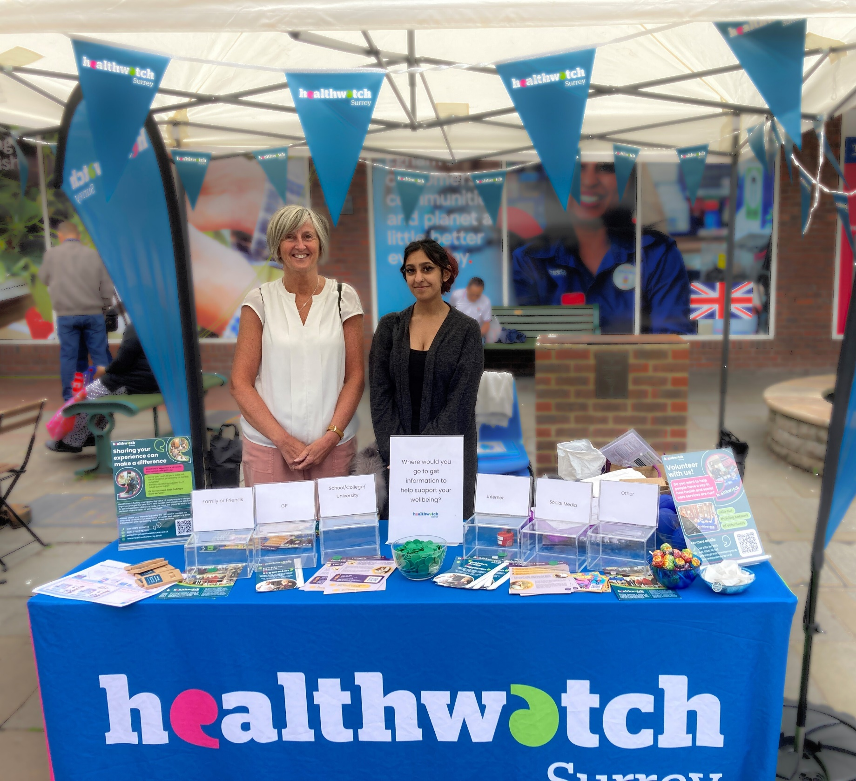

Contents

This quarter in numbers 3

Information and signposting 4

Supporting residents through our Helpdesk 5

Supporting residents in the community 6

Advocacy & complaints 7

Delivering on our thematic priorities 8

Access to Primary Care 9

Improving information on complaints procedures 10

Making a difference at a system level 11

Ensuring the voices of those in Guildford and Waverley are heard 11

Improving communication to those awaiting a neurodevelopment review 14

Helping to shape quality appraisals 15

Involving local people in health and social care 16

Ensuring Quality Accounts meet the needs of those they’re written for 17

Helping men to open up about their health 18

Empowering our volunteers to make a difference in their community 18

Healthwatch Surrey – Contact us 19

If you would like a paper copy of this document or require it in an alternative format, please get in touch with us.

# This quarter in numbers

|  |  |
| --- | --- |
| **Icon of a telephone.** | **74** People supported through our Helpdesk |
| **Icon of a person holding up a sign** | 30 **People supported by our Independent Health Complaints Advocacy service** |
| **Icon of people gathered together and talking** | **16 Community engagement events** |
| **Icon of a group of people** | **124 People helped and supported whilst on engagement in the community** |
| **Icon of a report** | **5 Reports published\*** |
|  | **374 Hours provided by our volunteers** |

* Both local elections and a general election campaign took place in this quarter, during which time we were unable to publish any reports on our website.

# Information and signposting

Healthwatch Surrey offer information and signposting – via our Helpdesk or during engagement in the community - to support people to navigate health and care services across Surrey. We help people to identify the services and support they need and provide advice about what to do when things go wrong. Through our relationships with system partners we can also escalate concerns, providing resolutions to individuals and ensuring an improved experience for others.

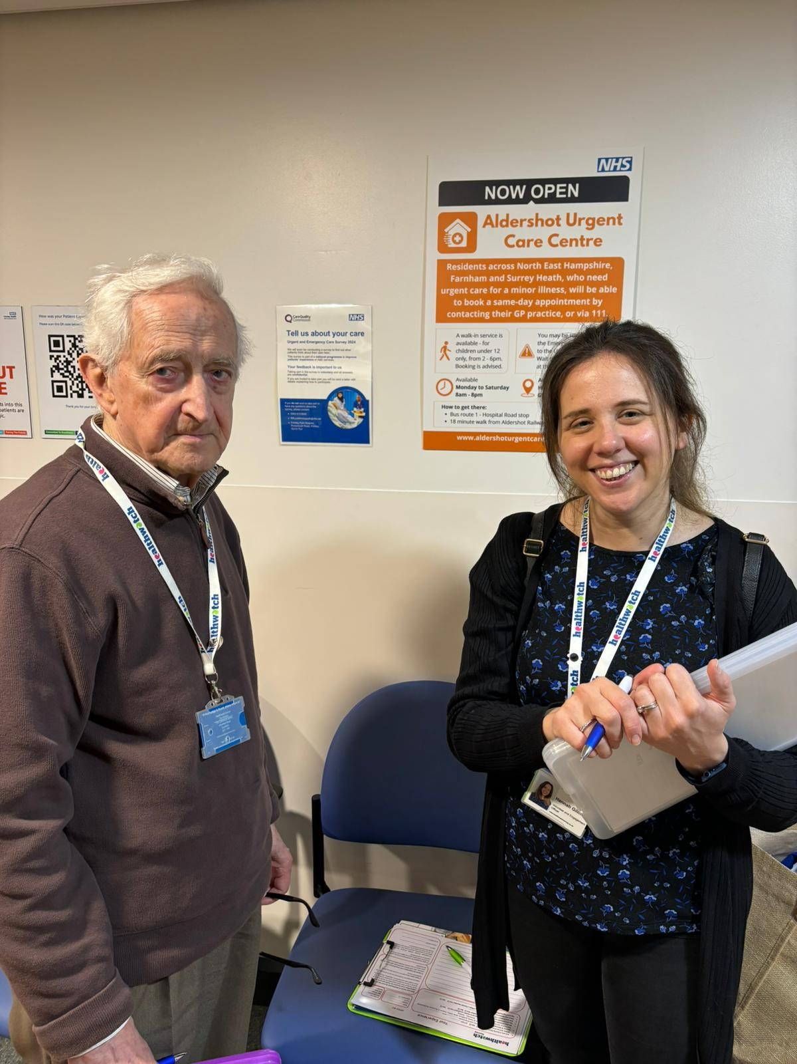

## Supporting residents through our Helpdesk

We helped **74** people navigate health and social care services through calls and e-mails to our [Helpdesk](https://www.healthwatchsurrey.co.uk/contact/) and enquiries received via our website.

“Thank you, really, for speaking to me. It’s nice to feel like people still care about me while I try and get this sorted.”

Helpdesk user

“You have been fantastic, I don't feel as alone in this process now I have spoken to you.”

Helpdesk user

#### ****Case study: Tim’s* Experience****

Tim*, who has a hearing impairment, emailed the Helpdesk following a distressing experience at his local pharmacy. Staff at the pharmacy told him they didn’t have a hearing loop - despite an 'Ask staff for the Loop’ sign and one person claimed to not even know what a hearing loop was.

We contacted the CEO of Community Pharmacy Surrey and Sussex who was able to speak to the pharmacy directly, to secure valuable information to support Tim and to instigate some changes in the pharmacy to help future users.

**Outcome for Tim**

Tim was provided with clear information on the availability and location of the hearing loop, so he felt confident returning to the store to collect his medication.

**Improvement for others**

Information on the hearing loop was made more visible and the store team were reminded how to use it and how to guide customers appropriately, ensuring other people wouldn’t have the same experience as Tim.

* Names have been changed.

## Supporting residents in the community

We visited **16** venues across surrey and offered support to **111** people.

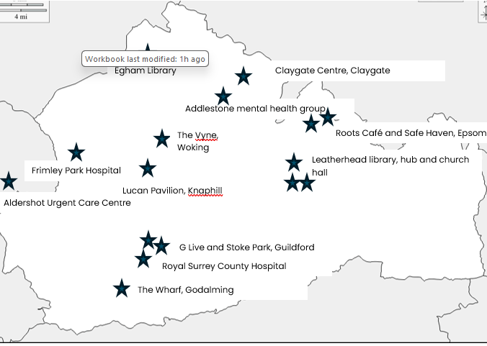In April our community visits took place in Guildford & Waverley, in May Surrey Downs and in June North West Surrey. We visited: Egham library; The Claygate Centre; Addlestone Mental Health Group; Roots Café, Epsom; Safe Haven, Epsom; Leatherhead Library; Leatherhead Hub; Leatherhead Church Hall; The Vyne, Woking; Frimley Park Hospital; Lucan Pavillion, Knaphill; Aldershot Urgent Care Centre; G Live, Guildford; Stoke Park, Guildford; Royal Surrey County Hospital and The Wharf, Godalming. Next quarter we’ll be focusing our engagement in East Surrey, North East Hants & Farnham and Surrey Heath.

## The map below shows the venues we visited this quarter.

#### Case study: Empowering the Epsom Safe Haven

Our visit to the Safe Haven in Epsom was arranged in partnership with Combating Drugs Partnership Public Involvement (CDPPI), another service of [Luminus Insight CIC](https://luminus-cic.uk/). We visited to speak with service users, staff and volunteers. By partnering with CDPPI we were also able to facilitate an information session between Safe Haven and [i-access](https://www.surreydrugandalcohol.com/) staff, so that both could more appropriately signpost and direct to the other vital service.

## Advocacy & complaints

This quarter we supported 30 people to make a complaint through our [Independent Health Complaints Advocacy service](https://www.surreyilc.org.uk/independent-health-complaints-advocacy-service/) (IHCA). Run in partnership with the [Surrey Independent Living Charity](https://www.surreyilc.org.uk/independent-health-complaints-advocacy-service/), IHCA provides free, confidential and independent support.

#### Case study: Jane’s* Experience

Jane, who has a range of complex mental health issues, had engaged with the formal NHS complaints procedure to raise concerns about certain medications and interventions which were given to her during her teens. Jane had received an outcome to the investigation but sought advocacy support as she did not feel that all her questions had been answered. She had also been offered a local resolution meeting which she didn’t feel confident attending the alone.

The IHCA obtained a copy of the complaint response and worked with Jane to establish what she felt was missing. The IHCA drafted an agenda for a meeting and confirmed with Jane what could be expected to be achieved from it. The IHCA helped Jane to prepare for the meeting, clarifying all the points which needed to be addressed, and attended with her.

**Outcome for Jane**

All of Jane’s questions were answered during the meeting and she felt her complaint had been resolved. She has told us that she felt empowered by being able to see the complaints process through to the end of the local resolution stage, something she wouldn’t have been able to do alone.

* Names have been changed.

# Delivering on our thematic priorities

Along with our core priorities of agenda free listening, the provision of information and advice and amplifying the VCSE voice, we also have four thematic priorities – access to primary care, social care, mental health and the involvement of people.

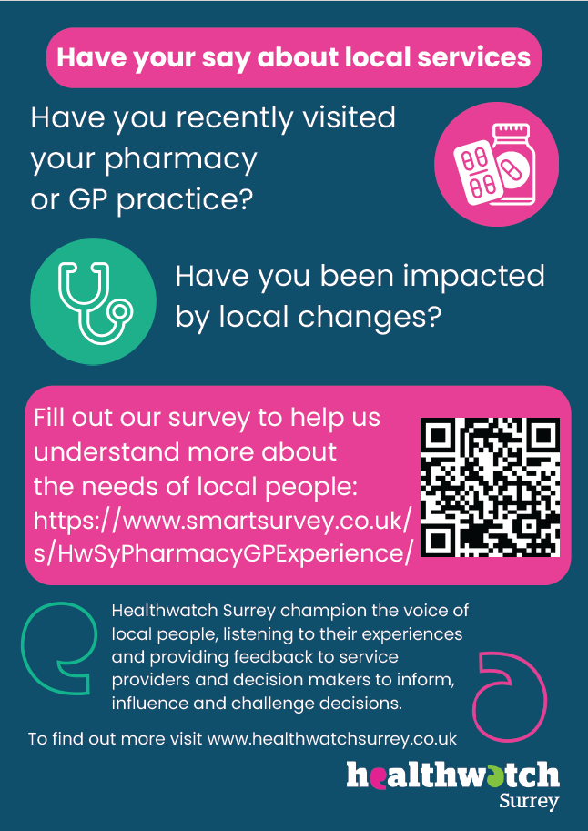

## Access to Primary Care

### Ensuring the real impact of pharmacy closures on residents is considered

Local residents and community groups shared their concerns about the negative impact which the closure of several pharmacies – in Thames Ditton, Cranleigh, Merrow and Burpham - were having on them. We were also being notified of other pharmacy closures across Surrey – [16 since the publication of the Pharmaceutical Needs Assessment (PNA) in 2022](https://mycouncil.surreycc.gov.uk/documents/s96151/Item%206%20-%20Surrey%20Pharmaceutical%20Needs%20Assessment%202025%20-%20Proposed%20Delivery%20Plan.pdf) - and how they were affecting local people.

We wanted to ensure that the level and nature of the impact of the closure of these pharmacies was having on the local population was considered by those looking at pharmacy provision. 429 people told us about how they were affected. Based on the survey findings we developed a series of [recommendations](https://www.healthwatchsurrey.co.uk/report/what-were-hearing-about-pharmacy-provision-summary-pharmacy-closures-impact-on-surrey-residents/) for the Surrey PNA Steering Group, and some significant changes to the assessment criteria have been made as a result.

Following our recommendation, walking time maps and a new question assessing how pharmacists would handle increased demand if the nearest alternative pharmacy were to close, will now be included in the latest PNA, ensuring that pharmacy provision is evaluated based on what really matters to people. We will continue to share the views of patients as part of the PNA Steering Group.

In addition to this work here in Surrey we have also conducted in depth interviews and contributed to a [national survey](https://www.healthwatch.co.uk/sites/healthwatch.co.uk/files/Pharmacy%20what%20people%20want.pdf) for Healthwatch England. This survey explored the current state of pharmacy services across the country, as well as the opportunities and challenges which lie ahead.

Findings from this national survey have contributed to the [House of Commons Health and Social Care Committee Pharmacy Report](https://committees.parliament.uk/publications/45156/documents/223614/default/?utm_source=The%20King%27s%20Fund%20newsletters%20%28main%20account%29&utm_medium=email&utm_campaign=14510341_NEWSL_HMP_Library%202024-06-04&dm_i=21A8,8N091,6JI20V,ZU6NL,1), meaning that insight from Surrey residents will be considered as part of national policy decisions.

## Improving information on complaints procedures

This quarter 9 people contacted us to discuss their dissatisfaction with the way that their NHS complaints were being handled, and several more spoke to us about their confusion around how to navigate the complaints procedure. 30 people have been helped by our [Independent Health Complaints Advocacy Service](https://www.surreyilc.org.uk/independent-health-complaints-advocacy-service/) as they felt that they needed more support to initiate and/or see through a complaint.

Whilst supporting these residents we identified that searching for "complaint" on the Surrey Heartlands ICB GP website directed users to an old complaints page containing incorrect signposting. Surrey Heartlands told us that they would not have picked up on this error had it not been for our alert, and they have now ensured that these pages are no longer publicly accessible.

Following our feedback, Surrey Heartlands have worked with their developers to remove the duplicate page, meaning that people will have access to the correct, clear, information when seeking out how to raise a complaint.

Healthwatch Surrey have also contributed to continuous improvements being made to the websites by sharing examples of where people have been confused by how to contact their GP practice online and how to register as a carer with their GP practice.

# Making a difference at a system level

We ensure that decision-makers in Surrey Heartlands and Frimley Health hear about the insights and experiences residents have shared with us, both positive and negative. We sit on a number of boards and committees and hold regular ‘what we’re hearing meetings’ with Place (the 6 health areas across Surrey). We also proactively challenge system partners over issues identified to us by local residents and share when things have gone well to help to identify best practice.

## Photo showing a Healthwatch Surrey leaflet in front of Merrow Park Surgery sign.Ensuring the voices of those in Guildford and Waverley are heard

In April we visited a number of community locations in Guildford & Waverley and made a series of recommendations to the Guildford & Waverley Alliance based on what people told us.

### Helping new parents find invaluable peer support

The Guildford and Waverley Alliance asked us to speak to parents of children aged 0-5 in certain key neighbourhoods experiencing particularly poor outcomes, to ascertain if a lack of support in the early years was contributing to these outcomes.

Parents told us that peer support is invaluable for new parents, but many simply don’t know what is available and how to access it. As a result, we recommended that the Guildford and Waverley Alliance develop a comprehensive list of peer support groups and activities available in the Godalming area, to be shared with new parents. Our recommendation was taken to a new working group made up of representatives from local authorities, the county council, voluntary sector, health and local services.

Insight provided by Healthwatch Surrey was utilised to help this important new working group devise a plan of action to address poor local outcomes. Following our recommendation, the group are now working together on a service mapping exercise so that new parents will be able to easily find appropriate local sources of support.

### Increasing uptake of the MyCare Portal at Royal Surrey County Hospital (RSCH)

People told us that they were confused about the new [MyCare portal](https://www.royalsurrey.nhs.uk/mycare) -how to use it and even what it is. We therefore recommended that all communication which is shared with patients about the portal is evaluated to ensure it is as clear as possible.

Our feedback supported and added further insight to the hospital’s existing understanding of the confusion which exists amongst patients, and led them to change the MyCare poster available in all departments, review all patient letters talking about the Portal and update the information on the RSCH website, to ensure they are all clear and address any confusion.

Uptake of the MyCare portal has risen from 63% to 71%. Being registered with the portal gives patients instant access to their information and reduces their reliance on paper letters which are easily mislaid. It will also help RSCH to become more environmentally friendly and reduce printing and postage costs, saving the Trust a significant amount of money that can be invested in clinical services.

### Encouraging young people to use reliable sources of information about their health

This quarter we have also followed up with the Guildford and Waverley Alliance regarding a recommendation made in our [previous report](https://www.healthwatchsurrey.co.uk/report/what-were-hearing-about-guildford-waverley-november-2023/) (November 2023) that more should be done to encourage young people to use reliable sources of information about their health.

Our report and recommendations led the Guildford & Waverley Alliance to initiate a discussion with the children’s and young people's commissioning team at Surrey County Council about how they could best address the issues raised. The two teams are now considering adding places to go for trusted information to “Wellbeing Plans” (being launched in school in October). They are also exploring how the Mental Health Investment Fund (MHIF) could be utilised, and how [Kooth](https://www.kooth.com/) (an on-line support service for young people) is promoted to young people.

### Improving communication to those awaiting a neurodevelopment review

One of our key themactic priorities is mental health. This quarter we have been working with Mindworks Surrey and Surrey Heartlands ICB to address some of the issues we’ve been hearing about in relation to [delays](https://www.mindworks-surrey.org/talking-points/update-neurodevelopmental-diagnostic-assessment-pathway-children) to the revision of the neurodevelopmental (ND) diagnostic assessment pathway for children in schools. Our previous [report](https://www.healthwatchsurrey.co.uk/report/neurodiversity-the-hidden-value-of-diagnosis/) on this topic (in March 2023) highlighted the importance of a formal diagnosis and the positive impact it can have on mental health, peace of mind and family life. People told us that a formal diagnosis can also help them to access the right statutory support.

More recently, parents and carers have told us that current delays are causing concern and confusion. We shared these concerns and asked Mindworks and Surrey County Council to confirm when the review is likely to conclude and when young people, their families and carers can expect to have an assessment. We also asked for reassurance that people are being appropriately supported and kept safe while the review is taking place, and appropriately communicated with. Our insights were well received and have led to some immediate actions to try to improve communication and reassurance.

“We welcome all feedback and your ‘Hidden value of diagnosis’ report has been incredibly helpful in providing further insight into how young people and their families are feeling. The additional information you have shared in relation to what families are experiencing while they remain on the pathway is also helpful and we are already looking at how we can address some of these areas, where we have received similar feedback.”

Children and Young People’s Integrated Commissioning and Mindworks

We were pleased that Mindworks and Surrey County Council have hosted a webinar for schools and looking at how they can work most effectively together as a system to support the needs of young people. They have also established a joint communications group, working across all relevant partner organisations.

The joint communications group is currently developing a comprehensive communications plan. This plan includes regular updates to parents, schools, partners and professionals, as well as other key stakeholders, so that this delay should not continue to cause confusion, distress and worry.

## Helping to shape quality appraisals

In our May [Insight Bulletin](https://www.healthwatchsurrey.co.uk/report/insight-bulletin-may-2024/) we identified a number of factors – such as responding to individual needs and efficient communication – which affect people’s experiences of primary care.

Surrey Heartlands used these factors as markers to measure quality in their latest quality report, meaning it was a review of quality based on what the public – not the system – think ‘quality’ really means.

# Involving local people in health and social care

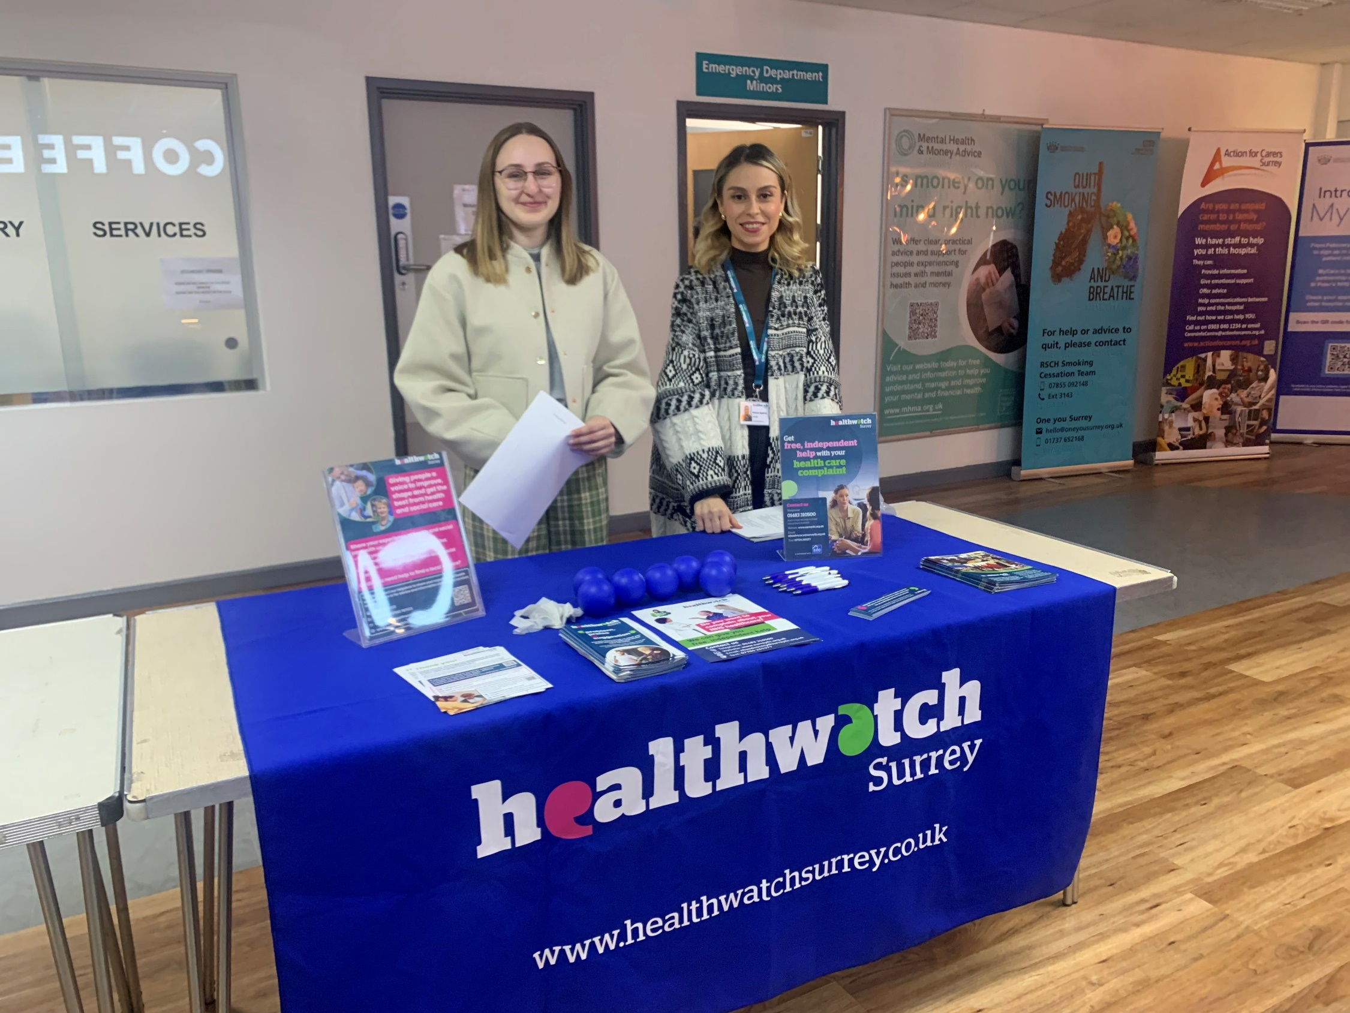Our dedicated team of volunteers help us to ensure that local people have their say, and that we hold decision makers to account.

## Ensuring Quality Accounts meet the needs of those they’re written for

Healthwatch Surrey facilitated our system partners’ listening to local people as they developed their quality accounts and, thanks to our volunteer Reading Panel their accounts were made more public friendly and accessible.

Many of our system partners have an obligation to report on the quality of their services and their upcoming priorities. This quarter our volunteer Reading Panel reviewed the draft quality accounts of 8 system partners to offer the lay perspective and to ensure that the views of local people were incorporated into the documents.

"Thanks for sending this through, the comments are much appreciated to help us improve the readability and will be incorporated."

Ashford St Peters Hospitals NHS Foundation Trust

One of our volunteers has also attended a provider Quality Improvement Day to learn more about quality improvements, meaning they are now better informed and more empowered to support our system partners in listening to the views of local people.

## Helping men to open up about their health

Two of our volunteers visited a mental health [peer support group](https://cocopcn.gpweb.org.uk/pcn-news/coco-pcn-art-peer-support-for-wellbeing-2) in North West Surrey.

The volunteers were able to offer valuable signposting to other local sources of support – to ensure the men were as well supported as they could be - and to listen to the men’s experiences of healthcare, which they wouldn’t have felt comfortable sharing in another forum.

“We were well received by the group, I think that it provided them with an opportunity to talk about something different, and to use this opportunity to voice some points about health and care services.”

Healthwatch Surrey Volunteer

## Empowering our volunteers to make a difference in their community

This quarter we delivered [Making Every Contact Count](https://www.healthysurrey.org.uk/professionals/making-every-contact-count) (MECC) training to 11 of our volunteers. MECC is a countrywide initiative to encourage public facing staff and volunteers to make the most of the contact they have with the general public, by using these interactions to have conversations about making positive improvements to health or wellbeing.

“We all came away better informed and prepared.”

Healthwatch Surrey volunteer

MECC improves access to healthy lifestyle advice, ultimately contributing to an improvement in morbidity and mortality risk factors within a local population and cost savings for the local health economy. Data has shown that for every 8 people receiving a MECC conversation 1 will change their behaviour [Prevention Pilot Advisory Group workshop].

We would like to thank everyone who gave their time and shared their experiences with us this quarter.

# 

# A blue background with a green curve going from one side of the page to the other.Healthwatch Surrey – Contact us

Website: [www.healthwatchsurrey.co.uk](http://www.healthwatchsurrey.co.uk)

Phone: 0303 303 0023

Text/SMS: 07592 787533

Email: [enquiries@healthwatchsurrey.co.uk](mailto:enquiries@healthwatchsurrey.co.uk)

Address: Freepost RSYX-ETRE-CXBY, Healthwatch Surrey, Astolat,

Coiners Way, Burpham, Guildford, Surrey, GU4 7HL

Facebook logo [Healthwatch Surrey](https://www.facebook.com/healthwatchsurrey)

 [HW_Surrey](https://twitter.com/HW_Surrey)

Instagram logo [Healthwatch_surrey](https://www.instagram.com/healthwatch_surrey)

LinkedIn logo [Healthwatch Surrey](https://www.linkedin.com/company/healthwatch-surrey/)

The Committed to quality marque - in white there is an icon of a rosette, inside the rosette is a tick. Beside the rosette are the words - Committed to quality.

We are committed to the quality of our information.

Every three years we perform an audit so that we can be certain of this.

The Healthwatch Surrey service is run by Luminus Insight CIC

(known as Luminus)