

Neurodivergent people’s experiences of outpatient appointments in Surrey hospitals

August 2024

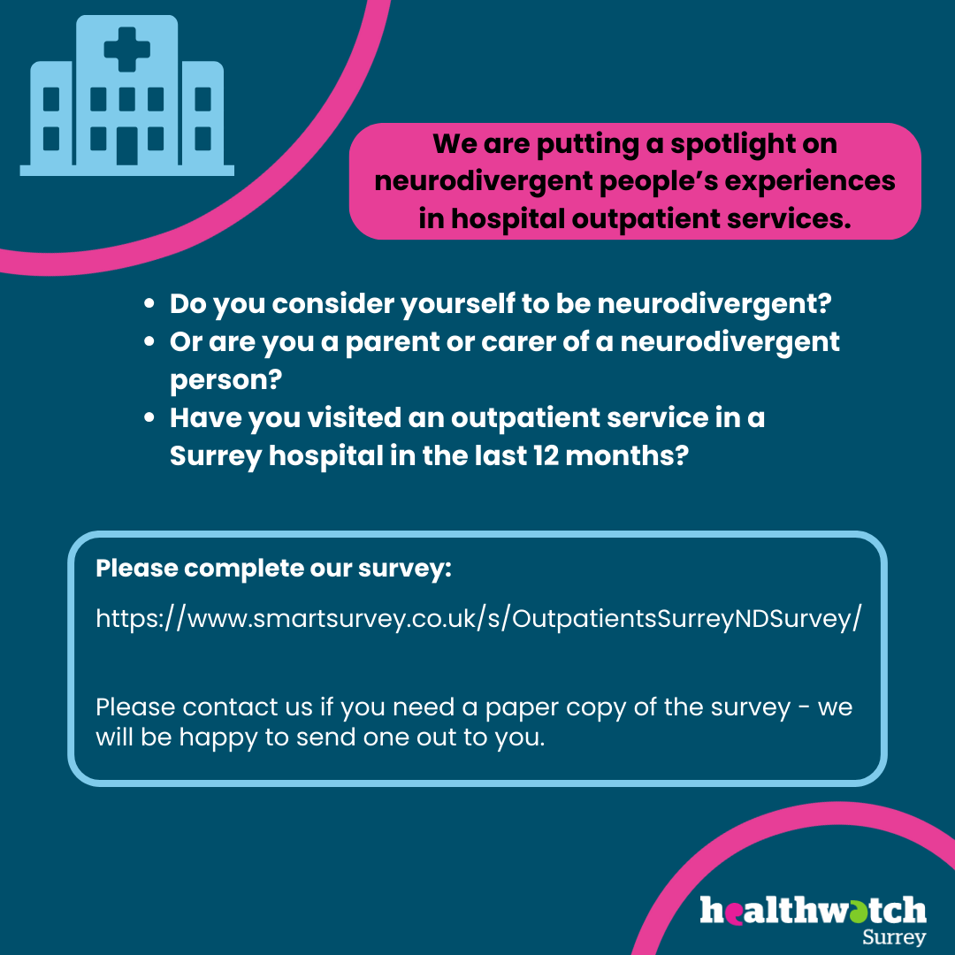

If you would like a paper copy of this document or require it in an alternative format, please get in touch with us.

Contents

Executive summary 4

Background 5

Purpose 6

Objectives 6

Approach 7

Who we listened to 7

Summary of key findings 8

Theme 1 - Environment 8

Theme 2 - Information 9

Theme 3 - Communication 9

Theme 4 - Waiting times 9

Theme 5 - Length of appointment 10

Theme 6 - Clinical 10

Theme 7 -Training and awareness of neurodiversity 10

Recommendations 11

Environment 11

Information 11

Communication 12

Waiting time 12

Length of appointment 12

Training and awareness of neurodiversity 12

Context 12

What is neurodiversity? 12

Resources for neurodiverse communities 14

Main findings 15

Before the appointment 15

During the appointment 17

After the appointment 19

Triggers and enablers 21

About the respondents 26

Case studies 30

Key takeaways and resources 35

Summary and thanks 36

About Healthwatch Surrey 37

Healthwatch Surrey – Contact us 38

# Executive summary

Neurodivergent people are one of the priority populations for Surrey. In the health and wellbeing strategy neurodivergent people are recognised as a community who may experience poorer health outcomes or health inequalities.

[Health and wellbeing strategy | Healthy Surrey](https://www.healthysurrey.org.uk/about/strategy)

Neurodivergent people are known to have poorer health outcomes than neurotypical people and have been found to be more at risk of early mortality overall. Mortality rates for neurodivergent individuals in England are notably higher compared to the general population. For instance, autistic people (and those with learning disabilities) often face a significantly reduced life expectancy, dying on average 15-20 years earlier than their neurotypical peers. This highlights the urgent need for better healthcare and support systems tailored to the needs of neurodivergent individuals to improve their quality of life and longevity.

[2018-12-neurodevelopmental-rightcare-pathway-proposal.pdf (neural.org.uk)](https://www.neural.org.uk/wp-content/uploads/2021/04/2018-12-neurodevelopmental-rightcare-pathway-proposal.pdf)

Considering what we have been hearing, our aim has been to highlight the experiences of neurodivergent people before, during and after their outpatient appointment for medical conditions and to highlight what would help to improve their experience.

The aim of this project is to understand the experiences of neurodivergent people when they attend outpatient services for medical needs in Surrey; what the triggers are that lead to poor experiences, the barriers to using services, and how health professionals can help to improve experience of neurodivergent people in health settings.

This project gathered qualitative experiences of outpatient services in Surrey hospitals. We worked with a Healthwatch Surrey volunteer who has lived experience of being a parent to a neurodivergent child and her advice was to do an online survey initially. 70 people responded. Some of the questions invited further comments and this gave over 250 free text comments which we were able to categorise into themes. The findings are illustrative of themes in other studies with neurodiverse communities.

The project investigated 3 key areas: communication received before the appointment, experiences before meeting with a clinician and experience of the appointment. The findings have been grouped under seven themes: information, environment, communication, waiting times, length of appointment, clinical approach, and training and awareness of neurodiversity.

The recommendations are broken into the same 7 themes as the findings, and some of our recommendations may be beneficial to improve the experience of many others, as well as neurodivergent people. However, we wish to stress that for neurodivergent people these suggested changes to practice can reduce barriers that may prevent people attending health appointments and relieve severe anxiety and distress, which may lead to poorer health and wellbeing outcomes.

Key recommendations include calm and quiet spaces, providing details about what the appointment will entail, providing accessible formats for communications, involving carers where people request it, minimising waiting times, extending appointments to allow more time for people and ensuring staff have had training in neurodiversity.

During the time the survey ran, Healthwatch Surrey built relationships with groups and organisations supporting people in the community. These groups said they would be happy to be approached for any further phases of this project.

# Background

The Surrey Health and Wellbeing Board aims to ensure that anyone who uses services receives the opportunity to live healthy lives without disparities due to ethnicity, age, wealth, disability, or geographical area [Health and wellbeing strategy | Healthy Surrey](https://www.healthysurrey.org.uk/about/strategy)

Neurodivergent people are in the priority populations (i.e. children with additional needs and disabilities, adults with learning disabilities and/or autism and people with long term health conditions, disabilities, or sensory impairments.)

In March 2023 Healthwatch Surrey published a report on the value of a formal diagnosis for children and young people for conditions relating to neurodiversity – their expectations and hopes, and the reality of their experiences since diagnosis.

[Neurodiversity - the hidden value of diagnosis (healthwatchsurrey.co.uk)](https://www.healthwatchsurrey.co.uk/wp-content/uploads/2023/03/Neurodiversity-%E2%80%93-the-hidden-value-of-diagnosis-1.pdf).

In the online survey, people with no diagnosis felt that their requests for adjustments were not taken seriously and impacted negatively on their experience and outcome.

“I do not have a diagnosis, and I have found that requests for adjustments do not tend to get taken seriously unless you have a diagnosis. If you have a diagnosis, then it is a formal reasonable adjustment, and they legally must try to accommodate it - without a diagnosis you do not have this protection. This makes it very difficult for people who do not meet the threshold for a diagnosis but have neurodiverse traits, people who are stuck on the waiting list for a diagnosis, or people who just do not want to receive a diagnostic label for personal reasons.”

## Purpose

Considering what we have been hearing, our aim has been to highlight the experiences of neurodivergent people before, during and after their outpatient appointment and to highlight what would help to improve their experience.

## Objectives

1. To seek to understand experiences of neurodivergent people when receiving care as an outpatient in Surrey hospitals.
2. To understand what triggers people's anxiety and things that can enable emotional regulation.
3. To provide the hospitals with suggestions, from those accessing their services, about what can be improved.

Approach

This was a project that aimed to gather qualitative data and experiences through an online survey. We worked with a Healthwatch Surrey volunteer who has lived experience of being a parent to a neurodivergent child. Her advice was to avoid focus groups/workshop as neurodivergent people were unlikely to attend a workshop in an unknown setting. The volunteer described herself and other parents as being “Rich in experience and time poor” and felt a survey would be a valuable first step to gather views. The results could be used as a baseline to decide if further research would be beneficial. We also reached out to community organisations and received positive affirmation of their willingness to be involved in future work with neurodivergent people.

We included several free text comments boxes in the survey and from these we were able to achieve an understanding of what difficulties neurodivergent people encounter and heard what would improve their experience.

What we heard represents themes that are present in the population, rather than the extent to which they are present. Our aim was to deliver insight that can provoke reflection and enrich strategy. We studied 70 completed surveys and about 250 free text comments. The survey ran in April and May 2024.

Respondents all consented to our inclusion of anonymised quotes in our report. We used a thematic analysis approach to develop our findings and report.

Who we listened to

Recruitment was undertaken through a combination of social media and networking with partner organisations. Respondents were selected to deliver a breadth of situations, diagnoses, and demographics, but this was not a scientific exercise. While we are confident our respondents represent a broad spectrum of experiences, we are aware there is a bias towards more engaged, and those who have access to complete an online survey.

Of the sample, 28 people considered themselves neurodivergent with a diagnosis and 28 were parent/carers of a person with a diagnosis. The other respondents were waiting for a diagnosis. 34 people were responding about themselves and 36 were responding on behalf of someone else.

Of the respondents who answered about themselves, 28 had received a diagnosis, 6 were waiting and 2 had no diagnosis. Parents or carers who were answering on behalf of their child or cared for person said that 28 had received a diagnosis, 3 were waiting for a diagnosis and 3 had no diagnosis.

# Summary of key findings

All NHS hospitals (including Farnham Road Hospital) were represented, with the highest responses for Ashford and St Peters Hospitals, Epsom Hospital, and Royal Surrey County Hospital. There was equal distribution of those people who consider they are neurodivergent and those responding as a parent/carer of a neurodivergent person.

Every person's experience was unique but there were some similarities in what people shared as triggers. Some people had a positive experience of their outpatient appointment whilst others felt that their needs and preferences were not met. Questions about the appointment were split into the following areas:

* Information and communication pre-appointment
* During the appointment
* After the appointment.

We also asked what people identified as their triggers and people’s suggestions of what would improve their experience to reduce anxiety and enable emotional regulation. Several cross-cutting themes emerged.

## Theme 1 - Environment

Many respondents said that crowded, noisy, confined, small spaces, and bright lights were triggers which caused increased anxiety. The lack of personal space was an issue and being in a small clinical room with several members of the team was difficult.

## Theme 2 - Information

Many people felt that the appointment letter was unclear and there was conflicting information which meant that they needed to get in touch for clarification. This then increased anxiety and meant that some would not attend their appointment.

People also wanted clear and detailed information pre-appointment about what would happen in the appointment, or additional information about a procedure to enable them to prepare in advance of the appointment.

## Theme 3 - Communication

Some people find it difficult to speak on the phone due to their processing issues and felt there was a lack of other options to contact e.g. text, email. When trying to contact the hospital, people told us they were often not able to get through or were put on hold.

People also mentioned being interrupted by the clinical team with questions that diverted their thoughts and felt they were not given time to process thoughts which made effective communication difficult. When care takes place over a series of appointments (such as maternity), the perceived lack of continuity in the team meant people were unable to build a rapport and feel comfortable. The attitude and lack of understanding of needs from some clinicians were difficult for some.

Many people involved a family member or care giver to help them in their appointment but on occasion this was not allowed or encouraged by the clinical team.

## Theme 4 - Waiting times

Waiting for an appointment caused anxiety and several parents said that their child’s behaviour deteriorated especially when waiting in crowded and noisy environments.

## Theme 5 - Length of appointment

Many people found that short appointments were particularly difficult, giving them no time to explain or process thoughts and left them feeling rushed.

Theme 6 - Clinical

There were examples of clinical procedures causing anxiety, such as fear of needles, blood and pain. Thorough explanation of the procedure by the clinician, whilst good practice, was perceived as causing delay in an anxiety provoking situation. People preferred information pre appointment so the procedure could be carried out quickly.

Some people felt being asked to identify body symptoms and questions such as ‘how bad is the pain on a scale of 1-10’, caused anxiety as they felt unable to define this.

## Theme 7 -Training and awareness of neurodiversity

People also shared positive experiences, and these were when adjustments, consideration of triggers, and preferences were considered. One person shared how their GP gives support:

“My GP is amazing and sends me texts/messages with what has been agreed. I am also flagged on their system as being at risk due to chronic health issues and my autism, so I am given priority appointments and repeatedly called in for face-to-face appointments, even for smaller issues. I also see the same 2 doctors and nurse, so I know them and can get to the point quicker!”

There were, however, experiences which demonstrated a lack of pre-planning, staff awareness and understanding of neurodiverse conditions. For these experiences we were unable to determine whether the now mandatory Oliver McGowan training had been completed.

# Recommendations

Many of the themes listed above can affect us all and improvements in these areas can improve patient experience overall. We recognise, however, that whilst some of these things can be frustrating for all, for a neurodivergent person they can cause severe anxiety and behaviours. This may mean an inability to attend appointments, which then impacts health and wellbeing.

These recommendations are based on the key findings of this report and should be considered based on the evidence collected. We are aware that there are some things which cannot be easily fixed (such as estates). When considering the experience of neurodiversity in outpatient settings we recommend the following:

## Environment

* Provide the option of a calm waiting area, (play area or sensory room for children) or enabling someone to wait in a different area such as a café and being called prior to the appointment by a buzzer system.
* Consider the number of team members who need to be present in a clinic room and ask those not needed to leave.
* Allow family members and carers to attend appointments as they can provide valuable insights into a person’s needs and preferences.
* Encourage secondary care to learn from primary care and each other where there are areas of good practice.

## Information

* Ensure that letters are clear, with appropriate information, and that they do not conflict with other letters sent.
* Ensure people are asked whether they have any specific access requirements or adjustments needed and record on patient’s information for future reference.
* Send information on procedures before the appointment so people have time to process and know what to expect.
* Consider using visual illustrations and photographs of the team and location.

## Communication

* Offer a range of communication formats including Easy Read format [NHS England » Accessible Information Standard](https://www.england.nhs.uk/about/equality/equality-hub/patient-equalities-programme/equality-frameworks-and-information-standards/accessibleinfo/).
* Consider additional ‘contact us’ options such as text, email, answer phone, WhatsApp. This would negate the need to be put on hold.

## Waiting time

* Keep people regularly informed with accurate expectations of delays.

## Length of appointment

* Consider offering longer appointments or an option to contact a member of the team after the appointment to ask questions.

## Training and awareness of neurodiversity

* Ensure all staff complete mandatory neurodiversity awareness training.

[The Oliver McGowan Mandatory Training on Learning Disability and Autism - elearning for healthcare (e-lfh.org.uk)](https://www.e-lfh.org.uk/programmes/the-oliver-mcgowan-mandatory-training-on-learning-disability-and-autism/)

# Context

## What is neurodiversity?

Each person has a brain that is unique to them; no two brains are quite the same. Neurodiversity is the concept that brain differences are natural variations – not deficits, disorders, or impairments. While some individuals do refer to themselves as neurodiverse, the term neurodiversity is mostly now used to refer to a group which encompasses the full spectrum of brain differences and is made up of neurodivergent traits such as autism, ADHD, and dyslexia ([Neurodivergent, neurodiversity and neurotypical: a guide to the terms - The Brain Charity](https://www.thebraincharity.org.uk/neurodivergent-neurodiversity-neurotypical-explained/)).

In this report we have used the term neurodiversity in the way described above.

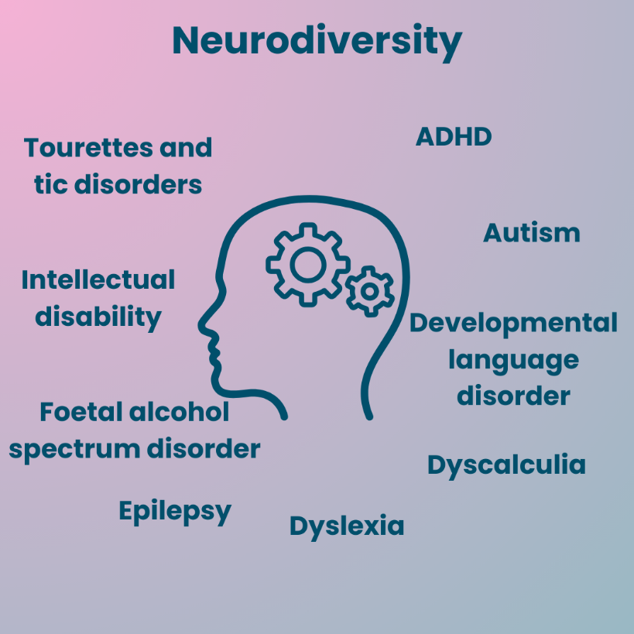

We wanted to shine a light on neurodivergent people's views and experiences in their own words and to increase awareness that neurodiversity covers a wider spectrum of disorders such as Tourette’s, dyscalculia, epilepsy, developmental language disorder as well as autism and ADHD.

We also wanted to ensure the voice of the people most deeply affected by outpatient hospital appointments was clearly heard by those who plan and deliver services.

We have listened to neurodivergent people who shared the difficulties they encounter when attending outpatient hospital appointments, either as a patient themselves or as a parent/carer.

We have also looked at other relevant research. [A report completed by Healthwatch Hertfordshire in November 2023 (GP Services and Autistic People)](https://nds.healthwatch.co.uk/sites/default/files/reports_library/20231114_Hertfordshire_%20GPs%20Services%20and%20Autism%20Report%20FINAL.pdf) investigated how GP practices could become more accessible to autistic people. Several of the recommendations in this report mirror our own findings, including awareness training for clinical and non-clinical staff, quiet waiting spaces, more flexibility for appointments and a range of communication options.

## Resources for neurodiverse communities

The 2010 Equality Act dictates that the NHS puts reasonable adjustments in place for disabled people to ensure that they have equal access to healthcare. Examples of reasonable adjustments that neurodivergent people might need in healthcare environments include quiet environments, flexible appointment times, longer appointments, and different communication options.

Many NHS Trusts have resources to enable people with learning disabilities to access NHS Services, for example some have a dedicated specialist nurse or coordinator. NHS England has developed a programme making health and care services better so that more people with a learning disability, autism or both can live in the community, with the right support and has published the five-year autism research strategy ([NHS England » The five-year NHS autism research strategy update, one year on](https://www.england.nhs.uk/blog/the-five-year-nhs-autism-research-strategy-update-one-year-on/)).

When we researched NHS England and NHS Trust websites, we found that there is awareness of learning disability and autism, and there is statistical information on these groups but scant information about neurodivergence as an umbrella term. There is recognition that neurodivergent people are known to have poorer health outcomes than neurotypical people and have been found to be more at risk of early mortality overall, more than double in the case of both physical and mental ill health. National and local data shows that statistically, a neurodivergent person is more likely to die by suicide than a neurotypical person.

The Autism Centre of Excellence has shown that autistic adults are more likely to die 16 years earlier than neurotypical adults, if you are autistic and have a learning disability, you are more likely to die 30 years earlier. 8 out of 10 autistic adults have had suicidal thoughts or attempted suicide, with it being the second biggest reason why autistic adults are more likely to die earlier – ([Health and wellbeing - Autism Centre of Excellence](https://www.autismcentreofexcellence.org/partnerships/health-and-wellbeing/)).

# Main findings

This section provides a detailed overview of the findings from this study and is the basis for the summary of key findings.

## Before the appointment

### Was the appointment letter you/they received clear?

The chart below shows that 42 out of 60 people who answered this question said that the information in the appointment letter was clear and easy to understand.

Bar chart showing responses to the question: Was the appointment letter you/they received easy to understand?

Bar chart showing responses to the question:
Yes: 42
No: 8
To some extent: 7
Don't know: 3

One person received their letter (from the Community Hub in Redhill) in an Easy Read format.

“It was in an Easy Read format. They asked if any specific requirements were needed.”

15 said that it was either not easy to understand or only to an extent. People said that the letters were often confusing and not clear. Responses were about: Royal Surrey County Hospital (7), Epsom Hospital (5), Ashford and St. Peter’s Hospitals (2), Surrey and Borders Partnership NHS Trust (2), Frimley Park Hospital (1), East Surrey Hospital (1). Easy Read format was mentioned as available or provided in only one hospital.

Examples of feedback about unclear letters were:

“I did not attend an appointment as I did not understand the letter, I have a degree and work full time. The letter was unclear of what to do/where to go and it had too much information that was non-specific. I was sent (medical) blood forms which I assumed was an error.”

“The letters contained where and when the appointments were, but it was not clear who I would be meeting or what the appointment would entail. For example, it would be helpful to know if I would need to undress for an appointment, but it feels embarrassing to ask.”

“The appointment letter was received after the appointment and it was confusing as the time had changed, though a letter with the original time arrived. If this had gone direct to my son, he would have turned up at the original time.”

“The appointment letter did not recognise the adjustments I had requested which were made in the first appointment. As it turned out, the service and referral from Specsavers was more considerate of my multiple disabilities than the service from the hospital.”

### Before the appointment, were you/they asked if there are special requirements or preferences?

Bar chart showing responses to the question: Before the appointment were you/they asked if there are special requirements or preferences?

Responses in the bar chart:
Yes: 7
No: 48
Don't know: 5

Only 7 out of 60 respondents said they were asked if they had any specific requirements. They felt that being able to communicate specific requirements or considerations enhanced their experience.

“I was able to bring my daughter’s teacher with me to support my daughter’s surgery as she needs 2:1 support.”

“Learning disability means that appointments are difficult. The neurology team did a pre-appointment call to go through information that would have otherwise prolonged the appointment. This left the appointment shorter as it was able to focus on the physical examination etc. Excellent considerations approach.”

48 out of 60 people said they were not asked if they had any specific requirements before the appointment. One person did suggest they would feel confident in communicating their needs direct to the clinician, but this is likely to be a minority of neurodivergent people.

“I would always make sure to speak to the clinician at the time of the appointment to discuss what I need if I would be working with them long term i.e. physio or midwife.”

## During the appointment

### During the appointment were your/their requirements and preferences met?

Bar chart showing responses to the question: During the appointment were your/their requirements and preferences met?

Responses in the bar chart:
Yes: 20
No: 16
To some extent: 18
Don't know: 5

There were 20 positive experiences from 59 respondents. People felt the staff were kind, understanding and patient. 1 person was not asked before the appointment but when the staff saw her son’s behaviour, they asked how they could help and was there anything they could do that would relieve his distress and help with the appointment. Distraction techniques were used effectively by hospital staff.

“One lady found something on YouTube for my daughter and helped me. Then they did a quick oral exam and photos and discussion (while I was actively containing a screaming and wild child).”

“The team at the dental unit [East Surrey Hospital] were fabulous. This was the third session of treatment for my daughter under sedation, so they know her well and take our input into consideration.”

“The orthotist had an excellent manner with my daughter. He explained everything as he measured her head for the helmet. He had a good sense of humour with her, which was helpful. All appointments have been excellent.”

There were examples of how the environment was used to improve experience.

“My daughter is completely non-verbal, and she has little understanding. She also is a runner and tall for her age. She has complex needs and we were able to visit the hospital before the appointment. She was able to access the sensory room. She was the first to be seen as she is unable to wait as she does not understand why she needs to wait.”

There were, however, some experiences that were not so positive. People felt ignored, not believed and experienced poor attitudes and communication from team members.

“I asked for my spouse to be present as I would struggle to have the appointment without him, the administrator was not sure if this would be allowed and said they would have to find out. The admin was kind and said the doctor had agreed this, however when I later attended for the appointment, the doctor denied having this conversation with the admin and seemed surprised and irritated by the request. The doctor was very reluctant to allow my spouse into the room and it was only because of me making the effort (against my nature) to push for this that they agreed.”

“I felt that my perceptions about what was wrong were ignored in favour of their theory, which was made into a diagnosis regarding viral infection without any test.”

## After the appointment

### After the appointment did you/they feel clear about what had been agreed and the next steps?

Bar chart showing responses to the question: After the appointment did you/they feel clear about what had been agreed and the next steps?

Responses in the bar chart:
Yes: 36
No: 20
Don't know: 4

36 out of 60 people said they felt clear about what had been agreed and the next steps had been discussed with them.

“Those who I saw on a regular basis would note things down for me, or to make sure it was recorded in my notes which I could access. The lady who assessed me from the perinatal mental health team also wrote me a letter outlining the next steps, for myself and my partner.”

“The midwife and the physio would write things down for me to remember what we had spoken about, or instructions /information for my partner who supports me at home.”

20 people felt unclear about what had been discussed and agreed during the appointment and that they left feeling unclear.

“The plan was quite different from previous plans. The approach was not clearly explained in terms of the change.”

### Is your GP aware you/they are neurodivergent?

Bar chart showing responses to the question: Is your GP aware you/they are neurodivergent?

Responses in the bar chart:
Yes: 50
No: 5
Don't know: 14

50 out of the 69 who answered this question said that their GP was aware and felt that this was positive and made a real difference to their experience. It also helped when the same GPs could be seen.

“My GP is amazing and sends me texts/messages with what has been agreed. I am also flagged on their system as being at risk due to chronic health issues and my autism, so I am given priority appointments and repeatedly called in for face-to-face appointments, even for smaller issues. I also see the same 2 doctors and nurse, so I know them and can get to the point quicker!”

Many people do not have a formal diagnosis and were not recognised on their GP practice’s system, however, there was recognition and consideration given during appointments.

“The senior GP had to intervene after I had a meltdown at the surgery and has been supportive since then and was insistent on better assessment and treatment by the Community Mental Health Recovery Team and supported me to get further treatment for my complex trauma. I have noticed that the staff there on a recent visit to take my partner to an appointment during which she collapsed, were responsive to my advising them of my partner's underlying mental health conditions!”

## Triggers and enablers

The Oxford Dictionary describes a trigger as something that is the cause of a particular reaction.

We asked what triggers people experienced. Many examples were shared, and these have been grouped into themes.

### Environment

“My triggers tend to be sensory based; I struggle a lot with loud noises and crowds and can struggle with lights. I also get quite anxious when I do not know what is going to happen in an appointment, or what a procedure entails. I prefer to be informed fully as I then feel I can mentally prepare for any potential outcomes. If I am overwhelmed with information or overwhelmed with sensory input, I can shut down. In the past this has been mistaken for seizures because I glaze over and become unresponsive. It would be really helpful if I could note down what can trigger this, and how to help me when this happens on my medical record.”

### Information

“It told me a place to go, when I got there, I was told I was in the wrong place and many people get confused. I was then given instructions to another place. Got completely lost and had to make a new appointment. For the next appointment, the lady on the phone gave me a step-by-step guide and that was very helpful.”

“The letter was fine for me but would not have been understood by my daughter.”

Sometimes having images to accompany things can be beneficial. This could also include images of what the person would see, i.e. a photo of the front of the hospital, then the main reception, then the staircase, then the clinic and the waiting room and so on.

### Communication with the hospital and team

Some people find it difficult to speak on the phone due to processing issues and felt there was a lack of other options to contact e.g. text, email.

When trying to contact the hospital, people were often not able to get through or were put on hold.

Some people found communication with the clinical team was difficult and they did not feel listened to.

“Being interrupted by clinical team with questions that divert thoughts.”

“Not given time to process thoughts.”

“Lack of continuity of team with a longer-term issue so unable to build a rapport and feel comfortable.”

“Attitude and lack of understanding of some clinicians.”

“1 or 2 people in a room - although for medical learning and consultation I can understand why everyone is in there but as I was getting beaten up and it would then take hours to calm him [son] down – for everyone’s benefit perhaps they could be in another room on a video conference instead.”

### Waiting time

“No waiting. The wait was only about 20 minutes but that is a lifetime for a special needs autistic child and is enough to set him off when he can see so many things he can get hold of.”

“Recognition of waiting times and the impact on the patient. Even something as simple as allowing him to wait in the café/ reception would be preferable and then calling us from there and would then result in better results as he would be more compliant.”

### Length of appointment

Many people felt that the appointment was too short and did not give time to process thoughts and answer questions.

“I need to have things explained to me clearly before any action is taken. This is because of a combination of profound hearing loss, complex trauma, and severe autism, so called high functioning. I simply need more time than average for cognitive processing and self-regulation.”

“Longer appointments, I have difficulty processing information, especially when it is spoken and I am already out of my comfort zone, i.e. in a hospital! Having slightly longer appointments, or the option to contact the clinician I spoke to after my appointment, would allow me to fully process what has been said and ask any questions I need to.”

### Neurodiversity awareness

“A greater understanding from the medical community about how autism is a broad spectrum. Some clinicians have not seemed to believe me when I say I am autistic because I come across well-spoken and put together, but this leads to them not accommodating my needs and me not feeling like I can speak up if I do not understand something/something is bothering me. This also includes better knowledge of comorbid conditions that neurodiverse people may have, both physical and mental and how they can impact on care.”

|  |  |  |  |  |  |  |  |  |  |  |  |  |  |  |  |  |  |  |  |  |  |  |  |  |  |  |  |  |  |  |  |  |  |  |  |  |  |  |  |  |  |  |  |  |  |  |  |  |
| --- | --- | --- | --- | --- | --- | --- | --- | --- | --- | --- | --- | --- | --- | --- | --- | --- | --- | --- | --- | --- | --- | --- | --- | --- | --- | --- | --- | --- | --- | --- | --- | --- | --- | --- | --- | --- | --- | --- | --- | --- | --- | --- | --- | --- | --- | --- | --- | --- |
| |  |  |  | | --- | --- | --- | |  | **Triggers** | **Enabler (to enable emotional regulation)** | | **1** | **Environment** | | |  | Crowded and noisy places  Bright lights  Confined and small spaces  No personal space  Being in a small clinic room with doctor and trainees | Able to wait in a playroom, café or reception and using a buzzer to call when appointment is next in queue.  Sensory room.  Appointment at beginning or end of day when it is quieter.  Have 1 or 2 of the team in a room – although for medical learning staff be in another room on a video conference instead. | | **2** | **Information** | | |  | Lack of information about a procedure or appointment.  Unclear and conflicting information.  Getting letters and texts which conflict. | Leaflet/link to information about procedures and links to team websites to be prepared.  Information to refer to post appointment.  Summarised information available  Letters should be jargon-free and clear.  Easy Read to be available – images of what the person would see i.e. photo of hospital, reception, clinic etc.  Text reminders of appointments, that arrive prior to appointment not after. | | **3** | **Communication** | | |  | With the hospital and team:  Speaking on phone.  Not able to get through.  Annoying music whilst on hold. | Easy access to clinical team – through email or webchat | |  | With the clinical team:  Being interrupted by clinical team with questions that divert thoughts.  Lack of continuity of team. | The option to contact the clinician after appointment, would allow people to fully process what has been said and ask any questions.  Listen to the voice of the person and advice of those who know the person best. | | **4** | **Waiting time** | | |  | Waiting increases frustration and boredom.  Increased anxiety when there are delays during a clinic appointment. | Clear communication about delays and give regular timely updates. | | **5** | **Length of appointment** | | |  | Short appointments are difficult – no time to explain. | Either longer appointments to enable process information or more information pre-appointment.  Doctors having more time and allowing people to explain properly what they are worried about/what they need before diving in with solutions or questions. | | **6** | **Clinical** | | |  | Needles, blood, and pain.  Being asked to identify body symptoms.  Questions such as ‘how bad is the pain on a scale of 1-10’. | Clear and concise explanation.  Completing the procedure quickly.  Allowing the person to talk about symptoms in own words. | | **7.** | **Awareness of neurodiversity and training** | | |  | Lack of understanding and awareness of neurodiversity.  Triggers and enablers. | Training for all staff.  [The Oliver McGowan Mandatory Training on Learning Disability and Autism - elearning for healthcare (e-lfh.org.uk)](https://www.e-lfh.org.uk/programmes/the-oliver-mcgowan-mandatory-training-on-learning-disability-and-autism/) | |

# About the respondents

There were 70 completed responses across Surrey.

The chart below shows a wide range of people completed the survey. The majority of people represented were under 18 years and between 18 and 29 years old.

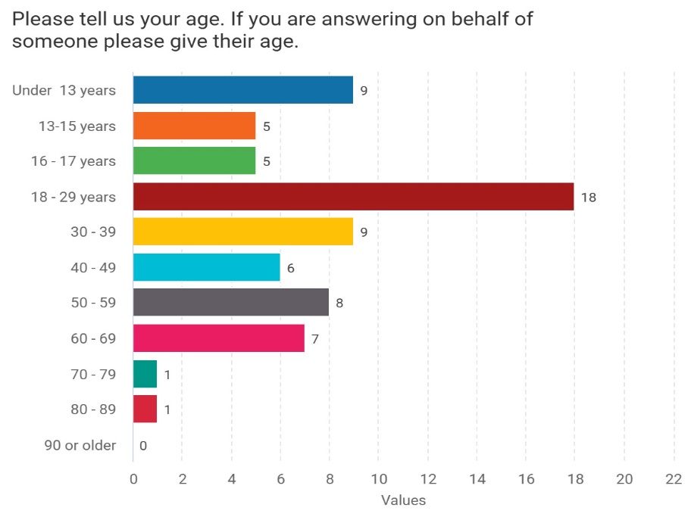

The chart below shows a good representation of male and female respondents. Views of non-binary people were included, and some people preferred to self-describe or not to say.

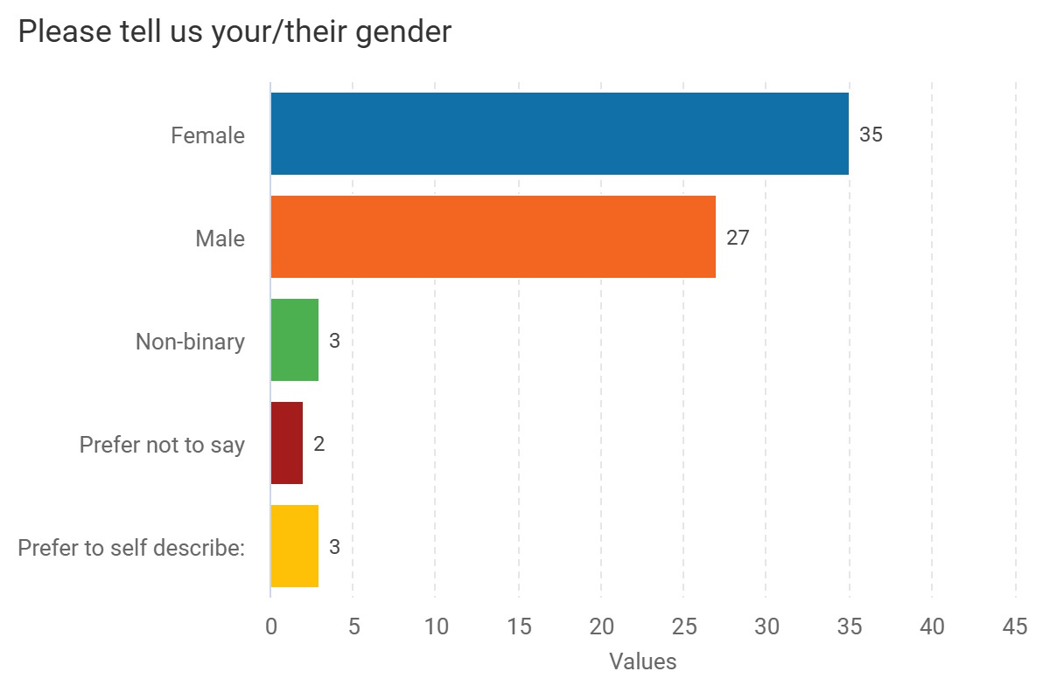

The majority of respondents (54) were white British, white other (7), mixed/multiple ethnicities (3), Asian (2) and the remaining preferred not to say. There is no evidence to suggest that there is a difference between ethnicities in their access or experiences, but we recognise that the samples are small.

The chart below shows there was equal distribution of those people who consider they are neurodivergent and those responding as a parent/carer of a neurodivergent person.

Bar chart showing responses to the question: Are you/or the person you are answering for, a neurodivergent person?

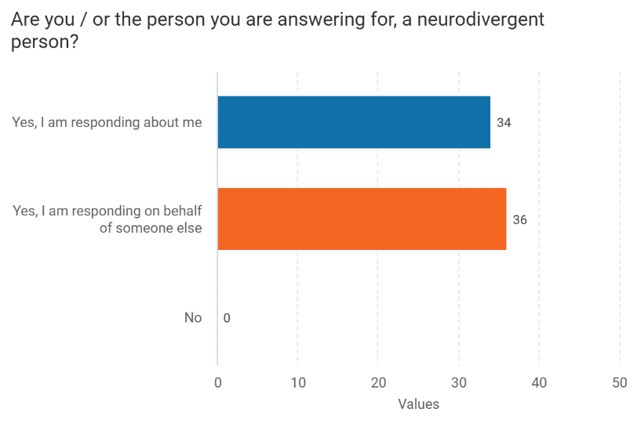

28 people considered themselves neurodivergent with a diagnosis and 28 were parent/carers of a person with a diagnosis. The other respondents were waiting for a diagnosis.

34 people were responding about themselves and 36 were responding on behalf of someone else.

The chart below shows that 36 people answered about themselves, 28 of these people had received a diagnosis, 6 were waiting and 2 had no diagnosis.

34 people said they were a parent/carer and were answering on behalf of this group. 28 had received a diagnosis, 3 were waiting for a diagnosis and 3 had no diagnosis.

Bar chart showing responses to the question: Which of the following replies to you/them - regarding diagnosis

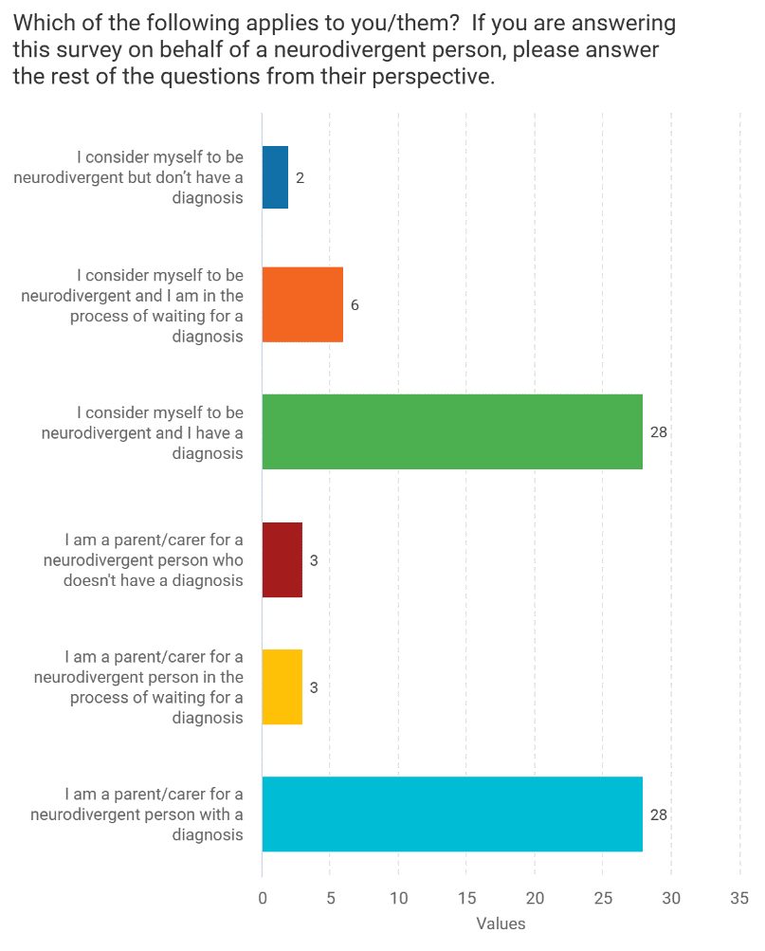

The chart below shows that all Surrey NHS hospital trusts (including Surrey and Borders) were represented, with the highest responses for Ashford and St Peters Hospitals, Epsom Hospital and Royal Surrey County Hospital.

Bar chart showing responses to the question: Please tell us which hospital was in charge of your/their care?

Bar chart showing responses:
Ashford and St. Peter's: 16
East Surrey: 9
Epsom: 18
Frimley Park: 5
Royal Surrey: 18
Surrey and Borders: 7
Other: 7


The chart below shows that of these trusts, 41 people said their hospital was aware that they are neurodivergent.

Bar chart showing responses to the question: Is the hospital you/they attended in the last 12 months aware you/they are neurodivergent?

Bar chart showing responses:
Yes: 41
No: 7
Don't know: 12

# Case studies

We have included some case studies form people with a diagnosis and those waiting for a diagnosis as it is important to consider people’s entire experience of care.

Case study 1 - parent carer of young person aged 16 with a diagnosis

“The appointment letter was clear. I was not asked before the appointment if my child had any special preferences but during the appointment I informed them of pronouns and communication preferences.

I had some issues with the GP practice in failing to recognise that my child often requires somebody to accompany them into GP appointments to help with communication. The GP does NOT like me accompanying my 16-year-old into the consulting room and has asked me to leave on more than one occasion so they can talk to my child ‘in private’. I cannot dispute that in the moment because my child may get upset and I do not want to create problems for my child's care. At times, the GP has then had to come and retrieve me to their room to help with communication as my child has become overwhelmed. Such unnecessary upset.

The appointment needs planning in terms of school day, the reason for the appointment and what they can expect to happen. They have to be allowed a parent/carer to attend with them as they often clam up when new people speak to them. The longer they have to wait to see their specialist the higher their anxiety levels grow.

At the [Farnham Road] clinic the team there are particularly good at meeting appointments on time and preparing my child by discussing what will happen at the next appointment. My child is always asked if they want someone to accompany them into the room but they are comfortable with the team now so I can sit in the waiting room. The only thing I would say at this point is that communication style is deeply important for our experience to be positive.

If staff have no understanding of how neurodiversity affects communication style it can become a stressful process lacking warmth or understanding.

Employing the correct people into client facing roles is crucial to developing a reputation as inclusive and understanding. We have personally seen improvement in staff calibre over the last couple of years but there is still so much more to do. For example, my child's GP seems very unaware of how neurodiversity affects individuals and therefore does not temper their communication style to accommodate this. It makes appointments incredibly stressful for my child and myself and takes the entire day to recover from it.”

Case Study 2 – Adult with diagnosis

“It is on my medical record that I am diagnosed with autism, and I also alert clinicians when I attend the appointments. With those I was working with over an extended period, i.e. my midwife, I also told them that I am awaiting an ADHD diagnosis as well.

Overall, the letters were easy enough to understand. However, there is a major flaw in how Epic app works. When I was 27 weeks pregnant, I had to move an appointment to a different date. When they booked in my new appointment, the app sent me to the wrong hospital. The missed appointment also meant that I had a different midwife, which was not ideal as I had a special midwife, due to my neurodivergence and history of mental health issues. I told the midwives on the phone that this had happened, and they said it was an issue that they know of, but that has not been fixed.

I was never asked prior to my appointment what adjustments needed to be made. I would always make sure to speak to the clinician at the time of the appointment to discuss what I need, if I would be working with them long term, i.e. midwife and physio. Some of the clinicians would take note, others did not. It tends to vary a lot depending on the appointment and who you see on the day. However, the midwife and the physio would write things down for me to remember what we had spoken about, or instructions / information for my partner who supports me at home. Those who I saw on a regular basis would note things down for me, or make sure it was recorded in my notes which I could access. The lady who assessed me from the perinatal mental health team also wrote me a letter outlining the next steps, for myself and my partner.

My GP is amazing and sends me texts/messages with what has been agreed. I am also flagged on their system as being at risk due to chronic health issues and my autism, so I am given priority appointments and regularly called in for face-to-face appointments, even for smaller issues. I also see the same 2 doctors and nurse, so I know them and can get to the point quicker!

My specific requirements are to have photos of the staff who I will be seeing on that day. This is especially important for me when attending an appointment which may be quite personal, such as a midwife appointment, or having an echo (ultrasound of my heart). This could just be a board with staff photos on.

It is also important for me to have everything summarised in writing. Due to my autism and sensory processing issues, I can struggle to process information at the time, so having something to read can help. I also prefer to have appointments either first thing or last thing, when it is quieter in the hospital. Lastly, if it is a long-term thing, such as maternity care, seeing the same clinician or group of clinicians is important for me. If I feel comfortable with someone, I can be more direct in appointments and feel less overwhelmed.

My triggers tend to be sensory based; I struggle a lot with loud noises and crowds and can struggle with lights. I also get quite anxious when I do not know what is going to happen in an appointment, or what a procedure entails. I prefer to be informed fully as I then feel I can mentally prepare for any potential outcomes. If I am overwhelmed with information or overwhelmed with sensory input, I can shut down. In the past this has been mistaken for seizures because I glaze over and become unresponsive. It would be helpful if I could note down what can trigger this, and how to help me when this happens on my medical record.

Things that would improve my experience are leaflet/link to information about procedures and links to team websites to mentally prepare for what will be happening at the appointment; text reminders of appointments that arrive prior to appointment.”

Case study 3 – parent/carer of child (under 16) waiting for a diagnosis

“I was not asked before the appointment whether my daughter had any specific requirements but did explain on arrival how scared /anxious she was about blood tests. My daughter fears needles, blood, and pain. This causes her to faint. [Requirements during the appointment were addressed to some extent] and the only thing that was provided was a reclining chair but no attempt to settle her nerves, no attempt to calm her when she was having a panic attack, how to shout for help when she fainted. The end of the appointment was a bit of a rush as my daughter had to leave hospital in a wheelchair as she could not stand or walk due to fainting.

She has been through this many times, but this last occasion was the worst - it was an extremely traumatic experience, and she finds it very difficult to access any health services now. An understanding of her needs, distraction during the process, better after care and no rush to leave but calmly looked after [would have made this process better].

Our GP was not aware that she is suspected to be autistic, and this incident contributed to the autistic burnout she has gone out to develop and is still suffering with.”

Case Study 4 – Adult with no diagnosis

“I do not have a diagnosis and I have found that requests for adjustments do not tend to get taken seriously unless you have a diagnosis. If you have a diagnosis, then it is a formal reasonable adjustment, and they legally must try to accommodate it - without a diagnosis you do not have this protection. This makes it very difficult for people who do not meet the threshold for a diagnosis but have neurodiverse traits, people who are stuck on the waiting list for a diagnosis, or people who just do not want to receive a diagnostic label for personal reasons.

I asked for my spouse to be present as I would struggle to have the appointment without him. The administrator was kind and said the doctor had agreed to this, however when I later attended for the appointment the doctor denied having this conversation and seemed surprised and irritated by the request. The doctor was reluctant to let my spouse into the room……the whole attitude to my request made me feel completely dismissed.

I find it helpful to have longer appointments as it can be difficult to get through everything I want to say. I might need more time to think about a response or to work out what questions to ask. I need more processing time so sometimes I do not think of questions or answers until after the appointment, and then it is really difficult to follow this up because you cannot contact the doctor directly and you must wait for your next appointment.

I can find it helpful to have things written down before I go in, so I do not forget points I want to say. I find it challenging when I am trying to explain a problem and the GP or doctor interrupts with questions that divert the conversation, because I lose my train of thought and then essential information also gets missed because they do not give you time to finish or to tell them everything. It is fine to interrupt for clarification, but they should let you say what you have to say. They only ask the things that they think are important.”

# Key takeaways and resources

Osmosis is an international organisation whose mission is “to empower the world clinicians and caregivers with the best learning experience possible.” It began as a tool to help medical students to learn medicine more effectively and now offers guidance to help people around the world to understand health more thoroughly.

‘Providing effective medical care to neurodivergent people requires a thoughtful and personalised approach. By embracing and understanding each persons’ individual needs, healthcare providers can create a safe and inclusive environment that promotes positive outcomes. And by prioritising these strengths-based methods, clinicians can empower neurodivergent patients to thrive as well as ensure they receive the personalised care they deserve.

It is common for neurodivergent patients to involve a family member or carer in their healthcare. Support can involve everything from travel to their appointment, help with paperwork, to being present during an examination to ease patient anxiety. Family members and carers can also often provide valuable insights into a patient’s needs and preferences, leading to improved treatment outcomes.’

In the checklist below, Osmosis gives suggestions of how to how to engage with a neurodivergent person in a clinical setting. The checklist is reflective of what we have been hearing through the survey and talking to neurodivergent people.

Use this checklist to help frame your neurodivergent patient care: 
* Prepare the examination room with a patient’s sensory needs in mind.  
* Ask simple and direct questions. 
* Use clear language. 
* Take your time—don’t rush an answer and try to extend the appointment time. 
* Use detailed explanations of tasks to reinforce compliance. 
* Consider input from caregivers when working on diagnoses. 
* Allow patients to have sensory time with medical equipment before use. 
* Don’t assume that a patient’s current behavior is their baseline—everyone processes their experiences, like pain and anxiety, uniquely.

[Clinical: Treating Neurodivergent Patients: A helpful checklist (osmosis.org)](https://www.osmosis.org/blog/2023/05/29/treating-neurodivergent-patients-a-helpful-checklist)

# Summary and thanks

We hope our report shines a light on the difficulties that neurodivergent people experience when navigating outpatient in Surrey Hospitals.

We would like to thank all our survey responders for sharing their experiences with us.

# About Healthwatch Surrey

Healthwatch Surrey champions the voice of local people to shape, improve and get the best from NHS, health, and social care services. As an independent statutory body, we have the power to make sure decision makers listen to the experiences of local people.

We passionately believe that listening and responding to local people's experiences is vital to create health and social care services that meet the needs of people in Surrey. We seek out people’s experiences of health and care services, particularly from people whose voices are seldom heard, who might be at risk of health inequalities and whose needs are not met by current services. We share our findings publicly and with service providers and commissioners to influence and challenge current provision and future plans.

We also provide reliable and trustworthy information and signposting about local health and social care services to help people get the support they need.

# Healthwatch Surrey – Contact us

Website: [www.healthwatchsurrey.co.uk](http://www.healthwatchsurrey.co.uk)

Phone: 0303 303 0023

Text/SMS: 07592 787533

Email: [enquiries@healthwatchsurrey.co.uk](mailto:enquiries@healthwatchsurrey.co.uk)

Address: Freepost RSYX-ETRE-CXBY, Healthwatch Surrey, Astolat, Coniers Way, Burpham, Guildford, Surrey, GU4 7HL.

Facebook icon [healthwatchsurrey](https://www.facebook.com/healthwatchsurrey)

X (formerly Twitter) icon [HW_Surrey](https://twitter.com/HW_Surrey)

Instagram Icon [healthwatch_surrey](https://www.instagram.com/healthwatch_surrey)

LinkedIn icon [Healthwatch Surrey](https://www.linkedin.com/company/healthwatch-surrey/)



We are proud to be commended in the National Healthwatch Impact Awards, recognising our work helping to improve local NHS and social care. You can view [our video](https://www.youtube.com/watch?v=y7jVu38Twno) highlighting how feedback has enabled us to make positive changes to health and social care services.



We are committed to the quality of our information.

Every three years we perform an audit so that we can be certain of this.

The Luminus logo. The word Luminus is deep purple in colour. It is in a rounded font. The ‘L’ is a capital but the rest of the word is in lower case. From each side of the dot above the ‘i’ of Luminus are yellow beams which run horizontally stopping to the left before the ‘L’ starts and to the right at the end of the letter ‘s’.

The Healthwatch Surrey service is run by Luminus Insight CIC, known as Luminus.

Registered office: GF21, Astolat, Coniers Way, Burpham, Surrey, GU4 7HL.