


Men in Mind:
  - Loneliness, mental health and men’s access to support in Dorking and across Surrey
  - March 2026

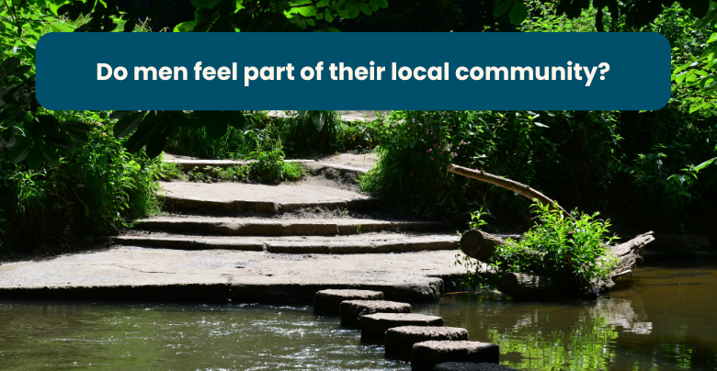


“I wish there were services specifically for men like me - not just general mental health support, but somewhere to talk about….my relationship and my mental health. I need a place where it’s safe to say I’m struggling without feeling guilty or weak. Peer groups, drop-in sessions, or even one to one support would make a huge difference.”


If you would like a paper copy of this document or require it in an alternative format, please get in touch with us.

Contents
Executive summary 3
Approach and methodology 5
Findings 6
The importance of being part of a community 6
Emotional wellbeing and mental health 10
In focus: Dorking Men’s Shed 16
Conclusion 18
Appendices 19
Summary of recommendations 19
Engagement statistics and demographic data 20
Acknowledgements and thank yous 22
About Healthwatch Surrey 23
Contact us 24

Executive summary
In 2024 nearly three quarters (74%) of suicides in England and Wales were male. (Suicides in England and Wales - Office for National Statistics). A 2025 study from Healthwatch England found that men are less likely to seek mental health support than women and that men are significantly less likely than women to seek support from friends and family (38% versus 45%). The first ever Men’s Health Strategy for England (published 19 November 2025) demonstrates national recognition of the importance of looking at men’s mental health specifically and the challenges that men face.

Locally, statistics from the Surrey Health and Wellbeing Strategy Index show that Mole Valley has the highest incidence of suicide of all Surrey boroughs. The Dorking and Villages Neighbourhood Area Committee (a pilot scheme which Healthwatch Surrey is a part of) has identified loneliness and isolation as one of the most prevalent issues in the area.

This project (through community based face to face engagement and a supporting survey) sought to:

- Identify the impact which loneliness and isolation has on men’s mental health, what is available to support them and how easy it is to find and access
- Explore whether men feel part of a community and what impact that has on their emotional wellbeing and mental health
- Identify if men know what support is available – what that can look like (that it’s not all clinical) - how to access it, and whether it’s well enough promoted.

The findings indicate that – though the majority of men do feel part of their community - there is a clear desire for deeper connection. While many men value their existing relationships and sense of inclusion, there is a significant appetite for stronger social ties, greater involvement, and more opportunities to engage locally. Men told us that a lack of social ties can lead to feelings of isolation and loneliness and have a significant impact on their mental health.

Although a lot of men would like to do more to support their emotional wellbeing and mental health, barriers included lack of time, lack of awareness about the range of support and services available and a lack of options which really meet their needs.

Our recommendations focus on increasing awareness of, and access to, community based, peer to peer support specifically targeted at men.

A note on study remit
This report is designed to highlight the themes we have been hearing about and includes quotes from local people to provide context on these themes. Whilst this report accurately reflects what we hear from the individuals we speak to, we are aware that it may not be representative of everyone’s views of a particular service.

All appropriate information and signposting has already been given.

If you would like more information or examples of what people have shared, please get in touch.

Approach and methodology

We visited 7 locations in Dorking to speak to a variety of men from different backgrounds.


125 people completed our survey, either online or face to face with us at our engagement events.

The survey examined emotional wellbeing and mental health in relation to perceived community belonging. It also assessed if the services currently provided – whether formal or informal – were sufficient and what stops men from accessing them. The survey was predominantly completed online although paper copies were available.

Although the survey was open to men across Surrey we focused our engagement activities in Dorking and its neighbouring villages.

Engagements took place over a two month period during which we completed the survey with men face to face at supermarkets, the community fridge and the local Men’s Shed.

We circulated details of our survey via local companies, the local secondary school in Dorking and through Dorking Wanderers FC.

In total, 81 of the 125 survey respondents (65%) lived in Dorking and the neighbouring villages; the remainder lived in other parts of Surrey.

Throughout the report we have highlighted key differences where relevant or useful.

Prior to the launch of the survey we also spoke to men accessing the most local Andy’s Man Club (in Leatherhead) to build a picture of what men already accessing mental health services felt the barriers were to access and what community means to them – this provided invaluable context to guide our survey and engagement activity.

Findings

The importance of being part of a community

Our research explored what community means to men, whether they feel connected to their local area and what impact it has if they don’t.

The findings show that a strong majority already experience a sense of belonging. However, despite this generally positive picture, there is also a clear desire for deeper connection. While many men recognise and value their existing sense of belonging, there remains significant appetite for stronger relationships, greater inclusion and more opportunities to engage with others locally.

We asked a number of questions about community; what community means to men and if they feel part of theirs locally. 86% of those surveyed (87% of Dorking residents) feel part of theirs. However, almost two thirds (61%) of those in Dorking said they would like to feel more part of their community than they do.

What makes men feel part of their community?
79 out of 125 men asked felt that having people they know living locally was important.

“[Community is] important to me as the idea of “home isn’t good without community around it. Otherwise it’s just a house, or flat, or other domicile.”
Central Dorking, age 25-49

“Even if you’re able to just say good morning to a neighbour it can make you feel like you’re around friends.”
Central Dorking, age 25-49

Men also talked to us about the importance of a sense of shared community.

“Getting out and meeting people or just helping out with something can make a big difference. We all helped with gritting pathways when it was cold and it was great to meet people and feel like you’ve done a good thing.”
Central Dorking, age 25-49

While community is important for men’s wellbeing, what community means to each individual is different. 71% said that doing good work in their area and 68% said that belonging to more local clubs would help their sense of community. In addition, 61% thought having local clubs, sports and social activities were necessary to feel part of their community.

And what stops them?
While 86% of respondents said they feel part of their community, more than half (58%) of those surveyed across Surrey reported finding it difficult to integrate. This included individuals who, though they already feel a sense of belonging, would like to be more involved and face challenges in becoming more engaged.

“We are still new here having arrived from overseas. We are getting there but there was definitely a time where I thought no one knew my name. That is lonely.”
Dorking Rural, age 50-64

When asked what stops them, answers ranged from feeling guilty taking time for themselves (38%) to being too nervous to join new groups (12%).

“I often feel very guilty. We are lucky and privileged in so many ways, we should be content and able to sort ourselves out without putting demands on others.”
Dorking Rural, age 50-64

“I do think about going to the Men’s Shed but I guess I am nervous.”
Dorking Rural, age 50-64

Additional reasons for not feeling part of a community include external pressures such as work being more of a priority and family commitments.

“I work 50 miles away so I leave early and return late. I try hard and if there was a halfway answer I would be a bit more connected.”
Dorking Rural, age 50-64

“[I struggle] balancing my needs with those of others (spouse and family).”
Central Dorking, age 65-79

The impact of not feeling part of a community
100% of the men that don’t consider themselves part of their local community felt that this is important to them.

“Community gives me a strong foundation to everything else in my life.”
Dorking South and Holmwood, age 65-79

The same 100% said not being part of their community made them feel lonely and isolated.

“Everyone I know seems to mind their own lives and business.”
Guildford, 25-49

“I’d like to have more people to talk to.”
Mole Valley, age 65-79

One of the aims of this project was to identify the impact which loneliness and isolation has on men’s mental health. Over half (56%) of the men that said they did not feel part of their community rated their mental health as poor to average.

“I struggle with mental health and find it difficult to meet people. When I do meet people I eventually shutdown and push everyone away.”
Reigate and Banstead, age 25-49
Recommendations
Provide more community based opportunities for men to connect, build relationships and meet others locally.

Consider working with an independent VCSE organisation specialising in community engagement to codesign what would really work for men.

Offer online options for engagement where time pressures or work/family commitments make attending in person sessions difficult.

Emotional wellbeing and mental health

We asked a series of questions about emotional wellbeing and mental health support: what provision currently exists, whether more is needed, and what barriers might prevent men from accessing it. In addition, we wanted to understand how the men we surveyed define ‘support’ itself.

By exploring both availability and perception, we aimed to build a clearer picture of not only what support is accessible, but also what feels relevant, approachable, and valuable to the men in their community.

Our findings show that many men feel guilty about accessing services, as doing so often means taking time away from their families for themselves. We also identified a lack of awareness about the support and services that are available to them.

Why don’t men access support for wellbeing and mental health?
Almost half (41%) of the men surveyed would like to do more to support their wellbeing and mental health. Reasons for not were complex and varied but being ‘time poor’ was a recurring theme, with half of those surveyed (50%) feeling guilty about using any sort of support services.

“[I feel] I shouldn’t spend time enjoying myself if there are things that still need doing. By the time I sit down of an evening the last thing I want to do is go somewhere.”
Waverley, age 25-49

“I want to do more but there is something stopping me. As if I can’t be bothered to do anything but then feeling guilty for not doing anything. The constant feeling of being exhausted.”
Reigate and Banstead, age 25-49

Lack of time could be attributed to family commitments which often take priority over wellbeing.

“In reality, my mental wellbeing is strongly affected by my family, so they need to be happy for me to have permission to be happy. When money is tight and kids are working through neurodiversity, this is something that is a lot to ask for.”
Mole Valley, age unknown

There were a number of men that attributed family life to their current sense of wellbeing.

“I spend time with my children [to support my wellbeing]. Apart from the pleasure it gives me it also gives an incredible sense of purpose.”
Elmbridge, age 25-49

Recommendations
Support men restricted by time pressures by hosting more community and family-friendly activities that fall on weekends and in evenings.

Local support groups: meeting men’s needs?
Just 15 out of 125 men accessed a local group to support their mental health and wellbeing. We can attribute this to a number of factors:

- Lack of knowledge about what is available
- Lack of men’s specific groups
- Not feeling comfortable accessing them.

Lack of options, lack of knowledge of the options, or lack of the right options?
87 out of the 125 men we surveyed either didn’t know what groups were available or didn’t think there were enough of them.

Lack of local groups was a particular issue in the Dorking area.

“I’d like to see a wider geographical spread of physical spaces: more clubs in local communities, particularly those easily accessible after work.”
Mole Valley, age unknown

“Services [in this area] are only available for crisis management and not general mental health maintenance.”
Central Dorking, age 25-49

For many there was a feeling that what is available doesn’t really meet their needs, with more community based spaces a key priority.

“I think we are quite well served with clubs and societies and opportunities to take up support. However, we are rather limited in terms of community spaces that people can just drop into. I can only really think of the Christian Centre or the library. It would be good to have a non-denominational community hub in the town.”
Central Dorking, age 50-64

“We need more early intervention, community based spaces for men, places that aren’t clinical or intimidating.”
Mole Valley, age unknown

“Based on my experience, the biggest missing piece is more readily available, low barrier, peer to peer services.”
Mole Valley, age unknown

Would better information and signposting about the groups which do exist (including that some are informal, peer networks that foster connection and shared experience rather than more structured mental health support) reduce the anxiety that some men face about joining?

“More transparency on the 'how-to' of services [would be helpful]; men don't know how services like Andy’s Man Club work. A simple, clear 60 second video explaining the Andy’s Man Club format – 'turn up, get a brew, here are the five questions, it's non-judgemental' – would massively reduce apprehension and anxiety.”
Mole Valley, age unknown

“I was terrified of clinical settings, medication and formal 'therapy’.”
Mole Valley, age unknown
A lack of local groups specifically targeted at men was seen as an issue in terms of community integration and mental health.

“I feel part of the community but not fully. For example, I belong to our street WhatsApp and [I’m] also a member of a local gardening group. However, there are no ‘man’ groups locally like Men in Sheds.”
Epsom and Ewell, age 65-79

“Men cover up a lot of their issues, worries and fears through the fear of being labelled weak. More clubs like Pitstop and Andy’s Man Club would be fantastic.”
Mole Valley, age unknown

“The work around men’s mental health is slow, there needs to be an urgency is pushing this and ensuring more men are engaging with services available, when you actually look to identify such groups for men there is a huge lack.”
Mole Valley, age unknown

A lot of the community groups available both in Dorking and in Surrey more widely are aimed at both men and women, which is off putting for some men who would feel more comfortable in a male only space.

“I wish there were services specifically for men like me not just general mental health support, but somewhere to talk about….my relationship, and my mental health. I need a place where it’s safe to say I’m struggling without feeling guilty or weak. Peer groups, drop in sessions, or even one to one support would make a huge difference.”
Mole Valley, age unknown

Recommendations
Ensure that men accessing community based support are informed about additional, more formal services that are available to them.

Increase men only mental health community support in Dorking and across Surrey, either by establishing new initiatives or expanding existing provision.

Strengthen the advertising and promotion of available services to reach more men who may benefit from them – whether formal or informal services.

Work with men who are already accessing services to serve as ‘community champions’ to encourage other men to attend.

Support for young people in Dorking

There was some concern about the lack of youth facilities in the Dorking area.

“Not enough youth clubs, and there are lots of people with issues at the [community] fridge.”
Dorking Rural, age 65-79

“Some organisations are in place to join, but I am concerned at the lack of facilities such as youth clubs for the younger generation to socialise and continue with friendships from school or college.”
Dorking South, age 65-79

We spoke to some younger men who had previously accessed services, who told us how isolated they felt now they weren’t being supported in the same way.

“[Being at the] Amber Foundation meant that I had people locally to talk to, I don’t now. Last week I didn’t even leave my room for 5 days.”
Dorking Hills, age 18-24*

Transport (or lack of) also plays a part in the accessibility of services for younger men, particularly those who live in the outer villages in Dorking.

*signposted to Mary Frances Trust and Dorking Men’s Shed

Recommendations
Encourage and support the development of more youth focused groups for younger men in the Dorking area.

In focus: Dorking Men’s Shed

Launched in 2019 Dorking Men’s Shed is a dedicated community hub that has been set up by men, for men, to help build connections and improve mental wellbeing through sharing skills, creativity and conversation. The shed helps men to connect, converse and create, with activities similar to those of garden sheds and workshops.

They have a membership of over 70 men, aged 30-90+, with new enquiries weekly. However, they are currently considering limiting the membership due to their temporary premises not being fit for purpose for such a large group. At present, they have a regular attendance of 25-30 people on a Thursday and 35-40 on a Saturday.

They hold monthly fish and chip suppers, summer BBQs, Christmas meals at a local village hall and other social events for their members to attend.

Many of the members are from Dorking and surrounds, but there are also members from Wallington, Banstead, Bookham and Leatherhead who come regularly.

28 of our survey respondents are using Dorking Men’s Shed. All of the men that utilise the Shed live in Mole Valley (though not necessarily Dorking). 25 of 28 users rate their mental health as either good or very good.

“I have recently moved to Dorking and have found church and Men's Shed very helpful in quickly helping me integrate socially.”
Central Dorking, age 65-79

“Before moving to Dorking I had not come across Men’s Shed organisations, but I have found it excellent in providing support for men; as most organisations are dominated by women even if they have not been set up exclusively for women e.g. U3A.”
Central Dorking, age 65-79

“Having lived in Dorking since 2013, I mixed with long- standing out of area friends and in reality I knew very few people until 2019 when I was asking to join Dorking Men’s Shed. I now know all 60 members and socialise with a good few of those on a regular basis. My partner has also made friends with some of the members’ wives / partners.”
Dorking South and Holmwood, age 65-79

It was clear from the men that we spoke to at the Shed that this is a vital resource in the area and there is an appetite to grow their membership. However, until a more suitable premises can be found the group are limited in how much they can help local men.

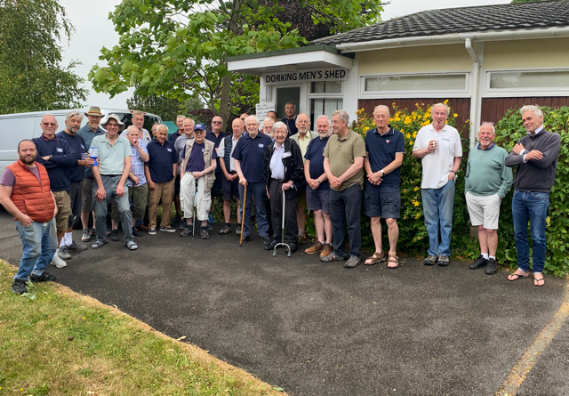

Conclusion
Men who do not feel part of a community are more likely to experience poorer mental health and reduced overall wellbeing. Greater support is needed for those who struggle to feel included, in order to prevent more serious mental health challenges developing over time. There are several ways this can be addressed.

There needs to be clearer and more consistent communication about the services available and how men can access them. Support should be easy to reach and designed without barriers or expectations that may discourage men from engaging.

The Men’s Shed Dorking is a strong example of a community space where men can come together in an informal setting and engage in peer to peer interaction without external pressures. More groups with this same level of informality should be established, alongside increased investment in existing initiatives, to enable men from a wider range of backgrounds to participate - regardless of time constraints or family commitments that might otherwise limit their involvement.

Appendices

Summary of recommendations

Provide more community based opportunities for men to connect, build relationships and meet others locally.

Consider working with an independent VCSE organisation specialising in community engagement to co-design what would really work for men.

Offer online options for engagement where time pressures or work/family commitments make attending in person sessions difficult.

Support men restricted by time pressures by hosting more community and family friendly activities that fall on weekends and in evenings.

Ensure that men accessing community based support are informed about additional, more formal services that are available to them

Increase men only mental health community support in Dorking and across Surrey, either by establishing new initiatives or expanding existing provision.

Strengthen the advertising and promotion of available services to reach more men who may benefit from them – whether formal or informal services.

Work with men who are already accessing services to serve as community champions to encourage other men to attend.

Encourage and support the development of more youth focused groups for younger men in the Dorking area.

Engagement statistics and demographic data

Age range of participants:

Carer status:

District/Borough residents:
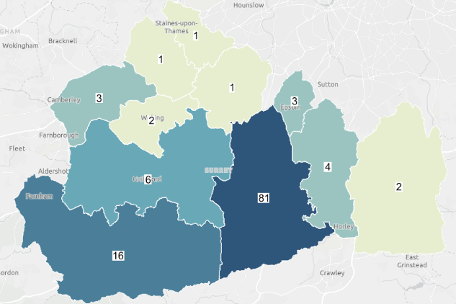

Disability:

Details of long term health condition, disability or impairment | Number of people
Long term health condition | 29
Physical or mobility impairment | 14
Mental health condition | 12
Other | 8
Neurodivergent | 5
Sensory impairment | 4
Prefer not to say | 2
Learning disability | 1
Grand Total | 75

Acknowledgements and thank yous
We would like to thank the following people/organisations for their support.

- Action for Carers Surrey
- Alan Horden, Healthwatch Surrey volunteer
- Andy’s Man Club, Leatherhead
- Ashcombe School, Dorking
- Blair Parrott, Surrey County Council
- Dorking Christian Centre
- Dorking Men’s Shed
- Dorking Wanderers Football Club
- Mary Frances Trust
- Mid-Surrey Community Fridge
- Waitrose Dorking

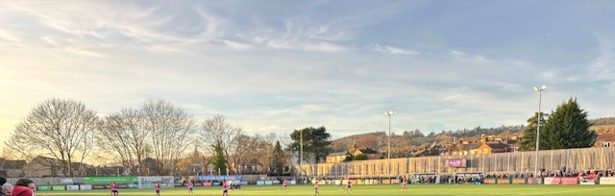

About Healthwatch Surrey
Healthwatch Surrey champions the voice of local people to shape, improve and get the best from NHS, health and social care services. We are independent and have statutory powers to make sure decision makers listen to the experiences of local people.

We passionately believe that listening and responding to local people's experiences is vital to create health and social care services that meet the needs of people in Surrey. We seek out people’s experiences of health and care services, particularly from people whose voices are seldom heard, who might be at risk of health inequalities and whose needs are not met by current services. We share our findings publicly and with service providers and commissioners to influence and challenge current provision and future plans.

We also provide reliable and trustworthy information and signposting about local health and social care services to help people get the support they need.

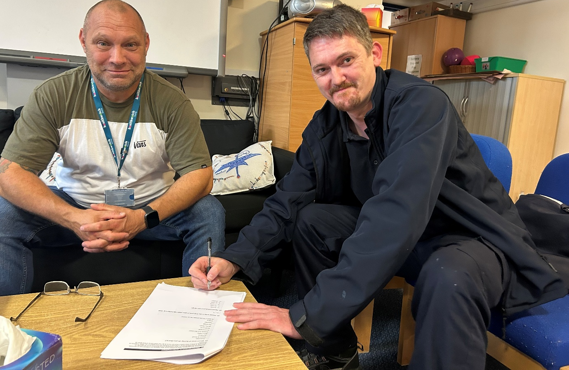


Contact us
Website: www.healthwatchsurrey.co.uk
Phone: 0303 303 0023
Text/SMS: 07592 787533
WhatsApp: 07592 787533
Email: enquiries@healthwatchsurrey.co.uk
Address: Freepost RSYX-ETRE-CXBY, Healthwatch Surrey, Astolat, Coniers Way, Burpham, Guildford, Surrey, GU4 7HL.
 healthwatchsurrey
 healthwatch_surrey
 Healthwatch Surrey


The Healthwatch Surrey service is run by Luminus Insight CIC, known as Luminus. Luminus is a Surrey based, independent, community interest company which exists to empower people to have their voices heard. We help organisations provide equity of access and the best services possible, through the inclusive involvement of local people.


We are committed to the quality of our information.
Every 3 years we perform an audit so that we can be certain of this.


We are proud to have signed up to the End Poverty Pledge –
End Poverty Surrey – Good Company.

