

Making mental health inclusive: supporting people with learning disabilities

June 2025



“We have tried for many years to access support, particularly from learning disability teams but with no success. We continue to struggle daily without the right support.”



**If you would like a paper copy of this document or require it in an alternative format, please get in touch with us.**

Contents

Executive summary 3

Approach and methodology 5

Findings: recognition of emotional distress 7

Findings: How and where do people get support for emotional issues 11

Findings: effectiveness and accessibility of support 14

Findings: the role of primary care 19

Conclusion 20

Acknowledgements and thank yous 22

Healthwatch Surrey 23

Appendix A 25

Appendix B 27

Appendix C 32

# Executive summary

A learning disability is defined as:

“Reduced intellectual function and difficulty with everyday activities. It is characterised by a significantly reduced ability to understand new or complex information, to learn new skills, and with a reduced ability to cope independently. The condition affects someone for their whole life.”

[Mencap, What is a learning disability?](https://www.healthwatchsurrey.co.uk/information-and-advice/resources-for-health-and-social-care-partners/)

[Figures](https://www.mencap.org.uk/learning-disability-explained/research-and-statistics/health/mental-health) show that people with a learning disability are twice as likely to have mental health issues as those without. A [study](https://www.mencap.org.uk/learning-disability-explained/research-and-statistics/health/health-inequalities) in 2017/18 found that severe mental illness was [8.4 times more common](https://www.mencap.org.uk/learning-disability-explained/research-and-statistics/health/health-inequalities#:~:text=In%202017%2F18%20severe%20mental,(NHS%20Digital%2C%202019).)in people with a learning disability than in those without, and that 13.3% of people with a learning disability have an active diagnosis of depression. [NICE Guidance](https://www.nice.org.uk/guidance/ng54/chapter/Recommendations#organisation-and-delivery-of-care-and-support) published in 2016 flagged the need for improved awareness and training for staff working with people with learning disabilities in the assessment of mental health support.

The aim of this study was to explore how access to and experiences of emotional wellbeing and mental health support for people with a learning disability can be improved. We obtained the views of both those with a learning disability, as well as their families and carers, across Surrey. Via an online survey and a series of focus groups, we sought to gain a deeper understanding of:

* How emotional wellbeing is recognised
* How people get support
* How accessible and effective the support is
* The role of primary care in identifying the need for support.

## Recognition of emotional distress

Although the family and carers of those with learning disabilities generally feel able to recognise if the person they care for is struggling with their feelings and emotions, the person they care for may not be able to recognise it in themselves.

The importance of families and carers to those with learning disabilities is therefore two-fold; they are a support mechanism in themselves and are also essential for recognition of emotional distress.

## How and where support for emotional issues is sought

Relatives and carers may not know the most appropriate way to get help and support when they recognise emotional distress. They are often not turning to those with specific mental health training or those equipped to direct them to the most appropriate sources of support. Professionals may also be unsure whether the support should come from learning disability or mental health services.

## Accessibility and effectiveness of support

For those with a learning disability and their families to benefit from support for emotional wellbeing, it needs to be accessible and tailored to their specific needs. However, less than two-thirds of respondents (16 of 27) felt that the services were accessible for the person they care for.

## The role of primary care

Anyone aged 14 or over who is on their GPs learning disability register should have an annual health check; it’s an opportunity to identify any health problems and to help people stay well. However, when asked if emotional wellbeing was included in their annual health check, only a third (33%) felt it was.

## How can emotional wellbeing and mental health support for people with a learning disability be improved?

Carers (both paid and unpaid) need to be equipped to deal with changes in the emotional wellbeing of the people they care for, particularly recognising when distress merits further intervention and knowing who they can refer to. This includes being able to access services which are coordinated and integrated with other areas of care, as well as being fully accessible and tailored to the specific needs of those with a learning disability. Primary care plays an integral role here and an increased focus on emotional wellbeing, for people with learning disabilities as well as their carers, is required.

# Approach and methodology

For this project we wanted to speak directly to people with a learning disability but also to their families and carers.

Views were gathered via:

* An online survey for families and paid carers
* Focus groups with people with learning disabilities.

## Online survey

We asked how confident families and carers felt in recognising whether the people they care for are struggling with their feelings and emotions (as well as if the person themselves would recognise that) and where they have or would seek support (note: a full list of questions can be found in the Appendix B).

A total of **47** people engaged with the survey; **32** people met the criteria for completion. Of those that completed it, the pie chart below shows their ages with 28% of people being aged between 50 – 64 years and 25% of respondents being in either the 25 – 49 or 65 – 79 year age ranges.

Most (**22** of the 32) respondents identified as White[1].

Further demographic information can be found in Appendix A.

## Focus groups

We held **5** focus groups and spoke to **70** people. The Surrey People’s Group and Post 19 Group in Farnham kindly allowed us to hold the events as part of sessions that were already planned, thus ensuring attendees were in environments and with people they were familiar and comfortable with.

The focus groups consisted of a brief presentation about keeping yourself healthy followed by a series of questions for attendees:

* What makes you happy?
* What stops you from doing the things that make you happy?
* What makes you sad?
* Who would you talk to when you are sad?

Respondents were helped to complete the task by the support workers who know them well.

We collated the themes that came from the brainstorm[2] and produced Word Clouds to represent the contributions. The session concluded with a reminder to respondents that everyone gets sad, angry and worried and that it is important to speak to someone.

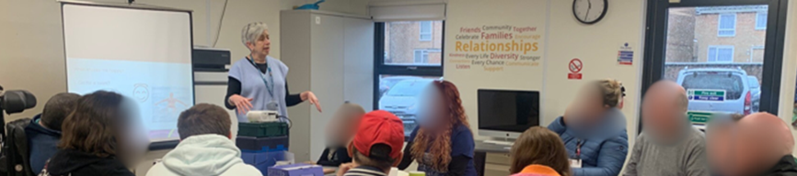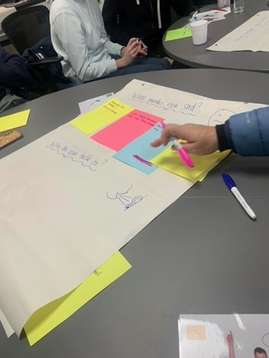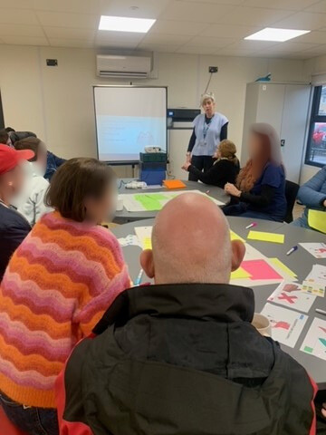

# Findings: recognition of emotional distress

**People with a learning disability rely on family and carers (and support staff) to help them to recognise emotional distress. It is vital that carers (both paid and unpaid) are well supported and equipped to recognise and deal with changes in people’s emotional wellbeing**. **This is especially important to help recognise when intervention is needed to manage distress and knowing who they can refer to.**

## Recognition amongst families / carers

We asked people whether they would be able to recognise if the person they care for was struggling with their feelings and emotions. This covered a range of conditions from mood changes through to mental health conditions.

The chart below shows **over three quarters** (**25** of **32**) of people felt that they would recognise emotional distress in the person/people they care for.

**Would you know if the person/ people you care for are struggling with their feelings and emotions?**

Some of the people completing the survey were paid carers for more than one person with learning disabilities; they felt that they would be able to recognise emotional distress in some of the people that they support but not others. This could be associated with the length of time people had worked with an individual as this may be something that improved with experience generally and/or with improved knowledge of the person.

### Signs of emotional distress

Respondents reported that the following signs would alert them to emotional distress in the people they care for:

“Changes in behaviour and how they respond to certain things.”

“Facial expressions, not interested in eating food or taking drinks, moving here and there as can’t verbally express their emotions.”

“They are much quieter.”

“Body language; repetitive speech; increased rituals; behaviours that can challenge; physical health deterioration - e.g increase in seizures if stressed and anxious.”

## Recognition amongst those with a learning disability

We also asked family/carers whether they believe that the people they care for would recognise emotional distress in themselves. As indicated in the pie chart below, only **38%** (12) felt the people they care for would recognise emotional distress and **22%** (7) felt that some of the people they care for would recognise it. The remaining **40%** (13) were unsure, or felt that the person they look after would not recognise these feelings. Similarly, the focus group attendees found talking about the things that made them ‘happy’ easier than things that made them ‘sad’.

**Do you think the person/ people you care for knows or would know if they were struggling with their feelings and emotions?**

Not seeing people they cared about (mainly family and friends) was the main thing people said made them sad. Bereavement also came up frequently. There were also themes around bullying (“being called names”, “mean texts”, “people being mean”) and also changes to routine or plans, which could be particularly difficult for people with learning disabilities who are also autistic.

**What makes you sad?**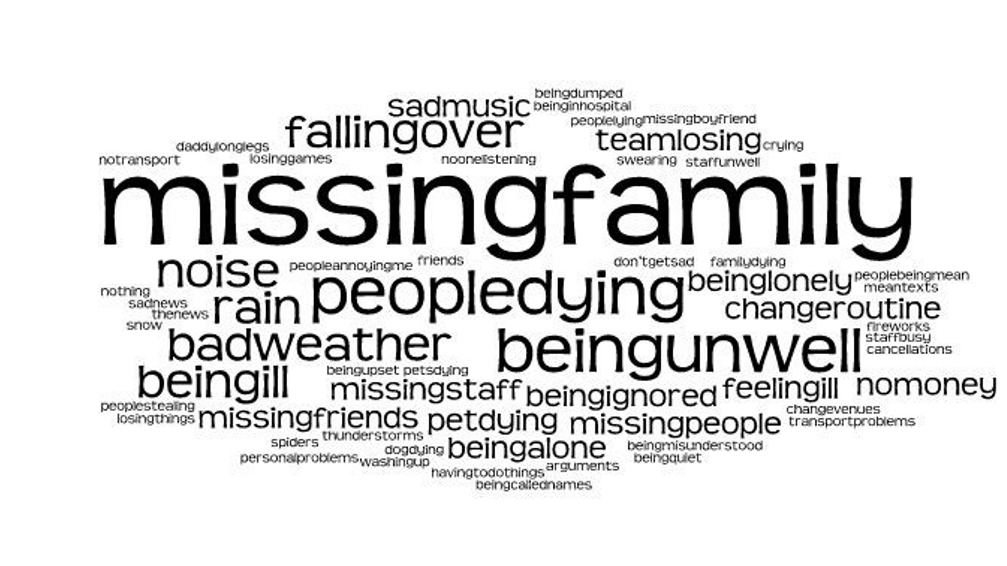

## The importance of carers to support emotional wellbeing

**Half** the family and carers (**16** of the **32**) said that the person they care for would speak to them if they were struggling with their feelings. This was supported by the people with a learning disability who confirmed they would speak to staff or family if they were sad.The focus group attendees alsosaid they would speak to their friends if they were sad. Friends, particularly those who also have a learning disability, may not know how to escalate concern and to whom.

**Who would you talk to?**

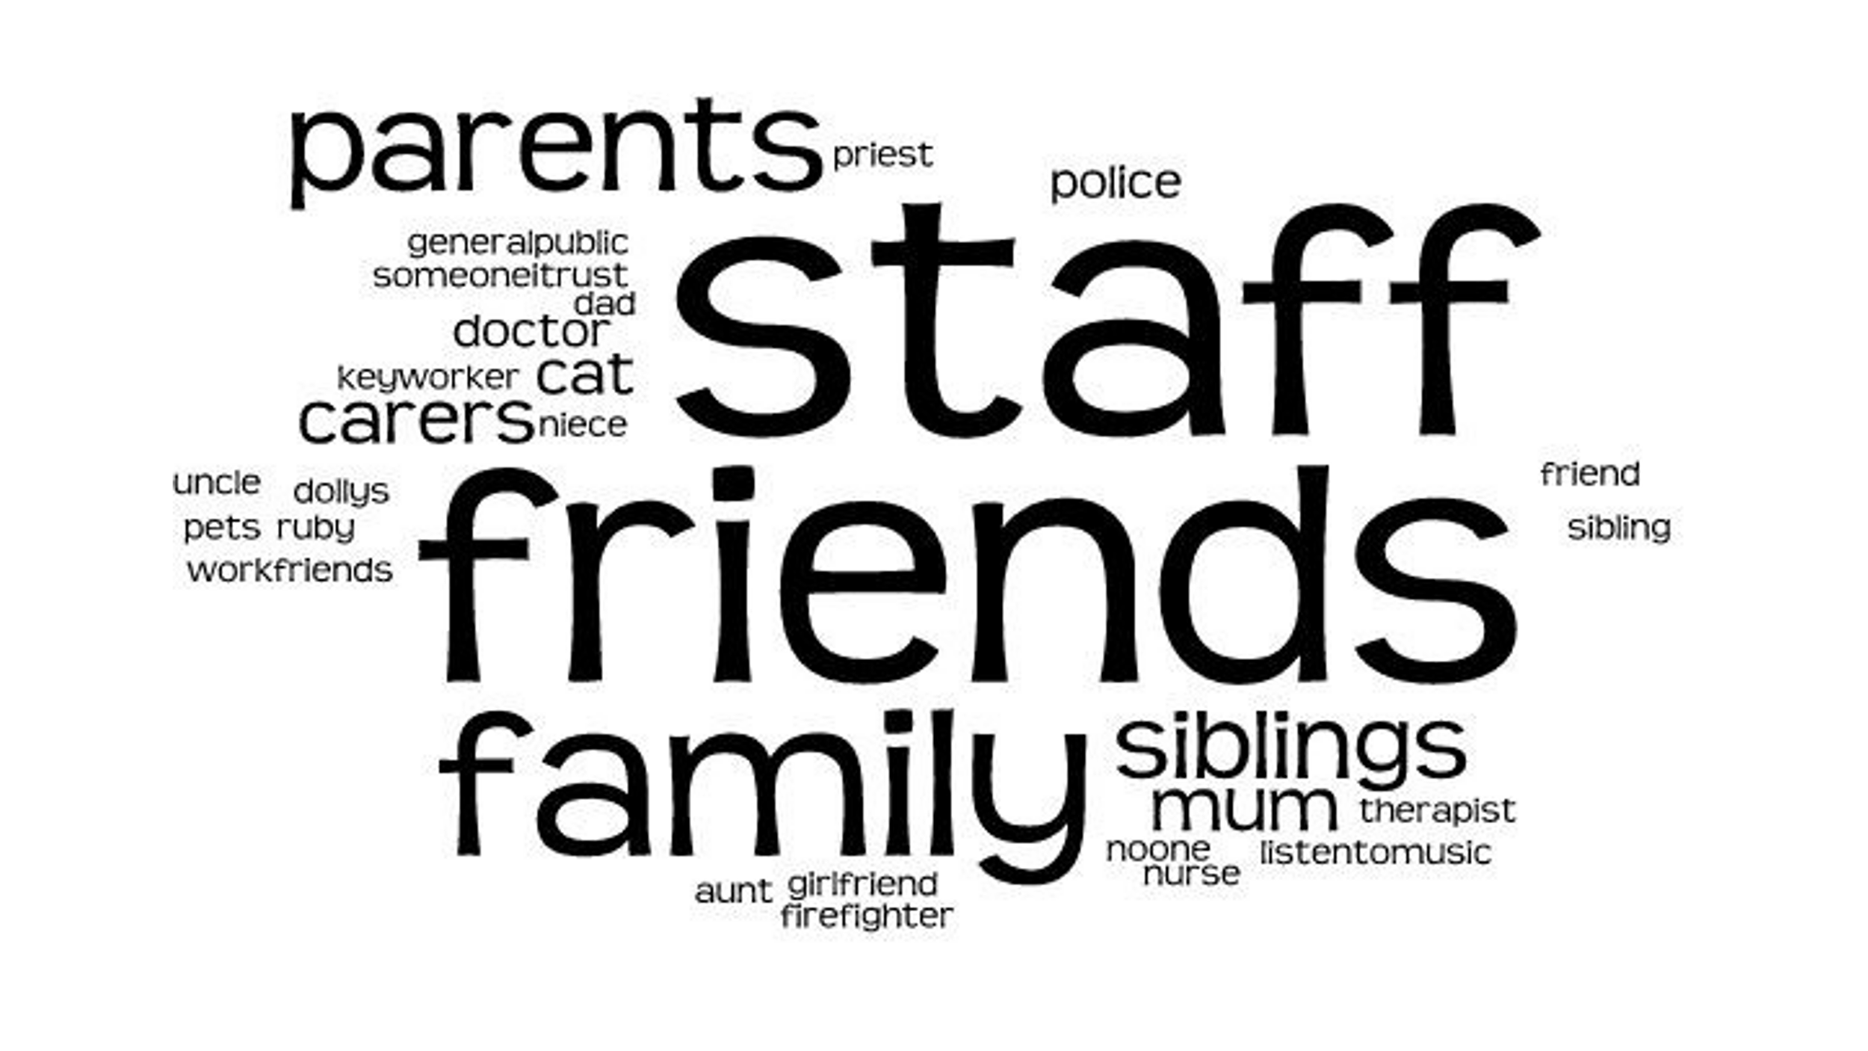

# Findings: How and where do people get support for emotional issues?

**Relatives and carers may not know the most appropriate way to get help and support when they recognise emotional distress. Therefore, there is disparity in where people turn for initial help and advice to deal with this distress. Some people spoke to health professionals (such as the GP or Community Learning Disability staff) others escalated their concerns to other staff (such as teachers or day centre managers). People also spoke to family about their concerns. Across the board, people are often not turning to those with specific mental health training or those equipped to direct them to the most appropriate sources of support. Professionals may also be unsure whether the support should come from learning disability or mental health services.**

## Initial help and advice

Some people felt they had no support:

“I have no one else to consult and neither has he.”

However, of the 32 people who responded, **27** said that they had sought help for the people they care for to manage their emotional wellbeing; some people had spoken to several people to get help. The bar chart shows that of the people who responded, everyone would speak to family or friends. All other people received a mix of yes and no responses but the majority of people would speak to their GP or a paid carer. Others included speaking to paid carers, teachers, day centre manager, other healthcare professionals and other people.

**Who have/would you speak to if you had a concern about the emotional wellbeing or mental health of the person/ people you care for?**

Other healthcare professionals included dieticians, physiotherapist, speech and language therapist and transition team in social care. People may have spoken to the professional they see routinely but many of these may not have had specific mental health training or be equipped to direct people to the most appropriate sources of emotional support.

“The only team that have been able to provide support was the CTPLD [Community Teams for People with Learning Disabilities]. The only issue is that it cannot be open ended. It would be wonderful if my young person could visit regularly to keep them engaged and have an open line of communication with someone they have built a rapport with.”

## Specialist support

Of the 27 respondents most (**23**) went on to get specialist support. Of those, **11** of the 23 had been referred for help by a healthcare professional and **2** of the 23 were signposted. **4** of the 23 did their own research to try to identify specialist support as shown in the pie chart below.

**Why did you go to the person or organisation you went to for support?**

Some paid for care workers would escalate to colleagues within their own teams:

“[I] would inform my line manager or deputy manager or any senior staff on duty and document all as record if any of them not available inform healthcare professionals.”

# Findings: effectiveness and accessibility of support

**As well as the disparity in where people turn for support, there is also disparity in how effective this support is.** **For those with** **learning disabilities and their families to benefit from support for emotional wellbeing, it needs to be accessible, tailored to their specific needs and integrated with other areas of care.**

## Impact and effectiveness of support

Just under **two thirds** of those who had accessed specialist support (**16** of the 26) felt that the intervention had a positive impact, either short or long term as indicated in the pie chart below.

**Did the help or support offered make a difference to the person’s emotional wellbeing/mental health?**

“Social Services responded very quickly and the Learning Disability Team took a bit longer to kick in but we have no complaints. We really feel we have been shown concern, care and a willingness to work towards a productive, positive outcome from all in the Learning Disability Team (admin staff to Consultant).”

However, some people said that they had not been seen:

“Still waiting on an appointment 15 months on...”

Others were not able to comment on the longer term impact:

“It has been fairly recent and ongoing, so difficult to comment on long term impact yet.”

Some people felt that the right services were not necessarily available:

“Negative long term impact as the teams you expect to help are often unable, causing more distress and ongoing referrals. This leads to lots of false hope and time wasting for unpaid carers and the person with the learning disability.”

“This all depends on availability of services and the ability of the person with learning [disabilities] to communicate and understand their emotions.”

## Accessibility and reasonable adjustments

As part of the Equality Act 2010, service providers are required to make 'reasonable adjustments' to allow disabled people to access the same opportunities and services as non-disabled people.

Less than **two-thirds** of respondents who had sought help (**16** of 27) felt that the services were accessible for the person they care for.

“Was told by the GP to refer myself to services but links given were not appropriate for the care support required.”

“Requested through care provider for over a year for help. Had to reach crisis as parents of adults with severe learning disabilities are unable to raise concerns.”

“No. They couldn’t find a way to meet his needs and support him.”

**When you sought help and support was the service accessible for the person you care for?**

Of those that had sought help, almost **half** (**13** of 27) felt that services could have done more to make themselves accessible to the people using them.

“The person I care for would only engage if the therapist established a rapport with him.”

“The assessment process is not accessible, particularly if people ‘appear’ to be able to cope day to day.”

## How could accessibility and effectiveness be improved?

People told us that accessibility of support for those with a learning disability could be improved by:

* Stronger identification of individual needs (and service providers using different communication styles to meet these needs)
* Continuity of care (ability to see the same clinician to establish a rapport)
* Face to face consultations
* Longer appointment slots.

“The therapist had experience both lived and professional of neurodiverse needs which made a difference to enabling them to access it.”

Some people also suggested having an advocate would help with communication both ways.

### The importance of coordination

People told us that they would like services to be more coordinated and for mental health support and services (both designated mental health support as well as those services and activities which support mental wellbeing) to be more integrated with other areas of care.

“I would love for him to have a more regular mental and physical check up - a holistic approach where one team could provide mental health support alongside GP/practice nurse.”

Another respondent agreed, saying that said they would like access to a range of services that could respond to different needs, such as immediate support for suicidal ideas, peer support and activities to encourage physical and emotional wellbeing.

“Perhaps access to a mentor who could check in, meet and support them to engage with other activities.”

“Access to additional meaningful activities out of the home.”

Families and carers mentioned music or art therapy as being particularly useful but it was noted that access to these is often limited. The importance of these creative activities was supported by those with a learning disability themselves. When asked what makes them ‘happy’, music featured highly along with ‘friends’, ‘family’ ‘social groups’ and ‘going out’.

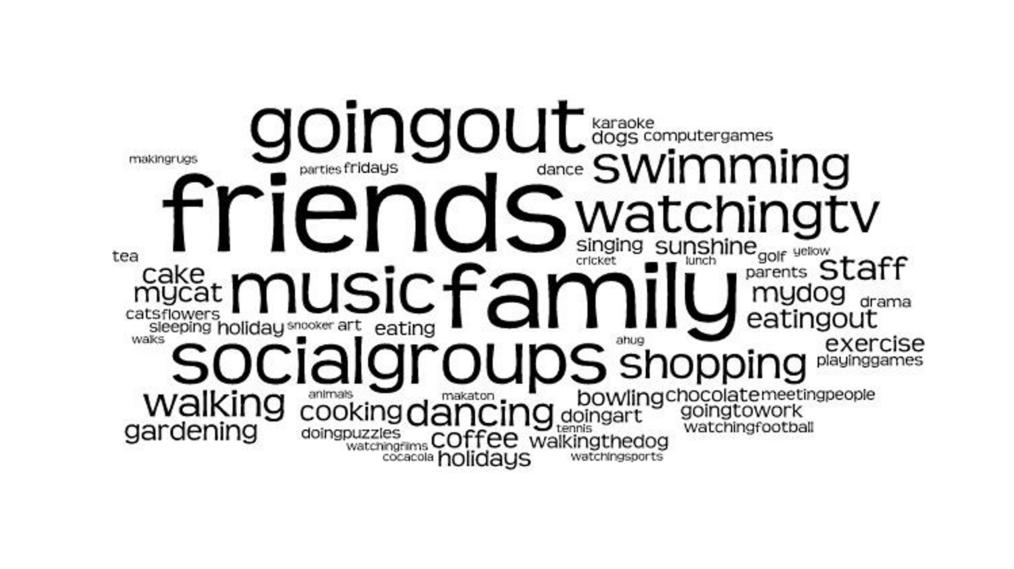

# Findings: the role of primary care

**Annual health checks delivered through primary care play an important role in identifying the support needs of those with** **learning disabilities. However, an increased focus on emotional wellbeing, for people with learning disabilities as well as their carers, is required.**

### Annual health checks

The [NHS](https://www.nhs.uk/conditions/learning-disabilities/annual-health-checks/) recognise that people with a learning disability often have poorer physical and mental health than those without. Anyone aged 14 or over who is on their doctor's learning disability register should therefore have an annual health check; it’s an opportunity to identify any health problems and to help people stay well.

We asked if the people respondents cared for had an annual health check from their GP, the majority of people did as shown in the pie chart below.

**Does the person you care for have an Annual Health Check from their GP practice?**

When asked if emotional wellbeing was included in their annual health check only a **third** (**33%**) felt it was.

# Conclusion

This research took a deep dive into the access to, and experiences of, emotional wellbeing and mental health support for people with learning disabilities. It specifically interrogated how emotional wellbeing is recognised, how support is obtained, how accessible and effective the support currently available is and the role of primary care in identifying the need for support.

The conclusions reached – and recommendations for how things can be improved - can be summarised as follows:

**Recognition of emotional distress**

People with a learning disability might not always recognise when they need help. Conversely, paid and unpaid carers can recognise this need and are in a good position to know when to ask for more support/intervention**.**

However, when carers or those with learning disabilities do ask for help, many don’t know where to turn for support and/or go to professionals who are unable to help directly. If they’re referred/signposted they don’t always follow up or get sent to the right places.

**Paid and unpaid carers** **need appropriate and sufficient support to fulfil their caring responsibilities, including information on the recognition of emotional distress and where and how further support can be accessed.**

**Accessibility and effectiveness of support**

When support is sought it’s not always provided in a person-centred or accessible way, meaning any support/interventions don’t have a lasting impact.

**People with** **learning disabilities need a holistic, integrated approach to care, covering physical and mental health across services. Services designed to provide emotional and mental support should consider their accessibility and whether they can make reasonable adjustments to ensure they can meet the needs of people with learning disabilities.**

**The role of primary care**

Annual health checks delivered through primary care play an important role in identifying the support needs of those with learning disabilities. However, currently carers report they are not being utilised to recognise emotional wellbeing needs.

**Annual health checks should routinely include discussion of emotional wellbeing to more effectively identify behaviour change and adverse life events. This will ensure appropriate assessment and referral for intervention can be made in a timely manner.**

Across the board more needs to be done to ensure that the mental health of those with a learning disability is appropriately monitored, that those caring for them are facilitated and supported to intervene where necessary and that the support offered is appropriate and tailored to the specific needs of this community.

# Acknowledgements and thank yous

We would like to thank everyone who supported us to carry out this research, particularly those with a learning disability and their families who spoke to us and shared their experiences. Also, the teams in health and social care supporting people with learning disabilities, who worked with us to develop the project and allowed us access to learning disability support groups to run focus groups.

* Surrey People’s Groups – especially Dexter James and Phil Mack
* Farnham Post 19 Group – especially Dan McCormack and Lottie Gilroy
* Lynne Ramnanansingh - Surrey Heartlands LeDeR (Learning from lives and deaths of people with a learning disability and autistic people) Team
* Liz Williams - Joint Strategic Commissioning Convener, Surrey County Council
* Lauren Bowller – Learning Disability and Autism Specialist Nurse, Royal Surrey County Hospital
* Amanda Aldridge – Engagement and Partnership Officer, Surrey County Council.

# Healthwatch Surrey

Healthwatch Surrey champions the voice of local people to shape, improve and get the best from NHS, health and social care services. We are independent and have statutory powers to make sure decision makers listen to the experiences of local people.

We passionately believe that listening and responding to local people's experiences is vital to create health and social care services that meet the needs of people in Surrey. We seek out people’s experiences of health and care services, particularly from people whose voices are seldom heard, who might be at risk of health inequalities and whose needs are not met by current services. We share our findings publicly and with service providers and commissioners to influence and challenge current provision and future plans.

We also provide reliable and trustworthy information and signposting about local health and social care services to help people get the support they need.

## Healthwatch Surrey and mental health

Healthwatch Surrey has prioritised mental health as a key area for improvement, and one of their overarching goals is to ensure equitable opportunities for all individuals, particularly those most at risk of health inequalities, to have their voices heard in service design and delivery. The need to identify groups that have difficulty accessing services and better understand their experiences has been identified as a critical part of achieving this goal.

# Appendix A

## Demographic Data

Demographic data from the Smart Survey.

**Geographical location: which area of Surrey do you live in?**

**Gener: what is your gender?**

**Disability: Please select any of the following that apply to you.**

# Appendix B

## Smart Survey questions

This survey ran from 23rd January to 16th March 2025

### How can access to emotional wellbeing and mental health support for people with learning disabilities be improved?

**Introduction**

Healthwatch Surrey are exploring access to and experiences of emotional and mental health support for people who have a learning disabilities. Whilst we are talking to people with a learning disabilities directly, we would also appreciate hearing the experiences of those supporting or caring for them.

Healthwatch Surrey champions the voice of local people to shape, improve and get the best from NHS, health and social care services. As an independent statutory body, we have the power to make sure decision makers listen to your feedback.

Responses to this survey are anonymous and you can complete as much as you wish.

The closing date for the survey is 16th March 2025.

If you are happy, please consent to us storing and anonymously using your answers by ticking the box in question 1 of this survey. We store your data in accordance with current UK data protection legislation, for more information please see our [Privacy statement - Healthwatch Surrey](https://www.healthwatchsurrey.co.uk/privacy-statement/).

You can withdraw or amend your consent at any time by contacting us via:

Email: [enquiries@healthwatchsurrey.co.uk](mailto:enquiries@healthwatchsurrey.co.uk)

Phone: 0303 303 0023

SMS (text only) or WhatsApp: 07592 787533.

**Consent**

Q1

Please consent to us storing and anonymously using your answers by ticking the box below: *

I consent to my answers being stored and used anonymously in a report and supporting communications.

**Questions**

Q2

Do you care for someone with a learning disabilities as a family member, friend or paid carer?

* Yes
* No

Q3

Would you know if the person/ people you care for are struggling with their feelings and emotions?

* Yes
* No
* I don’t know

Q4

What do you look for to identify when the person/ people you care for are struggling with their emotional wellbeing?

Q5

Do you think the person/ people you care for knows or would know if they were struggling with their feelings and emotions?

* Yes
* No
* I don’t know

Q6

Do you think the person/ people you care for would let you know if they were struggling with their feelings and emotions?

* Yes
* No
* Don’t know

Q7

Have you ever sought help and support from any person or organisation regarding the emotional wellbeing and/or mental health of someone with a learning disabilities that you care for?

* Yes
* No
* Don’t know

Q8

Who have/would you speak to if you had a concern about the emotional wellbeing or mental health of the person/ people you care for? (choose all that apply)

* Paid Carers
* GP
* Community Learning Disability Team
* Teachers
* Family and friends
* Other healthcare? Professional (please specify)
* Day Centre Manager
* Other (please specify)

Q9

Why did you go to the person or organisation you went to for support?

* I was referred to them by a healthcare professional
* They were recommended to me by a healthcare professional
* They were recommended to me by someone else
* 'They support my family member/friend'
* 'They support me as an carer
* I found them via my own research

Q10

Did the help or support offered make a difference to the person’s emotional wellbeing/mental health?

* Positive impact long term
* Positive impact short term
* No significant impact
* Negative impact short term
* Negative Impact long term

Please provide further information

Q11

When you sought help and support was the service accessible for the person you care for?

* Yes
* No
* I don’t know

Q12

Could the service have done anything differently to make the support more accessible?

* Yes
* No
* I don’t know

Please provide further information

Q13

Does the person you care for have an annual health check from their GP Practice?

* Yes
* No
* Don’t Know

Q14

Is emotional health and wellbeing covered in the Annual Health Check for the person you care for?

* Yes
* No
* I don’t know

Q15

Are there any emotional wellbeing support services that you would like the person you care for to have access to?

Q16

Do you think there would be any barriers for the person you care for accessing services?

# Appendix C

## Focus group question answers

**What makes you happy?**



**What stops you from doing the things that make you happy?**

## Word cloud for what stops you from doing things that make you happy - key words are: Money, weather, transport, staff availability, work, no internet.

# Contact us

Website: [www.healthwatchsurrey.co.uk](http://www.healthwatchsurrey.co.uk)

Phone: 0303 303 0023

Text/SMS: 07592 787533

WhatsApp: 07592 787533

Email: [enquiries@healthwatchsurrey.co.uk](mailto:enquiries@healthwatchsurrey.co.uk)

Address: Freepost RSYX-ETRE-CXBY, Healthwatch Surrey, Astolat, Coniers Way, Burpham, Guildford, Surrey, GU4 7HL.

Facebook icon [healthwatchsurrey](https://www.facebook.com/healthwatchsurrey)

Instagram Icon [healthwatch_surrey](https://www.instagram.com/healthwatch_surrey)

LinkedIn icon [Healthwatch Surrey](https://www.linkedin.com/company/healthwatch-surrey/)



We are proud to be commended in the National Healthwatch Impact Awards, recognising our work helping to improve local NHS and social care. You can view [our video](https://www.youtube.com/watch?v=y7jVu38Twno) highlighting how feedback has enabled us to make positive changes to health and social care services.



We are committed to the quality of our information.

Every three years we perform an audit so that we can be certain of this.

The Luminus logo. The word Luminus is deep purple in colour. It is in a rounded font. The ‘L’ is a capital but the rest of the word is in lower case. From each side of the dot above the ‘i’ of Luminus are yellow beams which run horizontally stopping to the left before the ‘L’ starts and to the right at the end of the letter ‘s’.

The Healthwatch Surrey service is run by Luminus Insight CIC, known as Luminus.

Registered office: GF21, Astolat, Coniers Way, Burpham, Surrey, GU4 7HL.

1. This is lower than the 85.5% of people in Surrey who said they were White British in the 2021 Census.
2. Where there were similar responses a key term was used (e.g. family = families, family and Social Groups = Valuing People Group or Post 19 Group).