

Left on the shelf:

Why Surrey’s library independence courses and community centres go unused

Surrey County Council (SCC) run a free 8 week course to teach skills that support independence. The aim is that participants leave feeling more connected to their community and other residents, and more informed about the support available to them, ultimately helping to combat loneliness.
But why is uptake so low? Are the right cohort of people being reached?
SCC also told us there has been a downturn in community centre attendance – is, as is believed, the cost of transport to get there really the issue?


What did we do?
34 Surrey residents spoke to us at 3 community settings - the Spire Café in Farnham, Roots Café in Epsom and Oasis group in Camberley – and via a survey.

Key findings: library independence courses
There is a cohort of people who would be interested in the course, but we need to find
new ways to reach them to promote it.

- Two thirds of the people we heard from had visited a library but only 6 were aware of the course and no one had attended one.
- 12 people were interested in attending the course after an explanation of what it entailed. Of these, only 1 had heard of it.
- We asked people which of the 6 elements of the course they’d find interesting; many people said they would find it all interesting, but most appealing were the sessions on “staying independent” and “avoiding scams.”
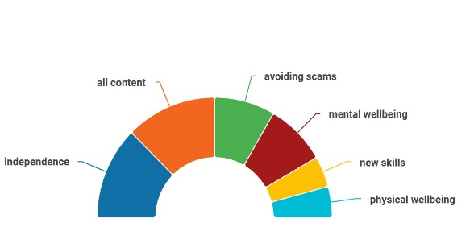


“I will be referring my mum to the course as she is very vulnerable to financial scams”. Female, Reigate and Banstead 25-49.

- The main reason for people not being interested was simply not having a “need” for it. However, some people shared concerns about getting there, the location and the 8 week time commitment.

Key findings: community / day / social centres
The majority of respondents had heard of these but less than half had visited.

Those who had visited had done so for a variety of reasons. 6 people were current users. People commented on the “community spirit” and “friendly staff” and one person said:

“It offers a range of activities for people who might otherwise be isolated. Also, the lunch club is a great service”. Female, Reigate and Banstead 50-64

- The main reason for not using community/day centres were once again a belief that they didn’t need it.

Key findings: where are people going? And what motivates them?
People told us that they attend social groups for friendship, exercise, mental
stimulation, and because they are convenient.

- Of the 12 people who said they were interested in the library independence course, 9 of them currently attend the following groups:

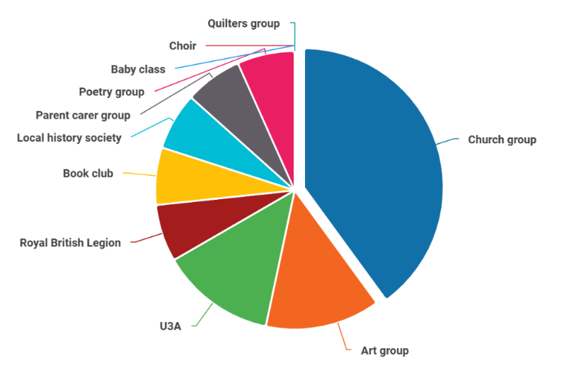

Recommendation: Target social groups– possibly via a roadshow - to promote the library independence course and community centres.

- Of the 11 people who don’t currently attend any social groups, 2 said that they would like to, and gave the following reasons:

“To have people to talk to and to combat loneliness.”

“It depends on what social groups, but some groups are good at helping and supporting each other.”

- One person who doesn’t currently attend a group and doesn’t want to, gave the following reason:

“I get nervous in groups, and this can put me off.”

Recommendation: Offer a buddy/befriending service (not just for the elderly) to encourage those feeling nervous to attend.

- People told us that they would be more likely to attend somewhere that’s easy to get to. Almost half of our respondents said that they walk to the social group that they attend and a third that said that they drive themselves. Others took the bus or got a lift. No one used community transport or private taxis.
- One person told us:

“It is a matter of getting there, it is too far away. If there was a way, I would.” Male, Waverley, 65-79

Recommendation: Raise awareness of community transport.

There is interest in the library independence courses and the support which community centres can offer, but more needs to be done to alert people to them and to ensure they’re accessible.

Do you have any experience of library independence courses and / or community centres? We’d love to hear from you.

