

Insight Bulletin

October 2024

A large speech mark, outlined in pink.

“There is a 3-4 week wait for a face to face appointment. They do offer you a phone call before that, but sometimes I need a face to face quicker than they can offer it… I've got to wait another month to see my named GP. They won't let me see another, even though I don't really care who I see. It’s made me anxious waiting this long.”



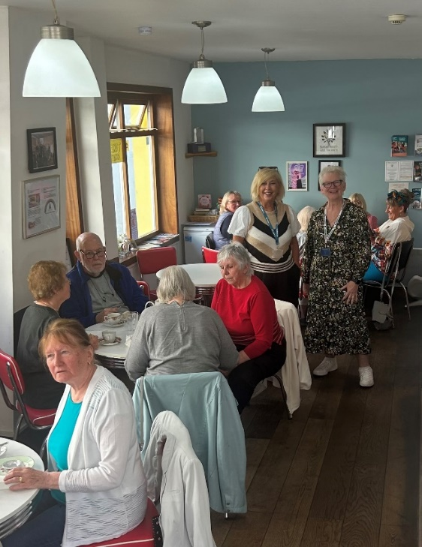

**If you would like a paper copy of this document or require it in an alternative format, please get in touch with** **us.**

# This bulletin: at a glance

## Hot topics

In this bulletin we are focussing on 4 key areas:

* Thanks and praise
* Secondary care: Over stretched services affecting quality of care
* Primary care: waiting lists for face to face appointments and digital exclusion a continuing challenge for patients
* Confusion around weight loss support

We also have a spotlight on our report ‘Neurodivergent people’s experiences of outpatients in Surrey hospitals’ and an update on the Healthwatch Surrey team!

## Who have we been hearing from?

Since our last bulletin we’ve heard from **140** people across Surrey, via our Helpdesk or during engagement events in the community.

* **28%** of the feedback relates to GP practices.
* **31%** of the feedback relates to hospitals
* Of those happy to disclose their gender, **65%** identified as female.
* Of those willing to share their age, **62%** were aged over 50
* Of those willing to share, **43%** had a long term condition.

# Thanks and praise

**Some people have shared really positive experiences with us this month, relating to good communication, efficient service and respectful treatment.**

In the case below, despite long waiting times the patient’s overall experience was positive due to good communication.

“At around 2am it was decided maxillofacial would lead and [I would be] “Blue lighted” to St George’s hospital after the anaesthetist examined me [and said I was] fit to travel the journey. Due to the heavy demand on ambulances I was eventually transferred at 7am. Very efficient service and I was kept informed whilst they decided on treatment.”

221636, Epsom and Ewell resident

“I was having a day case procedure yesterday in hospital. Everyone was very professional. The anaesthetist gave me an excellent general anaesthetic and I had no discomfort or side effects. My recovery team treated me with great respect and love. I recovered quickly and was discharged promptly. So that was nice.”

221636, Epsom and Ewell resident

# Secondary care: Overstretched services affecting quality of care

# ****On 12 September**** Lord Darzi's report on the state of the NHS in England noted that it was in a ‘critical condition’. Talking specifically about A&E, Lord Darzi noted that “Very long waits in A&E have become all too common, and they are a quality of care issue as well as an access problem.”

Here in Surrey people have shared their experiences of treatment in A&E, and in other departments where they felt that their concerns around quality of care weren’t being addressed.

“I arrived [in A&E] to have my cauterization and the practitioner came and spoke to me and told me that I would either need to accept a student carrying out the procedure, or they would be unable to help me. I needed the issue resolved, so I accepted. However, the student had never done this procedure before, and did not know how to use the equipment required. This means that I have now suffered several burns on the inside and outside of my nose. I feel that I was intimidated into accepting the student, and the student was intimidated into carrying out the procedure, because he looked horrified at the end.”

220162, Surrey resident

“I made multiple complaints in the ward about his treatment. He wasn’t being washed or helped to the toilet. He wasn’t being fed. They were treating him as if nothing else could be done for him. They had several ‘best interests’ meetings with me about his quality of life but I wasn’t being listened to. What they were saying about his condition I didn’t agree with.”

220387, Surrey resident

# General Practice: misunderstanding around triage and digital exclusion a continuing challenge for patients

We continue to hear that, though same day remote appointments are easy to access, requesting to see a clinician face to face can often lead to an extended waiting time, and increased anxiety for patients.

“There is a 3-4 week wait for a face to face appointment. They do offer you a phone call before that, but sometimes I need a face to face quicker than they can offer it… I've got to wait another month to see my named GP. They won't let me see another, even though I don't really care who I see. It’s made me anxious waiting this long.”

221610, Waverley resident

“It is not as good as before. Waiting times are a lot longer on the phone, and also a lot longer to get an appointment. I was told I'd have to wait two weeks.”

222025, North West Surrey resident

There is often an assumption made that people will be able to adapt to changes and navigate them by themselves without any support from services:

“This is about my mother in-law aged 89yrs. She is very together and for her age is brilliant with apps, emails etc.. However, our local surgery seem to have tightened their belts with regards to access due to using the NHS App more.

They seem to be aware that there are issues but they told my mother in-law that they had sent her an email regarding deleting & re-installing the app and doing all sorts of "things". She never received the email. the receptionist printed it off and gave it to her and left an 89yr old to sort it out herself.”

219887, Weybridge resident

# Confusion around weight loss support

It’s unusual for us to hear about weight loss support but some people have talked to us about this topic this month. Residents have expressed confusion about the options available or dissatisfaction with what they have been able to access.

“What is NHS weight loss support? If it exists, I haven't been told.”

221640, Surrey resident via Healthwatch England

“The options were not at all helpful. As someone with mobility and allergy problems the suggestion of a weight loss clinic or online was pointless and not at all motivational.”

221638, Surrey resident via Healthwatch England

“I was referred for NHS weight management from my endocrine consultant via a GP referral. It was a complete waste of time… I got offered Slimming World (already doing that!) or an online service. I opted for that, then had conflicting phone calls about being eligible as my BMI wasn’t high enough, then told off for not registering online. I don’t know where they got my weight from, nobody asked for it. Eventually a human spoke to me and I could register after all. The online service was hopeless, they told me to read about healthy eating which I knew about, and to take exercise!! All I wanted to do was to speak to a dietician for advice.”

221946, Surrey resident via Healthwatch England

# SPOTLIGHT ON: Neurodivergent people’s experiences of outpatients in Surrey hospitals

**Neurodivergent people are one of the priority populations for Surrey, recognised in the** [**Health and Wellbeing Strategy**](https://www.healthysurrey.org.uk/about/strategy) **as a community who may experience poorer health outcomes or health inequalities.**

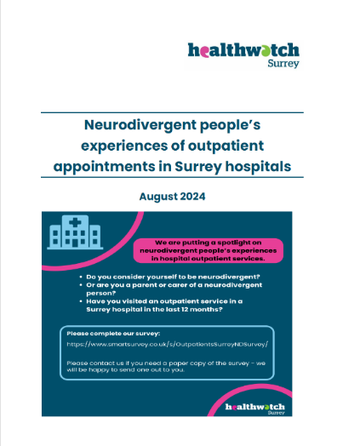

This month we published a new [report](https://www.healthwatchsurrey.co.uk/report/neurodivergent-peoples-experiences-of-outpatients-in-surrey-hospitals-september-2024/) highlighting the experiences of neurodivergent people before, during and after outpatient appointments, and making recommendations for how their experiences could be improved.

70 people (people with or waiting for a neurodivergent diagnosis and parent/carers of neurodivergent people) shared their experiences with us.

### Key findings

We identified 7 key themes which we based our recommendations on:

1. Environment
2. Information
3. Communication
4. Waiting Times
5. Length of appointment
6. Clinical
7. Training and awareness of neurodiversity

Our recommendations have been shared with all 5 Surrey hospital trusts for their consideration and response.

# Meet the Healthwatch Surrey Team!

There have been some exciting changes and new additions to the [Healthwatch Surrey team](https://www.healthwatchsurrey.co.uk/about-us/our-team/) recently!

Please get in touch if you'd like to find out more about what we do, what we’re working on and how we might be able to collaborate. We’d love to hear from you!

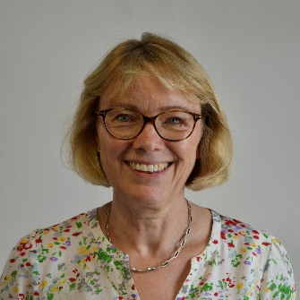

**Kate Scribbins, Chief Executive**

[Kate.scribbins@healthwatchsurrey.co.uk](mailto:Kate.scribbins@healthwatchsurrey.co.uk)

Kate provides **leadership and direction** to the Healthwatch Surrey and wider Luminus team.

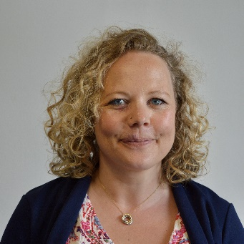

**Sam Botsford, Healthwatch Surrey Contract Manager**

[Samantha.botsford@healthwwatchsurrey.co.cuk](mailto:Samantha.botsford@healthwwatchsurrey.co.cuk)

Sam **oversees the** **delivery of the Healthwatch Surrey contract** and the strategic direction of our activity.

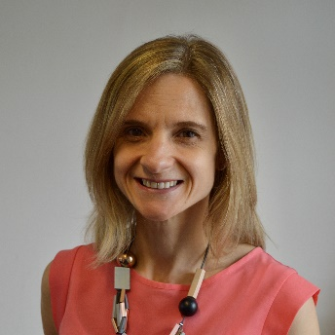

**Abby Rodd, Healthwatch Surrey Deputy Contract Manager**

[Abby.rodd@healthwatchsurrey.co.uk](mailto:Abby.rodd@healthwatchsurrey.co.uk)

Abby **supports the** **delivery of the Healthwatch Surrey contract** and is also Place lead for **Guildford and Waverley.**

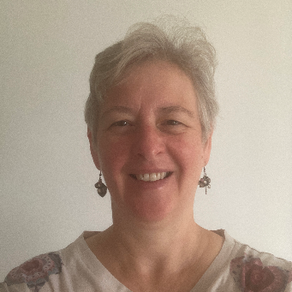**Vicky Rushworth, Communications Lead**

[Vicky.rushworth@healthwatchsurrey.co.uk](mailto:Vicky.rushworth@healthwatchsurrey.co.uk)

Vicky is responsible for our **internal and external communications.**

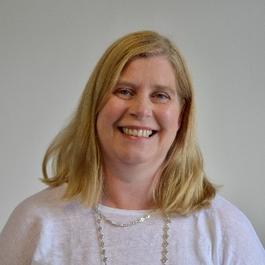**Katharine Newman, Insight and Engagement Officer**

[Katharine.newman@healthwatchsurrey.co.uk](mailto:Katharine.newman@healthwatchsurrey.co.uk)

Katharine is Place Lead for **North West Surrey Place** and priority coordinator for **Social Care.**

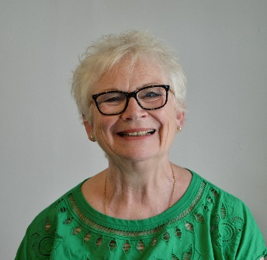

**Julie Calin, Insight and Engagement Officer**

[Julie.calin@healthwatchsurrey.co.uk](mailto:Julie.calin@healthwatchsurrey.co.uk)

Julie is Place Lead for **East Surrey** **Place** and priority coordinator for the **Involvement of People**.

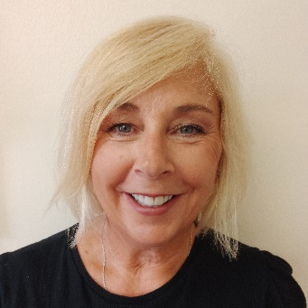**Lou Danaher, Insight and Engagement Officer**

[Louise.danaher@healthwatchsurrey.co.uk](mailto:Louise.danaher@healthwatchsurrey.co.uk)

Lou is Place Lead for **Surrey Heath Place** and priority coordinator for **Primary Care.**

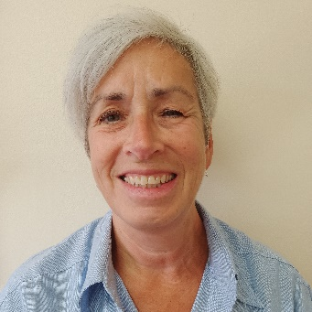**Shelley Cummings, Insight and Engagement Officer**

[Shelley.cummings@healthwatchsurrey.co.uk](mailto:Shelley.cummings@healthwatchsurrey.co.uk)

Shelley is Place Lead for **Surrey Downs Place** and priority coordinator for **Mental Health**.

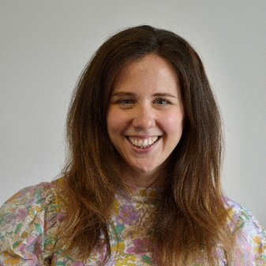**Hannah Gilmour, Volunteer and Engagement Officer**

[Hannah.gilmour@healthwatchsurrey.co.uk](mailto:Hannah.gilmour@healthwatchsurrey.co.uk)

Hannah **manages and supports our wonderful team of volunteers.**



**Ellen Evans, Information and Advice Officer**

[Ellen.evans@healthwatchsurrey.co.uk](mailto:Ellen.evans@healthwatchsurrey.co.uk)

Ellen works on our busy **Helpdesk** and helps to ensure that our **signposting** information is always up to date. She is also out and about in the community engaging with Surrey residents.

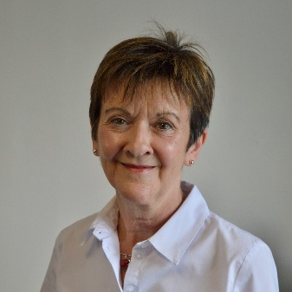

**Maureen Carroll, Information and Advice Officer**

[maureen.carroll@healthwatchsurrey.co.uk](mailto:maureen.carroll@healthwatchsurrey.co.uk)

Maureen also works on our **Helpdesk** and out and about in the community.

# Event invitation: Find out more about

# co-production

## Luminus



Did you know that the Healthwatch Surrey service is delivered by [Luminus](https://luminus-cic.uk/services/public-involvement-for-the-combating-drugs-partnership/)?

Luminus is a Surrey based independent community interest company which exists to empower people to have their voices heard. We are an enterprise driven by social value, that invests in the local community. We help organisations provide equity of access, and the best services possible, through the inclusive involvement of local people. Our vision is to create a society where everyone’s voice is heard so we all receive the support we need for our wellbeing.

As Luminus we can be commissioned for projects that fall outside our remit as Healthwatch Surrey. Please contact our COO, Lisa Sian ([lisa.sian@luminus.co.uk](mailto:lisa.sian@luminus.co.uk)), for more information.

## Co-production Lunch and learn

Our Luminus colleagues are running **2 free online lunch and learn sessions** next month, exploring the key elements needed for making co-production a success.

Aimed at people working in health, social care, public services or university research roles who would like to co-produce with people from a range of communities, the sessions will be run by Becki Meakin, Research Manager at Luminus.

Understanding co-production: Tuesday 12 November, 12 – 1pm

[Eventbrite booking page](https://gbr01.safelinks.protection.outlook.com/?url=https%3A%2F%2Fwww.eventbrite.co.uk%2Fe%2Funderstanding-co-production-tickets-1008215518757%3Futm-campaign%3Dsocial%26utm-content%3Dattendeeshare%26utm-medium%3Ddiscovery%26utm-term%3Dlisting%26utm-source%3Dcp%26aff%3Debdsshcopyurl&data=05%7C02%7CAbby.Rodd%40healthwatchsurrey.co.uk%7C6fd1f1a4a58f45c62b2408dcd62b4260%7C80dab1ec97604877b0d434d3f00e7800%7C0%7C0%7C638620728578314898%7CUnknown%7CTWFpbGZsb3d8eyJWIjoiMC4wLjAwMDAiLCJQIjoiV2luMzIiLCJBTiI6Ik1haWwiLCJXVCI6Mn0%3D%7C0%7C%7C%7C&sdata=ub5aq0pI4ivH7dcWkM4L7Jk8De%2BZjVLwnRdpcOg%2F22k%3D&reserved=0)

Co-production in practice: Tuesday 3 December, 12 – 1pm

[Eventbrite booking page](https://gbr01.safelinks.protection.outlook.com/?url=https%3A%2F%2Fwww.eventbrite.co.uk%2Fe%2Fco-production-in-practice-tickets-1009171829107%3Futm-campaign%3Dsocial%26utm-content%3Dattendeeshare%26utm-medium%3Ddiscovery%26utm-term%3Dlisting%26utm-source%3Dcp%26aff%3Debdsshcopyurl&data=05%7C02%7CAbby.Rodd%40healthwatchsurrey.co.uk%7C6fd1f1a4a58f45c62b2408dcd62b4260%7C80dab1ec97604877b0d434d3f00e7800%7C0%7C0%7C638620728578325499%7CUnknown%7CTWFpbGZsb3d8eyJWIjoiMC4wLjAwMDAiLCJQIjoiV2luMzIiLCJBTiI6Ik1haWwiLCJXVCI6Mn0%3D%7C0%7C%7C%7C&sdata=q0Wtso%2B3%2BxYDRNgpECS2NCSQWhrDDJD7gI9zdDvvca8%3D&reserved=0)

You can attend one or both sessions.

If you have any queries, please contact [becki.meakin@luminus-cic.uk](mailto:becki.meakin@luminus-cic.uk)



# Sharing our insight and raising concerns

Whilst this bulletin accurately reflects what we hear from the individuals we speak to, we are aware that it may not be representative of everyone’s views of a particular service. Multiple references to a specific service may be due to where our community engagement has recently taken place.

If we hear a case of concern regarding patient safety, we immediately signpost the sharer to the appropriate body and escalate the case with the provider/commissioner. All appropriate information and signposting has already been given.

We share our wider themes with Trusts, Integrated Care Systems (ICSs), Surrey County Council, Public Health, Care Quality Commission (CQC), and in various boards and groups across Surrey.

If you would like more information or examples of what people have shared with us, please get in touch with us.

# Community engagement

Below are details of our upcoming engagement sessions where we visit venues in local communities to listen to what people think about local health and care services, and to ask specific questions related to [our priorities](https://www.healthwatchsurrey.co.uk/about-us/our-priorities/). We also provide information and signposting regarding health and social care. Each month we focus on a different area of the county. Last month this was Surrey Heath and through October we’ll be focusing in Guildford and Waverley. Throughout the year, we also attend events across Surrey to raise awareness of our work.

|  |  |  |  |  |
| --- | --- | --- | --- | --- |
| Date | Place | Time | Open  to | Surrey Area |
| 01/10/2024 | University of Surrey part time work fair | 11am – 2pm | **Public** | Guildford and Waverley |
| 09/10/2024 | Surrey Heath Citizens Advice team | **10am – 12noon** | **Private** | Surrey Heath |
| 22/10/2024 | Respiratory clinic, Royal Surrey County Hospital | 1.30 – 5pm | **Public** | Guildford and Waverley |
| **30/10/2024** | **The Hive, Guildford** | **10am – 12noon** | **Public** | Guildford and Waverley |
| **07/11/2024** | **Working together for Woking** | **10am – 12noon** | **Public** | **North West Surrey** |

**Please note: these dates may be subject to change.**

To share an experience with us, or for information and signposting about health and social care, people can also contact our Helpdesk in the following ways:

Phone: 0303 303 0023

SMS (text only): 07592 787 533

Email: [enquiries@healthwatchsurrey.co.uk](mailto:enquiries@healthwatchsurrey.co.uk)

Share your feedback via our website: <https://www.healthwatchsurrey.co.uk/feedback-centre/>

# About Healthwatch Surrey

Healthwatch Surrey champions the voice of local people to shape, improve and get the best from NHS, health and social care services. As an independent statutory body, we have the power to make sure decision makers listen to the experiences of local people.

We passionately believe that listening and responding to local people's experiences is vital to create health and social care services that meet the needs of people in Surrey. We seek out people’s experiences of health and care services, particularly from people whose voices are seldom heard, who might be at risk of health inequalities and whose needs are not met by current services. We share our findings publicly and with service providers and commissioners to influence and challenge current provision and future plans.

We also provide reliable and trustworthy information and signposting about local health and social care services to help people get the support they need.

# Our distribution list

If you would like to be added to or removed from the distribution list for this Insight Bulletin, please contact our Communications Lead [vicky.rushworth@healthwatchsurrey.co.uk](mailto:vicky.rushworth@healthwatchsurrey.co.uk)



We are committed to the quality of our information.

Every three years we perform an audit so that we can be certain of this.



The Healthwatch Surrey service is run by Luminus Insight CIC, known as Luminus.

Registered office: GF21, Astolat, Coniers Way, Burpham, Surrey, GU4 7HL.