

Insight bulletin

May 2025

A large speech mark, outlined in pink.

This coordination between specialist, GP, hospital and pharmacy was efficient, and it made me feel valued and cared for.”



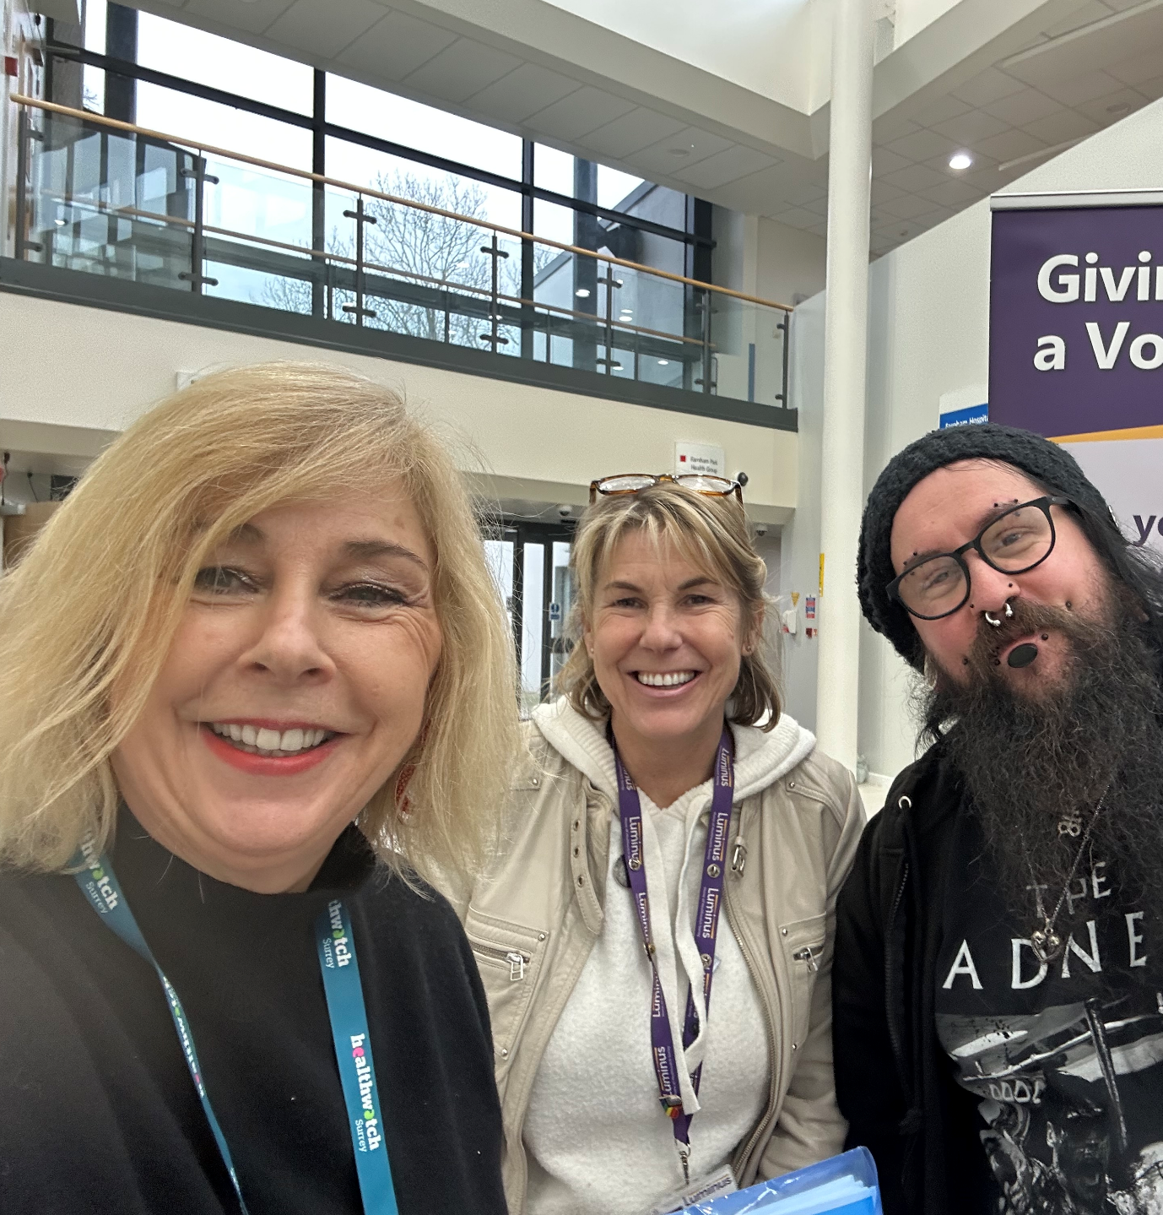

**If you would like a paper copy of this document or require it in an alternative format, please get in touch with** **us.**

# This bulletin: at a glance

## Hot topics

In this bulletin we are focussing on 4 key areas:

* Thanks and praise: GP practices
* Spotlight on: NHS dentistry
* GP practices: patients not feeling listened to
* Hospitals: lack of communication about waiting times causing stress for many

Since our last Insight bulletin we’ve published our [quarterly Impact Report](https://www.healthwatchsurrey.co.uk/report/quarterly-impact-report-january-to-march-2025/), highlighting the impact we made in the fourth quarter of our 2024/25 year (January – March 2025). Read more on page7!

## Who have we been hearing from?

Since our last bulletin* we’ve heard from **118** people across Surrey, via our Helpdesk or during engagement events in the community.

* **39%** of the feedback relates to GP practices
* **32%** of the feedback relates to hospitals
* The majority of the remaining feedback relates to community, social care and mental health services
* Of those willing to share their age, **82%** were aged over 50.

*This covers experiences received between February and the end of March 2025.

# Thanks and praise: GP practices

**We’ve had some really positive feedback on GP practices this month.**

“[The practice] are excellent. Whenever I phone they will see you. I’ve never had a problem, the receptionists are lovely and they will always get back to you.”

229933, Woking resident

“I went into the practice the receptionist was fine and completed a triage form, she did it all. She explained that someone will ring – by 1pm that day we’d had a call and my husband saw a doctor at 2.30pm. The doctor was brilliant, really took his time and explained that if what he’d suggested didn’t work, what else he would suggest.”

229919, Woking resident

In April the Health Services Safety Investigation Body [called on the Government](https://www.hssib.org.uk/patient-safety-investigations/workforce-and-patient-safety/fourth-investigation-report/#analysis-of-the-evidence) to ensure that all patients with long term conditions have their care coordinated and are allocated a single point of contact. People often talk to us about the lack of coordination between services and the negative effect it can have. Conversely, when care is joined up the positive impact can be immeasurable.

“A specialist advised my GP to change my prescription and requested blood tests. My GP produced the blood test form when I requested it and added further tests to check my general health. I booked online [for an appointment at the hospital]. The blood was drawn on Thursday morning at 9am and the GP advised me later that day …this coordination between specialist, GP, hospital and pharmacy was efficient, and it made me feel valued and cared for.”

230027, Surrey Downs resident

Did you know we have [information and advice pages on our website](https://www.healthwatchsurrey.co.uk/information-and-advice/understanding-gp-practices/) to help people understand how GP practices work?

We’ve also been working closely with individual practices - read about that in our [Impact report](https://www.healthwatchsurrey.co.uk/report/quarterly-impact-report-january-to-march-2025/) and in our [What we’re hearing about The Molebridge Practice](https://www.healthwatchsurrey.co.uk/report/what-were-hearing-about-the-molebridge-practice-march-2025/) and [What we’re hearing about Glenlyn Medical Centre](https://www.healthwatchsurrey.co.uk/report/what-were-hearing-about-glenlyn-medical-centre-february-2025/) reports.

# Spotlight on: NHS dentistry

**In March the Government** [**announced that NHS dental charges**](https://questions-statements.parliament.uk/written-statements/detail/2025-03-11/hcws512) **would be increasing by 2.39% from 1st April. Later in the month a** [**report by the Public Accounts Committee**](https://committees.parliament.uk/publications/47347/documents/245396/default/) **challenged the Government to set out the exact cost of providing NHS dentistry and to address concerns by dentists that the current contract doesn’t properly cover the work involved, forcing them to take on private work.**

When people do talk to us about dentistry, it’s often about availability of NHS services and affordability:

“I am on Universal Credit. I have received a bill for dental work which I cannot pay. I called Universal Credit and they said to sort it out with the NHS.”

230562, Surrey Heath resident

People also tell us about poor standards of care which can create a lasting legacy of anxiety:

“I have massive anxiety at the dentist. I’ve been to many, nearly all NHS. And I have been treated appallingly. The first teeth I lost were removed using such force, the dentist removed teeth that weren’t numbed and butchered me during the process.”

230490, Surrey resident

You can read more about NHS dentistry on our [information and signposting pages.](https://www.healthwatchsurrey.co.uk/information-and-advice/dentistry-nhs/)

Earlier this year we attended a Dental Services in Surrey Pre-Market Engagement Event. The event was an opportunity for commissioners, providers and key stakeholders to come together to explore innovative approaches to enhancing the accessibility and quality of NHS dental care. Read more about how we were able to utilise our attendance in our [Impact Report](https://www.healthwatchsurrey.co.uk/report/quarterly-impact-report-january-to-march-2025/).

# GP Practices: patients not feeling listened to

**Despite some very positive feedback on GP practices, people do continue to come to us with their concerns.**

People often tell us that they can feel dismissed or not listened to, and that their individual needs are not being met or even appreciated.

“My GP and the hospital have been pretty much useless. When I am suicidal the GP tells me to go to the hospital as a safe place, when I get to the hospital they give me a leaflet for crisis lines and tell me they can’t help me and tell me to speak to my GP. When I call the GP back then I can’t get past the receptionist and they say they can’t give me an appointment for 2-3 weeks. Not helpful if you are suicidal at all.”

230295, Woking resident

“Sadly, the GP wouldn't refer me and said that basically some women always have pain and nothing can be done. I understand this might be the case and to say such a thing without having gone down every possible avenue feels like I was being fobbed off.”

229463, Surrey Heath resident

In April, new [research from the Royal National Institute for the Deaf](https://signhealth.org.uk/wp-content/uploads/2025/04/ENGLAND-Still-Ignored-The-fight-for-Accessible-Healthcare-policy-report-FINAL.pdf#:~:text=Our%20new%20research%20shows%20that%20the%20NHS%20often,devastating%2C%20as%20we%20set%20out%20on%20pages%2010-17.) (RNID) and SignHealth on the Accessible Information Standard (AIS) revealed that less than a quarter of NHS staff can always meet deaf people's AIS need.

“I asked for a BSL interpreter… the doctor advised they could understand me and therefore I don't need one… [but] it was for **me**.”

230663, Woking resident

You can read more about our work to shine a light on the importance of the Accessible Information Standard in our [Quarter 3 Impact Report](https://www.healthwatchsurrey.co.uk/report/quarterly-impact-report-october-to-december-2024/) .

# Hospitals – lack of communication about waiting times causing stress for many

People tell us that the lack of communication and uncertainty around waiting times and delays is having a negative impact on them in various ways:

“I am now waiting for a follow up appointment with [the hospital]. It mentions in the discharge letter that I have to wait until 3-4 months after having the injection. So it is now coming up to 3 months and I still have not heard anything back from them.”

229724, Surrey Downs resident

“10 month wait from seeing an audiologist to having a hearing aid fitted… Impacted on my job as on the phone all day to outpatients but that was not considered a priority.”

229487, Surrey resident

“My hearing was tested and I was advised I need hearing aids. I was told the waiting list was 6 months. I have now been waiting 8 months. After several emails to them I have been told they are taking on more staff ‘in the next few months’ which should help. At this rate it will be nearly a year’s wait with no feedback at all from the hospital.”

230107, Surrey resident

People are often confused about routes for obtaining further information.

“Still waiting for results of test done in December and for follow up appointment. Consultant also referred to neurologist 4 months ago. Still waiting. No contact details available, had to chase last follow up via PALS and GP and finally got appointment 15 months later.”

230469, Surrey Heath resident

# How have we affected change? Our Quarterly Impact Report

In May we published our [Quarterly Impact Report](https://www.healthwatchsurrey.co.uk/report/quarterly-impact-report-january-to-march-2025/), highlighting some ways we’ve made an impact throughout our final quarter of 2024/25 (January to March 2025).

The report shows the impact we have by:

* Providing information and signposting
* Delivering on our thematic priorities
* Making a difference at system level
* Involving people in health and social care.

In this quarter:

* **122** People were supported through our Helpdesk
* **32** People were supported by our Independent Health Complaints Advocacy service
* **24** Community engagement events were attended
* **363** People were helped and supported whilst on engagement in the community
* **9** Reports were published
* **312** Hours were provided by our volunteers.

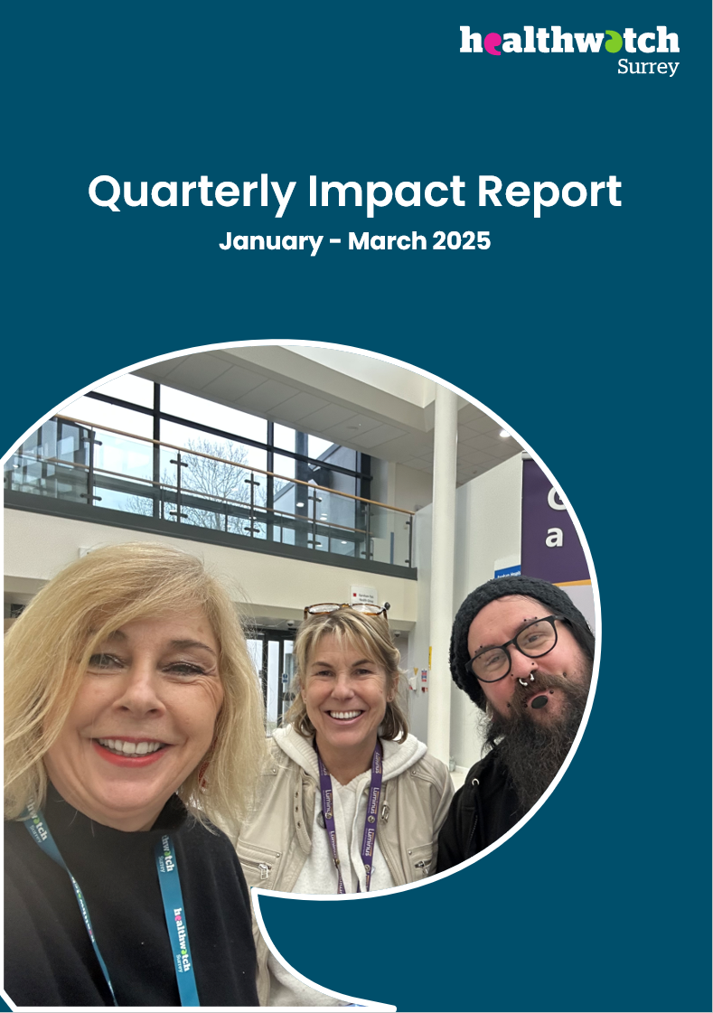

# Have your say!

**A** [**survey by the Royal College of Physicians**](https://www.rcp.ac.uk/news-and-media/news-and-opinion/nearly-90-of-doctors-warn-that-health-inequalities-are-harming-patients/) **found that 72% of doctors reported seeing more patients in the past 3 months with illnesses caused or worsened by wider social determinants of health, such as poor housing, low incomes and air pollution.**

As part of our mental health priority, we are currently looking at the emotional impact of financial insecurity on those with mental health and other long term conditions.

This short survey will take less than 10 minutes to complete so please take the time to tell us what you think and share it with your networks.

<https://www.smartsurvey.co.uk/s/financeandmentalhealth/>

**The more people we hear from, the more impactful our research will be, and the more likely we are to be able to bring about positive change.**

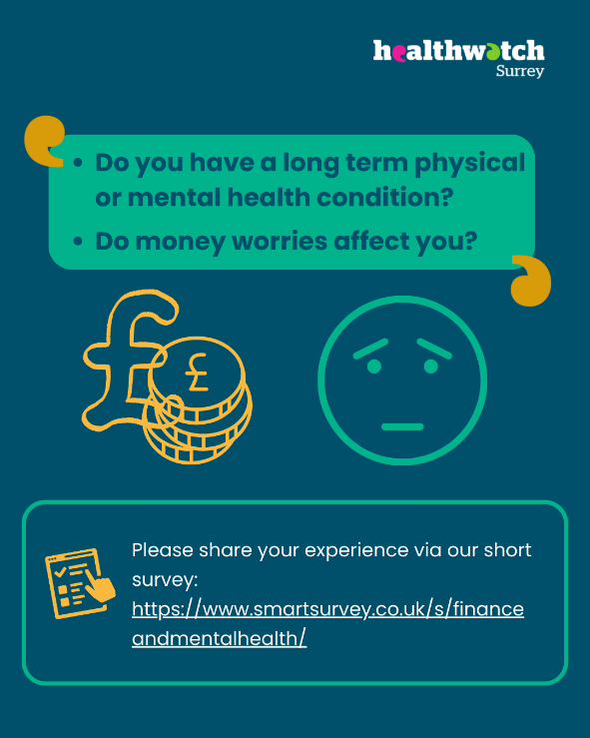

## Watch this space! Upcoming research reports

Our [learning disability and mental health](https://www.healthwatchsurrey.co.uk/news/access-to-emotional-and-mental-health-support-for-people-who-have-a-learning-disability/) and [GP access and domestic abuse](https://www.healthwatchsurrey.co.uk/news/does-your-gp-practice-understand/) surveys have now closed. We will be publishing reports on both over the coming weeks. Please check our website or [contact us](https://www.healthwatchsurrey.co.uk/contact/) for further information.

# Sharing our insight and raising concerns

Whilst this bulletin accurately reflects what we hear from the individuals we speak to, we are aware that it may not be representative of everyone’s views of a particular service. Multiple references to a specific service may be due to where our community engagement has recently taken place.

If we hear a case of concern regarding patient safety, we immediately signpost the sharer to the appropriate body and escalate the case with the provider/commissioner. All appropriate information and signposting has already been given.

We share our wider themes with Trusts, Integrated Care Systems (ICSs), Surrey County Council, Public Health, Care Quality Commission (CQC), and in various boards and groups across Surrey.

If you would like more information or examples of what people have shared with us, please get in touch with us.

# Community engagement

Below are details of our upcoming engagement sessions where we visit venues in local communities to listen to what people think about local health and care services, and to ask specific questions related to [our priorities](https://www.healthwatchsurrey.co.uk/about-us/our-priorities/). We also provide information and signposting regarding health and social care. Throughout the year, we also attend events across Surrey to raise awareness of our work.

|  |  |  |  |
| --- | --- | --- | --- |
| Date | Place | Time | Open to |
| 21/5/2025 | East Surrey College | 11:30am – 2pm | Private |
| 2/6/2025 | St John’s Church, Merrow | 10am – 12noon | Group |
| 4/6/2025 | Hale Community Centre | 3 – 4pm | Group |
| 4/6/2025 | YMCA Horley Young People and Family Centre | 10am – 12noon | Group |
| 24/6/2025 | Godalming College | TBC | Private |
| 28/6/2025 | Royal Surrey County Hospital Open Day | 11am – 3pm | Public |
| 27/7/2025 | Surrey Hills Wellfest, Horsley | 10am – 6pm | Public |

**Please note: these dates may be subject to change.**

To share an experience with us, or for information and signposting about health and social care, people can also contact our Helpdesk in the following ways:

Phone: 0303 303 0023

SMS (text only): 07592 787 533

WhatsApp: 07592 787 533

Email: [enquiries@healthwatchsurrey.co.uk](mailto:enquiries@healthwatchsurrey.co.uk)

Share your feedback via our website: <https://www.healthwatchsurrey.co.uk/feedback-centre/>

# About Healthwatch Surrey

Healthwatch Surrey champions the voice of local people to shape, improve and get the best from NHS, health and social care services. We are independent and have statutory powers to make sure decision makers listen to the experiences of local people.

We passionately believe that listening and responding to local people's experiences is vital to create health and social care services that meet the needs of people in Surrey. We seek out people’s experiences of health and care services, particularly from people whose voices are seldom heard, who might be at risk of health inequalities and whose needs are not met by current services. We share our findings publicly and with service providers and commissioners to influence and challenge current provision and future plans.

We also provide reliable and trustworthy information and signposting about local health and social care services to help people get the support they need.

# Our distribution list

If you would like to be added to or removed from the distribution list for this Insight bulletin, please contact our Communications Lead [vicky.rushworth@healthwatchsurrey.co.uk](mailto:vicky.rushworth@healthwatchsurrey.co.uk)



We are committed to the quality of our information.

Every three years we perform an audit so that we can be certain of this.



The Healthwatch Surrey service is run by Luminus Insight CIC, known as Luminus.

Registered office: GF21, Astolat, Coniers Way, Burpham, Surrey, GU4 7HL.