

Insight bulletin

March 2025

A large speech mark, outlined in pink.

“My wife was discharged from hospital with a care package which I was told was "self funded" but I have no idea how they know how much money I have. Is this allowed without my permission? And how do I get funding? As far as I’m concerned I only have mine and my wife’s pension and I can’t afford to self fund.”



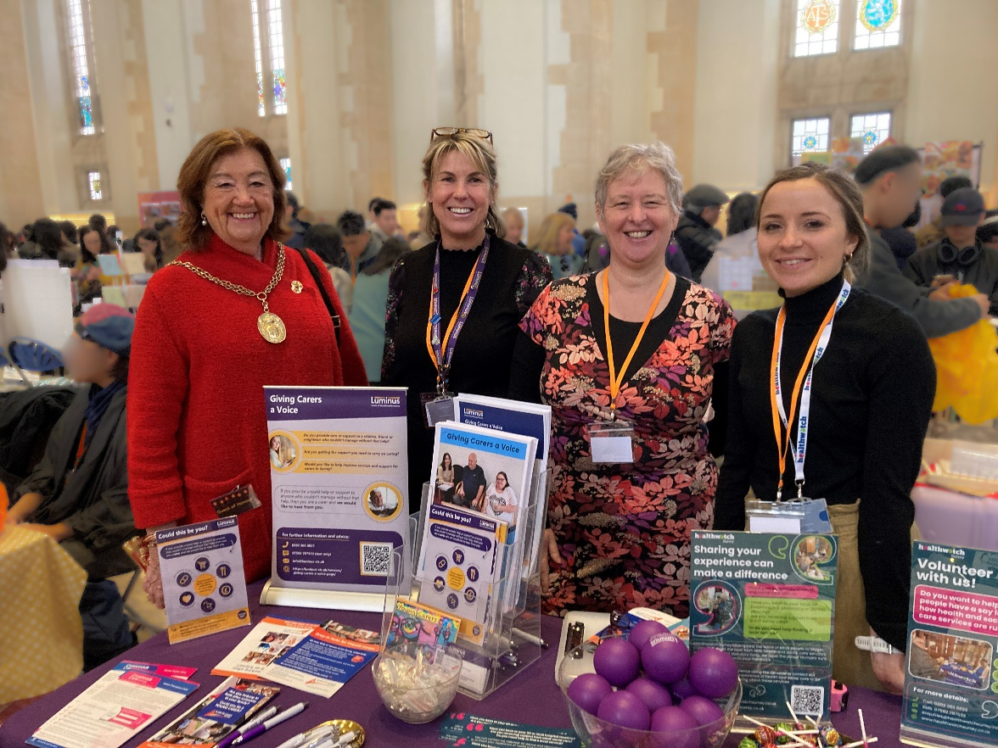

**If you would like a paper copy of this document or require it in an alternative format, please get in touch with** **us.**

# Exciting news!

We’re delighted to share that we’ve been shortlisted for a prestigious **Healthwatch England Impact Award!**

In 2023 we conducted [research](https://www.healthwatchsurrey.co.uk/report/summary-involvement-of-people-feedback-in-hospitals-march-2024/) in Surrey hospitals to understand how effectively each hospital was listening to, and acting on, patient feedback. Each NHS Hospital trust received a personalised report with recommendations, and we are pleased that each has acted on our recommendations to try to improve feedback mechanisms for patients.

We look forward to finding out whether we’ve won at the awards ceremony later this month!

# This bulletin: at a glance

## Hot topics

In this bulletin we are focussing on 4 key areas:

* Thanks and praise: GP practices
* Spotlight on: eye care services
* Spotlight on: social care
* Hospitals: perceived lack of accountability

Since our last Insight bulletin we’ve published our quarterly [Impact Report](https://nds.healthwatch.co.uk/sites/default/files/reports_library/20250120_Complaints%20report%20draft%20FINhttps:/www.healthwatchsurrey.co.uk/report/quarterly-impact-report-october-to-december-2024/AL%20HWE.pdf), highlighting the impact we made in the third quarter of our 2024/25 year (October to December 2024). Read more on page 8!

## Who have we been hearing from?

Since our last bulletin we’ve heard from **181** people across Surrey, via our Helpdesk or during engagement events in the community.

* **31%** of the feedback relates to GP practices
* **44%** of the feedback relates to hospitals
* The majority of the remaining feedback relates to pharmacy, social care and mental health services
* Of those willing to share, **73%** were aged over 50
* Of those willing to share, **51%** had a long term condition.

# Thanks and praise: GP practices

# In January the Government produced its [mandate to NHS England](https://www.gov.uk/government/publications/road-to-recovery-the-governments-2025-mandate-to-nhs-england/road-to-recovery-the-governments-2025-mandate-to-nhs-england), an annual document setting objectives and goals for the year ahead. Healthwatch England provides [formal input](https://www.healthwatch.co.uk/response/2025-01-30/nhs-mandate-what-objectives-should-nhs-focus#:~:text=The%20Government%20publishes%20the%20NHS,be%20included%20in%20these%20objectives.) into the mandate, based on what they’re hearing at a national level and locally through local Healthwatch. This year’s mandate included a commitment to improve GP access, a recommendation made by Healthwatch England. Although difficulties with access is something we continue to hear about (and in a recent [survey](https://www.health.org.uk/press-office/press-releases/gp-access-tops-list-of-public-concerns-about-the-nhs) published by The Health Foundation, GP access topped the list of public concerns about the NHS) this month we’ve heard some positive access stories too!

“I really like the online form to request medical help. I filled out the form and, given the uncertain nature of my symptoms, I suggested having blood tests. Within about 30 minutes I received a text inviting me to book a blood test, including options for the same day. Once the results came in, I was then sent a GP appointment.”

228416, Waverley resident

“I am very happy with the service [our GP practice] provides. It is easy to get to the new premises and I can get an appointment either online, by telephone or in person.”

228476, Waverley resident

“It is easy for me to get an appointment on the same day [with my GP practice] and if I phone to make it, it usually takes between 3-10 minutes to get answered.”

227953, Spelthorne resident

We continue to hear about positive interactions with clinical staff too.

“[the nurse] is friendly and polite. I don't always see the same one but the others have been friendly and polite too.”

228089, Surrey resident

Visit the [information and advice page of our website](https://www.healthwatchsurrey.co.uk/information-and-advice/understanding-gp-practices/) for more information on understanding how GP practices work.

# Spotlight on: eye care

# 2.7 million people are expected to live with sight loss by 2030. Following feedback on  long waits and high costs for care – and the evidence that eye care and related health issues disproportionately affect specific communities - in July 2024 Healthwatch England launched a national drive to learn about people's eye care experiences.

Here in Surrey we worked with local partners to promote the survey and to find out what the people of Surrey think.

**61** Surrey residents responded to the national survey.

A flyer for the Healthwatch England national eye care survey. 

It reads:
"Are you getting the eye care you need?

2.7 million people are expected to live with sight loss by 2030.  

Take part in a national survey.

Complete the Healthwatch England survey to help Government and NHS Manages understand what is working and what they need to fix." 

## The Surrey results

### Waiting times and the impact of waiting

* 10 out of the 61 respondents were currently waiting for NHS specialist treatment for an eye condition
* Of these, 2 had been waiting over a year and said they had experienced **considerable deterioration in vision in that time**
* People talked about the substantial negative impact on **ability to work, mental health and wellbeing and the ability to carry out hobbies** whilst they waited for treatment
* It was also noted that waiting for secondary care can also impact regular check ups.

“I should have a glaucoma check every year. But now I am officially under the eye clinic for investigation, so my local optician won’t do it. But my next appointment with the eye clinic is now a year overdue.”

### The cost burden

* 5 people told us that they avoid care due to the cost

“I need an eye test but my supplier is more than work pay and covering the difference and the admin to claim from work is a blocker to me going for a test.”

### The issue of “upselling”

* 98% of the people eligible for free eye care had experienced some kind of “upselling”, for things such as additional tests, more expensive frames and contact lenses.

“At each visit they try to sell me new glasses. I am not getting a free eye test despite history of glaucoma in family.”

### Praise for opticians

There was also praise for local opticians, with people discussing thorough service, expertise and support.

“Visited [the optician] recently as I felt my eye vision had changed. It was under 2 years but as my prescription had changed, the eye test was free. I was also offered the new eye health test free of charge.”

“My optician is very thorough and explains things well.”

“Excellent service, knowledge and support.”

You can read more about eye health and optometry on our [information and signposting pages](https://www.healthwatchsurrey.co.uk/information-and-advice/eye-health-and-optometry/).

# Spotlight on: social care

**When we asked what you wanted to see more of in our Insight bulletin, some of you mentioned** [**social care**](https://www.healthwatchsurrey.co.uk/report/insight-bulletin-february-2025/)**. Social care is one of our 4 strategic priorities and we actively engage with people on this topic.**

Last year Surrey County Council (SCC) approached Healthwatch Surrey to support them with providing benchmark insight into the journey self-funders (people paying for their own care home accommodation) have taken to arrive in a residential care home setting. Our [findings](https://www.healthwatchsurrey.co.uk/report/who-can-help-me-plan-for-my-future-as-an-older-person/) helped to shape SCCs ‘Planning for Your Future’ campaign messages and activities – you can read more [here](https://www.healthwatchsurrey.co.uk/wp-content/uploads/2024/11/Healthwatch-Surrey-Impact-report-Quarter-2-2024-2025-1.pdf). Since our last report we have undertaken additional research and we’re continuing to work closely with SCC – keep an eye on our website for further updates.

Understanding or securing funding for social care is something we continue to hear about, with people unsure both about their eligibility for funding and how to navigate the system to find out more.

“My wife was discharged from hospital with a care package which I was told was "self funded" but I have no idea how they know how much money I have. Is this allowed without my permission? And how do I get funding? As far as I’m concerned I only have mine and my wife’s pension and I can’t afford to self fund.”

228572, Dorking resident

“My Dad was very well cared for [at a care home]. He was really happy. Before he went into the care home, I lived with my dad. When he moved into the care home I was told I had to move out of our family home. So we rented out my dad’s house to generate an income to pay for my dad’s care. I was made homeless.”

227997, Guildford resident

You can read more about what people are saying about adult social care in our new [report](https://www.healthwatchsurrey.co.uk/report/what-were-hearing-about-adult-social-care-february-2025/). There’s also further information on social care within our [information and signposting](https://www.healthwatchsurrey.co.uk/information-and-advice/understanding-social-care/) pages.

# Hospitals – perceived lack of accountability

**In their new** [**report**](https://nds.healthwatch.co.uk/sites/default/files/reports_library/20250120_Complaints%20report%20draft%20FINAL%20HWE.pdf)**, Healthwatch England note that “the way the NHS handles, responds and learns from complaints is vital”. However, their research found that more than half (56%) of people who experienced poor care took no action, and fewer than one in ten (9%) made a formal complaint.**

Back in 2023 we [shared](https://www.healthwatchsurrey.co.uk/report/maximising-the-learning-from-complaints/) learnings from Surrey’s Independent Health Complaints Advocacy service and suggested best practice relating to complaints handling. People continue to share their dissatisfaction with how their complaints and concerns – submitted formally or via PALS - are handled, with some people feeling hospitals are unresponsive and not taking accountability or responding as fully as they should.

“I raised a complaint in December 2024, the Trust have not complied with their timeline service level agreement nor responded with any further updates.”

228542, Surrey resident

“30 days ago I submitted a complaint to PALS regarding my father's care. He has had 2 A&E trips and is now an inpatient because of seriously reduced kidney function which I believe was caused by his stay in hospital. I got an acknowledgement that they received my complaint and would respond by 14 February. Today is 21 February and I have heard nothing. I sent an email to PALS and directly to the individual dealing with my complaint. I received an "Out of Office" from both. How can PALS be out of office?”

228956, Surrey resident

“We have had our complaint responded to, but not had a full investigation with all parties concerned.”

227965, Surrey resident

You can read more about how to offer feedback or make a complaint on [information and signposting pages.](https://www.healthwatchsurrey.co.uk/information-and-advice/feedback-and-complaints/)

# How have we affected change? Our Quarterly Impact Report

In January we published our [Quarterly Impact Report](https://www.healthwatchsurrey.co.uk/report/quarterly-impact-report-october-to-december-2024/), highlighting our major impacts throughout our third quarter of 2024/25 (October to December 2024).

In this quarter:

* **105** People were supported through our Helpdesk
* **18** People were supported by our Independent Health Complaints Advocacy service
* **26** Community engagement events were attended
* **510** People were helped and supported whilst on engagement in the community
* **7** Reports were published
* **332** Hours were provided by our volunteers

The report looks at our work:

* Providing information and signposting
* Delivering on our thematic priorities
* Making a difference at system level
* Involving people in health and social care
* Supporting providers through our Enter and View visits.

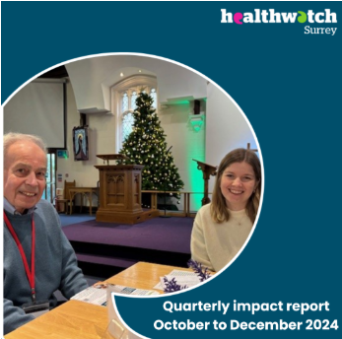

# Have your say!

**We currently have 3 surveys where people can share their experiences:**

* **Emotional and mental health support for people who have a learning disability.**
* **Access to and experience of GP practices for people who have experienced or are experiencing domestic abuse**
* **People using non emergency patient transport**

Our [learning disability and mental health survey](https://www.smartsurvey.co.uk/s/LDandMentalHealthHWS/) will be closing on the 16March and our [GP access and domestic abuse survey](https://www.smartsurvey.co.uk/s/3SO2LM/) on the 31March. Our [EMED survey, relating to non-emergency hospital transport](https://www.smartsurvey.co.uk/s/HWSyEMED2025/) closes on 6 April.

The more people we hear from the more impactful our research will be, and the more likely we are to be able to bring about positive change. Please complete if relevant to you, or pass to contacts and networks where appropriate.

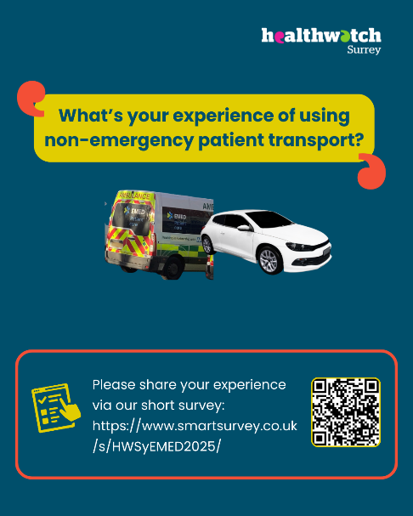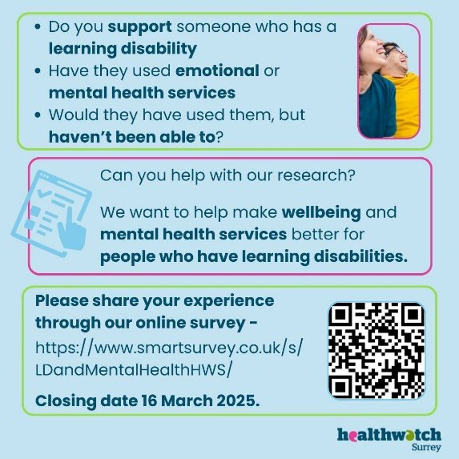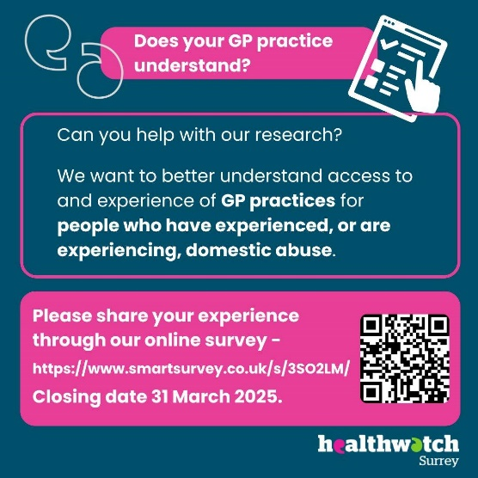

Further details about these pieces of research are available on our website:

[Access to emotional and mental health support for people who have a learning disability](https://www.healthwatchsurrey.co.uk/news/access-to-emotional-and-mental-health-support-for-people-who-have-a-learning-disability/)

[Does your GP practice understand?](https://www.healthwatchsurrey.co.uk/news/does-your-gp-practice-understand/)

[Have you used hospital transport in Surrey provided by EMED?](https://www.healthwatchsurrey.co.uk/news/have-you-used-hospital-transport-in-surrey-provided-by-emed/)

# Sharing our insight and raising concerns

Whilst this bulletin accurately reflects what we hear from the individuals we speak to, we are aware that it may not be representative of everyone’s views of a particular service. Multiple references to a specific service may be due to where our community engagement has recently taken place.

If we hear a case of concern regarding patient safety, we immediately signpost the sharer to the appropriate body and escalate the case with the provider/commissioner. All appropriate information and signposting has already been given.

We share our wider themes with Trusts, Integrated Care Systems (ICSs), Surrey County Council, Public Health, Care Quality Commission (CQC), and in various boards and groups across Surrey.

If you would like more information or examples of what people have shared with us, please get in touch with us.

# Community engagement

Below are details of our engagement sessions for March onwards, where we visit venues in local communities to listen to what people think about local health and care services, and to ask specific questions related to [our priorities](https://www.healthwatchsurrey.co.uk/about-us/our-priorities/). We also provide information and signposting regarding health and social care. Each month we focus on a different area of the county. In February we were in Farnham and in March we will be focussing our engagement in Surrey Heath. Throughout the year, we also attend events across Surrey to raise awareness of our work.

|  |  |  |  |  |
| --- | --- | --- | --- | --- |
| Date | Place | Time | Open to | Surrey Area |
| 08/03/2025 | Macular Society, Woking | 10.30am – 12.30pm | Group | North West Surrey |
| 11/03/2025 | Guildford Baptist Church,  Millmead, Guildford | 10am –1pm | Public | Guildford & Waverley |
| 11/03/2025 | St Peters Hospital discharge lounge | 2 - 4pm | Public | North West Surrey |
| 13/03/2025 | Epsom Hospital discharge lounge | 1.30 – 3.30pm | Public | Surrey Downs |
| 15/03/2025 | The Cafe in a Library, Lightwater | 10am –  12 noon | Public | Surrey Heath |
| 19/03/2025 | Wednesday Cafe, St Martins,  Old Dean Estate, Camberley | 10am –  11.30am | Public | Surrey Heath |
| 20/03/2025 | Tadworth Leisure Centre | 10am –4pm | Public | East Surrey |
| 25/03/2025 | Oasis Group – St Pauls | 10am –  12 noon | Public | Surrey Heath |
| 25/03/2025 | RSCH discharge lounge | 10.30 –12.30pm | Public | Guildford & Waverley |
| 27/03/2025 | East Surrey Hospital discharge lounge | 1 – 3pm | Public | East Surrey |

**Please note: these dates may be subject to change.**

To share an experience with us, or for information and signposting about health and social care, people can also contact our Helpdesk in the following ways:

Phone: 0303 303 0023

SMS (text only): 07592 787 533

Email: [enquiries@healthwatchsurrey.co.uk](mailto:enquiries@healthwatchsurrey.co.uk)

Share your feedback via our website: <https://www.healthwatchsurrey.co.uk/feedback-centre/>

# About Healthwatch Surrey

Healthwatch Surrey champions the voice of local people to shape, improve and get the best from NHS, health and social care services. As an independent statutory body, we have the power to make sure decision makers listen to the experiences of local people.

We passionately believe that listening and responding to local people's experiences is vital to create health and social care services that meet the needs of people in Surrey. We seek out people’s experiences of health and care services, particularly from people whose voices are seldom heard, who might be at risk of health inequalities and whose needs are not met by current services. We share our findings publicly and with service providers and commissioners to influence and challenge current provision and future plans.

We also provide reliable and trustworthy information and signposting about local health and social care services to help people get the support they need.

# Our distribution list

If you would like to be added to or removed from the distribution list for this Insight bulletin, please contact our Communications Lead [vicky.rushworth@healthwatchsurrey.co.uk](mailto:vicky.rushworth@healthwatchsurrey.co.uk)



We are committed to the quality of our information.

Every three years we perform an audit so that we can be certain of this.



The Healthwatch Surrey service is run by Luminus Insight CIC, known as Luminus.

Registered office: GF21, Astolat, Coniers Way, Burpham, Surrey, GU4 7HL.