

Insight bulletin

August 2025

A large speech mark, outlined in pink.

“I am afraid of the hospital and that if I complain, they won’t give me the surgery. I have a problem with my left knee. I went to hospital and they did some x-rays and told me that I needed a knee replacement. I was due to have the surgery next week, but they have called me and told me that I won’t be having the surgery and they have not told me why. My English isn’t very good, so they spoke to my son, and I think they mentioned something about not being able to attend physio. Can you help?”



**If you would like a paper copy of this document or require it in an alternative format, please get in touch with** **us.**

# This bulletin: at a glance

## Hot topics

In this bulletin we are focussing on 5 key areas:

* Thanks and praise: from primary to secondary care
* Hospitals: failure to meet individual needs impacting patients
* Spotlight on: domestic abuse
* Spotlight on: the emotional wellbeing of those with learning disabilities
* Spotlight on: parents and carers understanding of sight tests for school aged children

## Who have we been hearing from?

Since our last report we’ve heard from **116** people across Surrey, via our Helpdesk or during engagement events in the community.

* **21%** of the feedback relates to hospitals
* **15%** of the feedback relates to GP practices
* The majority of the remaining feedback relates to community, social care and mental health services
* Of those willing to share their age, **71%** were aged over 50.

# Thanks and praise: from primary to secondary care

# This month people have talked to us about how well cared for they have been by staff at their GP practice and in hospital.

# (To note, resident doctors – formerly known as junior doctors – undertook strike action from July 25 to July 30. This feedback was all provided before the strike began.)

When talking to us about their experience in hospital, people have praised both the efficiency and the clinical care received.

“I could not fault any of the treatment that I got, I had the operation and was discharged the next day, they also arranged an ambulance to take me home.”

230838, Guildford resident

“My brother is now on [the] ward and is being looked after very well by [the nurse] - she is lovely, caring, very friendly and my brother is very fond of her.”

230808, Woking resident

The transition between primary and secondary care was praised by this resident.

“The receptionists have been fantastic, no problems at all. We have been very lucky! They will even have a joke with you if it’s appropriate.”

230826, Surrey Heath resident

We know that not everyone is digitally able, but for those that are, the digital route into their GP practice can be efficient and effective.

“Went online, asked to be contacted by a GP. A few hours later I received a phone call from the GP who recommended I use the physiotherapy service. An appointment was made that was convenient for me. Good job.”

230853, Surrey resident

# Hospitals: failure to meet individual needs impacting patients

# This month people have contacted us for advice and support when hospitals have been unable to meet their or their relative’s individual communication or access needs. The impact this can have shows the importance of getting communication right.

In this example a patient was left confused after a hospital appointment, due in part to a language barrier. They also expressed concern around complaints processes and wanted to talk to us as an independent body.

“I am afraid of the hospital and that if I complain, they won’t give me the surgery. I have a problem with my left knee. I went to hospital and they did some x-rays and told me that I needed a knee replacement. I was due to have the surgery next week, but they have called me and told me that I won’t be having the surgery and they have not told me why. My English isn’t very good, so they spoke to my son, and I think they mentioned something about not being able to attend physio. Can you help?”

230875, Surrey resident

We continue to hear from people who are experiencing significant barriers to accessing services as they are digitally excluded. Failure to address these problems can lead to services having to deal with multiple complaints and people still being unable to access the services they need:

“I have had to put in multiple complaints because of issues with everything going digital. I booked in a fasting blood test face to face, when I arrived for the test, I was told that I didn’t have an appointment… A lot of people at my group are concerned about the move over to digital, it’s not uncommon for my friends to have a husband who is digitally connected, then when they die the wife is left without a clue how to access it. I do feel that with all the changes over to digital, that the elderly or those who have accessibility needs are being hidden, out of sight.”

230814, Waverley resident

In this example the specific needs of an elderly patient were not taken into consideration, leading to unnecessary stress.

“We arrived [at A&E] at 8pm and periodically over the next few hours were tested by various physicians for temperature, blood pressure and other vital measurements. At some point after midnight my mother was informed that her blood pressure was too high to immediately treat her so she was given a blood pressure tablet to reduce the pressure. We then had to wait some time for the tablet to take effect. However, at about 1.30am we were called in to one of the consultant's rooms to say that it was too late in the evening now to perform any operation and we were advised to go home and return the next day. This was rather annoying as we had spent the whole evening waiting around with the anticipation of needing urgent treatment. Additionally, my mother is fairly elderly and it was an unnecessarily stressful experience to have to go through. If it seemed unlikely we'd be seen that evening, why did someone in A&E not advise us to go home and return the next day early in the evening.”

230879, Spelthorne resident

In this final example a patient’s carer felt that her visual impairment was not addressed when trying to advocate for her elderly mother.

“I need your help after having had my mum in hospital for 3 weeks. I am blind and so is my sister…. the staff weren’t really very helpful to me as a blind person, I found them stuffy and not wanting to help mum. She is 88 and has some form of dementia. They kept giving her these drugs which I don’t believe were helping her.”

230844, Reigate and Banstead resident

Please see our website for further information on feedback and complaints - [Feedback and complaints - Healthwatch Surrey](https://www.healthwatchsurrey.co.uk/information-and-advice/feedback-and-complaints/)

# In safe hands? Domestic abuse survivors’ experiences of general practice

**Primary care is an important point of contact for people to ask for help when experiencing domestic abuse, but little was known about this experience. The aim of our latest primary care research project was to explore whether general practice is meeting the needs of people who are experiencing domestic abuse within Surrey, and what improvements could be made to better meet these needs.**

The project was endorsed by the Surrey Domestic Abuse Partnership, and, through them, DA SEEN (formerly the Surrey Survivor Steering Group) as well as the Surrey wide designated GP for safeguarding children and adults and the Surrey wide designated nurse for safeguarding adults.





Via an online survey and a series of focus groups we sought to gauge the views of both survivors and professionals. In total we spoke to **64** Surrey survivors and **8** GP practices about all stages of people’s primary care journey, from disclosure to onward referrals and follow up.

We identified 7 barriers to people disclosing their abuse, including lack of confidential spaces in the GP practice, concerns around digital trail and a fear of not being believed.

“When trying to book an appointment to let my GP know, the receptionist would not accept ‘personal reasons’ as a valid response for an appointment; this was not something I was comfortable in sharing whilst others could hear in an open space.”

**Surrey survivor (female)**

Survivors also cited issues of ‘problematising’ or being labelled with a specific medical condition or problem (and then being treated for that problem, not supported to deal with the abuse).

“Problematising? Yes, that is a fair criticism and something we should be aware of. It’s very easy to use a code to label like that. If someone pitched up at A&E drunk that could cloud your judgement.”

Surrey GP

68% of respondents to our survey said they were not signposted tospecialist help from an independent domestic abuse and violence service once they had shared their domestic abuse experience with their GP. 89% of respondents said that a GP or another member of the practice team had not directly referred them to receive specialist help.

“When I went to see my GP he said that he could see that I was embarrassed so he wouldn’t write anything in my notes. Nothing was recorded and I wasn’t offered any help.”

**Surrey survivor (female)**

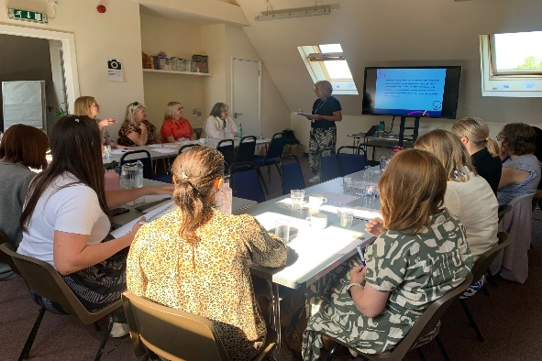

Systems partners, general practice and external stakeholder organisations representing survivors attended a convening workshop on 14 May 2025 to review the findings and agree short and long term recommendations. We look forward to continuing to work with them to bring about positive change.

An image of a flyer for our one pager. It reads:

"In safe hands? Domestic abuse survivors experiences of general practice.

Listening to survivors and working togetehr t bring about positive change.

Read our report.

Co produced with survivors, local domestic abuse organisations and NHS colleagues."



Read the full report on our website:[**In safe hands - Domestic abuse survivors experiences of general practice - July 2025 - Healthwatch Surrey**](https://www.healthwatchsurrey.co.uk/report/in-safe-hands-domestic-abuse-survivors-experiences-of-general-practice-july-2025/)

# Making mental health inclusive: supporting people with learning disabilities

# Figures show that people with learning disabilities are twice as likely to have mental health issues as those without. We obtained the views of both those with a learning disability, as well as their families and carers, across Surrey to explore how access to and experiences of emotional wellbeing and mental health support can be improved.

A total of **33** people completed our family and friends survey, and we spoke to **70** people with learning disabilities at **5** focus groups.

We learnt that, though the family and carers of those with learning disabilities generally feel able to recognise if the person they care for is struggling with their feelings and emotions, the person they care for may not be able to recognise it in themselves.

“[these signs would alert me to emotional distress in the person I care for] facial expressions, not interested in eating food or taking drinks, moving here and there as can’t verbally express their emotions.”

Relatives and carers may not know the most appropriate way to get help and support when they recognise emotional distress and they are often not turning to those with specific mental health training or those equipped to direct them to the most appropriate sources of support.

“Was told by the GP to refer myself to services but links given were not appropriate for the care support required.”

When support was sought, less than two-thirds of respondents felt that the services were accessible for the person they care for and many told us that they would like services to be more coordinated and for mental health support and services (both designated mental health support as well as those services and activities which support mental wellbeing) to be more integrated with other areas of care.

“This all depends on availability of services and the ability of the person with learning [disabilities] to communicate and understand their emotions.”

“I would love for him to have a more regular mental and physical check up - a holistic approach where one team could provide mental health support alongside GP/practice nurse.”

The [NHS](https://www.nhs.uk/conditions/learning-disabilities/annual-health-checks/) recognise that people with a learning disability often have poorer physical and mental health than those without. Anyone aged 14 or over who is on their doctor's learning disability register should therefore have an annual health check; it’s an opportunity to identify any health problems and to help people stay well. When asked if emotional wellbeing was included in their annual health check only a third felt it was.

Image of a flyer for our report. it reads:

"Making mental health inclusive: supporting people with learning disabilities. 

We have tried for many years to access support, particularly from learning disability teams but with no success. We continue to struggle daily without the right support. 

Read the report on our website."

Read the full report on our website: [Making mental health inclusive: supporting people with learning disabilities - July 2025 - Healthwatch Surrey](https://www.healthwatchsurrey.co.uk/report/making-mental-health-inclusive-supporting-people-with-learning-disabilities-july-2025/)

# Spotlight on: parents and carers’ understanding of sight tests for school aged children

# Through May and June we asked parents of school age children about whether their children had sight (eye) tests and if there were any barriers to having these tests.

**87** Surrey parents/carers responded to our survey or spoke to us at our community engagement events, which took place in areas classified as deprived in some way1 in Guildford & Waverley, Farnham and Reigate & Banstead.

Only half of those we spoke to reported that they took their child/ren for a sight test annually; 1 out of 5 said that they didn't visit regularly.

Experiences of sight tests were mixed, particularly for neurodivergent children, with some residents describing excellent service, adapting to the child’s needs, and others reporting abruptness and impatience.

“This experience is never easy. I have 3 children who all have special educational needs and often the staff have very little understanding of their autism and other conditions. Every time we attend, I have to request a quiet room, end of day appointment and waiting times to be minimum.”

Mum of 3, Guildford resident

Read more on our website: [Out of sight, out of mind: parents and carers understanding of sight tests for school aged children - Healthwatch Surrey](https://www.healthwatchsurrey.co.uk/report/out-of-sight-out-of-mind-parents-and-carers-understanding-of-sight-tests-for-school-aged-children/)

There’s more information about eye health on our website - [Eye health and optometry - Healthwatch Surrey](https://www.healthwatchsurrey.co.uk/information-and-advice/eye-health-and-optometry/)

1. [Census 2021: Household deprivation | Surrey-i](https://www.surreyi.gov.uk/census-2021/census-2021-household-deprivation/)

# Have your say!

|  |  |
| --- | --- |
| Icon of a group of people representing different roles. | For our **Involvement of People** **priority** we are looking at whether community healthcare services are accessible/available to people who are classified as being housebound.  [Home based healthcare survey](https://www.smartsurvey.co.uk/s/HWSYHouseboundProject0525/) |
| An icon showing a set of double doors with the word entrance above them and a healthcare cross above that. | For our **access to primary care priority** we arecurrentlylooking at online access to GP services.  [Online access to GP services survey](https://www.smartsurvey.co.uk/s/HwSyOnlineAccessGPServices/) |
| An icon showing 2 people standing together under a roof. | And finally, for our **social care priority** we are looking at why there has been a downturn in the numbers of people using day centres and library services.  [Library independence courses and community centre survey](https://www.smartsurvey.co.uk/s/HealthwatchSurreylibraryindependencecoursecommunitycentresurveyQ22025/) |

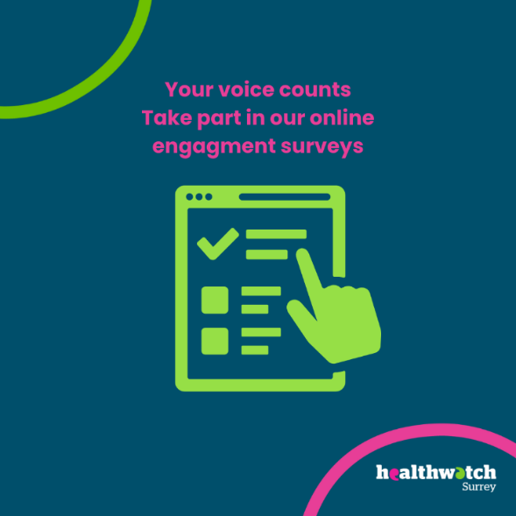

**The more people we hear from, the more impactful our research will be, and the more likely we are to be able to bring about positive change.**

## The NHS 10 Year Health Plan and Healthwatch: your voice matters

The [NHS 10 Year Health plan](https://gbr01.safelinks.protection.outlook.com/?url=https%3A%2F%2Fassets.publishing.service.gov.uk%2Fmedia%2F6866387fe6557c544c74db7a%2Ffit-for-the-future-10-year-health-plan-for-england.pdf&data=05%7C02%7CSamantha.Botsford%40healthwatchsurrey.co.uk%7Cb3cea35a9b384ef1621408ddbdff4a71%7C80dab1ec97604877b0d434d3f00e7800%7C0%7C0%7C638875626429351487%7CUnknown%7CTWFpbGZsb3d8eyJFbXB0eU1hcGkiOnRydWUsIlYiOiIwLjAuMDAwMCIsIlAiOiJXaW4zMiIsIkFOIjoiTWFpbCIsIldUIjoyfQ%3D%3D%7C0%7C%7C%7C&sdata=MRS1avO5Q3u%2BP0sYgu4IwFX0GXonZB%2Fvi4ouTLpXTdY%3D&reserved=0) proposes to abolish Healthwatch England and 152 local Healthwatch, and transfer our functions ‘in-house’ to local authorities and NHS Integrated Care Boards once legislation has passed. This is a result of the [Review of patient safety across the health and care landscape](https://gbr01.safelinks.protection.outlook.com/?url=https%3A%2F%2Fwww.gov.uk%2Fgovernment%2Fpublications%2Freview-of-patient-safety-across-the-health-and-care-landscape%2Freview-of-patient-safety-across-the-health-and-care-landscape%23the-6-organisations-under-review&data=05%7C02%7CSamantha.Botsford%40healthwatchsurrey.co.uk%7Cb3cea35a9b384ef1621408ddbdff4a71%7C80dab1ec97604877b0d434d3f00e7800%7C0%7C0%7C638875626429314054%7CUnknown%7CTWFpbGZsb3d8eyJFbXB0eU1hcGkiOnRydWUsIlYiOiIwLjAuMDAwMCIsIlAiOiJXaW4zMiIsIkFOIjoiTWFpbCIsIldUIjoyfQ%3D%3D%7C0%7C%7C%7C&sdata=NXiNaZvOxNbDbjNdek%2FGgctPFEPiXXp6%2BCKl9pTkfNc%3D&reserved=0), led by Dr Penny Dash.

Given the Dash review’s aim of “greater emphasis being placed on the patient voice”, and the aim of the NHS 10 Year Health Plan to give greater power to patients, we cannot see how this can be achieved by abolishing local Healthwatch, which has worked for the last 12 years to amplify voices which otherwise may not be heard. There has been a statutory provision of an independent service representing the public voice for over 50 years.

**Why what we do is important:**

* **Being an independent critical friend** – working constructively with local stakeholders, but always with the freedom to raise concerns without fear or favour. Services can’t be held to account by the same bodies that fund or manage them. Independence is essential for honest feedback and meaningful scrutiny.
* **Amplifying the collective voices of people at risk of health inequalities** – speaking to people experiencing health inequalities and asking about the barriers to accessing services. The new plan relies heavily on individuals feeding back to the services they use. Listening to communities is essential to the successful delivery of services.
* **Driven by communities** - based on what people with lived experience say, with no other taskmaster or agenda. Designed to be owned and governed by communities with their best interest at heart.
* **A bridge across sectors** – people do not fit neatly into one box, they often experience and need services across multiple providers. Connecting VCSE organisations, local authorities, health services, and communities to build more integrated and inclusive services.
* **Independent, trusted and impartial** – people want an independent service because they often lack trust and fear repercussions sharing their feedback direct with those providing their care. They find provider feedback routes difficult to navigate or have shared in the past and feel that they have not been heard.

To find out more about how our work reflects these, please watch our Annual report video: <https://www.healthwatchsurrey.co.uk/wp-content/uploads/2025/07/Annual-report-video-2024-2025.mp4>.

[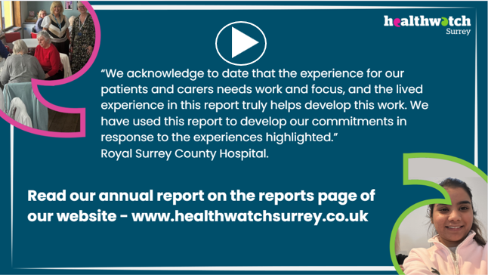](https://www.healthwatchsurrey.co.uk/wp-content/uploads/2025/07/Annual-report-video-2024-2025.mp4)

### What can you do?

* **Sign our petition:**

To protect the independent voice, local Healthwatch have put together a petition calling on the government to review the decision to abolish independent local Healthwatch. We ask for your support in signing it: [Review decision to abolish independent local Healthwatch - Petitions](https://petition.parliament.uk/petitions/732993)

* **Send us a statement of support:**

131 local Healthwatch have written [an open letter](https://www.healthwatchsurrey.co.uk/news/urgent-call-to-protect-independent-patient-voice-open-letter-from-healthwatch-leaders/) to the Secretary of State for Health and Social Care. If you share our concerns, please send us a short statement in support of retaining an independent voice for the people of Surrey in the design and delivery of health and care services. We can then collate these to help demonstrate to government and other decision makers why it is important for the people of Surrey to have an independent route to champion their voice. Please email any statements or supporting comments that you would be happy for us to share publicly to [kate.scribbins@luminus-cic.uk](mailto:kate.scribbins@luminus-cic.uk)

* **Highlight the issue and share our social media posts**

Please also do all you can to highlight the issue, raise the risks attached to the abolition of local Healthwatch, and share our posts on social media.

**In the meantime we continue with business as usual, delivering on our contract with SCC, hearing people’s experiences, conducting projects and influencing change.**

](https://petition.parliament.uk/petitions/732993)

## Join our Luminus vaccine hesitancy fireside chat

* What are the main barriers to taking up COVID-19 and flu vaccines?
* How do we increase the number of people who have a vaccination?
* What does good look like?

During the last year Luminus have completed 3 research studies about why older people, people from ethnically minoritised communities and care workers are reluctant to take-up a COVID-19 and flu vaccination or booster.

Join our virtual fireside chat to hear the main findings and recommendations, with lots of opportunities to ask your own questions too.

**Cost:** Free

**Date:** Wednesday 17 September 2025

**Time:** 12.30 to 1.30pm

**Audience:** Anyone in charge of vaccine programmes or promotion.

The fireside chat will last for about 20 minutes and the remainder of the time is for questions and answers.

At the top of the image on a slanted purple background are the words vaccine hesitancy and the Luminus logo.
Underneath, on a bright yellow background is the words:
What are the main barriers to taking up COVID-19 and flu vaccines?
How do we increase the number of people who have a vaccination?
What does good look like?
Fireside chat, 17 September 
Each of the questions has a small icon beside it and to the right of the words is an icon of a vaccine syringe and a question mark. Beside the Fireside chat is the image of a 2 people talking in front of a fireplace.Please email @Becki Meakin ([becki.meakin@luminus-cic.uk](mailto:becki.meakin@luminus-cic.uk)) if you want to attend and a Teams invitation will be sent to you. We are keen to make this as accessible as possible, so please state any access requirements you have.

# 

# Sharing our insight and raising concerns

Whilst this bulletin accurately reflects what we hear from the individuals we speak to, we are aware that it may not be representative of everyone’s views of a particular service. Multiple references to a specific service may be due to where our community engagement has recently taken place.

If we hear a case of concern regarding patient safety, we immediately signpost the sharer to the appropriate body and escalate the case with the provider/commissioner. All appropriate information and signposting has already been given.

If you would like more information or examples of what people have shared with us, please get in touch with us.

# Community engagement

Below are details of our upcoming engagement sessions where we visit venues in local communities to listen to what people think about local health and care services, and to ask specific questions related to [our priorities](https://www.healthwatchsurrey.co.uk/about-us/our-priorities/). We also provide information and signposting regarding health and social care. Throughout the year, we also attend events across Surrey to raise awareness of our work.

|  |  |  |  |
| --- | --- | --- | --- |
| Date | Place | Time | Open to |
| 07/08/2025 | Spire Café at Farnham Methodist Church | 10am – 12noon | Public |
| 13/08/2025 | Woking Minor Injuries Unit | 10am – 12noon | Public |
| 14/08/2025 | Phylis Tuckwell Hospice Carers Drop in, The Beacon Centre | 1.30 – 3pm | Public |
| 20/08/2025 | Caterham Dene Minor Injuries Unit | 10am – 12noon | Public |
| 26/08/2025 | Macular Society, Cranleigh | 2 – 4pm | Group |

**Please note: these dates may be subject to change.**

To share an experience with us, or for information and signposting about health and social care, people can also contact our Helpdesk in the following ways:

Phone: 0303 303 0023

SMS (text only): 07592 787 533

WhatsApp: 07592 787 533

Email: [enquiries@healthwatchsurrey.co.uk](mailto:enquiries@healthwatchsurrey.co.uk)

Share your feedback via our website: <https://www.healthwatchsurrey.co.uk/feedback-centre/>

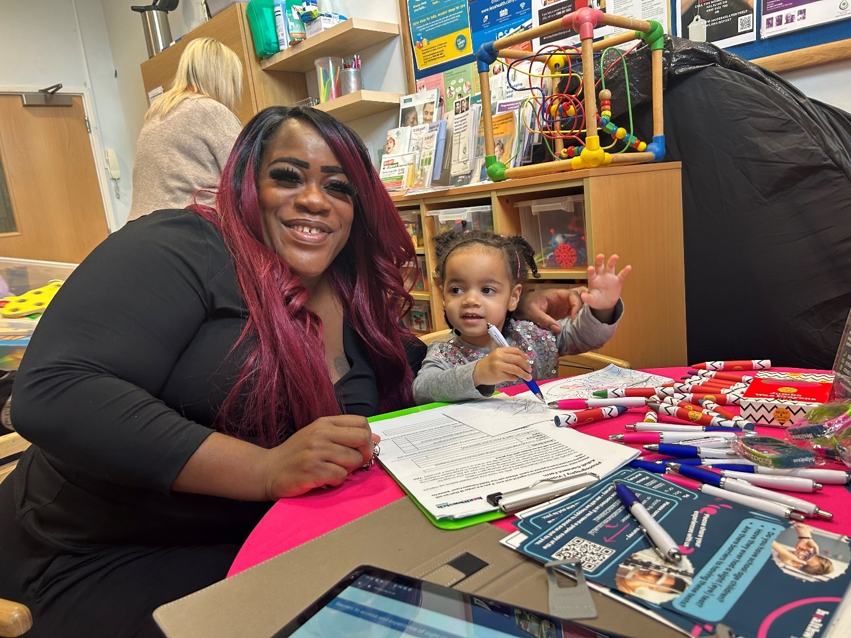

# About Healthwatch Surrey

Healthwatch Surrey champions the voice of local people to shape, improve and get the best from NHS, health and social care services. We are independent and have statutory powers to make sure decision makers listen to the experiences of local people.

We passionately believe that listening and responding to local people's experiences is vital to create health and social care services that meet the needs of people in Surrey. We seek out people’s experiences of health and care services, particularly from people whose voices are seldom heard, who might be at risk of health inequalities and whose needs are not met by current services. We share our findings publicly and with service providers and commissioners to influence and challenge current provision and future plans.

We also provide reliable and trustworthy information and signposting about local health and social care services to help people get the support they need.

# Our distribution list

If you would like to be added to or removed from the distribution list for this Insight bulletin, please contact our Communications Lead [vicky.rushworth@healthwatchsurrey.co.uk](mailto:vicky.rushworth@healthwatchsurrey.co.uk)



We are committed to the quality of our information.

Every three years we perform an audit so that we can be certain of this.



The Healthwatch Surrey service is run by Luminus Insight CIC, known as Luminus.

Registered office: GF21, Astolat, Coniers Way, Burpham, Surrey, GU4 7HL.