


Insight bulletin

  - May 2026

“If you want people, especially older people, to use your new technology you have to make sure they can use it. That it is suitable for them to use. It is difficult enough to talk to a doctor now without further obstacles being put in the way.”


If you would like a paper copy of this document or require it in an alternative format, please get in touch with us.

How do we make a difference?
Last quarter we helped, supported or engaged with over 600 people whilst out and about in the community, and over 100 people who contacted our Helpdesk. But it doesn’t stop there. We champion the voice of local people to shape, improve and get the best from NHS and social care services; we are independent and have statutory powers to make sure decision makers listen to the experiences of local people.

You can read about the difference we’ve made in our latest Impact Report.

Did you know that Luminus is also commissioned to deliver Giving Carers a Voice (including young carers), Surrey Substance Use Partnership – Public Involvement and specific Community Voice Projects. You can read more about the impact of our work on the Luminus website.

This bulletin: at a glance

Hot topics
In this bulletin we are focussing on 5 key areas:
- Thanks and praise for hospital staff
- General practice appointments: digital access issues
- Lack of information causing unnecessary confusion and concern
- Research update: Men in Mind
- Research update: Living, coping, thriving

Who have we been hearing from?
Since our last bulletin 169 people have shared their experiences of health and social care across Surrey.

- 43% of feedback relates to hospitals
- 23% of feedback relates to GP practices.

People have also talked to us about social care, community services, mental health services, dental services and pharmacies.

Since our last bulletin we’ve had more than 60 enquiries to our Helpdesk. People can come to our Helpdesk with questions, concerns or feedback on any aspect of health and social care, so what we’re hearing here can be a good indicator of the main issues that matter to local people. This month people have shared experiences about appointment booking, communication, and accessibility and reasonable adjustments.



Thanks and praise for the reassurance and empathy shown by hospital staff

“What stood out for me was the level of empathy and care shown by all members of staff.”
231517, Waverley resident

“He carried out the procedure in a quick, confident and reassuring manner.”
231546, Surrey resident

“I've had a 10/10 experience today. The staff were very positive and reassuring to me throughout.”
231584, Surrey resident

“I am attending a neurology appointment that is running late. I am here with my wife. The nurse has come to update me and we are grateful for this. I had a mini stroke and I have Parkinson’s, so speech is limited.”
231591, Spelthorne resident

In this example staff were particularly attentive to a patient navigating a new country, language and culture.

“I want to thank you so much for taking good care of me and my baby. You gave me good care and love in the NICU (Neonatal Intensive Care Unit). For me, it was a new country, a new place and a new language. They did not leave me be alone. They made everything easy for me.”
231533, Spelthorne resident

People often tell us how important having adequate time and attention given to them is.

“They were super helpful and they didn't rush him at all.”
231554, Mole Valley resident

General practice appointments: digital access issues

In February, NHS England launched a new campaign “Tap it, type it and we’ll take care of it” to encourage patients to contact their GP using online forms. However, we continue to hear from people struggling to book appointments due to issues with digital systems which do not meet their needs.

“If you have more than one medical condition, or an ongoing condition, you are not dealt with quickly or in a prioritised manner. There is no clear space for making or updating referrals. You can only fill in a form for one thing on one day, which is useless for me with several conditions. There are questions that could be missed if the form collects information by age…Then answering those questions times you out of the form and you have to start again. Or the software doesn't recognise what went on and you can't fill out a form for that day.”
231496, Woking resident

“The Rapid Health system is very problematic, with too few appointments for the number of households now in the area. I feel it is particularly inaccessible for the elderly who may struggle with technology. We don’t, but still find requesting an appointment difficult, especially when the result is “you need to have an appointment.“ The link lasts for 3 days, but you actually have to fill the whole form in again to get an appointment, if you aren’t allocated one on day one. Madness. I can see the elderly giving up and then there is more strain on the hospital as they become more ill.”
231395, Farnham resident

“If you want people, especially older people, to use your new technology you have to make sure they can use it. That it is suitable for them to use. It is difficult enough to talk to a doctor now without further obstacles being put in the way.”
231529, Surrey resident
“After being discharged from hospital with a neck injury I was asked to contact my GP for a follow up appointment, further painkillers and a physio appointment. Neither has happened, although I followed procedure by completing a form on a Rapid Health site. I was sent a link to organise an appointment which constantly tells me there are no bookings.”
231512, Waverley resident

You can read more about what people are telling us about digital access in our Digital Divide report. And we’d love to hear more – please see our digital survey to give us your views.

People have also talked to us about not being able to access the type of appointment that they need, not helped by confusion around who can, or should, provide their care.

“The GP has said that I need to see them to go over some test results urgently, but they are suggesting an appointment 2 weeks out for something that is urgent. In the end I had to take a call while I was out and not in an appropriate setting to discuss my results.”
231334, Surrey resident

“I have decided to get in touch today because I tried to book an appointment yesterday because we are unwell. The receptionist told me that they ‘don’t see sick people anymore’ and that we would need to go to the walk-in centre, which doesn’t make sense to me. I have heard this from others in the village.”
231302, Woking resident

Lack of information causing unnecessary confusion and concern

People have told us that they have been unable to obtain information, both on their clinical condition and administrative queries, and that this has had a detrimental impact on their experience.

“We have been trying to get information from the clinic regarding [my mum’s] position in the queue and when she can expect to be seen as she now no longer leaves the house due to pain. I contacted the receptionists multiple times and, in the end, needed to pay to see her consultant privately, in order to ask some clarifying questions about her NHS care. Otherwise all of my communications to him went unanswered.”
231452, Epsom and Ewell resident

“Ankle was dislocated and broken while [abroad]. The dislocation was fixed [while abroad], but the break wasn’t. I was told [in a Surrey hospital] that I would have surgery next week… I was only given 2 crutches and was not told how to use them; I have to go up the stairs on my bottom and when I get to the top, I am prone to falling. I was told that no one in my position could get occupational therapy and get support to get around the house. I have had to YouTube how to get up and down stairs, but I feel very vulnerable and like I could fall.”
231427, Surrey resident

“Got admitted for medical treatment [from A&E] and it was wrongfully decided to also detain me under section 2 of the Mental Health Act. Nothing was explained to me about what grounds this was on…totally left out from the communication perspective upon what grounds and I’d like to get more information on my rights and how to file a complaint.”
231389, Surrey resident

Research update: Men in mind

Healthwatch Surrey was invited to be a part of the Dorking and Villages Neighbourhood Area Committee pilot. As the committee identified loneliness and isolation as one of the most prevalent issues in the area, this research project aimed to identify what impact these have on men’s mental health specifically, and to explore the importance, availability and awareness of community ties and local groups to support them.

We focused our engagement activities in Dorking and its neighbouring villages, visiting 7 locations and speaking to 125 men, face to face or via a survey co-designed with men accessing the most local Andy’s Man Club.

Our findings
Men who do not feel part of a community are more likely to experience poorer mental health and reduced overall wellbeing. Greater support is needed for those who struggle to feel included in order to prevent more serious mental health challenges developing over time. Support should be easy to reach and designed without barriers or expectations that may discourage men from engaging.

“Getting out and meeting people or just helping out with something can make a big difference.”

“I wish there were services specifically for men like me – not just general mental health support, but somewhere to talk about my relationship and mental health. I need a place where it’s safe to say I’m struggling without feeling guilty or weak...”

You can read more in our Men in Mind report. The report has been shared with the Dorking and Villages Neighbourhood Area Committee and Team Around the Community and we look forward to taking the recommendations forward.

Research update: Living, coping, thriving

Prevention - specifically ‘Supporting people to lead healthy lives by preventing physical ill health and promoting physical wellbeing’ - is Priority 1 of the Surrey Health and Wellbeing Strategy. Prioritising prevention, moving from reactive to proactive care, is also one of the cornerstones of the NHS 10 Year Plan.

This project explored the behaviours and attitudes to health and wellbeing of people aged 50-66 (those approaching the age range which, statistically, needs the NHS and social care the most). Geographically, we focussed on Spelthorne, the neighbourhood with the poorest health outcomes in Surrey, and compared to the rest of Surrey.

Over 150 people contributed to this research; 35 people spoke to us at 8 community engagement events and 118 people completed our survey.

Our findings
- Almost half (44%) of the people we heard from said that they are too busy working to do more to look after their wellbeing; 35% said they are too busy caring for others, and 25% said they can’t afford it.
- Very few people (11%) claim to have excellent physical health, and many have concerns about their future health.
- Although people reported excellent mental health more commonly than excellent physical health, only a small proportion of people rated their mental health as excellent.

“Human contact is the biggest positive, knowing that people care is more important than any amenities.”

Our report concluded that there are opportunities to help people to understand more about the importance of prevention; there are also opportunities to design services to help them to do this.

Find out more in our Living, coping, thriving report

Have your say!

We want to hear from as many people as possible which is why we have surveys to accompany our face to face engagements in the community.

    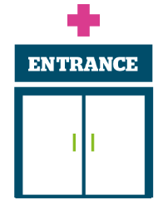 | Access to primary care – we would love to hear your feedback about online access to GP services, how you manage your health care needs with your GP practice using online technology and your views on the use of AI (Artificial Intelligence) within general practice. Our digital survey closes 1 July 2026.  Involvement of people - we’re looking at residents’ experiences of care delivered by Surrey’s hospitals, both in the hospital and the community. Whether you’ve been for a short appointment or a longer stay, or even just visited a friend or relative, please give us your views via our hospital survey.  We’d love to hear from anyone with recent experience of oral health in Surrey’s care homes, either yourself or on behalf of a family member. Please contact our Helpdesk.
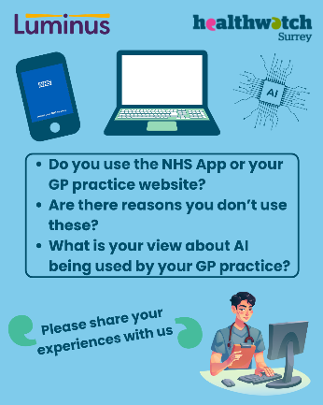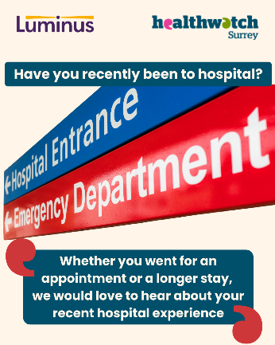

To share an experience with us, or for information and signposting about health and social care, people can also contact our Helpdesk in the following ways:
Phone: 0303 303 0023
SMS (text only)/ WhatsApp: 07592 787533
Email: enquiries@healthwatchsurrey.co.uk
Share your feedback via our website: https://www.healthwatchsurrey.co.uk/share-your-views

Stopping smoking – your thoughts

Luminus is also working with Public Health, to support Surrey residents, wherever they are in their smoking journey, to understand the risks of smoking and get free support to quit. As part of this there is an online survey people can complete: Stopping Smoking - your thoughts which closes on 1 August 2026.

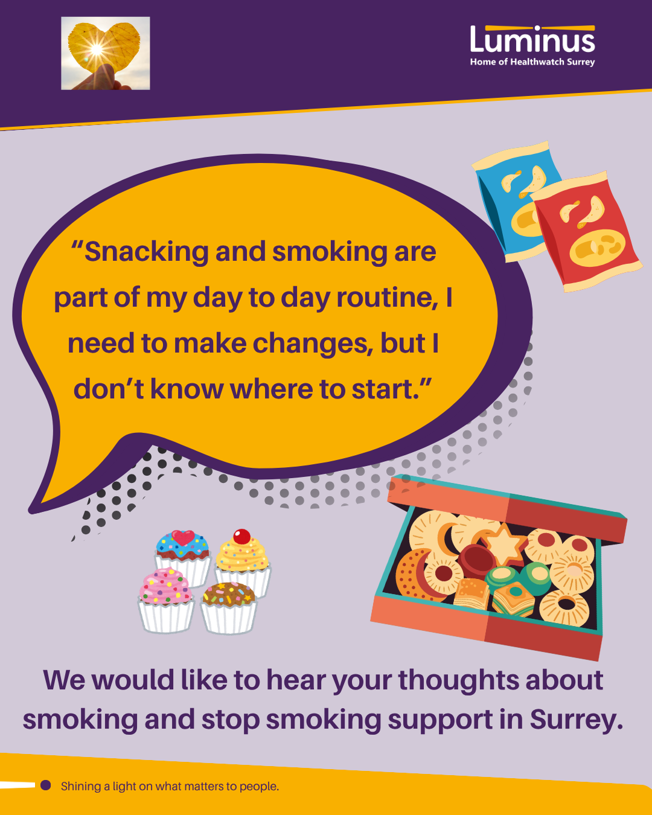

The more people we hear from, the more impactful our research will be, and the more likely we are to be able to bring about positive change.

Sharing our insight and raising concerns
Whilst this bulletin accurately reflects what we hear from the individuals we speak to, we are aware that it may not be representative of everyone’s views of a particular service. Multiple references to a specific service may be due to where our community engagement has recently taken place.

If we hear a case of concern regarding patient safety, we immediately signpost the sharer to the appropriate body. All appropriate information and signposting has already been given.

If you would like more information or examples of what people have shared with us, please get in touch with us.

Our distribution list
If you would like to be added to or removed from the distribution list for this Insight bulletin, please contact our Communications Lead vicky.rushworth@healthwatchsurrey.co.uk

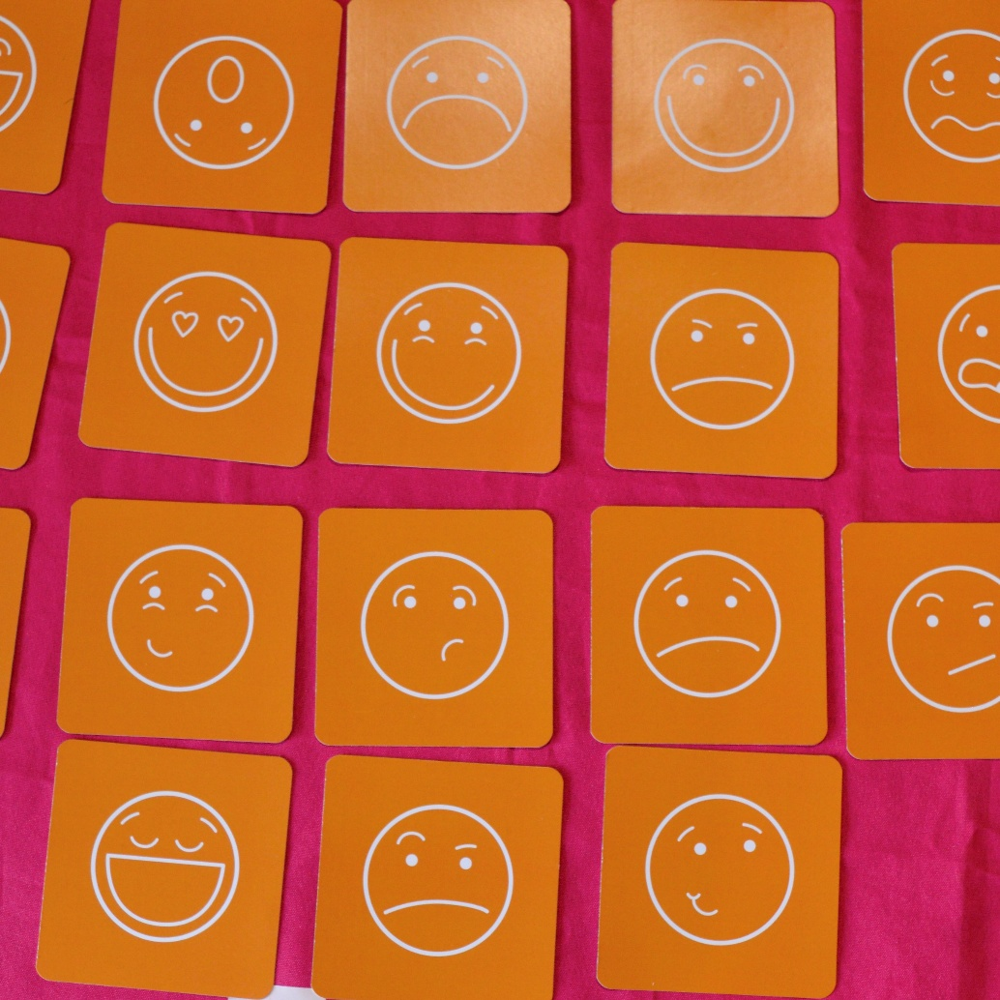

About Healthwatch Surrey
Healthwatch Surrey champions the voice of local people to shape, improve and get the best from NHS, health and social care services. We are independent and have statutory powers to make sure decision makers listen to the experiences of local people.

We passionately believe that listening and responding to local people's experiences is vital to create health and social care services that meet the needs of people in Surrey. We seek out people’s experiences of health and care services, particularly from people whose voices are seldom heard, who might be at risk of health inequalities and whose needs are not met by current services. We share our findings publicly and with service providers and commissioners to influence and challenge current provision and future plans.

We also provide reliable and trustworthy information and signposting about local health and social care services to help people get the support they need.


We are committed to the quality of our information.
Every 3 years we perform an audit so that we can be certain of this.


We are proud to have signed up to the End Poverty Pledge - End Poverty Surrey – Good Company.



The Healthwatch Surrey service is run by Luminus Insight CIC, known as Luminus. Luminus is a Surrey based, independent, community interest company which exists to empower people to have their voices heard. We help organisations provide equity of access and the best services possible, through the inclusive involvement of local people.
Registered office: GF21, Astolat, Coniers Way, Burpham, Surrey, GU4 7HL.

