


Insight bulletin

  - June 2026


“My aunt was discharged on a Friday night, she’s 84 years old, she was in a hospital gown and socks and looked extremely unkempt. She had one pad and we had no information about her medication, why she was on it, or anything other than what was on the discharge summary.”


If you would like a paper copy of this document or require it in an alternative format, please get in touch with us

This bulletin: at a glance

Hot topics
In this bulletin we are focussing on 4 key areas:
- Thanks and praise: those with long term conditions
- General practice: administrative errors and staff attitudes impacting care
- Patients and carers not feeling listened to in hospital
- Discharge: perceived lack of planning causing concern for carers and relatives

Who have we been hearing from?
Since our last bulletin 83 people have shared their experiences of health and social care across Surrey.*

Whilst we hear about a range of services across health and social care, the services we have heard most about since the last bulletin are:

- Hospitals (over half of the feedback)
- GP practices (over a quarter of the feedback).

People have also talked to us about mental health and community services.

Since our last bulletin more than 30 people have contacted our Helpdesk with questions, concerns or feedback about any aspect of health and social care. This bulletin is a good indicator of the main issues that currently matter to local people. This month people have shared experiences about administrative errors and staff attitudes at their GP practice.

* Following a reduction in the funding of the Healthwatch Surrey service for 2026–27 we are conducting fewer community engagement events than in previous years. This may mean we hear from fewer people, but we remain committed to gathering meaningful insight and providing a high quality service that reflects local people’s experiences.

Thanks and praise from those with long term conditions

Long term conditions can require ongoing management and treatment, meaning those that have them may regularly be interacting with healthcare services. At Luminus we are committed to ensuring that we shine a light on this priority population’s views, and this month we’ve heard some really positive ones.

“Nothing could be better! I cannot understand why this practice does not have an outstanding rating! I am something of a frequent flier. I always get seen same day as I have raised an issue with the surgery online. I asked for an emergency portable prescription today and got it in 23 minutes after asking online. When I see a doctor time never seems to be an issue. Caring, responsive and efficient!”
231653, Waverley resident

“I was seen face to face on a Saturday so it was enhanced access. Surgery was empty so it helped my anxiety and autism in the waiting room. The doctor was thorough and was really helpful and made sure to talk through everything and get the right things done and get support, plus anything that needed to be done. He explained my test results and asked my partner to come in and put a plan in place. He cared rather than just see me as ‘another random patient’.”
231671, Surrey resident

“I go to the [diabetes centre] regularly. I have an annual review there too – it’s pretty good. Everyone’s friendly, and they seem to know what they’re talking about which is good.”
231631, Guildford resident

General practice: administrative errors and staff attitudes impacting care

Recent research from Healthwatch England, The Kings Fund and National Voices found that two-thirds of NHS patients and carers experienced at least one admin problem in the past year, up slightly from 64% in 2024.

Here in Surrey people often talk to us about administrative errors and delays and the impact these can have on their care.

“The service provided is appalling. It is virtually impossible to get an appointment, and when you do...
- The clinician is always late (especially if it is a phone appointment)
- It is not possible to see the same GP twice and so there is no continuity of care
- Follow up actions are not processed
- Online appointment forms are missed
- Letters from consultants or other healthcare bodies are lost, ignored or experience significant delays in being processed.”
231615, Epsom resident

“The GP should have completed an important referral for me a long time ago, but they seem to be giving me various excuses, as there have been lots of mess-ups during the whole procedure.”
231644, Surrey resident

Issues with administrative processes can lead to patients being given conflicting information, which can be both confusing and unsettling.

“At the end of the appointment [the GP] asked me to book for a therapist [at the practice reception] and to ask for a form to complete for an X-ray for hospital. On reception, all good: they booked me for a therapist, they looked for the form and informed me that the GP is still working, but I can leave and in a couple hours they will give me a call….But until yesterday evening no call back, today I called them back and they've told me that I need to go to hospital….I go to hospital only to find out that I'm not on the list for an X-ray, so the lady there was very nice and helped me to go to CT and to MRI but I wasn't on any list there too. So, I go back to surgery and asked what happened? They said to wait for a couple of minutes, later they said that the form will be completed and in couple hours they will call me back. …they called me and said that the form is online and I need to wait for the hospital X-ray department to call me.”
231629, Reigate resident

People have also talked to us about feeling dismissed by their GP practice.

“It takes a lot for some patients, me included, to find the courage to go to the doctors and discuss things that we are struggling with. I have to write things down but generally that gets swept away with the things they want to discuss. My GP doesn't seem to want to talk to anyone over the age of 60, unless it's when they want us to make appointments for various tests… I feel I'm 'farmed off' to the hospital when I request an appointment, which is hardly ever.”
231640, Surrey resident

“For many months I have repeatedly taken my daughter to the GP due to ongoing symptoms including abdominal pain, vomiting, leg pain, difficulty walking, swelling, fever, and general deterioration in her condition. Despite my concerns as her mother, I was repeatedly told that everything was “normal” and that no further investigations were necessary.
During one appointment, a GP even stated that I was “looking for diseases” in my daughter when I requested further investigations such as ultrasound scans and more detailed tests. I found this extremely upsetting and dismissive.”
231677, Woking resident

Patients and carers not feeling listened to in hospital

People have come to us when they feel that their views, wishes or concerns – about themselves or a family member – are not being taken seriously.

“Our elderly relative became seriously unwell and the paramedics were called. Despite having a DNR (Do Not Resuscitate) and a ReSPECT document the paramedics insisted they went to hospital. The hospital insisted on scans and we, the family, were excluded. The hospital was continuing to try and scan our relative even as they were dying. We were told after our relative had died and weren't given the opportunity to comfort them while they died. When we eventually were allowed to go in to see them, after they had died, a nurse stayed in the room with us which we found extremely intrusive.”
231623, Tandridge resident

“[The doctor] did not seem to have been passed [relevant] information, and she dismissed it and did not discuss it with me when I mentioned it… Prior to my appointment (which I waited 9 months for) I expected that [the doctor] would be trained, experienced and know how to deal with vulnerable people like myself suffering from chronic pain and trauma. She came across as intolerant of my frustration that I have tried everything I can on a low single parent income. At several points she said “I don’t have a magic wand” and “There is no magic wand” a comment that I found highly offensive given my acceptance of my situation, fight, self-accountability and self-management so far. This led to me bursting into tears on the phone and explaining that I don’t know where else to turn, that I felt like I was at a dead end… Overall, I was disgusted at the treatment I received and the lack of care, understanding and the apparent inability [the doctor] has to work with people like myself. Perhaps if this had been a video call, not on the phone, she may have been forced to present in a more caring manner and not hidden behind a level of anonymity which seemed to have made her rudeness more accessible to her.”
231656, Surrey resident

A lack of acknowledgment of concerns and questions can also make people feel like they’re not being taken seriously.

“I was sent through an appointment to see a cardiologist at the start of 2025 - the appointment was for July. It was then changed to October, then February, now it’s back to July 2026 - 12 months later. I contacted PALS and the cardiologist's PA about this in December but I've not even had an acknowledgment from either. I emailed the cardiologist and left an answerphone message for PALS. I was in test group for new cardiology drugs before this and I was seen all the time, so it’s been difficult to go from regular appointments to nothing at all. I am worried.”
231605, Surrey resident

People also tell us that individual access needs are not addressed, such as in this example when staff were not aware how to assist a visually impaired patient.

“Attended A&E at the hospital with a suspected blood clot… Staff were not trained properly in how to lead a blind person and were not doing it correctly. A male nurse shoved me backwards into a wheelchair and shouted at me. Some staff were patronising and disrespectful...The experience left me feeling upset and vulnerable.”
231627, Reigate and Banstead resident

You can read more about what people are telling us about accessible information and reasonable adjustments in our report.

Discharge: perceived lack of planning causing concern for carers and relatives

Back in 2021 we explored carers’ experiences of hospital discharge and uncovered a number of issues, including poor communication between ward and carers and the provision of contradictory, confusing information. We continue to hear similar experiences today.

People have talked to us about relatives being discharged without appropriate planning – or before they feel they are ready – and with insufficient information provided to carers.

“My aunt was discharged on a Friday night, she’s 84 years old, she was in a hospital gown and socks and looked extremely unkempt. She had one pad and we had no information about her medication, why she was on it, or anything other than what was on the discharge summary.”
231673, Reigate and Banstead resident

“My daughter developed swelling and severe pain near her left groin and leg area, together with difficulty walking. We attended hospital where she remained for approximately 7 hours and was discharged home. Only after repeated requests was she prescribed antibiotics.

She continued to deteriorate and returned to hospital again on [3 days later] for further assessment and ultrasound. We were again told she was fit to return home. As I did not feel safe with the situation and continued to believe something was seriously wrong, I arranged a private physiotherapy assessment and private blood tests…”
231677, Woking resident
“I feel like more information and more follow up would be useful - when to stop using eye drops for example - you're told how to use them but not if and when to stop, I can't imagine I should be using them 4 times a day forever more?”
231645, Waverley resident

Have your say!

We want to hear from as many people as possible which is why we have surveys to accompany our face to face engagements in the community.

    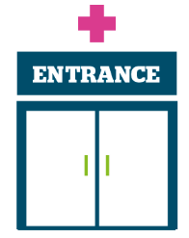 | Access to primary care – we would love to hear your feedback about online access to GP services, how you manage your health care needs with your GP practice using online technology and your views on the use of AI (Artificial Intelligence) within general practice. Our digital survey closes 1 July 2026.  Are you an unpaid carer? We’re also really interested to hear carers’ experience of accessing primary care for the people they care for. Our online survey is: Carers Experiences of GP practices.  Involvement of people - we’re looking at residents’ experiences of care delivered by Surrey’s hospitals, both in the hospital and the community. Whether you’ve been for a short appointment or a longer stay, or even just visited a friend or relative, please give us your views via our hospital survey.  Public Health and Adult Social Care - We’d love to hear from anyone with recent experience of oral health in Surrey’s care homes, either yourself or on behalf of a family member. Please contact our Helpdesk.

To share an experience with us, or for information and signposting about health and social care, people can also contact our Helpdesk in the following ways:
Phone: 0303 303 0023
SMS (text only)/ WhatsApp: 07592 787533
Email: enquiries@healthwatchsurrey.co.uk
Share your feedback via our website: https://www.healthwatchsurrey.co.uk/share-your-views

Stopping smoking – your thoughts

Luminus is also working with Public Health, to support Surrey residents, wherever they are in their smoking journey, to understand the risks of smoking and get free support to quit. As part of this there is an online survey people can complete: Stopping Smoking - your thoughts which closes on 1 August 2026.

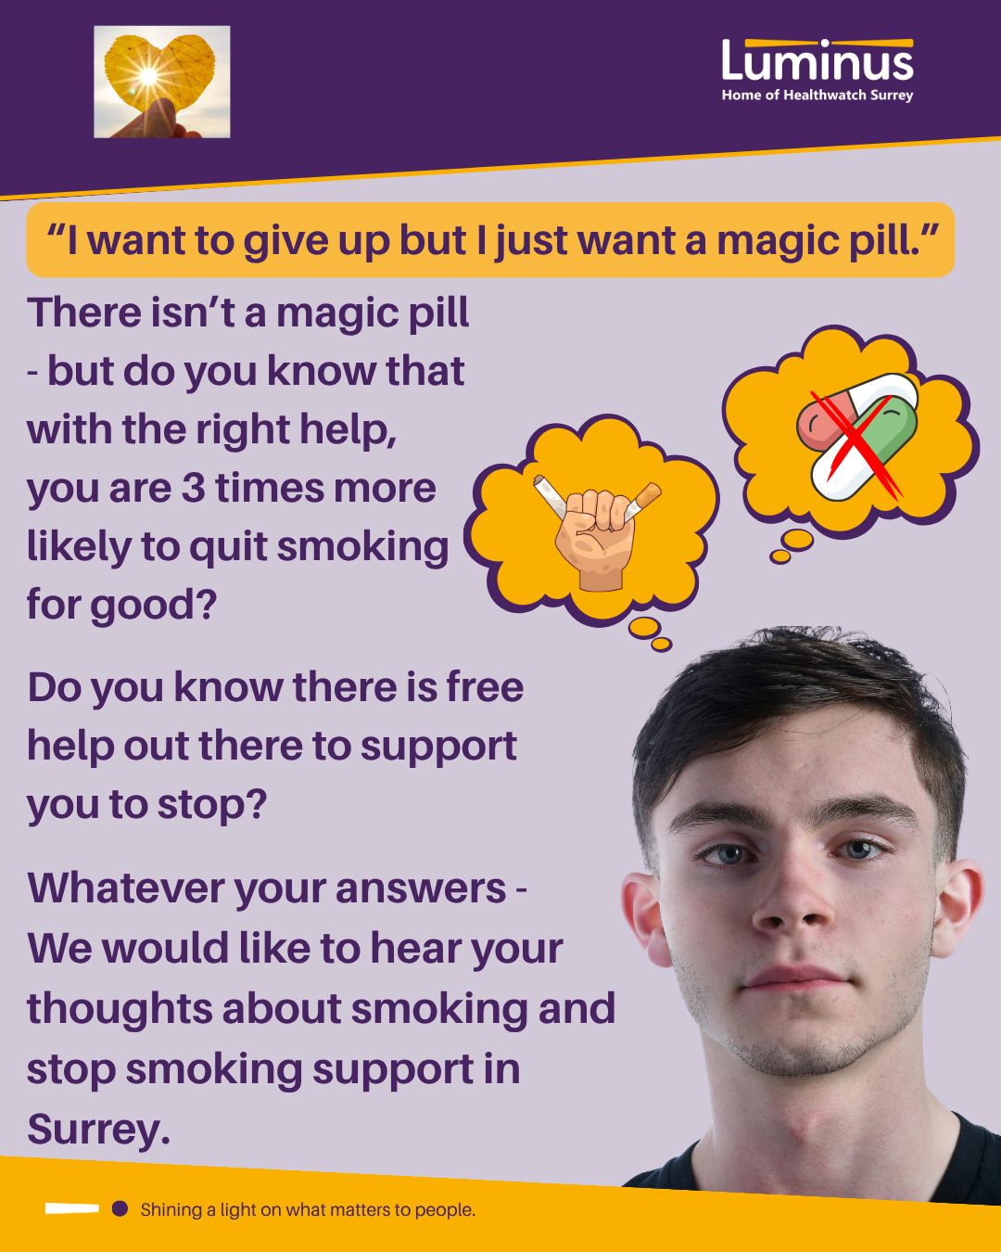

The more people we hear from, the more impactful our research will be, and the more likely we are to be able to bring about positive change.

Sharing our insight and raising concerns
Whilst this bulletin accurately reflects what we hear from the individuals we speak to, we are aware that it may not be representative of everyone’s views of a particular service. Multiple references to a specific service may be due to where our community engagement has recently taken place.

If we hear a case of concern regarding patient safety, we immediately signpost the sharer to the appropriate body. All appropriate information and signposting has already been given.

If you would like more information or examples of what people have shared with us, please get in touch with us.

Our distribution list
If you would like to be added to or removed from the distribution list for this Insight bulletin, please contact our Communications Lead vicky.rushworth@healthwatchsurrey.co.uk

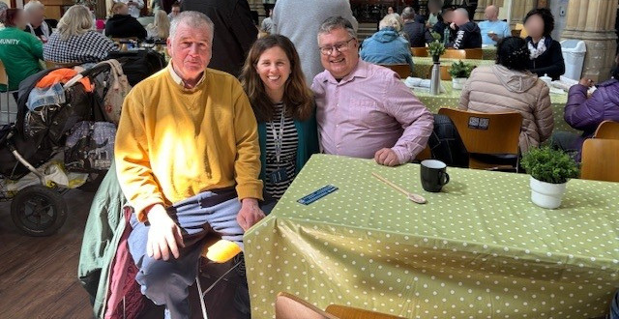

About Healthwatch Surrey
Healthwatch Surrey champions the voice of local people to shape, improve and get the best from NHS, health and social care services. We are independent and have statutory powers to make sure decision makers listen to the experiences of local people.

We passionately believe that listening and responding to local people's experiences is vital to create health and social care services that meet the needs of people in Surrey. We seek out people’s experiences of health and care services, particularly from people whose voices are seldom heard, who might be at risk of health inequalities and whose needs are not met by current services. We share our findings publicly and with service providers and commissioners to influence and challenge current provision and future plans.

We also provide reliable and trustworthy information and signposting about local health and social care services to help people get the support they need.


We are committed to the quality of our information.
Every 3 years we perform an audit so that we can be certain of this.


We are proud to have signed up to the End Poverty Pledge - End Poverty Surrey – Good Company.



The Healthwatch Surrey service is run by Luminus Insight CIC, known as Luminus. Luminus is a Surrey based, independent, community interest company which exists to empower people to have their voices heard. We help organisations provide equity of access and the best services possible, through the inclusive involvement of local people.
Registered office: GF21, Astolat, Coniers Way, Burpham, Surrey, GU4 7HL.

