


Insight bulletin

  - August 2026



“My dentures have broken and I am struggling to eat. I have to push the food to the roof of my mouth or mash it up to try and eat. I have been trying to find an NHS dentist and can't find anything. I am a pensioner and a carer for my wife and my daughter, both who have stage 4 terminal cancer. I am going to have to pay for funerals, I can't afford to pay for my dentures too. I also have dyslexia so struggle to access things online.”


If you would like a paper copy of this document or require it in an alternative format, please get in touch with us.

Healthwatch Surrey: a year in review
During 2025-26 over 2400 Surrey residents shared their experiences of health and social care with us and over 400 people came to our Helpdesk for information and advice. Our Annual Report, ‘Making every voice count’, looks back at our impact throughout the year.

We also look back at what people told us about adult social care specifically between March 2025 - March 2026 in our ‘Adult social care a year in review report’.

Save the date!
Please register to join us for a special, in person, Healthwatch Surrey event celebrating the power of lived experience, sharing what we’ve learned over more than a decade, and looking ahead to the future.

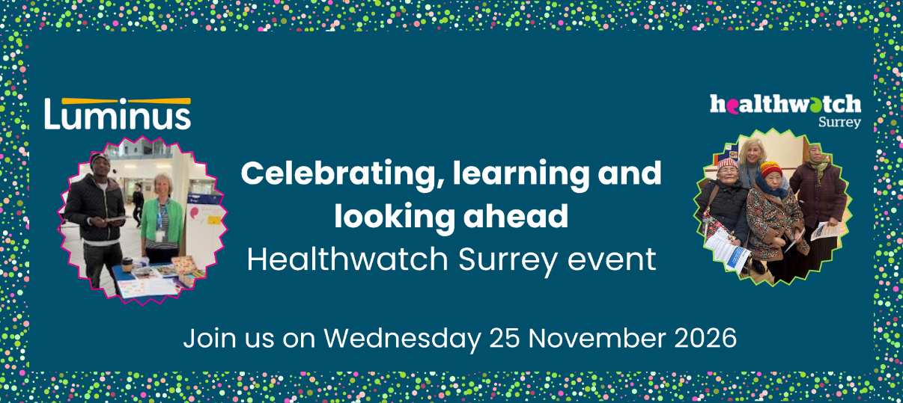

Our event will take place on Wednesday 25 November 2026, 9.30am – 12noon, at The Grange in Bookham.

Join us to find out:
- How lived experience has shaped our work
- What we’ve learnt about how to reach and engage with Surrey’s priority populations
- How we have used our Enter and View powers to reach people who wouldn’t otherwise be heard
- How our information and signposting has helped local residents over the years
- Our latest update about the Health Bill and what this might mean for the future
- More about Luminus’s work and explore the potential for public voice services.

Please register your interest to join us for a celebratory, inspiring and enjoyable morning: Healthwatch Surrey celebration: Sharing our learnings.

This bulletin: at a glance

Hot topics
In this bulletin we are focussing on 6 key areas:
- Thanks and praise for staff going above and beyond under pressure
- Dental care: confusion around access to NHS treatment
- Challenges accessing mental health support for children and young people with special educational needs
- Hospitals: discharge delays and lack of appropriate planning
- Research update: weight management
- Research update: hearing every voice

Who have we been hearing from?
Since our last bulletin 144 people have shared their experiences of health and social care across Surrey.
- Over 50% of the feedback relates to hospitals
- A quarter of the feedback relates to GP practices.

People have also talked to us about social care, mental health services, dental services and the NHS 111 service.

Since our last bulletin we’ve had more than 80 enquiries to our Helpdesk. People can come to our Helpdesk with questions, concerns or feedback on any aspect of health and social care, so what we’re hearing here can be a good indicator of the main issues that matter to local people. This month people have shared experiences about access to NHS dental care and mental health services for children and young people with special educational needs and disabilities.

Thanks and praise for busy staff going ‘above and beyond’

Reception staff in medical settings do a vital job supporting the clinical team and making patients feel at ease – we’ve been pleased to hear recognition of the difference they can make this month, along with appreciation for the dedication of other members of the clinical and non-clinical team.

“The man on reception [at the hospital] is always friendly, approachable and goes above and beyond to help.”
231704, Surrey resident

“I was seen earlier than anticipated, as soon as I entered I was greeted with a smile by the receptionist. I was called in to see the urologist straight away. She explained the procedure and what they were going to do. There were three young ladies in total and during the procedure, about which I was a little nervous, all the staff were courteous and caring.”
231739, Tandridge resident

“Would like to extend my gratitude for the excellent care received last night. Staff go the extra mile for all even when SO busy. Special thank you to the doctor for making me feel so at ease.”
231759, Surrey resident

“The whole experience was incredibly positive. All of the staff were kind, patient and friendly. I was in at 1.30pm and discharged by 6.30pm.”
231750, Waverley resident
.

Dental care: confusion around access to NHS treatment

People often reach out to Healthwatch Surrey when they are unable to get NHS dental care. They are confused both about the process and concerned about the financial impact of having to pay for treatment.

“I have been trying to register my daughter and myself with an NHS dentist for the past 10 months without any luck. I currently have a maternity exemption, would this make me eligible to register? I have also recently had to have an emergency dental appointment, which I paid for. In the appointment they said that I need an extraction and a course of antibiotics. I am still unable to find a dentist which will either treat or refer me.”
231456, Spelthorne resident

“I was made homeless 6 weeks ago, and the first night I was made homeless I slept in a cemetery. During the night, some drunk men came in to the cemetery, so I tried to escape but the gate was shut. I tried to climb over but fell from the gate and landed on my face. This broke 3 teeth in my mouth. Over the past 6 weeks I have been calling NHS 111 to get an emergency dental appointment. They first told me to go to the GP, who told me that they were not a dentist and couldn’t do anything for me. I tried calling 111 again and they assessed me and told me to just take paracetamol to manage the pain which isn't working. I also now have an infection, I can't eat and it takes me 25 minutes to brush my teeth. I also can't find any NHS dentists in my area to see me and because I am still recovering from being made homeless, I can't afford private care.”
231797

“I am moving [and have registered with a new] dentist. The price of treatment is very high, so I asked them to put me on their list for NHS treatment. I spoke to a receptionist on Friday and they said that they could put me on a list, but they would need to wait for the Government guidance to come through before they did. I then called up again today and they said that they could add me to their NHS waiting list but it would be a 2 to 3 year wait and that I would need to wait for someone to be deregistered before I could be an NHS patient. But that is taking away my choice, I want to attend this dentist because I have mental health conditions and they have good reviews, it’s just not right. I can't afford to pay for any treatment, it cost me £160 for a check-up and two x-rays.”
231306, Surrey resident

Dentures
People have told us that there is no clear process in place if you require a new set of dentures but aren’t registered with an NHS dentist, this can lead to people surviving without them.

“My dentures have broken and I am struggling to eat. I have to push the food to the roof of my mouth or mash it up to try and eat. I have been trying to find an NHS dentist and can't find anything. I am a pensioner and a carer for my wife and my daughter, both who have stage 4 terminal cancer. I am going to have to pay for funerals, I can't afford to pay for my dentures too. I also have dyslexia so struggle to access things online.”
231747, Surrey Heath resident

We’ve produced a guide to NHS dental services to try to address some of the confusion.

Challenges accessing mental health support for children and young people with special educational needs

People have talked to us about the issues they’ve faced accessing mental health support for their children and /or about the support not meeting their needs.

“[my son] was referred for [mental health support] by both his paediatrician and his disability social worker. We then spent an extremely long time on the waiting list, during which I repeatedly had to chase for updates before he was finally offered appointments. I understood that [my son] was due to receive a programme of five therapy sessions. However, after attending the first two appointments, I am genuinely at a loss as to what therapeutic intervention was actually being provided. During both sessions [my son] was simply given some fidget toys and allowed to play with them while we sat in the room. I fail to understand how this constituted therapy or how it was intended to help address his significant needs.

What made the situation even more concerning was that, after just two sessions, I was informed that this service did not feel it was the right place for [my son] and that they were unable to offer him the support he needed. Since then, no alternative support has been offered whatsoever.”
231776, Surrey resident

“Four referrals and offered nothing until my daughter’s physical health was severely compromised due to unmet mental health needs. They need to listen more, services need to respond to child’s needs, not the child respond to the service.”
231486, Surrey resident

“There is nothing that is going well - appointments cancelled due to therapists’ illness, I would think she has been ill more than not. They seem to have very little idea what’s going on with my son.”
231379, Surrey Heath resident

“I got Cytomegalovirus [CMV] in utero so my daughter [16] is completely deaf. She is also non verbal and has cerebral palsy.…. My daughter has been out of school for a year now. She has very complex needs. She is hopefully starting her new school this week. We did get alternative provision for her but that didn’t start until February so she had just a couple of months of it. I can’t leave my daughter alone at all so I have been unable to work. I usually consult so I can have some income but since being in the UK, I haven’t been able to as she’s been at home. I have to look after her 24/7 and be with her… As a carer, I really need more help. My daughter can get very violent and it’s very difficult to calm her down. I spoke to [mental health services] in February but nothing since. They told me to just call the helpline. That’s not helpful to me as a carer. I need more support and help. I am worried about what will happen as she gets older. People have mentioned the move to adult services and warned me about that.”
300349, Reigate and Banstead resident

People continue to tell us about the lack of smooth transition between children’s and adult services and the feeling of being abandoned by the system when their child turns 18.

“No support after 18 except the GP practice who don’t really understand and aren’t specialists. Discharged from psychiatrist at 18. No support that is specific to autism unless it’s paid for - talking therapy doesn’t help.”
231499, Surrey Heath resident

Hospitals: discharge delays and lack of appropriate planning

We’re currently undertaking a piece of work to explore people’s experiences of care delivered by Surrey’s acute hospitals, both in the hospital and the community. Whilst we’re pleased to be working with individual providers to determine where our focus should be, we’re also offering people the opportunity to talk to us, agenda free, about any aspect of their care or experience and are spotting common themes across the county.

Delays with discharge – and a lack of communication around these delays – can cause unnecessary stress for patients.

“The service has been great, right up to the point of discharge. I was told at 8am I was to be discharged. By 12noon no sign of it happening. Talked to nurses who said it will take many more hours. Talked to others in the hospital. This is normal for the hospital. You have people in corridors needing beds in wards. Sorting this out should be a priority for the hospital as it’s a win win.”
231497, Surrey resident

“Discharge was very slow, I feel unnecessarily slow. I was told at 3am I'd be able to leave first thing, I assumed they meant around 7am so I asked my partner to pick me up. He was waiting for me for hours. I have no idea why they couldn't discharge me earlier if we were healthy enough to leave at 3am. I felt that the only reason they discharged me in the end was because I kept badgering them.”
231785, Reigate and Banstead resident

In addition, we’ve heard from people who have been discharged without appropriate planning and support.

“The appointment was organised very quickly and the doctor carrying out the procedure was good, telling me what he was doing at all times. However, I was sent home with no information on how to look after the equipment I had fitted & no spares. This led to me rushing round on Christmas Eve trying to get enough to last me until I could get an order organised. I had to return to the hospital department to get spares to be met by a rather arrogant doctor who couldn't understand why I was returning just for equipment.”
231417, Surrey resident

“I was then admitted to hospital, but they then discharged me incorrectly on grounds that I did not agree with, and neither did the registrar…. they did try and check my tooth and the nurse who did this did not use a trauma informed approach and shoved her fingers in my mouth. This massively triggered me and I had a trauma response and left. No one could find me for 3 hours in which they decided to discharge me and handed over all my discharge notes and medications to an acquaintance who had come to visit me in hospital.”
231700, Guildford resident

We’re out and about talking to people in the community, but they can also share their experience via our online survey.

Research update: weight management

In 2022/23 an estimated 58% of adults in Surrey were classified as overweight or obese (Healthy Surrey). Whilst this is lower than the England average at that time of 64%, this represented an increase on the previous 5 years.

We talked to people at weight management groups, leisure centres and minoritised ethnic community groups to understand what they knew about the weight management support options available to them and to identify any barriers to access. As well as hearing about their experiences we also helped people to work out their BMI (Body Mass Index) and to understand its meaning, and provided signposting to weight management support.

Over 240 people gave us their views, at community engagement events or via our survey.

Our findings
- People’s primary concern is reducing their risk of heart disease, but some did not realise the correlation between weight and other health conditions.
- People’s motivation changes over time, from concern over appearance to concern to stay healthy for others they care about and for.
- There is a strong psychological and emotional relationship with weight management support, often rooted in childhood and lasting throughout life.

“…there needs to be a more holistic approach to weight management, looking at people’s circumstances, their mental health and their physical health to make a meaningful change.”
Survey respondent

Find out more in our weight management report, which has been shared with our primary care colleagues.

Research update: Hearing every voice

How accessible are NHS complaints and feedback mechanisms in Surrey? And what might reduce the barriers faced by people who have additional needs in being able to have their voices heard by NHS providers? Our review sought to find out.

The first stage of this project involved the collation of experiences - shared with us between April 2025 and April 2026 - relating to how accessible raising a concern with an NHS provider is for people with additional needs. We then interrogated the accessibility of a selection of GP practice and hospital websites across Surrey.

Key findings
Navigating the NHS can be challenging for anyone accessing services, but particularly for those who have additional needs. From the experiences shared and desk based research, our report identifies some key themes, including complex complaints processes and digital platforms.

It also highlights people's concerns about complaining directly to the service provider, often due to a fear that their care might be affected.

“I don’t really want to keep escalating. I just want engagement and being deflected incorrectly by PALS is immensely depressing and immensely reinforcing of the mounting belief that the NHS and all associated bodies have no interest in supporting those in need.”
Survey respondent

Find out more in our Hearing every voice report, which has been shared with complaints teams at all Surrey hospital trusts, GP practices and the Parliamentary and Health Service Ombudsman.

Have your say!

We want to hear from as many people as possible which is why we have surveys to accompany our face to face engagements in the community.

 | Involvement of people - we’re looking at residents’ experiences of care delivered by Surrey’s hospitals, both in the hospital and the community. Whether you’ve been for a short appointment or a longer stay, or even just visited a friend or relative, please give us your views via our hospital survey.
 | Public health and adult social care: we’d love to hear from anyone with recent experience of oral health in Surrey’s care homes, either yourself or on behalf of a family member. Please contact our Helpdesk.
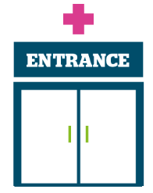 | Primary care: we’re working with our Giving Carers a Voice colleagues to hear about carers’ experiences of accessing primary care (particularly GP practices) for the people they care for. Are you a carer? We’d love to hear from you via our carers’ survey.

Other ways to have your say!



The Big Conversation on Care, part of the work being undertaken by the Independent Commission on Adult Social Care, also known as the Casey Commission, is a chance, for everyone in England to have their say on the future of adult social care. To ensure it hears from as many people as possible, it has also launched an online conversation platform where you can share ideas and vote on the ideas posted by other people.

The Government are calling for evidence from organisations and individuals who have information that is relevant to how Carer’s Allowance could be modernised, including through an earnings taper, the role of the earnings rules and how they operate in practice. Information and forms to complete are available on our website.
`
To share an experience with us, or for information and signposting about health and social care, people can also contact our Helpdesk in the following ways:
Phone: 0303 303 0023
SMS (text only)/ WhatsApp: 07592 787533
Email: enquiries@healthwatchsurrey.co.uk
Share your feedback via our website: www.healthwatchsurrey.co.uk/share-your-views

Stopping smoking – your thoughts

Luminus is working with Public Health, to support Surrey residents, wherever they are in their smoking journey, to understand the risks of smoking and get free support to quit. As part of this there is an online survey people can complete: Stopping Smoking - your thoughts which closes on 31 August 2026.

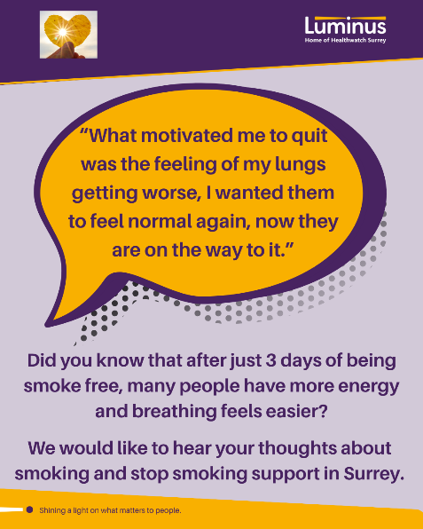

The more people we hear from, the more impactful our research will be, and the more likely we are to be able to bring about positive change.

Sharing our insight and raising concerns
Whilst this bulletin accurately reflects what we hear from the individuals we speak to, we are aware that it may not be representative of everyone’s views of a particular service. Multiple references to a specific service may be due to where our community engagement has recently taken place.

If we hear a case of concern regarding patient safety, we immediately signpost the sharer to the appropriate body. All appropriate information and signposting has already been given.

If you would like more information or examples of what people have shared with us, please get in touch with us.

Our distribution list
If you would like to be added to or removed from the distribution list for this Insight bulletin, please contact our Communications Lead vicky.rushworth@healthwatchsurrey.co.uk

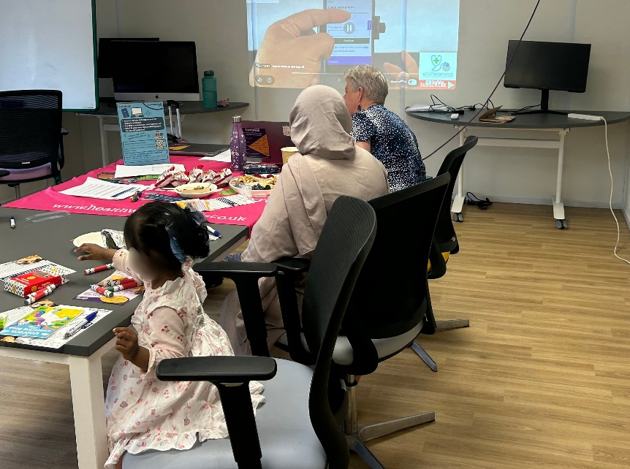

About Healthwatch Surrey
Healthwatch Surrey champions the voice of local people to shape, improve and get the best from NHS, health and social care services. We are independent and have statutory powers to make sure decision makers listen to the experiences of local people.

We passionately believe that listening and responding to local people's experiences is vital to create health and social care services that meet the needs of people in Surrey. We seek out people’s experiences of health and care services, particularly from people whose voices are seldom heard, who might be at risk of health inequalities and whose needs are not met by current services. We share our findings publicly and with service providers and commissioners to influence and challenge current provision and future plans.

We also provide reliable and trustworthy information and signposting about local health and social care services to help people get the support they need.


We are committed to the quality of our information.
Every 3 years we perform an audit so that we can be certain of this.


We are proud to have signed up to the End Poverty Pledge.



The Healthwatch Surrey service is run by Luminus Insight CIC, known as Luminus. Luminus is a Surrey based, independent, community interest company which exists to empower people to have their voices heard. We help organisations provide equity of access and the best services possible, through the inclusive involvement of local people.
Registered office: GF21, Astolat, Coniers Way, Burpham, Surrey, GU4 7HL.
Company number: 08737632. Registered in England and Wales.

