


Insight bulletin – October 2026

Heard in hospital:
  - Exploring patient’s experiences of care in Surrey’s hospitals

We regularly share patient feedback with hospital trusts in Surrey, providing them with insights they might not otherwise hear from their patients. These are based on what patients tell us when they talk to us, agenda-free, about any aspect of their care, as well as insights on specific departments, therapeutic areas or patient populations where there is felt to be the greatest need to hear patient voice.

Our engagement approach

Live feedback on services

Talking to people at the point of care, in clinical settings, gives them an opportunity to share their experiences with an independent, impartial organisation. This allows us to capture feedback from those who are actively using services and can provide insights into current areas for praise or concern.

Retrospective feedback
Engagement in community settings gives us the opportunity to hear from people who may be using services but may also be experiencing barriers to care and treatment. In addition to experiences about acute care, we give people the opportunity to talk more widely about health and care. We have visited church groups and community cafes in priority population areas, as well as support groups for those with disabilities.

People come to us
Our Helpdesk offers an information and advice service for residents of Surrey. They also provide a listening ear for people’s queries, experiences or complaints. These are combined with conversations we have had when people have contacted our Helpdesk.
Surrey residents can also share their experiences with Healthwatch England and the Independent Health Complaints Advocacy Service.

People can choose to take part in our Hospital feedback survey to share their views.

Who have we been working with?
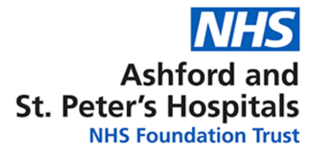
In April we talked to people about the care they had received across the trust. We visited Ashford Hospital and a local Church
in an area with high rates of disadvantage and poorer health outcomes, where barriers to social and economic participation can exist.

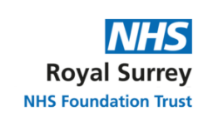
In May, along with our general engagement, we supported the Trust to evaluate patient experience, accessibility, communication and service flow within the ophthalmology department. We visited the department, a Sight for Surrey drop in and a Macular Society support group.


In June our focus was maternity, the accessibility of the MySASH portal, carers and virtual wards. We spoke to people in the maternity department at East Surrey Hospital, a Family Centre, a breast feeding support group and a memory café.
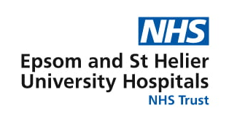
In July we spoke to people about stroke and emergency care specifically. Our engagement took us to relevant departments at Epsom hospital, a church café and a Stroke Association Support Group.

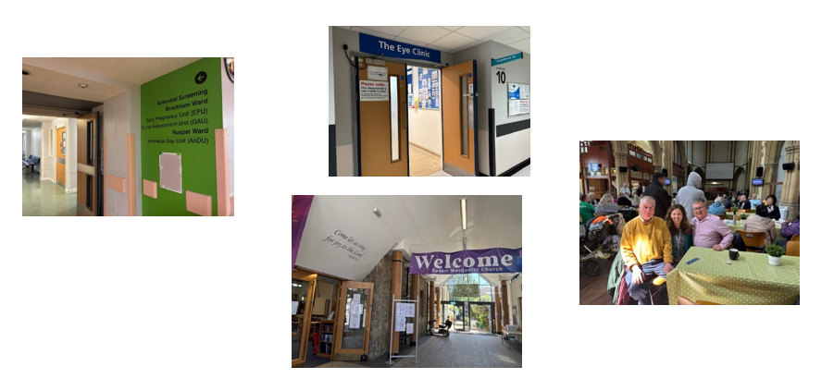

What did we hear?
We have shared reports detailing our findings and addressing specific areas of interest with the relevant Trusts. Whilst these are all different, some recurring themes did emerge across all four Trusts.

People frequently praised the commitment, kindness and clinical skill of staff. However, their overall experience of care was often shaped by how services communicated with them, whether their individual needs were met, discharge planning and the impact of delays, pressure on services and hospital environments.

Please note, whilst this report accurately reflects what we hear from the individuals we speak to, we are aware that it may not be representative of everyone’s views of a particular service.

Thanks and praise


“The care has been absolutely lovely. The nurses are so kind, they can't do enough for you.”
Surrey resident

Communication and information gaps
People told us they didn’t always know what was happening, waiting times were unclear, phone calls unanswered, there was a lack of updates about appointments or transfers, and they had to repeat their story to different staff. For some people this caused anxiety and frustration; for others, it affected their ability to make decisions about their care or plan their return home.

“It's very frustrating as we really haven’t had many updates. It feels like the systems don't work - the staff aren't communicating between each other, let alone to us.”
230974

National data on NHS complaints reveals that "The largest proportion of new complaints received by individual subject area was communications" and a recent report by NHS England - Learning from national patient experience surveys: qualitative insights across care pathways found that poor or inconsistent communication undermined trust and confidence in care, including questioning of clinical decision-making. It is an area that local Healthwatch and Healthwatch England continue to highlight nationwide – with the Healthwatch England report NHS Communications: What are the four things people want? stating that feeling listened to, informed and involved in decision-making is paramount to a positive experience across all pathways.

System pressures leading to environmental pressures
People described receiving care on trolleys or in corridor areas, with concerns about privacy, dignity, comfort and access to basic support and amenities such as food, water, medication, toileting and the ability to contact family. For some people, the environment itself became a significant part of their experience of care.

“I could not believe the amount of people on trolleys, rested on waiting room chairs doubling as beds, in corridors etc. The indignity of it all - sharing details that can be heard by others was a shock to me.”
231824

Many of the examples we heard from people experiencing “corridor care” were during Spring/Summer months and not at the height of “winter pressures.” It is concerning to hear the prevalence of this care. NHS England states (2026):

“NHS England considers the delivery of corridor care in departments or wards experiencing patient crowding to be unacceptable and should never be considered standard. Patients should only be placed in corridors in extremis and for the shortest possible duration, to ensure the time patients are cared for in this environment is kept to a minimum.”

Meeting individual needs and reasonable adjustments
People’s experiences varied when they needed additional support or reasonable adjustments. Some described thoughtful and flexible support, but others told us that adjustments were not consistently offered, understood or acted on, despite The Oliver McGowan Mandatory Training on Learning Disability and Autism for health and social care staff.

“There was no understanding of how traumatic and scary appointments could be for my autistic son, he was told he was wrong when he said the intravenous antibiotic was hurting, he has sensory differences and experiences some things as pain that others may not, there was no patience to take time to make him feel safe.”
231505

Discharge planning and follow-up support
Some people felt well informed and clear about who to contact with concerns relating to discharge from hospital. Others described delays, unclear next steps, insufficient information about medication or equipment, and worries about whether discharge had been planned safely.

“On discharge I was given a bag of medication and 3 pages worth of details to tell me when to take them all. Nothing else.”
231859

How is the lived experience shared with us making a difference?
We attend monthly patient experience forums for each Trust and we’re working with all providers to ensure our findings lead to positive changes for patients and their carers.

Based on the findings of our report, Royal Surrey County Hospital NHS Foundation Trust are making a number of changes, including reviews of:
- Receptionist roles to ensure an allocated person answers the phone – ensuring patients receive a callback within a clearly defined timeframe - and an allocated person supports patients when they arrive in the department
- How patients can be better informed about waiting times
- Improved signage to refreshments
- Signposting to feedback mechanisms, to ensure patients are clear about how they can do this.

Since our report to Ashford and St Peters NHS Foundation Trust, the following changes have been implemented:
- An increase in food rounds on the wards
- Improved signage to refreshments
- Additional hot drinks machines installed.

Surrey and Sussex Healthcare have made a number of changes since our report. They told us they have:
- Recruited 10 new early career midwives and 4 additional Band 6 midwives
- Reviewed postnatal staffing
- Purchased new seats for birthing partners
- Developed clearer discharge information for new parents.

What’s next?
We will continue to combine community and clinical engagement over the coming months. We’ll be making repeat visits to Trusts and reaching new ones. We’d love to hear from you via our Hospital feedback survey too!

What else are we doing?
 | Public health and adult social care: We’d love to hear from anyone with recent experience of oral health in Surrey’s care homes, either yourself, on behalf of a friend or family member or if you work in a care home.  If you or your friend or relative live in a care home, then please complete this survey - Oral health in care homes - residents and family survey Healthwatch Surrey 2026-27  If you work in a care home, please complete this one - Oral health in care homes staff survey Healthwatch Surrey 2026-27.  This survey closes on 15 November 2026.  If you need a paper copy, or would prefer to share your experience in your own words, please get in touch with our Helpdesk.
If you don’t have an experience that relates to the topics above, we would still love to hear from you about any health and social care experience you wish to share. To share an experience with us, or for information and signposting about health and social care, people can also contact our Helpdesk in the following ways:
Phone: 0303 303 0023
SMS (text only)/ WhatsApp: 07592 787533
Email: enquiries@healthwatchsurrey.co.uk
Share your feedback via our website: www.healthwatchsurrey.co.uk/share-your-views

Update on the Health Bill
The Health Bill, which (amongst other things) proposes the abolition of NHS England, the introduction of a Single Patient Record and transferring the functions of local Healthwatch to ICBs and Local authorities, is progressing through Parliament.

During the Third Reading in the House of Commons, we were pleased to hear from the Minister for Health that the government recognised the strength of feeling in support of Healthwatch in the House and committed to reviewing the provisions to “ensure that our approach sufficiently empowers and devolves to local populations.”.

The Second Reading of the Bill in the House of Lords took place on Tuesday 13 October. There was strong cross-bench support for retaining an independent local patient voice, with Peers highlighting Healthwatch’s trusted community relationships, independent scrutiny and ability to reach seldom heard groups.

Several Peers called for reform rather than abolition, warning that transferring responsibilities to ICBs and local authorities could undermine independence and public trust.

Further scrutiny is expected during the Lords Committee Stage, beginning on 28 October.

Whilst these discussions continue, we are very much still here.
We are proud of our independent and impartial role, championing the voice of local people to shape, improve and get the best from NHS, health and social care services.

Whatever is decided regarding Healthwatch, we will work with our partners to establish what this could mean for patient/service user feedback; community engagement; understanding needs and barriers, and information/advice. Luminus will continue to shine a light on what matters to people through our Giving Carers a Voice and Surrey Substance Use Partnership Public Involvement services, and our many other projects ensuring people’s voices are heard to support their wellbeing.

Our distribution list
This report has been sent to you as part of our Insight bulletin series. If you would like to be added to or removed from this distribution list, please contact our Communications Lead vicky.rushworth@healthwatchsurrey.co.uk

About Healthwatch Surrey
Healthwatch Surrey champions the voice of local people to shape, improve and get the best from NHS, health and social care services. We are independent and have statutory powers to make sure decision makers listen to the experiences of local people.

We passionately believe that listening and responding to local people's experiences is vital to create health and social care services that meet the needs of people in Surrey. We seek out people’s experiences of health and care services, particularly from people whose voices are seldom heard, who might be at risk of health inequalities and whose needs are not met by current services. We share our findings publicly and with service providers and commissioners to influence and challenge current provision and future plans.

We also provide reliable and trustworthy information and signposting about local health and social care services to help people get the support they need.


We are proud to have signed up to the End Poverty Pledge.



The Healthwatch Surrey service is run by Luminus Insight CIC, known as Luminus. Luminus is a Surrey based, independent, community interest company which exists to empower people to have their voices heard. We help organisations provide equity of access and the best services possible, through the inclusive involvement of local people.

Registered office: GF21, Astolat, Coniers Way, Burpham, Surrey, GU4 7HL.
Company number: 08737632. Registered in England and Wales.

